
CURICULLUM VITAE
Personal Detail
- Name |  | : Nandra Maulana Irawan
- Date of Birth |  | : Bogor, 4th November 1987
- Gender |  | : Male
- Address |  | : JL . Majapahit 2 Blok a6 no 20 cimanggu permai RT 03/07  Bogor
- Nationality |  | : Indonesia
- Marital Status |  | : Married
- Mobile Phone |  | : 081314029904
- Telephone |  | : 02519661296
- Email |  | : na2n_sp@yahoo.com
Education
- 2005 - 2008 | : Diploma 3 Politeknik Kent Bogor Majoring Informatics
- 2002 - 2005 | : SMU Negeri 2 Bogor
- 1999 - 2002 | : SMP Negeri 12 Bogor
- 1993 – 1999 | : SD Negeri Pabrik Gas IV Bogor
Computer Skill
- PHP | - Postgre
- Web GIS  - Javascript  - Jquery | - Mysql  - CSS  - Codeigniter
WEBSITE HAS BEEN MADE
- pnpm-pisew.org/webGIS  - lailaazra.com  - fpks.or.id  - gis.kominfo.go.id | - www.halalmui.org  - www.kapi.kkp.go.id  - www.whfc-halal.com

WORK EXPERIENCES
- March 2011 - December 2012
Application Developer On PT. ASIA E SERVICES
Job Description :
- Developing Learning Management System on Perusahaan Gas Negara
- Developing Aplikasi Presensi KOMINFO on Kementrian Komunikasi dan
Informatika
- Developing geographic information system (GIS) on Kementerian Komunikasi dan Informatika

- May 2010 - Feb 2011
Application Developer On PT. ASIAKOMNET
Job Description : Developing application to support all Business Process on company

- July 2009 - march 2010
Web Programmer on PT. Sucofindo . TBK
Job Description : Developing Web Portal Ministry of Fishery (Divisi Kapal Perikanan dan Alat Penangkap Ikan ).

- January 2009 – June 2009
Web Programmer on PT. Navindo Geosat
Job Description : Developing GPS Realtime vehicle tracking system based on web

- October 2008 – December 2008
Freelance Programmer on PT Sucofindo TBK
Job Description : Developing SISTEM INFORMASI MANAJEMEN PELAYANAN TERPADU SATU PINTU (SIMANTAP) on Ambon City Goverment

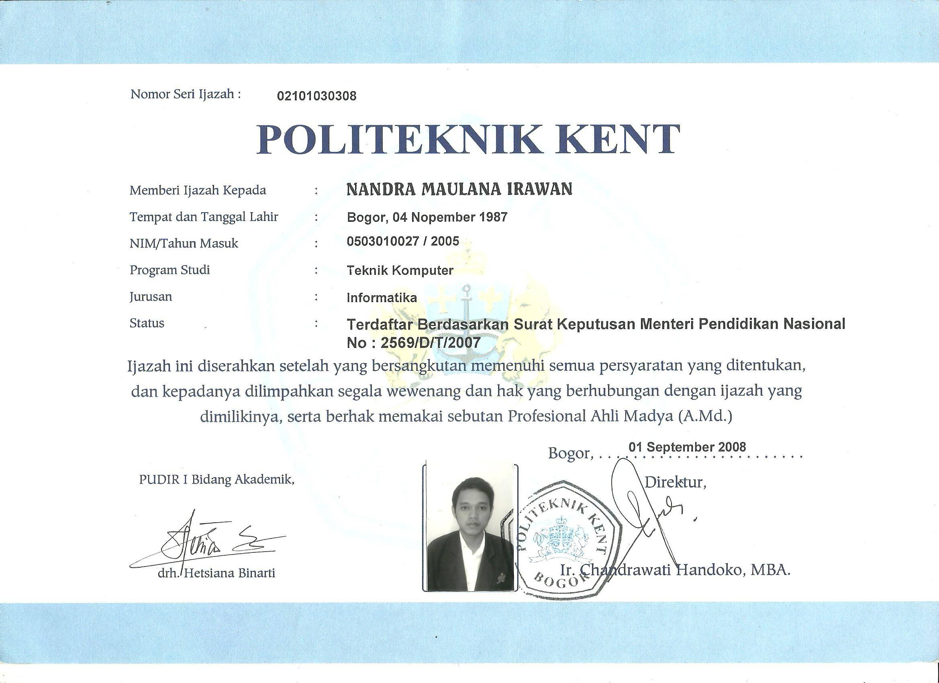
CERTIFICATE
