AhkWord showcase
A word processor for Windows that runs inside AutoHotkey. Everything in this document was made with the editor's own commands: the ribbon, the keyboard, or AHK scripts calling it through RteClient2.ahk. AhkWord on GitHub
Lists
- Write the document
  - Headings, block styles and fonts
  - Tables and pictures
- Export to Word, OpenDocument or PDF
Legal numbering
1. Definitions
1.1 The editor is the program described here.
1.2 A macro is an AHK script that drives it.
2. Obligations
A table
Feature | Shortcut | Ribbon
Page break | Ctrl+Enter | Insert
Record a macro | Ctrl+Shift+R | Tools
A picture
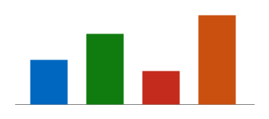
Rest the mouse on the picture to see its alt text; right-click it to change it.

Page two
Printing, PDF export and Word files start a new page at the break above.

