1. What are three conclusions we can make about Kickstarter campaigns given the provided data?

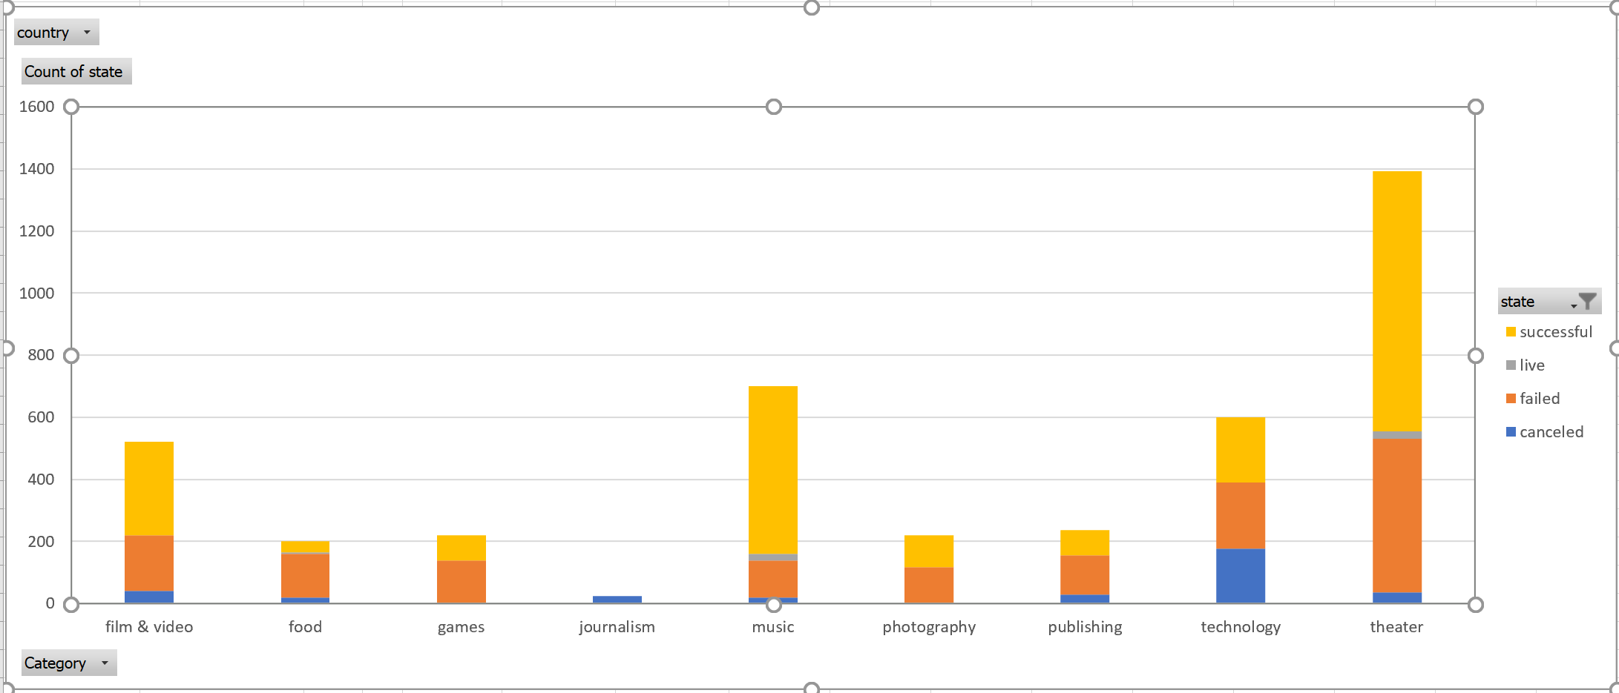

The chart measures Number of Outcomes by Category and by Outcome.

* The minimum value is 24(Journalism) and the maximum is 1,393 (theater) , a difference of 1,369 averaging 457.11.
* Theater accounts for 34% of overall number of outcomes.
* Theater (1,393) is more than three times bigger than the average across all the categories.

For theater, the distribution ranges from 24(live) to 839 (successful), a difference of 815, averaging 348.25. Successful (839) is more than 2 times bigger than average across the four subcategories.

For music, Total number of outcomes is 700 (representing 17% of the total number if outcomes across all categories. Successful (540) is more than three times bigger than the average across the four subcategories.

For Technology, Total number of outcomes is 600 across all the three subcategories (representing 15% of the total number of outcomes across all categories).

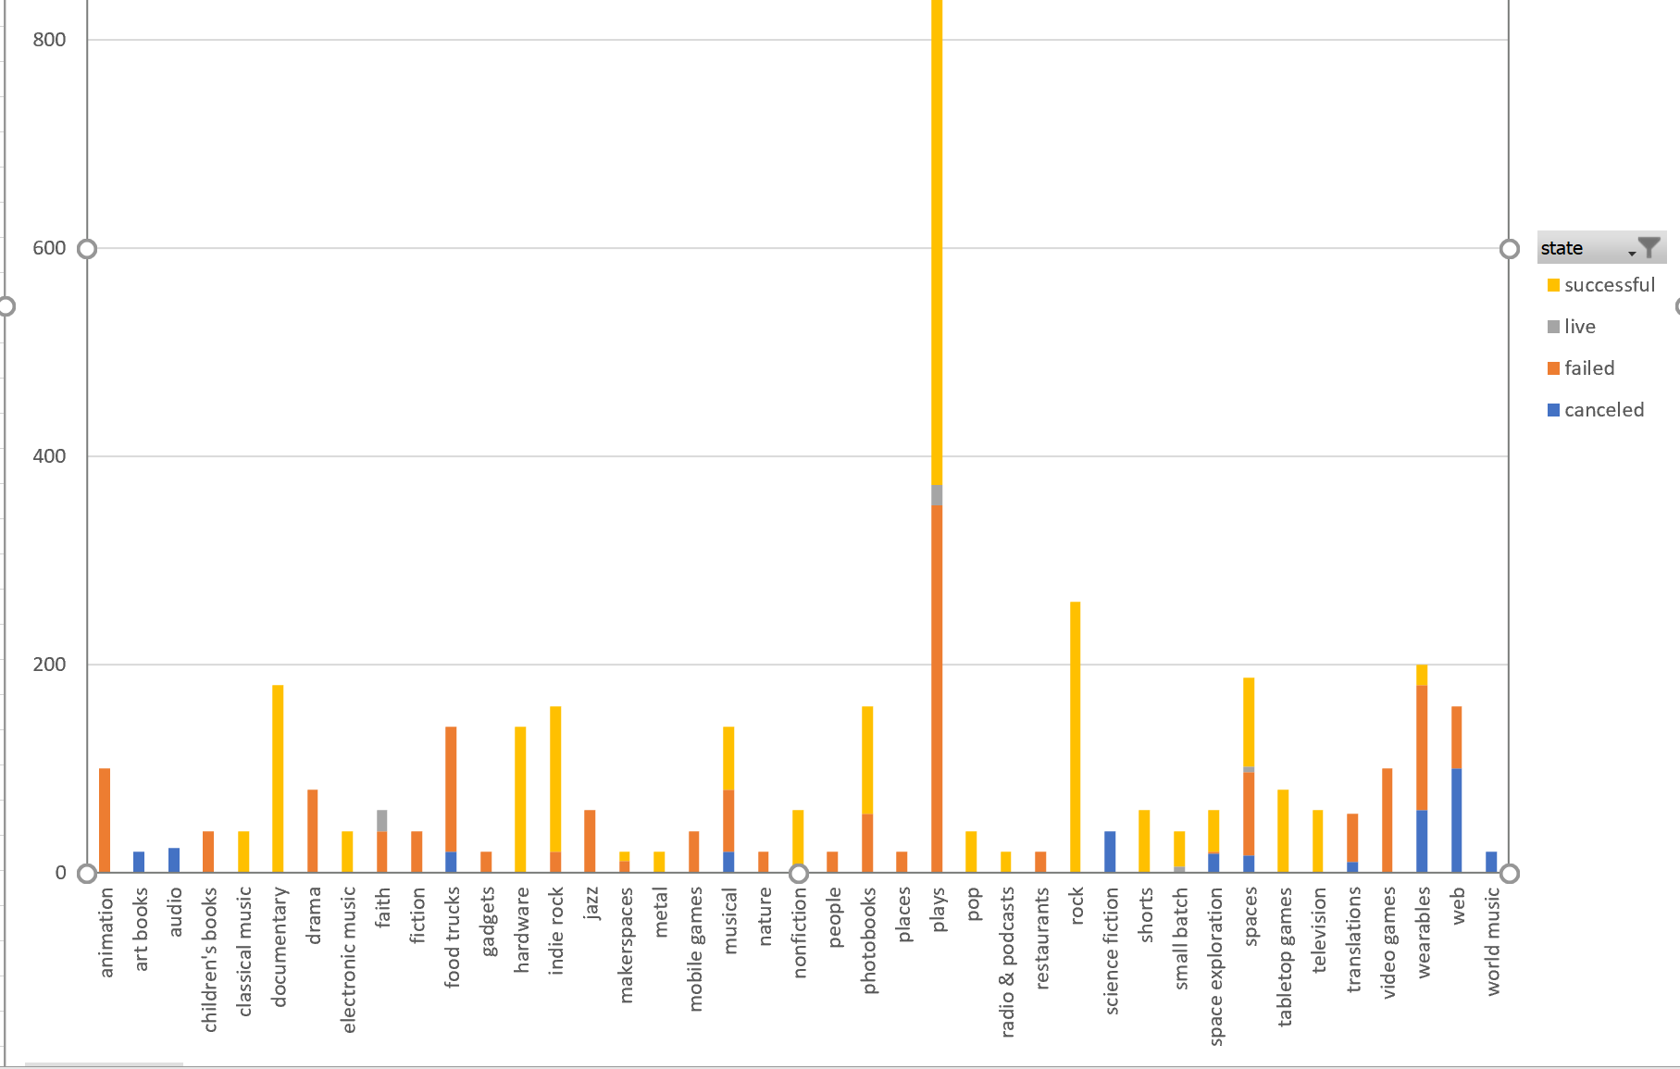

For number of outcomes by subcategory,

The distribution ranges from 20(art books, gadgets and marketspaces, among others) to 1,066 (plays) , a difference of 1,046 , averaging 100.34.

The distribution is positively skewed as the average of 100.34 is much greater than the median of 60.

Plays accounts for 26% of overall number of outcomes

Plays (1,066) is almost 11 times bigger than the average across all 41 subcategories.

A safe conclusion to make, is that plays are very popular.

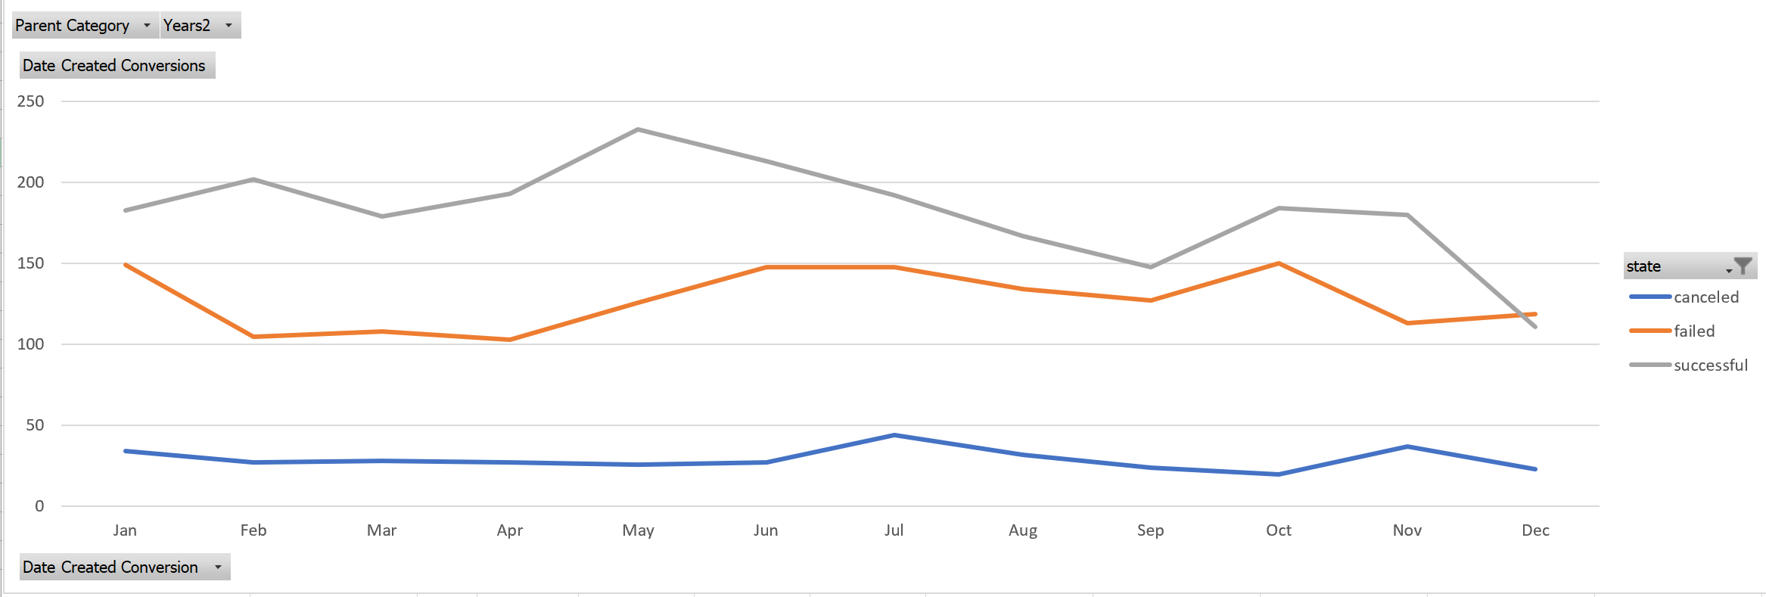

This chart measures %successful, % failed and % calculated by GOAL across months.

Past mid-May we have an accelerated decrease of success and the gap between successful and unsuccessful narrows down until the month of December when the lines intersect and the failed count surpasses successful for the first time. What this suggests is that we need to look at the information such as the percent funded for the highest and lowest success count and see if we can see significant correlations. Even when we filter the last months of the year by category no industry shows a trend of “success” in the month December.

1. What are some of the limitations of this dataset?

No Large Data available, so some of the results are not statistically relevant given the small sample size.

1. What are some other possible tables/graphs that we could create?

->

If we could analyze the data by states, we could see trends in which states have Kickstarters with the highest rates of success and which ones have the lowest rate of success.

->

We can also have maybe countries divided into states and regions to get more picture in detail.