1. What are three conclusions we can make about Kickstarter campaigns given the provided data?

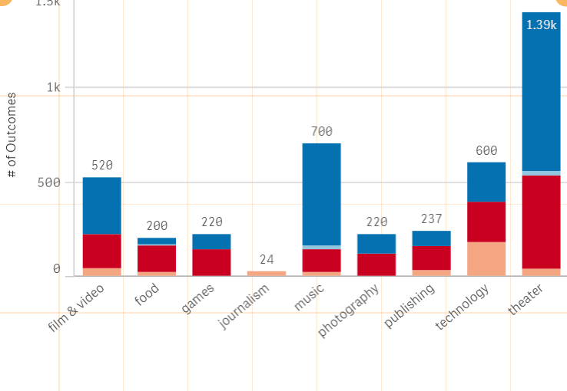

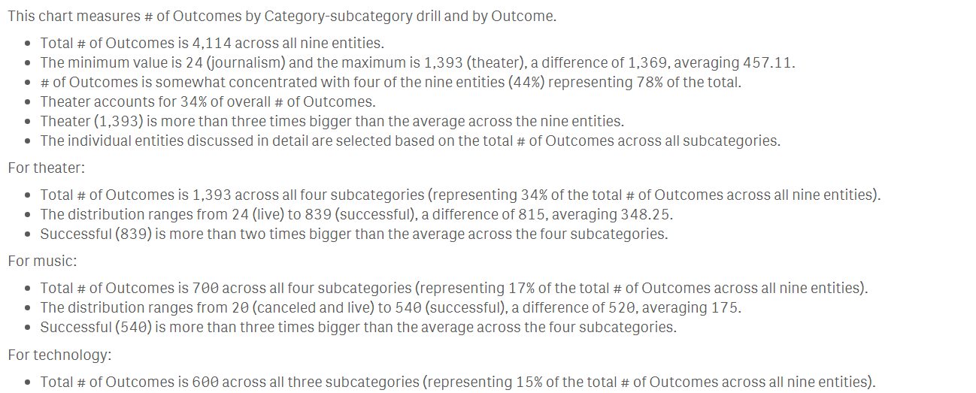

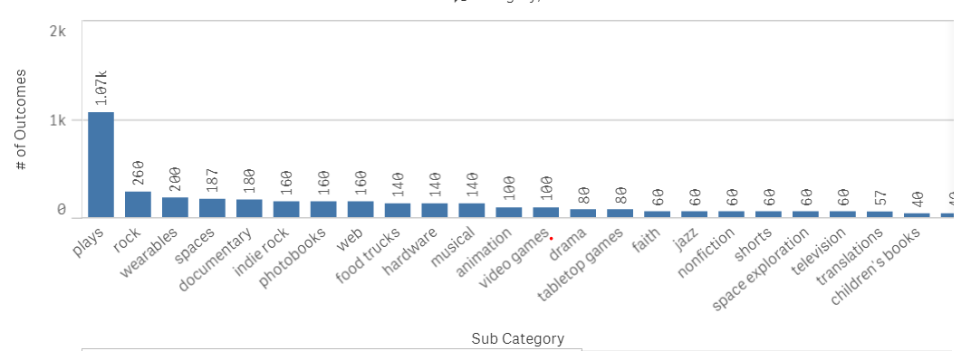

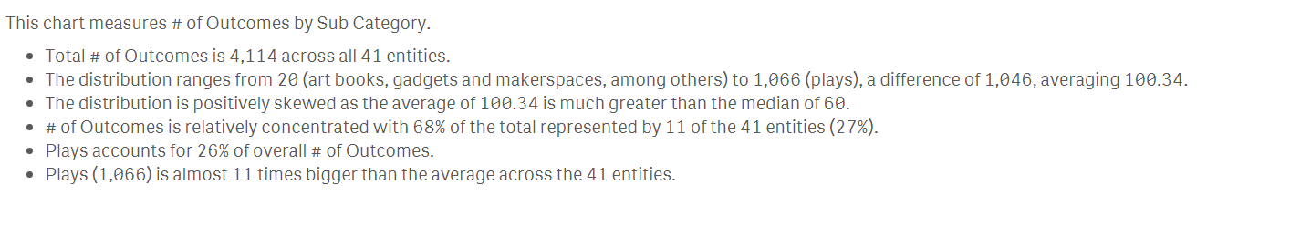

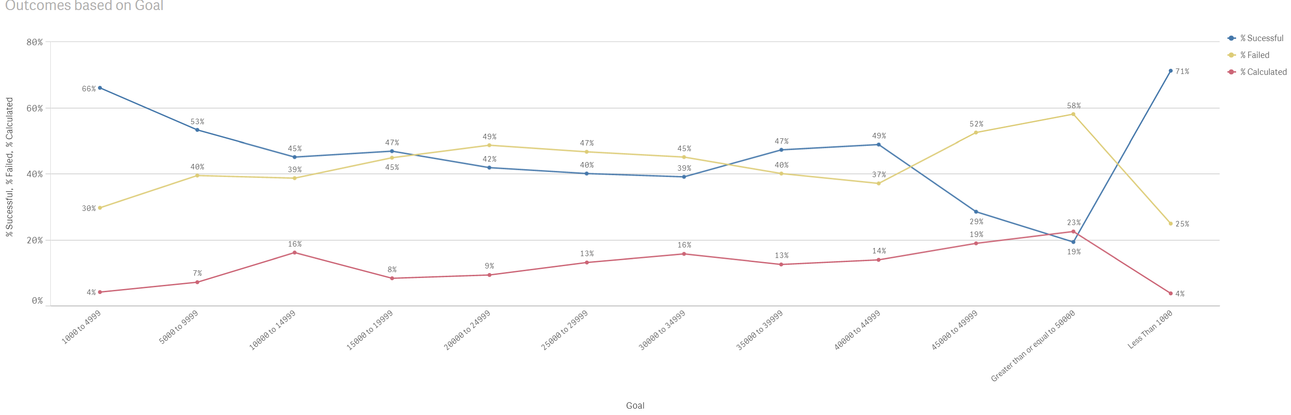

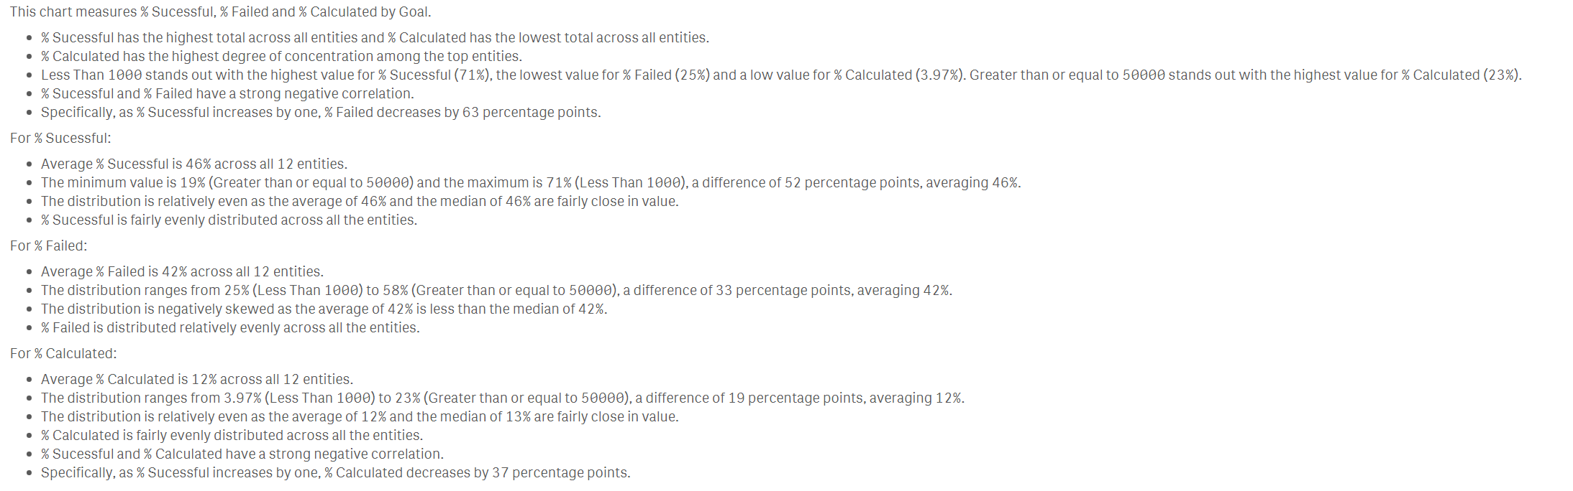

1. What are some of the limitations of this dataset?

No Large Data available.

1. What are some other possible tables/graphs that we could create?

