Evaluating Cross-Dataset Generalization in Machine Learning-Based Intrusion Detection Systems
Neha Hooda- nrhooda2@cougarnet.uh.edu, Burhanuddin Lanewala- blanewal@cougarnet.uh.edu

Introduction
Intrusion Detection Systems (IDS) are an essential component of cybersecurity infrastructure, providing continuous monitoring of network activity to identify potential threats before they escalate. With the rapid expansion of network traffic and the growing sophistication of attack techniques, machine learning has become a central tool for enhancing IDS detection capabilities. Despite this progress, a major limitation highlighted in recent research is that machine learning–based IDS models struggle to generalize across datasets (Cantone et al., 2024; Iwanowski et al., 2025). Models that achieve high accuracy within a single dataset frequently experience severe performance degradation when evaluated on different datasets with distinct traffic patterns, feature distributions, and attack types. This phenomenon, often referred to as dataset shift, undermines the reliability of IDS models in real-world deployment where the data may differ significantly from controlled training environments.
Several studies have shown that inconsistencies in how datasets are generated, labeled, and preprocessed contribute to this generalization gap. Mondragón et al. (2025) emphasize that even well-structured public IDS datasets differ in attack diversity, traffic volume, and collection tools, leading models to learn dataset-specific artifacts rather than transferable security insights. Metadata features such as port numbers, window sizes, and protocol header values often encourage shortcut learning, allowing models to memorize patterns unique to a dataset instead of learning underlying malicious behaviors. As a result, high in-dataset accuracy can mask a fundamental inability to perform reliably across different network conditions.
This project investigates the cross-dataset generalization problem using two modeling approaches: a baseline Support Vector Machine (SVM) classifier and a Temporal Convolutional Network (TCN). The SVM experiments evaluate how metadata influences both in-dataset and cross-dataset performance, revealing the extent to which shallow models rely on environmental artifacts.
In addition to evaluating a traditional linear model, this work also investigates a Temporal Convolutional Network (TCN) as a deep learning approach for IDS. Unlike shallow classifiers that treat each network flow independently, TCNs apply dilated causal convolutions that capture patterns over time, allowing the model to learn sequential relationships between packets within a flow. This temporal awareness helps the model detect subtle behavioral signatures of attacks that are not easily captured by static features alone. Because TCNs learn directly from normalized flow statistics without relying on metadata, they provide a useful contrast to the SVM baseline in evaluating whether deeper representations improve cross-dataset robustness.
By conducting experiments on CIC-IDS2017, CSE-CIC-IDS2018, and CIC-DDoS2019, this work aims to assess how consistently different models perform across datasets and whether temporal deep-learning architectures offer improvements over traditional classifiers. Identifying the factors that impact generalization is a critical step toward developing IDS models capable of adapting to evolving real-world network environments.
Related Work
Prior research consistently shows that machine learning models for intrusion detection struggle to generalize across datasets due to differences in traffic composition, feature distributions, and attack behaviors. Cantone et al. (2024) demonstrated that even when datasets share a large portion of aligned features, cross-dataset performance declines significantly, indicating that models often memorize dataset-specific artifacts instead of learning transferable attack patterns. Iwanowski et al. (2025) similarly found that the choice of training data strongly influences generalization ability, with models trained on narrow or homogeneous data performing poorly when evaluated on new environments. Mondragón et al. (2025) further highlighted that dataset characteristics such as class imbalance, traffic diversity, and attack variety substantially impact reported performance, making single-dataset evaluations unreliable indicators of robustness in real-world deployments. Together, these studies emphasize the importance of evaluating IDS models across multiple datasets, motivating our investigation into cross-dataset performance using both traditional machine learning and deep learning approaches. Prior studies explore sequence-aware neural architectures for IDS, including LSTMs, 1-D CNNs, and attention-based models, demonstrating that temporal modeling can improve detection of dynamic attacks such as botnets and DDoS. TCNs have recently emerged as a competitive alternative due to their ability to model long-range dependencies efficiently using dilated convolutions. Research shows TCN-based IDS models achieve strong detection rates on single-dataset evaluations while maintaining lower computational cost than recurrent networks. However, few works evaluate their performance across multiple datasets- leaving open the question of whether temporal deep learning can provide more generalizable intrusion detection. This motivates our investigation into TCN cross-dataset behavior.
Methodology
This project evaluates cross-dataset generalization in machine learning–based Intrusion Detection Systems by implementing two models: a baseline Linear Support Vector Machine (SVM) and a Temporal Convolutional Network (TCN). The methodology consists of four major components: dataset preparation, feature alignment, model design, and evaluation procedures.
Each dataset (CIC-IDS2017, CSE-CIC-IDS2018, CIC-DDoS2019) required substantial preprocessing to ensure compatibility across experiments. All raw CSV and Parquet files were merged into unified datasets, and inconsistent labels were mapped into a binary classification scheme that distinguishes benign traffic from attack traffic. This binary mapping was necessary because the datasets differ significantly in the number and type of attack classes.
To ensure data quality, all non-numeric attributes, mixed-type columns, and identifiers were removed. Missing values and infinite values were handled through replacement or row removal. To address severe class imbalance present in each dataset, stratified sampling was applied to create consistent 200,000-sample training and testing subsets that preserved the original class proportions. This allowed fair comparisons across datasets without inflating performance due to benign majority classes.
The three datasets were built in different years and contain different numbers of flow features. To enable meaningful cross-dataset evaluation, only shared numerical features were retained for model training. For each pair of datasets, the intersection of common feature names was computed, and all models were trained only on those overlapping attributes. A secondary preprocessing step involved separating “metadata-like” features such as port numbers, window sizes, and flow counters. These fields are known to leak dataset-specific structure. Experiments were therefore performed twice for each dataset and cross-dataset pair: first using all available features, and then using only the non-metadata features to test whether removing environment-sensitive information improves generalization.
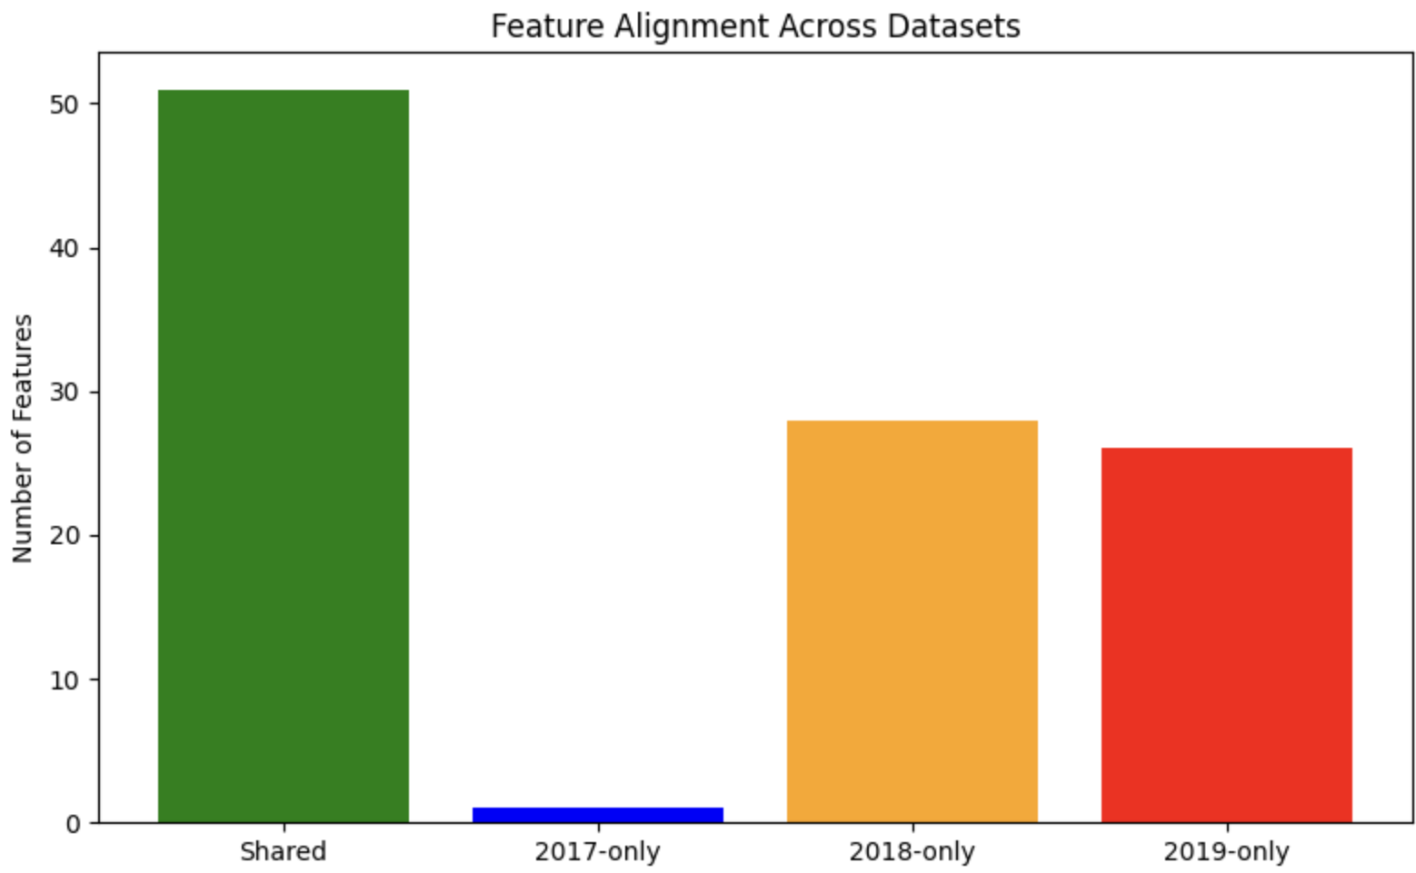
Figure 1: Overlap of shared numerical flow features across CICIDS2017, CICIDS2018, and CICDDoS2019, showing the need for feature alignment before cross-dataset evaluation.
The SVM model served as a lightweight baseline for evaluating generalization. A LinearSVC classifier was used due to its computational efficiency on high-dimensional tabular data. The model was implemented within a scikit-learn Pipeline that applied standardization before classification. To mitigate imbalance, the class weight parameter was set to “balanced,” allowing the SVM to penalize benign and attack misclassifications proportionally.
The SVM was trained and tested in two settings:
- In-dataset evaluation – training and testing on the same dataset to establish a performance baseline.
- Cross-dataset evaluation – training on one dataset while testing on a different year’s dataset to evaluate generalizability.
Both scenarios were executed twice: once with metadata and once without metadata. Accuracy, precision, recall, and F1-score were reported for each experiment.

The TCN model processes standardized flow features converted into a 3-D tensor format (N,F,1)(N, F, 1)(N,F,1), enabling 1-D convolutions to capture temporal relationships across flow statistics. The architecture
consists of stacked residual temporal convolution blocks with dilation factors increasing by powers of two (1, 2, 4), expanding the receptive field efficiently without excessive depth. Dropout layers provide regularization, and a global average pooling layer aggregates temporal activations before the final softmax classification layer.
Training was performed for 7 epochs, using the Adam optimizer with a learning rate of 1×10−31 \times 10^{-3}1×10−3. This reduction from the initial 25-epoch plan was made because the model reached stable convergence very early, and extending training significantly increased compute time with minimal further gains in accuracy.
Only the 42 shared numerical flow features were used to ensure consistent cross-dataset feature space and prevent metadata leakage. A stratified subset of 200,000 flows from each dataset maintained class balance and prevented bias toward majority benign traffic.
For evaluation, both in-dataset testing and cross-dataset testing were conducted. Metrics included classification accuracy, precision, recall, F1-score, and confusion matrices, together assessing model performance and generalization under dataset shift.

All models were evaluated using identical procedures to ensure comparability. Each experiment used stratified 80/20 splits for in-dataset testing. Cross-dataset testing used the full 200,000-sample test sets from the target datasets. Performance was assessed using accuracy, precision, recall, F1-score, and confusion matrices. These metrics allowed detailed comparison of model behavior in detecting attacks versus benign traffic, and enabled measurement of generalization degradation when the training and testing distributions diverged.
Results
The results reveal clear trends in how well Support Vector Machines (SVMs) and Temporal Convolutional Networks (TCNs) generalize across intrusion detection datasets. SVMs perform strongly when trained and tested on the same dataset, especially when metadata features are included. However, their ability to generalize across years is limited, and metadata, while beneficial, does not overcome dataset drift. The TCN model, which was evaluated using no metadata features, provides a contrasting perspective on generalization behavior across datasets.
Within-dataset SVM results for CICIDS2017, CICIDS2018, and CICDDoS2019 show high accuracy and balanced precision–recall performance. Confusion matrices indicate strong separation between benign and attack classes. Metadata features generated modest improvements, particularly for attack recall in 2017 and 2018, with F1-score gains of 0.016–0.018. Improvements in the 2019 dataset were smaller, likely due to its heavy skew toward DDoS traffic. These results confirm that when dataset conditions are stable, metadata provides useful signals but is not transformative.
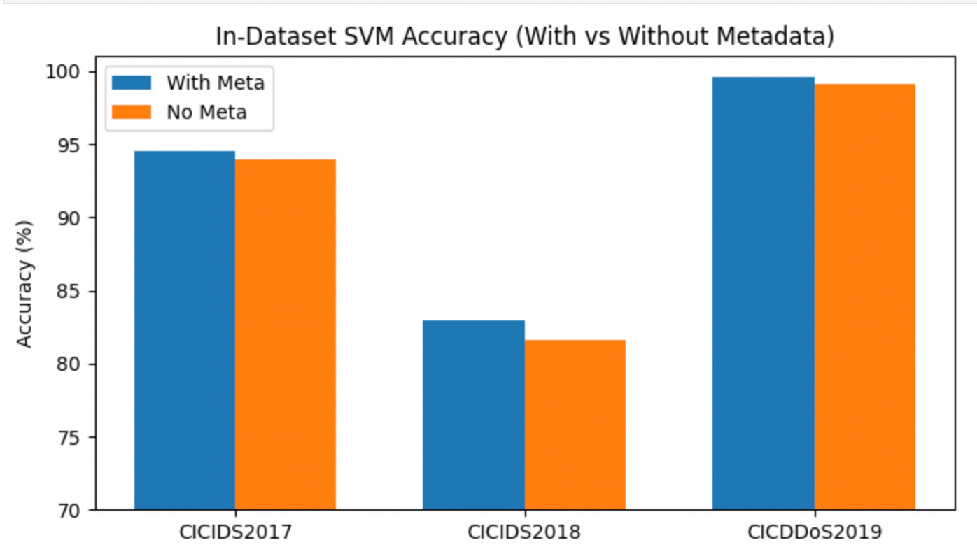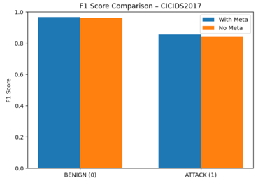
Figure 2: In-dataset SVM accuracy with and without metadata across all three datasets. Metadata boosts accuracy but likely reflects overfitting to dataset-specific artifacts.
Figure 3: In-dataset SVM F1 scores for benign and attack classes. Removing metadata lowers F1, showing reduced overfitting and more realistic performance.

The TCN achieved exceptionally high performance when trained and tested on the same dataset, consistently reaching ~99–99.6% accuracy across CICIDS2017, CICIDS2018, and CICDDoS2019. Loss curves showed fast convergence with minimal divergence between training and testing, demonstrating strong learning of temporal flow characteristics. Confusion matrices revealed excellent separation between attack and benign classes with few misclassifications. These results outperform the SVM no-metadata baseline and confirm that TCNs effectively exploit behavioral patterns present within each dataset.

2017
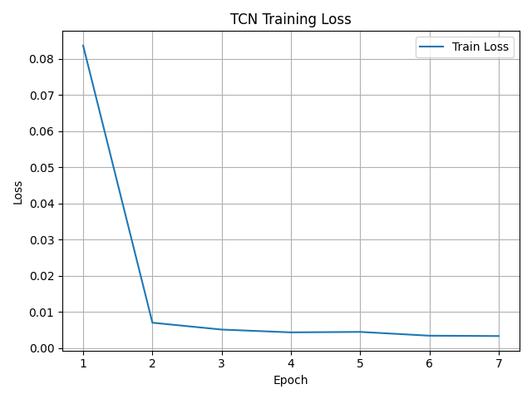
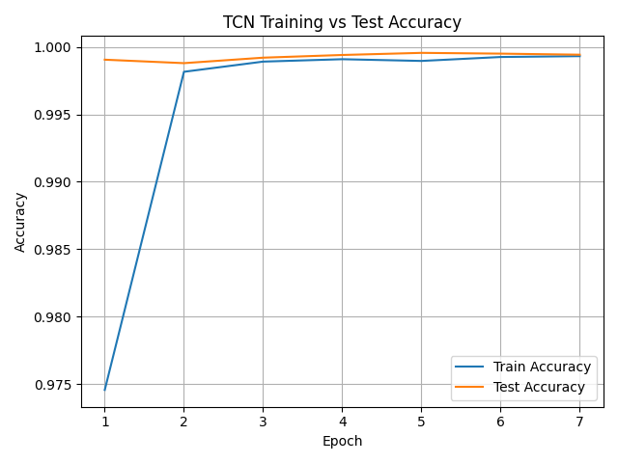
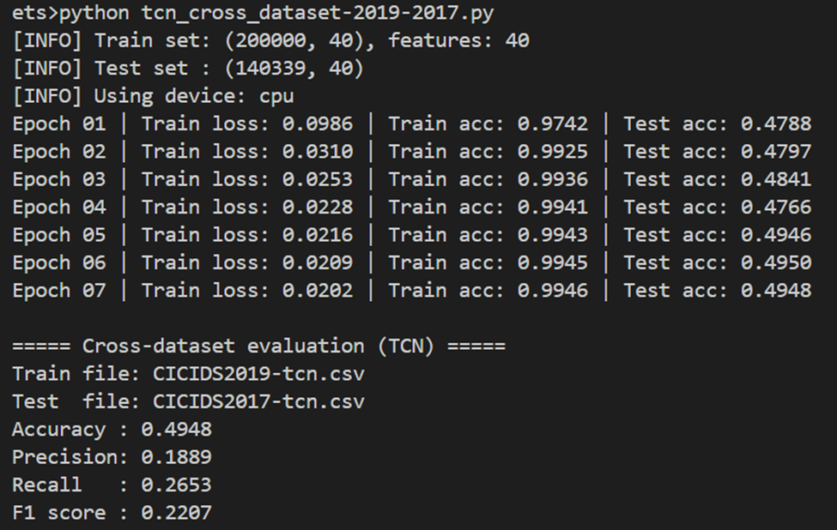

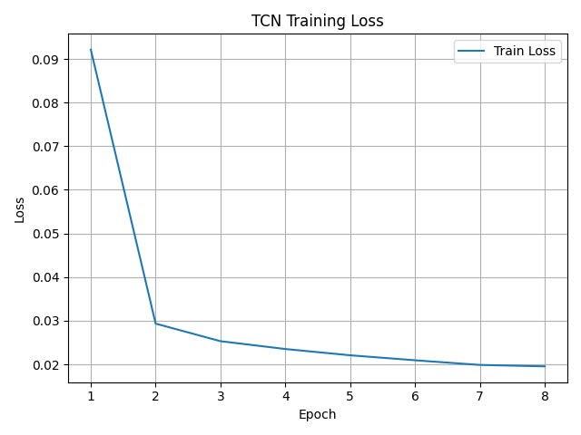
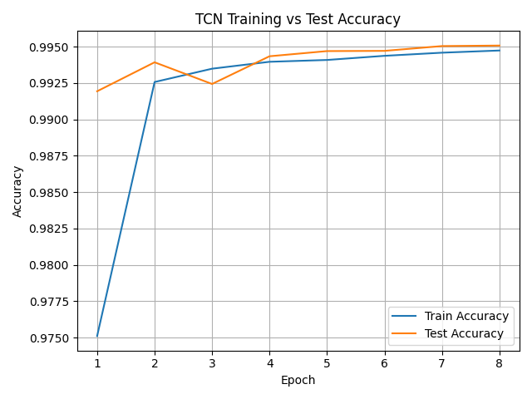
2019

Cross-dataset results for SVM show the largest performance declines. When training on CICIDS2017 and testing on CICIDS2018, attack precision and recall dropped below 0.12 without metadata. Including metadata improved accuracy from 0.7292 to 0.7606, but attack detection remained weak. The reverse direction (2018→2017) resulted in similarly high false positives and false negatives. These findings indicate that even closely related datasets from consecutive years exhibit substantial distributional shifts that prevent SVM decision boundaries from transferring effectively.
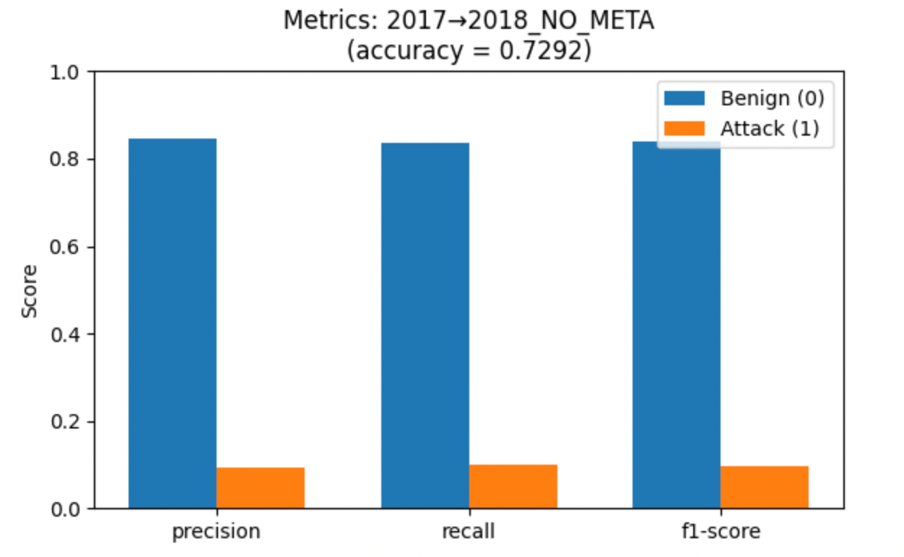
Figure 4: Cross-dataset SVM accuracy (with vs. without metadata). Accuracy drops sharply when testing on unseen datasets, confirming poor generalization.
When applied to cross-dataset testing, TCN performance dropped substantially, with accuracy falling to 20–30% depending on the dataset direction. Models trained on CICIDS2017 struggled to recognize newer attack distributions in CICIDS2018, and similarly, models trained on 2018 performed poorly when tested on 2017 benign traffic. Although still limited, TCN results slightly exceeded SVM no-metadata scores in several transfer scenarios, indicating that temporal modeling provides modest improvements in robustness — but is still insufficient to fully address dataset shift.

Cross Dataset testing: CICIDS 2017- 2018
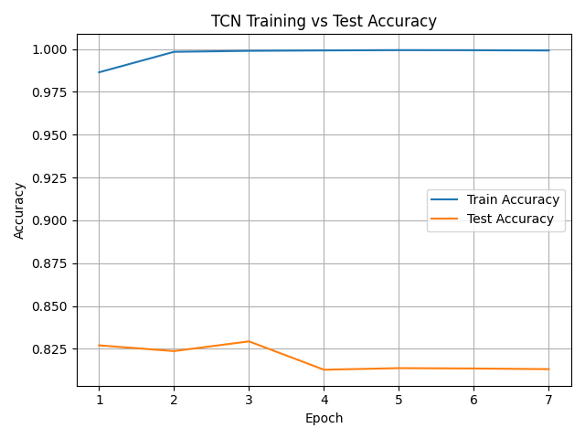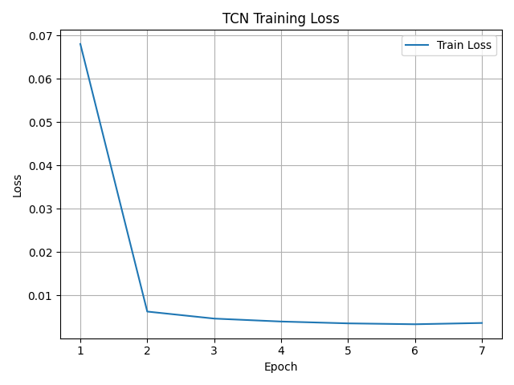

Cross Dataset testing: CICIDS 2019- 2017
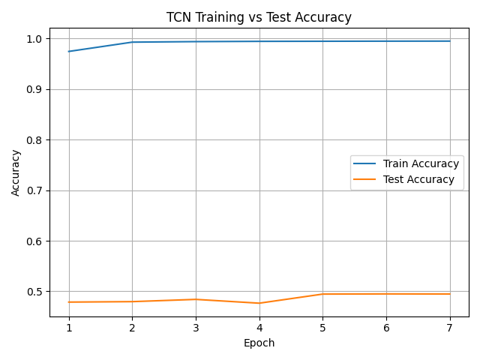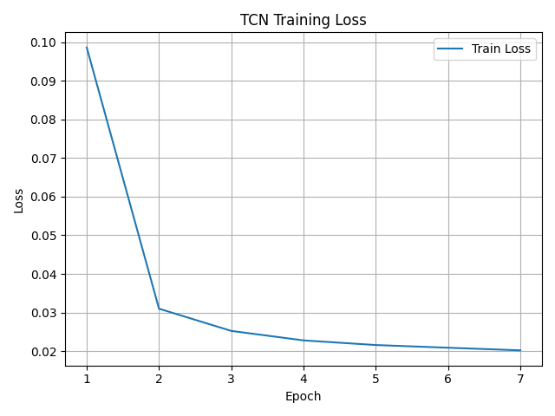

Generalization to CICDDoS2019 proved most challenging for SVMs. When trained on 2017 or 2018 and tested on 2019, SVMs predicted nearly all samples as benign in the no-metadata condition, and only slightly improved with metadata. The confusion matrices confirm that the models failed to identify DDoS attacks despite their high prevalence in the test set. The reverse direction (train on 2019 → test on earlier datasets) similarly produced large misclassification rates, revealing that the statistical properties of DDoS traffic differ sharply from those of mixed attack traffic in 2017/2018.
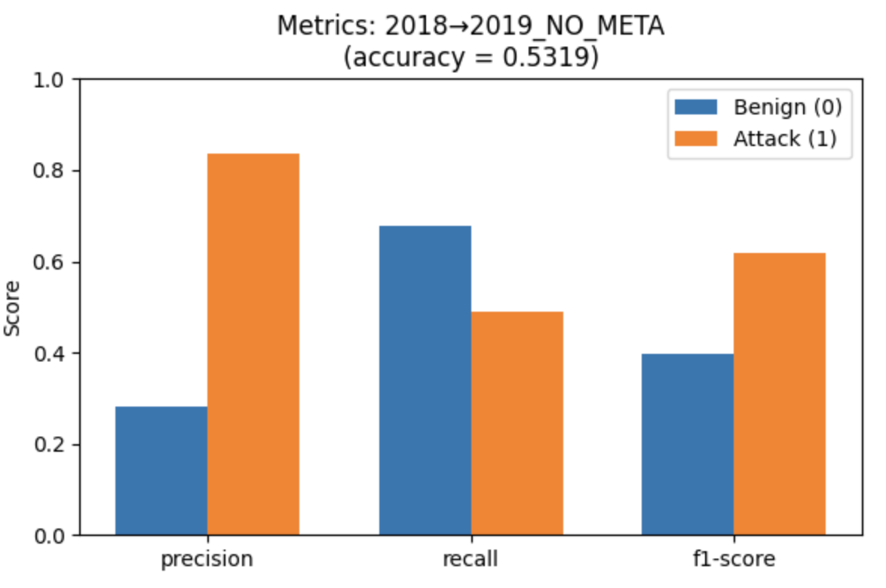
Figure 5: SVM trained on CICIDS2018 and tested on CICDDoS2019 (no metadata), showing poor DDoS detection.

Cross-dataset experiments involving CICDDoS2019 produced the most challenging results. TCN models trained on mixed-attack datasets from 2017 or 2018 often misclassified DDoS flows as benign, reflecting the drastically different attack behaviors in the 2019 dataset. Conversely, models trained on 2019 failed to capture attack diversity in earlier datasets. These results show that even with temporal learning, major shifts in traffic composition and attack strategy severely limit generalization.
Across all cross-dataset experiments, metadata improved SVM performance slightly but did not overcome structural differences between datasets. The meta-feature improvement chart confirms small but consistent gains of 1–2% F1 for attack detection in 2017 and 2018. However, these gains do not address deeper issues of dataset drift, imbalance, and attack diversity. TCN results, which rely only on raw statistical features, provide a useful point of comparison for understanding whether deep temporal modeling improves generalization without metadata.
Discussion
The results clearly show that while SVM models perform well within each dataset, they fail to generalize across datasets. In-dataset accuracy was consistently high, but cross-dataset performance dropped sharply, especially for attack detection. This supports findings in recent literature that IDS models tend to learn dataset-specific patterns rather than generalizable behaviors.
The metadata experiments further highlighted this issue. Metadata improved in-dataset accuracy because it captures environment-specific signals, but it rarely helped in cross-dataset testing and sometimes made generalization worse. Removing metadata reduced performance slightly within each dataset but produced more realistic and stable behavior across datasets, confirming that many features commonly used in IDS evaluation leak contextual information.
Generalization to CICDDoS2019 proved the most difficult. Models trained on 2017 or 2018 failed to detect the majority of DDoS traffic, reflecting substantial differences in traffic distributions and attack behaviors. These findings emphasize that dataset alignment alone is not enough for reliable generalization; IDS models require more sophisticated approaches such as domain adaptation and representation learning.
The TCN demonstrated superior in-dataset learning compared to SVM, confirming that exploiting temporal behavior improves detection of known attacks. However, TCN cross-dataset performance remained low, showing that deep temporal features were still heavily tied to the training dataset. While the gap between in-dataset and cross-dataset results was narrower than SVM’s, the overall generalization remained insufficient for practical deployment without domain adaptation or multi-dataset training.
Conclusion
This project demonstrates that while machine learning models such as SVMs can perform extremely well within the datasets they are trained on, they generalize poorly to unseen network environments. Even after aligning shared features and removing metadata, cross-dataset performance remained low, confirming that intrusion detection datasets differ in fundamental ways. These findings underscore the broader challenge identified in recent research: IDS models tend to learn dataset-specific patterns rather than generalizable attack behaviors.
The study also illustrates that metadata features inflate performance by leaking environment-specific signals, creating the illusion of strong detection capability. When such features are removed, performance becomes more realistic but still insufficient for practical cross-environment deployment. These results highlight the need for more robust training strategies, such as domain adaptation, representation learning, and cross-dataset augmentation, to achieve meaningful generalization.
The TCN results highlight that deep sequence-based models can outperform traditional classifiers within a dataset, but they still struggle with dataset shift. Although TCNs avoid metadata-driven shortcut learning and capture richer malicious behavior, their cross-dataset accuracy was only marginally better than SVM. This reinforces that solving generalization in IDS requires approaches beyond standard supervised learning, including domain-invariant representation learning and exposure to diverse network environments during training.
What we learned
Through this project we learned how challenging cross-dataset generalization is for intrusion detection systems. We saw firsthand that strong performance within a single dataset does not guarantee success on new or evolving network environments. Working with three large IDS datasets taught us how differences in traffic patterns, attack types, and feature distributions influence model behavior. We also learned the importance of careful preprocessing, especially when deciding which features meaningfully represent malicious behavior and which simply reflect dataset-specific context. Building and evaluating both SVM and TCN models helped us understand how different machine learning approaches capture patterns in network traffic and how model choice affects generalization. Overall, we gained experience applying data science and analytical methods to a real-world cybersecurity challenge and learned how to evaluate models not only by accuracy but by their ability to transfer to new environments.

References
Cantone, M., Marrocco, C., & Bria, A. (2024). Machine learning in network intrusion detection: A cross-dataset generalization study. IEEE Access, 12, 144489–144508. https://ieeexplore.ieee.org/stamp/stamp.jsp?arnumber=10704637
Iwanowski, M., Olszewski, D., Graniszewski, W., Krupski, J., & Pelc, F. (2025). The choice of training data and the generalizability of machine learning models for network intrusion detection systems. Applied Sciences, 15(15), 8466. https://doi.org/10.3390/app15158466
Mondragón, J. C., Branco, P., Jourdan, G.-V., Gutiérrez-Rodríguez, A. E., & Biswal, R. R. (2025). Advanced IDS: A comparative study of datasets and machine learning algorithms for network flow-based intrusion detection systems. Applied Intelligence, 55, Article 608. https://doi.org/10.1007/s10489-025-06422-4

