Meeting Thurley/Burt 20200113

We discussed to include intermediate proliferating stage in all T cell homeostasis models.

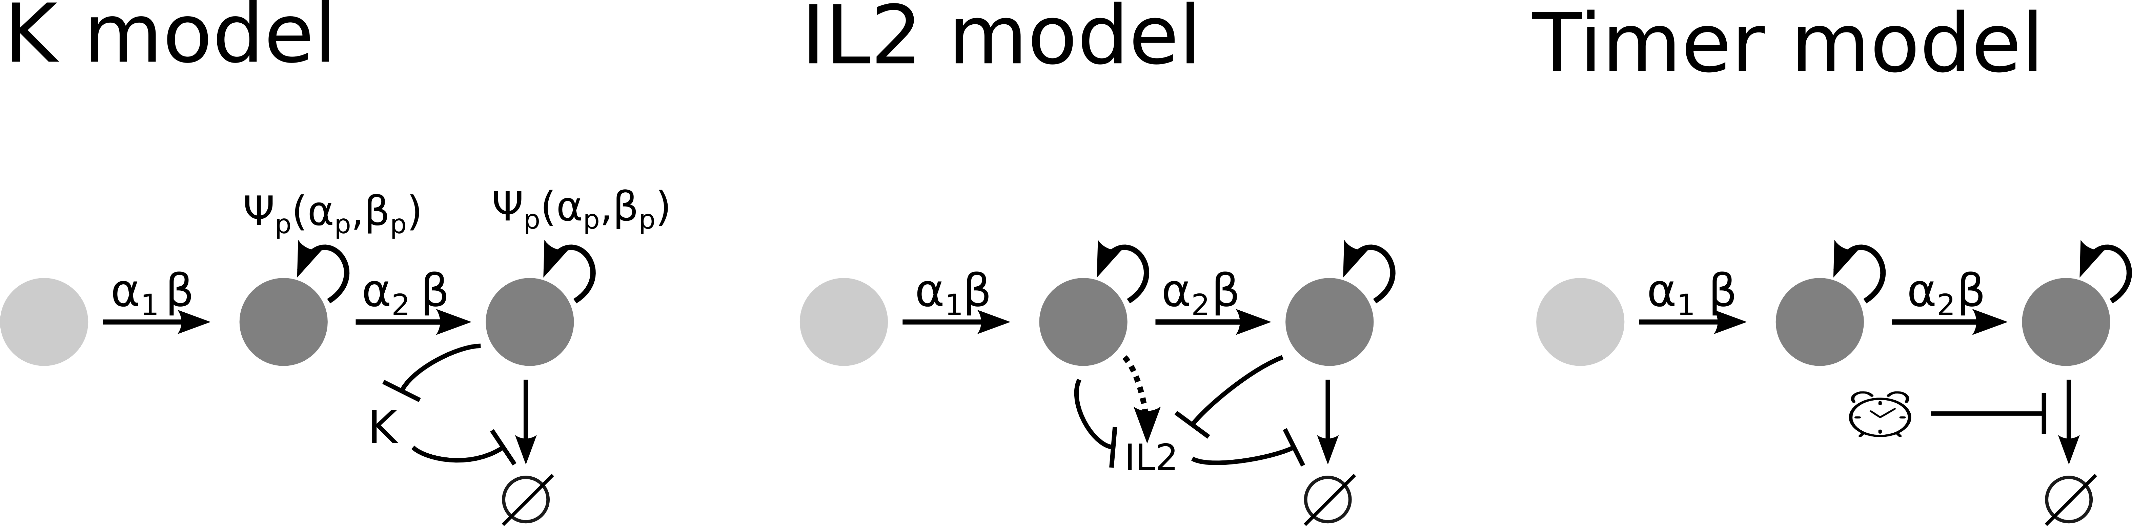New models:

* In IL2 model, IL2 cells stop secreting IL2 when they arrive in effector state. Question is if this is reasonable (literature data analysis required).
* I still have the effect that in the IL2 model cell density goes up for small diff. Rates (beta). Have to check if this is still true for new model version (see above) and if this effect is robust for different model versions (i.e. timing on IL2 secretion).
* Extend analysis with normalized response size: check how much beta_p, d, beta change (y axis) if I vary model specific parameters (x axis)
* Check how much readouts vary if I change beta_p, d, beta and normalize to resp. size
* Plot IL2 vs Timer heatmap in contour-plot