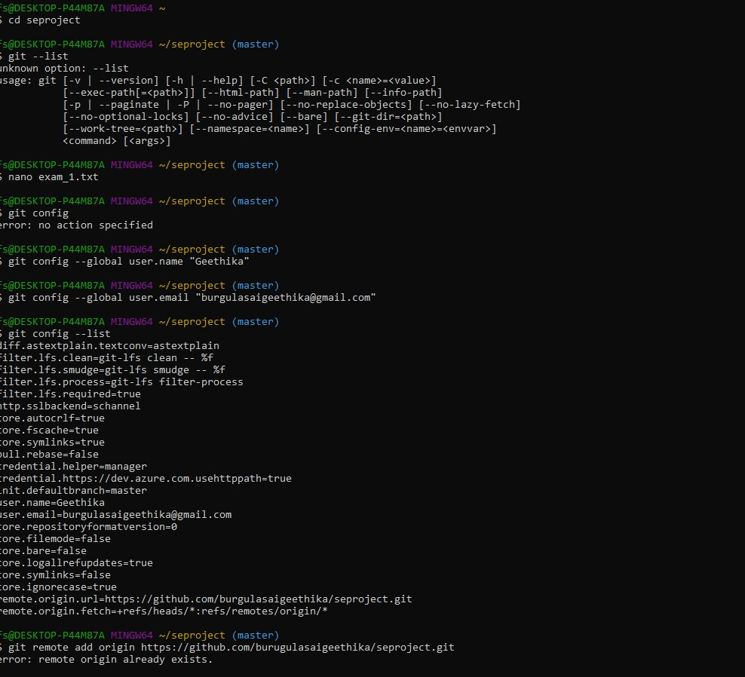
Mkdir : Creates directory
Ls : lists all files in the particular directory
Cd : changes directory
Nano : creates a file
Git version : tells the latest version of git installed
INIT : initializes empty git repo
Config: global user name and email . Introducing to github

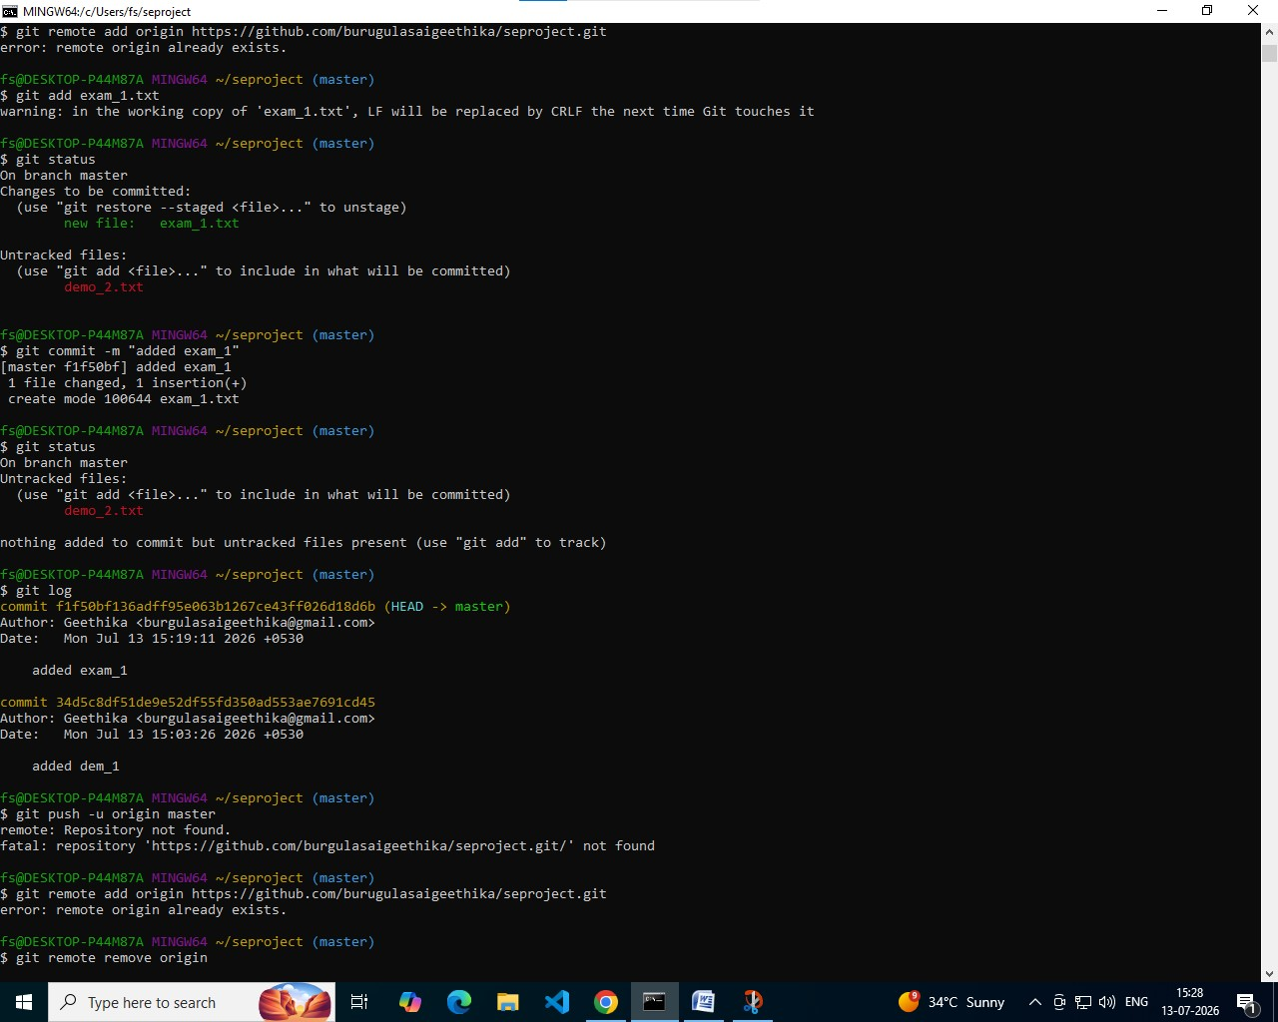
Git hub Linking: Linking local git to a git repo
Git add: adding files from working dir to staging area
Git status : To know the status of the untracked files.
COMMIT: commits all the files from staging area to repository

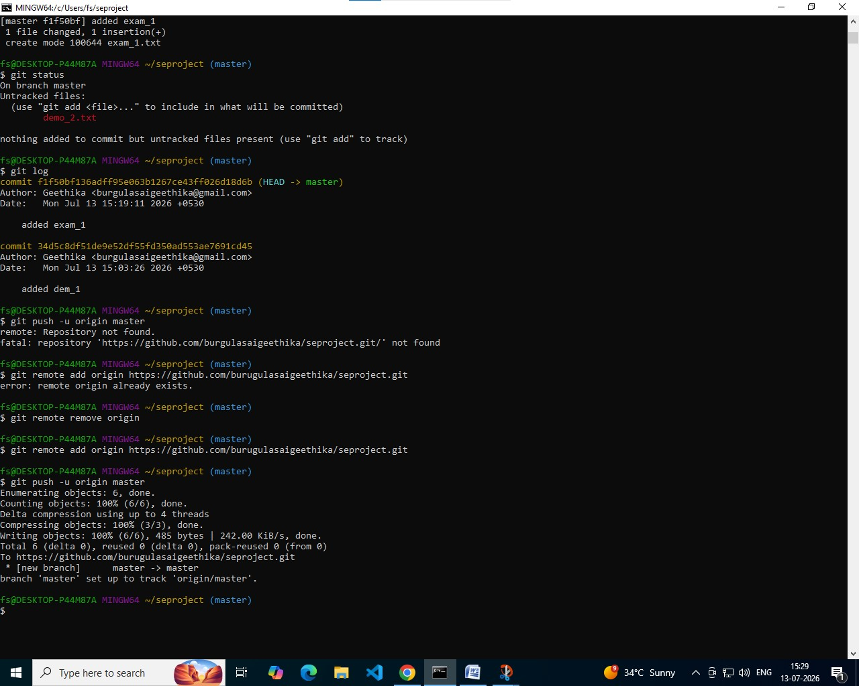

LOG : gives history of all commits

