ACCIDENT LOCATIONS ON

INDIAN ROADS

RSM Group

B.Ramya(21N31A6711)

S.Srinidhi(21N31A6749)

N.Mounika(22N35A6704)

Date:-14/07/2023

# ABSTRACT:

The main aim of this report is to analyse the road accidents in India at state, and metropolitan city level. Analysis shows about the Block Spots locations in Telangana, India. This report gives methods and techniques that are used to analyse black spots and black zones. Although, no universally accepted definition of a black spot or black zone is given, these locations will in generally be described as high risk accident locations. In this context, several statistical analysis on the road accident locations.

# INTRODUCTION:

Motivation:- “India tops the world with 11% of global death in road accidents

It has 1 per cent of the world's vehicles but accounts for 11 per cent of all road crash deaths, witnessing 53 road crashes every hour; killing 1 person every 4 minutes” – World Bank Report

The problem of accident on Indian roads is a very acute in highway transportation due to complex flow pattern of vehicular traffic, presence of mixed traffic along with pedestrians. Traffic accident leads to loss of life and property. According to Ministry of Road Transport & Highways (MoRTH), Government of India, road accident black spot on National Highways is a road stretch of about 500m in length in which either 5 road accidents (involving fatalities/grievous injuries) took place during last three calendar years or 10 fatalities took place during last three calendar years.

# Related work:

* TS police station official Website

Link:-https://tspolice.gov.in/jsp/roadSafetyDoc.jsp

# DATA SOURCE:

* QGIS
* Latlong.net
* Jupyter notebook

# WORK:

MAP WITH BLACKSPOTS

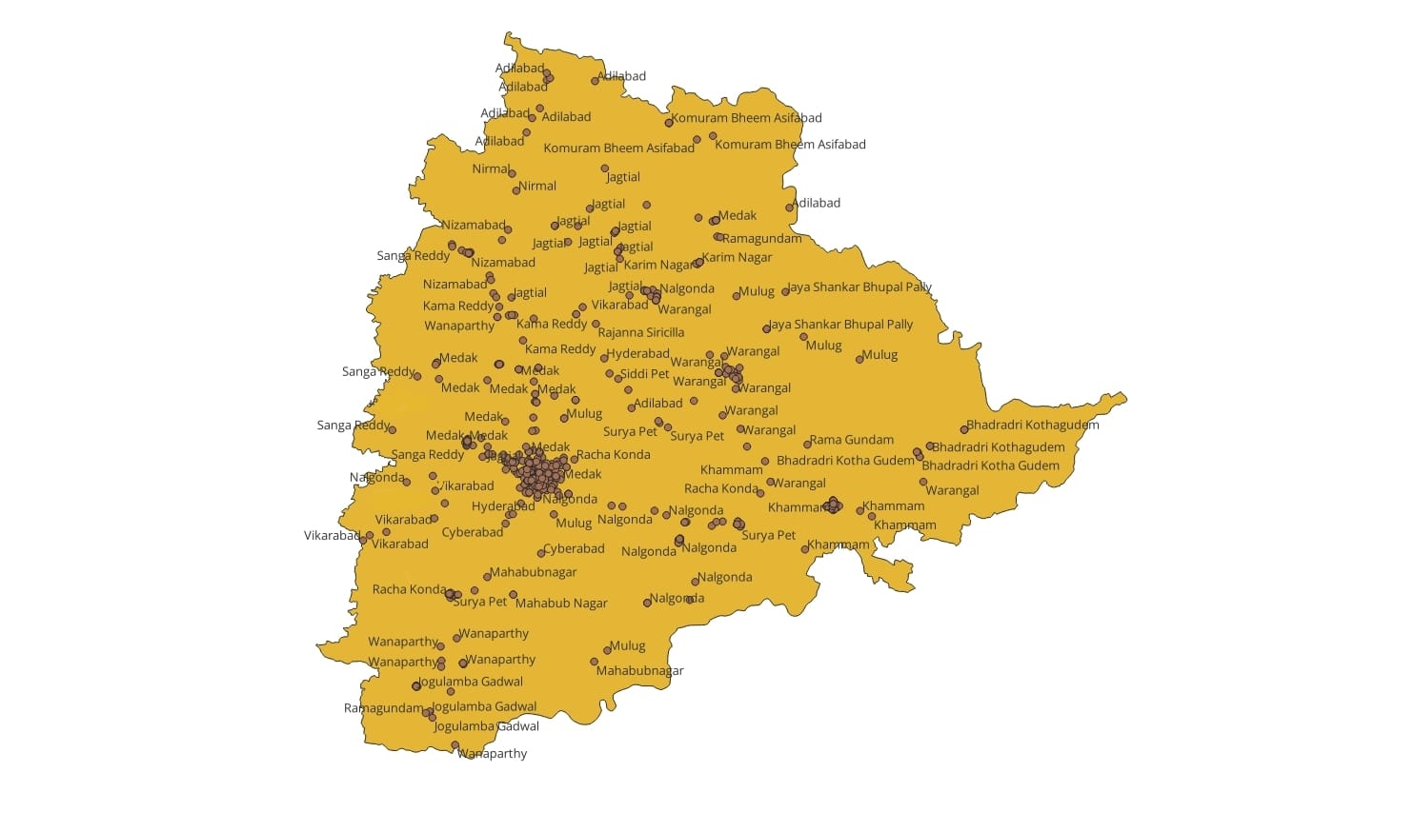 Analysis of the year 2018

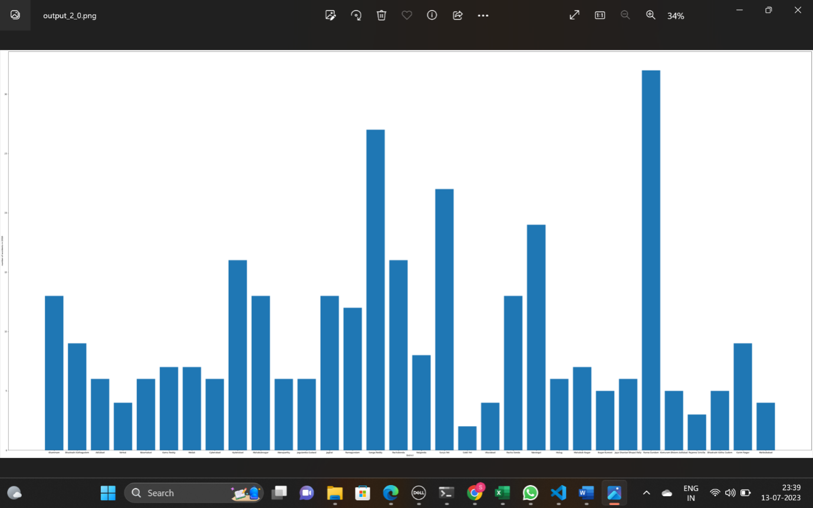The about plot is plot between number of accidents in year 2018 to the districts in Telangana. The analysis shows, that Rama Gundam district has the highest number of accidents in year 2018

Analysis of the year 2019

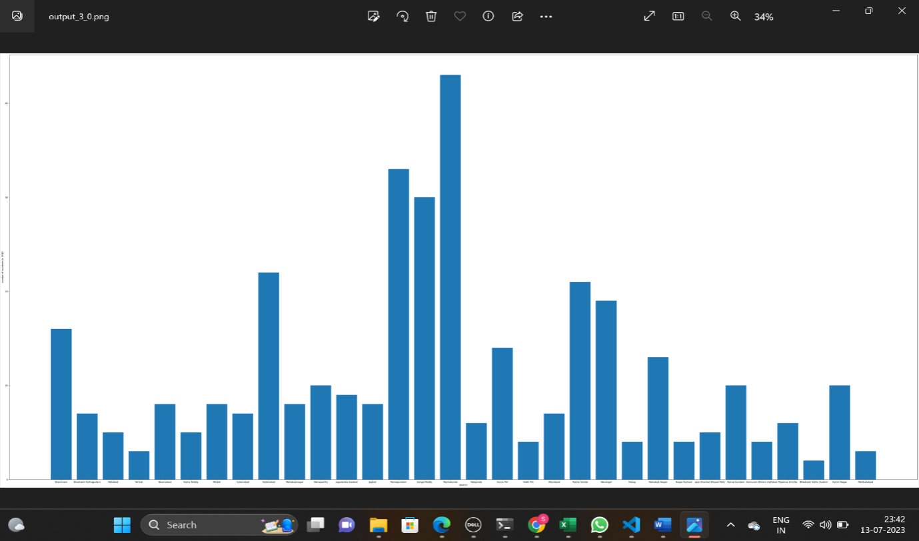

The about plot is plot between number of accidents in year 2019 to the districts in Telangana. The analysis shows, that Rachakonda district has the highest number of accidents in year 2019

Analysis of the year 20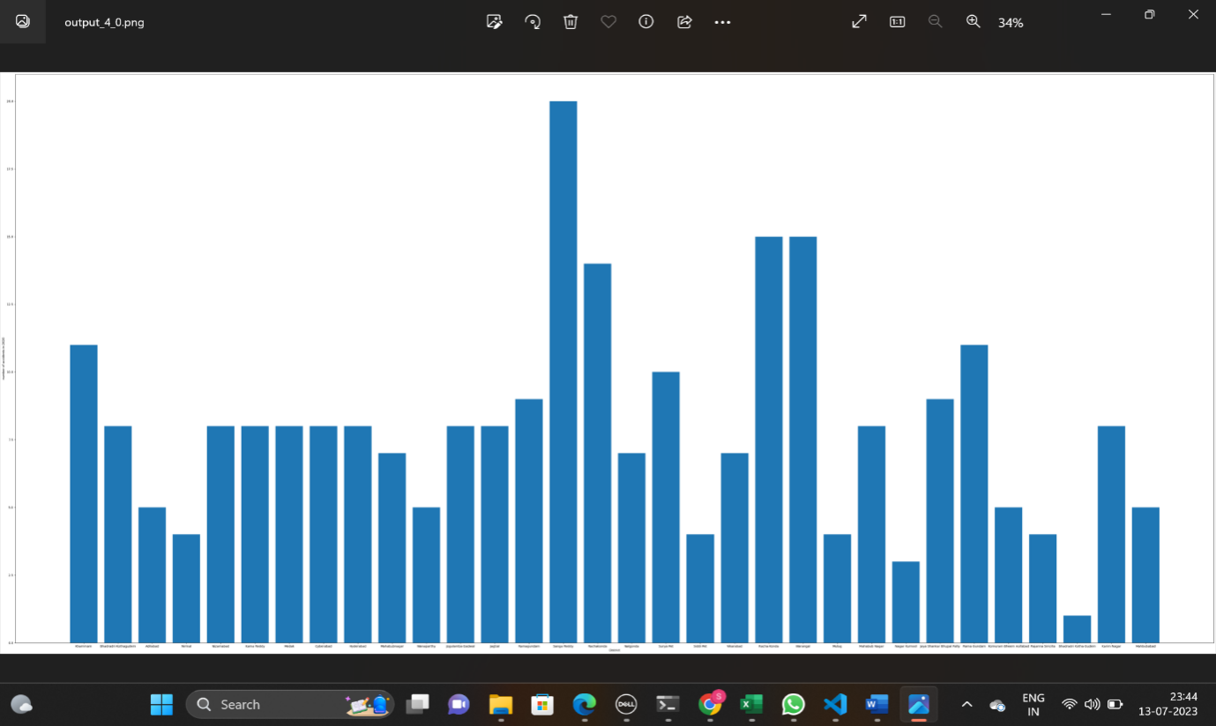20

The about plot is plot between number of accidents in year 2020 to the districts in Telangana. The analysis shows, that Sanga Reddy district has the highest number of accidents in year 2020

Analysis of all the three years

(2018,2019,2020)

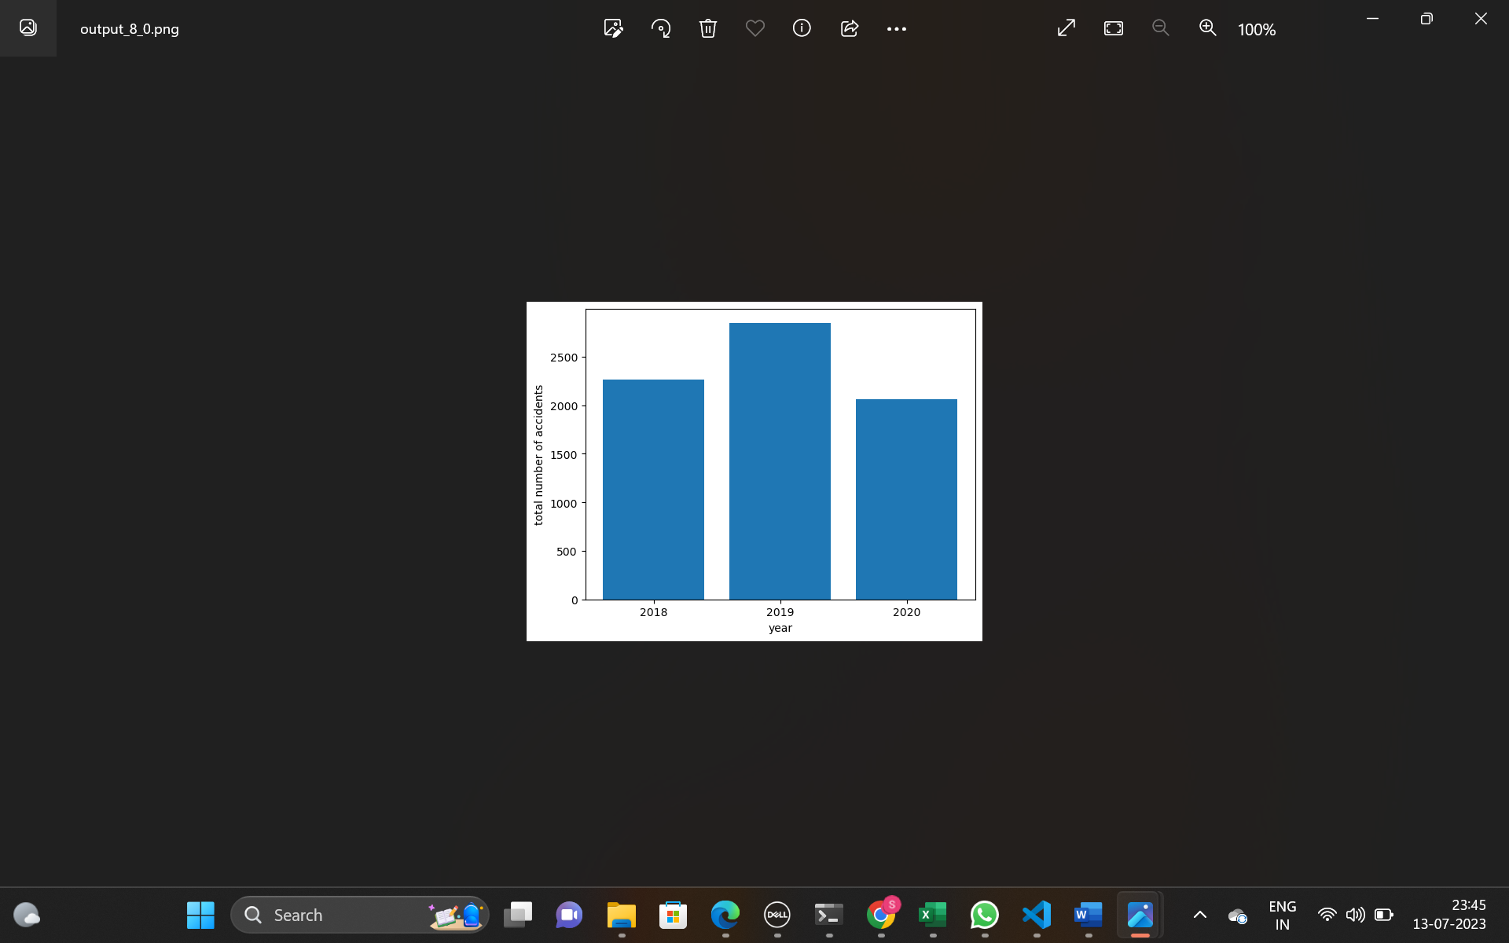

* The about plot is plot between total number of accidents in year to the years (2018,2019,2020) in Telangana. the analysis shows, that the year 2019 has the highest number of accidents compare to other 2 years

Links:

file:///C:/Users/burugu%20ramya/Downloads/intershipseabornn.html