

**Middle East Technical University**

**Electrical and Electronics Department**

**EE463 - Static Power Conversion I**

**Simulation Project 1:**

**Diode Rectifiers**

**Project Group:** Team 13

**Group Members:** Burak Yalçın - 2167534

Ayşe Beyhan Türkyılmaz - 2232825

1. **Introduction**

This report includes the Simulink simulation results for the first simulation project of the course: EE463 Static Power Conversion I. The topics of interest in this simulation assignment can be listed as: single & three phase half bridge and three phase full bridge diode rectifiers. The interpretations of the effects of line inductances, line resistances and also non ideal diodes, along with some calculations for a number of parameters such as: the output average voltage and input current THD, can be found in the following sections of this document.

The main purpose of this simulation project is to properly document our knowledge on diode rectifiers, get ourselves accustomed to the newer concepts and to be able to comment on the effects of some of the parameters which were presented in the lectures, with the help of a new simulating tool: Matlab Simulink.

1. **Question 1: Single Phase Half Bridge Rectifiers**
   1. **Plots obtained in Simulink for the Output Voltage with Different Time Steps**

The screenshot of the single phase half bridge rectifier constructed in Simulink along with the tools which help to obtain output average voltage value and the THD(%) value, can be found in Figure 1, below.

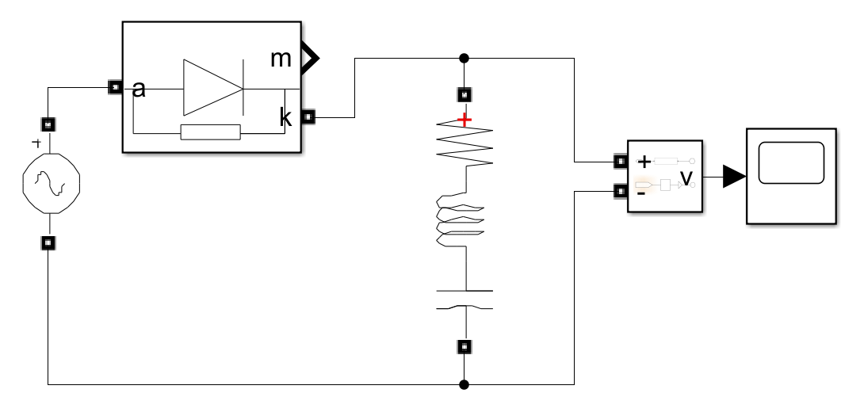

Figure 1. Simulink Schematic for the Single Phase Half Bridge Rectifier

The output voltage waveforms of the single phase bridge rectifier for step times of 1ns, 0.5ms and 5ms can be found in Figures 2,3 and 4, respectively.

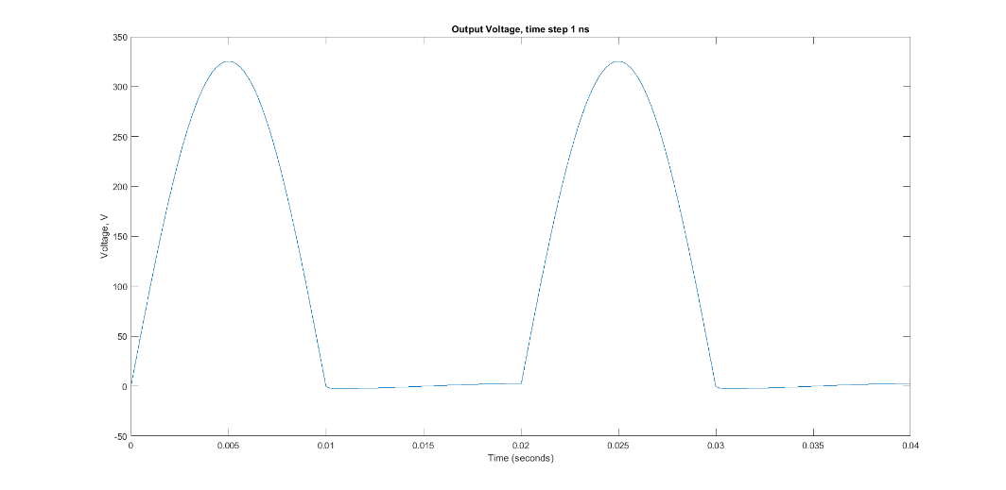

Figure 2. Output waveform of the single phase half bridge rectifier, when the time step = 1ns

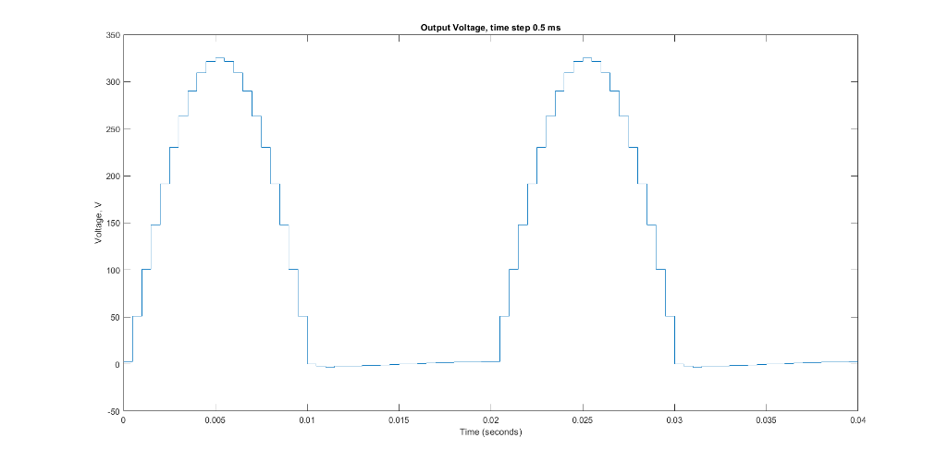

Figure 3. Output waveform of the single phase half bridge rectifier, when the time step = 0.5ms

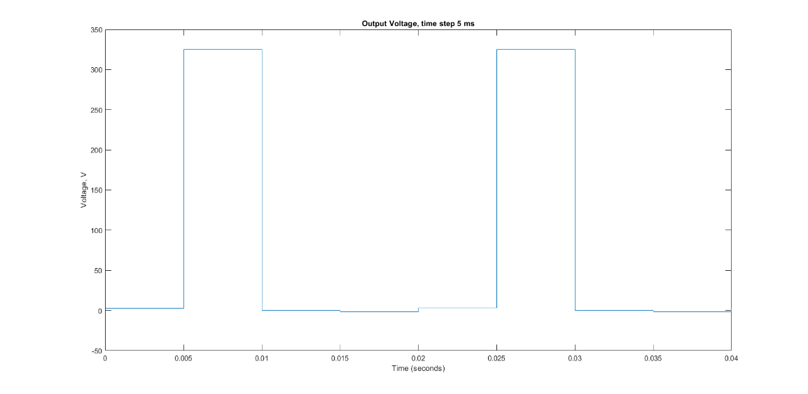

Figure 4. Output waveform of the single phase half bridge rectifier, when the time step = 5ms

* 1. **Significance of Step Time in Simulations**

As one can observe from the waveforms in the figures 2,3 and 4, the step time with which the simulation is executed, has a great effect on the resulting waveform.

The concept of the step time can be interpreted as the sampling rate at which the samples from the simulated signal is taken. Therefore, this parameter is directly linked with the shape of the outcome of the simulated waveform.

The sampling procedure is related with the sampling theorem, in which the minimum required sampling rate (in order to obtain the original signal without any changes in its frequency) is defined as the double of the frequency of the maximum frequency component that exists in the original signal.If the step time is chosen too small, this corrupts the original curve of the signal, due to the existence of ‘aliasing’, which can be explained in other words as: the appeareance of a higher frequency signal as low frequency due to the lack of sampled points. An example for such a situation can be observed in Figure 4.

If the step time is chosen too large, theis would enable us to have an accurate representation of the original curve (an examplification of this situation can be seen in Figure 2), but unfotunately having too many sampled points would slow down the procedure and it would occupy quite a lot of storage room.

* 1. **Output Average Voltage and Input Current THD Calculations**

Output average voltage is calculated with the formula in equation 1, where the operation is basically sums the output voltage vd over its one period and obtaines the mean by dividing by the value of this time interval.

(1)

The analytical calculation for finding the output average voltage can be found below in equation 2, where the output function is taken as a sine and the integral is taken over (0,π).

V (2)

The total harmonic distortion(THD) can be calculated from the formula in equation 3, where the operation is basically taking the ratio of RMS values of all of the signal’s harmonics (except the first one) to the RMS value of the first harmonic of the signal.

(3)

The analytical calculation for finding the input current THD can be found below in equation 7, where the current is taken as,

A (4)

For the period when the diode is conducting. Then the RMS value is equal to the value in equation 5.

ARMS (5)

And the RMS value for the fundamental harmonic componenet is equal to the value found in equation 6, below.

ARMS (6)

So the THD for the input current can be calculated as:

(7)

* 1. **Comparison of Analytical Results with Quantities Obtained Through Simulation Tools**

The calculation for the output average voltage, when one of the operational blocks in Simulink was utilized, namely ‘mean’ . After choosing the fundamental frequency as 50 Hz, which will indicate the length of the one cycle, and simulatneously the sampling time as 5 us, the average output voltage can be observed on the ‘Display1’ as: 103.5.

The calculation for the input curret THD, when one of the operational blocks in Simulink was utilized, namely ‘THD’. After choosing the fundamental frequency as 50 Hz, which will indicate the length of the one cycle, and simulatneously the sampling time as 5 us, and finally measuring the input current by a ‘current measurement’ tool; the input current THD can be observed on the ‘Display’ as: 43.46.

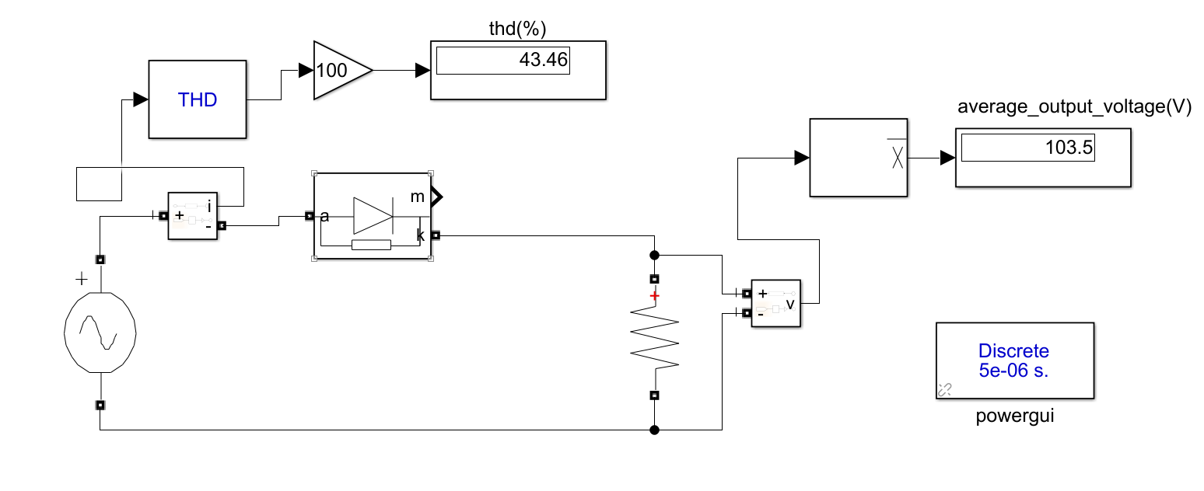

Figure 5. Simulink schematic of single phase half bridge rectifier with the calculator operators: THD and mean

1. **Question 2: Single Phase Full Bridge Rectifiers**
   1. **Ls and Rs in Practical Applications**

Ls and Rs, in this schematic of a single phase full bridge diode rectifier, represent the internal impedance of the voltage source vs. Ls represents the inductive part of source impedance, while Rs represents the resistive part.

* 1. **Finding Minimum Output Filter Capacitance**

A rather experimental way is used finding the desired output filter capacitance. By using the ‘Measurement’ tab of Scope building block and trial and error, this value is determined to be around 2E-3 F.

* 1. **Plot for Output Voltage, Input Current THD and Power Factor**

Output voltage, input voltage and current plotted at the same graph can be found in Figure 6, below.

**harita, metin içeren bir resim

Açıklama otomatik olarak oluşturuldu**

Figure 6. Input Current, Input Voltage & Output Voltages for the Sİngle Phase Rectifier

* 1. **Measurements of Output Voltage, Input Current THD and Power Factor**

Average of the output voltage is measured to be around 313 V. It is measured from Scope.

Input current harmonics analysis is done through the powergui FFT Analysis facility. It is around 127.5 %.

Power factor is calculated and displayed directly on SIMULINK. “Power” block is connected on the input side and a simple MATLAB function block examining the definition of power factor based on P and Q variables are used. The result is 0.98.

* 1. **Simulation without Ls and Rs**

Without source side resistance and inductance, the input current becomes full of spikes and the magnitude of them are much higher than the previous case. These spikes should be avoided, smoother waveforms are more desired.

* 1. **Stresses on the Diodes**

Without source side resistance and inductance, the input current becomes full of spikes and the magnitude of them are much higher than the previous case. These spikes should be avoided and surely causes a stress on diodes. Diodes have limited repetitive peak current handling capability and their limits can be found from datasheets. In case of such repetitive current spikes, diodes can have problems and get damaged.

The aforementioned current spikes can be observed in the graph below, given in Figure 7.

harita, metin içeren bir resim

Açıklama otomatik olarak oluşturuldu

Figure 7. Current spikes apparent when there is no Ls and Rs

* 1. **Rectifier Efficiency without the effects of Ls and Rs**

As the real diode example, RA254-BP is chosen. It is a standard diode with standard recovery times, since a standard line frequency rectifier is modeled. It has 400 V reverse voltage handling capability and allows a maximum of 25 A current flow through it. Opening voltage is 1.1 V and internal capacitance is 300pF.

For rectifiers, the efficiency is defined as follows.

Input AC power is already obtained in previous cases. On the output side, DC power is used. Averaged output current is squared and multiplied with load resistance to obtain output power. The ratio of two is calculated by a simple MATLAB Function block. The result is obtained to be 99.3 %.

1. **Question 3: Three Phase Full Bridge Diode Rectifiers**
   1. **Plot of Output Voltage and Phase-A Input Current when Ls=0**

Output voltage and phase-a input curret are plotted from the constructed three phase full bridge diode rectifier when the source side inductance is taken as zero, which is given in Figure 8.

ekran görüntüsü içeren bir resim

Açıklama otomatik olarak oluşturuldu

Figure 8. Output Voltage & Input Phase-A Current

* 1. **Output Average Voltage Calculations and Comparison with Simulated Results (Ls=0)**

The average value of the output can be calculated on only one of the curved portions of the rectified signal, by performing the following operations in equations 8, 9 and 10.

(8)

(9)

(10)

These calculation were done under the assumption of no line inductance at the source side, which indicates that there are no commutation periods that would have had an impact on the average voltage.

The result of the analytical calculations for the output average voltage is found to be 537.99V, where we obtained the value for the same parameter in the Simulink simulation as 538V. Therefore it can be observed that the simulation gives quite realistic outcomes.

* 1. ekran görüntüsü içeren bir resim

     Açıklama otomatik olarak oluşturuldu**Harmonic Analysis up to 30th Harmonic**

Figure . Harmonics Analysis for Input Current

ekran görüntüsü içeren bir resim

Açıklama otomatik olarak oluşturuldu

Figure . Harmonics Analysis for Output Voltage

* 1. **Plots of Output Voltage and Phase-A Input Current when Ls=1mH**

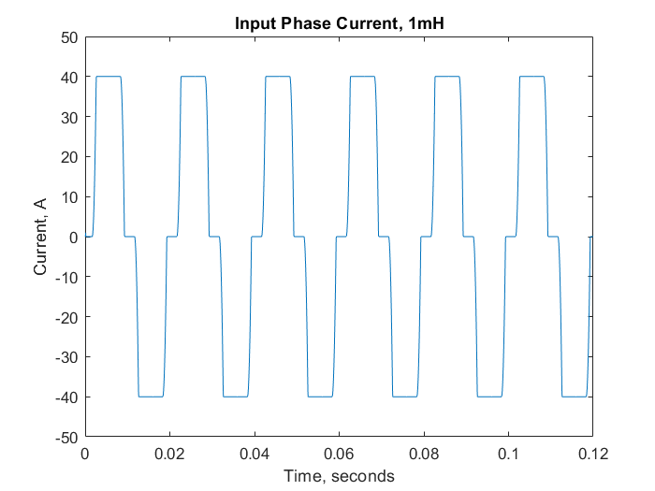

Figure 11

**ekran görüntüsü içeren bir resim

Açıklama otomatik olarak oluşturuldu**

Figure 12

* 1. **Output Average Voltage Calculations and Comparison with Simulated Results (Ls=1mH)**

The average value of the output when the line inductances are not ignored (which was the case in part b) can be calculated on only one of the curved portions of the rectified signal, by performing the following operations in equations 11, 12 and 13.

(11)

(12)

(13)

Where Δvd is representing the lost voltage due to the commutation operation.

These calculation were done under the assumption of existing line inductances at the source side, which would lead to commutation and therefore a decrease in the average voltage.

The result of the analytical calculations for the output average voltage is found to be 525.99 V, where we obtained the value for the same parameter in the Simulink simulation as 528.2V. The difference between the simulated result and the analytical result is more than that of the comparison without the line inductances, but with this small difference it is still a very reliable test tool.

* 1. **Comparison of the Harmonic Content of the Input Current for Different Values of Ls**

Without any line inductance, which is an ideal but not probable case, the input current has a high THD value, which means the signal carries too much harmonics on it. It is an exact square wave. By increasing the line inductance to some extent, this form of the input current can be changed. As the line inductance increases, THD value of the signal decreases which is something desired.

1. **Question 4: Feedback**

To complete the SIMULINK parts took most of the time. Around 6-7 hours have been devoted. But a reason for that is we are amateurs using SIMULINK. This is going to decrease probably in the upcoming tasks.