Beyond Employment: Evaluating the Poverty-Reducing Effects of Minimum Wage Increases in the United States

Introduction: Debates on economic justice and reducing poverty often center on minimum wage laws. While research frequently examines employment impacts, less is known about whether higher wages help full-time workers truly escape poverty. Beyond employment, do increases in minimum wage at the state-level reduce poverty rates for full-time workers in low-paying occupations? To assess this question, this project focuses on poverty outcomes rather than employment numbers, focusing on full-time employees in occupations near or below the poverty threshold. Using data from the American Community Survey (ACS), Bureau of Labor Statistics (BLS), and the U.S. Department of Labor, I will create a state-level panel dataset. Descriptive statistics, fixed-effects regression, and difference-in-difference models will be employed, with exploratory cluster analysis to identify groups of states that respond similarly. I will present the results in a research paper, accompanied by a replicable dataset and annotated code. This research has intellectual significance because it advances the study of minimum wage legislation by focusing on the understudied topic of poverty consequences for full-time low-wage workers rather than employment impacts. Its wider effects include guiding discussions on economic fairness and anti-poverty tactics by giving campaigners and policymakers data on the circumstances and times when raising the minimum wage successfully lowers poverty. Building upon evidence linking minimum wages to food insecurity (Winkler et al., 2025) and public health (Leigh, 2016), while also addressing skepticism about their anti-poverty effects (Sabia & Burkhauser, 2010), this study will provide a more nuanced understanding of when wage increases achieve their intended goals.
Background: Many studies have examined the effects of minimum wage regulations, although most of them have concentrated on employment rather than poverty consequences. The discussion shifted away from presumptions of guaranteed job loss after Card and Kruger’s (1994) analysis highlighted that raising minimum wage in New Jersey did not result in a decrease in fast-food employment. Subsequent research has highlighted that context affects impacts. Wang, Phillips, and Su (2019), for instance, emphasize the importance of panel techniques that monitor results over time by highlighting the varied impacts among states.
There is more conflicting evidence about poverty reduction and how it interacts with minimum wage. Since many recipients live over the poverty line, Sabia and Burkhauser (2010) contend that increasing the federal minimum wage would not significantly reduce poverty among the working poor. On the other hand, Romich and Hill (2018) show that more significant reductions may be achieved when public interventions, such as tax credits, are combined with increased wages. Wage rises have also been linked to better public health (Leigh, 2016), and less food insecurity in households with children (Winkler et al., 2025), according to other research, suggesting wider societal benefits. These results imply that wage policy shapes a wider range of well-being outcomes, of which poverty is but one aspect.
Recent state-level analyses provide mixed but illuminating findings. Although the impacts vary by state, Arranz (2025) indicates that raising minimum wage somewhat increases household earnings. Low-paid workers are more directly impacted by occupational inequalities, which also influence how inequality reacts to pay policy (Medrano-Adán, 2023). These studies together imply that wage policy may, in certain circumstances, lessen poverty, especially when focused on vulnerable worker groups or in conjunction with supporting measures. This research lacks a cross-state, systematic emphasis on full-time low-wage workers, who are most directly situated close to the poverty line. By focusing on this population, the research fills significant gaps and uses techniques like difference-in-differences analysis and fixed-effects regression to determine not just if poverty reductions take place, but also the conditions under which they are most likely to occur.
Methodology: By integrating minimum wage regulations from the U.S. Department of Labor, poverty data from the American Community Survey, unemployment and occupational data from the Bureau of Labor Statistics, and household income indicators from FRED, this project will generate a state-level panel dataset. To account for timing implications, I’ll also note when the minimum wage was last hiked in each state, which may require doing some more extensive research into state laws and policies.
The analysis will proceed in three stages. First, state patterns in poverty in relation to wage changes will be highlighted using descriptive statistics and visualizations. Second, the association between state minimum wages and poverty rates among full-time low-wage workers will be estimated using fixed-effects panel regressions that adjust from employment, income, and demography. Third, states that increased their minimum wage and those that did not during the same time period will have their changes in poverty compared using difference-in-differences models (Arranz, 2025; Wang, Phillips, & Su, 2019). The stability of the results will be confirmed by robustness assessments using different specifications. Additionally, states with comparable economic or demographic characteristics may be grouped using exploratory cluster analysis to see if policy efficacy differs within clusters. The project will be conducted in organized stages. The design and literature review will be improved in weeks one and two, while data collection and cleaning will be the main emphasis of weeks three and four. Descriptive analysis will take place in weeks five and six; fixed-effects regressions and difference-in-differences models will be run in weeks seven and eight; robustness checks and exploratory clustering will take place in week nine; findings will be drafted in weeks ten and eleven; and the paper, dataset, and code will be finalized in week twelve. The conclusion of this proposal includes a Gantt chart in Appendix A (Figure 1) that lists these milestones.
Qualifications: Both my academic background and practical experience are evident in my preparation for this assignment. I built a foundation in various statistical methods like regression analysis, clustering, and statistical testing using R, STATA, and Python. This has been established through my coursework in economics and data analytics. I obtained practical experience gathering, sorting, and cleaning datasets during my time as an intern at the Ohio State Center for HOPES. This included incorporating various demographic indicators into policy studies and clustering time-series data. Other initiatives, such as final projects from previous courses I have taken and strong foundational skills within the domain of economics, further highlight my capacity to combine intricate datasets and concisely communicate findings.
References
Arranz, J. M. (2025). Assessing the impact of an increase in the minimum wage: Evidence from household data. Social Science Research, 116, 102762. https://www.sciencedirect.com/science/art icle/pii/S0049089X25000043?via%3Dihub
Card, D., & Krueger, A. B. (1994). Minimum wages and employment: A case study of the fast-food industry in New Jersey and Pennsylvania. The American Economic Review, 84(4), 772–793. https://www.jstor.org/stable/2118030?seq=1
Leigh, J. P. (2016). Could raising the minimum wage improve the public’s health? American Journal of Public Health, 106(8), 1355–1356. https://pmc.ncbi.nlm.nih.gov/articles/PMC4940672/
Medrano-Adán, L. (2023). Minimum wage effects on income inequality and occupational choices. Economic Modelling, 122, 106398. https://www.sciencedirect.com/science/article/pii/S03135926 23001947
Romich, J. L., & Hill, H. D. (2018). Coupling a federal minimum wage hike with public investments to make work pay and reduce poverty. RSF: The Russell Sage Foundation Journal of the Social Sciences, 4(3), 22–43. https://pmc.ncbi.nlm.nih.gov/articles/PMC8286698/
Sabia, J. J., & Burkhauser, R. V. (2010). Minimum wages and poverty: Will a $9.50 federal minimum wage really help the working poor? Southern Economic Journal, 76(3), 592–623. https://www.jstor.org/stable/27751487?seq=1
Wang, Z., Phillips, K. R., & Su, Y. (2019). The heterogeneous effects of the minimum wage on employment across states. Economics Letters, 174, 179–182. https://www.sciencedirect.com/scie nce/article/pii/S0165176518304580?via%3Dihub
Winkler, M. R., Clohan, J. R., Komro, K. A., Livingston, M. D., & Markowitz, S. (2025). State minimum wage and food insecurity among US households with children. JAMA Network Open, 8(3), e246734. https://jamanetwork.com/journals/jamanetworkopen/fullarticle/2831998
Appendix
Figure 1: Gantt Chart of semester project milestones (Weeks 1–17)
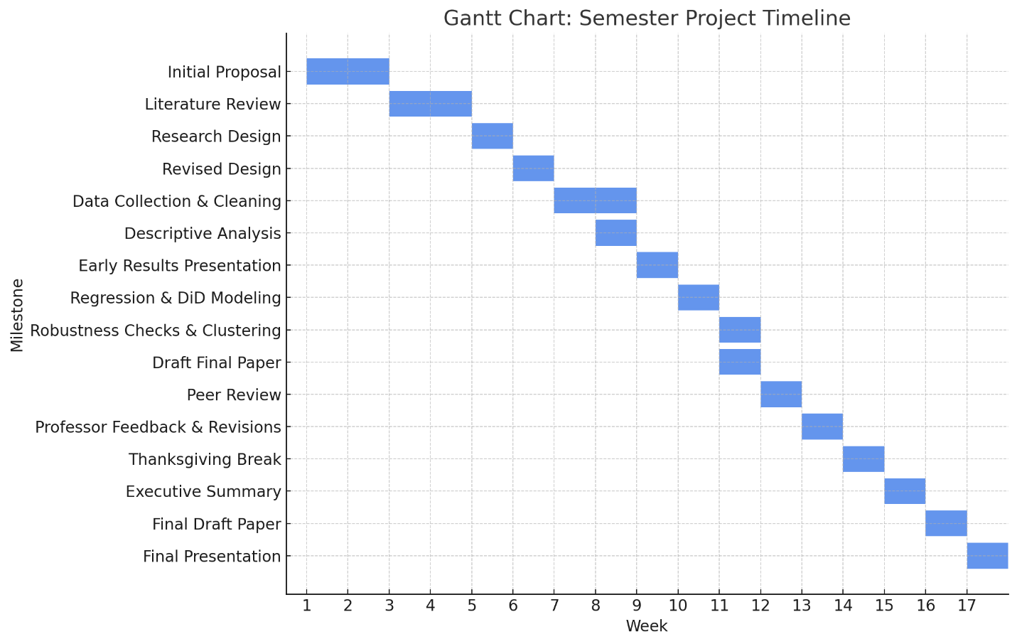This Gantt chart showcases the timeline of all major milestones/assignments, aligning tasks such as proposal drafting, literature review, data collection, analysis, and final deliverables with the semester schedule.

