BeagleBone Black Board(BBB)

- It’s an open source h/w, s/w platform

- A low cost Single Board Computer (SBC)

- BBB uses TI’s AM355x SOC, which can run at 1GHZ clock speed

- SOC stands for System on Chip.
- As the name indicates,a single chip contains most of the essential computing /communication/storage engine of the computing world, like Flash memory, Graphics processing engine, the image processing engine, the USB communication engine, RS232, SPI, I2C engine and much more. The heart of the SOC is a processor.
- For example AM355x SOC is powered by ARM cortex A8 processor.
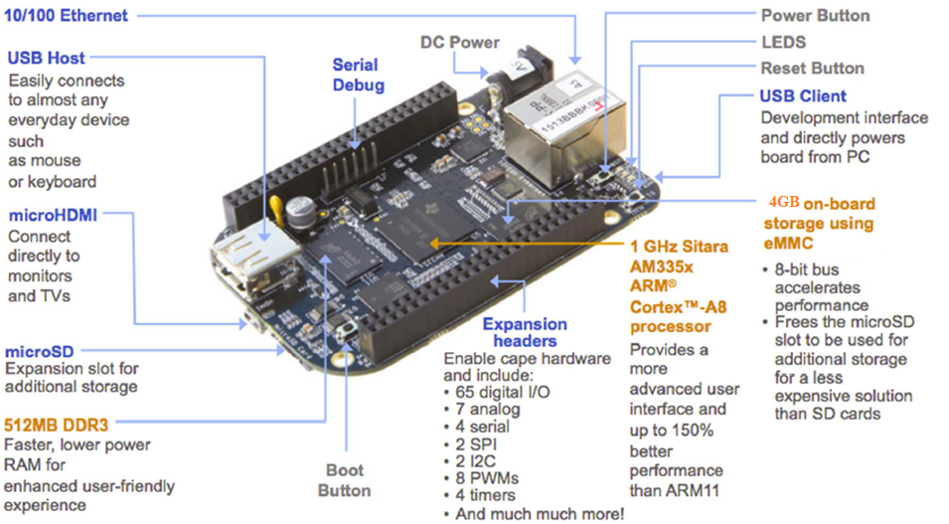

WI-Fi & BLE/BLUETOOTH module

- The WiFi module in BBBW is based on the Texas Instruments WiLink8 chip, which supports dual-band 2.4GHz and 5GHz operation with 2x2 MIMO antennas. It supports all the standard WiFi security protocols such as WPA2, WEP, and AES. The WiFi module can be used to connect the BBBW to a local network or to create a wireless access point.

- The BLE module in BBBW is based on the Texas Instruments CC2650 chip, which supports Bluetooth 4.2 and Bluetooth Low Energy (BLE) protocols. It can be used to communicate with other BLE-enabled devices such as smartphones, fitness trackers, and other IoT devices.

Sysfs

sysfs is a pseudo file system provided by the Linux kernel that exports information about various kernel subsystems, hardware devices, and associated device drivers from the kernel's device model to user space through virtual files.

sysfs is a RAM-based filesystem initially based on ramfs. It provides a means to export kernel data structures, their attributes, and the linkages between them to userspace. sysfs is tied inherently to the object infrastructure.

Ramfs
Ramfs is a very simple filesystem that exports Linux's disk caching mechanisms (the page cache and dentry cache) as a dynamically resizable RAM-based filesystem.

It’s main purpose is to copy data and binary files from storage to memory, thus reducing disk I/O and improving overall performance.

NAND flash

NAND flash is a type of non-volatile storage technology commonly used in digital devices such as smartphones, USB drives, and solid-state drives (SSDs).

NAND flash memory is made up of memory cells that use a combination of floating-gate transistors and NAND gates to store data. The NAND gate is a type of logic gate that can perform Boolean algebraic functions, and the floating-gate transistor can store an electrical charge to represent a binary value (0 or 1).

NAND flash memory is designed to be accessed randomly, meaning that data can be read from or written to any location in the memory at any time. It is also known for its high storage density, fast read speeds, and low power consumption, which makes it a popular choice for mobile devices and other applications where space and power are limited.

DDRX (Double Data Rate X) memory

DDR4 memory modules transfer data twice per clock cycle, just like DDR3, but they operate at a higher clock speed, starting from 2133 MHz and ranging up to 4800 MHz. This results in higher data transfer rates and faster performance for memory-intensive applications such as gaming, video editing, and 3D modeling.

DDR4 memory modules also have a higher density than DDR3, meaning that they can store more data per module. This is made possible by the use of advanced manufacturing processes that allow for more memory cells to be packed onto each chip.
In addition to speed and capacity improvements, DDR4 memory also offers improved power efficiency compared to DDR3. DDR4 memory operates at a lower voltage of 1.2V, which reduces power consumption and heat output. This makes it a popular choice for laptops and other mobile devices where battery life is important.

Overall, DDR4 memory represents a significant improvement over its predecessors and is now the standard memory technology used in modern computers.

BOOTLOADER

The bootloader typically resides in a special area of non-volatile memory, such as the device's ROM or flash memory, and is executed automatically when the device is powered on or reset. The bootloader is responsible for initializing the hardware, such as setting up the processor and memory, and then loading the operating system or other software into memory and passing control over to it.

The bootloader can also be used to perform other tasks, such as firmware updates, system diagnostics, and recovery operations. Bootloaders can be customized or replaced with alternative bootloaders, and are often used in embedded systems, mobile devices, and other specialized computing environments.

Linux Boot Requirement

RBL (ROM Boot Loader): The RBL is a small program that resides in the ROM of the device and is responsible for initializing the hardware and loading the MLO-SPL or U-Boot into memory. The RBL is executed immediately after the device is powered on and is responsible for setting up the basic system environment.

The SPL provides more advanced features and loads U-Boot, which is a popular third-stage bootloader. U-Boot loads the Linux kernel image into memory and prepares the system for kernel execution. It also provides a command-line interface for configuring the system, loading additional software, and debugging.

Finally, the Linux kernel image initializes the system's hardware, loads device drivers, and provides the core operating system functionality. Once the kernel is loaded, the device is ready to execute applications and user code.

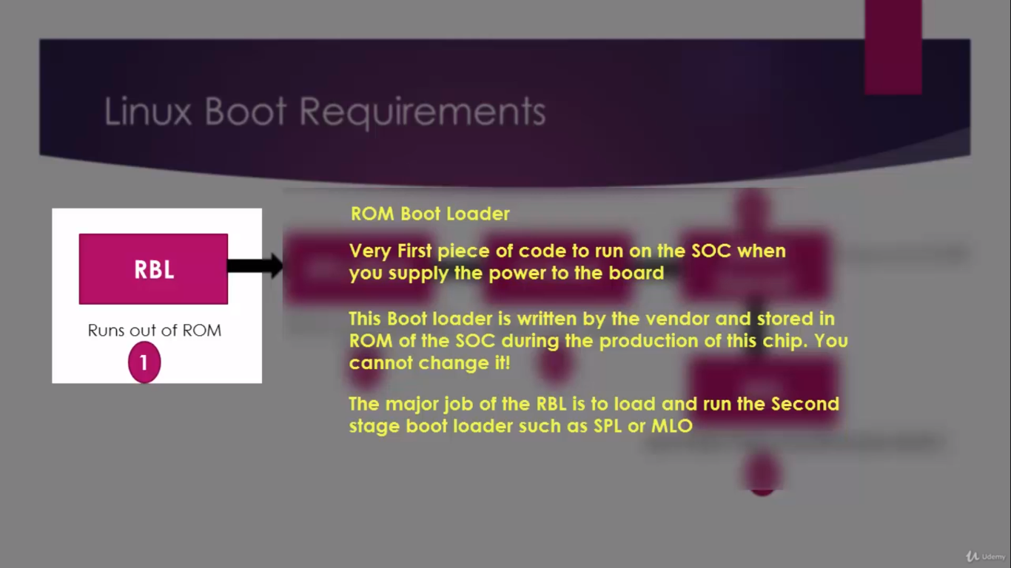

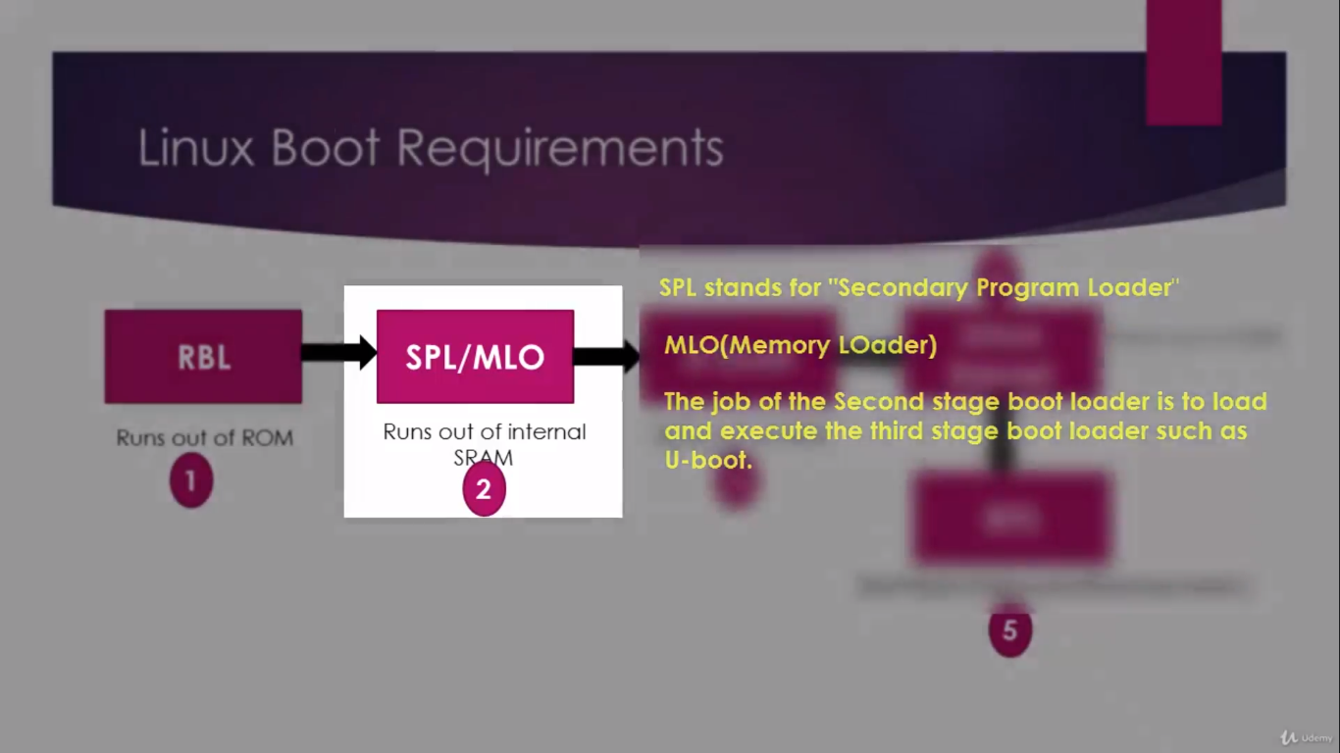

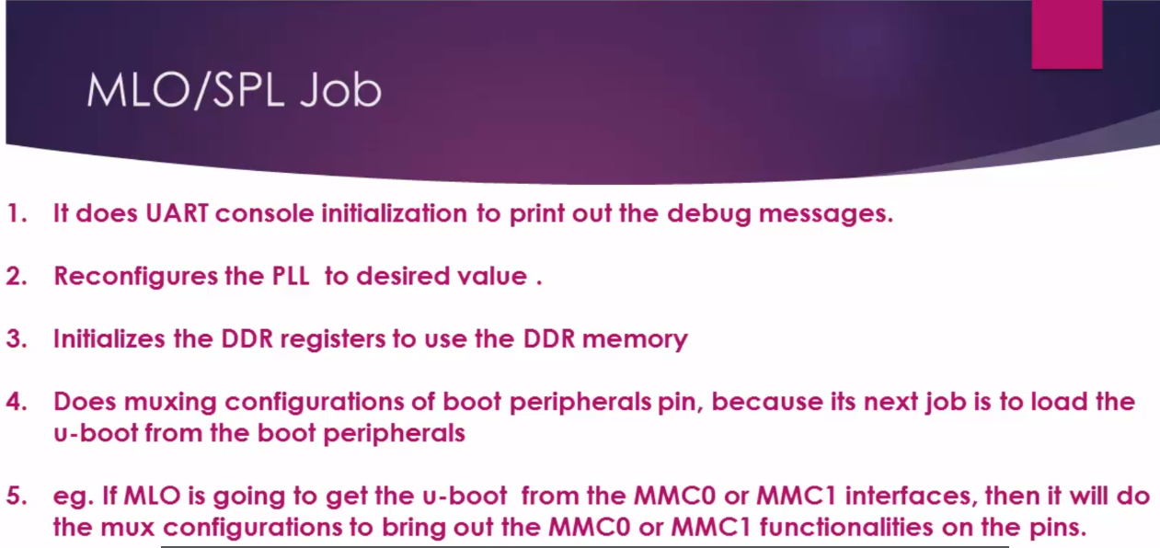

U-Boot :- The job of third stage bootloader is to load and run the linux kernel.

NOTE:- To Successfully Boot Linux we also need Linux kernel and RFS(Root File System) of Linux.

BeagleBone Board Boot Options
1) NAND Flash
2) NOR Flash (eXecute In place, XIP)
3) USB
4) eMMC
5) SD card
6) Ethernet
6) UART
7) SPI

Bootstrap loader

Kernel_entry(0,machid,r2);
Here:
Machine id of the board which is detected by the u-boot (Passed to linux vie register”r1”).
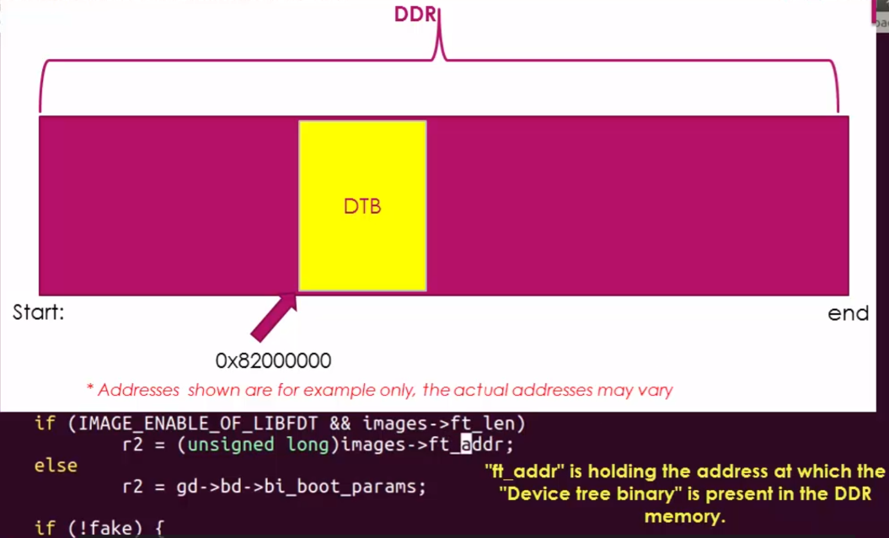
Address of “DTB” present in the DDR RAM (Passed to linux via Register “r2”).

Device Tree Binary

DTB is nothing but a stream of bytes which encodes the details of the hardware which is derived from DTS compilation

During booting linux must know the address at which DTB file is present in the RAM.

uENV.txt file

It contains environment variables that define various system settings and parameters that U-Boot uses during the boot process.

The uENV.txt file can be used to set parameters such as the system's hostname, IP address, netmask, gateway, console settings, and more. These variables can be set to default values or can be overridden at runtime by the user.

Another use of the uENV.txt file is to store configuration data that is specific to the hardware platform. For example, it can store calibration data or board-specific settings that are required during the boot process.

uImage
- The uImage is a compressed Linux kernel image that is used by U-Boot bootloader to boot the Linux operating system on an embedded device. The uImage contains the Linux kernel and other data, such as the device tree blob, initrd image, and boot configuration information.

- The uImage is typically generated by the kernel build system using the mkimage tool. The mkimage tool takes the uncompressed Linux kernel image and creates a compressed uImage with a 64-byte header. The header contains information such as the image type (kernel or initrd), the architecture, the compression type, the entry point of the image, and the load address.

- When the U-Boot bootloader loads the uImage, it reads the header to determine the image type and architecture, and then decompresses the kernel image into memory. It also loads the device tree blob (DTB) and the initial RAM disk (initrd) image, if they are present in the uImage.

- After the kernel is loaded, U-Boot sets up the boot arguments, such as the root file system location, kernel parameters, and other parameters needed for the kernel to initialize and mount the root file system. Once the kernel is booted and the root file system is mounted, the Linux operating system is up and running on the embedded device.

- In summary, the uImage is a compressed Linux kernel image that is used by the U-Boot bootloader to boot the Linux operating system on an embedded device. It contains the Linux kernel, device tree blob, initrd image, and boot configuration information. The uImage is generated using the mkimage tool and loaded by the U-Boot bootloader during the boot process.

Breakdown of uimage header

- ih_magic: The magic number that identifies the image type.
- ih_hcrc: The header checksum, calculated over the entire header, including this field.
- ih_time: The creation timestamp of the image.
- ih_size: The size of the entire image, including the header.
- ih_load: The load address of the image.
- ih_ep: The entry point address of the image.
- ih_dcrc: The data checksum, calculated over the entire image, excluding the header.
- ih_os: The operating system that the image is intended to run on.
- ih_arch: The architecture of the image.
- ih_type: The image type. For a uImage, the type is 0x00000001.
- ih_comp: The compression type used for the image data.
- ih_name: The name of the image, terminated by a null byte.
- ih_ostype: The type of operating system that the image is intended to run on.
- ih_pad: Padding to align the header to 64 bytes.

What is booting process in linux and Explaining about Linux Booting Process.(Click below link)
https://busadhruv.blogspot.com/2023/03/linux-booting-process.html

kernel initialization process
NOTE : Below details where function name may be different from actual name it’s for understanding purpose only.

- The kernel Initialization Process starts in the start_kernel() function, which is located in init/main.c.
- start_kernel() sets up the initial kernel environment and initializes the memory management unit (MMU).
- The kernel then initializes the interrupt controller and starts the scheduler.
- The init process is started, which is responsible for initializing the system and starting user processes.

- Before the start_kernel() function is called, the bootloader loads the kernel image into memory and jumps to the entry point specified in the image header. This entry point is typically located in a file called head.S or head-common.S.

- The head.S file contains the assembly code that sets up the initial kernel environment and prepares the system to start running C code. Specifically, head.S is responsible for performing the following tasks:
- Setting up the stack pointer and initializing the CPU.
- Loading the initial kernel page tables and enabling the MMU.
- Jumping to the __turn_mmu_on() function, which sets up the kernel environment in C code.
- The __turn_mmu_on() function is located in arch/arm/mm/init.c and is responsible for initializing the kernel memory management system, which includes initializing page tables, enabling caching, and setting up virtual memory.
- After the __turn_mmu_on() function completes, control is returned to head.S, which then jumps to the start_kernel() function in init/main.c.

mkimage
- mkimage is a tool used to create bootable images for U-Boot bootloader.

- mkimage is part of the U-Boot source code and is typically located in the tools directory. It is a command-line tool that takes several arguments and options to create the bootable image.

- For example, to create a uImage, mkimage takes an uncompressed Linux kernel image as input and creates a compressed uImage with a header containing information such as the image type, architecture, compression type, entry point of the image, and the load address. The resulting uImage can then be loaded by U-Boot during the boot process to boot the Linux operating system on the embedded device.

Check detailed explaination of mKimage https://manpages.ubuntu.com/manpages/xenial/man1/mkimage.1.html

Question
can we not write environment variable and command into u-boot.img file without using uENV.txt file?

ANS:
- To create a U-Boot image with environment variables and commands, you can use the mkimage tool with the -A, -T, -C, -n, and -d options to specify the architecture, image type, compression type, image name, and input file, respectively. You can also use the -e option to specify the entry point address for the image.
- For example, the following command creates a U-Boot image that includes the environment variable bootargs with the value console=ttyS0,115200:
- mkimage -A arm -T standalone -C none -n "My U-Boot Image" -d my_u-boot.bin -e 0x80008000 -o my_u-boot.img -e "bootargs=console=ttyS0,115200"
- In this example, my_u-boot.bin is the input file that contains the U-Boot binary code, and my_u-boot.img is the output file that contains the U-Boot image with the environment variable bootargs included.
Note : that including environment variables and commands directly in the U-Boot image can make it more difficult to change them later, since the image would need to be re-created and re-flashed. Using a separate uEnv.txt file provides a more flexible and easily-editable way to set environment variables and commands in U-Boot.

Why uENV.txt file name common can we change file name or it has to this?
- The U-Boot environment variable file is commonly named uEnv.txt because U-Boot looks for this specific filename by default when reading environment variables from the boot partition.
- However, it is possible to use a different filename for the environment variable file if necessary. To do so, you would need to specify the filename explicitly in the U-Boot boot command or in the U-Boot script.
- For example, if you wanted to use a file named myenv.txt for the environment variables, you could specify this in the U-Boot boot command as follows:
u-boot# bootm ${kernel_addr} - ${fdt_addr} -e -c "env import -t ${fdt_addr} $ {filesize} myenv.txt"

Why AM335x RBL cannot load the Uboot directly to DDR?
- The reason why ROM boot loader of the AM335x SOC cannot load Uboot directly to DDD3 by skipping SPL is,
- ROM code won’t be having any idea about what kind of DDR RAM being used in the product to initialize it.
- DDR RAM is purely product/ board specific.
- So, RBL has no idea in which product this chip will be used and what kind of DDR will be used, and what are DDR tuning parameters like speed, bandwidth, clock augments, size, etc.
- Because to read ( or write) anything from/to DDR RAM , first, the tuning parameters must be set properly and DDR registers must be initialized properly .
- RBL just tries to fetch the SPL found in memory devices such as eMMC and SD card or peripherals like UART,EMAC,etc.
- And in the SPL/MLO, you should know, what kind of DDR is connected to your product and based on that you have to change the SPL code , rebuild it and generate the binary to use it as the second stage boot loader.

Board Start Sequence and linux boot from micro sd card

Requirement : USB to TTL converter with 3 female-female jumper.
5-V DC Power supply or micro usb cable.
Micro SD-card.

NOTE: Before connection kindly refer datasheet of BBB which user can find below link.

Connection : Beaglebone black wireless pin(UART0) USB to TTL converter
1 (GND) GND
4 (RX) TX
5 (TX) RX
For Power supply either connect 5-V DC adaptor or connect BBB to PC via micro USB cable.

* For Download MLO ,U_image ,u_ENV file and root file system for boot linux in BBB click on below link

https://github.com/busadhruv/Beagle-Bone-Black-Wireless

for booting linux into BBB u need bootable sd card with two partition 1) BOOT 2)ROOTFS

with the help of Gparted application on linux u can partitioned sd card.

After that copy MLO , U_image, U_ENV file in boot partition. And copy root file into ROOTFS.
NOTE: IF user can’t directly copy then try to use cp command in terminal with sudo privilage.

Befor press “boot” button make sure board in power down mode.
To enter power down mode user needs to press “power button” until power led turns off.
After insert micro sd card into board press and hold “Boot” button and then press “power button” and release “boot” button.

That’s it done .

Initramfs

Generating "initramfs" using RFS

What is initramfs ?
- The word "initramfs" is made up of three words "initial" "RAM based" "file system"
- This is nothing but a file system hierarchy (which you just studied in the last lecture, all those directory structure), made to live in the RAM of the device by compressing it (we use compression because RAM is precious, we cannot use whole RAM just to store the FS) and during booting, Linux mounts this file system as the initial file system. That means you just need RAM to mount the FS and get going with the complete boot Process.
- Does that mean usage of initramfs is compulsory? Used everywhere, every time ?
- No, not necessarily. Using initramfs is optional.
- So, why do we need initramfs ?
- Let’s understand this with an example.
- Let’s say you have a product and your product has USB interfaces, mass storage devices like SD card and let’s say you also have networking peripherals like Ethernet and also display.
- Now, to operate this wide range of peripherals, all the device drivers must be in place right?
- That means all the drivers must be loaded in to the kernel space.
- And along with the drivers, some peripherals may require the firmware binaries to operate.
- One idea is make sure that all those drivers are “built in” in to the kernel, that’s not a great idea because that makes your Linux kernel specific to your product and it will drastically increase the Linux kernel image size.
- Another good way is, you come up with the minimal file system, where you store all your drivers and firmware, and load that FS in to the RAM and ask the Linux to mount that file system during boot( Thanks to kernel boot arguments , you can use the kernel boot arguments to indicate kernel that your FS resides in RAM )
- When the kernel mounts that file system from RAM, it loads all the required drivers for your product and all the peripherals of your product are ready to operate, because the drivers are in place.
- after That you can even get rid of this RAM based file system and use (switch to) some other advanced file system which resides on your other memory devices like eMMC/SD card or even you can mount from the network.
- So, basically initramfs embedded into the kernel and loaded at an early stage of the boot process, where it gives all the minimal requirements to boot the Linux kernel successfully on the board just from RAM without worrying about other peripherals. And what you should store in initramfs is left to your product requirements, you may store all the important drivers and firmware, you may keep your product specific scripts, early graphic display logos, etc.
- How to keep initramfs in to RAM?
- There are 2 ways,
1) You can make initramfs “built in” in to the Linux Kernel during compilation , so when the Linux starts booting , it will place the initramfs in the RAM and mounts as the initial root file system and continues.
2) You can load the initramfs from some other sources in to the RAM of your board and tell the Linux Kernel about it (that is , at what RAM address initramfs is present ) via the kernel boot arguments.

How to generate the innitramfs ?

Step 1: Download and extract the root file system attached with this lecture. This root file system I took from TI software SDK.

https://github.com/busadhruv/Beagle-Bone-Black-Wireless/blob/master/am335x_tiny_filesystem.zip

Step 2: Get in to the extracted folder and run the below 2 commands from the “terminal”
$ find . | cpio -H newc -o > ../initramfs.cpio
$ cat ../initramfs.cpio | gzip > ../initramfs.gz
In the first command we are generating a cpio archive and then gz archive.
STEP 3 : install mkImage command
For that run “apt-get install u-boot-tools” on your terminal software, this will install all the u-boot related tools along with mkImage tool.
$ apt-get install u-boot-tools
STEP 4: Make our initramfs , uboot friendly by attaching the uboot header with load address and other info .
Run the below command.
$ mkimage -A arm -O Linux -T ramdisk -C none -a 0x80800000 -n "Root Filesystem" -d ../initramfs.gz ../initramfs

The busy box init tries to execute a script called rcS, which is present in the directory /etc/init.d/ of the file system. And system V init program tries to execute a special script called inittab found in /etc/init.d directory of the file system.

