Lab 7: Free-Energy Perturbation

In this lab, you will integrate the skills you have developed and the knowledge you have ­gained so far this semester to study the M2 proton channel of the Influenza A virus. Upon completion of this lab, you should be able to accomplish the following objectives:

* Understand the TSM perturbation syntax and methodology
* Perform TSM simulations of amantadine and rimantadine in water
* Compare ΔG from water TSM simulations to given ΔG's from channel TSM simulations to obtain ΔΔG's for amantadine and rimantidine.
* Analyze TSM trajectories in VMD

# Background

The M2 proton channel of the influenza viral membrane is a key component involved in viral replication. When the channel is blocked by channel inhibitors, such as Amantadine (alm no. 035) or Rimantadine (alm no. 150), the virus cannot replicate. In mutant forms of the virus such as S31N, these drugs are no longer effective due to amino-acid changes in the M2 channel. Understanding the M2 channel is, therefore, essential in searching for new, effective anti-viral drugs.

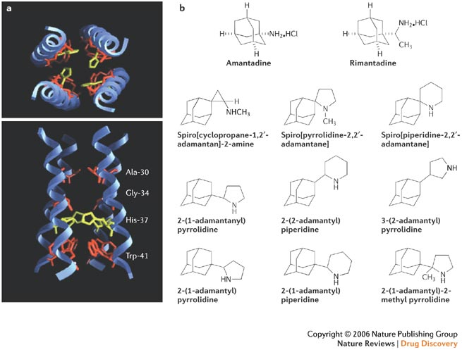

*Fig. 1: a) Superior and lateral views of the M2 proton channel.*

*b) Various adamantyl derivatives.*

Free-energy Perturbation

In Lab 5 you were introduced to determining free energy using umbrella sampling. This lab, however, focuses on determining free energy in a system using free-energy perturbation.

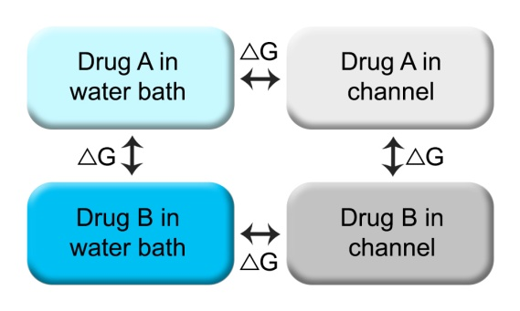

In practice, ΔG is usually calculated by comparing a difference in energy for a molecule of interest as conditions in the system change. However, in free-energy perturbation, ΔG is determined by keeping the system conditions constant and changing the molecule of interest into another molecule via piecewise mutations. For example, one might determine the ΔG for Drug A by comparing Drug A in water and Drug A in the M2 channel. The same effect can be accomplished by comparing Drug A in water to Drug B in water. (See Fig. 2.)

*Fig. 2: Determining ΔG*

***Question 1: A student previously studied the ΔΔG's of various drugs in the M2 channel using umbrella sampling and free-energy profiles using the techniques learned in lab 5. However, the ΔG's he determined varied immensely and little valuable data was retrieved. Using free-energy perturbation he was able to get much more consistent results. Why might this be?***

TSM

CHARMM has two methods of performing free-energy perturbation, the first is using the command PERT, and the second is using the command TSM. We will use TSM free-energy perturbation in this lab to compare the relative ΔΔG's of amantadine (ALM-035) and rimantadine (ALM-150).

TSM uses degrees of mutation, termed lambda, for which a percentage of Drug A is compared to a percentage of Drug B. These values of lambda that are calculated are .125, .500, and .875. Using thermodynamic perturbation, midpoints and endpoints can be predicted, giving ΔG at the following points:

* λ = 0.000 (100% Drug A)
* λ = 0.125
* λ = 0.250
* λ = 0.500 (50% Drug A, 50% Drug B)
* λ = 0.750
* λ = 0.875
* λ = 1.000 (100% Drug B)

# Procedure

Before we can use the free-energy perturbation method, the system we need to simulate must first be created. Fortunately, the system you will be simulating is provided in the lab. Once you have obtained a good system for simulation, you will (1) heat the system, (2) allow the system to begin equilibration and perform TSM, and (3) execute a post-processing script to interpret TSM data.

Heating

For the purposes of this lab, you will not be performing any heating of the drugs in the M2 channel. Rather, you will be heating the drugs in water and comparing your results to M2 results that are given to you (found in the lab7_files directory).

Open the lab7_files directory found on the home charmmlab directory and examine the contents (do not edit any of the files here, and do not copy the directory to your personal directory). The alm folder contains the .pdb's, .prm's, and .rtf's of the drugs you will be simulating. Alm-035 is amantadine and alm-150 is rimantadine. The output directory contains the output .crd, .dcd., restart, tsm, and .xtl files from the TSM scripts for the drugs in the M2 channel (2kqt). The prep directory contains other files essential for the lab, but will not require editing.

Copy the lab7 directory from the home charmmlab directory into your personal directory and examine the contents. In this directory you will find CHARMM scripts (prefix=tsm), slurmm submission scripts (prefix=pbs), and a shell batch submission script (labeled "submitter") which has been customized for this lab. The output directory here corresponds to the output directory found in the lab7_files directory and will be used for your personal submissions.

Open the file in the lab7 directory labeled "tsm.heat_2kqt.str." This file is the CHARMM script used to heat the drugs in the 2kqt model of the M2 proton channel in a lipid bilayer. You should be familiar with many of the commands seen in this script from previous labs. You may notice some of the variables are passed to CHARMM from the bash submission script, such as L. You will also notice the use of absolute references and pathnames, rather than the usual relative references, to allow CHARMM to access the files in the lab7_files directory from any directory on the cluster. *(Bomlev is set at -5 for these heating scripts due to a bug in CHARMM--although "bad base passed" error messages will be generated in your log file, your results will be unaffected. You may use the cleanup tool in the log directory to remove this warning in your log files.)*

***Question 2: To what temperature is the system being heated?***

***Question 3: As written, this CHARMM script heats the system and then allows the system to equilibrate with constant volume for 3 picoseconds each. What changes would you make to the script to allow the system, after heating, to equilibrate for 0.75 nanoseconds?***

Now that you are familiar with the system heating process, modify the script in your lab7 directory labeled "tsm.heat_water.str" for use with simulating the drugs in water. Anywhere you find ### written in the script is where you will need to supply code. Use *absolute references for files that already exist*, and use *relative references for files you write* in this script. Use the method you used to answer question 3 to heat the system for 0.75 picoseconds and then equilibrate for 1.5 picoseconds. Modify and use the submitter file in your lab7 directory to submit your script. To check on the status of your jobs, type "squeue" and press enter. To receive an update every 2 seconds, use "watch squeue." This script may take several minutes to complete.

Once your jobs are complete, open the log directory and execute the file "cleanup" to cleanup the log files with the "bad base" error to make the log files easier to read. Then examine your log files.

***Question 4: After both rounds of minimization, what was the total energy of the system? What was the total energy of the system after heating and 1.5 picoseconds of equilibration? Why did it change this way?***

Equilibration & TSM

Now the system has been heated and has begun to equilibrate, the equilibration process can be extended to allow for calculation of ΔG. Equilibration is performed in a step-wise fashion using restart files. You can imagine the way restart files are used just like working on a lengthy project in a word processor. It is ideal to save often and pick up your work where you previously saved, rather than completing it all at once without saving at all during the process.

***Question 5: In theory, you could use one script and one submission and extend the equilibrium dynamics process to a longer amount of time. However, this is often an impractical solution. Name two reasons that you can think of that make the use of restart files advantageous.***

The files with the prefix tsm.restart in your lab7 directory are the scripts that would be used to extend equilibration time for the system and perform TSM calculations. These scripts can take more than a day to complete on the supercomputer--for this reason you will not be required to edit or submit these scripts. The coordinate files, dcd files, tsm files, and more from these restart scripts are found in the output directory in your lab7 directory. However, take some time to examine the differences between the restart script and your heating script, and answer the following question:

***Question 6: What variable, besides L, would you have to pass to the CHARMM script from the shell or from a submission script to allow the restart script to load the output files from the heating script? What would the value of the variable need to be for the first restart after heating?***

Post-Processing of TSM

TSM's output files in lab7/output/tsm/ are not in a format that is readily understood for analysis. For this reason, TSM has its own CHARMM post-processing method that it employs to give a printout of ΔG.

You will find in your lab directory a file named "tsm.post_processing.str." Edit the ##'s found in this file to get ΔG printouts for both 2kqt *and* water. The water files should be in your personal lab7/output/tsm/ directory, and the 2kqt files are in the lab7_files/output/tsm/ directory in the charmmlab home. (Do not worry about overwriting log files, the submitter script will adjust them.) Adjust the submitter file and then execute the script.

Inspect the post-processing log files. After the words "plot files" you will have your TSM information for each value of lambda. Delta A (in this case, ΔG) is the data you are interested in. Delta E is the change in energy and Delta S is the change in entropy.

# Analysis

The data analysis for this lab takes place in two parts. You will begin with a graphical analysis of data and then finish with a visual analysis of the system in equilibrium.

Graphical Analysis

Prepare two graphs: one which shows ΔG in 2kqt for values of lambda and a similar graph for water. *Include these graphs in your lab write-up.*

Compute the ΔΔG's for amantadine and rimantadine by comparing your data sets for 2kqt and water from your post-processing log files and then answer the following question:

***Question 7: Which drug has a lower ΔΔG? By how much?***

Visual Analysis

Open lab7/output/crd/ and select the coordinate file for the 2kqt system in equilibrium. Load this file in VMD (be sure to specify CHARMM coordinates) and add the corresponding DCD file to the molecule. Press play and inspect the molecule and its trajectory while beginning equilibrium. Use labels and the representations SEGID M2A M2B M2C M2D and RESNAME L035 L150 to help you find the channel and the drugs. Answer the following questions:

***Question 8: Toward which terminus (N or C) is the drug oriented in 2kqt while in equilibrium?***

***Question 9: What amino acids do you find nearest to the drug while the system is in equilibrium?***

Feel free to explore the molecule more and see what other interactions may be occurring.

# Post-lab Questions

***Question 10: Name two things you would change in the scripts or in your methods to collect more accurate and reliable TSM data.***