

Faculty of Natural and Mathematical Sciences

# Department of Informatics

King's College London, Strand Campus, London, United Kingdom

7CCSMPRJ

Individual Project Submission 2021/22

Name: Olubusayo Akeredolu

Student Number: 20107125

Degree Programme: MSc Artificial Intelligence

Project Title: Text vs Trees vs Graphs: Deep Learning Techniques for Program Understanding

Supervisor: Dr Maria Polukarov

Word Count: 13,161

RELEASE OF PROJECT

Following the submission of your project, the Department would like to make it publicly available via the library electronic resources. You will retain copyright of the project.

I **agree** to the release of my project

I **do not** agree to the release of my project

Signature:



Date: August 4, 2022



Department of Informatics

King’s College London

United Kingdom

7CCSMPRJ MSc Project

TEXT VS TREES VS GRAPHS:

DEEP LEARNING TECHNIQUES FOR PROGRAM UNDERSTANDING

Name: Olubusayo Akeredolu

Student Number: 20107125

Degree Programme: MSc Artificial Intelligence

Supervisor’s Name: Dr Maria Polukarov

This dissertation is submitted for the degree of MSc in Artificial Intelligence

Acknowledgement

I thank my parents and siblings for their support throughout this project. I also want to thank Dr Maria Polukarov for her guidance on this project. Finally, I want to thank the Stack Overflow community for existing.

Abstract

Programming Language Understanding (PLU) is a field of Artificial Intelligence and Machine Learning that seeks to find the most suitable Deep Learning (DL) models for carrying out learning tasks on source code. The emphasis here is on DL models because other non-DL machine learning models can be applied to understand programs. This project takes this core objective of PLU and aims to compare the performance of mainstream DL models to the performance of non-DL machine learning models using three different data structures. These data structures are text, trees and graphs. This research project aims to determine which DL models are the most suitable for understanding source code and which of these three data structures is the most ideal for the task. This project also goes beyond PLU using deep learning models. It looks at the performances of select non-DL models to see which model and data structure is best suited for learning tasks on source code overall.

Contents

1 Introduction 6

1.1 Project Overview 6

1.2 Aims and Objectives 7

1.3 Background and Literature Survey 12

1.4 Motivations 13

2 Background Theories 11

2.1 Programs As Graphs and Trees 11

2.2 Underlying Theory and Background 11

3 Objectives, Specifications and Design 14

3.1 Specific Project Objectives 14

3.2 Technical Specifications 15

3.3 Design 15

4 Methodology and Implementation 22

4.1 Methodology 22

4.2 Implementation 22

5 Results, Analysis and Evaluation 34

5.1 Minimum Criteria for Success 34

5.2 Setting Up and Executing the Experiments 35

5.3 Analysis and Evaluation of Results 35

5.4 Overall Findings 40

6 Legal, Social, Ethical and Professional Issues 46

6.1 Legal Issues 46

6.2 Social and Ethical Issues 46

6.3 Professional Issues 46

7 Conclusion 47

7.1 Specific Objectives Achieved 47

7.2 Future Work 47

8 References 48

9 Appendices 51

9.1 Appendix A: Source Code File Structure 51

9.2 Appendix B: Source Code Files 53

List of Tables

Table 5.1: Results from all experiments on text

table 5.2: Results from graphs with unhashed embeddings, padding and segmentation

table 5.3: Results from Graphs with hashed embeddings, padding and segmentation

Table 5.4: Tree experiment results using Unsorted Max Segmentation and hashing

Table 5.5: Tree experiment results using unsorted max segmentation and unhashing

List of Figures

Fig 1.1a: One way of implementing the Bubble Sort algorithm

Fig 1.1b: Another way to implement the Bubble Sort algorithm

Fig 1.2a: Flowgraph of code snippet from fig 1.1a

Fig 1.2b: Flowgraph of code snippet from fig 1.1b

Fig 3.1: Simple MLP architecture

Fig 3.2: Cross section of a densely connected neural network

Fig 3.3: The design of a standard LSTM model [28]

Fig 3.4: Simple GRU model design [29]

Fig 3.5: Simple RNN architecture [32]

Fig 3.6: Naïve Bayes probability model

Fig 3.7: Random Forest classifier architecture [35]

Fig 3.8: Gradient Descent Algorithm pictured as a graph [36]

Fig 3.9: Support Vector Machine classifier design [37]

Fig 4.1: Dataflow diagram for pre-processing stage

Fig 4.2: Declaration of a segmentation function using unsorted square root of n with segment

count = 40

Fig 4.3: Example of sorted max segmentation

Fig 4.4: Implementation of runFFModel method in the MLP class

Fig 4.5: Implementation of backPropagate method in the MLP class

Fig 4.6: The implementation of the cross-validation function on the Gaussian NB classifier

Fig 4.7: The methods to make predictions and carry out classification

Fig 5.1: Graph showing changes between TA and VA from text-based deep learning models

Fig 5.2: Graph showing changes between TA and VA from tree-based deep learning models and unhashing

# Introduction

## Project Overview

This project is concerned with Programming Language Understanding (PLU) using deep learning (DL) and machine learning techniques. PLU is a field of DL that aims to use various deep learning techniques to train neural networks (NNs) to understand programs called source code.

PLU, while relatively new, is a significant field of Artificial Intelligence (AI) and Machine Learning (ML). This is because it deals with one specific way in which NNs are yet to catch up with humans (or programmers and software developers, in this case); they are unable to tell the difference between normal human language text (HLT) and source code, regardless of the programming language. For example, take a scenario where a text processing NN is built using source code as its training data. This text-based model will treat the input the same way an extract from a novel or a piece of text would. Unfortunately, this treatment of source code in the same way as text will result in loss of critical data due to all the differences between HLT and source code.

One of these differences, and the most important of them all, is that every human language has a finite grammar – every single word available for use in it. On the other hand, the source code is unlimited in its grammar because the names of the elements in the program are entirely up to the programmer.

Another critical distinction between source code and HLT is that single sentences in HLT do not usually need additional context to be understood. For example, the English language sentence “The woman walked into the room” follows the grammatical rules of the English language and can be understood entirely on its own. Source code is not like this. An example of a Python program line is “c = a + b”. This is meaningless if the rest of the program is not considered. This line of code requires the programmer – and the compiler or interpreter – to consider where the variables ‘a’, ‘b’ and ‘c’ were initially declared. Additionally, in a strongly typed language [6], the data types of each variable will have to be considered to ensure that no errors or exceptions are raised during execution and that they are all compatible with the ‘=’ and ‘+’ operations. The programmer will also have to examine how the variables change during the program's execution.

A third way in which programs and HLT differ is that programs contain many conceptual and structural information that HLT does not possess. These concepts include conditions and control flow, inheritance and objects in Object Oriented Programming (OOP) languages, abstract classes, abstraction, etc. Examples of structural information in programs but not in HLT include the programming paradigm (imperative, event-driven or declarative languages), typing structure (weakly typed or strongly typed languages), and the use of features from imported classes and external libraries, etc.

It is imperative to note that many different types of programming languages exist. These include non-scripting languages [1] (procedural languages, object-oriented languages, etc.) and scripting languages [2] (server-side scripting, query languages, etc.). Additionally, it is necessary to note that specific programming languages, e.g., Python, are considered both scripting and non-scripting languages.

The main difference between these two programming languages is that scripting languages are generally interpreted (processed line by line at execution), and non-scripting languages are usually compiled (processed as one at execution). The important difference between these two types of languages that needs to be considered for this project is that scripting languages tend to be closer in syntax to HLT than non-scripting languages. For example, the SQL (query language) statement “SELECT name FROM myTable” follows the rules of an English language sentence – it contains an object, a verb, and a subject – and can be understood without further context.

For this reason, this project focuses solely on non-scripting languages, specifically, the Python programming language in a Procedural programming [3] context.

## Aims and Objectives

This project’s main objective is to compare ML models based on three different information storage structures to determine which data structures are the most suitable for designing NNs to carry out classification tasks on source code. Furthermore, to get the most accurate picture of how generic NN models work when trained and tested on source code, this project will compare the performances of 9 different Natural Language Processing (NLP) [7] classification models. 5 of these models are deep learning models, while the other 4 are simple classification models. These have been included in this project to observe and compare the behaviour of non-deep-learning models when trained and tested with source code.

I have chosen these models because they are conventionally used when carrying out NLP tasks. The deep learning models are the Long Short-Term Memory (LSTM) network, the Simple Recurrent Neural Network (SRNN), and the Gated Recurrent Unit (GRU) model. All Recurrent Neural Network (RNN) models and the Multi-Layer Perceptron (MLP) and the Dense model. The non-deep-learning (NDL) models are the Gaussian Naïve Bayes classifier, the Stochastic Gradient Descent (SGD) classifier, the Random Forest (RF) classifier and the Support Vector Machine (SVM) classifier.

### Information Storage Structures

The first information storage structure I will be considering is text. As indicated above, multiple existing models for carrying out Natural Language Processing (NLP) on text exist. This reference shows how text-based NNs work when trained and tested on source code.

The second information storage structure I have chosen is the Tree data structure [4]. I have chosen this abstract data type because every program has an Abstract Syntax Tree (AST), which shows the source code structure and connections. This project involves the development of the NLP models named above in such a way that they take data extracted from a program’s AST as their input.

The final information storage structure is the graph data structure. This is also an abstract data type. I have chosen graphs because every program, no matter how large or small, has a flow chart or flow graph form, both of which are directed graphs. Like the tree-based models, this project aims to develop several NNs based on those described above, and each graph-based model will take data developed from a NetworkX graph as its input.

I have chosen to develop models based on trees and graphs because of the differences between text and HLT as outlined in section 1.1 and because of the shortcomings of text-based models when processing source code. In addition, the advantages of trees and graphs over text for capturing structural information are another reason for this decision.

The major shortcoming of text-based models is that they convert each word or a series of words (known as n-grams, where n is the word count) into a vector or ‘token’ when carrying out learning tasks. This is an issue when training a neural network on programs because program grammars are unlimited, as outlined in section 1.1. Therefore, different programs that solve the same problem in the same way might use completely different names to label variables, functions, classes, etc. For example, in *fig 1.1a* and *fig 1.1b*, both functions pictured here implement the bubble sort algorithm similarly. The only difference is that they have their variables and functions named differently. This difference means that to a neural network trained on text vectors, they are two completely different pieces of text. Alternatively, both programs have the exact flowgraph representations when represented by a tree or flowgraph, as in *fig 1.2a* and *1.2b*.

fig 1.1a: One way of implementing the Bubble Sort algorithm

fig 1.1b: Another way to implement the Bubble Sort algorithm

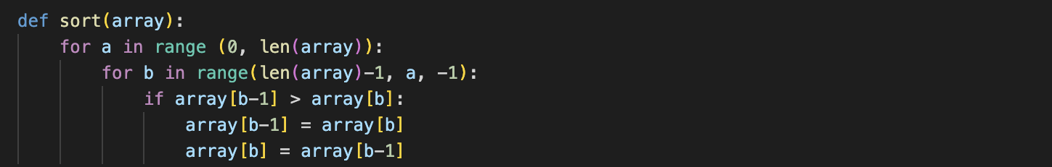

fig 1.2a: Flowgraph of code snippet from fig 1.1a

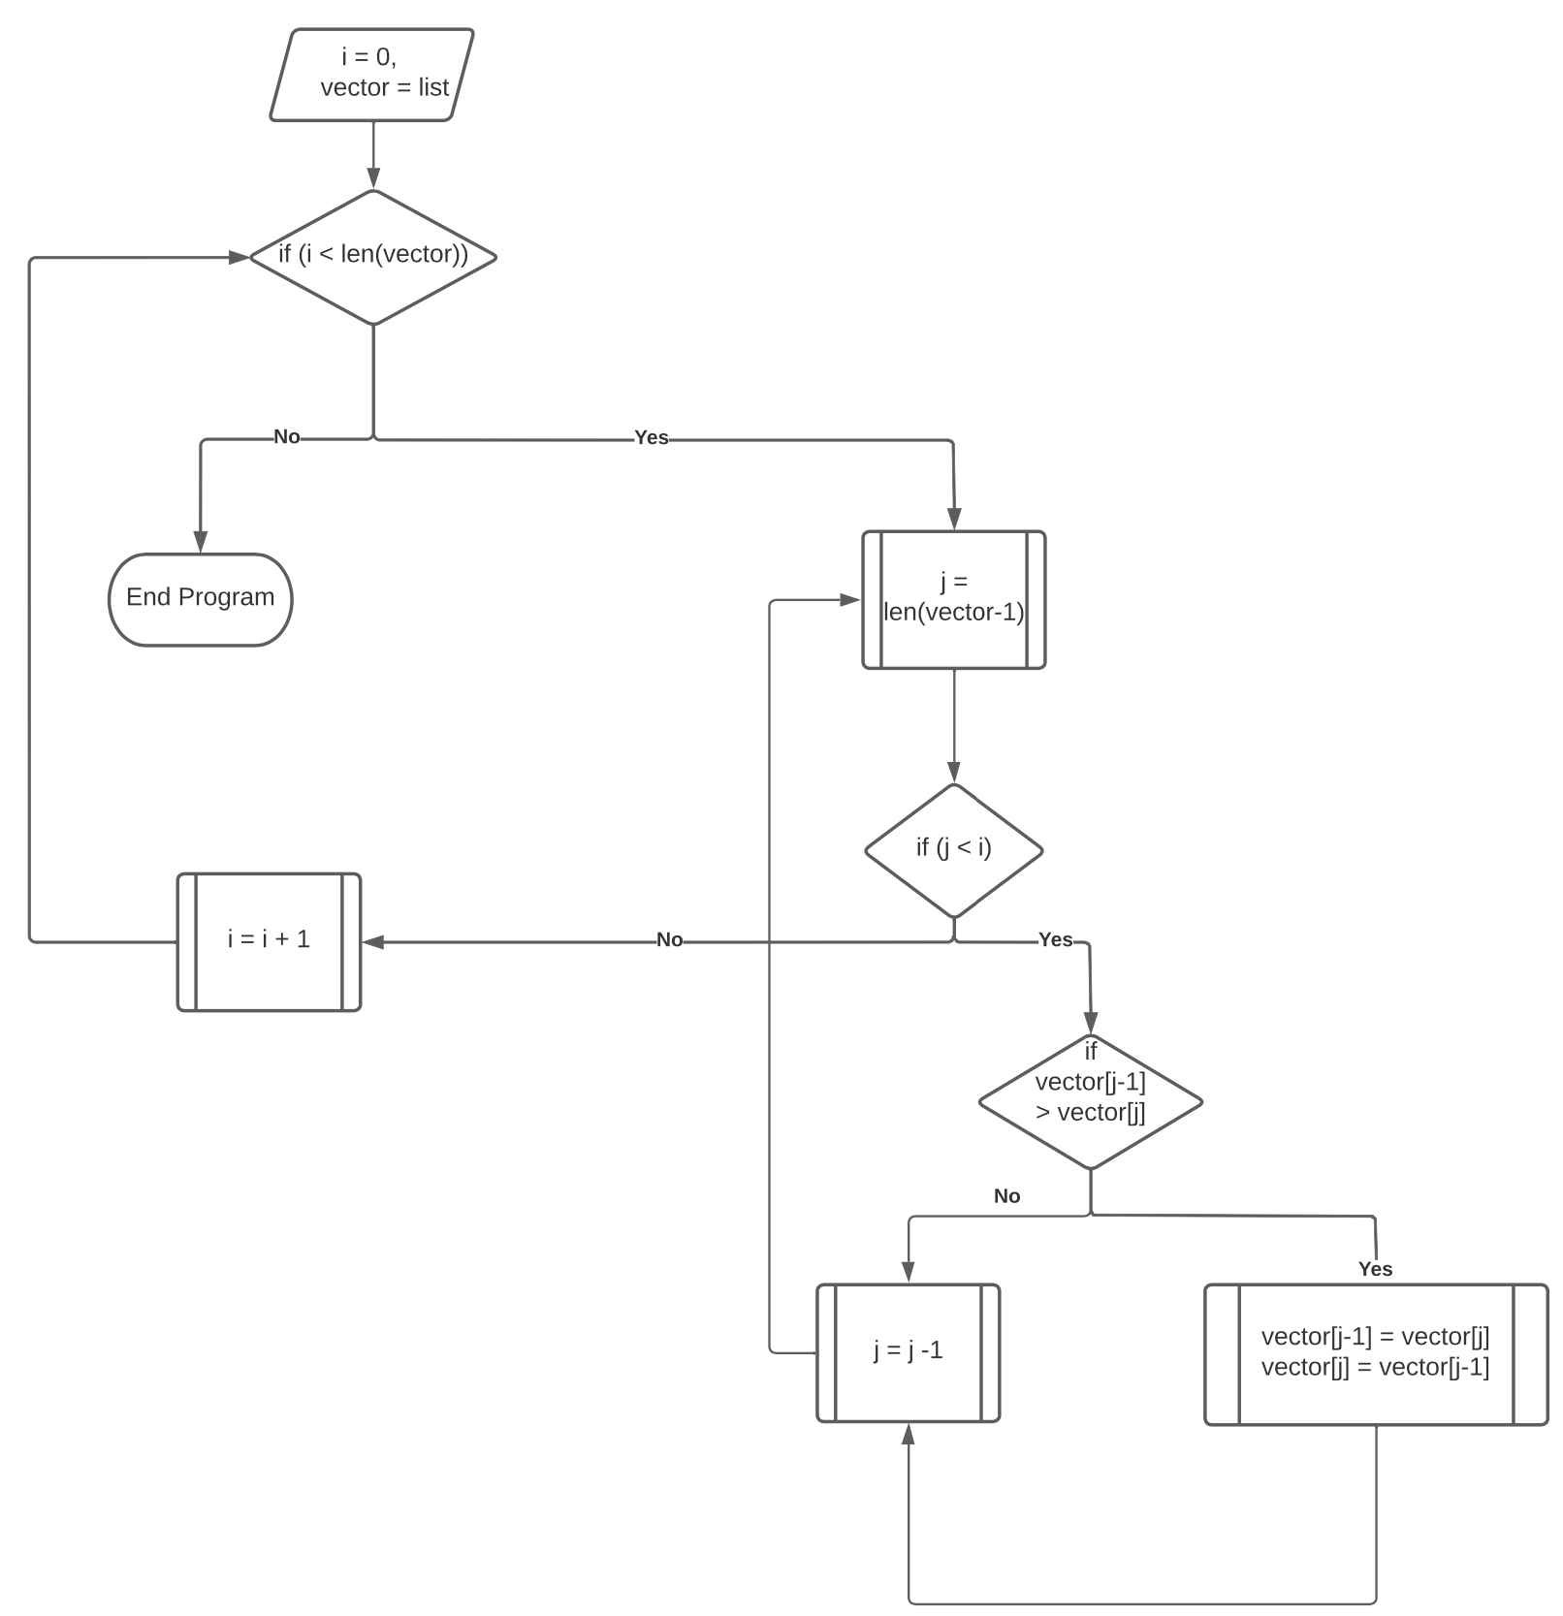

fig 1.2b: Flowgraph of code snippet from fig 1.1b

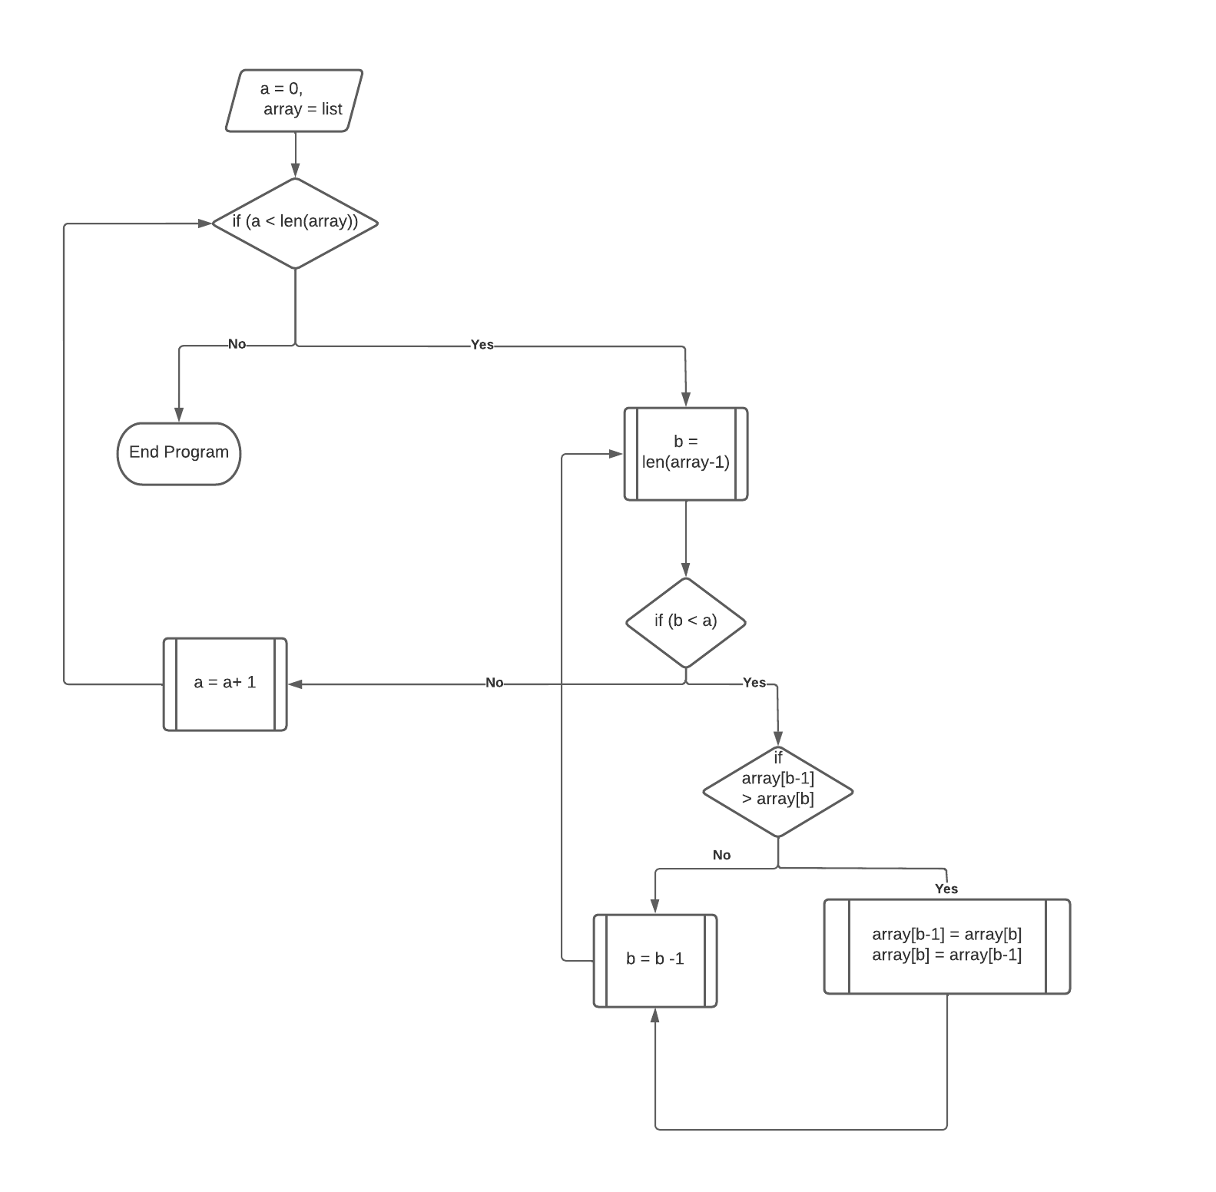

### Models For Classification

The models this project aims to develop for both the graph and tree-based models are listed below:

1. Deep Learning (DL) Models:
   1. LSTM RNN classification model.
   2. GRU RNN classification model.
   3. Simple RNN classification model.
   4. MLP classification model.
   5. Dense classification model
2. Non-Deep-Learning (NDL) Models:
   1. GNB model.
   2. SGD model.
   3. RF model.
   4. SVM model.

### Classification Task

The classification task in this project is a binary classification problem to classify programs based on the sorting algorithm they implement. The applicable sorting algorithms here are the Merge Sort and the Quick Sort. I have chosen these two algorithms because they are typically longer in implementation code than most other sorting algorithms. This means that there is usually more information to be derived from the AST of a program that implements one of these algorithms.

# Background AND LITERATURE REVIEW

## Programs As Graphs and Trees

It is well known that every program has an abstract syntax tree representation. In theory, this could lead to the assumption that every program has a graph representation or an abstract graph representation, but there has not been enough work done to demonstrate this. The leading driving theory of this project is using a program’s abstract graph or tree representation, a neural network can be trained to learn the structure of the code and classify it based on that structure.

## Underlying Theory and Background

The underlying theory behind this project is this; using the right design and model specifications, a neural network can be trained to carry out classification tasks on source code, resulting in a suitable level of accuracy.

This project has its background rooted in the fundamentals of the Graph Neural Network (GNN). This network architecture, as described in [14], presents a method for processing information stored in the form of a graph using a specially designed NN. There have been several developments on this model. These include the GGNN, the Gated Graph Sequence Neural Network (GGSNN) [15], the Gated Graph Convolutional Neural Network (GGCNN) [16], the Gated Graph Recurrent Neural Network (GGRNN) [17], etc.

Another field that serves as the background of this project is NLP (Natural Language Processing) [7]. This is a branch of AI and ML with a lot of pre-existing work done to understand how NLP models process HLT. The shortcoming of NLP models, as described in section 1.2, is their use of tokens based on individual words or a series of words. This vector representation is unsuitable for source code tasks because of the lack of limits on the grammar of source code. This means that if different people wrote all the files in a training dataset to solve the same problem, the dataset could end up having very few words, or tokens, in common, leading to underfitting in the model. Underfitting is where the model does not accurately learn the training data and cannot be applied to generalize unseen data. It results in poor performance of the model. NLP tokens are also unsuitable for PLU due to the existence of programming concepts such as loops. In HLT, a loop is the equivalent of saying the same thing repeatedly, leading to an increase in the number of tokens corresponding to that word. In source code, however, a conditional loop is used, eliminating the need to repeat the statement. This results in the structural information the loop communicates being lost.

Finally, this project has its background in the study of the tree data structure. I believe that there has not been enough work to examine how trees and graphs can be used to represent the programs. This project will demonstrate the suitability of graph and tree-based models for understanding and processing the complex information contained in source code.

## Literature Review

Although PLU as a branch of AI and ML is relatively new, there is some interesting pre-existing literature in this field. Some exciting work has been done in building NNs specifically for processing and classifying programs. One of such is [5], where the researchers define a method for converting source code to graph representations based on the program’s AST. To the best of my understanding, this study is the first of its kind, which makes it very relevant to the work done in this project. This paper uses the Gated Graph Neural Network (GGNN) [8] to carry out two learning tasks on source code. The first is the ‘VARNAMING’ task which is designed to predict what a variable should be called based on how it is used in a program. The second learning task is the ‘VARMISUSE’ task, in which the model predicts whether a variable has been used correctly or not.

On the VARNAMING task, they receive an accuracy score of 53.6%, while on the VARMISUSE task, they receive a score of 85.5%. The results of the VARNAMING task indicate that the model used in this study might need modifications to its design and parameters to produce more robust results. On the other hand, the results of the VARMISUSE task indicate that the GGNN model built in this study can accurately tell when a variable has been misused.

These results are a motivation for this project. They indicate that NNs can be used to process and understand source code. Still, the model must be specifically designed to handle data types, such as graphs, that accurately represent the complex information contained in the source code.

Another interesting study is [9]. This paper presents a model for processing source code by introducing the TBCNN (Tree-Based Convolutional Neural Network). The method outlined here uses a process the researchers refer to as one-way pooling and convolution to process a vector representation of a program’s AST. To the best of my knowledge, it is also the first of its kind, making it a motivation for this project.

The most interesting aspect of this paper is its use of convolution. Convolution is commonly used when processing images [10, 11] and the researchers admit that Convolutional Neural Networks (CNNs) do not accurately represent tree-based information. The results from this study are a classification accuracy score of 94% on a task to classify programs based on functionality. This reinforces the notion that with the right techniques, conventional NN models that are usually unsuitable for working with source code can be utilised and structured in such a way that they produce good results when trained and tested on source code.

Additionally, some interesting work has been done on training NNs to detect syntax errors in programs [11] and on converting code to embeddings suitable for processing by a neural network model [12].

The main point that sets this project apart from the studies described above is that this project defines a new way of accurately creating embeddings for processing source code. To the best of my knowledge, this project is also the first to compare the performances of graph-based and tree-based models on the same tasks to determine which method is most suitable for programming language processing.

The primary motivation for this project is the shortage of pre-existing literature in the field of PLU. In addition, I am interested in exploring how graphs and trees work when processed by standard NLP models compared to how they work when the data is stored as text. Finally, I am also interested in observing the differences in the behaviour of DL and NDL models when they are trained and tested on source code.

# Objectives, Specifications and Design

## Specific Project Objectives

The main objective of this project has been outlined in section 1.2 (comparing the accuracy scores of tree-based models, graph-based models, and text-based models to determine which model is best suited for classifying source code). This objective has been broken down into eight specific parts, each outlining a core objective of the project.

### Text-Based Objectives

Objective 1: To implement a series of text-based DL and NDL models (section 1.2.1) to compare their results when trained and tested on source code.

### Graph-Based Objectives

Objective 2: To convert the contents of programs into directed graphs.

Objective 3: To convert the results of Objective 2 into vector embeddings that a neural network can process.

Objective 4: To train and test the models built in Objective 1 (section 1.2.1) for carrying out classification and learning tasks on the results of Objective 3.

### Tree-Based Objectives

Objective 5: This is to design a method for converting a program into an AST and extracting the important information from the AST to create a tree data structure to represent the program.

Objective 6: Following on from Objective 5, this is to design a method for converting the results of Objective 5 into vector embeddings that a neural network can process.

Objective 7: This objective seeks to train and test the NDL classifiers and DL models from Objective 1 (section 1.2.1) to carry out classification tasks on the results derived from Objective 6.

### Final Objective

Objective 8: The final objective is to compare the results received from Objectives 1, 4 and 7 to assess which data structure is the most suitable for the classification task (section 1.2.2).

## Technical Specifications

The models for this project have been built using the Python programming language and a range of Python-specific DL and ML libraries; Keras, TensorFlow, NumPy, Scikit Learn, Matplotlib and NetworkX. In addition to Python 3.10, these libraries must be installed on any device this project will be executed on. Keras, TensorFlow and Python 3.10 have been used for most of the implementation of this project.

The Dense (section 3.3.2) and RNN (LSTM, GRU & SRNN) models (section 3.3.3) have been built using a combination of Keras and TensorFlow. The SGD, RF and SVM models (section 3.3.5) have all been built using built-in functions from the Scikit Learn library. The Gaussian Naïve Bayes Classifier has been built solely using Python 3.10, while the MLP model has been built using a combination of TensorFlow and Python 3.10. Matplotlib displays graphs where necessary, NumPy is used for minor conversions and classifications, and the NetworkX library stores graph data structures.

### Dataset

All the datasets used in this project have been collected from GitHub [18, 19]. The dataset consists entirely of Python source code files. The dataset is split into two groups based on which sorting algorithm they implement. These groups are Merge Sort and Quick Sort.

The Merge Sort dataset comprises 84 different implementations of the Merge Sort algorithm. The Quick Sort group contains 77 implementations of the Quick Sort algorithm. These data groups are used for the training and testing of each model built as part of this project.

## Design

In total, I have built nine different models to be as thorough as possible in my research. This project seeks to find the most suitable data structure for classifying source code based on the type of sorting algorithm implemented in the program. The models described below are all designed to work on binary classification problems, but they can be easily modified to become multiclass classification problems.

### Deep Learning Models

#### Multi-Layer Perceptron (MLP) Network Model

The MLP [20] is a type of feed forward [21] artificial neural network (ANN) [23] that consists of multiple layers of perceptrons [22], hence the name. A perceptron is a type of classifier used for binary classification problems. An example of a cross-section of an MLP is shown in *fig 3.1.* I have opted to use the MLP network model for its popularity and use on binary classification tasks.

This model has been constructed using a combination of Python 3.10 and TensorFlow. All the variables in this model, including the model weights and biases, are declared as tensors (TensorFlow variables), and the calculations are all carried out using TensorFlow functions. In addition, this model uses back-propagation [24] (section 4.2.4.1.2), a method used in ANNs to fine-tune the outputs of a neural network model and make them as accurate as possible.

fig 3.1: Simple MLP architecture

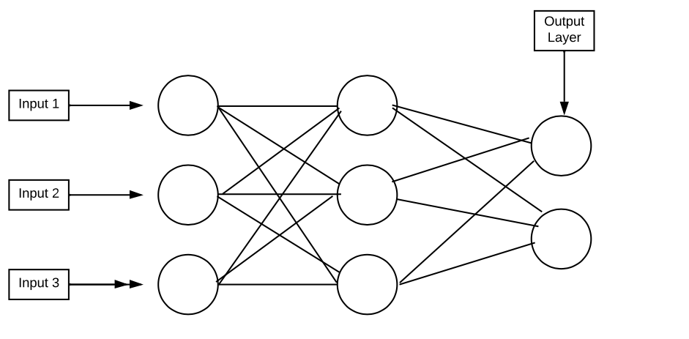

#### 

#### Simple Dense Network Model

This model has been added to verify the results of the MLP model. It comprises one input layer and three densely connected layers [25]. Densely connected in this context means that all the nodes in the hidden layers connect to every single node in the following layer. An example of this dense structure can be seen in *fig 3.2*. I have chosen this model because densely connected layers are conventionally used in deep learning.

fig 3.2: Cross section of a densely connected neural network

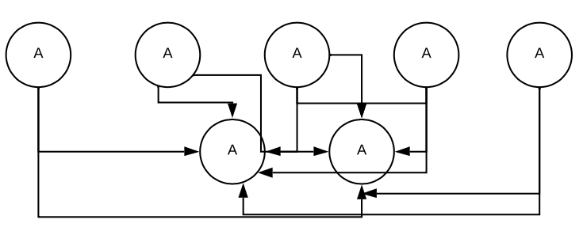

#### Recurrent Neural Network (RNN) Models

##### Long Short-Term Memory (LSTM) Network Model

An LSTM is an RNN developed to solve the vanishing gradient problem [26], an issue that arises in back-propagation models such as the MLP. LSTMs are comprised of four components:

1. Cell
2. Input gate
3. Output gate
4. Forget gate

LSTMs can ‘remember’ data across various time steps using the cell component. This feature is why I have chosen to build this model because it means the model can remember a sequence of data, which is vital in the context of this project. I have built this model entirely in Keras and TensorFlow.

The LSTM model is comprised of an input layer (input_1), two hidden LSTM layers (lstm_1, which is bidirectional, and lstm_2), and a densely connected output layer (dense_1). I have chosen to use a bidirectional layer [27] in lstm_1 because of how Bidirectional LSTMs work. With this layer, the input moves in two directions; input-to-lstm_1 and lstm_1-to-input. This means that the information from both layers is preserved, and the results being passed to lstm_2 are likely to be more accurate.

I have opted not to make lstm_2 bidirectional in order to avoid overfitting – a situation in which the NN learns the training data too well while not performing well on unseen tasks. This layer passes information in one direction (lstm_2-to-dense_1).

Before deciding on this selection of layers, I experimented with different combinations of layers and layer types. Finally, I chose the above because it is the combination that produced the best accuracies of all my experiments. The design of a standard LSTM model is shown in *fig 3.3*.

fig 3.3: The design of a standard LSTM model [28]

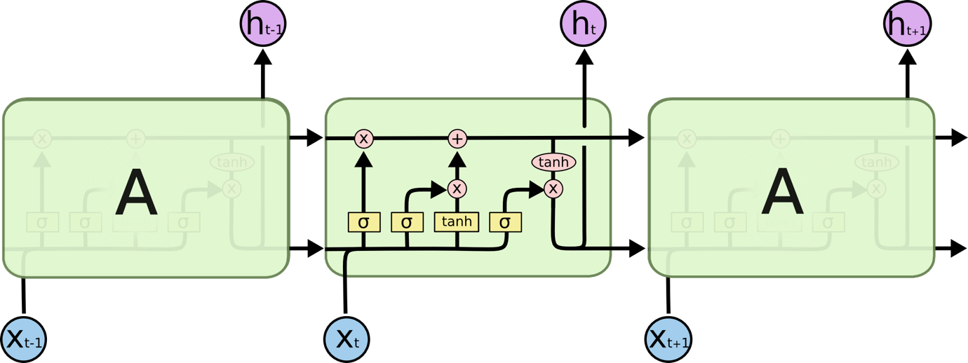

##### Gated Recurrent Unit (GRU) Model

A GRU [30] is shares many similarities with an LSTM. The contrast between both models is this; GRUs tend to have fewer parameters and no output gate. GRUs also generalise better to smaller datasets, and it is for this reason that I have opted to use this model.

The setup of the GRU model is identical in layers to the LSTM. An input layer (input_1), two hidden GRU layers (gru_1, which is bidirectional, and gru_2) and a densely connected output layer (dense_1). An example design of the GRU model is in *fig 3.4*.

fig 3.4: Simple GRU model design [29]

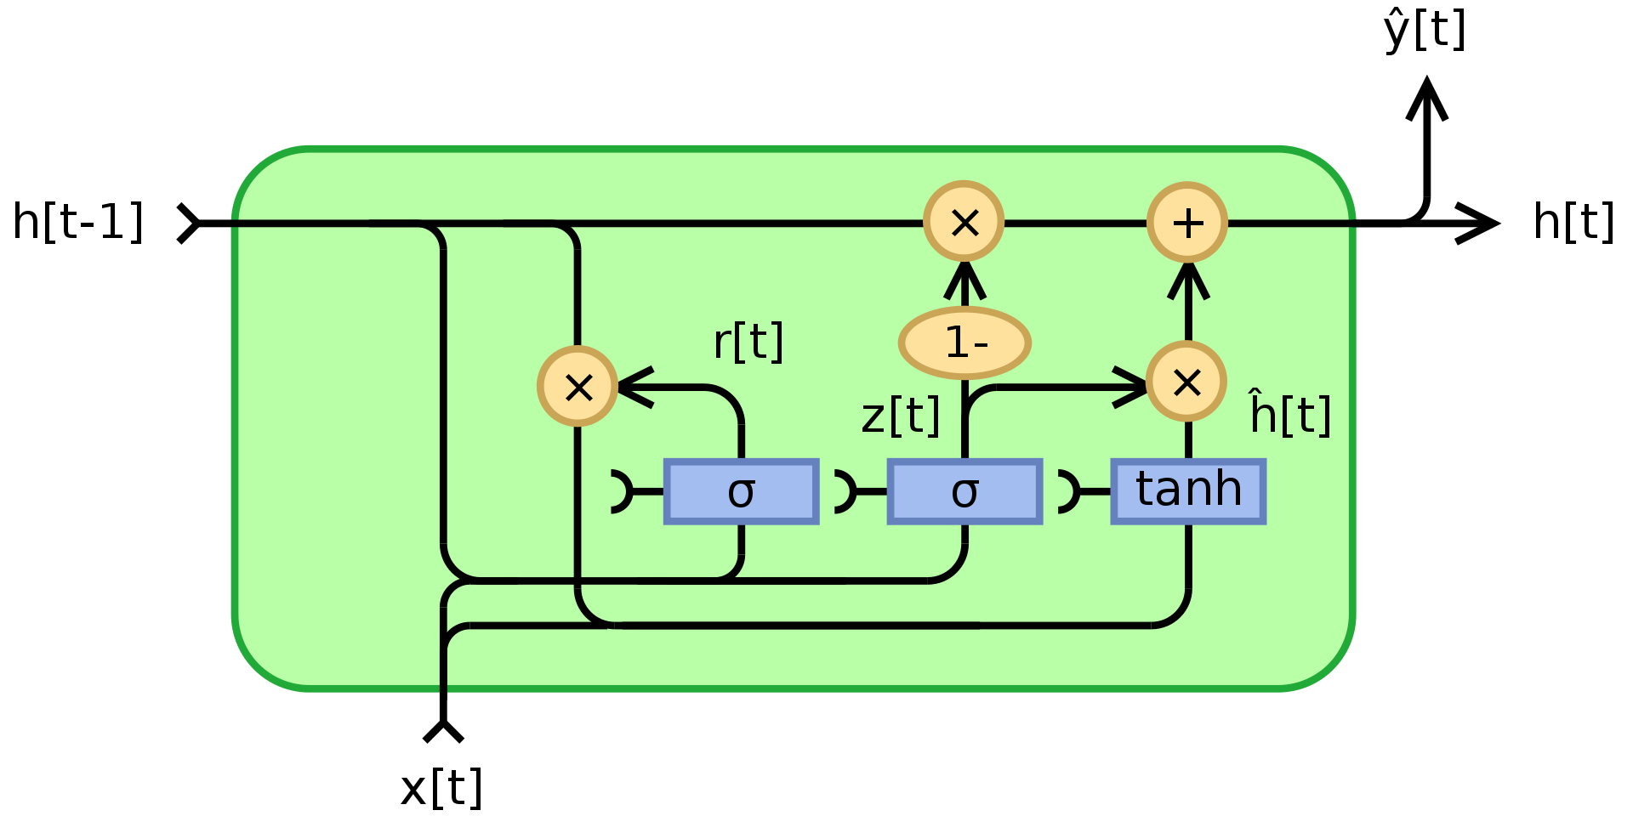

##### Simple Recurrent Neural Network (SRNN) Model

I have built the SRNN model because it is the original iteration of the RNN and the simplest of the available RNN model architectures. This model is also identical in structure to the GRU and the LSTM. The input layer (input_1), two hidden SimpleRNN [31] layers (simplernn_1, which is bidirectional, and simplernn_2) and a densely connected output layer (dense_1). A simple RNN architecture is demonstrated in *fig 3.5*.

fig 3.5: Simple RNN architecture [32]

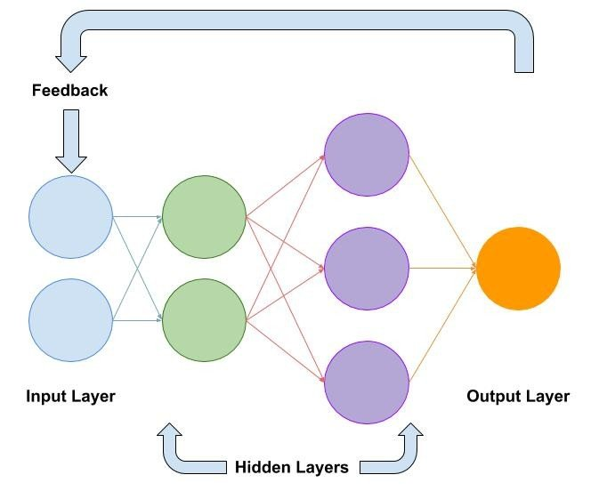

### Non-Deep learning Models

#### Naïve Bayes Classifiers

The NB model is simple classifier that carries out classification based on Bayes’ theorem [33]. It is based on probabilities.

NB classifiers assume independence of variables, i.e., each value is independent of all the others. They tend to be outperformed by most other models, but I have included this classifier because NB classifiers scale well to real-world problems [33] and are commonly used in NLP for spam detection [33]. I have built a Gaussian NB Classifier (one that assumes the data is normally distributed). This classifier has been built using only Python 3.10 and is tested using cross-validation [34]. The Naïve Bayes probability calculation is shown in fig 3.6.

fig 3.6: Naïve Bayes probability model

#### Random Forest, Stochastic Gradient Descent, and Support Vector Machine Classifiers

These three models have been built using Python 3.10 and Scikit Learn code. I have chosen to add these models because I want to explore as many possible options for carrying out source code classification tasks. The architectures of these models are pictured in figures *3.7*, *3.8* and *3.9* respectively.

Fig 3.7: Random Forest classifier architecture [35].

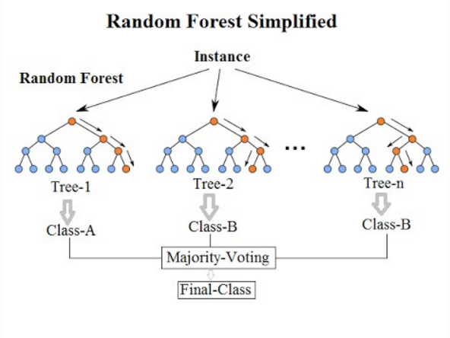

fig 3.8: Gradient Descent Algorithm pictured as a graph [36]

fig 3.9: Support Vector Machine classifier design [37]

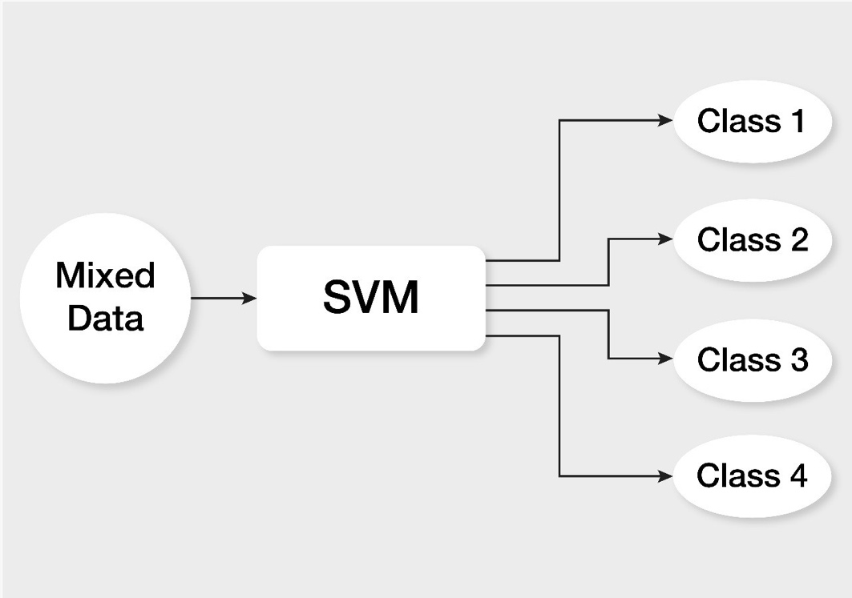

# Methodology and Implementation

## Methodology

The chosen methodology for achieving the project aims is to build multiple classifiers and NN models, train them using a section of the dataset and test them on unseen data from the dataset. I have made use of Python 3.10 for the implementation of the entirety of this project. I made this decision because a wide range of DL libraries can be used with Python. Furthermore, this decision was reinforced by Keras and TensorFlow being built for Python programming. These libraries provide potent tools for building NN models, which is essential to this project. Additionally, all the previous work referenced in the literature review (section 1.3) uses Python for implementation, reinforcing my decision.

## Implementation

This project has been implemented using the Object-Oriented Programming paradigm [38]. Each file in the entire program – except the experiment files – contains a class that defines all the properties needed from that file. Files, or objects, are called by creating instances of the class declared in the respective file.

The implementation process has been broken down into five stages:

1. Pre-Processing Stage.
2. Embedding Stage.
3. Data Structuring Stage.
4. Model Implementation or Neural Network Construction Stage.
5. Model Execution or Neural Network Processing Stage.

### Pre-Processing Stage: Classes for Reading and Parsing Program Files

Parsers: The parser class is the first step in the implementation process. For each data structure, I have implemented a parser class (TextParser for text, GraphParser for graphs, and TreeParser for trees). Each of these deals with reading the program files' data and converting it into either text, a tree, or a graph. This class is also responsible for assigning the class labels (0 for Merge Sort, 1 for Quick Sort) to the appropriate file.

* TextParser Class (TextParser.py): With the text data structure, the parsing process starts and ends in the parser class. Once the files are read in this class and class labels are assigned, the data is split (70% for training, 30% for testing). The next step is the vectorization of the programs as text. This vectorization process is straightforward and is carried out by the Scikit Learn Count Vectorizer [39], which converts the programs' contents into vectorized tokens, assuming they are no different from HLT. This is the end of the pre-processing process for text.
* GraphParser Class (GraphParser.py): This class is initialised with one parameter: ‘hashed: bool’. This means that ‘hashed’ is a Boolean variable that, if set as ‘True’, denotes that the HashVisitor class is to be run. If set to false, the parser is to run the Visitor class. The GraphParser class contains six functions. The first of these is ‘convertToGraph’. This function takes a single file path as its parameter and reads the file corresponding to the file path using the Python AST class ‘ast. parse’ [40] method. This method returns an AST, which is then passed to a Visitor object, traverses the AST and returns the list of edges present in the AST.

The next functions are ‘assignLabels’ and ‘assignLabelsToFiles’ which assign class labels to program files and return the graph representations and class labels of all the files in the dataset. After these come the ‘convertToMatrix’ and ‘extractNodes’ methods. ‘convertToMatrix’ converts an individual graph to its matrix representation using the NetworkX API [41], while ‘extractNodes’ extracts a list of nodes from the NetworkX digraph object.

The final method is ‘readFiles’, which combines all the methods described above and executes the stream of reading all the files, converting them to graphs and assigning labels.

* TreeParser Class (TreeParser.py): This class is also initialised with one parameter: ‘hashed: bool’. It has three functions. The first, called ‘parse’, takes a file path as its input and executes the same function as the ‘assignLabels’ in the GraphParser class. The next is ‘createTreeFromEdges’, which, given a list of edges present in a tree, creates a tree made up of TreeNode objects. The final is ‘convertToTree’ which reads a program file, applies either Visitor or HashVisitor to the file, and then runs ‘createTreeFromEdges’ on the list of edges returned by the Visitor or HashVisitor.

Visitor Class (Visitor.py): The process of conversion from code to graph or tree is carried out by the ‘Visitor’ class. This class inherits from the Python AST Nodevisitor class [40]. Its function is to traverse the AST of the program and add nodes to the tree or graph according to the relationships observed in the program’s AST. This file comprises three classes; the AbstractVisitor super class, which defines the essential functions required by its subclasses, and the Visitor and HashVisitor subclasses, which inherit from AbstractVisitor. The HashVisitor establishes the process of traversing a graph and embedding the nodes by implementing a hashing function. The Visitor class leaves the nodes to be embedded later by a vectorization function (unhashing). The difference between hashing and unhashing is described in section 4.2.2.

* AbstractVisitor: This Class defines multiple functions. The first of these is the generic_visit method that is inherited from the Nodevisitor object. This method is an abstract method that is left to be implemented by each individual subclass. AbstractVisitor also implements three methods (splitSnakeCase, splitCamelCase and splitIdentifier) for splitting the identifier of an object or AST node into separate words based on either snake case (e.g., snake_case) or camel case (e.g., camelCase). The next method implemented in this abstract class is the convertToGraph function. This method creates a NetworkX directed graph [41] from a list of edges and returns a NetworkX Digraph object. The remaining methods (visitSpecial, visitDef, etc.) are concerned with traversing the AST, getting the type of an AST node (each object in the AST) and returning a string representation of the AST node.
* Visitor: The Visitor subclass implements a generic_visit method that takes an AST root node and simply traverses the children of the node recursively and creates the required list of edges from the node’s children. This means that the generic_visit method ‘calls’ itself repeatedly until all the nodes in the AST have been visited, preventing the need for implementing the method multiple times or using nested loops, which take more time to run as the number of nested loops increases.
* HashVisitor: The HashVisitor subclass implements a generic_visit method that takes an AST root node as its input and gets the string representation of the node by calling the visitSpecial function inherited from the AbstractVisitor class. After this string representation is collected, it is hashed, and the result of this hash is divided by 1. Additionally, the node object is hashed and has its result divided by 1. Finally, these two hash values are added together to get the vectorized embedding for that node. This generic_visit method also implements recursion.

TreeNode Class (TreeNode.py): This class defines a node object for the tree. On initialisation, it takes an embedding as its parameter, representing that node's embedding. In addition, it implements a function called ‘preOrderTraversal’. This method traverses the tree using Pre-Order Traversal [42] and returns the list of all the nodes in the tree. It also uses recursion to avoid making use of nested loops.

Overall, the flow of data across these classes is demonstrated in *fig 4.1* below.

fig 4.1: Dataflow diagram for pre-processing stage

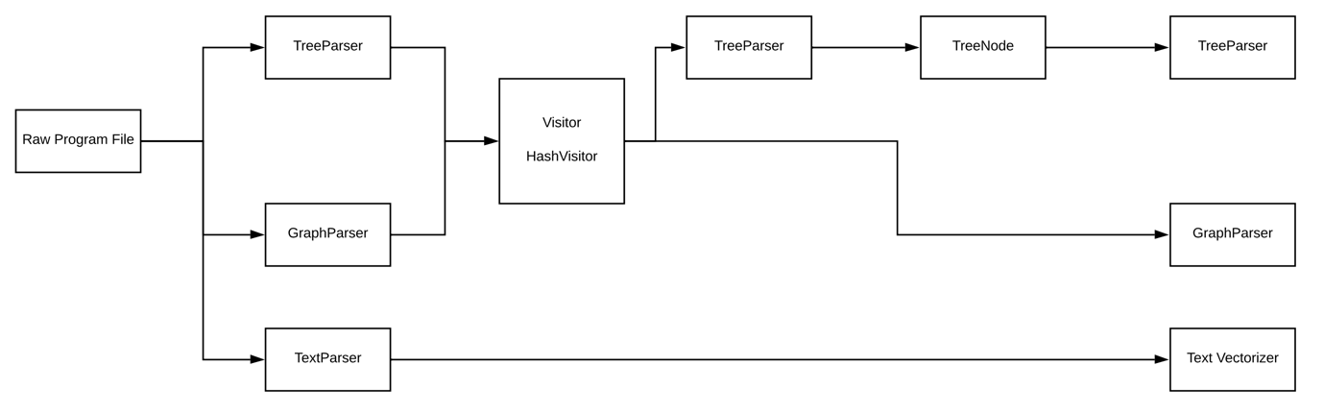

### Embedding Stage: Vector Embeddings for Trees and Graphs

Before a neural network can be trained on any type of data, that data must first be converted into vector embeddings because this is the only data format that NNs and ML models can process. This is the second step in the implementation process. Each model I build will be tested using two types of vector embeddings: Hashed and Unhashed. I have described the process of Hashing in the HashVisitor section of section 4.1.1. The alternative to this will be referred to as ‘Unhashing’.

#### Unhashing in Trees (TreeEmbeddingLayer.py)

#### This class implements an embedding feature that works like this:

1. Run pre-order traversal [42] on the root node of the tree to get all the nodes in the tree and their respective children.
2. Get the depth of the tree (maximum number of nodes along a single branch).
3. Create a copy of the list of all nodes, call it ‘unvectorized’.
4. Initialise random weights and biases for each node in the tree.
5. Randomly create a float, assign this value as the vector embedding of the root node and add it to a new list called ‘vectors’.
6. Remove the root node from the unvectorized list.
7. Check if the length of the unvectorized list is not equal to zero. If yes:
   1. For each node in the list of nodes (that is not the root node):
      1. Check if it is in the unvectorized list.
      2. If yes:
         * Remove it from the unvectorized list.
         * Get the index of the current node with the index of its parent node.
         * Run the vectorization function (outlined at the end of this section) on the node.
         * Add the result of vectorization to the vectors list.
         * For each child of the current node, repeat the process from point ‘vii’.
8. If no, the length of the unvectorized list is equal to zero, so stop the process because all the nodes have been vectorized.

##### Tree Vectorization Function (vecFunction):

The vectorization function for an individual node is described below.

1. Get the number of children the node has.

* If this value is greater than 0:
* Else if it is 0:

1. The value of result is the node embedding

#### Unhashing in Graphs (GraphEmbeddingLayer.py)

This class implements an embedding feature that works in an almost identical way to the tree embedding function. The only difference is that the graph vectorization function does not use graph depth in its calculations.

After vectorisation is carried out in both the tree and the graph, each set of embeddings is saved into a text file. This prevents the embedding process from occurring all the time and slows down the execution process unnecessarily. For all the stages that come after this, the contents of the text files are read to be used for processing.

### Data Structuring Stage

In the text vectorizer, all the text is fitted based on a fixed size. This means that at the end of the vectorization process, the vectorized forms of all the files in the dataset are the same size. However, when working with graphs and trees, each tree or graph has its structure and size, which might be completely different from all the other trees and graphs. These cannot be passed to a neural network because NNs require all the inputs to be of the same fixed size. To circumvent this issue, I have applied two methods. The first is Segmentation [43], where each graph or tree is clustered down into segments of a fixed size, and the second is Padding.

#### Padding (GraphDataProcessor.py)

The length of the longest tree or largest graph (maxLen) is derived. All the other trees and graphs are padded with zeros until they are as long as maxLen to ensure all the inputs are the same size. I have excluded padding from trees in this project because all my experiments with trees and padding resulted in training accuracies of over 80% and validation accuracies of less than 30%. The reason this is insufficient is explained in section 5.1.

Another reason padding is insufficient is that the model will be unable to handle unseen trees or graphs that are longer maxLen.

#### Segmentation (TreeSegmentationLayer.py, TreeSegmentation.py, TreeDataProcessor.py and GraphDataProcessor.py)

Segmentation [43] is a process that is usually applied in image classification and computer vision. It is a process where parts of a vector representation of an image with the same class label are combined into the same cluster. I have decided to use segmentation to prove that methods for other classification tasks can be applied to source code problems, providing good results if the underlying data structure accurately captures the program’s information.

The segmentation function has been implemented using TensorFlow. TensorFlow has eleven different options for segmentation based on two categories: sorted and unsorted segmentation. Unsorted segmentation can be done using one maximum, mean, minimum, square root of *n*, sum and product. Sorted segmentation is the same, except it does not include the square root of *n.*

The way segmentation generally works is that the programmer defines the segment ids as in *fig 4.2* and declares several segments (numSegments as in *fig 4.2*), which must be equivalent to the values in segment ids. The dataset is then split into segments corresponding to the values in segment ids. For example, if you want three segments, segment ids must have three values, e.g., [12, 13, 14]. The size of the first dimension in the dataset to be segmented must also be the same size as the number of segments; else, an error will occur. If max segmentation has been used, for example, a segment of [1, 2, 3, 4] will have [4] as its output – the maximum value in that segment. An example of sorted max segmentation can be seen in *fig 4.3.*

In this project, step one in segmentation is deciding on how many segments *n* to be used. After deciding on this number, each graph or tree’s embedding list is converted to an *n*-dimensional version of itself. Then, segmentation is carried out on this new *n*-dimensional version. For example, the Python list [1, 2, 3, 4] with 3 segments becomes [[1, 2, 3, 4], [1, 2, 3, 4], [1, 2, 3, 4]]. I experimented with varying segments, starting from 10 and decided on 40 after observing that a higher number of segments produces better results from the models.

fig 4.2: Declaration of a segmentation function using unsorted square root of n with segment count = 40

fig 4.3: Example of sorted max segmentation

### Model Implementation or NN Construction Stage

#### Deep Learning Models

The DL models developed as part of this project have two main things in common. First, they accept only tensors [44] as their input. The second is that they make use of the same four activation functions.

##### Activation Functions (Afs)

An AF is a one that is applied to a value in a neural network to get its output. I have tested each DL model using four different activation functions – Tanh, ReLu, SoftMax and Logarithmic Sigmoid – to determine which activation function produces the best outputs. The formula of each function is shown below.

* + 1. Tanh:
    2. ReLu:
    3. SoftMax:
    4. Logarithmic Sigmoid:

##### MLP Model (MLP.py)

This model is made up of 8 functions. The most important is the ‘runFFModel’, where FF stands for ‘Feed Forward’. This method is where all the other methods are initiated from. It starts by initialising the model weights and biases by calling ‘initialiseWeights’. Next, a for loop is created based on the epoch count, and a ‘backPropagate’ method is called. This method, in turn, starts by calling the ‘FFLayer’ method. In the FFLayer method, the inputs are multiplied by the weights and added to the biases across all the hidden layers – a forward pass. Then, the applicable activation function is gotten from the ‘getActivationFunction’ method and is applied to the weight of the output to give a final weight. After running the FFLayer method, the predictions are returned to the backPropagate method. Next, these predictions are used to calculate the loss value. Finally, the loss is calculated in the ‘lossFunction’ method.

This method calls the TensorFlow ‘softmax_cross_entropy_with_logits’ method on the predictions alongside the actual labels. Its value is returned to backPropagate where the gradient of the loss and weights is calculated. The results of this calculation are used in the ‘updateWeights’ function to update the weights. This process is what is called back-propagation [24]. After updating the weights, they are applied to the inputs to get more accurate predictions. Finally, SoftMax activation is run on the outputs to derive a final prediction.

Finally, the model predicts the labels of unseen testing data in the ‘makePredictions’ method. This method runs ‘FFLayer’ method on the unseen data, applies SoftMax to the outputs and calculates the accuracy of the predictions using the NumPy or TensorFlow argmax function. The implementations of runFFModel and backPropagate are in *fig* *4.4* and *4.5,* respectively.

fig 4.4: Implementation of runFFModel method in the MLP class

fig 4.5: Implementation of backPropagate method in the MLP class

##### LSTM, GRU & Simple RNN (RNN.py) Models

This model is made up of 7 methods. The first is ‘RNNLayer’, which creates and returns a TensorFlow Simple RNN layer object. The second is ‘LSTMLayer’, which is the same as RNNLayer but returns a TensorFlow LSTM layer object instead. The third is ‘GRULayer’, which is the same as the two before it, but it returns a GRU layer object. The parameters used here are activation function – any of the four listed in section 4.2.4.1 –, useBias, the value of which is determined at runtime, input shape, which is the shape of the first dimension of the input and the number of neurons, which is also defined at runtime. This is followed by the ‘DenseLayer’ function, which returns a TensorFlow Dense Layer object.

‘getActivationFunction’ comes next. Depending on the activation function passed as the desired input, this method returns the corresponding TensorFlow function. The only exception is the logarithmic sigmoid function which I have implemented using a combination of standard Python 3.10 and TensorFlow.

The final function is the function that calls and executes the LSTM, SRNN and GRU. This method has been called ‘runModel’. It begins by instantiating the input layer, defining an input shape and the output layer (dense). It then creates a Sequential [45] Keras model and adds the input layer. Step two is deciding if the model will be an LSTM, a GRU, or a Simple RNN. This decision will be based on the input to the method. Finally, the output layer is added after deciding which type of hidden layers the model will have.

The model is compiled and fitted on the training and testing data with a batch size [46] and the number of epochs [47] determined at runtime.

##### Dense Model (DenseModel.py)

This model is made up of only one function called ‘runDenseModel’. This method creates a sequential Keras model, adding an input layer. Three densely connected layers follow this input layer with 128, 64 and 2 neurons, respectively. The model parameters used for fitting are binary crossentropy to calculate loss, the Adam optimizer for optimization and batch size and number of epochs to be determined at runtime.

#### Non-Deep Learning Models

##### Gaussian Naïve Bayes Classifier (NaiveBayes.py)

This model has been written in Python 3.10. It contains 12 methods, the most important of which is the cross-validation method (gaussianCrossValidation), as seen in *fig 4.6*. This method is used to validate the results of the Gaussian NB classifier. First, it takes all the program files and all the class labels as inputs. It then calls the ‘splitIntoFolds’ method, responsible for splitting the data into folds of equal lengths. After the data has been split, the folds are looped through, and each fold is used as the testing data exactly once, while all the other folds are used as the training data. Finally, the classification is done by the ‘runGNBClassifier’ method, which takes the training folds, the training label folds and the test fold as input. The implementation of this method is described in *fig 4.7* alongside the function for making predictions, ‘makePredictions’.

The remaining methods include the method for calculating the accuracy score (calculateAccuracyScore) – which calculates the percentage to which the predictions are equal to the actual labels – and the ‘getMean’ function that calculates the mean of a set of values. There is also the ‘separationFunction’ method that separates the data based on classes, and the ‘getStandardDev’ function that calculates the standard deviation of a set of values. Other methods include ‘collateStatistics’ and ‘collateClassStatistics’, which collate the statistics (mean and standard deviation) for each row and class.

Finally, the last two methods are the methods that calculate the Gaussian probability for a row and a class. These are called ‘getGaussianProbability’ and ‘getClassGaussianProbability’, respectively.

fig 4.6: The implementation of the cross-validation function on the Gaussian NB classifier

fig 4.7: The methods to make predictions and carry out classification

##### SGD, RF & SVM Classifiers (SKLearnClassifiers.py)

These classifiers have been created with an external library. This is the Scikit Learn machine learning library [48]. I chose this library because it provides easy-to-understand code and a wide range of classification models. Each of these three classifiers is declared as its own function. The functions here are SGDClassify, SVMClassify and rfClassify. Each method takes four inputs: a set of training data, training data labels, testing data and testing data labels. The first step in each method is to create a ‘Pipeline’ [49]. This simplifies the process of calling the classifier and saves time at runtime. After the pipeline is created, it is fitted to the training data and its labels. The testing data is then passed to the pipeline to make predictions. After the predictions are made, the accuracy of the predictions is calculated and returned.

### Model Execution or NN Processing Stage

(textExperiments.py, treeExperiments.py and graphExperiments.py)

This stage is the final stage of the implementation phase of the project. I have created three separate files, each corresponding to one of the data structures. Each file calls its respective parser and data processor classes to get the training and testing data. After this data is collected, each model is run across all data structures using hashed and unhashed data.

These three files contain all the experiments used to get the results. These results are analyzed in the next section.

# Results, Analysis and Evaluation

## Minimum Criteria for Success

For this project, the metrics I will be examining are the model accuracy for all nine models and the loss of each DL model.

### Deep Learning Models

For each deep learning model, there are two different accuracy scores; Training Accuracy (TA), which is the model accuracy for predictions on seen training data, and Validation Accuracy (VA), which is the accuracy of the predictions on the testing data.

The TA is important because it shows how well the model has learnt the training dataset. Due to the relatively small training and testing datasets, the acceptable scores for the TA that denote a successful model will be any scores from 60%. Any TA scores below this range will be considered as too low or not accurate enough. This will indicate that the model needs to have its parameters adjusted, the data format applied to the model is leading to a loss of important information. It might also be an indicator that underfitting is occurring (where the model has not learnt the training data well enough).

The VA is important because it demonstrates how well the model works when classifying data it has not learnt (unseen data). Acceptable scores for the VA that indicate success are any values from 70%. Any scores below this will lead to the respective model being considered insufficiently accurate. Therefore, I consider the VA to be more important than the TA. This is not to say that the TA is unimportant, but rather, that the VA gives a better indication of how well each model performs when tested on new data.

Another metric usually observed in DL models is the loss [50]. A loss here refers to the level of error the model produces when carrying out classification. A higher value for loss means that the model makes more inaccurate predictions. The loss values are Training Loss (TL) and Validation Loss (VL). Because I am applying binary crossentropy [51] as my loss function, I expect the loss values to be relatively high. This is because of the nature of crossentropy functions where a single incorrectly classified value can cause the loss to increase exponentially. Usually, when working with NNs, the loss is expected to be as low as possible. Still, because I have applied crossentropy, I will consider a good loss value as anything below 1.0.

To conclude, the measures for a successful DL model are a TA of at least 60%, a VA of at least 70%, with a TL and VL below 1.0 each.

### Non-Deep Learning Models

Due to the Scikit Learn classifiers (SGD, SVM & RF), the only score produced from these models is the Validation Accuracy (VA). A good VA here will be anything higher than 70%.

The Gaussian NB classifier uses cross-validation [34] to verify the accuracy of the models across each fold. As a result, the only metric to be observed here is the mean Validation Accuracy from running cross-validation on all the folds.

## Setting Up and Executing the Experiments

I will run experiments on the nine models for each information storage structure. Each storage structure will contain all its experiments in the same file to make identifying the most accurate model easier.

To execute the models, I have created a Boolean variable called ‘hashed’. If this value is set to ‘True’, the model is tested on the hashed version of the embeddings. If it is set to ‘False’, then the model is being tested on the version of the embeddings calculated using the vectorization function (unhashed). I have run experiments on both the hashed and unhashed versions of the datasets.

## Analysis and Evaluation of Results

### Result Overview

The general observation in this project is that NDL models perform much better than conventional DL models when trained and tested on source code using the text data structure. Regardless, this project aims to determine the DL architecture that is the most accurate for classifying programs.

The tree-based models outperform the graph-based models. This indicates one of two things. The first is that the tree data structure is better than graphs for classifying programs based on what algorithm they implement. The second is that in vectorizing the graph-based data, not enough information is being learnt about each node, leading to a loss of important information in the node embeddings.

Unhashed nodes with trees produced the best results – several TA scores above 60% and several VA scores greater than or equal to 70%. None of the experiments on graphs had VA results that can be considered accurate enough, but some experiments produced TA scores in the acceptable range. I will explore these results in detail in sections 5.3.2, 5.3.3 and 5.3.4.

### Results from Experiments on Text

The results from all the models are outlined in *table 5.1*. The results from running the models on text have proved to be very interesting. The DL models all perform relatively averagely, as expected. What is unexpected, however, is that the NDL models perform incredibly well when trained and tested using text-based data. An example is the Gaussian NB classifier which produced a VA of 86.88%, which was completely unexpected. This indicates that I have either built an exceptional model, or the Gaussian NB method for classification is well suited for classifying programs based on the algorithms they implement.

Even more interesting is the Random Forest classifier, which produces a VA of 100% when tested on text. RF classifiers are based on trees, so this could be a possible reason that this classifier works so well on the classification task for this project. In the future, it could be worth exploring how RF classifiers are built to observe how they process input.

The SVM classifier produces a VA of 76%, which is also considered as good. In comparison, the SGD classifier is the least accurate NDL model, with a VA score of 64%, which is below the threshold for being considered a precise model. In the future, it will be worth exploring why this model performs worse than the other NDL models.

The conclusion to be drawn from this is that when using text-based data, non-deep learning models are better than deep learning models.

#### Statistics and Performance

The Deep Learning model results for text are not as remarkable. The mean TA is 53.88%, while the mean VA is 52.16%. The best performing model was the Dense model, which produced a TA score of 82.88%, a VA score of 68%, a TL of 0.66 and a VL score of 0.83—using the ReLu activation of 256 neurons, a batch size of 10, and 10 epochs. This sharp drop in values between TA and VA is demonstrated in the graph pictured in *fig 5.1*. The accuracy and loss values are in the range to be considered a good model for classifying source code based on sorting algorithms. However, the VA score falling just outside the acceptable range for VA scores indicates that the model is either insufficient to classify unseen data or that overfitting might be occurring during training.

The next best DL model was the GRU model with SoftMax activation, 256 neurons, and batches of 10, and 10 epochs. This model produced a TA score of 55.86%, VA of 60%, a TL of 0.68 and a VL of 0.69. This result further proves that converting source code to tokens as if it were text is insufficient for classification in DL models. The LSTM models all produced the same VA, indicating that the activation function used with this model is not a significant factor in determining the model's output. All the MLP models produce VA scores in the 48% - 52% range, supporting this assumption.

The worst performing DL model overall was the Simple RNN model with Tanh activation, 256 neuron units, and batch size and epoch size of 10 each. This model produced the lowest VA with 42% and a TA of 49.55% (the second lowest, the lowest overall was the Simple RNN model with SoftMax activation and a TA score of 46.85% but a VA score of 50%).

To sum up, I observed that the Simple RNN model performed the worst across the board, regardless of the activation function. This indicates that the updated versions of this model (the LSTM and the GRU) are better suited for carrying out the classification tasks in this project and may be better suited to classification tasks in general. The results also show that the activation function used only creates a marginal difference in results. These results have been plotted in a graph in *fig 5.1* to show the changes in TA and VA scores.

fig 5.1: Graph showing changes between TA and VA from text-based deep learning models

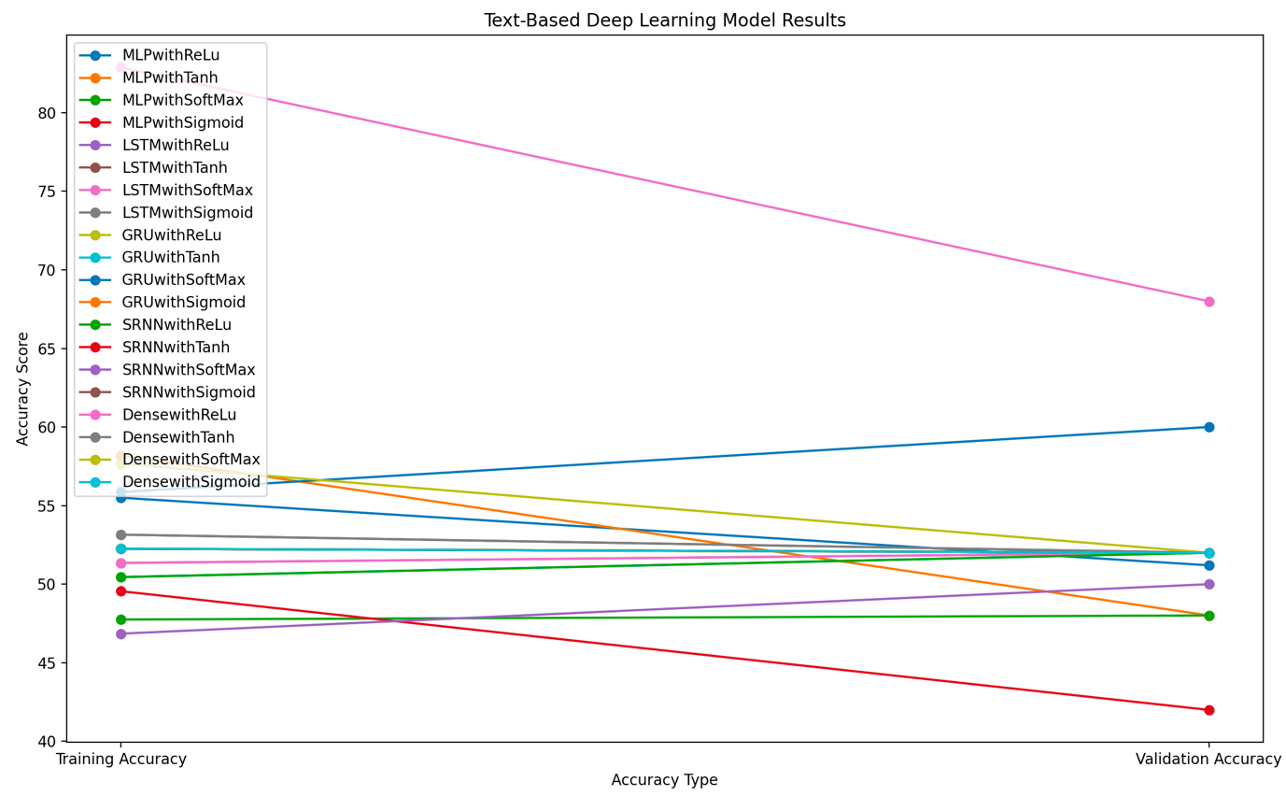

### Results from Experiments on Graphs

The results derived from running each model are displayed in tables *5.2* and *5.3*. The headings indicate each metric for both padding (PTA – Padded Training Accuracy, PVA – Padded Validation Accuracy, PVL – Padded Validation Loss, and PTL – Padded Training Loss) and segmentation (STA – Segmented Training Accuracy, SVA – Segmented Validation Accuracy, SVL – Segmented Validation Loss and STL – Segmented Training Loss). In addition, the results from running the models on graphs with vectorized (unhashed) embeddings are displayed in *table 5.2. The* results from running the models using the hashed embeddings are in *table 5.3*.

The results from these experiments on graphs do not appear interesting at first glance. The hashed and unhashed embeddings provide very similar results. The padded and segmented graphs also give results that do not differ much.

#### Statistics and Performance

The mean TA for padded and hashed graphs is 57.64%, while the mean VA was 48.76%. The mean TA for segmented and hashed graphs is 53.49%, with a mean VA of 51.85%, the highest mean VA. The lowest average VA is from padding and unhashed graphs at 46.25%. One assumption that can be drawn from the similarity of these values (VA range = 5.2) is that with graphs, both padding and segmentation are insufficient for evening out the sizes of the graphs, and another alternative is necessary.

The model with the highest TA scores was the Dense model using ReLu activation. Its scores were 100% using padded graphs and 88.39% using segmented graphs. This might seem like a good result without further exploration, but a closer look at the VA scores indicates otherwise. The VA scores for padding were 40.82%, and 65.31% for segmentation. These high TA scores with low VA scores show that during the training phase, overfitting is occurring, and the model has become unable to generalize to new data (overfitting). The Dense model also experiences overfitting when used with Sigmoid and Tanh activation functions. With Tanh activation, it provides TA scores of 98.21% and 69.64% on padding and segmentation, respectively. The Tanh VA scores are much lower, with 48.98% on both padding and segmentation.

The Dense model with Sigmoid activation results in a TA score of 86.61% on padding and 56.25% on segmentation. Here, the segmentation model does not seem to experience overfitting, with a VA score of 59.18%. On the other hand, the padded model also experiences overfitting with a considerably lower VA of 48.98%.

In general, the best performing graph-based model was the Simple RNN with SoftMax activation, 256 neurons, 10 epochs and batch sizes of 10. For padding, it produced TA of 61.61% and VA of 67.35%, the highest VA of all the graph-based experiments. This contrasts with the text-based model, where the SRNN was generally the worst performing model across the board.

The loss values mainly were under 1.0, with a few exceptions. The GRU regularly produced the highest TL values with an average of 5.955. This indicates that the GRU model is experiencing the most incorrect classifications.

The NDL models do not perform very well, as seen in tables *5.2* and *5.3*. In comparison to their results on text, they perform much worse. This could be because these models are specifically designed to work with text-based data and do not generalize well to other types of data structures.

Overall, the results from these graphs experiments indicate that padding and segmentation are not well suited for carrying out classification tasks on graph-based source code, and a more accurate alternative is necessary. The results from the NDL models reinforce this conclusion due to the enormous drop in VA scores compared to their results on the text-based models. It would also be interesting to observe how all these scores increase or decrease when more data is added for training and testing.

### Results from Experiments on Trees

To carry out segmentation on the trees, I initially experimented with all 11 options provided by TensorFlow and found that all the functions give approximately the same results, except the mean function, which produced better results than the others. As a result, I have chosen to use unsorted mean segmentation for my final experiments. The preliminary experiments to compare the results of the different segmentation methods have been included in a file called ‘preliminaryTreeExperiments.py’. In addition, the results for the tree experiments using unhashed and hashed embeddings can be found in tables *5.4* and *5.5,* respectively.

#### Statistics and Performance

The statistics for the tree-based models with unhashed node embeddings are very promising. The mean TA for unhashing was 68.69%, with a mean VA of 61.71%. This indicates that with more data for training and testing, these scores could go up and be even more accurate. The hashed nodes do not produce as good results. The mean TA for hashing was 50.04%, with an average VA of 52.28%. The closeness of all these values indicates that there is little to no overfitting occurring in both the hashed and unhashed models. The changes between TA and VA for all the models using unhashing are plotted on the graph in *fig 5.2*.

The highest TA scores are from the Simple RNN model with 100% TA on SoftMax and Sigmoid activations. The SoftMax model produces a VA of 60.61%, while the Sigmoid model has a VA of 70%. The Sigmoid model has both values in the acceptable range for accuracy, making it the superior model. However, the SoftMax model has its VA score below the acceptable range, which indicates that in this model, either there is overfitting occurring, or the model needs to be tested using more validation data to increase the VA score.

Other models that perform very well on both TA and VA include the GRU model with Sigmoid (TA 76.56%, VA 75.76%), the LSTM model with Tanh activation (TA 60.94%, VA 70%) and Sigmoid activation (TA 77.34% and VA 70%) and the Dense Model with SoftMax activation (96.88% TA, 75.76% VA). These four models prove the underlying theory behind this project that says that conventional neural network architectures can be made to process source code accurately using the right data structures. It appears that trees are an appropriate data structure for achieving this aim.

Other models with either a high TA and a low VA or a low TA and a high VA are the LSTM model with ReLu activation (TA 56.25% and VA 75.76%), the LSTM with SoftMax activation (72.66% for TA and 63.64% for VA), the GRU with ReLu (TA 71.88% and VA 66.67%) and the GRU with SoftMax (TA 74.22 % and VA 60.61%). There is also the Simple RNN, with Tanh activation, which has a TA score of 71.09% and VA score of 66.67%, and the Dense model with Sigmoid activation, which has a TA of 97.66% and VA of 57.58%. This high TA and low VA indicate that this dense model overfits itself during training.

The MLP underperformed across the board (on trees, text, and graphs), indicating that this model might be entirely unsuitable for carrying out classification tasks on source code, regardless of the data structure used to store the program. All the LSTM models had either a high TA or a high VA, or both. This indicates that these models might be even more accurate with more training and testing data. This is also the case with the SRNN model. Finally, the GRU model only had one activation that fell below the acceptable range in TA and VA. This is the Tanh activation function. This is interesting because GRUs and LSTMs usually work best with Tanh activation.

The best performing models for the tree data structure are the GRU model with Sigmoid activation and the Dense model with SoftMax activation. These models’ performances show that deep learning models can be used to carry out learning tasks on source code, given that the source code has been embedded using the tree data structure. As with graphs, the NDL models generally do not perform well with trees except for the SGD classifier, which recorded a VA score of 81.82% using unhashed tress. This contrasts with its results on text (64%) and indicates that maybe the SGD classifier is better suited to work with tree-based data than text. This is a theory that needs to be explored beyond the scope of this project.

fig 5.2: Graph showing changes between TA and VA from tree-based deep learning models and unhashing

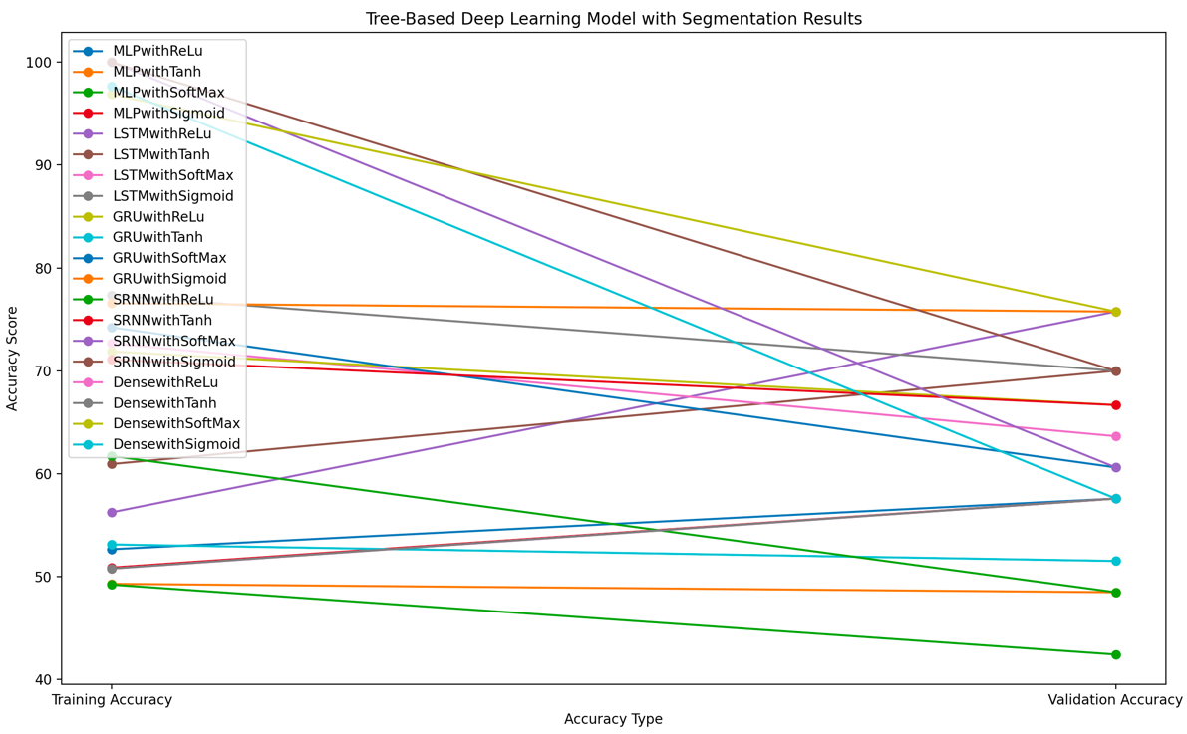

## Overall Findings

The consensus from the results is that segmentation is better suited for scaling trees to be the same size and a suitable method for scaling graphs needs to be explored. Padding and segmentation are insufficient for graphs as they do not result in high training or validation accuracy levels. These results also show that unhashing in trees is a better option than hashing. This is likely because unhashing allows a node’s embedding to embed information about the tree in general (e.g., tree depth, as in section 4.2.2.1.1) alongside information about its parent node, if one exists.

In addition, the research carried out for this project shows that on the classification task (see section 1.2.2), trees are better suited for representing source code than graphs when using deep learning models. On the other hand, non-deep learning models do not need the data to be converted into trees and graphs because their architectures allow the information stored in source code to be accurately captured.

Table 5.1: Results from all experiments on Text

|  |  |  |  |  |
| --- | --- | --- | --- | --- |
| Model | TA % | VA % | TL | VL |
| MLP with ReLu | 55.50 | 51.2 | 0.91 | - |
| MLP with Tanh | 58.2 | 48.01 | 0.82 | - |
| MLP with SoftMax | 47.75 | 48.01 | 0.78 | - |
| MLP with Sigmoid | 52.25 | 52.0 | 0.76 | - |
| LSTM with ReLu | 51.35 | 52.0 | 0.70 | 0.70 |
| LSTM with Tanh | 52.25 | 52.0 | 0.71 | 0.70 |
| LSTM with SoftMax | 51.35 | 52.0 | 0.69 | 0.69 |
| LSTM with Sigmoid | 53.15 | 52.0 | 0.70 | 0.70 |
| GRU with ReLu | 52.25 | 52.0 | 0.70 | 0.70 |
| GRU with Tanh | 50.45 | 52.0 | 0.71 | 0.71 |
| GRU with SoftMax | 55.86 | 60.0 | 0.68 | 0.69 |
| GRU with Sigmoid | 52.25 | 52.0 | 0.69 | 0.70 |
| SRNN with ReLu | 50.45 | 52.0 | 6.95 | 6.67 |
| SRNN with Tanh | 49.55 | 42.0 | 2.65 | 1.30 |
| SRNN with SoftMax | 46.85 | 50.0 | 0.94 | 0.73 |
| SRNN with Sigmoid | 52.25 | 52.0 | 6.55 | 7.36 |
| Dense with ReLu | 82.88 | 68.0 | 0.66 | 0.80 |
| Dense with Tanh | 53.15 | 52.0 | 3.91 | 3.98 |
| Dense with SoftMax | 57.66 | 52.0 | 0.69 | 0.69 |
| Dense with Sigmoid | 52.25 | 52.0 | 0.69 | 0.69 |
| Gaussian NB | - | 86.88 | - | - |
| RF Classifier | - | 100 | - | - |
| SGD Classifier | - | 64.0 | - | - |
| SVM Classifier | - | 76.0 | - | - |

Table 5.2: Results from graphs with unhashed embeddings, padding and segmentation

|  |  |  |  |  |  |  |  |  |
| --- | --- | --- | --- | --- | --- | --- | --- | --- |
| Model | PTA % | STA % | PVA % | SVA % | PTL | STL | PVL | SVL |
| MLP with ReLu | 53.21 | 51.61 | 44.69 | 55.31 | 100.29 | 1.61 | - | - |
| MLP with Tanh | 52.21 | 52.05 | 44.69 | 63.27 | 100.29 | 0.87 | - | - |
| MLP with SoftMax | 49.11 | 50.89 | 59.18 | 40.82 | 0.76 | 0.75 | - | - |
| MLP with Sigmoid | 58.04 | 47.32 | 46.94 | 59.18 | 0.69 | 0.81 | - | - |
| LSTM with ReLu | 50.89 | 46.43 | 40.82 | 51.02 | 7.53 | 0.70 | 9.08 | 0.71 |
| LSTM with Tanh | 48.21 | 51.79 | 40.82 | 51.02 | 0.70 | 0.69 | 0.70 | 0.71 |
| LSTM with SoftMax | 49.11 | 53.57 | 59.18 | 51.02 | Nan | 0.69 | Nan | 0.70 |
| LSTM with Sigmoid | 49.11 | 45.54 | 59.18 | 44.90 | 7.81 | 0.70 | 6.26 | 0.71 |
| GRU with ReLu | 48.21 | 59.82 | 57.14 | 44.9 | 7.71 | 0.68 | 7.60 | 0.73 |
| GRU with Tanh | 44.64 | 52.68 | 48.98 | 57.14 | 7.71 | 0.71 | 7.71 | 0.69 |
| GRU with SoftMax | 49.11 | 55.36 | 40.82 | 42.86 | 0.69 | 0.70 | 0.70 | 0.71 |
| GRU with Sigmoid | 48.21 | 46.43 | 48.98 | 44.90 | 7.71 | 0.71 | 7.63 | 0.73 |
| SRNN with ReLu | 49.11 | 47.32 | 44.9 | 51.02 | 5.52 | 7.72 | 3.68 | 7.70 |
| SRNN with Tanh | 50.0 | 42.86 | 51.02 | 53.06 | 3.11 | 2.64 | 3.06 | 0.99 |
| SRNN with SoftMax | 61.61 | 51.79 | 67.35 | 53.06 | 0.69 | 0.78 | 0.66 | 7.73 |
| SRNN with Sigmoid | 56.25 | 49.11 | 40.82 | 59.18 | 7.71 | 7.71 | 7.71 | 7.71 |
| Dense with ReLu | 100 | 88.39 | 40.82 | 65.31 | 1.13 | 0.40 | 2.97 | 1.31 |
| Dense with Tanh | 98.21 | 69.64 | 48.98 | 48.98 | 0.15 | 0.53 | 3.05 | 1.41 |
| Dense with SoftMax | 50.89 | 50.89 | 40.82 | 40.82 | 40.82 | 0.69 | 0.70 | 0.69 |
| Dense with Sigmoid | 86.61 | 56.25 | 48.98 | 59.18 | 48.98 | 0.83 | 0.72 | 0.69 |
| Gaussian NB | - | - | 55.0 | 51.25 | - | - | - | - |
| RF Classifier | - | - | 57.14 | 55.1 | - | - | - | - |
| SGD Classifier | - | - | 48.98 | 53.06 | - | - | - | - |
| SVM Classifier | - | - | 46.94 | 59.18 | - | - | - | - |

Table 5.3: Results from Graphs with hashed embeddings, padding and segmentation

|  |  |  |  |  |  |  |  |  |
| --- | --- | --- | --- | --- | --- | --- | --- | --- |
| Model | PTA % | STA % | PVA % | SVA % | PTL | STL | PVL | SVL |
| MLP with ReLu | 50.89 | 53.56 | 49.39 | 47.55 | 5.03 | 10.69 | - | - |
| MLP with Tanh | 45.54 | 45.54 | 53.06 | 53.06 | 0.69 | 0.70 | - | - |
| MLP with SoftMax | 45.54 | 45.54 | 53.06 | 53.06 | 0.75 | 0.74 | - | - |
| MLP with Sigmoid | 45.54 | 45.54 | 53.06 | 53.06 | 0.69 | 0.76 | - | - |
| LSTM with ReLu | 53.57 | 52.68 | 46.94 | 46.94 | 7.71 | 7.71 | 7.71 | 7.71 |
| LSTM with Tanh | 55.36 | 43.75 | 46.94 | 53.06 | 7.71 | 7.71 | 7.71 | 7.71 |
| LSTM with SoftMax | 54.46 | 54.46 | 46.94 | 46.94 | 0.69 | 0.69 | 0.70 | 0.70 |
| LSTM with Sigmoid | 50.89 | 45.54 | 57.14 | 53.06 | 7.71 | 7.71 | 7.71 | 7.71 |
| GRU with ReLu | 56.25 | 47.32 | 46.94 | 46.94 | 7.71 | 7.71 | 7.71 | 7.71 |
| GRU with Tanh | 33.04 | 54.46 | 18.37 | 46.94 | 7.71 | 7.71 | 7.71 | 7.71 |
| GRU with SoftMax | 54.56 | 54.46 | 46.94 | 46.94 | 0.70 | 0.69 | 0.70 | 0.70 |
| GRU with Sigmoid | 40.18 | 48.21 | 24.49 | 53.06 | 7.71 | 7.71 | 7.71 | 7.71 |
| SRNN with ReLu | 45.54 | 53.57 | 53.06 | 46.94 | 8.35 | 7.71 | 7.20 | 7.71 |
| SRNN with Tanh | 54.46 | 53.57 | 46.94 | 46.94 | Nan | 7.71 | Nan | 7.71 |
| SRNN with SoftMax | 55.36 | 54.46 | 46.94 | 46.94 | 0.78 | 0.88 | 0.75 | 1.06 |
| SRNN with Sigmoid | 54.46 | 56.25 | 46.94 | 46.94 | Nan | 7.71 | Nan | 7.71 |
| Dense with ReLu | 54.46 | 45.54 | 46.94 | 53.06 | 7.71 | 7.71 | 7.71 | 7.71 |
| Dense with Tanh | 55.36 | 45.54 | 46.94 | 45.54 | 7.71 | 7.71 | 7.71 | 7.71 |
| Dense with SoftMax | 54.56 | 54.54 | 46.94 | 46.94 | 0.69 | 0.69 | 0.70 | 0.70 |
| Dense with Sigmoid | 43.75 | 46.43 | 46.94 | 46.94 | 0.70 | 0.70 | 0.70 | 0.70 |
| Gaussian NB | - | - | 53.13 | 50.63 | - | - | - | - |
| RF Classifier | - | - | 46.94 | 53.06 | - | - | - | - |
| SGD Classifier | - | - | 46.94 | 46.94 | - | - | - | - |
| SVM Classifier | - | - | 46.94 | 46.94 | - | - | - | - |

Table 5.4: Tree experiment results using Unsorted Max Segmentation and hashing

|  |  |  |  |  |
| --- | --- | --- | --- | --- |
| Model | TA % | VA % | TL | VL |
| MLP with ReLu | 51.56 | 54.55 | 1.75 | - |
| MLP with Tanh | 51.56 | 54.55 | 0.69 | - |
| MLP with SoftMax | 51.56 | 54.55 | 0.69 | - |
| MLP with Sigmoid | 51.56 | 54.55 | 0.70 | - |
| LSTM with ReLu | 47.66 | 54.55 | 7.71 | 7.71 |
| LSTM with Tanh | 48.44 | 45.45 | 7.71 | 7.71 |
| LSTM with SoftMax | 50.78 | 54.55 | 0.69 | 0.69 |
| LSTM with Sigmoid | 51.56 | 54.55 | 0.69 | 0.69 |
| GRU with ReLu | 52.34 | 54.55 | 7.71 | 7.71 |
| GRU with Tanh | 55.47 | 45.45 | 7.71 | 7.71 |
| GRU with SoftMax | 51.56 | 54.55 | 0.70 | 0.69 |
| GRU with Sigmoid | 51.56 | 54.55 | 0.69 | 0.69 |
| SRNN with ReLu | 49.22 | 45.45 | 7.71 | 7.71 |
| SRNN with Tanh | 50.78 | 54.55 | 7.71 | 7.71 |
| SRNN with SoftMax | 54.69 | 54.55 | 0.69 | 0.69 |
| SRNN with Sigmoid | 42.97 | 54.55 | 0.75 | 0.69 |
| Dense with ReLu | 51.56 | 54.55 | 0.69 | 0.69 |
| Dense with Tanh | 41.41 | 36.36 | 7.71 | 7.71 |
| Dense with SoftMax | 51.56 | 54.55 | 7.71 | 7.71 |
| Dense with Sigmoid | 42.97 | 54.55 | 0.69 | 0.69 |
| Gaussian NB | - | 48.75 | - | - |
| RF Classifier | - | 45.45 | - | - |
| SGD Classifier | - | 54.55 | - | - |
| SVM Classifier | - | 54.55 | - | - |

Table 5.5: Tree experiment results using unsorted max segmentation and unhashing

|  |  |  |  |  |
| --- | --- | --- | --- | --- |
| Model | TA (%) | VA(%) | TL | VL |
| MLP with ReLu | 52.66 | 57.58 | 495.12 | - |
| MLP with Tanh | 49.30 | 48.48 | 0.91 | - |
| MLP with SoftMax | 49.22 | 42.42 | 0.77 | - |
| MLP with Sigmoid | 50.78 | 57.58 | Nan | - |
| LSTM with ReLu | 56.25 | 75.76 | 4.05 | 3.33 |
| LSTM with Tanh | 60.94 | 70.00 | 2..01 | 2.49 |
| LSTM with SoftMax | 72.66 | 63.64 | 0.53 | 0.64 |
| LSTM with Sigmoid | 77.34 | 70.00 | 0.50 | 0.56 |
| GRU with ReLu | 71.88 | 66.67 | 0.62 | 1.48 |
| GRU with Tanh | 53.12 | 51.52 | 0.67 | 0.92 |
| GRU with SoftMax | 74.22 | 60.61 | 0.56 | 0.69 |
| GRU with Sigmoid | 76.56 | 75.76 | 0.53 | 0.57 |
| SRNN with ReLu | 61.72 | 48.48 | 4.32 | 5.63 |
| SRNN with Tanh | 71.09 | 66.67 | 1.92 | 2.54 |
| SRNN with SoftMax | 100 | 60.61 | 0.07 | 0.89 |
| SRNN with Sigmoid | 100 | 70.00 | 0.16 | 0.69 |
| Dense with ReLu | 50.78 | 57.58 | 7.71 | 7.71 |
| Dense with Tanh | 50.78 | 57.58 | 0.32 | 1.57 |
| Dense with SoftMax | 96.88 | 75.76 | 0.69 | 0.69 |
| Dense with Sigmoid | 97.66 | 57.58 | 0.16 | 0.80 |
| Gaussian NB | - | 61.88 | - | - |
| RF Classifier | - | 60.61 | - | - |
| SGD Classifier | - | 81.82 | - | - |
| SVM Classifier | - | 51.52 | - | - |

# Legal, Social, Ethical and Professional Issues

## Legal Issues

The research done in this project has been carried out in compliance with all the applicable laws and regulations. Where third-party work is made use of or applied, it has been referenced, clearly stating the source of the work. This project references third-party work and uses images collected from third-party websites. Where this is the case, credit is given according to professional standards.

Additionally, the guidelines of the British Computing Society have been followed all through the development process for this project.

## Social and Ethical Issues

To my knowledge, the main social and ethical issue that could arise from this project is the development of neural networks to process and understand source code in a context where the source code being learnt is closed source. For example, where the developer has not been permitted to use that program for research or testing purposes. Using any of the ideas presented in this project in such a situation is unethical and is unintended in all cases.

Another issue that could rise from this project is the use of neural networks to replicate the work done by the researchers referenced in the literature review without giving credit where it is needed.

## Professional Issues

The professional issues this project could solve include building specific neural networks and the development of deep learning techniques to understand source code directly from the program’s AST without needing to convert it into trees or graphs and embedding the nodes. This could be done by learning how compilers and interpreters process source code from the program AST at runtime and applying this knowledge to build an entirely new type of neural network architecture.

This development would see a huge leap forward in Programming Language Understanding (PLU). It would provide entirely new ways for programs to be understood by deep learning methods. It could even lead to further research interest in the field of PLU.

# Conclusion

In conclusion, with the results of this project, I have determined if trees are more suited than graphs for representing source code which is to be learnt by a neural network. Furthermore, I have also achieved each specific objective outlined in section 3.1.

## Specific Objectives Achieved

Objective 2: This project has successfully implemented a method for converting source code into a graph represented by a NetworkX Digraph object (section 4.2.1).

Objective 3: The method for converting the graph nodes from Objective 2 into node embeddings has been completed (section 4.2.2).

Objective 5: A method for converting a program into an AST and extracting the complex and important information in the program into a tree data structure has been implemented (section 4.2.1).

Objective 6: I designed a method to convert the tree data structure into a list of node embeddings that can be understood by a neural network (section 4.2.2).

Objectives 1, 4 and 7: I aimed to build 9 DL and NDL models to compare their results when trained and tested using source code represented with three different data structures (trees, graphs, and text), and I have achieved this aim (section 4.2.4).

Objective 8: I have compared the results of running the models from Objectives 1, 4 and 7 with the results of Objectives 3 and 6 and text embeddings to determine the most suitable for classifying programs based on the sorting algorithm they implement (section 4.5).

## Future Work

One possible future improvement on this project could be to examine how an individual programmer’s programming style (e.g., do they always use camelCase or snake_case, etc.) influences the ability of a deep learning model to understand the code. Another example could be to construct a model that can describe programs based on the functions they implement. Finally, work could be done to implement neural networks and machine learning models that can understand multiple programming languages. This could lead to models being trained in one language and tested in another. This does not have to be limited to deep learning models.

# References

1. McCaffrey, J., 2006. *Scripting Languages vs. Non-Scripting Languages in Test Automation*. James D. McCaffrey. <https://jamesmccaffrey.wordpress.com/2006/10/06/scripting-languages-vs-non-scripting-languages-in-test-automation/>
2. En.wikipedia.org. n.d. *Scripting language - Wikipedia*. <https://en.wikipedia.org/wiki/Scripting_language>
3. En.wikipedia.org. n.d. *Procedural programming - Wikipedia*. <https://en.wikipedia.org/wiki/Procedural_programming>
4. GeeksforGeeks. n.d. Introduction to Tree Data Structure - GeeksforGeeks. <https://www.geeksforgeeks.org/introduction-to-tree-data-structure/>
5. Allamanis, M., Brockschmidt, M. and Khademi, M., 2017. Learning to represent programs with graphs. *arXiv preprint arXiv:1711.00740*.
6. Zola, A., n.d. *What is a strongly typed programming language?*. <https://www.techtarget.com/whatis/definition/strongly-typed>
7. Nadkarni, P.M., Ohno-Machado, L. and Chapman, W.W., 2011. Natural language processing: an introduction. *Journal of the American Medical Informatics Association*, *18*(5), pp.544-551.
8. Beck, D., Haffari, G. and Cohn, T., 2018. Graph-to-sequence learning using gated graph neural networks. *arXiv preprint arXiv:1806.09835*.
9. Mou, L., Li, G., Zhang, L., Wang, T. and Jin, Z., 2016, February. Convolutional neural networks over tree structures for programming language processing. In *Thirtieth AAAI conference on artificial intelligence*.
10. Browne, M. and Ghidary, S.S., 2003, December. Convolutional neural networks for image processing: an application in robot vision. In *Australasian Joint Conference on Artificial Intelligence* (pp. 641-652). Springer, Berlin, Heidelberg.
11. Browne, M., Ghidary, S.S. and Mayer, N.M., 2008. Convolutional neural networks for image processing with applications in mobile robotics. In *Speech, Audio, Image and Biomedical Signal Processing using Neural Networks* (pp. 327-349). Springer, Berlin, Heidelberg.
12. Van Emden, E. and Moonen, L., 2002, October. Java quality assurance by detecting code smells. In *Ninth Working Conference on Reverse Engineering, 2002. Proceedings.* (pp. 97-106). IEEE.
13. Alon, U., Zilberstein, M., Levy, O. and Yahav, E., 2019. code2vec: Learning distributed representations of code. *Proceedings of the ACM on Programming Languages*, *3*(POPL), pp.1-29.
14. Scarselli, F., Gori, M., Tsoi, A.C., Hagenbuchner, M. and Monfardini, G., 2008. The graph neural network model. *IEEE transactions on neural networks*, *20*(1), pp.61-80.
15. Li, Y., Tarlow, D., Brockschmidt, M. and Zemel, R., 2015. Gated graph sequence neural networks. *arXiv preprint arXiv:1511.05493*.
16. Shi, Y., Li, Q. and Zhu, X.X., 2020. Building segmentation through a gated graph convolutional neural network with deep structured feature embedding. *ISPRS Journal of Photogrammetry and Remote Sensing*, *159*, pp.184-197.
17. Ruiz, L., Gama, F. and Ribeiro, A., 2020. Gated graph recurrent neural networks. *IEEE Transactions on Signal Processing*, *68*, pp.6303-6318.
18. GitHub. n.d. *Build software better, together*. <https://github.com/search?l=Python&q=quick+sort&type=Repositories>
19. GitHub. n.d. *Build software better, together*. <https://github.com/search?l=Python&q=merge+sort&type=Repositories>
20. Ramchoun, H., Ghanou, Y., Ettaouil, M. and Janati Idrissi, M.A., 2016. Multilayer perceptron: Architecture optimization and training.
21. Bebis, G. and Georgiopoulos, M., 1994. Feed-forward neural networks. *IEEE Potentials*, *13*(4), pp.27-31.
22. Kanal, L.N., 2003. Perceptron. In *Encyclopedia of Computer Science* (pp. 1383-1385).
23. Hopfield, J.J., 1988. Artificial neural networks. *IEEE Circuits and Devices Magazine*, *4*(5), pp.3-10.
24. Hecht-Nielsen, R., 1992. Theory of the back-propagation neural network. In *Neural networks for perception* (pp. 65-93). Academic Press.
25. Verma, Y., 2021. *A Complete Understanding of Dense Layers in Neural Networks*. Analytics India Magazine. <https://analyticsindiamag.com/a-complete-understanding-of-dense-layers-in-neural-networks/>
26. Hochreiter, S., 1998. The vanishing gradient problem during learning recurrent neural nets and problem solutions. *International Journal of Uncertainty, Fuzziness and Knowledge-Based Systems*, *6*(02), pp.107-116.
27. Schuster, M. and Paliwal, K.K., 1997. Bidirectional recurrent neural networks. *IEEE transactions on Signal Processing*, *45*(11), pp.2673-2681.
28. Olah, C., 2015. *Understanding LSTM Networks -- colah's blog*. Colah.github.io. <http://colah.github.io/posts/2015-08-Understanding-LSTMs/>
29. En.wikipedia.org. n.d. *Gated recurrent unit - Wikipedia*. <https://en.wikipedia.org/wiki/Gated_recurrent_unit>
30. Dey, R. and Salem, F.M., 2017, August. Gate-variants of gated recurrent unit (GRU) neural networks. In *2017 IEEE 60th international midwest symposium on circuits and systems (MWSCAS)* (pp. 1597-1600). IEEE.
31. Mikolov, T., Karafiát, M., Burget, L., Cernocký, J. and Khudanpur, S., 2010, September. Recurrent neural network based language model. In *Interspeech* (Vol. 2, No. 3, pp. 1045-1048).
32. Abdelrahman, M.M.H.M., 2019. Analyzing robustness of models of chaotic dynamical systems learned from data with Echo state networks
33. En.wikipedia.org. n.d. *Bayes' theorem - Wikipedia*. <https://en.wikipedia.org/wiki/Bayes%27_theorem>
34. Brownlee, J., 2018. *A Gentle Introduction to k-fold Cross-Validation*. Machine Learning Mastery. <https://machinelearningmastery.com/k-fold-cross-validation/>
35. En.wikipedia.org. n.d. *Random forest - Wikipedia*. <https://en.wikipedia.org/wiki/Random_forest#/media/File:Random_forest_diagram_complete.png>
36. Kapil, D., 2019. *Stochastic vs Batch Gradient Descent*. Medium. <https://medium.com/@divakar_239/stochastic-vs-batch-gradient-descent-8820568eada1>
37. Pupale, R., 2018. *Support Vector Machines(SVM) — An Overview*. Medium. <https://towardsdatascience.com/https-medium-com-pupalerushikesh-svm-f4b42800e989>
38. Rentsch, T., 1982. Object oriented programming. *ACM Sigplan Notices*, *17*(9), pp.51-57.
39. scikit-learn. n.d. *sklearn.feature_extraction.text.CountVectorizer*. <https://scikit-learn.org/stable/modules/generated/sklearn.feature_extraction.text.CountVectorizer.html>
40. Docs.python.org. n.d. *ast — Abstract Syntax Trees — Python 3.10.5 documentation*. <https://docs.python.org/3/library/ast.html>
41. Networkx.org. n.d. *NetworkX — NetworkX documentation*. <https://networkx.org>
42. Kural, M., 2005. Tree traversal and word order. *Linguistic Inquiry*, *36*(3), pp.367-387.
43. Minaee, S., Boykov, Y.Y., Porikli, F., Plaza, A.J., Kehtarnavaz, N. and Terzopoulos, D., 2021. Image segmentation using deep learning: A survey. *IEEE transactions on pattern analysis and machine intelligence*.
44. Landsberg, J.M., 2012. Tensors: geometry and applications. *Representation theory*, *381*(402), p.3.
45. Denoyer, L. and Gallinari, P., 2014. Deep sequential neural network. *arXiv preprint arXiv:1410.0510*.
46. Brownlee, J., 2019. *How to Control the Stability of Training Neural Networks With the Batch Size*. Machine Learning Mastery. <https://machinelearningmastery.com/how-to-control-the-speed-and-stability-of-training-neural-networks-with-gradient-descent-batch-size/>
47. Brownlee, J., 2018. *Difference Between a Batch and an Epoch in a Neural Network*. Machine Learning Mastery. <https://machinelearningmastery.com/difference-between-a-batch-and-an-epoch/>
48. Scikit-learn.org. n.d. *scikit-learn: machine learning in Python — scikit-learn 1.1.1 documentation*. <https://scikit-learn.org/stable/>
49. scikit-learn. n.d. *sklearn.pipeline.Pipeline*. <https://scikit-learn.org/stable/modules/generated/sklearn.pipeline.Pipeline.html>
50. Wang, Q., Ma, Y., Zhao, K. and Tian, Y., 2022. A comprehensive survey of loss functions in machine learning. *Annals of Data Science*, *9*(2), pp.187-212.
51. Saxena, S., 2021. *Binary Cross Entropy/Log Loss for Binary Classification*. Analytics Vidhya. <https://www.analyticsvidhya.com/blog/2021/03/binary-cross-entropy-log-loss-for-binary-classification/>

# Appendices

## Appendix A: Source Code File Structure

The structure of the files described in the implementation section of this report are displayed below:

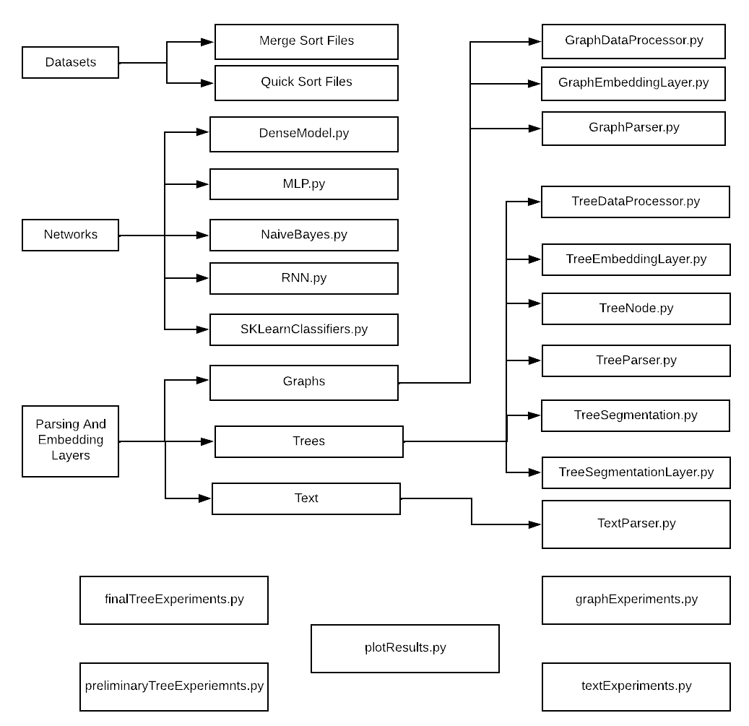

Visitor.py

* The Datasets file contains the training and testing data files. These are divided into Merge Sort and Quick Sort.
* The Networks file contains the implementations of the nine DL and NDL models used for the classification tasks. This folder contains 5 different files. One each for the Dense Model, the MLP model and the Naïve Bayes classifier. ‘RNN.py’ contains the implementations for the LSTM, the GRU and the Simple RNN. ‘SKLearnClassifiers.py’ contains the implementations for the SGD, SVM and RF classifiers.
* Parsing And Embedding Layers is divided into three subfolders.
* Graphs: Contains all the files for running the background operations for the graph data structure. These files are ‘GraphDataProcessor.py’, ‘GraphEmbeddingLayer.py’ and ‘GraphParser.py’. The contents and functions of these files have been described in detail in section 4.2.
* Trees: This holds the files for running the background operations on the abstract tree data structure. The files here are ‘TreeEmbeddingLayer.py’, ‘TreeDataProcessor.py’, ‘TreeNode.py’, ‘Treeparser.py’, ‘TreeSegmentation.py’ and ‘TreeSegmentationLayer.py’.
* The remaining files are for running the experiments and plotting their results. These are:
* ‘Visitor.py’: This is where the AbstractVisitor, HashVisitor and Visitor are implemented.
* ‘preliminaryTreeExpeirments.py’: This file implements the preliminary experiments for determining which segmentation function provides the best results. It uses the MLP to make this decision.
* ‘finalTreeExpeirments.py’: This is where the final experiments for getting the results on the trees are contained.
* ‘graphExperiments.py’: This file is where I implement the experiments on the graph-based data using all 9 models.
* ‘textExperiments.py’: This file is the experiments on text are carried out.
* ‘plotResults.py’: This file contains the code for plotting the graphs seen in *fig* *5.1* and *5.2*.

To run the experiments in the files above, open the file and click F5 (fn + F5 with a MacBook) or select the debug file option in the project menu.

## Appendix B: Source Code Files

The project files outlined above have their source code shown in this section with the appropriate names.

### Networks

## Appendix B: Source Code Files

The project files outlined above have their source code shown in this section with the appropriate names.

### Networks

#### DenseModel.py

import tensorflow as tf

def runDenseModel(x_train, y_train, x_test, y_test, activation: str, batchSize: int, epochs: int, filename: str = None):

""" The method to run the model made up of densely connected layers

x_train - The training data

y_train - The training data labels

x_test - The testing data

y_test - The testing data labels

activation: str - The activation function to be applied

batchSize: int - The size of each batch for the model

epochs: int - The number of epochs

filename: str = None - THe name of the file to be saved """

model = tf.keras.models.Sequential()

#Insert the input layer

model.add(tf.keras.layers.InputLayer(input_shape=(x_train.shape[1], )))

# Add the densely connected layers

model.add(tf.keras.layers.Dense(256, activation=activation))

model.add(tf.keras.layers.Dense(64, activation=activation))

model.add(tf.keras.layers.Dense(2, activation=activation))

# Compile and train/fit the model

model.compile(loss='binary_crossentropy', optimizer='adam', metrics=['accuracy'])

model.summary()

model.fit(x_train, y_train, epochs=epochs, batch_size=batchSize, validation_data=(x_test, y_test))

if filename is not None:

model.save(filename)

#### MLP.py

import tensorflow as tf

import numpy as np

from typing import List

class MLP:

def __init__(self, x_train: tf.Tensor, y_train: List, layers: List[int],

activationFunction: str, learningRate: float, epochs: int):

""" The Multi Layer Perceptron Class

x_train: tf.Tensor - The training data

y_train: List - The training data labels

layers: List[int] - The list of layer units

activationFunction: str - The activation function to be used

learningRate: float - The learning rate

epochs: int - The number of times the data is passed back and forth in the network"""

self.x_train = x_train

self.y_train = y_train

self.layers = layers

self.layerCount = len(self.layers)

self.xCount = len(self.x_train)

self.activationFunction = self.getActivationFunction(activationFunction)

self.learningRate = learningRate

self.epochs = epochs

self.weights, self.bias, self.weightDeltas, self.biasDeltas = {}, {}, {}, {}

self.hiddenLayerCount = len(layers)-2

self.featureCount = layers[0]

self.classCount = layers[-1]

self.parameterCount = 0

self.initialiseWeights()

# Calculate the number of parameters in the model

for i in range(1, self.layerCount):

self.parameterCount += self.weights[i].shape[0] * self.weights[i].shape[1]

self.parameterCount += self.bias[i].shape[0]

# Print a summary of the model

print(self.featureCount, "features,", self.classCount, "classes,", self.parameterCount, "parameters, and", self.hiddenLayerCount, "hidden layers", "\n")

for i in range(1, self.layerCount-1):

print('Hidden layer {}:'.format(i), '{} neurons'.format(self.layers[i]))

def getActivationFunction(self, activationFunction: str):

""" The method to seelct an activation function

activationFunction: str - The string representation of the activation function"""

if activationFunction == 'softmax':

return tf.nn.softmax

elif activationFunction == 'relu':

return tf.nn.relu

elif activationFunction == 'tanh':

return tf.tanh

elif activationFunction == 'sigmoid':

def logSigmoid(x):

x = 1.0/(1.0 + tf.math.exp(-x))

return x

return logSigmoid

else:

return None

def lossFunction(self, outputs: tf.Tensor, yValues: tf.Tensor):

""" Calculate the loss between the actual and predicted outputs """

return tf.reduce_mean(tf.nn.softmax_cross_entropy_with_logits(yValues, outputs))

def makePrediction(self, x_test: tf.Tensor):

"""Make predictions on the unseen testing data

x_test: tf.Tensor - The unseen testing data in tensor format"""

predictions = []

output = self.FFLayer(x_test)

prediction = tf.argmax(tf.nn.softmax(output), axis=1)

predictions.append(prediction)

return tf.convert_to_tensor(predictions)

def initialiseWeights(self):

"""Initialise the weights and biases for the model"""

for i in range(1, self.layerCount):

self.weights[i] = tf.Variable(tf.random.normal(shape=(self.layers[i], self.layers[i-1])))

self.bias[i] = tf.Variable(tf.random.normal(shape=(self.layers[i], 1)))

def FFLayer(self, x: tf.Tensor):

""" The Feed Forward layer for the model

x: tf.Tensor - The data to be passed across the layers """

for i in range(1, self.layerCount):

x = tf.matmul(x, tf.transpose(self.weights[i])) + tf.transpose(self.bias[i])

x = self.activationFunction(x)

return x

def backPropagate(self, xValues: tf.Tensor, yValues: tf.Tensor):

""" Run the backpropagation algorithm on the training data

xValues: tf.Tensor - The training data

yValues: tf.Tensor - The training data labels

"""

with tf.GradientTape(persistent=True) as tape:

output = self.FFLayer(xValues)

loss = self.lossFunction(output, yValues)

for i in range(1, self.layerCount):

tape.watch(self.weights[i])

# calcualte the gradients of the weights and biases

self.weightDeltas[i] = tape.gradient(loss, self.weights[i])

self.biasDeltas[i] = tape.gradient(loss, self.bias[i])

del tape

# update the weights after calculating the gradients

self.updateWeights()

return loss.numpy()

def updateWeights(self):

"""The method that updates the weights and biases after backpropagation

has been carried out"""

for i in range(1, self.layerCount):

if self.weightDeltas[i] is not None:

# Subtract the learning rate * the gradient from the current weight/bias

self.weights[i].assign_sub(self.learningRate * self.weightDeltas[i])

if self.biasDeltas[i] is not None:

self.bias[i].assign_sub(self.learningRate * self.biasDeltas[i])

def runFFModel(self, x_train: tf.Tensor, y_train: tf.Tensor, x_test: tf.Tensor, y_test: tf.Tensor):

""" The method to implement the MLP

x_train: tf.Tensor - The training data

y_train: tf.Tensor - The training data labels

x_test: tf.Tensor - The testing data

y_test: tf.Tensor - The testing data labels"""

index = 0

loss = 0.0

metrics = {'trainingLoss': [], 'trainingAccuracy': [], 'validationAccuracy': []}

self.initialiseWeights()

for i in range(self.epochs):

print('Epoch {}'.format(i), end='........')

predictions = []

if index % 5 == 0:

print(end=".")

if index >= len(y_train):

index = 0

# First forward pass

loss = self.backPropagate(x_train, y_train)

# Second forward pass/Recurrent Loop with the updated weights

newOutputs = self.FFLayer(x_train)

# run softmax activation on the outputs to get the final prediction

pred = tf.argmax(tf.nn.softmax(newOutputs), axis = 1)

predictions.append(pred)

index += 1

predictions = tf.convert_to_tensor(predictions)

# add the calculated loss to the list of metrics

metrics['trainingLoss'].append(loss)

# make predictions on the unseen testing data

unseenPredictions = self.makePrediction(x_test)

# Calculate the accuracies of the seen and unseen predictions

metrics['trainingAccuracy'].append(np.mean(np.argmax(y_train, axis=1) == predictions.numpy()))

metrics['validationAccuracy'].append(np.mean(np.argmax(y_test, axis=1) == unseenPredictions.numpy()))

print('\tLoss:', metrics['trainingLoss'][-1], 'Accuracy:', metrics['trainingAccuracy'][-1],

'Validation Accuracy:', metrics['validationAccuracy'][-1])

return metrics

#### NaiveBayes.py

import random, math

from statistics import mean

class NBClassifier:

def __init__(self, x: list, y: list):

"""A Naïve Bayes classifier model with cross-validation

x: list - The x values (training data)

y: list - The y values (training data labels)"""

self.x = x

self.y = y

self.crossValFolds = 5 #the number of folds

self.crossValFoldSize = int(len(self.x)/self.crossValFolds) # the size of each fold

def separationFunction(self, xValues: list, yValues: list):

""" Separate the data based on classes to get a summary of the data

xValues: list - The data

yValues: list - The data labels """

separatedDict = {} #separate the data into a dictionary with the labels as the keys

for i in range(len(xValues)):

x = xValues[i]

label = yValues[i]

if label not in separatedDict:

separatedDict[label] = []

separatedDict[label].append(x)

return separatedDict

def splitIntoFolds(self, xValues, yValues):

"""Split the data and the labels into folds for cross-validation"""

splitFolds, xVals = [], xValues #the folds for the data

yFolds, yTrain = [], yValues # the folds for the labels

for i in range(self.crossValFolds):

currentFold, yFold = [], []

while len(currentFold) < self.crossValFoldSize: #make sure the folds are all the same size

j = random.randrange(len(xVals)) #randomly select data to be in each fold

currentFold.append(xVals.pop(j))

yFold.append(yTrain.pop(j)) #repeat for the label

splitFolds.append(currentFold)

yFolds.append(yFold)

return splitFolds, yFolds

def calculateAccuracyScore(self, values: list, predictions: list):

"""Get the overall accuracy score of the model

values: list - the actual y values

predictions: list - the predicted y values"""

accuracyScore = 0.0

for i in range(len(values)):

if values[i] == predictions[i]:

accuracyScore += 1.0

accuracyScore = accuracyScore/float(len(values)) * 100.0

return accuracyScore

def getMean(self, values: list):

"""Get the mean of a set of values

values: list - The lsit of values from which to calculate the mean"""

return float(mean(values))

def getStandardDev(self, values: list):

"""Calculate the standard deviation of a set of values

values: list - The lsit of values from which to calculate the standard deviation"""

meanValue = self.getMean(values)

var = sum([(i-meanValue) * (i-meanValue) for i in values]) / float(len(values)-1)

return math.sqrt(var)

def collateStatistics(self, values: list):

"""Get the statistics for a set of values

values: list - The list from which the statistics are to be collected"""

return [(self.getMean(i), self.getStandardDev(i), len(i)) for i in zip(*values)]

def collateClassStatistics(self, xValues: list, yValues: list):

"""Get the statistics for an individual class

xValues: list - The class data

yValues: list - The class labels"""

separatedDict = self.separationFunction(xValues, yValues) #separate the data by class

classStats = {}

# collate the statistics for each separate class

for i, j in separatedDict.items():

classStats[i] = self.collateStatistics(j)

return classStats

def getGaussianProbability(self, val, valMean, valStd):

"""Calculate the Gaussian probability for a set of values

val - Each individual value

valMean - The mean of the set of values from which 'val' came from

valStd - The standard deviation of the set of values from which 'val' came from"""

distFromMean = (val-valMean) * (val-valMean) #the distance between the value and its mean

if valStd == 0:

valStd = 1 # if the standard deviation is 0, set it to 1 so it can be multiplied and divided

# calculate the Gaussian probablilty using the above values

stdSqr = 2 * valStd * valStd

e = distFromMean/stdSqr

piSqrt = 1/(math.sqrt(2 * math.pi) * valStd)

gaussianProb = math.exp(-(e)) * (piSqrt)

return gaussianProb

def getClassGaussianProbability(self, classStats, values):

"""Get the Gaussian probability of a class of values

classStats - The statistics of the individual class

values - The values in the class

"""

rowSum, probabilities = sum(classStats[y][0][2] for y in classStats), {}

for value, stat in classStats.items():

probabilities[value] = classStats[value][0][2]/float(rowSum)

for i in range(len(stat)):

valMean, valStd, valCount = stat[i]

# get the probability of a value belonging to the current class

probabilities[value] *= self.getGaussianProbability(values[i], valMean, valStd)

return probabilities

def makePrediction(self, classStats, xValue):

"""Make a prediction on a value in the testing fold based on its properties

classStats - The statistics of all the classes

xValue - The value who's class is to be predicted

"""

# Get the gaussian probabilities of the class based on its mean and standard deviation

classProbabilities = self.getClassGaussianProbability(classStats, xValue)

label, probability = 10, -1

classProbs = classProbabilities.items()

for value, prob in classProbs:

if label == 10 or prob > probability:

probability = prob #select the highest probability as the final prediction

label = value

return label

def runGNBClassifier(self, xTrain: list, yTrain: list, xTest: list):

"""Make classifications and predictions

xTrain: list - The training data folds

yTrain: list - The training label folds

xTest: list - The testing data fold"""

# Get the mean and standard deviation for the training folds

classStats = self.collateClassStatistics(xTrain, yTrain)

predictions = []

for x in xTest:

# make the predictions on the testing data fold

prediction = self.makePrediction(classStats, x)

predictions.append(prediction)

return predictions

def gaussianCrossValidation(self, xValues: list, yValues: list):

"""Run the cross-validation algorithm on all the data

xValues: list - The data

yValues: list - The data class labels"""

# split the data into folds of equal values:

foldsX, foldsY = self.splitIntoFolds(xValues, yValues)

accuracyScores = []

# for each data fold, separate it from the rest of the folds

# use the other folds as training data and use the current fold as testing data

# calculate the and return the mean accuracy score when the prediction process is complete.

for i in range(len(foldsX)):

currentTrainX, currentY = foldsX[i], foldsY[i]

allTrain, allY, allTest, allTestY = list(foldsX), list(foldsY), [], []

allY.remove(currentY)

allTrain.remove(currentTrainX)

allTrain = sum(allTrain, [])

allY = sum(allY, [])

for j in range(len(currentTrainX)):

trainY = currentY[j]

trainX = currentTrainX[j]

allTest.append(trainX)

allTestY.append(trainY)

predicted = self.runGNBClassifier(allTrain, allY, allTest)

accuracyScore = self.calculateAccuracyScore(allTestY, predicted)

accuracyScores.append(accuracyScore)

return mean(accuracyScores)

#### RNN.py

import tensorflow as tf

class RNN:

def __init__(self, layerName: str, x_train: tf.Tensor, y_train: tf.Tensor,

x_test: tf.Tensor, y_test: tf.Tensor, activationFunction: str = None,

neurons:int = None, dropoutRate: float = None):

"""The RNN class from where all RNN layers are called

layerName: str - The string representation of the type of layer that has been selected

x_train: tf.Tensor - The training data

y_train: tf.Tensor - The training data labels

x_test: tf.Tensor - The testing data

y_test: tf.Tensor - The testing data labels

activationFunction: str = None - The activation function as a string

neurons:int = None - The number of units each layer is to have

dropoutRate: float = None - The dropout rate"""

self.layerName = layerName.lower()

self.x_train = x_train

self.y_train = y_train

self.x_test = x_test

self.y_test = y_test

if activationFunction is not None:

self.activationFunction = self.getActivationFunction(activationFunction)

if neurons is not None:

self.neurons = neurons

if dropoutRate is not None:

self.dropoutRate = dropoutRate

def RNNLayer(self, neurons: int, activationFunction: str, useBias: bool, inputShape, returnSequences):

"""Get the Simple RNN layer"""

activationFunction = self.getActivationFunction(activationFunction)

return tf.keras.layers.SimpleRNN(neurons, activation=activationFunction, use_bias=useBias, return_sequences=returnSequences, input_shape=inputShape)

def LSTMLayer(self, neurons: int, activationFunction: str, useBias: bool, inputShape, returnSequences):

"""Get the LSTM layer"""

activationFunction = self.getActivationFunction(activationFunction)

return tf.keras.layers.LSTM(neurons, activation=activationFunction, use_bias=useBias, return_sequences=returnSequences, input_shape=inputShape)

def GRULayer(self, neurons: int, activationFunction: str, useBias: bool, inputShape, returnSequences):

"Get the GRU layer"

activationFunction = self.getActivationFunction(activationFunction)

return tf.keras.layers.GRU(neurons, activation=activationFunction, use_bias=useBias, return_sequences=returnSequences, input_shape=inputShape)

def DropoutLayer(self, dropoutRate: float):

"""Get the Dropout Layer

dropoutRate: float - The probability of a weight being dropped in the range 0 - 1

"""

return tf.keras.layers.Dropout(dropoutRate)

def DenseLayer(self, neurons: int, useBias: bool):

"""Get a densely connected layer to be used as the output layer

neurons: int - The number of units the layer should have

useBias: bool - Whether or not to use a bias"""

activationFunction = self.activationFunction

return tf.keras.layers.Dense(neurons, activationFunction, useBias)

def getActivationFunction(self, activationFunction: str):

"""Retrieve the activation function based on the input to the method

activationFunction: str - A string representation of the activation function to be retrieved"""

if activationFunction == 'softmax':

return tf.nn.softmax

elif activationFunction == 'relu':

return tf.nn.relu

elif activationFunction == 'tanh':

return tf.tanh

elif activationFunction == 'sigmoid':

def logSigmoid(x):

x = 1.0/(1.0 + tf.math.exp(-x))

return x

return logSigmoid

else:

return None

def runModel(self, layerType: str, neurons: int, epochs: int, batchSize: int, filename: str = None):

""" Run the RNN model

layerType: str - The type of layer: LSTM, GRU or RNN

neurons: int - The number of units for the chosen layer type

epochs: int - THe number of times the data will be passed back and forth in the network

batchSize: int - The size of each training batch in the model

filename: str = None - The name of the file to save the model into

"""

print("USING THE RECURRENT NEURAL NETWORK")

inputLayer = tf.keras.layers.InputLayer(input_shape=(self.x_train.shape[1], 1))

inputShape=(self.x_train.shape[0], )

dropout = self.DropoutLayer(0.3)

output = self.DenseLayer(2, False)

print("USING", layerType.upper(), "LAYERS")

model = tf.keras.models.Sequential()

model.add(inputLayer)

if layerType == "lstm":

print("USING LSTM LAYERS")

lstmLayer = self.LSTMLayer(neurons, self.activationFunction, True, inputShape, True)

model.add(tf.keras.layers.Bidirectional(lstmLayer))

model.add(tf.keras.layers.LSTM(256))

elif layerType == "gru":

print("USING GRU LAYERS")

gruLayer = self.GRULayer(neurons, self.activationFunction, False, inputShape, True)

model.add(tf.keras.layers.Bidirectional(gruLayer))

model.add(tf.keras.layers.GRU(10))

elif layerType =="rnn":

print("USING SRNN LAYERS")

rnnLayer = self.RNNLayer(neurons, self.activationFunction, False, inputShape, True)

model.add(tf.keras.layers.Bidirectional(rnnLayer))

model.add(tf.keras.layers.SimpleRNN(256))

model.add(output)

model.compile(loss='binary_crossentropy', optimizer='adam', metrics=['accuracy'])

model.summary()

model.fit(self.x_train, self.y_train, epochs=epochs, batch_size=batchSize, validation_data=(self.x_test, self.y_test))

if filename is not None:

model.save(filename)

#### SKLearnClassifiers.py

from sklearn.pipeline import Pipeline

from sklearn.linear_model import SGDClassifier

from sklearn.svm import LinearSVC

from sklearn.ensemble import RandomForestClassifier

from sklearn.metrics import accuracy_score

def SGDClassify(x_train: list, y_train: list, x_test: list, y_test: list):

"""A Stochastic Gradient Classifier

x_train: list - The training data

y_train: list - The training data labels

x_test: list - The testing data

y_test: list - The testing data labels

"""

classifier = Pipeline([('clf', SGDClassifier())]) #create a classification pipeline

classifier.fit(x_train, y_train)

predictions = classifier.predict(x_test)

accuracyScore = accuracy_score(y_test, predictions)

return accuracyScore

def SVMClassify(x_train: list, y_train: list, x_test: list, y_test: list):

"""A Support Vector Machine Classifier

x_train: list - The training data

y_train: list - The training data labels

x_test: list - The testing data

y_test: list - The testing data labels

"""

classifier = Pipeline([('clf', LinearSVC())])

classifier.fit(x_train, y_train)

predictions = classifier.predict(x_test)

accuracyScore = accuracy_score(y_test, predictions)

return accuracyScore

def rfClassify(x_train: list, y_train: list, x_test: list, y_test: list):

"""A RANDOM FOREST CLASSIFIER

x_train: list - The training data

y_train: list - The training data labels

x_test: list - The testing data

y_test: list - The testing data labels

"""

classifier = Pipeline([('clf', RandomForestClassifier())])

classifier.fit(x_train, y_train)

predictions = classifier.predict(x_test)

accuracyScore = accuracy_score(y_test, predictions)

return accuracyScore

### Parsing And Embedding Layers

#### Graphs

##### GraphDataProcessor.py

import tensorflow as tf

from ParsingAndEmbeddingLayers.Graphs.GraphParser import GraphParser

from ParsingAndEmbeddingLayers.Graphs.GraphEmbeddingLayer import GraphEmbeddingLayer

from os.path import dirname, join

class GraphDataProcessor:

def __init__(self, hashed: bool):

"""

A Graph Data Processor Class. This is where all the data for the graph

data structure is processed before the model is run on the data

hashed: bool - Whether or not we are working with hashed data

"""

self.hashed = hashed

self.parser = GraphParser(self.hashed) #initialise the parser object

self.segmentCount = 40 #the humber of segments for segmentation

def splitTrainTest(self, x, matrices, y):

"""

Split the data into training and testing

x - The graph data

matrices - The matrix representation of the graph data

y - The graph data labels

returns:

x_train - The training data

x_train_matrix - The training data in matrix form

y_train - The training data labels

x_test - The testing data

x_test_matrix - The testing data in matrix form

y_test - The testing data labels

"""

split = int(0.7 * len(x)) #split 70-30

# The training data

x_train = x[:split]

x_train_matrix = matrices[:split]

y_train = y[:split]

# The testing data

x_test = x[split:]

x_test_matrix = matrices[split:]

y_test = y[split:]

return x_train, x_train_matrix, y_train, x_test, x_test_matrix, y_test

def splitTrainTestNoMatrices(self, x, y):

"""

An alternative to splitTrainTest that does not involve the use of matrices

x - The graph data

y - The graph data labels

returns:

x_train - The training data

y_train - The training data labels

x_test - The testing data

y_test - The testing data labels

"""

split = int(0.7*len(x))

x_train = x[:split]

y_train = y[:split]

x_test = x[split:]

y_test = y[split:]

return x_train, y_train, x_test, y_test

def runSegmentation(self, nodeEmbeddings: tf.Tensor, numSegments: int):

"""

Run the unsorted segment mean algorithm on the node embeddings

nodeEmbeddings: tf.Tensor - The set of embeddings from each graph

numSegments: int - The number of segments to be used

Returns:

segFunc - The result of segmentation on the graph

"""

segments = tf.constant([0, 1, 2, 3, 4, 5, 6, 7, 8, 9, 10,

11, 12, 13, 14, 15, 16, 17, 18, 19, 20, 21,

22, 23, 24, 25, 26, 27, 28, 29, 30, 31, 32, 33, 34, 35, 36, 37, 38, 39])

segFunc = tf.math.unsorted_segment_mean(nodeEmbeddings, segments, num_segments = numSegments)

return segFunc

def getMaxLen(self, x):

"""

Get the maximum graph length for padding

x - The list of all graphs in both the training and testing data

Returns:

maxLen - The number of nodes in the largest available graph

"""

maxLen = 0

for i in x:

if len(i) > maxLen:

maxLen = len(i)

return maxLen

def padGraphs1(self, x, maxLen: int):

"""

A method to pad the graphs and return a tensor representation of the padded graphs

This is intended for use with the deep learning models

x - The list of graphs to be padded

maxLen: int - The number of nodes in the largest graph

Returns:

x - The padded graphs

"""

length = len(x)

for i in range(length):

if len(x[i]) < maxLen:

padCount = maxLen - len(x[i])

x[i] = list(x[i])

for j in range(padCount):

x[i].append(0.0)

x[i] = tf.convert_to_tensor(x[i])

return x

def padGraphs2(self, x, maxLen):

"""

A method to pad the graphs and return a list representation of the padded graphs

This is intended for use with the non deep learning models

x - The list of graphs to be padded

maxLen: int - The number of nodes in the largest graph

Returns:

x - The padded graphs

"""

length = len(x)

for i in range(length):

if len(x[i]) < maxLen:

padCount = maxLen - len(x[i])

for j in range(padCount):

x[i].append(0.0)

return x

def runProcessor1(self):

"""

Processor 1: This processor is run when working with deep learning models and padded graphs

Returns:

x_train - The padded training data in tensor format

y_train - The training data labels in categorical tensor format

x_test - The padded testing data in tensor format

y_test - The testing data labels in categorical tensor format

"""

# Collect all the required data

x_train, y_train, x_test, y_test = self.getData()

total_x = x_train + x_test #combine training and testing to find the largest graph

maxLen = self.getMaxLen(total_x)

# Pad the training and testing graphs

x_train = self.padGraphs1(x_train, maxLen)

x_test = self.padGraphs1(x_test, maxLen)

# Convert the padded graphs to tensors for use in the deep learning models

x_train = tf.convert_to_tensor(x_train)

y_train = tf.keras.utils.to_categorical(y_train)

x_test = tf.convert_to_tensor(x_test)

y_test = tf.keras.utils.to_categorical(y_test)

return x_train, y_train, x_test, y_test

def runProcessor2(self):

"""

Processor 2: This processor is run when working with non deep learning models and padded graphs

Returns:

xTrain2 - The padded training data in list format

yTrain - The training data labels in list format

xTest2 - The padded testing data in list format

yTest - The testing data labels in list format

"""

xTrain, yTrain, xTest, yTest = self.getData()

totalX = xTrain + xTest

maxLen = self.getMaxLen(totalX)

xTrain = self.padGraphs2(xTrain, maxLen)

xTest = self.padGraphs2(xTest, maxLen)

xTrain2, xTest2 = [], []

# Convert the tensors into Python list form

for i in xTrain:

xTrain2.append(i)

for i in xTest:

xTest2.append(i)

return xTrain2, yTrain, xTest2, yTest

def runProcessor3(self):

"""

Processor 3: This processor is run when working with deep learning models and segmented graphs

Returns:

x_train2 - The segmented training data in tensor format

y_train - The training data labels in categorical tensor format

x_test2 - The segmented testing data in tensor format

y_test - The testing data labels in categorical tensor format

"""

xTrain, yTrain, xTest, yTest = self.getData()

x_train2, x_test2 = [], [] #empty list to copy the segmented graphs into

# Run segmentation on the training data

for x in xTrain:

x = tf.convert_to_tensor(x)

x = [x, x, x, x, x, x, x, x, x, x, x, x, x, x, x, x, x, x, x, x, x,

x, x, x, x, x, x, x, x, x, x, x, x, x, x, x, x, x, x, x]

x = self.runSegmentation(x, self.segmentCount)

x = tf.reshape(x, (len(x[0]), self.segmentCount))

x_train2.append(x[0]) #add the segmented graph to a new list

# Run segmentation on the testing data

for x in xTest:

x = tf.convert_to_tensor(x)

x = [x, x, x, x, x, x, x, x, x, x, x, x, x, x, x, x, x, x, x, x, x,

x, x, x, x, x, x, x, x, x, x, x, x, x, x, x, x, x, x, x]

x = self.runSegmentation(x, self.segmentCount)

x = tf.reshape(x, (len(x[0]), self.segmentCount))

x_test2.append(x[0])

# COnvert all the data and labels into tensors for use in the deep learning models

x_train2 = tf.convert_to_tensor(x_train2)

y_train = tf.keras.utils.to_categorical(yTrain)

x_test2 = tf.convert_to_tensor(x_test2)

y_test = tf.keras.utils.to_categorical(yTest)

return x_train2, y_train, x_test2, y_test

def runProcessor4(self):

"""

Processor 4: This processor is run when working with non deep learning models and segmented graphs

Returns:

xTrain2 - The segmented training data in list format

yTrain - The training data labels in list format

xTest2 - The segmented testing data in list format

yTest - The testing data labels in list format

"""

xTrain, yTrain, xTest, yTest = self.getData()

x_train2, x_test2 = [], []

for x in xTrain:

x = tf.convert_to_tensor(x)

x = [x, x, x, x, x, x, x, x, x, x, x, x, x, x, x, x, x, x, x, x, x,

x, x, x, x, x, x, x, x, x, x, x, x, x, x, x, x, x, x, x]

x = self.runSegmentation(x, self.segmentCount)

x = tf.reshape(x, (len(x[0]), self.segmentCount))

x_train2.append(x[0])

for x in xTest:

x = tf.convert_to_tensor(x)

x = [x, x, x, x, x, x, x, x, x, x, x, x, x, x, x, x, x, x, x, x, x,

x, x, x, x, x, x, x, x, x, x, x, x, x, x, x, x, x, x, x]

x = self.runSegmentation(x, self.segmentCount)

x = tf.reshape(x, (len(x[0]), self.segmentCount))

x_test2.append(x[0])

xTrain2, xTest2 = [], []

for i in x_train2:

#get the actual value and add it to the list to be returned

xTrain2.append(list(i.numpy()))

for i in x_test2:

xTest2.append(list(i.numpy()))

return xTrain2, yTrain, xTest2, yTest

def runEmbeddingLayer(self):

"""

Run the Graph Embedding Layer on each graph/set of nodes

This is the method that performs 'unhashing' on the nodes

"""

index = 0 #tracker value

gp = GraphParser(False) #Create a GraphParser object with hashed = False

x, x_graph, matrices, labels = gp.readFiles()

embeddings = [] #an empty list for embeddings

print("Collecting Graph Embeddings:")

for graph in x_graph:

if index % 5 == 0:

print(end = ".")

embed = GraphEmbeddingLayer(graph)

embeddings.append(embed.vectors)

index += 1

# split into training and testing data after embedding

x_train, y_train, x_test, y_test = self.splitTrainTestNoMatrices(embeddings, labels)

# write the data into files for easy retrieval

self.writeToFiles(x_train, y_train, x_test, y_test)

def runHashLayer(self):

"""

The alternative to runEmbeddingLayer that runs the hashing algorithm on the nodes

"""

gp = GraphParser(True) #Create a GraphParser object with hashed = True

x, x_graph, matrices, labels = gp.readFiles()

embeddings = []

for graph in x:

# Hashed = true returns the graph with the label in the final position so the actual graph is at :-1

g = graph[:-1]

embeddings.append(g)

# split into training and testing data and write to files for easier processing

x_train, y_train, x_test, y_test = self.splitTrainTestNoMatrices(embeddings, labels)

self.writeToFiles(x_train, y_train, x_test, y_test)

def runParser(self, processor: int):

"""

Run the parser object on each processor for the padded graphs

processor: int - The number of the processor to be selected

Returns:

(If processor is 1)

x_train_graph - The training data in graph form

x_train_matrix - The training data in matrix form

y_train - The training data labels

x_test_graph - The testing data in graph form

x_test_matrix - The testing data in matrix form

y_test - The testing data labels

OR

(If processor is 2)

x_train_nodes - The list of nodes from the training data

y_train - The training data labels

x_test_nodes - The list of nodes from the testing data

y_test - The testing data labels

"""

x, matrices, labels = self.parser.readFiles()

x_train_all, x_train_matrix, y_train, x_test_all, x_test_matrix, y_test = self.splitTrainTest(x, matrices, labels)

x_train_nodes = [] #empty list for the node representations

x_train_graph = [] #empty list for the graph representations

for i in range(len(x_train_all)):

x_train_nodes.append(x_train_all[i][0]) #get the nodes

x_train_graph.append(x_train_all[i][1]) #get the entire graph

x_test_nodes = []

x_test_graph = []

for i in range(len(x_test_all)):

x_test_nodes.append(x_test_all[i][0])

x_test_graph.append(x_test_all[i][1])

if processor == 1:

return x_train_graph, x_train_matrix, y_train, x_test_graph, x_test_matrix, y_test

elif processor == 2:

return x_train_nodes, y_train, x_test_nodes, y_test

def getFileNames(self):

"""

Get the names of the files to be read

Returns:

xTrain - The name of the file containing the appropriate training data

yTrain - The name of the file containing the appropriate training data labels

xTest - The name of the file containing the appropriate testing data

yTest - The name of the file containing the appropriate testing data labels

"""

current_dir = dirname(__file__)

if self.hashed is False:

# if hashed is false, return the unhashed file names

xTrain = join(current_dir, "./Graph Data/graph_x_train.txt")

yTrain = join(current_dir, "./Graph Data/graph_y_train.txt")

xTest = join(current_dir, "./Graph Data/graph_x_test.txt")

yTest = join(current_dir, "./Graph Data/graph_y_test.txt")

else:

# if hashed is true, return the hashed file names

xTrain = join(current_dir, "./Graph Data/graph_x_train_hashed.txt")

yTrain = join(current_dir, "./Graph Data/graph_y_train_hashed.txt")

xTest = join(current_dir, "./Graph Data/graph_x_test_hashed.txt")

yTest = join(current_dir, "./Graph Data/graph_y_test_hashed.txt")

return xTrain, yTrain, xTest, yTest

def writeToFiles(self, x_train, y_train, x_test, y_test):

"""

Write the embeddings into files

x_train - The training data to be written

y_train - The training data labels to be written

x_test - The testing data to be written

y_test - The testing data labels to be written

"""

xTrain, yTrain, xTest, yTest = self.getFileNames() #collect the file names

with open(xTrain, 'w') as writer:

for i in x_train:

writer.write(str(i) + "\n")

with open(yTrain, 'w') as writer:

for i in y_train:

writer.write(str(i) + "\n")

with open(xTest, 'w') as writer:

for i in x_test:

writer.write(str(i) + "\n")

with open(yTest, 'w') as writer:

for i in y_test:

writer.write(str(i) + "\n")

def readFiles(self, filePath, yFile: bool):

"""

Read the contents of a file from a given file path

filePath - The path of the file to be read

yFile: bool - Whether or not the file contains labels

Returns:

values - The dformatted data read from the files

"""

with open(filePath, 'r') as reader:

values = reader.readlines()

# If it is a file of labels, convert into integers form from string

if yFile is True:

values = [int(i[0]) for i in values]

else:

# if not a file of labels, remove brackets and commas and newlines and convert bact to floats

for x in range(len(values)):

values[x] = values[x].replace("[", "").replace("]", "").strip("\n")

values[x] = values[x].split(",")

values[x] = [float(i) for i in values[x]]

return values

def getData(self):

"""

Get the data for running the models

Returns:

x_train - The training data that has been read

y_train - The training data labels that have been read

x_test - The testing data that has been read

y_test - The testing data labels that have been read

"""

self.runHashLayer()

self.runEmbeddingLayer()

xTrain, yTrain, xTest, yTest = self.getFileNames()

x_train, y_train, x_test, y_test = [], [], [], []

# Call the readfiles method to read all the files

x_train = self.readFiles(xTrain, False)

y_train = self.readFiles(yTrain, True)

x_test = self.readFiles(xTest, False)

y_test = self.readFiles(yTest, True)

return x_train, y_train, x_test, y_test

##### GraphEmbeddingLayer.py

import random

import tensorflow as tf

import networkx as nx

from networkx import DiGraph

class GraphEmbeddingLayer:

def __init__(self, graph: DiGraph):

"""

The Graph Embedding Layer class that carries out vectorization/unhashing on nodes

graph: DiGraph - The graph who's nodes are to be vectorized

"""

self.graph = graph

self.nodes = list(graph.nodes)

self.nodeCopy = list(graph.nodes)

self.edges = list(graph.edges)

self.root = self.nodes[0]

self.rootEmbedding = random.random() #set the root node's embedding to a random float

self.vectors = [self.rootEmbedding]

self.nodeCopy.remove(self.root)

self.unVectorised = self.nodeCopy #create a list of unvectorized nodes

self.weights = {}

for i in range(len(self.nodes)):

#initiailise a set of random weights for each node

self.weights[i] = tf.Variable(tf.random.normal(shape=(1, 1)))

self.embeddingFunction(self.root, None)

def embeddingFunction(self, node, parent):

"""

The embedding function from where the vectorization function is called on each node recursively

node - The node to be vectorized

parent - The parent node of 'node'

"""

# run the recursive method as long as the unvectorized list is not empty

if len(self.unVectorised) == 0:

return self.vectors

if parent is None: #if node is the root node

# get all the children of the current node

childNodes = nx.dfs_successors(self.graph, node)

for child in childNodes:

if child in self.unVectorised: #check that the node has not been vectorized

self.unVectorised.remove(child)

rootIndex = self.nodes.index(self.root) #index of the root node

childIndex = self.nodes.index(child) #index of the current node

parentChildCount = len(self.getChildNodes(self.root)) #the number of children the root node has

childNodeChildCount = len(self.getChildNodes(child)) # the number of children this child node has

# run the vectorization function on the node given the above variables

vec = self.vecFunction(parentChildCount, rootIndex, childIndex, childNodeChildCount)

self.vectors.append(vec)

for childNode in self.getChildNodes(child):

# recursively call the method until all the nodes are vectorized

self.embeddingFunction(childNode, child)

else: #if the current node is not the root node

if node in self.unVectorised:

self.unVectorised.remove(node)

parentIndex = self.nodes.index(parent) #index of the parent node

childIndex = self.nodes.index(node)

parentChildCount = len(self.getChildNodes(parent))

childNodeChildCount = len(self.getChildNodes(node))

vec = self.vecFunction(parentChildCount, parentIndex, childIndex, childNodeChildCount)

self.vectors.append(vec)

for childNode in self.getChildNodes(node):

self.embeddingFunction(childNode, node)

def getChildNodes(self, node):

"""

Get the all the child nodes of a node

node - The node who's children are to be collected

Returns

children - All the child nodes of 'node'

"""

edges = self.edges #all the edges in the graph

children = []

for edge in edges:

#if the right side of the edge is the current node, then the left side is a child node

if edge[0] == node:

children.append(edge[1])

return children

def vecFunction(self, parentChildCount, parentIndex, childIndex, childNodeChildCount):

"""

The function in which vectorization is carried out

parentChildCount - The number of children of the current node's parent node

parentIndex - The index of the current node's parent node in the node list

childIndex - The index of the current node in the node list

childNodeChildCount - The number of children the current node has

Returns

result.numpy() - The numpy representation of the final result of vectorization

"""

pre = 0.0

if childNodeChildCount > 0: #if the current node has one or more children

pre = (parentChildCount/childNodeChildCount) * (self.weights[parentIndex] + self.weights[childIndex])

else: #if the current node does not have any children

pre = (self.weights[parentIndex] + self.weights[childIndex])

result = tf.reduce_logsumexp(pre) * 0.1

if result < 0:

result = result * -1.0

return result.numpy()

##### GraphParser.py

import os, ast, random, sys

import networkx as nx

from ParsingAndEmbeddingLayers.Visitor import Visitor, HashVisitor

from os.path import dirname, join

class GraphParser:

def __init__(self, hashed: bool):

"""

Initliaise the GraphParser object with a truth value for hashed

hashed: bool - Whether or not we are to work with hashed data

"""

self.hashed = hashed

def convertToGraph(self, filePath):

"""

Read a file and convert its contents into its graph representation

filePath - The file that is to be read

Returns:

graph: The graph representation of the contents of the file

"""

programAST = ''

with open (filePath, "r") as file:

programAST = ast.parse(file.read())

# determine if the values are to be hashed or unhashed

if self.hashed is True:

visitor = HashVisitor()

visitor.generic_visit(programAST)

else:

visitor = Visitor()

visitor.generic_visit(programAST)

graph = visitor.convertToGraph()

return graph

def assignLabels(self, filePath):

"""

Assign class labels to each file and its corresponding graph based on

the sorting algorithm it implements. 0 for Merge Sort and 1 for Quick Sort.

filePath - The path to the set of files

Returns:

graphs - The graph representations of the file contents

labels - The class labels corresponding to the graphs

"""

current_dir = dirname(__file__)

filePath = join(current_dir, filePath)

graphs, labels = [], []

os.chdir(filePath)

for file in os.listdir():

if file.endswith(".py"):

path = f"{filePath}/{file}"

graphData = self.convertToGraph(path)

graphs.append(graphData)

if filePath.find("Merge") != -1:

labels.append(0)

elif filePath.find("Quick") != -1:

labels.append(1)

return graphs, labels

def assignLabelsToFiles(self, file1, file2):

"""

Call the assignLabels method on both the merge and quick sort files

file1: The file path of the merge sort

file2: The file path of the quick sort

Returns:

x - The graphs from all the sorting algorithms

y - The class labels from all the files

"""

graph1, labels1 = self.assignLabels(file1)

graph2, labels2 = self.assignLabels(file2)

x = graph1 + graph2

y = labels1 + labels2

return x, y

def convertToMatrix(self, x):

"""

Convert an individual graph to its matrix representation using the NetworkX API

x: The graph to be converted into a matrix

Returns:

matrices: The matrix representation of the graph in x

"""

matrices = []

for graph in x:

matrix = nx.to_numpy_array(graph)

matrices.append(matrix)

return matrices

def extractNodes(self, graphs):

"""

Given a set of NetworkX graphs, extract the nodes from each graph

graphs - The graphs from which nodes are to be extracted

Returns:

xNodes - The nodes extracted from the graphs in graphs

"""

xNodes = []

for i in range(len(graphs)):

currentGraph = list(graphs[i].nodes)

xNodes.append(currentGraph)

return xNodes

def readFiles(self):

"""

Tie all the above methods together and parse the files

Returns;

x - The list of graphs and nodes in pairs of tuples

x_graph - The lsit of graphs on its own

matrices - THe matrix representations of the graphs in x_graphs

labels - The class labels

"""

merge = "./Datasets/Merge Sort"

quick = "./Datasets/Quick Sort"

currentDirectory = dirname(__file__) #the current working directory on the device

pathSplit = "/ParsingAndEmbeddingLayers"

head = currentDirectory.split(pathSplit) #split the path into two separate parts

path = head[0]

merge = join(path, merge) #join the directory path to the absolute path

quick = join(path, quick)

x_graph, y = self.assignLabelsToFiles(merge, quick)

matrices = self.convertToMatrix(x_graph)

x_list = self.extractNodes(x_graph)

x = []

for i in range(len(x_list)):

x.append([x_list[i], x_graph[i]])

for i in range(len(x)):

x[i][0].append(y[i])

random.shuffle(x)

labels = []

for i in range(len(x)):

labels.append(x[i][0][-1])

x[i][0].pop()

return x, x_graph, matrices, labels

#### Text

##### Textparser.py

import os

import tensorflow as tf

import numpy as np

from sklearn.feature_extraction.text import CountVectorizer

from os.path import dirname, join

merge = "./Datasets/Merge Sort"

quick = "./Datasets/Quick Sort"

currentDirectory = dirname(__file__) #the current working directory on the device

pathSplit = "/ParsingAndEmbeddingLayers"

head = currentDirectory.split(pathSplit) #split the path into two separate parts

path = head[0]

# print(path)

merge = join(path, merge) #join the directory path to the absolute path

quick = join(path, quick)

class TextParser:

def readTextFile(self, filePath):

"""

Read the contents of a file

filePath - THe file to be read

Returns

f.read() - The contents of the file in 'filePath'

"""

with open(filePath, 'r') as f:

return f.read()

def assignTextLabels(self, filePath, fileList, labelList):

"""

Assign class labels to each file based on the sorting algorithm it implements

filePath - The path of the file to be read

fileList - The list to save the read files into

labelList - The list to save the class labels into

"""

os.chdir(filePath)

for file in os.listdir():

# Check whether file is in text format or not

if file.endswith(".py"):

path = f"{filePath}/{file}"

# call read text file function

fileList.append(self.readTextFile(path))

if filePath.find("Merge") != -1:

labelList.append(0)

elif filePath.find("Quick") != -1:

labelList.append(1)

def getTextData(self):

"""

Call the assignTextLabels method and splut the data into training and testing data

Returns

x_train - The training data

y_train - The training data labels

x_test - The testing data

y_test - The testing data labels

"""

mergeList, mergeLabels, quickList, quickLabels = [], [], [], [] #the training and testing data

self.assignTextLabels(merge, mergeList, mergeLabels)

self.assignTextLabels(quick, quickList, quickLabels)

x_train, y_train, x_test, y_test = [], [], [], []

x_train = mergeList[:int(0.7*len(mergeList))] + quickList[:int(0.7*len(quickList))]

x_test = mergeList[int(0.7*len(mergeList)):] + quickList[int(0.7*len(quickList)):]

y_train = mergeLabels[:int(0.7*len(mergeList))] + quickLabels[:int(0.7*len(quickList))]

y_test = mergeLabels[int(0.7*len(mergeList)):] + quickLabels[int(0.7*len(quickList)):]

return x_train, y_train, x_test, y_test

def getVectorizedTextData(self):

"""

Run vectorization on the training and testing data

Returns

x_train - The vectorized form of the training data

y_train - The training data labels

x_test - The vectorized form of the testing data

y_test - The testing data labels

"""

x_train, y_train, x_test, y_test = self.getTextData()

# use the Scikit Learn vectorizer to fit the data on the training set

vectorizer = CountVectorizer(tokenizer=lambda doc:doc, min_df=2)

vectorizer.fit(x_train)

x_train = vectorizer.transform(x_train)

x_train = x_train.toarray()/255.

x_train = tf.convert_to_tensor(x_train, dtype=np.float32)

y_train = tf.keras.utils.to_categorical(y_train)

x_test = vectorizer.transform(x_test)

x_test = x_test.toarray()/255.

x_test = tf.convert_to_tensor(x_test, dtype=np.float32)

y_test = tf.keras.utils.to_categorical(y_test)

return x_train, y_train, x_test, y_test

#### Trees

##### TreeDataProcessor.py

import random

import tensorflow as tf

from ParsingAndEmbeddingLayers.Trees.TreeEmbeddingLayer import TreeEmbeddingLayer

from ParsingAndEmbeddingLayers.Trees.TreeParser import TreeParser

from os.path import dirname, join

merge = "./Datasets/Merge Sort"

quick = "./Datasets/Quick Sort"

currentDirectory = dirname(__file__) #the current working directory on the device

pathSplit = "/ParsingAndEmbeddingLayers"

head = currentDirectory.split(pathSplit) #split the path into two separate parts

path = head[0]

merge = join(path, merge) #join the directory path to the absolute path

quick = join(path, quick)

def attachLabels(x, y):

"""

Pair up the class labels with the actual data and randomly shuffle the result

x: The list containing the actual data

y: The class labels

Returns

pairs - A list containing data and the labels in tuples

"""

pairs = []

for index in range(len(x)):

pairs.append([x[index], y[index]])

random.shuffle(pairs)

return pairs

def getFileNames(hashed: bool):

"""

Get the names of the files to be read depending on whether we are working

with hashed data or not

hashed: bool - Whether or not we are working with hashed data

Returns

xTrain - The name of the file containing the training data

yTrain - The name of the file containing the training data labels

xTest - The name of the file containing the testing data

yTest - The name of the file containing the testing data labels

"""

current_dir = dirname(__file__)

if hashed is False:

xTrain = join(current_dir, "./Tree Data/tree_x_train.txt")

yTrain = join(current_dir, "./Tree Data/tree_y_train.txt")

xTest = join(current_dir, "./Tree Data/tree_x_test.txt")

yTest = join(current_dir, "./Tree Data/tree_y_test.txt")

else:

xTrain = join(current_dir, "./Tree Data/tree_x_train_hashed.txt")

yTrain = join(current_dir, "./Tree Data/tree_y_train_hashed.txt")

xTest = join(current_dir, "./Tree Data/tree_x_test_hashed.txt")

yTest = join(current_dir, "./Tree Data/tree_y_test_hashed.txt")

return xTrain, yTrain, xTest, yTest

def saveData(train, test):

"""

Save the unhashed/vectorized training and testing data into lists

train - The training data

test - The testing data

"""

print("\nCollecting training data", end="......")

x_train, y_train = [], []

for i in range(len(train)):

if i % 2 == 0:

print(end=".")

current = train[i]

embedding = TreeEmbeddingLayer(current) #embed all the nodes in the current tree

x_train.append(embedding.vectors)

y_train.append(embedding.label)

print("\nCollecting testing data", end="......")

x_test, y_test = [], []

for i in range(len(test)):

if i % 5 == 0:

print(end=".")

embedding = TreeEmbeddingLayer(test[i])

x_test.append(embedding.vectors)

y_test.append(embedding.label)

# write the contents of each list into the appropriate files with hashed = false

writeToFiles(x_train, y_train, x_test, y_test, False)

def saveHashData(train, test):

"""

Save the hashed training and testing data into lists

train - The hashed training data

test - The hashed testing data

"""

print("\nCollecting training data", end="......")

x_train, y_train = [], []

for i in range(len(train)):

if i % 5 == 0:

print(end=".")

current = train[i]

tree = current[0].getTreeEmbeddings(current[0]) #get the embedding of each node in the tree

x_train.append(tree)

y_train.append(train[i][1])

# Repeat for the testing data

print("\nCollecting testing data", end="......")

x_test, y_test = [], []

for i in range(len(test)):

if i % 5 == 0:

print(end=".")

current = test[i]

tree = current[0].getTreeEmbeddings(current[0])

x_test.append(tree)

y_test.append(test[i][1])

# write the contents of the training and testing data into files with hashed = true

writeToFiles(x_train, y_train, x_test, y_test, True)

def writeToFiles(x_train, y_train, x_test, y_test, hashed):

"""

Write the contents of the inputs to this method into appropriate files

x_train - The training data

y_train - The training data labels

x_test - The testing data

y_test - The testing data labels

hashed - Whether or not hashed is true

"""

#collect the right file names based on the value of hashed

xTrain, yTrain, xTest, yTest = getFileNames(hashed)

# Write to each file

with open(xTrain, 'w') as writer:

for i in x_train:

writer.write(str(i) + "\n")

with open(yTrain, 'w') as writer:

for i in y_train:

writer.write(str(i) + "\n")

with open(xTest, 'w') as writer:

for i in x_test:

writer.write(str(i) + "\n")

with open(yTest, 'w') as writer:

for i in y_test:

writer.write(str(i) + "\n")

def readXFiles(filePath):

"""

Read the contents of a file containing either training or testing data

filePath - The path to the file containing the appropriate embeddings

Returns

values - The formatted contents of 'filePath'

"""

with open(filePath, 'r') as reader:

values = reader.readlines()

for x in range(len(values)):

# remove all unnecessary characters

values[x] = values[x].replace("[", "").replace("]", "").strip("\n")

values[x] = values[x].split(",")

values[x] = [float(i) for i in values[x]]

return values

def readYFiles(filePath):

"""

Read the contents of a file containing either training labels or testing data labels

filePath - The path to the file containing the appropriate embeddings

Returns

values - The formatted contents of 'filePath'

"""

with open(filePath, 'r') as reader:

values = reader.readlines()

for y in range(len(values)):

# strip newlines and brackets and convert back to float

values[y] = values[y].replace("[", "").replace("]", "").strip("\n")

values[y] = values[y].split(" ")

values[y] = [float(i) for i in values[y]]

return values

def getData(hashed: bool):

"""

This method is called by external classes when they want to access the contents of the saved files

It is also called by external methods when running the final experiments

hashed: bool - Whether or not hashed is true

Returns

x_train - The formatted contents of the training data file

y_train - The formatted contents of the training data labels file

x_test - The formatted contents of the testing data file

y_test - The formatted contents of the testing data labels file

"""

saveHashedFiles()

print()

saveUnhashedFiles()

xTrain, yTrain, xTest, yTest = getFileNames(hashed)

x_train, y_train, x_test, y_test = [], [], [], []

x_train = readXFiles(xTrain)

y_train = readYFiles(yTrain)

x_test = readXFiles(xTest)

y_test = readYFiles(yTest)

return x_train, y_train, x_test, y_test

def saveUnhashedFiles():

"""

Call the saveData method on the unhashed/vectorized files

"""

parser = TreeParser(False)

mergeTree, mergeLabels = parser.parse(merge)

quickTree, quickLabels = parser.parse(quick)

x = mergeTree + quickTree

y = mergeLabels + quickLabels

pairs = attachLabels(x, y) #attach class labels

split = int(0.8 * len(pairs)) #split 80-20 for training and testing

train, test = pairs[:split], pairs[split:]

saveData(train, test)

def saveHashedFiles():

"""

Call the saveHashData method on the hashed files

"""

hashParser = TreeParser(True)

mergeHashTree, mergeLabels = hashParser.parse(merge)

quickHashTree, quickLabels = hashParser.parse(quick)

x_hash = mergeHashTree + quickHashTree

y_hash = mergeLabels + quickLabels

hashedPairs = attachLabels(x_hash, y_hash) #attach class labels

split_hash = int(0.8 * len(hashedPairs))

train_hash, test_hash = hashedPairs[:split_hash], hashedPairs[split_hash:]

saveHashData(train_hash, test_hash)

def tensorToList(xValues: tf.Tensor):

"""

Convert a tensor to a list for processing by the Non-Deep Learning models

xValues: tf.Tensor - The data values to be converted into a list

"""

x = []

for i in xValues:

x.append(list(i.numpy()))

return x

def floatToInt(y):

"""

Convert a tensor to a list and a float to an int for processing by the Non-Deep Learning models

y - The data values to be converted into a list of integers

"""

y = list(y)

for i in range(len(y)):

j = y[i]

j = list(j)

j = j[0]

y[i] = int(j)

return y

##### TreeEmbeddingLayer.py

import random

import tensorflow as tf

from typing import List

class TreeEmbeddingLayer():

def __init__(self, values: list[List, List]):

"""

The stage where the nodes in each tree are vectorized/embedded

values: list[List, List] - A list containing the trees and their class labels

"""

self.root = values[0] #get the root node

self.nodes = self.root.preOrderTraversal(self.root) #get all the nodes in the tree

self.label = values[1] #the class label

self.rootVec = random.random() #set the root node's embedding to a random float

self.weights = {}

self.bias = {}

self.vectorEmbeddings = [[self.root, self.rootVec]]

self.vectors = [self.rootVec] #the list of vectorized embeddings

self.treeDepth = self.getTreeDepth(self.root) #the tree depth

self.unVectorised = self.root.preOrderTraversal(self.root) #all the non-root nodes are currently unvectorized

self.rootIndex = self.nodes.index(self.root) #the index of the root node

#the root node has been vectorized so remove it from the unvectorized list

self.unVectorised.remove(self.root)

self.initialiseInputWeights()

self.embeddingFunction(self.root, None)

def getTreeDepth(self, root):

"""

Get the depth of the tree

The depth is the maximum length of a single branch in the tree

"""

if root is None:

# return 0 is the root is empty

return 0

maxDepth = 0

for child in root.children:

# recursively loop through the tree to find the longest branch

maxDepth = max(maxDepth, self.getTreeDepth(child))

return maxDepth + 1

def initialiseInputWeights(self):

"""

Initialise a set of random weights and biases for each node to be

used in calculating the final vectorized form of the node

"""

for i in range(len(self.nodes)):

self.weights[i] = tf.Variable(tf.random.normal(shape=(1, 1)))

self.bias[i] = tf.Variable(tf.random.normal(shape=(1, 1)))

def embeddingFunction(self, node, parent):

"""

A recursive function that calls the vectorization function of individual nodes in the tree

node - The current node to be embedded

parent - The parent node of 'node'

Returns

self.vectors - The list of all the vecotirzed nodes in the tree

"""

if len(self.unVectorised) == 0:

return self.vectors

if parent is None: #when working with the root node

functionNodes = node.children #all the functions in the program file

for function in functionNodes:

if function in self.unVectorised: #while there are still unvectorized function nodes

self.unVectorised.remove(function)

rootIndex = self.nodes.index(self.root) #the index of the root/parent node

functionIndex = self.nodes.index(function) #the index of the current node

# call the vectorization function on the function node and add it to the vectors list

vec = self.vecFunction(len(functionNodes), rootIndex, function, functionIndex)

self.vectors.append(vec)

self.vectorEmbeddings.append([function, vec])

# repeat for all the children of the current function node

for child in function.children:

self.embeddingFunction(child, function)

else:

# When working with child nodes deeper into the tree

if node in self.unVectorised:

self.unVectorised.remove(node)

parentIndex = self.nodes.index(parent)

childIndex = self.nodes.index(node)

vec = self.vecFunction(len(parent.children), parentIndex, node, childIndex)

self.vectors.append(vec)

self.vectorEmbeddings.append([node, vec])

for child in node.children:

self.embeddingFunction(child, node)

def vecFunction(self, parentChildCount, parentIndex, child, index):

"""

The vectorization function where 'unhashing' is carried out

parentChildCount - The number of children the current node's parent has

parentIndex - The index of the current node's parent in the node list

child - The current node to be vectorized

index - The index of 'child' in the node list

Returns

result.numpy() - The vectorized form of the current node

"""

childCount = len(child.children) #the number of children the current node has

pre = 0.0

if childCount > 0: #if and only if the current node has any children

pre = float(self.treeDepth) * (parentChildCount/childCount) * (self.weights[parentIndex] + self.weights[index])

else: #what to do if the current node does not have any children

pre = float(self.treeDepth) * (self.weights[parentIndex] + self.weights[index])

a = pre + self.bias[index]

result = tf.reduce_logsumexp(a) * 0.1

if result < 0:

result = result * -1.0 #convert the result to a positive float

return result.numpy()

def findNodeEmbedding(self, node):

"""

In the list of vector embeddings, find the embedding corresponding to a particular node

node: The node who's embedding is to be found

Returns

embedding - The embedding corresponding to 'node'

"""

count, embedding = 0, 0.0

for i in self.vectorEmbeddings:

n = i[0] #the node

e = i[1] #the embedding

if n == node:

embedding = e

count += 1

return embedding

##### TreeNode.py

class TreeNode:

def __init__(self, embedding: float):

"""

A class to represent individual nodes in a tree

embedding: float - The embedding representation of a node

"""

self.children = [] #placeholder for the child nodes of the current TreeNode object

self.embedding = embedding

def preOrderTraversal(self, root):

"""

Run the pre-order traversal algorithm on a root node to get all the nodes present

in a tree as well as their respective children

root: The root node of the tree (Must be a TreeNode object)

"""

objectTree = [] #placeholder for all the nodes in the tree

if root is not None: #while the root node in the recursion is not none

objectTree.append(root)

for i in range(len(root.children)):

# recursively add nodes to the objectTree

objectTree = objectTree + self.preOrderTraversal(root.children[i])

return list(set(objectTree))

def getTreeEmbeddings(self, root):

"""

Run preorder traversal on a root node and get the embeddings of all the nodes in the tree

root: The root node of the tree

Returns

embeddings - The list of embeddings of all the nodes in the tree

"""

fullTree = self.preOrderTraversal(root)

embeddings = []

for i in fullTree:

embeddings.append(i.embedding)

return embeddings

##### Treeparser.py

import os, ast

from ParsingAndEmbeddingLayers.Trees.TreeNode import TreeNode

from ParsingAndEmbeddingLayers.Visitor import Visitor, HashVisitor

class TreeParser():

def __init__(self, hashed: bool):

"""

The Tree Parser class where the files are parsed for processing into trees

hashed: bool - Whether or not hashing is to be used

"""

self.hashed = hashed

def convertToTree(self, filePath):

"""

Convert the contents of a file into a tree

filePath - The file who's contents are to be converted into a tree data structure

Returns

tree - The tree representation of the contents of 'filePath'

"""

programAST = '' #placeholder for the file contents

with open (filePath, "r") as file:

programAST = ast.parse(file.read())

if self.hashed is True: #if we're working with hashed data, use the HashVisitor class

visitor = HashVisitor()

visitor.generic_visit(programAST)

#construct a tree from the edges provided by the HashVisitor

tree = self.createTreeFromEdges(visitor.edges)

else: #if we're working with unhashed data, use the Visitor class

visitor = Visitor()

visitor.generic_visit(programAST)

tree = self.createTreeFromEdges(visitor.edges)

return tree

def parse(self, filePath):

"""

Call the 'convertToTree' method on the contents of a file and assign class labels

filePath - The file to be converted into a tree

Returns

trees - The list of trees from each file

labels - The list of class labels for each tree

"""

trees, labels = [], []

os.chdir(filePath)

for file in os.listdir():

# Check whether file is in text format or not

if file.endswith(".py"):

path = f"{filePath}/{file}"

# call read text file function

tree = self.convertToTree(path)

trees.append(tree)

if filePath.find("Merge") != -1:

labels.append(0)

elif filePath.find("Quick") != -1:

labels.append(1)

return trees, labels

def createTreeFromEdges(self, edges):

"""

Given a set of tree edges, create an abstract tree

edges - The edges from which to create a tree

"""

individualNodes = [] #placeholder for the nodes in the edges list

for edge in edges: #for each pair of nodes that make an edge

for i in edge: # for each node in a pair of nodes

if i not in individualNodes: # prevent duplicate nodes

individualNodes.append(i)

# create a set of all the nodes as TreeNode objects

nodes = {i: TreeNode(i) for i in individualNodes}

for parent, child in edges: #for each pair of edges

# make sure the child node is not added to the list of child nodes twice

if child not in nodes[parent].children:

nodes[parent].children.append(nodes[child])

if child in individualNodes:

# remove a child from the overall node list once it has been added to its parent's child list

individualNodes.remove(child)

for edge in individualNodes:

return nodes[edge] #return the remaining nodes in the edge list

##### TreeSegementation.py

import tensorflow as tf

from ParsingAndEmbeddingLayers.Trees import TreeDataProcessor as tdp

from ParsingAndEmbeddingLayers.Trees.TreeSegmentationLayer import TreeSegmentationLayer

segmentCount = 40 #the number of segments to be used

segmentationLayer = TreeSegmentationLayer() #the segmentation layer object

def getUnsortedSegmentTrainData(hashed: bool):

"""

Run unsorted segmentation on the training data

hashed: bool - Whether or not the embeddings have been hashed

Returns

x_train_usum - The results of unsorted sum segmentation

x_train_umean - The results of unsorted mean segmentation

x_train_umax - The results of unsorted max segmentation

x_train_umin - The results of unsorted min segmentation

x_train_uprod - The results of unsorted product segmentation

y_train - The class labels

"""

x_train, y_train, x_test, y_test = tdp.getData(hashed)

y_train = tf.keras.utils.to_categorical(y_train)

x_train_usum, x_train_umean, x_train_umax, x_train_umin, x_train_uprod = [], [], [], [], []

for i in x_train: #for each tree in the list of trees

#duplicate the embedding list into a 40-dimensional version of itself

i = [i, i, i, i, i, i, i, i, i, i, i, i, i, i, i, i, i, i, i, i, i, i, i, i,

i, i, i, i, i, i, i, i, i, i, i, i, i, i, i, i]

i = tf.convert_to_tensor(i)

# unsorted sum segmentation

uSum = segmentationLayer.segmentationLayer("unsorted_sum", i, segmentCount)

uSum = tf.reshape(uSum, (len(uSum[0]), segmentCount))

x_train_usum.append(uSum[0])

# unsorted mean segmentation

uMean = segmentationLayer.segmentationLayer("unsorted_mean", i, segmentCount)

uMean = tf.reshape(uMean, (len(uMean[0]), segmentCount))

x_train_umean.append(uMean[0])

# unsorted max segmentation

uMax = segmentationLayer.segmentationLayer("unsorted_max", i, segmentCount)

uMax = tf.reshape(uMax, (len(uMax[0]), segmentCount))

x_train_umax.append(uMax[0])

# unsorted min segmentation

uMin = segmentationLayer.segmentationLayer("unsorted_min", i, segmentCount)

uMin = tf.reshape(uMin, (len(uMin[0]), segmentCount))

x_train_umin.append(uMin[0])

# unsorted product segmentation

uProd = segmentationLayer.segmentationLayer("unsorted_prod", i, segmentCount)

uProd = tf.reshape(uProd, (len(uProd[0]), segmentCount))

x_train_uprod.append(uProd[0])

# convert the results into tensors for use in the Deep Learning models

x_train_usum = tf.convert_to_tensor(x_train_usum)

x_train_umean = tf.convert_to_tensor(x_train_umean)

x_train_umax = tf.convert_to_tensor(x_train_umax)

x_train_umin = tf.convert_to_tensor(x_train_umin)

x_train_uprod = tf.convert_to_tensor(x_train_uprod)

return x_train_usum, x_train_umean, x_train_umax, x_train_umin, x_train_uprod, y_train

def getUnsortedSegmentTestData(hashed):

"""

Run unsorted segmentation on the testing data

hashed: bool - Whether or not the embeddings have been hashed

Returns

x_test_usum - The results of unsorted sum segmentation

x_test_umean - The results of unsorted mean segmentation

x_test_umax - The results of unsorted max segmentation

x_test_umin - The results of unsorted min segmentation

x_test_uprod - The results of unsorted product segmentation

y_test - The class labels

"""

x_train, y_train, x_test, y_test = tdp.getData(hashed) # used for when we want to test using hashed data

y_test = tf.keras.utils.to_categorical(y_test)

x_test_usum, x_test_umean, x_test_umax, x_test_umin, x_test_uprod = [], [], [], [], []

for i in x_test:

i = [i, i, i, i, i, i, i, i, i, i, i, i, i, i, i, i, i, i, i, i, i, i, i, i,

i, i, i, i, i, i, i, i, i, i, i, i, i, i, i, i]

i = tf.convert_to_tensor(i)

uSum = segmentationLayer.segmentationLayer("unsorted_sum", i, segmentCount)

uSum = tf.reshape(uSum, (len(uSum[0]), segmentCount))

x_test_usum.append(uSum[0])

uMean = segmentationLayer.segmentationLayer("unsorted_mean", i, segmentCount)

uMean = tf.reshape(uMean, (len(uMean[0]), segmentCount))

x_test_umean.append(uMean[0])

uMax = segmentationLayer.segmentationLayer("unsorted_max", i, segmentCount)

uMax = tf.reshape(uMax, (len(uMax[0]), segmentCount))

x_test_umax.append(uMax[0])

uMin = segmentationLayer.segmentationLayer("unsorted_min", i, segmentCount)

uMin = tf.reshape(uMin, (len(uMin[0]), segmentCount))

x_test_umin.append(uMin[0])

uProd = segmentationLayer.segmentationLayer("unsorted_prod", i, segmentCount)

uProd = tf.reshape(uProd, (len(uProd[0]), segmentCount))

x_test_uprod.append(uProd[0])

x_test_usum = tf.convert_to_tensor(x_test_usum)

x_test_umean = tf.convert_to_tensor(x_test_umean)

x_test_umax = tf.convert_to_tensor(x_test_umax)

x_test_umin = tf.convert_to_tensor(x_test_umin)

x_test_uprod = tf.convert_to_tensor(x_test_uprod)

return x_test_usum, x_test_umean, x_test_umax, x_test_umin, x_test_uprod, y_test

def getSortedSegmentTrainData(hashed):

"""

Run sorted segmentation on the training data

hashed: bool - Whether or not the embeddings have been hashed

Returns

x_train_sum - The results of sorted sum segmentation

x_train_mean - The results of sorted mean segmentation

x_train_max - The results of sorted max segmentation

x_train_min - The results of sorted min segmentation

x_train_prod - The results of sorted product segmentation

y_train - The class labels

"""

x_train, y_train, x_test, y_test = tdp.getData(hashed)

y_train = tf.keras.utils.to_categorical(y_train)

x_train_sum, x_train_mean, x_train_max, x_train_min, x_train_prod = [], [], [], [], []

for i in x_train:

i = [i, i, i, i, i, i, i, i, i, i, i, i, i, i, i, i, i, i, i, i, i, i, i,

i, i, i, i, i, i, i, i, i, i, i, i, i, i, i, i, i]

i = tf.convert_to_tensor(i)

uSum = segmentationLayer.segmentationLayer("sorted_sum", i, segmentCount)

uSum = tf.reshape(uSum, (len(uSum[0]), segmentCount))

x_train_sum.append(uSum[0])

uMean = segmentationLayer.segmentationLayer("sorted_mean", i, segmentCount)

uMean = tf.reshape(uMean, (len(uMean[0]), segmentCount))

x_train_mean.append(uMean[0])

uMax = segmentationLayer.segmentationLayer("sorted_max", i, segmentCount)

uMax = tf.reshape(uMax, (len(uMax[0]), segmentCount))

x_train_max.append(uMax[0])

uMin = segmentationLayer.segmentationLayer("sorted_min", i, segmentCount)

uMin = tf.reshape(uMin, (len(uMin[0]), segmentCount))

x_train_min.append(uMin[0])

uProd = segmentationLayer.segmentationLayer("sorted_prod", i, segmentCount)

uProd = tf.reshape(uProd, (len(uProd[0]), segmentCount))

x_train_prod.append(uProd[0])

x_train_sum = tf.convert_to_tensor(x_train_sum)

x_train_mean = tf.convert_to_tensor(x_train_mean)

x_train_max = tf.convert_to_tensor(x_train_max)

x_train_min = tf.convert_to_tensor(x_train_min)

x_train_prod = tf.convert_to_tensor(x_train_prod)

return x_train_sum, x_train_mean, x_train_max, x_train_min, x_train_prod, y_train

def getSortedSegmentTestData(hashed):

"""

Run sorted segmentation on the testing data

hashed: bool - Whether or not the embeddings have been hashed

Returns

x_test_sum - The results of sorted sum segmentation

x_test_mean - The results of sorted mean segmentation

x_test_max - The results of sorted max segmentation

x_test_min - The results of sorted min segmentation

x_test_prod - The results of sorted product segmentation

y_test - The class labels

"""

x_train, y_train, x_test, y_test = tdp.getData(hashed)

y_test = tf.keras.utils.to_categorical(y_test)

x_test_sum, x_test_mean, x_test_max, x_test_min, x_test_prod = [], [], [], [], []

for i in x_test:

i = [i, i, i, i, i, i, i, i, i, i, i, i, i, i, i, i, i, i, i, i, i,

i, i, i, i, i, i, i, i, i, i, i, i, i, i, i, i, i, i, i]

i = tf.convert_to_tensor(i)

uSum = segmentationLayer.segmentationLayer("sorted_sum", i, segmentCount)

uSum = tf.reshape(uSum, (len(uSum[0]), segmentCount))

x_test_sum.append(uSum[0])

uMean = segmentationLayer.segmentationLayer("sorted_mean", i, segmentCount)

uMean = tf.reshape(uMean, (len(uMean[0]), segmentCount))

x_test_mean.append(uMean[0])

uMax = segmentationLayer.segmentationLayer("sorted_max", i, segmentCount)

uMax = tf.reshape(uMax, (len(uMax[0]), segmentCount))

x_test_max.append(uMax[0])

uMin = segmentationLayer.segmentationLayer("sorted_min", i, segmentCount)

uMin = tf.reshape(uMin, (len(uMin[0]), segmentCount))

x_test_min.append(uMin[0])

uProd = segmentationLayer.segmentationLayer("sorted_prod", i, segmentCount)

uProd = tf.reshape(uProd, (len(uProd[0]), segmentCount))

x_test_prod.append(uProd[0])

x_test_sum = tf.convert_to_tensor(x_test_sum)

x_test_mean = tf.convert_to_tensor(x_test_mean)

x_test_max = tf.convert_to_tensor(x_test_max)

x_test_min = tf.convert_to_tensor(x_test_min)

x_test_prod = tf.convert_to_tensor(x_test_prod)

return x_test_sum, x_test_mean, x_test_max, x_test_min, x_test_prod, y_test

##### TreeSegmentationLayer.py

import tensorflow as tf

class TreeSegmentationLayer:

def __init__(self):

"""

The Tree Segmentation layer class where the functions for carrying out

segmentation on trees are declared

"""

pass

def segmentationFunction(self, segmentationFunction: str):

"""

Determine the type of segmentation function to use

segmentationFunction: str - The string representation of the chosen segmentation function

Returns

The tensorflow function corresponding to 'segmentationFunction'

"""

segmentationFunction = segmentationFunction.split("_")

if segmentationFunction[0] == "sorted":

if segmentationFunction[1] == "sum":

return tf.math.segment_sum

if segmentationFunction[1] == "mean":

return tf.math.segment_mean

if segmentationFunction[1] == "max":

return tf.math.segment_max

if segmentationFunction[1] == "min":

return tf.math.segment_min

if segmentationFunction[1] == "prod":

return tf.math.segment_prod

elif segmentationFunction[0] == "unsorted":

if segmentationFunction[1] == "sum":

return tf.math.unsorted_segment_sum

if segmentationFunction[1] == "mean":

return tf.math.unsorted_segment_mean

if segmentationFunction[1] == "max":

return tf.math.unsorted_segment_max

if segmentationFunction[1] == "min":

return tf.math.unsorted_segment_min

if segmentationFunction[1] == "prod":

return tf.math.unsorted_segment_prod

else:

return None

def segmentationLayer(self, segmentationFunction: str, nodeEmbeddings: tf.Tensor, numSegments: int):

"""

The segmentation function proper where the tree is segmented

segmentationFunction: str - The string representation of the segmentation function

nodeEmbeddings: tf.Tensor - The nodes to be segmented

numSegments: int - The number of segments to be used

Returns

The segmented representation of 'nodeEmbeddings'

"""

seg = segmentationFunction.lower()

segmentationFunction = self.segmentationFunction(segmentationFunction)

if seg.split("_")[0] == "unsorted":

return segmentationFunction(nodeEmbeddings, tf.constant([0, 1, 2, 3, 4, 5, 6, 7, 8, 9, 10, 11,

12, 13, 14, 15, 16, 17, 18, 19, 20, 21, 22, 23, 24, 25, 26, 27, 28, 29, 30, 31,

32, 33, 34, 35, 36, 37, 38, 39]), numSegments)

else:

return segmentationFunction(nodeEmbeddings, tf.constant([0, 1, 2, 3, 4, 5, 6, 7, 8, 9, 10, 11,

12, 13, 14, 15, 16, 17, 18, 19, 20, 21, 22, 23, 24, 25, 26, 27, 28, 29, 30, 31,

32, 33, 34, 35, 36, 37, 38, 39]))

### Visitor.py

import ast, re

import networkx as nx

from abc import ABC, abstractmethod

class AbstractVisitor(ast.NodeVisitor, ABC):

def __init__(self):

"""

An Abstract Visitor object. This is the super class that defines the

core functionalities of the Visitor and HashVisitor classes

"""

self.nodes = []

self.edges = []

self.adjList = []

self.hashedNodes = []

@abstractmethod

def generic_visit(self, node):

raise NotImplementedError()

def splitCamelCase(self, identifier: str):

"""

Split an identifier based on 'camelCase'

identifier: str - The identifier to split

Returns

The split identifier

"""

splitIdentifier = re.finditer('.+?(?:(?<=[a-z])(?=[A-Z])|(?<=[A-Z])(?=[A-Z][a-z])|$)', identifier)

return [i.group(0) for i in splitIdentifier]

def splitSnakeCase(self, identifier: str):

"""

Split an identifier based on 'snake_case'

identifier: str - The identifier to split

Returns

The split identifier

"""

return identifier.split("_")

def splitIdentifier(self, identifier):

"""

Split an idenfifier regardless of whether it is in 'snake_case' or 'camelCase'

identifier - The identifier to split

Returns

finalSplitID - The split identifier as a list of its parts

"""

splitId = self.splitSnakeCase(identifier) #start by splitting based on snake_case

finalSplitID = []

idParts = []

for part in splitId:

#if there are still more parts to split, split based on camelCase

if len(part) > 0:

idParts.append(self.splitCamelCase(part))

if len(idParts) == 0:

return [identifier]

else:

for i in idParts:

for j in i:

finalSplitID.append(j)

return finalSplitID

def convertToGraph(self):

"""

Convert the contents of an AST into a NetworkX DiGraph object

Returns

graph - The NetworkX DiGraph reepresentation of the AST

"""

graph = nx.DiGraph()

graph.add_edges_from(self.edges)

return graph

def createAdjList(self):

"""

Create an adjacency list containing all the nodes in the tree using hashing

"""

for node in self.nodes:

children = list(ast.iter_child_nodes(node))

if len(children) > 0:

self.adjList.append([1/hash(node), [1/hash(child) for child in children]])

def visitSpecial(self, node):

"""

Visit a node and return a string representation of the node

node - The node to visit

Returns

A string representation of 'node'

"""

if isinstance(node, ast.FunctionDef or ast.AsyncFunctionDef or ast.ClassDef):

return self.visitDef(node)

elif isinstance(node, ast.Return):

return self.visitReturn(node)

elif isinstance(node, ast.Delete):

return self.visitDelete(node)

elif isinstance(node, ast.Attribute):

return self.visitAttribute(node)

elif isinstance(node, ast.Assign):

return self.visitAssign(node)

elif isinstance(node, ast.AugAssign or ast.AnnAssign):

return self.visitAugAssign(node)

elif isinstance(node, ast.Attribute):

return self.visitAttribute(node)

elif isinstance(node, ast.Name):

return self.visitName(node)

elif isinstance(node, ast.Constant):

return self.visitConstant(node)

else:

className = 'value = ' + node.__class__.__name__

return className

def visitDef(self, node: ast.FunctionDef or ast.AsyncFunctionDef or ast.ClassDef):

"""

The special visitor class for Function and Class definition objects

Returns

The name of the function or class definition

"""

return str(node.name)

def visitReturn(self, node: ast.Return):

"""

The special visitor class for Return objects

Returns

returnValue - The string representation of the value to be returned

"""

returnValue = "return " + str(node.value)

return returnValue

def visitDelete(self, node: ast.Delete):

"""

The special visitor class for Delete obje

Returns

returnValue - The string representation of the value to be deleted

"""

returnValue = "delete " + str(node.targets)

return returnValue

def visitAssign(self, node: ast.Assign):

"""

The special visitor class for Assign objects

Returns

returnValue - The string representation of the value to be assigned and its targets

"""

returnValue = "assign " + str(node.value) + " to " + str(node.targets)

return returnValue

def visitAugAssign(self, node: ast.AugAssign or ast.AnnAssign):

"""

The special visitor class for Augmented and Annotated Assign objects

Returns

returnValue - The string representation of the value to be assigned and its targets

"""

returnValue = "assign " + str(node.value) + " to " + str(node.target)

return returnValue

def visitAttribute(self, node: ast.Attribute):

"""

The special visitor class for Attribute objects

Returns

returnValue - The string representation of the attribute name and its value

"""

returnValue = str(node.attr) + " = " + str(node.value)

return returnValue

def visitName(self, node: ast.Name):

"""

The special visitor class for Name objects

Returns

The name of the object

"""

return str(node)

def visitConstant(self, node: ast.Constant):

"""

The special visitor class for Constant objects

Returns

The value of the constant

"""

return "value = " + str(node.value)

class Visitor(AbstractVisitor):

def __init__(self):

"""

The Visitor object visits all the nodes in an AST without hashing them

"""

super().__init__()

def generic_visit(self, node):

"""

Recursively visit each node in the AST and add it to the node list

"""

if node not in self.nodes:

self.nodes.append(node)

if isinstance(node, ast.AST):

for child in list(ast.iter_child_nodes(node)): #loop through all the children of the current node

for child in list(ast.iter_child_nodes(node)):

self.edges.append([node, child])

if child not in self.nodes:

self.nodes.append(child)

self.generic_visit(child)

elif isinstance(node, list):

for child in list(ast.iter_child_nodes(node)):

self.edges.append([node, child])

if child not in self.nodes: #prevent duplicate nodes in the node list

self.nodes.append(child)

self.generic_visit(child) #recursively visit all the nodes

class HashVisitor(AbstractVisitor):

def __init__(self):

"""

The HashVisitor object visits all the nodes in an AST and performs hashing on them

"""

super().__init__()

def generic_visit(self, node):

"""

Recursively visit each node in the AST,

visit that node specially,

perform the hashing algorithm on it

add it to the node list

and add all its children in pairs to the list of edges

"""

nodeEmbedding = self.visitSpecial(node)

nodeEmbedding = 1/hash(node) + 1/hash(nodeEmbedding) * 0.005

if node not in self.nodes:

self.nodes.append(node)

self.hashedNodes.append(nodeEmbedding)

if isinstance(node, ast.AST):

for child in list(ast.iter_child_nodes(node)):

childEmbedding = self.visitSpecial(child)

childEmbedding = 1/hash(child) + 1/hash(childEmbedding) * 0.005

self.edges.append([nodeEmbedding, childEmbedding])

if child not in self.nodes:

self.nodes.append(child)

self.hashedNodes.append(childEmbedding)

self.generic_visit(child)

elif isinstance(node, list):

for child in list(ast.iter_child_nodes(node)):

childEmbedding = self.visitSpecial(child)

childEmbedding = 1/hash(child) + 1/hash(childEmbedding) * 0.005

self.edges.append([(node, nodeEmbedding), (child, childEmbedding)])

if child not in self.nodes:

self.nodes.append(child)

self.hashedNodes.append(childEmbedding)

self.generic_visit(child)

### finalTreeExperiments.py

import numpy as np

from Networks.MLP import MLP

from Networks.RNN import RNN

from Networks.NaiveBayes import NBClassifier

from Networks.DenseModel import runDenseModel

from Networks.SKLearnClassifiers import SGDClassify, rfClassify, SVMClassify

from ParsingAndEmbeddingLayers.Trees.TreeSegmentationLayer import TreeSegmentationLayer

from ParsingAndEmbeddingLayers.Trees import TreeDataProcessor as tdp

from ParsingAndEmbeddingLayers.Trees import TreeSegmentation as seg

# hashed = True

hashed = False

x_train_usum, x_train_umean, x_train_umax, x_train_umin, x_train_uprod, y_train = seg.getUnsortedSegmentTrainData(hashed)

x_test_usum, x_test_umean, x_test_umax, x_test_umin, x_test_uprod, y_test = seg.getUnsortedSegmentTestData(hashed)

lstm = "lstm"

gru = "gru"

simpleRNN = "rnn"

print("USING HASHED =", str(hashed).upper(), "DATA")

segmentCount = 40

segmentationLayer = TreeSegmentationLayer()

layers = [segmentCount, 128, 128, 2]

epochs = 10

lr = 0.001

def runUnsortedMLPModel(activationFunction: str):

"""

Run the MLP on the tree data

activationFunction: str - The activation function to apply

"""

print("RUNNING RNN MODELS USING UNSORTED SEGMENTATION")

model = MLP(x_train_umean, y_train, layers, activationFunction, lr, epochs)

metrics = model.runFFModel(x_train_umean, y_train, x_test_umean, y_test)

print("USING", activationFunction.upper())

print("Loss:", np.average(metrics['trainingLoss']), "Training Accuracy:",

np.average(metrics['trainingAccuracy']), "Validation accuracy:",

np.average(metrics['validationAccuracy']), "\n")

def runLSTM(activationFunction: str):

"""

Run the LSTM on the tree data

activationFunction: str - The activation function to apply

"""

model = RNN("lstm", x_train_umean, y_train, x_test_umean, y_test, activationFunction)

model.runModel(lstm, 12, 10, 70)

def runGRU(activationFunction: str):

"""

Run the GRU on the tree data

activationFunction: str - The activation function to apply

"""

model = RNN("gru", x_train_umean, y_train, x_test_umean, y_test, activationFunction)

model.runModel(gru, 64, 20, 64)

def runSRNN(activationFunction: str):

"""

Run the Simple RNN on the tree data

activationFunction: str - The activation function to apply

"""

model = RNN("rnn", x_train_umean, y_train, x_test_umean, y_test, activationFunction)

model.runModel(simpleRNN, 64, 10, 64)

def runUnsortedDenseModel():

"""

Run the Densely connnected model on the tree data using all 4 activation functions

"""

print("DENSE UNSORTED MODEL AND SOFTMAX")

runDenseModel(x_train_umean, y_train, x_test_umean, y_test, "softmax", 5, 10, "denseSegmented.hdf5")

print("DENSE UNSORTED MODEL AND RELU")

runDenseModel(x_train_umean, y_train, x_test_umean, y_test, "relu", 5, 10, "denseSegmented.hdf5")

print("DENSE UNSORTED MODEL AND TANH")

runDenseModel(x_train_umean, y_train, x_test_umean, y_test, "tanh", 5, 10, "denseSegmented.hdf5")

print("DENSE UNSORTED MODEL AND SIGMOID")

runDenseModel(x_train_umean, y_train, x_test_umean, y_test, "sigmoid", 5, 10, "denseSegmented.hdf5")

def runGaussianNBCUnsorted():

"""

Run the Gaussian Naïve Bayes CLassifier on the tree data

"""

# convert the training and testing data and their labels into lists from tensors

x_train = tdp.tensorToList(x_train_umean)

x_test = tdp.tensorToList(x_test_umean)

yTrain = tdp.floatToInt(y_train)

yTest = tdp.floatToInt(y_test)

x, y = [], []

for i in x_train:

x.append(i)

for i in x_test:

x.append(i)

for i in yTrain:

y.append(i)

for i in yTest:

y.append(i)

nbc = NBClassifier(x, y)

print("Gaussian NB Classifier Accuracy:", nbc.gaussianCrossValidation(x, y))

def runSKLearnClassifiersUnsorted():

"""

Run the SVM, SGD and RF classifiers on the tree data

"""

yTrain = tdp.floatToInt(y_train)

yTest = tdp.floatToInt(y_test)

sgdUSumAccuracy = SGDClassify(x_train_umean, yTrain, x_test_umean, yTest)

print("SGD CLASSIFIER AND UNSORTED:", sgdUSumAccuracy)

rfUSumAccuracy = rfClassify(x_train_umean, yTrain, x_test_umean, yTest)

print("RANDOM FOREST CLASSIFIER AND UNSORTED:", rfUSumAccuracy)

svmUSumAccuracy = SVMClassify(x_train_umean, yTrain, x_test_umean, yTest)

print("SVM CLASSIFIER AND UNSORTED:", svmUSumAccuracy)

# EXPERIMENTS AND RESULTS

runUnsortedMLPModel("relu")

runUnsortedMLPModel("tanh")

runUnsortedMLPModel("softmax")

runUnsortedMLPModel("sigmoid")

runLSTM("relu")

runLSTM("tanh")

runLSTM("softmax")

runLSTM("sigmoid")

runGRU("relu")

runGRU("tanh")

runGRU("softmax")

runGRU("sigmoid")

runSRNN("relu")

runSRNN("tanh")

runSRNN("softmax")

runSRNN("sigmoid")

runUnsortedDenseModel()

runGaussianNBCUnsorted()

runSKLearnClassifiersUnsorted()

### graphExperiments.py

import numpy as np

from Networks.MLP import MLP

from Networks.RNN import RNN

from Networks.NaiveBayes import NBClassifier

from Networks.DenseModel import runDenseModel

from Networks.SKLearnClassifiers import SGDClassify, rfClassify, SVMClassify

import ParsingAndEmbeddingLayers.Graphs.GraphDataProcessor as GDP

hashed = True # if you want to test with hashed graphs, set HASHED to True

# hashed = False # else, set to False

gdp = GDP.GraphDataProcessor(hashed)

def runMLPonPaddedGraphs():

"""RUNNING ON PADDED GRAPHS"""

x_train, y_train, x_test, y_test = gdp.runProcessor1()

layers = [len(x_train[0]), 128, 128, 2]

epochs = 10

lr = 0.001

mlp1 = MLP(x_train, y_train, layers, "relu", lr, epochs)

metrics1 = mlp1.runFFModel(x_train, y_train, x_test, y_test)

mlp2 = MLP(x_train, y_train, layers, "tanh", lr, epochs)

metrics2 = mlp2.runFFModel(x_train, y_train, x_test, y_test)

mlp3 = MLP(x_train, y_train, layers, "softmax", lr, epochs)

metrics3 = mlp3.runFFModel(x_train, y_train, x_test, y_test)

mlp4 = MLP(x_train, y_train, layers, "sigmoid", lr, epochs)

metrics4 = mlp4.runFFModel(x_train, y_train, x_test, y_test)

print("USING THE MULTI-LAYER PERCEPTRON AND PADDED GRAPHS")

print("USING RELU")

print("Loss:", np.average(metrics1['trainingLoss']), "Training Accuracy:",

np.average(metrics1['trainingAccuracy']), "Validation accuracy:",

np.average(metrics1['validationAccuracy']), "\n")

print("USING TANH")

print("Loss:", np.average(metrics2['trainingLoss']), "Training Accuracy:",

np.average(metrics2['trainingAccuracy']), "Validation accuracy:",

np.average(metrics2['validationAccuracy']), "\n")

print("USING SOFTMAX")

print("Loss:", np.average(metrics3['trainingLoss']), "Training Accuracy:",

np.average(metrics3['trainingAccuracy']), "Validation accuracy:",

np.average(metrics3['validationAccuracy']), "\n")

print("USING SIGMOID")

print("Loss:", np.average(metrics4['trainingLoss']), "Training Accuracy:",

np.average(metrics4['trainingAccuracy']), "Validation accuracy:",

np.average(metrics4['validationAccuracy']), "\n")

def runMLPonSegmentedGraphs():

"""RUNNING ON SEGMENTED GRAPHS"""

x_train, y_train, x_test, y_test = gdp.runProcessor3()

layers = [len(x_train[0]), 128, 128, 2]

epochs = 10

lr = 0.001

mlp1 = MLP(x_train, y_train, layers, "relu", lr, epochs)

metrics1 = mlp1.runFFModel(x_train, y_train, x_test, y_test)

mlp2 = MLP(x_train, y_train, layers, "tanh", lr, epochs)

metrics2 = mlp2.runFFModel(x_train, y_train, x_test, y_test)

mlp3 = MLP(x_train, y_train, layers, "softmax", lr, epochs)

metrics3 = mlp3.runFFModel(x_train, y_train, x_test, y_test)

mlp4 = MLP(x_train, y_train, layers, "sigmoid", lr, epochs)

metrics4 = mlp4.runFFModel(x_train, y_train, x_test, y_test)

print("USING THE MULTI-LAYER PERCEPTRON AND SEGMENTATION")

print("USING RELU")

print("Loss:", np.average(metrics1['trainingLoss']), "Training Accuracy:",

np.average(metrics1['trainingAccuracy']), "Validation accuracy:",

np.average(metrics1['validationAccuracy']), "\n")

print("USING TANH")

print("Loss:", np.average(metrics2['trainingLoss']), "Training Accuracy:",

np.average(metrics2['trainingAccuracy']), "Validation accuracy:",

np.average(metrics2['validationAccuracy']), "\n")

print("USING SOFTMAX")

print("Loss:", np.average(metrics3['trainingLoss']), "Training Accuracy:",

np.average(metrics3['trainingAccuracy']), "Validation accuracy:",

np.average(metrics3['validationAccuracy']), "\n")

print("USING SIGMOID")

print("Loss:", np.average(metrics4['trainingLoss']), "Training Accuracy:",

np.average(metrics4['trainingAccuracy']), "Validation accuracy:",

np.average(metrics4['validationAccuracy']), "\n")

def runDenseModelonPaddedGraphs():

x_train, y_train, x_test, y_test = gdp.runProcessor1()

print("DENSE PADDED MODEL AND SOFTMAX")

runDenseModel(x_train, y_train, x_test, y_test, "softmax", 5, 10, "densePaddedSoftmax.hdf5")

print("DENSE PADDED MODEL AND RELU")

runDenseModel(x_train, y_train, x_test, y_test, "relu", 5, 10, "densePaddedRelu.hdf5")

print("DENSE PADDED MODEL AND TANH")

runDenseModel(x_train, y_train, x_test, y_test, "tanh", 5, 10, "densePaddedTanh.hdf5")

print("DENSE PADDED MODEL AND SIGMOID")

runDenseModel(x_train, y_train, x_test, y_test, "sigmoid", 5, 10, "densePaddedSigmoid.hdf5")

def runDenseModelonSegmentedGraphs():

x_train, y_train, x_test, y_test = gdp.runProcessor3()

print("DENSE SEGMENTED MODEL AND SOFTMAX")

runDenseModel(x_train, y_train, x_test, y_test, "softmax", 5, 10, "denseSegmented.hdf5")

print("DENSE SEGMENTED MODEL AND RELU")

runDenseModel(x_train, y_train, x_test, y_test, "relu", 5, 10, "denseSegmented.hdf5")

print("DENSE SEGMENTED MODEL AND TANH")

runDenseModel(x_train, y_train, x_test, y_test, "tanh", 5, 10, "denseSegmented.hdf5")

print("DENSE SEGMENTED MODEL AND SIGMOID")

runDenseModel(x_train, y_train, x_test, y_test, "sigmoid", 5, 10, "denseSegmented.hdf5")

def runGaussianNBConPaddedGraphs():

x_train, y_train, x_test, y_test = gdp.runProcessor2()

x, y = [], []

for i in x_train:

x.append(i)

for i in x_test:

x.append(i)

for i in y_train:

y.append(i)

for i in y_test:

y.append(i)

nbc = NBClassifier(x, y)

print("Gaussian NB CLassifier Accuracy:", nbc.gaussianCrossValidation(x, y))

def runGaussianNBConSegmentedGraphs():

x_train, y_train, x_test, y_test = gdp.runProcessor4()

x, y = [], []

for i in x_train:

x.append(i)

for i in x_test:

x.append(i)

for i in y_train:

y.append(i)

for i in y_test:

y.append(i)

nbc = NBClassifier(x, y)

print("Gaussian NB CLassifier Accuracy:", nbc.gaussianCrossValidation(x, y))

def runLSTMonPaddedGraphs(activationFunction: str):

"""RUNNING LSTM ON PADDED GRAPHS"""

x_train, y_train, x_test, y_test = gdp.runProcessor1()

print(activationFunction.upper())

graphLSTM = "lstm"

lstmModel = RNN(graphLSTM, x_train, y_train, x_test, y_test, activationFunction)

lstmModel.runModel(graphLSTM, 256, 10, 5, "graphLSTMPadded.hdf5")

def runLSTMonSegmentedGraphs(activationFunction: str):

"""RUNNING LSTM ON PADDED GRAPHS"""

x_train, y_train, x_test, y_test = gdp.runProcessor3()

print(activationFunction.upper())

graphLSTM = "lstm"

lstmModel = RNN(graphLSTM, x_train, y_train, x_test, y_test, activationFunction)

lstmModel.runModel(graphLSTM, 256, 10, 5, "graphLSTMSegmented.hdf5")

def runGRUonPaddedGraphs(activationFunction: str):

"""RUNNING GRU ON PADDED GRAPHS"""

x_train, y_train, x_test, y_test = gdp.runProcessor1()

print(activationFunction.upper())

gru = "gru"

gruModel = RNN(gru, x_train, y_train, x_test, y_test, activationFunction)

gruModel.runModel(gru, 256, 10, 5, "graphGRUPadded.hdf5")

def runGRUonSegmentedGraphs(activationFunction: str):

"""RUNNING GRU ON PADDED GRAPHS"""

x_train, y_train, x_test, y_test = gdp.runProcessor3()

print(activationFunction.upper())

gru = "gru"

gruModel = RNN(gru, x_train, y_train, x_test, y_test, activationFunction)

gruModel.runModel(gru, 256, 10, 5, "graphGRUSegmented.hdf5")

def runSRNNonPaddedGraphs(activationFunction: str):

"""RUNNING GRU ON PADDED GRAPHS"""

x_train, y_train, x_test, y_test = gdp.runProcessor1()

print(activationFunction.upper())

srnn = "rnn"

srnnModel = RNN(srnn, x_train, y_train, x_test, y_test, activationFunction)

srnnModel.runModel(srnn, 256, 10, 5, "graphSRNNPadded.hdf5")

def runSRNNonSegmentedGraphs(activationFunction: str):

"""RUNNING GRU ON PADDED GRAPHS"""

x_train, y_train, x_test, y_test = gdp.runProcessor3()

print(activationFunction.upper())

srnn = "rnn"

srnnModel = RNN(srnn, x_train, y_train, x_test, y_test, activationFunction)

srnnModel.runModel(srnn, 256, 10, 5, "graphSRNNSegmented.hdf5")

def runSKLearnClassifiersOnPaddedGraphs():

"""RUNNING ON PADDED GRAPHS"""

x_train, y_train, x_test, y_test = gdp.runProcessor2()

sgdUSumPadAccuracy = SGDClassify(x_train, y_train, x_test, y_test)

print("SGD CLASSIFIER AND PADDED GRAPHS:", sgdUSumPadAccuracy)

rfUSumPadAccuracy = rfClassify(x_train, y_train, x_test, y_test)

print("RANDOM FOREST CLASSIFIER AND PADDED GRAPHS:", rfUSumPadAccuracy)

svmUSumPadAccuracy = SVMClassify(x_train, y_train, x_test, y_test)

print("SVM CLASSIFIER AND PADDED GRAPHS:", svmUSumPadAccuracy)

def runSKLearnClassifiersOnSegmentedGraphs():

"""RUNNING ON SEGMENTED GRAPHS"""

x_train, y_train, x_test, y_test = gdp.runProcessor4()

sgdUSumSegAccuracy = SGDClassify(x_train, y_train, x_test, y_test)

print("SGD CLASSIFIER AND SEGMENTED GRAPHS:", sgdUSumSegAccuracy)

rfUSumSegAccuracy = rfClassify(x_train, y_train, x_test, y_test)

print("RANDOM FOREST CLASSIFIER AND SEGMENTED GRAPHS:", rfUSumSegAccuracy)

svmUSumSegAccuracy = SVMClassify(x_train, y_train, x_test, y_test)

print("SVM CLASSIFIER AND SEGMENTED GRAPHS:", svmUSumSegAccuracy)

runMLPonPaddedGraphs()

runMLPonSegmentedGraphs()

runDenseModelonPaddedGraphs()

runDenseModelonSegmentedGraphs()

runGaussianNBConPaddedGraphs()

runGaussianNBConSegmentedGraphs()

runLSTMonPaddedGraphs("relu")

runLSTMonPaddedGraphs("tanh")

runLSTMonPaddedGraphs("sigmoid")

runLSTMonPaddedGraphs("softmax")

runLSTMonSegmentedGraphs("relu")

runLSTMonSegmentedGraphs("tanh")

runLSTMonSegmentedGraphs("sigmoid")

runLSTMonSegmentedGraphs("softmax")

runGRUonPaddedGraphs("relu")

runGRUonPaddedGraphs("tanh")

runGRUonPaddedGraphs("sigmoid")

runGRUonPaddedGraphs("softmax")

runGRUonSegmentedGraphs("relu")

runGRUonSegmentedGraphs("tanh")

runGRUonSegmentedGraphs("sigmoid")

runGRUonSegmentedGraphs("softmax")

runSRNNonPaddedGraphs("relu")

runSRNNonPaddedGraphs("tanh")

runSRNNonPaddedGraphs("sigmoid")

runSRNNonPaddedGraphs("softmax")

runSRNNonSegmentedGraphs("relu")

runSRNNonSegmentedGraphs("tanh")

runSRNNonSegmentedGraphs("sigmoid")

runSRNNonSegmentedGraphs("softmax")

runSKLearnClassifiersOnPaddedGraphs()

runSKLearnClassifiersOnSegmentedGraphs()

### plotResults.py

import matplotlib as mpl

import matplotlib.pyplot as plt

mpl.use("Qt5Agg")

# PLOT TEXT-BASED DEEP LEARNING MODEL ACCURACIES

MLPwithReLu = [55.50, 51.2]

MLPwithTanh = [58.2, 48.01]

MLPwithSoftMax = [47.75, 48.01]

MLPwithSigmoid = [ 52.25, 52.0]

LSTMwithReLu = [51.35, 52.0]

LSTMwithTanh = [52.25, 52.0]

LSTMwithSoftMax = [51.35, 52.0]

LSTMwithSigmoid = [53.15, 52.0]

GRUwithReLu = [52.25, 52.0]

GRUwithTanh = [50.45, 52.0]

GRUwithSoftMax = [55.86, 60.0]

GRUwithSigmoid = [52.25, 52.0]

SRNNwithReLu = [50.45, 52.0]

SRNNwithTanh = [49.55, 42.0]

SRNNwithSoftMax = [46.85, 50.0]

SRNNwithSigmoid = [ 52.25, 52.0]

DensewithReLu = [82.88, 68.0]

DensewithTanh = [53.15, 52.0]

DensewithSoftMax = [57.66, 52.0]

DensewithSigmoid = [52.25, 52.0]

textBasedTrainingMean = MLPwithReLu[0] + MLPwithTanh[0] + MLPwithSoftMax[0] + MLPwithSigmoid[0] + LSTMwithReLu[0] + LSTMwithTanh[0] + LSTMwithSoftMax[0] + LSTMwithSigmoid[0] + GRUwithReLu[0] + GRUwithTanh[0] + GRUwithSoftMax[0] + GRUwithSigmoid[0] + SRNNwithReLu[0] + SRNNwithTanh[0] + SRNNwithSoftMax[0] + SRNNwithSigmoid[0] + DensewithReLu[0] + DensewithTanh[0] + DensewithSoftMax[0] + DensewithSigmoid[0]

textBasedValidationMean = MLPwithReLu[1] + MLPwithTanh[1] + MLPwithSoftMax[1] + MLPwithSigmoid[1] + LSTMwithReLu[1] + LSTMwithTanh[1] + LSTMwithSoftMax[1] + LSTMwithSigmoid[1] + GRUwithReLu[1] + GRUwithTanh[1] + GRUwithSoftMax[1] + GRUwithSigmoid[1] + SRNNwithReLu[1] + SRNNwithTanh[1] + SRNNwithSoftMax[1] + SRNNwithSigmoid[1] + DensewithReLu[1] + DensewithTanh[1] + DensewithSoftMax[1] + DensewithSigmoid[1]

treeBasedTrainingMean = textBasedTrainingMean/20.0

treeBasedValidationMean = textBasedValidationMean/20.0

print("Avergae TA from Text-Based Deep Learning Models:", treeBasedTrainingMean)

print("Avergae VA from Text-Based Deep Learning Models:", treeBasedValidationMean)

xAxisLabels = ["Training Accuracy", "Validation Accuracy"]

fig, plot = plt.subplots(1)

plot.plot(MLPwithReLu, label="MLPwithReLu", marker="o")

plot.plot(MLPwithTanh, label="MLPwithTanh", marker="o")

plot.plot(MLPwithSoftMax, label="MLPwithSoftMax", marker="o")

plot.plot(MLPwithSigmoid, label="MLPwithSigmoid", marker="o")

plot.plot(LSTMwithReLu, label="LSTMwithReLu", marker="o")

plot.plot(LSTMwithTanh, label="LSTMwithTanh", marker="o")

plot.plot(LSTMwithSoftMax, label="LSTMwithSoftMax", marker="o")

plot.plot(LSTMwithSigmoid, label="LSTMwithSigmoid", marker="o")

plot.plot(GRUwithReLu, label="GRUwithReLu", marker="o")

plot.plot(GRUwithTanh, label="GRUwithTanh", marker="o")

plot.plot(GRUwithSoftMax, label="GRUwithSoftMax", marker="o")

plot.plot(GRUwithSigmoid, label="GRUwithSigmoid", marker="o")

plot.plot(SRNNwithReLu, label="SRNNwithReLu", marker="o")

plot.plot(SRNNwithTanh, label="SRNNwithTanh", marker="o")

plot.plot(SRNNwithSoftMax, label="SRNNwithSoftMax", marker="o")

plot.plot(SRNNwithSigmoid, label="SRNNwithSigmoid", marker="o")

plot.plot(DensewithReLu, label="DensewithReLu", marker="o")

plot.plot(DensewithTanh, label="DensewithTanh", marker="o")

plot.plot(DensewithSoftMax, label="DensewithSoftMax", marker="o")

plot.plot(DensewithSigmoid, label="DensewithSigmoid", marker="o")

plot.legend(loc="upper left")

xTickValues = [0, 1]

plt.title("Text-Based Deep Learning Model Results")

plt.xlabel('Accuracy Type')

plt.ylabel('Accuracy Score')

plt.xticks(ticks=xTickValues, labels=xAxisLabels)

plt.show()

# PLOT TREE-BASED DEEP LEARNING MODEL ACCURACIES USING UNHASHED NODES

fig2, plot2 = plt.subplots(1)

MLPwithReLu = [52.66, 57.58]

MLPwithTanh = [49.30, 48.48]

MLPwithSoftMax = [49.22, 42.42]

MLPwithSigmoid = [50.88, 57.58]

LSTMwithReLu = [56.25, 75.76]

LSTMwithTanh = [60.94, 70.00]

LSTMwithSoftMax = [72.66, 63.64]

LSTMwithSigmoid = [77.34, 70.00]

GRUwithReLu = [71.88, 66.67]

GRUwithTanh = [53.12, 51.52]

GRUwithSoftMax = [74.22, 60.61]

GRUwithSigmoid = [76.56, 75.76]

SRNNwithReLu = [61.72, 48.48]

SRNNwithTanh = [71.09, 66.67]

SRNNwithSoftMax = [100.0, 60.61]

SRNNwithSigmoid = [ 100.0, 70.0]

DensewithReLu = [50.78, 57.58]

DensewithTanh = [50.78, 57.58]

DensewithSoftMax = [96.88, 75.76]

DensewithSigmoid = [97.66, 57.58]

plot2.plot(MLPwithReLu, label="MLPwithReLu", marker="o")

plot2.plot(MLPwithTanh, label="MLPwithTanh", marker="o")

plot2.plot(MLPwithSoftMax, label="MLPwithSoftMax", marker="o")

plot2.plot(MLPwithSigmoid, label="MLPwithSigmoid", marker="o")

plot2.plot(LSTMwithReLu, label="LSTMwithReLu", marker="o")

plot2.plot(LSTMwithTanh, label="LSTMwithTanh", marker="o")

plot2.plot(LSTMwithSoftMax, label="LSTMwithSoftMax", marker="o")

plot2.plot(LSTMwithSigmoid, label="LSTMwithSigmoid", marker="o")

plot2.plot(GRUwithReLu, label="GRUwithReLu", marker="o")

plot2.plot(GRUwithTanh, label="GRUwithTanh", marker="o")

plot2.plot(GRUwithSoftMax, label="GRUwithSoftMax", marker="o")

plot2.plot(GRUwithSigmoid, label="GRUwithSigmoid", marker="o")

plot2.plot(SRNNwithReLu, label="SRNNwithReLu", marker="o")

plot2.plot(SRNNwithTanh, label="SRNNwithTanh", marker="o")

plot2.plot(SRNNwithSoftMax, label="SRNNwithSoftMax", marker="o")

plot2.plot(SRNNwithSigmoid, label="SRNNwithSigmoid", marker="o")

plot2.plot(DensewithReLu, label="DensewithReLu", marker="o")

plot2.plot(DensewithTanh, label="DensewithTanh", marker="o")

plot2.plot(DensewithSoftMax, label="DensewithSoftMax", marker="o")

plot2.plot(DensewithSigmoid, label="DensewithSigmoid", marker="o")

plot2.legend(loc="upper left")

xTickValues = [0, 1]

plt.title("Tree-Based Deep Learning Model with Segmentation Results")

plt.xlabel('Accuracy Type')

plt.ylabel('Accuracy Score')

plt.xticks(ticks=xTickValues, labels=xAxisLabels)

plt.show()

### preliminaryTreeExperiments.py

import numpy as np

from Networks.MLP import MLP

from Networks.RNN import RNN

from Networks.NaiveBayes import NBClassifier

from Networks.DenseModel import runDenseModel

from Networks.SKLearnClassifiers import SGDClassify, rfClassify, SVMClassify

from ParsingAndEmbeddingLayers.Trees.TreeSegmentationLayer import TreeSegmentationLayer

from ParsingAndEmbeddingLayers.Trees import TreeSegmentation as seg

hashed = True

# hashed = False

x_train_usum, x_train_umean, x_train_umax, x_train_umin, x_train_uprod, y_train = seg.getUnsortedSegmentTrainData(hashed)

x_test_usum, x_test_umean, x_test_umax, x_test_umin, x_test_uprod, y_test = seg.getUnsortedSegmentTestData(hashed)

x_train_sum, x_train_mean, x_train_max, x_train_min, x_train_prod, y_train = seg.getSortedSegmentTrainData(hashed)

x_test_sum, x_test_mean, x_test_max, x_test_min, x_test_prod, y_test = seg.getSortedSegmentTestData(hashed)

print("USING HASHED =", str(hashed).upper(), "DATA")

segmentCount = 40

segmentationLayer = TreeSegmentationLayer()

layers = [segmentCount, 64, 64, 2]

epochs = 30

lr = 0.05

# USING RELU ACTIVATION

print("RUNNING RNN MODELS USING UNSORTED SEGMENTATION AND HASHED NODES")

print("UNSORTED SEGMENT SUM AND RELU")

model1a = MLP(x_train_usum, y_train, layers, "relu", lr, epochs)

model1a.runFFModel(x_train_usum, y_train, x_test_usum, y_test)

print("UNSORTED SEGMENT MEAN AND RELU")

model1a.runFFModel(x_train_umean, y_train, x_test_umean, y_test)

print("UNSORTED SEGMENT MAX AND RELU")

model1a.runFFModel(x_train_umax, y_train, x_test_umax, y_test)

print("UNSORTED SEGMENT MIN AND RELU")

model1a.runFFModel(x_train_umin, y_train, x_test_umin, y_test)

print("UNSORTED SEGMENT PROD AND RELU")

model1a.runFFModel(x_train_uprod, y_train, x_test_uprod, y_test)

print()

# USING TANH ACTIVATION

print("UNSORTED SEGMENT SUM AND TANH")

model1b = MLP(x_train_usum, y_train, layers, "tanh", lr, epochs)

model1b.runFFModel(x_train_usum, y_train, x_test_usum, y_test)

print("UNSORTED SEGMENT MEAN AND TANH")

model1b.runFFModel(x_train_umean, y_train, x_test_umean, y_test)

print("UNSORTED SEGMENT MAX AND TANH")

model1b.runFFModel(x_train_umax, y_train, x_test_umax, y_test)

print("UNSORTED SEGMENT MIN AND TANH")

model1b.runFFModel(x_train_umin, y_train, x_test_umin, y_test)

print("UNSORTED SEGMENT PROD AND TANH")

model1b.runFFModel(x_train_uprod, y_train, x_test_uprod, y_test)

print()

# USING LOGSIGMOID ACTIVATION

print("UNSORTED SEGMENT SUM AND LOGSIGMOID")

model1c = MLP(x_train_usum, y_train, layers, "sigmoid", lr, epochs)

print("UNSORTED SEGMENT MEAN AND LOGSIGMOID")

model1c.runFFModel(x_train_umean, y_train, x_test_umean, y_test)

print("UNSORTED SEGMENT MAX AND LOGSIGMOID")

model1c.runFFModel(x_train_umax, y_train, x_test_umax, y_test)

print("UNSORTED SEGMENT MIN AND LOGSIGMOID")

model1c.runFFModel(x_train_umin, y_train, x_test_umin, y_test)

print("UNSORTED SEGMENT PROD AND LOGSIGMOID")

model1c.runFFModel(x_train_uprod, y_train, x_test_uprod, y_test)

print()

# USING SOFTMAX ACTIVATION

print("UNSORTED SEGMENT SUM AND SOFTMAX")

model1d = MLP(x_train_usum, y_train, layers, "softmax", lr, epochs)

model1d.runFFModel(x_train_usum, y_train, x_test_usum, y_test)

print("UNSORTED SEGMENT MEAN AND SOFTMAX")

model1d.runFFModel(x_train_umean, y_train, x_test_umean, y_test)

print("UNSORTED SEGMENT MAX AND SOFTMAX")

model1d.runFFModel(x_train_umax, y_train, x_test_umax, y_test)

print("UNSORTED SEGMENT MIN AND SOFTMAX")

model1d.runFFModel(x_train_umin, y_train, x_test_umin, y_test)

print("UNSORTED SEGMENT PROD AND SOFTMAX")

model1d.runFFModel(x_train_uprod, y_train, x_test_uprod, y_test)

print()

print("RUNNING RNN MODELS USING SORTED SEGMENTATION AND HASHED NODES")

# USING RELU ACTIVATION

print("SORTED SEGMENT SUM AND RELU")

model2a = MLP(x_train_usum, y_train, layers, "relu", lr, epochs)

model2a.runFFModel(x_train_sum, y_train, x_test_sum, y_test)

print("SORTED SEGMENT MEAN AND RELU")

model2a.runFFModel(x_train_mean, y_train, x_test_mean, y_test)

print("SORTED SEGMENT MAX AND RELU")

model2a.runFFModel(x_train_max, y_train, x_test_max, y_test)

print("SORTED SEGMENT MIN AND RELU")

model2a.runFFModel(x_train_min, y_train, x_test_min, y_test)

print("SORTED SEGMENT PROD AND RELU")

model2a.runFFModel(x_train_prod, y_train, x_test_prod, y_test)

print()

# USING TANH ACTIVATION

print("SORTED SEGMENT SUM AND TANH")

model2b = MLP(x_train_usum, y_train, layers, "tanh", lr, epochs)

model2b.runFFModel(x_train_sum, y_train, x_test_sum, y_test)

print("SORTED SEGMENT MEAN AND TANH")

model2b.runFFModel(x_train_mean, y_train, x_test_mean, y_test)

print("SORTED SEGMENT MAX AND TANH")

model2b.runFFModel(x_train_max, y_train, x_test_max, y_test)

print("SORTED SEGMENT MIN AND TANH")

model2b.runFFModel(x_train_min, y_train, x_test_min, y_test)

print("SORTED SEGMENT PROD AND TANH")

model2b.runFFModel(x_train_prod, y_train, x_test_prod, y_test)

print()

# USING LOGSIGMOID ACTIVATION

print("SORTED SEGMENT SUM AND LOGSIGMOID")

model2c = MLP(x_train_usum, y_train, layers, "sigmoid", lr, epochs)

model2c.runFFModel(x_train_sum, y_train, x_test_sum, y_test)

print("SORTED SEGMENT MEAN AND LOGSIGMOID")

model2c.runFFModel(x_train_mean, y_train, x_test_mean, y_test)

print("SORTED SEGMENT MAX AND LOGSIGMOID")

model2c.runFFModel(x_train_max, y_train, x_test_max, y_test)

print("SORTED SEGMENT MIN AND LOGSIGMOID")

model2c.runFFModel(x_train_min, y_train, x_test_min, y_test)

print("SORTED SEGMENT PROD AND LOGSIGMOID")

model2c.runFFModel(x_train_prod, y_train, x_test_prod, y_test)

print()

# USING SOFTMAX ACTIVATION

print("SORTED SEGMENT SUM AND SOFTMAX")

model2c = MLP(x_train_usum, y_train, layers, "softmax", lr, epochs)

model2c.runFFModel(x_train_sum, y_train, x_test_sum, y_test)

print("SORTED SEGMENT MEAN AND SOFTMAX")

model2c.runFFModel(x_train_mean, y_train, x_test_mean, y_test)

print("SORTED SEGMENT MAX AND SOFTMAX")

model2c.runFFModel(x_train_max, y_train, x_test_max, y_test)

print("SORTED SEGMENT MIN AND SOFTMAX")

model2c.runFFModel(x_train_min, y_train, x_test_min, y_test)

print("SORTED SEGMENT PROD AND SOFTMAX")

model2c.runFFModel(x_train_prod, y_train, x_test_prod, y_test)

print()

### textExperiments.py

import numpy as np

from ParsingAndEmbeddingLayers.Text.TextParser import TextParser

from Networks.MLP import MLP

from Networks.RNN import RNN

from Networks.NaiveBayes import NBClassifier

from Networks.DenseModel import runDenseModel

from Networks.SKLearnClassifiers import SGDClassify, rfClassify, SVMClassify

tp = TextParser()

x_train, y_train, x_test, y_test = tp.getVectorizedTextData()

lstm = "lstm"

gru = "gru"

simpleRNN = "rnn"

def runMLPModels():

"""

Run the Multilayer Perceptron Models on text

"""

layers = [len(x_train[0]), 128, 128, 2]

epochs = 10

lr = 0.001

mlp1 = MLP(x_train, y_train, layers, "relu", lr, epochs)

metrics1 = mlp1.runFFModel(x_train, y_train, x_test, y_test)

mlp2 = MLP(x_train, y_train, layers, "tanh", lr, epochs)

metrics2 = mlp2.runFFModel(x_train, y_train, x_test, y_test)

mlp3 = MLP(x_train, y_train, layers, "softmax", lr, epochs)

metrics3 = mlp3.runFFModel(x_train, y_train, x_test, y_test)

mlp4 = MLP(x_train, y_train, layers, "sigmoid", lr, epochs)

metrics4 = mlp4.runFFModel(x_train, y_train, x_test, y_test)

print("USING THE MULTI-LAYER PERCEPTRON")

print("USING RELU")

print("Average loss:", np.average(metrics1['trainingLoss']), "Average training accuracy:",

np.average(metrics1['trainingAccuracy']), "Average validation accuracy:",

np.average(metrics1['validationAccuracy']), "\n")

print("USING TANH")

print("Average loss:", np.average(metrics2['trainingLoss']), "Average training accuracy:",

np.average(metrics2['trainingAccuracy']), "Average validation accuracy:",

np.average(metrics2['validationAccuracy']), "\n")

print("USING SOFTMAX")

print("Average loss:", np.average(metrics3['trainingLoss']), "Average training accuracy:",

np.average(metrics3['trainingAccuracy']), "Average validation accuracy:",

np.average(metrics3['validationAccuracy']), "\n")

print("USING SIGMOID")

print("Average loss:", np.average(metrics4['trainingLoss']), "Average training accuracy:",

np.average(metrics4['trainingAccuracy']), "Average validation accuracy:",

np.average(metrics4['validationAccuracy']), "\n")

def runReluRNNs():

"""

Run the RNN Models using ReLu Activation

"""

reluModel = RNN("lstm", x_train, y_train, x_test, y_test, "relu")

print("LSTM WITH RELU")

reluModel.runModel(lstm, 256, 10, 10)

print("GRU WITH RELU")

reluModel.runModel(gru, 256, 10, 10)

print("SRNN WITH RELU")

reluModel.runModel(simpleRNN, 256, 10, 10)

def runSoftmaxRNNs():

"""

Run the RNN Models using SoftMax Activation

"""

softmaxModel = RNN("lstm", x_train, y_train, x_test, y_test, "softmax")

print("LSTM WITH SOFTMAX")

softmaxModel.runModel(lstm, 256, 10, 10)

print("GRY WITH SOFTMAX")

softmaxModel.runModel(gru, 256, 10, 10)

print("SRNN WITH SOFTMAX")

softmaxModel.runModel(simpleRNN, 256, 10, 10)

def runTanhRNNs():

"""

Run the RNN Models using Tanh Activation

"""

tanhModel = RNN("lstm", x_train, y_train, x_test, y_test, "tanh")

print("LSTM WITH TANH")

tanhModel.runModel(lstm, 256, 10, 10)

print("GRU WITH TANH")

tanhModel.runModel(gru, 256, 10, 10)

print("SRNN WITH TANH")

tanhModel.runModel(simpleRNN, 256, 10, 10)

def runSigmoidRNNs():

"""

Run the RNN Models using Sigmoid Activation

"""

sigmoidModel = RNN("lstm", x_train, y_train, x_test, y_test, "sigmoid")

print("LSTM WITH SIGMOID")

sigmoidModel.runModel(lstm, 256, 10, 10)

print("GRU WITH SIGMOID")

sigmoidModel.runModel(gru, 256, 10, 10)

print("SRNN WITH SIGMOID")

sigmoidModel.runModel(simpleRNN, 256, 10, 10)

def runDenseTextModels():

"""

Run the densely connected models with the four different activation functiond

"""

print("DENSE WITH RELU")

runDenseModel(x_train, y_train, x_test, y_test, "relu", 20, 10)

print("DENSE WITH SOFTMAX")

runDenseModel(x_train, y_train, x_test, y_test, "softmax", 20, 10)

print("DENSE WITH TANH")

runDenseModel(x_train, y_train, x_test, y_test, "tanh", 20, 10)

print("DENSE WITH SIGMOID")

runDenseModel(x_train, y_train, x_test, y_test, "sigmoid", 20, 10)

def runGaussianNBC():

"""

Run the Gaussian Naïve Bayes classifier on the text-based inputs

"""

# convert the tensors to simple Python lists

x, y = [], []

for i in x_train:

x.append(list(i.numpy()))

for i in x_test:

x.append(list(i.numpy()))

# convert the y tensors into simple Python lists

for i in y_train:

i = list(i)

label = i.index(1.0)

y.append(int(label))

for i in y_test:

i = list(i)

label = i.index(1.0)

y.append(int(label))

# Run the classifier on the converted lists

nbc = NBClassifier(x, y)

print("Gaussian NB Classifier Accuracy:", nbc.gaussianCrossValidation(x, y)) #86.875

def runSKLearnClassifiers():

"""

Run the SGD, SVM and RF classifiers on the tex-based input

"""

xTrain, yTrain, xTest, yTest = [], [], [], []

for i in x_train:

xTrain.append(list(i.numpy()))

for i in x_test:

xTest.append(list(i.numpy()))

for i in y_train:

i = list(i)

label = i.index(1.0)

yTrain.append(int(label))

for i in y_test:

i = list(i)

label = i.index(1.0)

yTest.append(int(label))

print("SGD CLASSIFIER:", SGDClassify(xTrain, yTrain, xTest, yTest))

print("RF CLASSIFIER:", rfClassify(xTrain, yTrain, xTest, yTest))

print("SVM CLASSIFIER:", SVMClassify(xTrain, yTrain, xTest, yTest))

runMLPModels()

runReluRNNs()

runSoftmaxRNNs()

runTanhRNNs()

runSigmoidRNNs()

runDenseTextModels()

runGaussianNBC()

runSKLearnClassifiers()