Photovoltaics
"energy_code": "2495",
"energy_type_name": "Photovoltaik - Photovoltaics",
"min_power_kw": 30.005,
"max_power_kw": 162262.2,
"min_ref": {
"file_name": "EinheitenSolar_17.json",
"index_in_file": 46559,
"bundesland_code": "1402",
"bundesland_name": "baden_wuerttemberg",
"state_name_norm": "badenwuerttemberg",
"energy_code": "2495",
"energy_label": "Photovoltaik - Photovoltaics",
"power_kw": 30.005,
"commissioning_date": "2006-12-06",
"commissioning_year": "2006",
"lon": 9.956972,
"lat": 47.826344,
"google_maps_url": "https://www.google.com/maps?q=47.826344,9.956972"
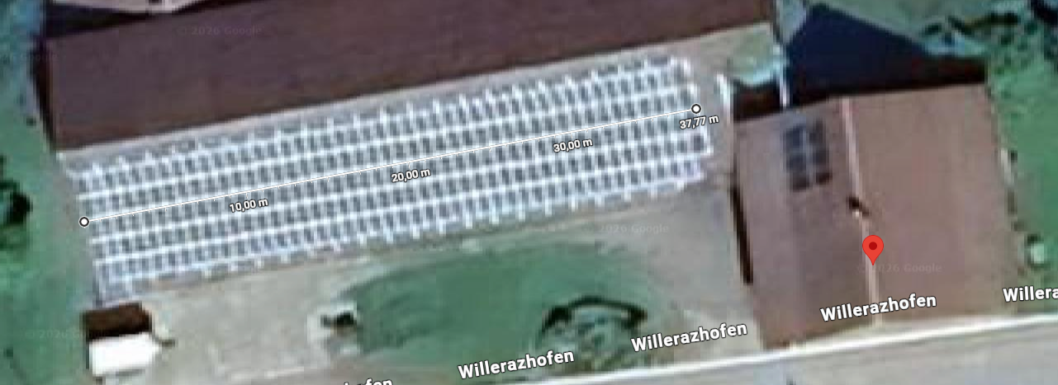
Google Maps Distance Measured: around 37.77 m and 5.96 m
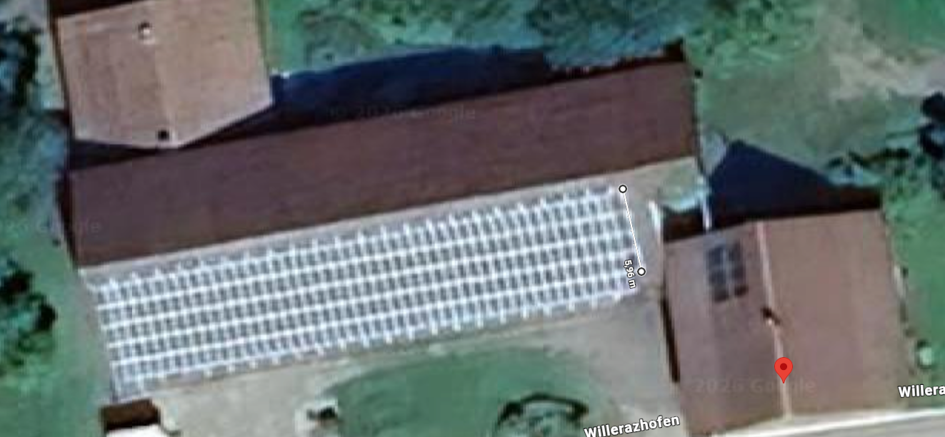
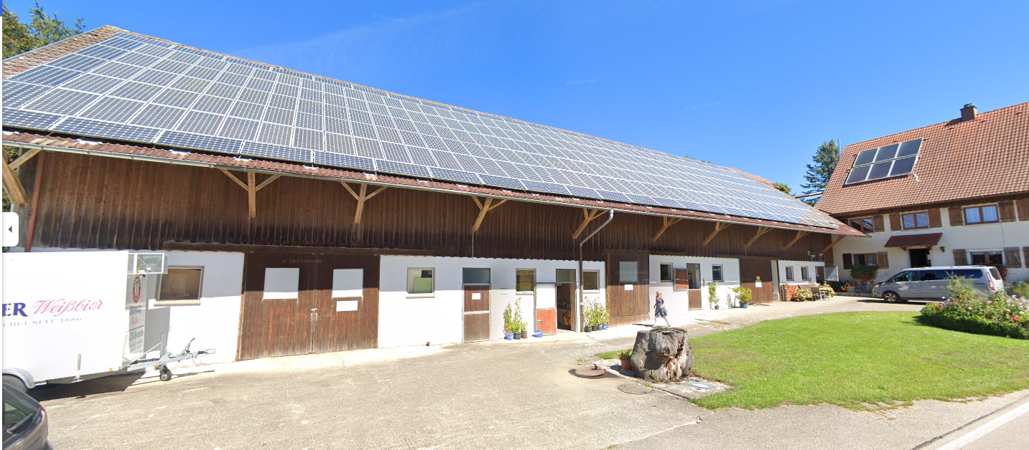
Vertical Solar Panels 44 columns with 5 rows = 220, 220 + 4(from 45th column) = 224
Horizontal Solar Panels 23(1st row) + 22(lowest row) = 45
Area = 0.858 m x 1.49 m ≈ 1.28 m²
Size Calculation:
Short Side: 37.77 m/44 columns (44 solar panels vertically) = around 85.8 cm or 0.858 m
Long Side: 5.96 m/4 rows (4 solar panels at the last column) = 149 cm or 1.49 m
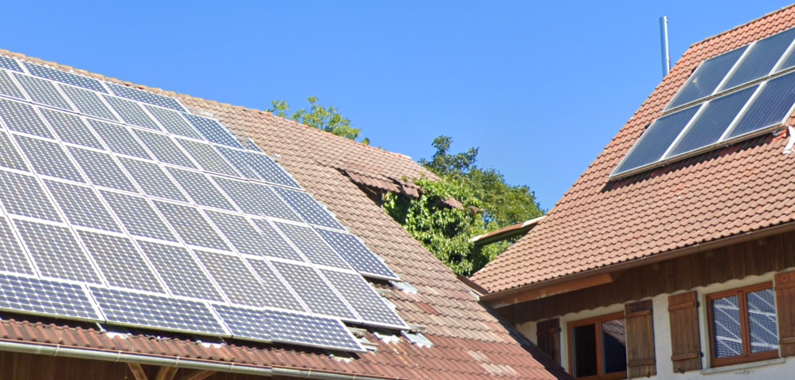
Left = Totally 269 (Monocrystalline or Polycrystalline?) Solar Panels
Right = 6 Solar Panels
Complete Guide About Types of Solar Panels
Since these solar panels belong to 2006, the efficiency of the solar panels can be low.

Onshore Wind Energy
"energy_code": "2497",
"energy_type_name": "Windenergie Onshore - Onshore Wind Energy",
"min_power_kw": 30.4,
"max_power_kw": 8000.0,
"min_ref": {
"file_name": "EinheitenWind.json",
"index_in_file": 4035,
"bundesland_code": "1411",
"bundesland_name": "schleswig_holstein",
"state_name_norm": "schleswigholstein",
"energy_code": "2497",
"energy_label": "Windenergie Onshore - Onshore Wind Energy",
"power_kw": 30.4,
"commissioning_date": "2016-04-29",
"commissioning_year": "2016",
"lon": 8.658601,
"lat": 54.543463,
"google_maps_url": "https://www.google.com/maps?q=54.543463,8.658601"
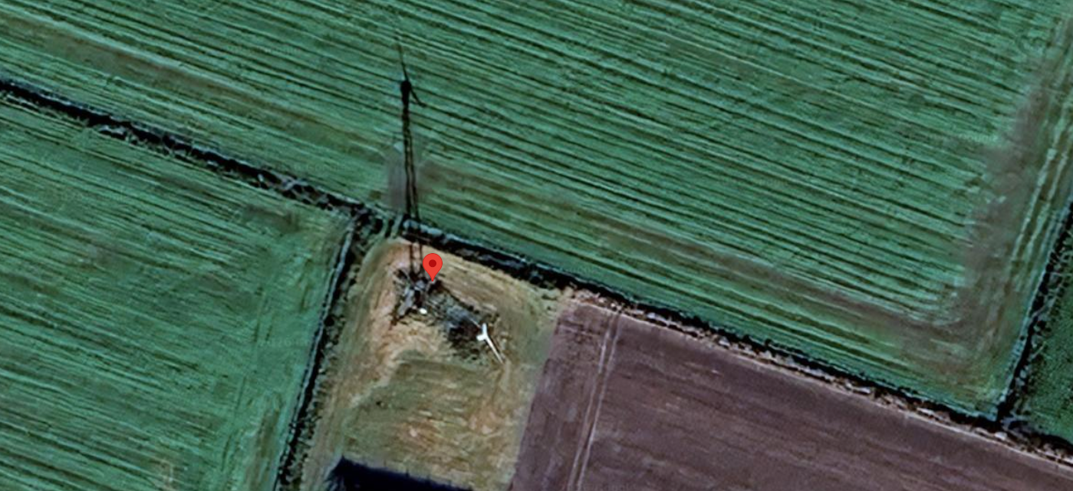

"max_ref": {
"file_name": "EinheitenWind.json",
"index_in_file": 25048,
"bundesland_code": "1404",
"bundesland_name": "bremen",
"state_name_norm": "bremen",
"energy_code": "2497",
"energy_label": "Windenergie Onshore - Onshore Wind Energy",
"power_kw": 8000.0,
"commissioning_date": "2017-07-25",
"commissioning_year": "2017",
"lon": 8.578927,
"lat": 53.505669,
"google_maps_url": "https://www.google.com/maps?q=53.505669,8.578927"
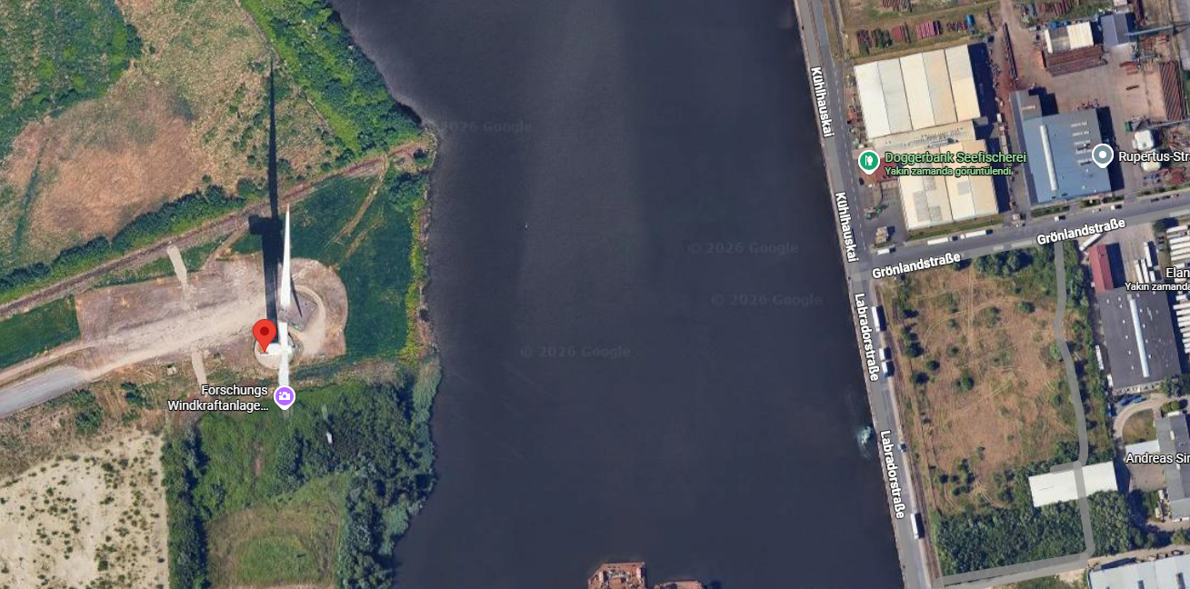
Forschungs Windkraftanlage, Fraunhofer-Institut/Alfred Wegener Institut
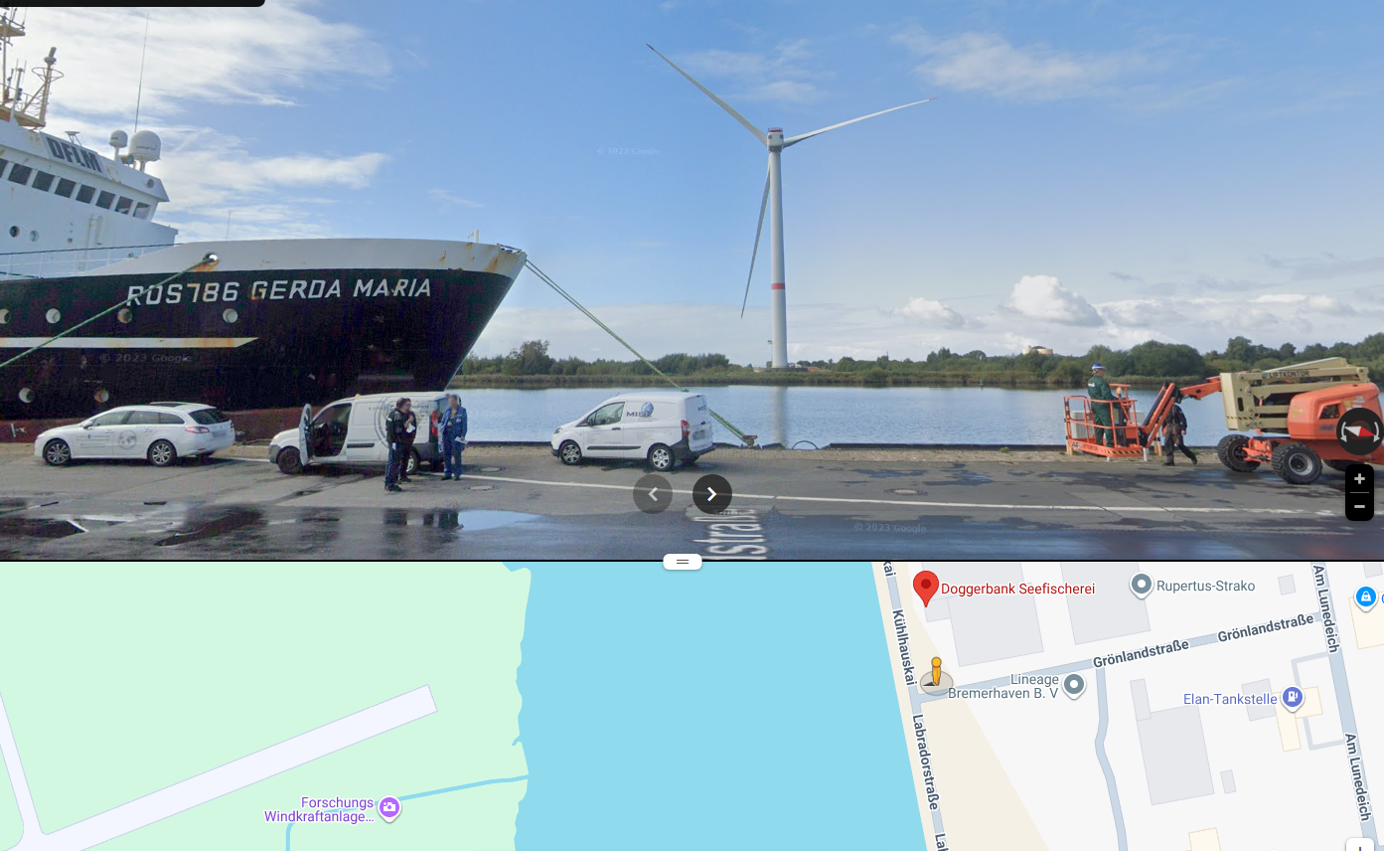

Onshore Wind Energy 2nd Maximum Value
{
"file_name": "EinheitenWind.json",
"index_in_file": 324,
"bundesland_code": "1410",
"bundesland_name": "rheinland_pfalz",
"state_name_norm": "rheinlandpfalz",
"energy_code": "2497",
"energy_label": "Windenergie Onshore - Onshore Wind Energy",
"power_kw": 7580.0,
"commissioning_date": "2012-10-29",
"commissioning_year": "2012",
"lon": 7.682222,
"lat": 49.978479,
"google_maps_url": "https://www.google.com/maps?q=49.978479,7.682222"
}

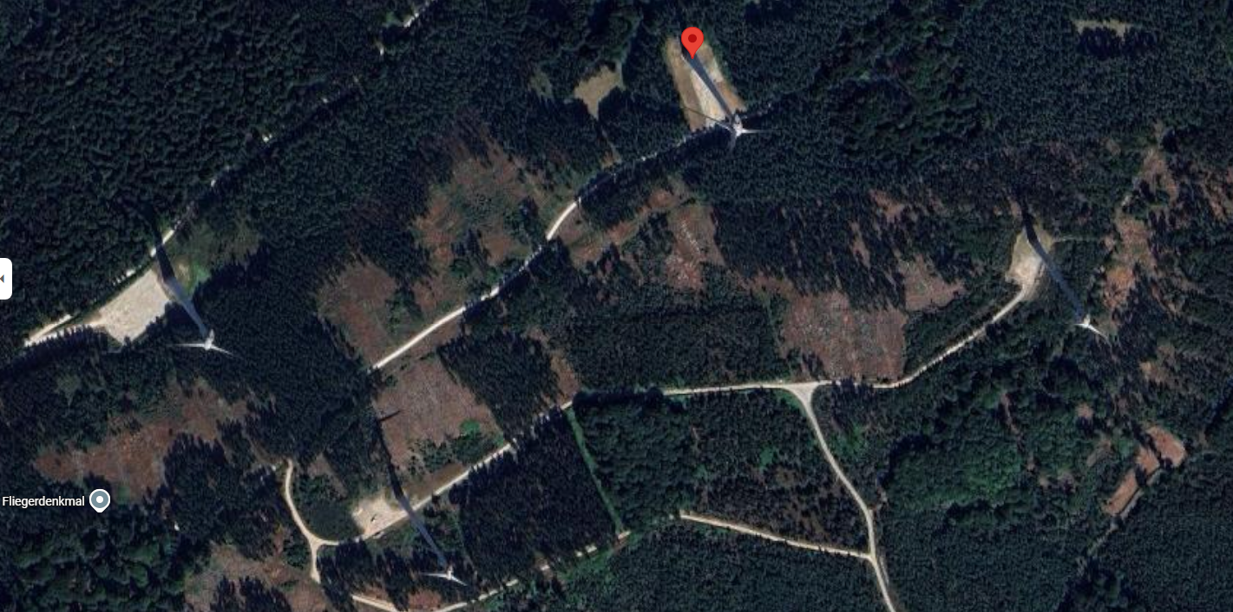
7.58 MW most probably belongs to these 4 onshore wind energy plants.

Onshore Wind Energy 3rd Maximum Value
{
"file_name": "EinheitenWind.json",
"index_in_file": 6874,
"bundesland_code": "1407",
"bundesland_name": "mecklenburg_vorpommern",
"state_name_norm": "mecklenburgvorpommern",
"energy_code": "2497",
"energy_label": "Windenergie Onshore - Onshore Wind Energy",
"power_kw": 7500.0,
"commissioning_date": "2013-09-19",
"commissioning_year": "2013",
"lon": 13.322525,
"lat": 53.720963,
"google_maps_url": "https://www.google.com/maps?q=53.720963,13.322525"
}

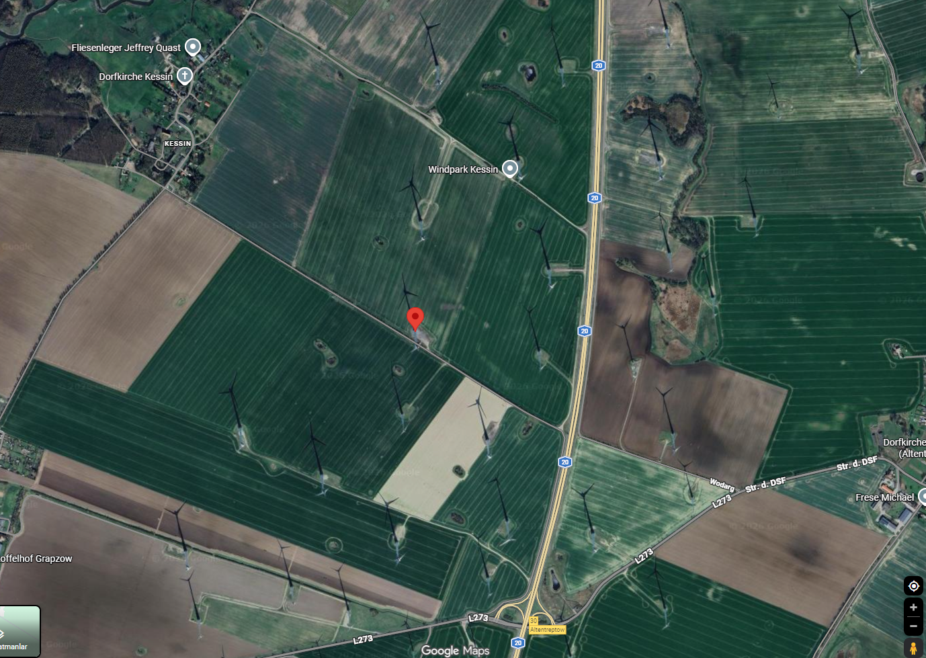
Here, we have a lot of onshore wind energy plants. Again power value can be total of these plants.

Onshore Wind Energy 4th Maximum Value
{
"file_name": "EinheitenWind.json",
"index_in_file": 28830,
"bundesland_code": "1411",
"bundesland_name": "schleswig_holstein",
"state_name_norm": "schleswigholstein",
"energy_code": "2497",
"energy_label": "Windenergie Onshore - Onshore Wind Energy",
"power_kw": 7200.0,
"commissioning_date": "2024-08-08",
"commissioning_year": "2024",
"lon": 9.317652,
"lat": 54.614643,
"google_maps_url": "https://www.google.com/maps?q=54.614643,9.317652"
}

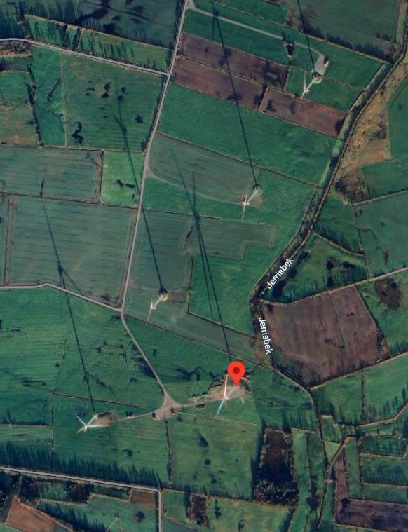

Onshore Wind Energy 5th Maximum Value
{
"file_name": "EinheitenWind.json",
"index_in_file": 29408,
"bundesland_code": "1410",
"bundesland_name": "rheinland_pfalz",
"state_name_norm": "rheinlandpfalz",
"energy_code": "2497",
"energy_label": "Windenergie Onshore - Onshore Wind Energy",
"power_kw": 7000.0,
"commissioning_date": "2025-03-06",
"commissioning_year": "2025",
"lon": 7.750484,
"lat": 49.631822,
"google_maps_url": "https://www.google.com/maps?q=49.631822,7.750484"
}

