Hedjhotep

Busenur Durak, Begüm Özkan, Zeynep Doğan

University of Bakırçay

Abstract

We are a company that produces clothes that adapt to the body of the wearer using 3d printing and nanotechnology. We have stated the details about our company in our report. You can find the relevant information by using the table of contents.

Anahtar sözcükler: clothing, nanotechnology, design, flexibility, 3d printing

Hedjhotep

Our company produces solutions to people's consumption frenzy by using technology. It promises people stylish clothes that they can use for years without worrying about their body.

# Part One

In this section, we have explained questions 1 to 12.

## 1)Business name

## 1.1 What is the name of your business?

Our business name is Hedjhotep.

## 1.2 Why did you choose that name?

While choosing this name, we were affected by the Egyptian god Hedjhotep. Hedjhotep is known as the god of clothing and fabric in Egyptian mythology. Our main purpose in choosing this name is to make women feel special and dazzling as a goddess.

### 2) Description of business

**2.1 What will your business do?**

Thanks to 3 d printing and nanotechnology, we produce flexible and standard size clothes that can adapt to everyone's body. People don't need a tailor and ask, "Is this dress suitable for my size, will it be loose or tight?" they don't think. They can shop freely thanks to hedjhotep without having to try on clothes. The most important feature of our product is that it combines technology and design. We think that people should interact with their clothes.

That's why we designed an outfit by combining feathers, leaf and similar parts that we produced using 3d printing.

#### 3)Slogan

*“Get dressed and go out!”* is our slogan. Because our product is easy to use and comfortable for many years.

##### **4)** **Form of business ownership**

**4.1 What form of business ownership will our business take?**

We choosed general partnership and we our partners is Materialise NV and BASF.

**4.2 Why did us choose this form?**

Companies with partners grow faster than other companies. Because they pool their capital and they can get loans from banks more easily than others.

**5) Ideal customer**

**5.1 Desciription of our ideal customer**

We divided our customers into 2 categories. First categories is women. We targeted espcially, pregnant women and those who gain and lose weight quickly. Because our product can adapt to their changing body sizes and saves them from constantly shopping for clothes. Our products are timeless, so our customers can use our products for a lifetime. With these aspects, we can also appeal to middle-income people. Second categories is 0-13 years old children. We aimed this group because kids grow up fast and their parents have to buy new clothes. Thanks to Hedjhotep kid’s clothes never shrink and pregnant women and when women gain and lose weight, they can continue to wear our products and do not have to buy new clothes.

**5.2What are they like in terms of age, income level, and so on?**

As we mentioned in 5.1, our ideal customers are:

* 0-13 years old children
* Middle-income people
* Pregnant women
* Fast weight gainers and weight losers
* İntermediate size

**6)Our advantages**

**6.1 Why will customers choose to buy from your business, instead of our competition?**

Gaining and losing weight is a problem for many people. Especially people with intermediate sizes need to try on clothes and need a tailor. Most people cannot find the right size for themselves. Our company eliminates these problems. In addition, our product idea is unique and there is no company in the sector that does this. Otherwise we have strong partners who support us.

**7) Ethical principles, code of ethics**

We have 4 ethical norms(utility, rights, justice, caring). First of all, we especially focused to protect the satisfaction and rights of our customers and employees. In the continuation of this we aimed for a high level of success, quality and contribution and we respect the rights of individuals. We, as a company, attach importance to law, regulation and laws. We conduct our business with confidence and fairness. In our company, we attach importance to gender equality.

**8) Social responsibility**

Our company has 2 social responsibility projects. We attach importance to social responsibility projects, but instead of doing many and simple projects, we want to do less and more effective projects. First social responsibility project is *“Buy 1 for yourself dress up 1 child in need”.* We aim to dress a child in need with every hedjhotep clothing purchase such as *“Alexander McQuenn’s shoes”.* Our customers can be accessed from Hedjhotep’s website. In the website, the aid and the places where the aid goes are shown in detail. People can easily access up-to-date information from here. Second social responsibility project is *“Choose Hedjhotep for cleaner waters”*. We clean our water resources with the water cost we reduce by using nanotechnology. We are working with government and environmental organizations around the world on this project. Likewise, you can easily access this information on our website.

**9) Mission and vision statements**

**9.1 Our Mision**

We want to produce comfortable, timeless and stylish clothes for our target audience that can take an active role in their lives.

**9.2 Our Vision**

We want to be one of the top 10 companies in the world clothing industry. We intent to prevent consumerism in the clothing industry and prevent waste.

**10)Analysis of external environment**

In global business environment, due to epidemics such as Covid-19, online sales increased and we made a difference in the clothing industry thanks to our clothes that adapt to every body. In economic environment ,demand for our product is increasing because other companies are selling high-priced clothing, so our income is increasing. In political-legal environment, the state provides grant support to entrepreneurial companies using high technology. In technological environment, thanks to nano technology and 3d printing, we can produce my product. So, technological environment directly affects us. In socioculturel environment, people of all cultures work at our company and we sell to various parts of the world. The last one is domestic business environment. We opened our first store in Istanbul because close to our suppliers, customers and rival companies do not have our characteristics.Our competitors don't have the technology we use.

**11) Business goals**

**11.1 First-years targets**

We want to be involved in the sector and to introduce ourselves and taking part in clothing trends.

**11.2 Medium-term targets**

We intent to have a loyal customer base and Integrating 3d printing and nanotechnology into the good clothing industry.

**11.3 Long-term targets**

We have in one’s sights open chain stores in European countries and the USA that import the most clothes. We want to be one of the top 10 companies in the world clothing industry.

**12)SWOT Analysis**

|  |  |  |  |
| --- | --- | --- | --- |
| Strengths | Weaknesses | Opportunities | Threats |
| * Fast and flexible production capability * We use the most advanced technologies in the clothing industry * We have website and mobile app * We are working with pre-order * Our staff consists of experienced and trained people | * Our costs is high * We have few branches | * We have no competitors yet * Government and technology companies provide support to our company. | * Because it is a first in the industry, people may approach it with prejudice. |

*(Table 1: This table shows Hedjhotep’s Company’s SWOT analysis)*

**PART TWO**

In this section, we have explained questions 13 to 33.

**13) Management**

Our manager should have “Big Five “ personality traits. This traits shoul include high-level agreeableness, medium-level consecientiousness, low-level emotionality, high-level extraversion , high-level openness. In addition, our manager shoul have locus of control, self efficacy, authoritarianism, self-esteem and risk propensity. Our manager can direct the employees and enforce their rules in our company. This shows that our manager is authoritarian.

Our manager should be open to trying new ideas and not avoid taking risks. in this aspect, it should be risk propensity.

**14) Organizational Chart**

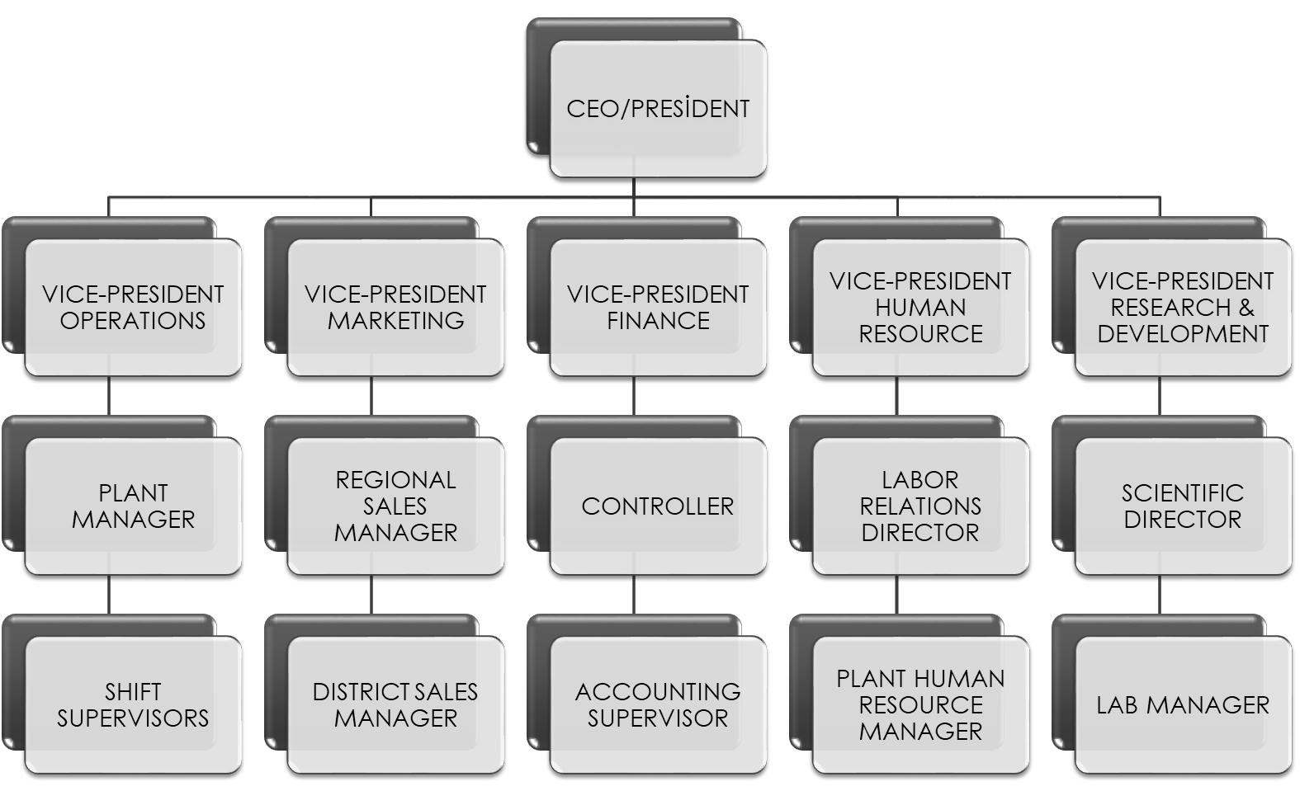

*(Table 2 : This table shows Hedjhotep Company’s organizational chart)*

We choosed funcitional organizational charts. Because, we are currently a small company. In addition, table shows relationship between group functions and activities determine authority. We are centralized company. Each departments should be connected with other departments.

**15) Job descriptions**

The CEO is the person who leads all the team within a company. CEO; manages changes in all departments in the company such as marketing, financing etc. In addition, it enables action by planning new strategies to increase the company's profits and lead employees.There are 5 departments. All of them work under the CEO. In operations department, shift supervisors work under the plant manager and plant manager work under the vice-president operations.In marketing department, district sales manager work under the regional sales manager and regional sales manager work under the vice-president marketing. In finance department, accounting supervisor work under the controller and controller work under the vice-president finance. In human resource, plant human resource manager work under the labor relations director and labor relations director work under the vice-president human resource. In research and development departments, lab manager work under the scientific director and scientific director work under the vice-president research and development.

**16) Job specifications**

The CEO is the person who leads all the team within a company. CEO; manages changes in all departments in the company such as marketing, financing etc. In addition, it enables action by planning new strategies to increase the company's profits and lead employees.

The Vice President of Operations will plan, direct, coordinate, and oversee operations activities in the organization, ensuring development and implementation of efficient operations and cost-effective systems to meet current and future needs of the organization. Serving as a financial advisor to the CEO and executive team for strategic planning purposes. The Vice President of Human Resources (HR) provides executive-level leadership and guidance to the organizations HR operations. The Vice President is responsible for setting, enforcing, and evaluating legally compliant human resources policies, procedures, and best practices, and identifying and implementing long-range strategic talent management goals. Oversee the translation of the needs and customer requirements into technical specifications. Supporting contractual, licensing, financing activities in the business. successful commercial product launches. management, project management and project execution in the group. The Plant Manager will oversee all daily operations of the plant from production and manufacturing to ensuring policies and procedures are followed. They develop processes that will maximize stewardship, safety, quality and productivity. Sells products by maintaining and expanding customer base and managing staff. The controller oversees all employees involved in the accounting process, including accounts receivable, accounts payable, payroll, inventory and compliance. A scientific director manages research programs for a company, organization, or institution.A Shift Supervisor is a professional who is in charge of overseeing business operations on their shift. They must be able to delegate tasks, resolve problems, and make sure that everything goes smoothly for everyone during a given work shift, including stocking inventory all day long until closing down at night. District sales managers are employed by companies to lead sales teams and ensure that company sales objectives are met. They are responsible for recruiting and training sales personnel, managing district sales operations, and evaluating employee performance. Oversees Accounting operations, which include financial accounting, accounts payable, and payroll. Recruits and hires Accounting staff and conducts performance evaluations. Plant Human Resources Manager designs, plans, and implements human resources programs for a plant. Lab managers make sure their employees follow industry standards and safety regulations for handling and disposing of test samples. It's a lab manager's job to schedule lab or equipment use time for staff.

**17) Training**

We provide in cultural centers and workshops our employees with occupational health and safety training, digital marketing training, and informative seminars about their work.

**18) Compensation**

|  |  |  |
| --- | --- | --- |
| Employees | Beginner Level  (0-5 years) | Experienced  (10+ years) |
| CEO | 44.000 | 50.000 |
| Vice-president operations | 22.500 | 27.500 |
| Vice-president marketing | 22.500 | 27.500 |
| Vice-president finance | 22.500 | 27.500 |
| Vice-president human resource | 22.500 | 27.500 |
| Vice-president research and development | 22.500 | 27.500 |
| Plant manager | 14.400 | 18.400 |
| Regional sales manager | 14.400 | 18.400 |
| Controller | 14.400 | 18.400 |
| Labor Relations Director | 14.400 | 18.400 |
| Scientific Director | 14.400 | 18.400 |
| Shift supervisor | 12.600 | 14.000 |
| District sales manager | 12.600 | 14.000 |
| Accounting supervisor | 12.600 | 14.000 |
| Plant human resource manager | 12.600 | 14.000 |
| Lab manager | 12.600 | 14.000 |

*( Table 3 : This table shows the salaries of employees in Turkish liras.)*

We gave the highest salary to the CEO. Because CEO is the most authoritative and senior employee in our company. We determined the salaries according to the subordinate relationship.

We provide insurance and compensation to our employees. Compensation system total package of rewards that organizations provideto individuals in return for their labor. In case of termination of any employment contract for a reason that requires severance pay, severance pay in the amount of 30 days' gross wage is paid for each full year worked. The periods increasing from one year are also included in the calculation by proportioning.

**19) Incentives**

We provide our employees with shopping checks ,extra wages, travel and meals. We also organize company events for our employees to work and socialize in harmony such as barbecue party, picnic, camping etc.

**20) Floor Plan**

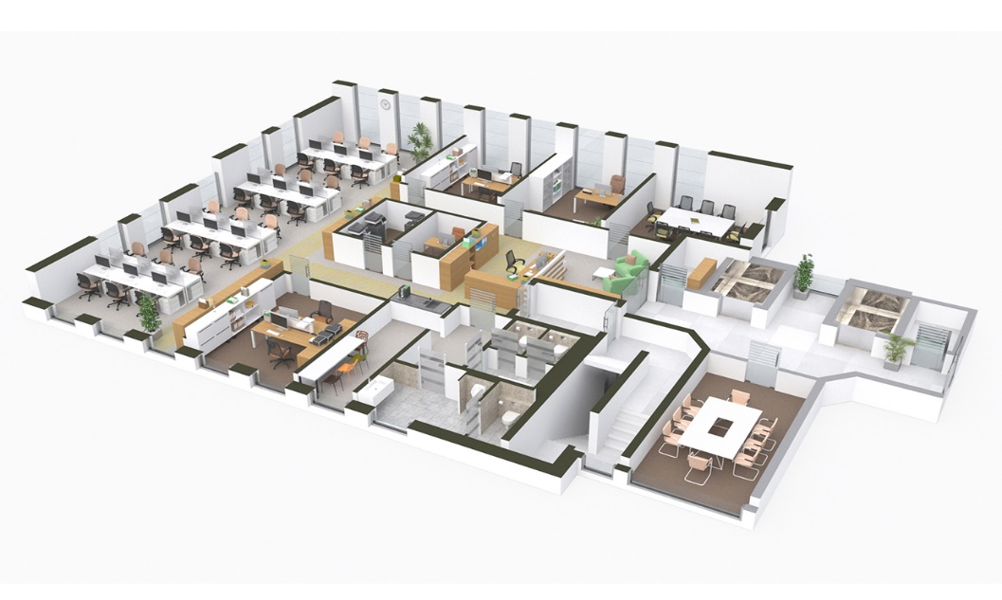

*(Picture1: Picture 1 shows Hedjhotep’s floor plan)*

**21) Quality assurance**

We have our quality control team and customer service. Besides our products , we provide warranty certificate and optional insurance**.**For example, when a customer who receives insurance service has a problem with the product, we provide service throughout the insurance period.

**22) Raw materials and supply**

We use ABS (Akrilonitril Butadien Stiren), PLA(Polilaktik Acit), TPU (Thermoplastic Poliuretan). Because we produce with 3d printing and we can produce our products thanks to these plastic raw materials. In addition, we use nano machines. We produce feather flakes, leaves and similar parts with 3d printing and combine them with nano machines.

We operate from 9.00 to 18.00 for 8 hours.

**23) Target market**

|  |  |
| --- | --- |
| Age | 0-13, 20-40 |
| Education | Grade school or less, graduated high school or not, graduated college or not |
| Family Life Cycle | Young single, young married without children, young married with children, older married with childen under 13,other |
| Family Size | 1, 2-3, 4-5, 6+ |
| Income | More than 8,500 Turkish Liras |
| Nationality | Each nation |
| Race | Each race |
| Religion | Each religion or not have religion |
| Gender | Male, Female |

*(Table 4 : It shows Hedjhotep’s target market)*

**24) Product features & benefits**

* It is flexible and adapts to the body of every wearer.
* People who use this product will not need a tailor.
* Prevents the shopping frenzy.
* It has a stylish, aesthetic and beautiful design.
* It adapts to the changes of the body and is timeless.

**25) Product differentiation**

The adaptability of our product to every body makes us stand out in the sector. We produce leaves, feathers, stamps, etc. with 3D printing in the design. we use parts. In addition, we also have optional color-changing models available thank to nanotechnology. People don't have to try on clothes and they can save their time.

**26) Pricing**

We preferred a pricing strategy that is above the market. Pricing above prevailing market price for similar product to take advantages of common assumption that higher price means higher quality we choosed this strategy.

**27) Place**

We preferred to establish our company in Istanbul. Because it is easier to distribute in terms of location. It is a city with the most developed transportation network in Turkey such as plane , ship etc. Also, there are many nanotechnology and 3d printing companies in Istanbul. This reduces our storage and transportation costs. Another advantage is the proximity to the market place and our customers.

**28) Advertising and promotions**

Our first advertising tool is Internet for global market. Because, we can easily reach our target audience through the Internet. The second advertising tool is TV because of program demographics allow fo customized ads and large audience. The another one is direct mail. Because, we can easily reach target audince and we can send personal messages. The other advertising tool is magazines. We want to introduce our company to people who often reader and shared. The last advertising tool is outdoor because of it’s inexpensive and effective.

**29) IT resources**

We will use intranet for just our employees and staff. Intranet includes confidential information on benefits programs a learning library, production management tools, product design resources. We will use extranet for our partnerships, suppliers and customers. They can reach to order information and stock status. In addition we use electronic conferance for from various location customers, suppliers and business partners.

**30) Customer service**

With data mining and data warehousing, we are able to analyze and get to know our customers better. For example, when the customer buying our product, we can collect customer’s information and analyze customer’s behaviors. Moreover, our company has customer service available 24/7 and a smart assistant in our mobile application like trendyol assistant. Summarize, this situation increasing customers’ satistification and it strengthens our customer relationships.

**31) Expected revenue**

We are aiming at 15 million customers from Turkey and 20 million customers from global market. We will sell 16.000.000 children’s clothes at TL 600 per unit. We will sell 19.000.000 women’s clothes at TL 500 per unit.

16.000.000 *600 = 9600000000

19.000.000 *500=9500000000

Total revenue of 1 year = 19 100 000 000 Turkish Liras

**32) Cost of doing business**

|  |  |
| --- | --- |
| Hedjhotep Company  Income Statement  2023 | |
| Sales Revenue | 19.100.000.000 |
| -Sales Return | (100.000.000) |
| Net Sales | 19.000.000.000 |
| -COGS | (13.200.000.000) |
| Gross P/L | 5.800.000.000 |
| Other Revenues | 1.200.000.000 |
| Insurance Revenue | 1.200.000.000 |
| -Operating Expenses | (251.200.000) |
| * Rent Expense 150.000.000 * Salary Expense 100.000.000 * Insurance Expense 200.000 * Utilities Expense 1.000.000 |
| Net P/L | 6.748.800.000 |

*(Table 5: Table 5 shows Hedjhotep’s estimation of income statement for 1 year)*

**33) Start-up costs**

We presented our product idea to our partners and they invested in us. In addition, it has become easier for us to get loans from banks. Our start-up cost is 7.000.000.000 Turkish Liras.

References

Ebert, Ronald J. (2018). *Business Essentialsı.* Şehir Adı: Pearson.

.

Tables

Table 1:

|  |  |  |  |
| --- | --- | --- | --- |
| Strengths | Weaknesses | Opportunities | Threats |
| * Fast and flexible production capability * We use the most advanced technologies in the clothing industry * We have website and mobile app * We are working with pre-order * Our staff consists of experienced and trained people | * Our costs is high * We have few branches | * We have no competitors yet * Government and technology companies provide support to our company. | * Because it is a first in the industry, people may approach it with prejudice. |

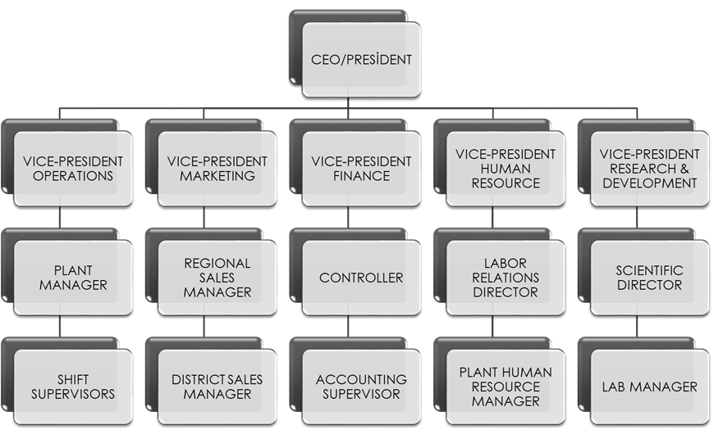Table2:

Table 3:

|  |  |  |
| --- | --- | --- |
| Employees | Beginner Level  (0-5 years) | Experienced  (10+ years) |
| CEO | 44.000 | 50.000 |
| Vice-president operations | 22.500 | 27.500 |
| Vice-president marketing | 22.500 | 27.500 |
| Vice-president finance | 22.500 | 27.500 |
| Vice-president human resource | 22.500 | 27.500 |
| Vice-president research and development | 22.500 | 27.500 |
| Plant manager | 14.400 | 18.400 |
| Regional sales manager | 14.400 | 18.400 |
| Controller | 14.400 | 18.400 |
| Labor Relations Director | 14.400 | 18.400 |
| Scientific Director | 14.400 | 18.400 |
| Shift supervisor | 12.600 | 14.000 |
| District sales manager | 12.600 | 14.000 |
| Accounting supervisor | 12.600 | 14.000 |
| Plant human resource manager | 12.600 | 14.000 |
| Lab manager | 12.600 | 14.000 |

Table 4:

|  |  |
| --- | --- |
| Age | 0-13, 20-40 |
| Education | Grade school or less, graduated high school or not, graduated college or not |
| Family Life Cycle | Young single, young married without children, young married with children, older married with childen under 13,other |
| Family Size | 1, 2-3, 4-5, 6+ |
| Income | More than 8,500 Turkish Liras |
| Nationality | Each nation |
| Race | Each race |
| Religion | Each religion or not have religion |
| Gender | Male, Female |

Table 5:

|  |  |
| --- | --- |
| Hedjhotep Company  Income Statement  2023 | |
| Sales Revenue | 19.100.000.000 |
| -Sales Return | (100.000.000) |
| Net Sales | 19.000.000.000 |
| -COGS | (13.200.000.000) |
| Gross P/L | 5.800.000.000 |
| Other Revenues | 1.200.000.000 |
| Insurance Revenue | 1.200.000.000 |
| -Operating Expenses | (251.200.000) |
| * Rent Expense 150.000.000 * Salary Expense 100.000.000 * Insurance Expense 200.000 * Utilities Expense 1.000.000 |
| Net P/L | 6.748.800.000 |