

University of Limerick

Department of Computer Science
and
Information Systems

Assessment Paper

Semester: 1 | Academic Year: 1995/96
Module Code: CS4313 | Module Title: Software Engineering Project
Duration of Exam: 2.5 hours | % of Total Marks: 35%
Lecturer: Michael Coughlan

Instructions to Candidates.

NOTE: As well as this exam paper you should have the following;
1. Cobol Metalanguage Elements.
2. Program Outline :- CS431395.Exm
3. Example Output :- OilStock.RPT
Error.DAT
4. Example Input :- Trans.DAT
ODF.DAT
OSF.DAT

Introduction

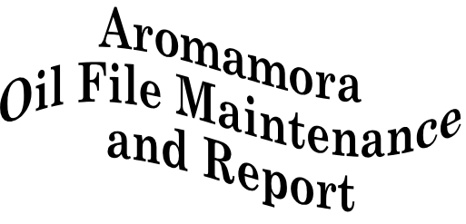
Aromamora PLC sells essential oils to Aromatherapists, Health Shops, Chemists and other retailers. Details of the oils sold are kept in two files:- the Oil-Details-File and the Oil-Stock-File. A program is required which will apply a file of sorted, validated transactions to the Oil-Stock-File and then produce a report based on the contents of both the Oil-Details-File and the Oil-Stock-File.
The report must be printed sequenced on ascending Oil-Name. The report writer must be used to produce the report.

Transaction File
The Transaction file is a sorted, validated file containing two types of stock movement record. The record types are distinguished from one another by a unique code in the first column of the record. The file has been sorted on ascending Type-Code.
The record descriptions for the Transaction file are as follows;

Record Type | Field | Type | Length | Value
AddToStock. | Type Code | 9 | 1 | 1
 | Oil-Number | 9 | 4 | -
 | Qty (in units) | 9 | 5 | 1-99999
RemoveFromStock | Type-Code | 9 | 1 | 2
 | Oil-Number | 9 | 4 | -
 | Qty (in units) | 9 | 5 | 1-99999

Oil-Stock-File
The Oil-Stock-File is used to hold details of the current stock levels. It is a relative file containing records with the following description;

Field | Key type | Type | Length | Value
Oil-Number | Primary | 9 | 4 | -
Qty-In-Stock | -- | 9 | 5 | 1-999999

Note : Only the first three digits of the Oil-Number are the Relative Record Key. The fourth digit is a check digit used to validate the Oil-Number. Before the Oil-Number can be used to access records in the Oil-Stock-File this fourth digit must be stripped off. For instance, to access the record for Oil-Number 0248 only the 024 part of the number can be used as the key.

Oil-Details-File
The Oil-Details-File is an indexed file containing records with the following description;
Field | Key type | Type | Length | Value
Oil-Number | Primary | 9 | 4 | -
Oil-Name | ALT with Duplicates | X | 20 | -
Unit-Size | -- | 9 | 2 | 03-90
Unit-Cost | -- | 9 | 4 | 1.50-99.99

Validation.
Although the Transaction file has been validated certain errors cannot be detected until an attempt is made to update the Oil-Stock-File. For both types of transaction record, check that the record you are about to update already exists in the Oil-Stock-File. If it does not then the transaction record must be written to an Error-File.

The Oil Stock Report
The Oil Stock Report must be printed after the Oil-Stock-File has been updated. The report must be printed sequenced on ascending Oil-Name.

Numeric values must be printed using comma insertion and either zero suppression or the floating currency symbol. Most of the Report Writer entries have been set up for you in the Program Outline. Please supply any missing entries (indicated by a row of dots).

See the print specification below for more report format details.
Line 1-2 Report Heading. To be printed on the first page of the report only.
Line 6 Page-Heading. To be printed at the top of each page.
Line 8 Detail line. The Oil-Name is suppressed after its first occurrence.
Size is the Unit-Size. Qty is the Quantity-In-Stock. Stock-Value is a computed value (Quantity-In-Stock * Unit-Cost).
Line 14 Control Footing. Total-Oil-Value is the sum of the Stock-Values for this oil.
Line 24 Final Control Footing. This is the sum of the Total-Oil-Values.
