Deliverable 1: Project Plan & Solution Architecture
DreamHouse Offer Management Capstone
Prepared for SkillWallet / AICAFE Program
Presenter: Bushra Salama Aljohani

1. Project Overview
DreamHouse Property Sales Assistant is a Salesforce solution for real-estate brokers. It extends the DreamHouse application with structured Offer management, data-quality controls, automated lifecycle initialization, high-value approval governance, and Agentforce-assisted access to Offer information.

2. Business Problem
Brokers need a reliable way to capture client offers against properties, connect each offer to a client, prevent invalid values, and escalate high-value offers for approval. Without a structured process, offer details can be inconsistent, approval decisions are harder to trace, and brokers spend extra time searching for record information.

3. Objectives
- Centralize Offer information in Salesforce.
- Connect each Offer to a Property and Contact.
- Block invalid offer amounts and past target close dates.
- Automatically initialize new Offers to Submitted.
- Route high-value Offers through a controlled approval process.
- Provide an Agentforce Employee Agent that helps brokers retrieve and explain Offer information.
- Integrate Agentforce with Flow to retrieve live Salesforce Offer data.

4. Scope
Area | Included Implementation
Data model | Offer object with amount, close date, status, Property relationship, and Contact relationship.
Data quality | Validation rules for positive Offer Amount and non-past Target Close Date.
Automation | Record-triggered Flow for Offer status initialization; autolaunched Flow for Agentforce retrieval.
Governance | High Value Offer Approval process for Offers of SAR 500,000 or more.
Agentforce | Employee Agent with Offer Management subagent and Get Offer Details Flow action.
Out of scope | Apex, LWC, external API integrations, and complex dashboards were not required for the minimal capstone demonstration.

5. Architecture
The solution combines standard DreamHouse records, a custom Offer object, Flow automation, approval management, and Agentforce. Agentforce calls an autolaunched Flow to retrieve Offer information from Salesforce and then explains the result using configured business rules.
Layer | Component | Purpose
Application/UI | DreamHouse App | Broker-facing workspace for Properties, Contacts, and Offers.
Data Model | Offer object | Stores offer amount, target close date, lifecycle status, Property link, and Contact link.
Controls | Validation Rules | Prevent invalid offer amounts and past close dates.
Automation | Offer Status Initialization Flow | Sets new Offer status to Submitted.
Automation | Get Offer Details Flow | Retrieves Offer information for Agentforce by Offer Name.
Governance | High Value Offer Approval | Routes Offers of SAR 500,000 or more to management review.
AI Assistant | DreamHouse Property Sales Assistant | Helps brokers retrieve Offer details and understand high-value Offer rules.

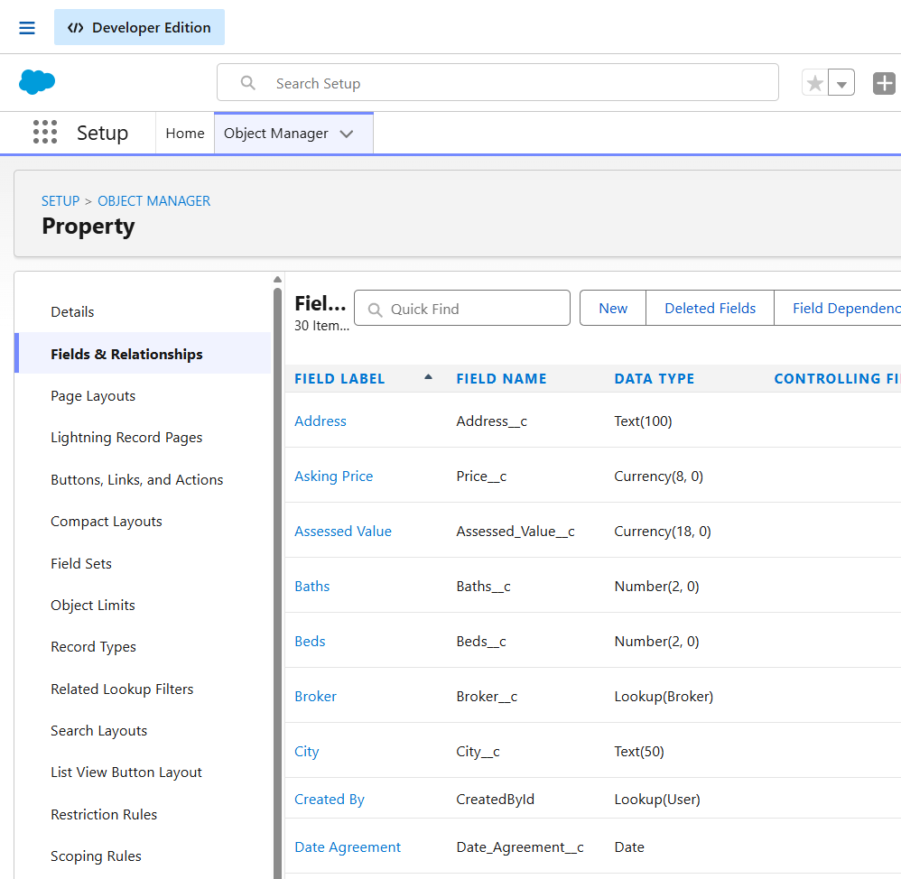
Evidence: Property fields and relationships configured in Salesforce.

6. Security and Access Model
- Offer access follows Property through the master-detail relationship.
- Contact is referenced through a lookup relationship.
- Approval locks high-value Offer records during review.
- A future production deployment should use dedicated permission sets for brokers and managers with least-privilege access.

7. Delivery Plan
Phase | Outcome
Planning | Defined the DreamHouse Offer Management scope and business process.
Data Model | Configured Offer fields, Property relationship, and Contact relationship.
Validation & Automation | Created validation rules and status initialization Flow.
Approval | Configured high-value approval threshold and final outcomes.
Agentforce | Created an Employee Agent and connected it to Get Offer Details Flow.
Testing & Demo | Validated Flow retrieval and Agentforce response using Offer OF-0001.

8. Conclusion
The project provides a coherent Salesforce CRM implementation for real-estate Offer management. It demonstrates data modeling, validation, Flow automation, approval governance, and a working Agentforce-to-Flow integration for live Offer retrieval.

