
Task-3 Report

Title: CNN baseline and Proposed GCN for Brain Tumor MRI Classification

Course Title: Machine Learning
Course Code: CSE475
Semester: Summer 2026
Section: 06
Submitted By:
Student Name | Student ID
Meghla Biswas | 2023-1-60-225
Musfirat Rahman Zilik | 2023-1-60-184
Bushra Khan Zilik | 2023-1-60-087

Submitted To:
Dr. Raihan Ul Islam
Associate Professor, Department of CSE
East West University

Abstract
Task 3 extends the Task 2 superpixel-graph GCN for four-class brain-tumor MRI classification. The main aim was not simply to increase the test accuracy, but to examine which graph and training choices actually help the model and to make the resulting predictions easier to interpret. The implementation first removed duplicate and cross-split leakage using the same 16×16 perceptual-hash procedure used in the earlier stage. After cleaning, 5,652 images were available for the train/validation pool and 575 images remained in the held-out test set. Graphs were constructed from SLIC superpixels and a region-adjacency graph (RAG), with an average of 61.3 nodes per image in the default graph.
The improvement study varied the number of superpixels, edge weighting, GCN depth and width, dropout, batch normalization, learning rate and schedule, and class-weighted loss. The strongest single change in the sweep was reducing dropout from 0.4 to 0.2. With this configuration, five-fold cross-validation produced 80.86% ± 0.80% validation accuracy and 81.23% ± 0.96% macro-F1. On the untouched test set, the hand-crafted-feature GCN reached 75.83% accuracy and 0.74 macro-F1, compared with 75.13% for the Task 2 GCN. This is a 0.70 percentage-point improvement, although the absolute test performance remains below the ViT baseline.
A second, controlled ablation used the same frozen ResNet18 feature extractor for both a CNN-only classifier and a CNN+GCN model. The CNN-only model reached 89.39% test accuracy, while the CNN+GCN model reached 90.78%, a gain of 1.39 percentage points. McNemar's test for these paired predictions gave p = 0.2433, so the observed gain was not statistically significant at α = 0.05. For interpretability, GNNExplainer, superpixel-level Grad-CAM and superpixel-level LIME were applied to one correct and one incorrect prediction. The report therefore separates measurable improvement from qualitative evidence and avoids presenting an unsupported claim of statistical superiority.

1. Introduction and Task 3 Objectives
The Task 2 model established a superpixel-graph representation in which each MRI image is converted into a graph before classification. Task 3 keeps that central idea and studies how the graph representation and the GCN training procedure can be improved. The practical motivation is straightforward: a graph model can fail because the graph is too coarse, too fragmented, or poorly weighted, or because the network is under- or over-regularized. A systematic sweep is therefore more informative than changing several settings at once.
- Vary graph construction through the number of superpixels and edge weighting.
- Vary GCN depth, hidden width, dropout and batch normalization.
- Test learning-rate and ReduceLROnPlateau choices and class-weighted loss.
- Report five-fold cross-validation as mean ± standard deviation without using the held-out test set for model selection.
- Compare the first GCN, the improved GCN and the strongest image baseline used in the implementation.
- Provide a paired significance test and controlled CNN-only versus CNN+GCN ablation.
- Use GNNExplainer, superpixel Grad-CAM and superpixel LIME on one correct and one wrong prediction.

2. Dataset Preparation and Leakage Control
The experiments use four classes: glioma, meningioma, notumor and pituitary. The cleaning procedure was deliberately kept consistent with the earlier implementation. A 16×16 perceptual hash was calculated for each image, duplicates were removed within each split, and then images whose hashes appeared in an earlier split were removed from later splits. This matters because near-identical images across training and testing could make a model appear stronger than it really is.
Stage | Images retained | Comment
Train after within-split deduplication | 5,041 | 559 duplicates removed from 5,600
Validation after within-split deduplication | 770 | 30 duplicates removed from 800
Test after within-split deduplication | 763 | 37 duplicates removed from 800
Train → validation leakage removal | 611 validation | 159 leaked images removed
Train → test leakage removal | 594 test | 169 leaked images removed
Validation → test leakage removal | 575 test | 19 additional leaked images removed
Train + validation pool | 5,652 | Used for CV and final training
Held-out test | 575 | Kept outside CV/model selection

The final 575-image test set was not used during the five-fold sweep or cross-validation. The Task 3 implementation also rebuilt test graphs when a graph-structure configuration required it, which prevents a mismatch between the graph used for training and the graph used for testing.

3. Graph Construction
Each image is converted to grayscale and resized to 128×128 before graph construction. SLIC segmentation creates superpixels, and each superpixel becomes one graph node. Adjacent superpixels are connected through a region-adjacency graph. The default setting targets 75 superpixels per image; the actual number of nodes varies with the segmentation.
Component | Implementation
Image representation | Grayscale, resized to 128×128
Node definition | One SLIC superpixel
Default target | 75 superpixels per image
Average nodes | 61.3 nodes/graph
Node features | Mean intensity, intensity standard deviation, normalized x/y centroid, area fraction
Node feature dimension | 5
Edges | RAG connections between adjacent superpixels
Edge weight | 1 / (1 + absolute difference in mean node intensity)
Alternative graph settings | 50 nodes target, 120 nodes target, or edge weights disabled

The edge-weight rule gives larger weights to neighboring regions with more similar mean intensity. In the sweep, this choice was tested against the same graph with edge weights removed. This is useful because it isolates whether similarity information between adjacent regions adds value beyond connectivity alone.

4. Improved GCN Architecture and Training
The GCN was rewritten as a configurable architecture so that the major design choices could be changed without creating separate model implementations. The default model contains three GCNConv layers, batch normalization, ReLU activations and dropout, followed by global mean pooling and global max pooling. The two pooled representations are concatenated and passed through a 128-unit classification layer before the four-class output.
Setting | Default / final sweep setting
GCN layers | 3
Hidden channels | 64
Batch normalization | Enabled
Dropout | 0.2 in the winning configuration; default 0.4
Pooling | Global mean + global max
Classifier hidden layer | 128
Optimizer | Adam
Base learning rate | 0.001
Weight decay | 1×10⁻⁴
LR schedule | ReduceLROnPlateau; factor 0.5
Class imbalance | Balanced class-weighted cross-entropy
Early stopping | Minimum 50 epochs; patience 6; best validation-loss weights restored
Maximum epochs in final runs | 60
Cross-validation | Stratified 5-fold on train+validation only

5. Improvement Sweep
Task 3 used a one-axis-at-a-time sweep rather than a large combinatorial search. This keeps the comparison readable and makes it easier to attribute a change in validation performance to one design decision. The sweep used a shorter training budget for ranking configurations; the selected configuration was then evaluated with the full training policy.
Variant | Layers | Width | Dropout | BN | LR | Schedule | Class weights | Val accuracy
dropout_low_0.2 | 3 | 64 | 0.2 | Yes | 0.001 | Yes | Yes | 0.814858
width_128 | 3 | 128 | 0.4 | Yes | 0.001 | Yes | Yes | 0.812500
lr_high_5e-3 | 3 | 64 | 0.4 | Yes | 0.005 | Yes | Yes | 0.812500
default_n75 | 3 | 64 | 0.4 | Yes | 0.001 | Yes | Yes | 0.808962
no_class_weights | 3 | 64 | 0.4 | Yes | 0.001 | Yes | No | 0.806604
no_lr_schedule | 3 | 64 | 0.4 | Yes | 0.001 | No | Yes | 0.804245
edges_off | 3 | 64 | 0.4 | Yes | 0.001 | Yes | Yes | 0.800708
nodes_n120 | 3 | 64 | 0.4 | Yes | 0.001 | Yes | Yes | 0.799528
dropout_high_0.5 | 3 | 64 | 0.5 | Yes | 0.001 | Yes | Yes | 0.798349
depth_4layers | 4 | 64 | 0.4 | Yes | 0.001 | Yes | Yes | 0.798349
nodes_n50 | 3 | 64 | 0.4 | Yes | 0.001 | Yes | Yes | 0.794811
width_32 | 3 | 32 | 0.4 | Yes | 0.001 | Yes | Yes | 0.794811
depth_2layers | 2 | 64 | 0.4 | Yes | 0.001 | Yes | Yes | 0.794811
batchnorm_off | 3 | 64 | 0.4 | No | 0.001 | Yes | Yes | 0.758255
lr_low_1e-4 | 3 | 64 | 0.4 | Yes | 0.0001 | Yes | Yes | 0.748821

The winning configuration was dropout 0.2. Its validation accuracy of 81.486% was higher than the default 80.896%. The sweep also shows that removing batch normalization or lowering the learning rate to 1×10⁻⁴ was particularly harmful under the short ranking budget. Turning off edge weights also reduced validation accuracy, supporting the decision to retain weighted RAG edges in the final hand-crafted-feature model.

6. Five-Fold Cross-Validation
After selecting dropout 0.2, the implementation performed stratified five-fold cross-validation on the 5,652-image train+validation pool. The held-out test set was not included. Each fold trained a fresh GCN using the same minimum/maximum epoch policy and early stopping.
Fold | Validation accuracy | Validation loss | Macro precision | Macro recall | Macro-F1
1 | 0.814324 | 0.475160 | 0.818391 | 0.824163 | 0.819986
2 | 0.816976 | 0.485403 | 0.821135 | 0.824027 | 0.820618
3 | 0.806195 | 0.482580 | 0.805640 | 0.816388 | 0.809736
4 | 0.796460 | 0.508261 | 0.793376 | 0.807587 | 0.797238
5 | 0.808850 | 0.494632 | 0.811906 | 0.818925 | 0.814131
Mean ± std | 0.8086 ± 0.0080 | — | — | — | 0.8123 ± 0.0096

The relatively small standard deviations indicate that the selected configuration behaved consistently across the five folds. At the same time, the fold range shows that performance was not identical across partitions, which is expected for a medical image dataset where visually similar classes can overlap.

7. Held-Out Test Performance
The final hand-crafted-feature GCN was trained using the selected configuration and evaluated once on the untouched 575-image test set. It achieved 75.83% accuracy and a macro-F1 of approximately 0.74. The class-level report shows the strongest recall for pituitary and notumor, while glioma and meningioma were more difficult to separate.
Class | Precision | Recall | F1-score | Support
glioma | 0.75 | 0.62 | 0.68 | 176
meningioma | 0.67 | 0.55 | 0.60 | 142
notumor | 0.59 | 0.98 | 0.74 | 58
pituitary | 0.89 | 0.96 | 0.93 | 199
Macro average | 0.72 | 0.78 | 0.74 | 575
Weighted average | 0.76 | 0.76 | 0.75 | 575

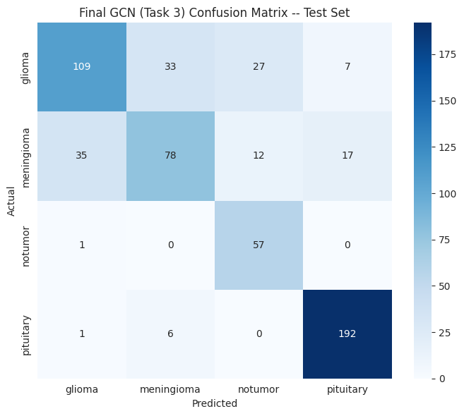
Figure 1. Final Task 3 GCN confusion matrix on the held-out test set. This figure is taken directly from the experiment output.

8. Comparison with Task 2 and the Best Image Baseline
The Task 2 GCN reached 75.13% held-out test accuracy. The Task 3 hand-crafted-feature GCN reached 75.83%, giving an improvement of 0.70 percentage points. The strongest image baseline supplied with the experiments was ViT-Base/16 with 94.97% accuracy and macro-F1 0.9465. The CNN transfer-learning baselines were VGG16 at 93.86%, ResNet50 at 93.39% and EfficientNetB0 at 88.01%.
Model | Accuracy | Macro-F1 | Role
Task 2 GCN | 75.13% | 0.73 | First GCN
Task 3 improved GCN | 75.83% | 0.74 | Selected hand-crafted-feature GCN
VGG16 transfer | 93.86% | 0.9336 | CNN baseline
ResNet50 transfer | 93.39% | 0.9222 | CNN baseline
EfficientNetB0 transfer | 88.01% | 0.8744 | CNN baseline
ViT-Base/16 | 94.97% | 0.9465 | Best image baseline in supplied experiments

The comparison should be interpreted carefully. ViT is a transformer rather than a CNN, although the Task 3 implementation uses it as the best baseline for the paired significance test. The Task 3 hand-crafted GCN therefore does not outperform the strongest image model. The important result is that the selected graph changes produced a small but measurable improvement over the original GCN while keeping the same leakage-controlled test protocol.

9. Statistical Significance
The Task 3 significance procedure uses McNemar's test because the two models are evaluated on paired predictions from the same images. The implementation aligned predictions by filepath rather than assuming that two independently produced files had identical row order. For the comparison with ViT, 573 test images matched between the two prediction files. The contingency table gave 434 cases where both models were correct, 108 where only ViT was correct, 2 where only the GCN was correct, and 29 where both were wrong. The resulting McNemar statistic was 100.2273 with p = 0.0000, which is significant at α = 0.05. This result indicates that the GCN and ViT made substantially different error patterns, with the ViT correct on many more of the paired cases.
This significance result is also why the accuracy values should not be interpreted as interchangeable. The paired test supports a clear difference in prediction behavior, but it does not show that the GCN is better; in this comparison the direction strongly favors the ViT.

10. Explainability
Task 3 adds three complementary explanation methods at the superpixel level. GNNExplainer estimates node and edge importance for the graph prediction. Superpixel Grad-CAM computes an importance score from gradients through the final GCN layer. Superpixel LIME perturbs subsets of nodes and fits a weighted linear surrogate to estimate which superpixels influence the model output. All three were applied to the same correctly classified and misclassified examples so that the explanations can be compared directly.
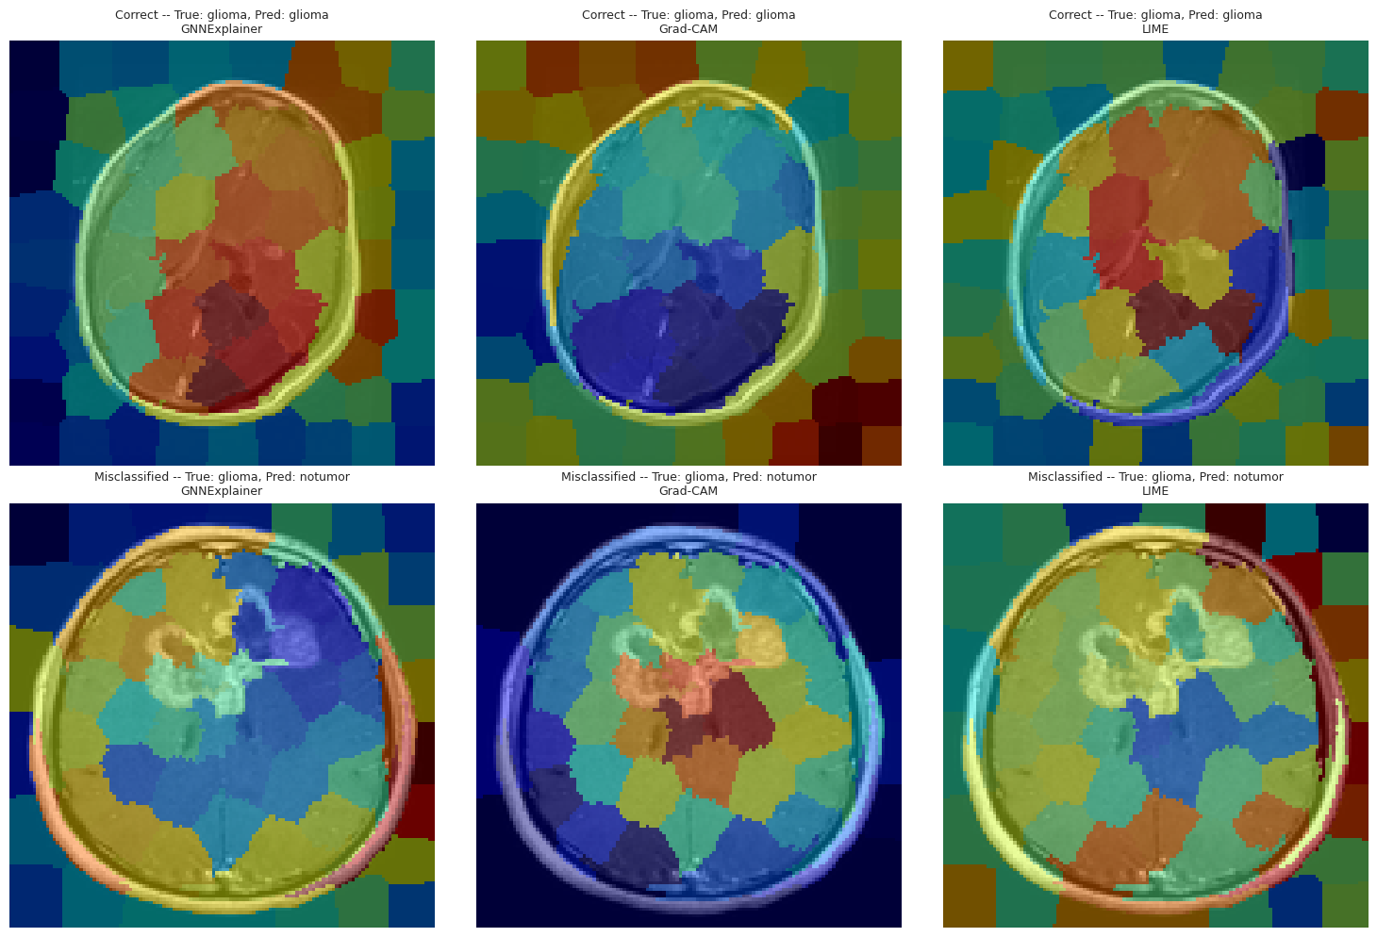
Figure 2. Direct experiment output showing GNNExplainer, superpixel Grad-CAM and superpixel LIME for one correct and one misclassified prediction.
In the correct example, the model predicted glioma as glioma. In the incorrect example, the true label was glioma but the model predicted notumor. The three maps do not need to be identical because they answer the explanation question in different ways: GNNExplainer focuses on graph attributes and structure, Grad-CAM follows gradient-based feature relevance, and LIME measures the effect of node perturbations. The wrong prediction is particularly useful because it shows that the model can place substantial importance on regions that do not lead to the correct class.

11. Ablation: CNN-only vs. CNN+GCN
A separate ablation was designed to isolate the contribution of graph structure. Both models use the same frozen ImageNet-pretrained ResNet18 feature extractor. Model A globally averages the CNN feature map and sends the resulting 128-dimensional vector to a small classifier. Model B keeps the same CNN feature source but assigns a 128-dimensional feature vector to each superpixel and then applies the GCN to the same graph structure. This makes the comparison more controlled than comparing two unrelated architectures.
Model | Test accuracy | Difference
CNN-only (Model A) | 89.39% | —
CNN+GCN (Model B) | 90.78% | +1.39 percentage points

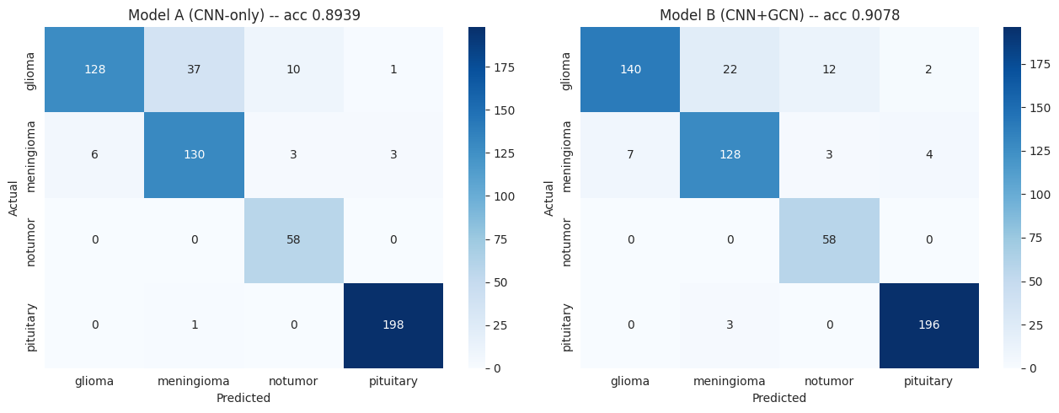
Figure 3. Direct ablation output: confusion matrices for the CNN-only and CNN+GCN models.
McNemar's test for the paired CNN-only and CNN+GCN predictions produced the contingency counts 500 both-correct, 14 CNN-only correct, 22 CNN+GCN-only correct and 39 both-wrong. The statistic was 1.3611 and p = 0.2433. Therefore, although the CNN+GCN model achieved a 1.39-point accuracy gain, the difference was not statistically significant at the 0.05 level. This is an important qualification: the ablation provides evidence that graph structure may help, but the current experiment is not strong enough to claim a statistically confirmed improvement.

12. What Was and Was Not Implemented
The implementation directly covers several requested Task 3 improvement axes: graph node count, edge weights, GCN depth and width, dropout, batch normalization, learning rate, learning-rate scheduling, class-weighted loss and early stopping. The explainability requirement is also covered with GNNExplainer, Grad-CAM and LIME at the superpixel level.
Requested direction | Status in supplied implementation
Vary graph construction / nodes per image | Implemented: 50, 75 and 120 superpixel targets
Edge weights on/off | Implemented
GCN depth/width | Implemented: 2/3/4 layers and 32/64/128 hidden channels
Dropout | Implemented: 0.2/0.4/0.5
Batch normalization | Implemented on/off
LR and LR schedule | Implemented: 1e-4, 1e-3, 5e-3 and scheduler on/off
Imbalance handling | Implemented: class-weighted loss on/off
Early stopping | Implemented
GraphSAGE / GAT / GIN | Not implemented in the supplied Task 3 code
Patch vs. superpixel | Not implemented as a separate patch graph; node count was varied through SLIC superpixels
CNN vs. CNN+GCN | Implemented
Explainability for correct/wrong prediction | Implemented

Because GraphSAGE, GAT and GIN were not implemented in the supplied experiment, this report does not invent their results. Likewise, the graph representation remains superpixel-based; changing the SLIC target changes graph granularity but is not the same as implementing a separate patch-based graph.

13. Discussion
The experiments suggest that the original GCN was more sensitive to regularization than to simply making the network deeper. Lowering dropout from 0.4 to 0.2 produced the best result in the one-axis sweep, whereas both two-layer and four-layer alternatives performed worse under the same short ranking budget. Increasing width to 128 was competitive, but it did not exceed the lower-dropout model. Batch normalization was particularly important in this implementation: removing it reduced validation accuracy to 75.83% in the sweep.
Graph construction also mattered. Removing edge weights reduced validation accuracy relative to the default weighted graph, while changing the target superpixel count to 50 or 120 also reduced performance. This indicates that the useful information is not only in the individual superpixel descriptors; the relationship between neighboring regions contributes to the representation.
At the same time, the held-out test result shows the main limitation. The improved hand-crafted GCN remains far behind the image baselines. The controlled CNN-feature ablation is more encouraging: replacing global CNN pooling with superpixel-level CNN features followed by graph message passing increased accuracy from 89.39% to 90.78%. This suggests that the graph becomes more useful when its nodes carry richer learned features rather than only five hand-crafted statistics.

14. Limitations and Next Steps
- The hand-crafted-feature GCN still has a large performance gap relative to the ViT and the strongest CNN baselines.
- The five-fold cross-validation validates stability but does not replace an external test set; the test set was correctly kept separate.
- The ViT significance comparison used 573 matched images rather than the full 575 GCN test images because the supplied prediction files did not match perfectly by filepath.
- The CNN+GCN ablation improved accuracy but was not statistically significant by McNemar's test.
- GraphSAGE, GAT and GIN were not evaluated, so no architecture-level conclusion can be made about those variants.
- A patch-based graph was not implemented as a separate representation.
- Future experiments should build on the controlled CNN-feature graph approach and evaluate multiple GNN operators under exactly the same test protocol.

15. Conclusion
Task 3 improved the Task 2 GCN in a controlled way rather than relying on a single change. The best hand-crafted GCN configuration used three layers, 64 hidden channels, batch normalization, weighted superpixel adjacency, class-weighted loss, a learning rate of 0.001, ReduceLROnPlateau and dropout 0.2. It achieved 80.86% ± 0.80% five-fold validation accuracy and 75.83% held-out test accuracy, a 0.70-point improvement over the 75.13% Task 2 GCN.
The more informative ablation showed a larger practical gain when graph reasoning was added to frozen CNN features: 90.78% for CNN+GCN versus 89.39% for CNN-only. However, the paired McNemar test was not significant (p = 0.2433), so the result should be described as an observed improvement rather than a statistically established advantage. The explainability analysis further makes the graph model easier to inspect by showing which superpixel regions influence correct and incorrect predictions. Overall, the experiments support the value of careful graph design and learned node features, while also showing that the current GCN implementation has substantial room for improvement before it can match the strongest image baseline.

