

Project Report Task-2

Title: CNN baseline and Proposed GCN for Brain Tumor MRI Classification

Course Title: Machine Learning
Course Code: CSE475
Semester: Summer 2026
Section: 06
Submitted By:

Student Name | Student ID
Meghla Biswas | 2023-1-60-225
Musfirat Rahman Zilik | 2023-1-60-184
Bushra Khan Zilik | 2023-1-60-087

Submitted To:
Dr. Raihan Ul Islam
Associate Professor, Department of CSE
East West University

Table of Contents

- Introduction

- Related Work

- Dataset Description

- Data Preprocessing

- CNN Baseline Models

- CNN Baseline Results

- Proposed Image-to-Graph Approach

8. Proposed GCN Architecture

9.GCN Results

10.CNN vs GCN Comparison

11.Limitations

12. Conclusion

13. References

1. Introduction

1.1 Background

Brain tumor classification from magnetic resonance imaging (MRI) is an image-classification problem in which the model must distinguish different tumor categories from medical images. In this project, the target classes are glioma, meningioma, notumor, and pituitary. It uses transfer learning baselines and a graph-based model so that the same classification task can be studied from both image-based and region-relationship perspectives.
The CNN baselines learn visual patterns directly from resized MRI images. The proposed GCN follows a different representation: each MRI is converted into a graph whose nodes correspond to superpixel regions and whose edges connect neighboring regions. This allows the model to process relationships between local image regions rather than treating the image only as a regular pixel grid.

1.2 Problem Statement

The main problem addressed in this task is four-class brain tumor MRI classification. The project also examines whether converting MRI images into graphs and applying graph convolution can provide a competitive alternative to conventional image classifiers.

1.3 Objectives

- Prepare the brain MRI dataset with resizing, normalization, augmentation, class-weight handling, and duplicate/leakage checks.
- Train and evaluate image-based baselines using VGG16, ResNet50, EfficientNetB0, and the uploaded ViT baseline.
- Convert MRI images into superpixel graphs using SLIC segmentation and a Region Adjacency Graph (RAG).
- Train a three-layer GCN with weighted graph edges and evaluate it on a held-out test set.
- Compare the observed performance of the image baselines and the proposed GCN without replacing the notebook-generated results with reconstructed values.
- Record model size and inference measurements where the notebooks actually provide them.

1.4 Contributions

- A cleaned MRI classification pipeline was implemented with explicit duplicate and near-duplicate checks.
- Several transfer-learning image baselines were trained using the same four target classes.
- A superpixel-based image-to-graph conversion was implemented with five node features and intensity-based edge weights.
- The proposed GCN used three GCNConv layers, batch normalization, dropout, and mean/max graph pooling.
- Five-fold cross-validation and a final held-out test evaluation were performed for the GCN.
- GNNExplainer was used to map node importance back to superpixel regions for one correct and one incorrect test prediction.

2. Related Work

The project combines established image-classification architectures with a graph neural network. VGG16 is a deep convolutional architecture built from small convolution filters. ResNet50 introduces residual connections, which make deeper networks easier to optimize. EfficientNetB0 scales network depth, width, and input resolution in a compact architecture. The uploaded ViT baseline uses patch-based transformer processing rather than convolution. These models provide image-level baselines against which the graph-based approach can be evaluated.
For the graph model, the implementation follows the general idea of graph convolutional networks: node representations are updated using information from neighboring nodes. In this project, SLIC superpixels provide the regions and a Region Adjacency Graph provides the neighborhood structure. GNNExplainer is then used to identify important graph nodes and edges.

3. Dataset Description

3.1 Dataset Overview

The project uses the Brain Tumor MRI Dataset by Masoud Nickparvar. The raw dataset contains 5,600 images in the Training folder and 1,600 images in the Testing folder, giving 7,200 images before the specific cleaning steps. The four classes are glioma, meningioma, notumor, and pituitary.

Item | Actual value from notebooks
Dataset | Brain Tumor MRI Dataset (Masoud Nickparvar)
Raw training images | 5,600
Raw testing images | 1,600
Raw total | 7,200
Classes | 4
Classes | glioma; meningioma; notumor; pituitary
Raw training distribution | 1,400 per class
Raw testing distribution | 400 per class

3.2 Class Distribution

The raw dataset is balanced at 1,400 training images and 400 testing images per class. After duplicate and leakage cleaning, the effective split depends on the notebook. For the GCN, the cleaned train+validation pool contains 5,652 images and the final held-out test set contains 575 images.
Class | GCN train+val after cleaning
glioma | 1,580
meningioma | 1,528
notumor | 997
pituitary | 1,547
Total | 5,652
Model track | Representation used in the experiment
Image baselines | 224×224 RGB images for VGG16, ResNet50, EfficientNetB0, and ViT
GCN | 128×128 grayscale MRI → SLIC superpixels → Region Adjacency Graph with five node features and intensity-based edge weights

3.3 Image Characteristics and Data Quality

It indicate that MRI image dimensions and color modes are not completely uniform. The ViT model explicitly notes a mixture of RGB, grayscale, and RGBA inputs and converts all images to three-channel RGB. The ViT model also reports that no corrupt files were found. Duplicate handling was treated as an important data-quality step because exact and near-duplicate slices can cause information leakage between training and evaluation sets.

4. Data Preprocessing

4.1 Resizing and Normalization

The CNN and ViT notebooks use 224×224 inputs. VGG16 and ResNet50 use their respective ImageNet preprocessing functions. EfficientNetB0 uses the Keras EfficientNet preprocessing pipeline. The ViT converts images to RGB, resizes them to 224×224, converts them to tensors, and applies ImageNet mean and standard deviation. The GCN uses grayscale 128×128 images before graph construction.

4.2 Train/Validation/Test Splits

The original Testing folder is split into validation and held-out test subsets in the CNN . The exact final counts differ because each model performs its own duplicate and leakage cleaning. The GCN keeps its cleaned test set completely outside five-fold cross-validation.
Notebook | Final train | Final validation | Final test
VGG16 | 5,600 | 626 | 603
ResNet50 | 5,041 | 611 | 575
EfficientNetB0 | 5,600 | 620 | 609
ViT | 4,614 | 719 | 1,273
GCN | 5,652 train+val pool for CV | Internal 10% slice for final early stopping | 575

4.3 Duplicate and Leakage Handling

The project uses 16×16 perceptual hashing in the VGG16, ResNet50, EfficientNetB0, ViT, and GCN pipelines to identify visually similar slices. The GCN model reports 559 within-training duplicates removed from 5,600 training images, 30 duplicates removed from validation, and 37 from the initial test split. It then removed 159 train-to-validation leaks, 169 train-to-test leaks, and 19 validation-to-test leaks, leaving 5,652 images for the train+validation pool and 575 held-out test images.

4.4 Data Augmentation

Model | Training augmentation
VGG16 | Rotation ±15°, width/height shifts 0.1, zoom 0.1, shear 0.05, horizontal flip
ResNet50 | Training augmentation defined in ImageDataGenerator; same general rotation/shift/zoom/flip pipeline
EfficientNetB0 | Horizontal flip, rotation 0.05, translation 0.08, zoom 0.1, contrast 0.1
ViT | Horizontal flip 0.5, rotation ±10°, brightness 0.1, contrast 0.1
GCN | No image augmentation during graph construction; graph input is grayscale 128×128

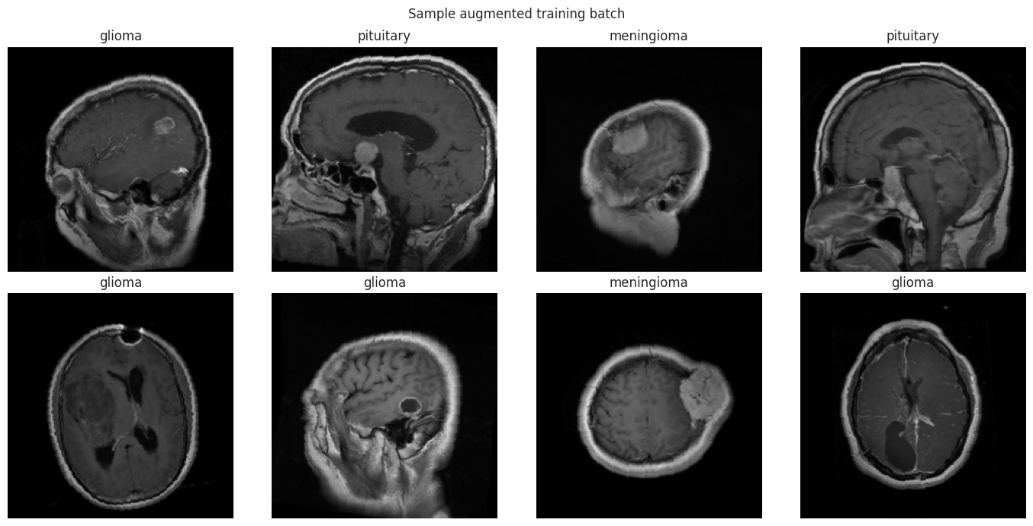
Figure 1. Examples of Augmented MRI Images Generated During the ViT Training Pipeline.

Methodology

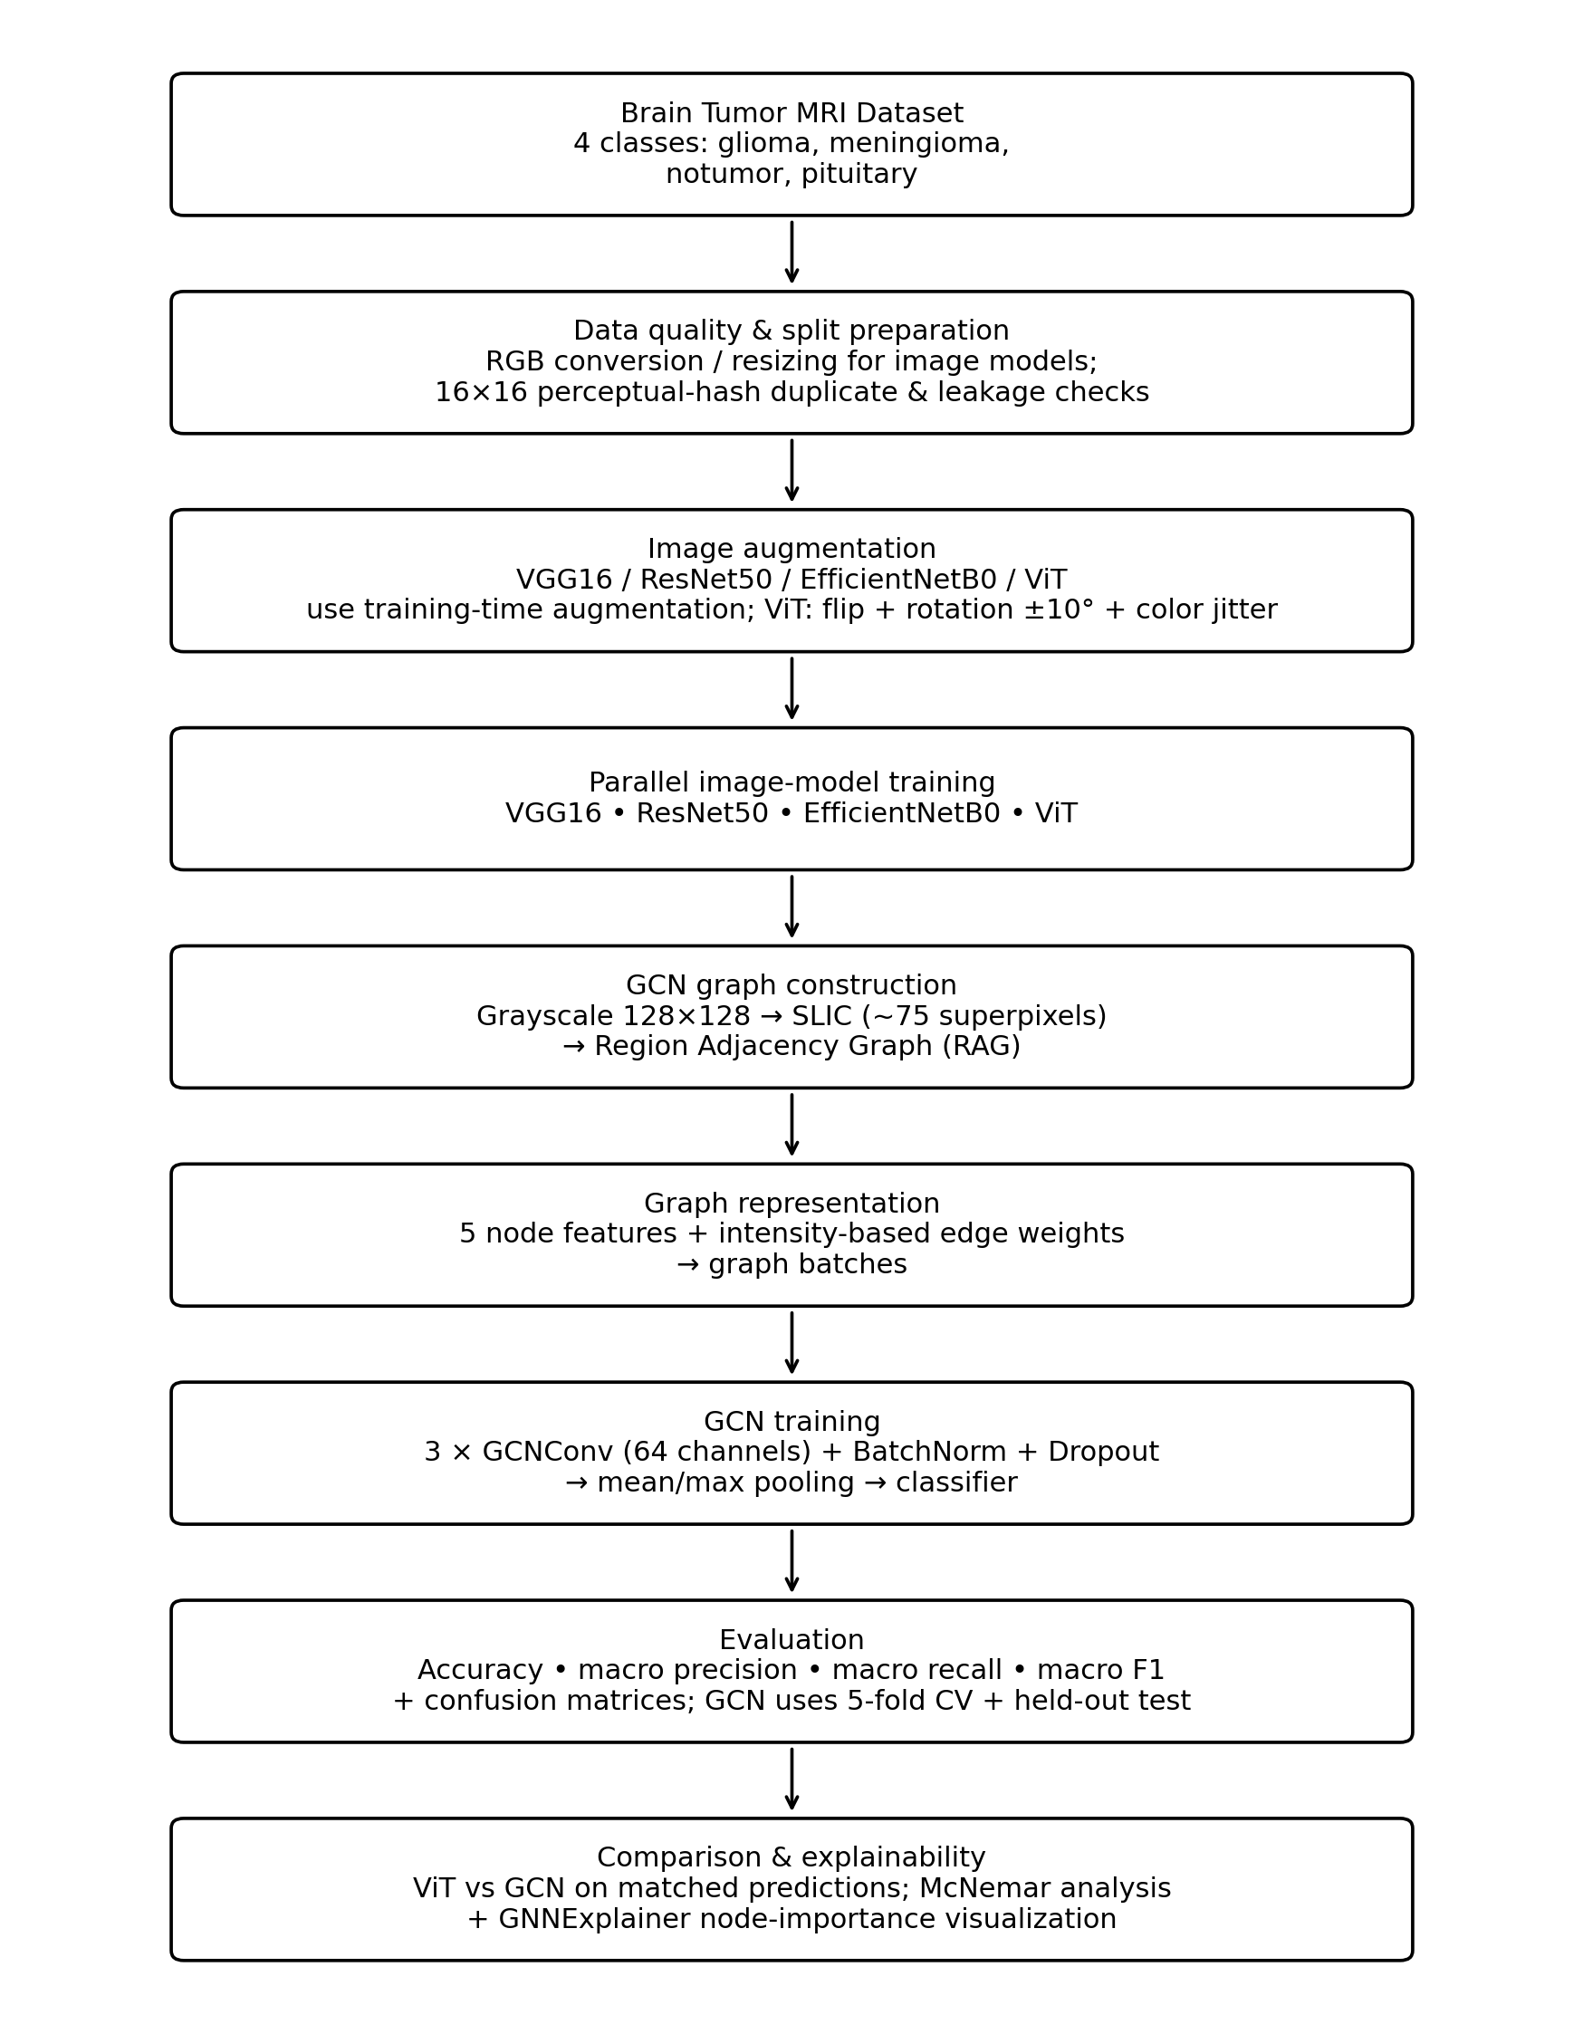

Figure 2. Workflow of the Implemented Brain Tumor MRI Classification Pipeline.

The workflow follows the executed models. The image-model branch converts MRI scans to RGB 224×224 inputs and applies model-specific training augmentation before classification with VGG16, ResNet50, EfficientNetB0, or ViT. In parallel, the GCN branch converts each scan to grayscale 128×128, segments it into SLIC superpixels, constructs a Region Adjacency Graph, extracts five node features with intensity-based edge weights, and applies the three-layer GCN. Both tracks are evaluated on held-out test predictions; the GCN additionally uses five-fold cross-validation and GNNExplainer.

4.6 Label Encoding and Imbalance Handling

The four classes are mapped to integer class IDs. The CNN and ViT pipelines use class weights computed from the actual training labels. The GCN uses balanced class weights in its weighted cross-entropy loss. This is important after cleaning because the effective class counts are no longer perfectly balanced.

5. CNN Baseline Models

5.1 VGG16

The VGG16 baseline uses an ImageNet-pretrained VGG16 backbone without the original classifier. The backbone is followed by global average pooling, batch normalization, dense layers of 256 and 128 units, dropout, and a four-class softmax output. The first training phase freezes the backbone; the second phase unfreezes the last convolutional block. The first phase uses Adam with learning rate 1×10⁻⁴ and the fine-tuning phase uses 1×10⁻⁵. Each phase has a minimum of 50 epochs and an early-stopping patience of 6.

5.2 ResNet50

The ResNet50 baseline uses ImageNet-pretrained ResNet50 with global average pooling, batch normalization, dense layers of 256 and 128 units, dropout, and a four-class softmax output. The first phase trains the custom head with the backbone frozen using Adam at 1×10⁻⁴. The second phase unfreezes the last residual stage (32 of 175 ResNet50 layers) and uses 1×10⁻⁵. The same minimum-50-epoch and patience-6 policy is used.

5.3 EfficientNetB0

EfficientNetB0 uses an ImageNet-pretrained backbone followed by global average pooling, batch normalization, dropout, dense layers of 384 and 128 units, further dropout, and a four-class softmax head. Phase 1 trains the head at 1×10⁻³. Phase 2 unfreezes the top portion of the backbone while keeping batch-normalization layers frozen and uses 1×10⁻⁵.

5.5 ViT Baseline

It uses timm's `vit_base_patch16_224`, 224×224 inputs, full fine-tuning, AdamW with learning rate 3×10⁻⁵, weight decay, three warm-up epochs, mixed precision, and early stopping after a minimum of 50 epochs.
Model | Input | Main architecture | Optimizer / LR | Total parameters
VGG16 | 224×224×3 | VGG16 + GAP + BN + Dense 256 + Dense 128 + Dropout | Adam / 1e-4; fine-tune 1e-5 | 14,881,476
ResNet50 | 224×224×3 | ResNet50 + GAP + BN + Dense 256 + Dense 128 + Dropout | Adam / 1e-4; fine-tune 1e-5 | 24,153,860
EfficientNetB0 | 224×224×3 | EffNetB0 + GAP + BN + Dense 384 + Dense 128 + Dropout | Adam / 1e-3; fine-tune 1e-5 | 4,597,927
ViT-Base/16 | 224×224×3 | ViT-Base/16, full fine-tuning | AdamW / 3e-5 | 85,801,732

6. CNN Baseline Results

6.1 Overall Performance

Model | Test n | Accuracy | Precision macro | Recall macro | F1 macro
VGG16 | 603 | 93.86% | 92.70% | 94.91% | 93.36%
ResNet50 | 575 | 93.39% | 91.10% | 94.35% | 92.22%
EfficientNetB0 | 609 | 88.01% | 87.02% | 89.13% | 87.44%
ViT | 1,273 | 94.97% | 94.20% | 95.68% | 94.65%

Among these image baselines, VGG16 achieves the highest CNN accuracy at 93.86% and a macro F1-score of 93.36%. ResNet50 follows at 93.39% accuracy and 92.22% macro F1, while EfficientNetB0 records 88.01% accuracy. ViT provides the highest image-model result, with 94.97% accuracy and 94.65% macro F1.

6.2 Classification Reports

Model / class | Precision | Recall | F1 | Support
VGG16 / glioma | 1.00 | 82.00% | 90.00% | 186
VGG16 / meningioma | 89.00% | 98.00% | 93.00% | 144
VGG16 / notumor | 85.00% | 1.00 | 92.00% | 74
VGG16 / pituitary | 97.00% | 1.00 | 99.00% | 199
ResNet50 / glioma | 99.00% | 84.00% | 90.00% | 176
ResNet50 / meningioma | 89.00% | 94.00% | 92.00% | 142
ResNet50 / notumor | 78.00% | 1.00 | 88.00% | 58
ResNet50 / pituitary | 98.00% | 99.00% | 99.00% | 199
EffNetB0 / glioma | 94.00% | 78.00% | 85.00% | 190
EffNetB0 / meningioma | 87.00% | 79.00% | 83.00% | 145
EffNetB0 / notumor | 79.00% | 1.00 | 88.00% | 75
EffNetB0 / pituitary | 88.00% | 1.00 | 94.00% | 199
ViT / glioma | 99.69% | 84.84% | 91.67% | 376
ViT / meningioma | 89.49% | 98.13% | 93.61% | 321
ViT / notumor | 88.12% | 1.0000 | 93.68% | 178
ViT / pituitary | 99.50% | 99.75% | 99.62% | 398

6.3 Confusion Matrices
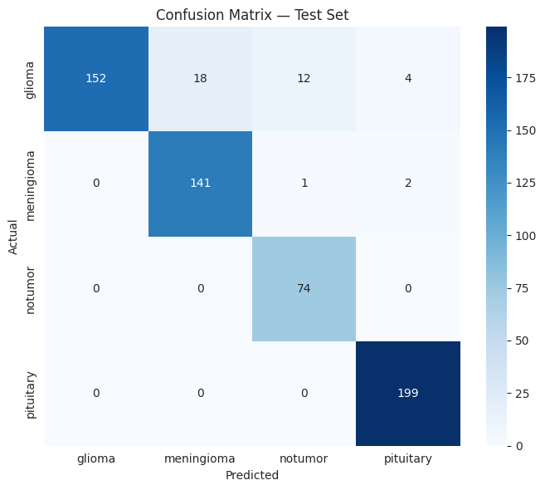
Figure 3. Actual VGG16 confusion matrix from the test-set evaluation. .
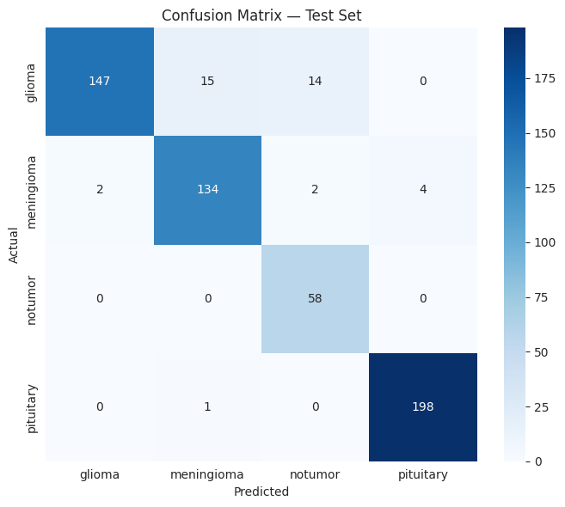
Figure 4. Actual ResNet50 confusion matrix from the test-set evaluation.

Figure 5. Actual EfficientNetB0 confusion matrix from the test-set evaluation.
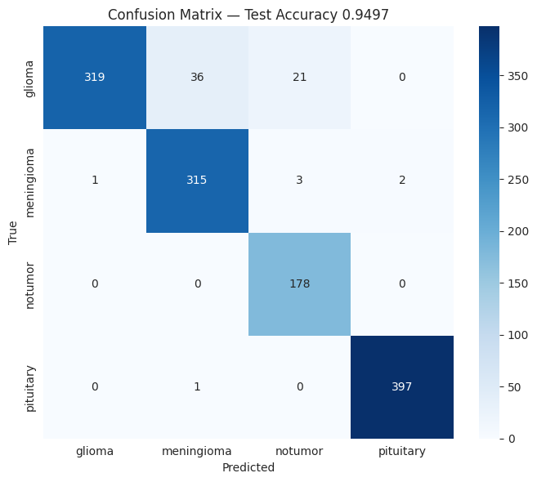
Figure 6. Actual ViT confusion matrix from the test-set evaluation.
The confusion matrices show a common pattern across the image models: pituitary is classified very well, while glioma and meningioma account for a larger share of the remaining errors. The notumor class has very high recall in all four reports, although its precision is lower than its recall for VGG16, ResNet50, and EfficientNetB0. These class-level differences are consistent with the macro metrics and show why accuracy alone is not enough to describe the classifiers.

6.4 Training and Validation Curves
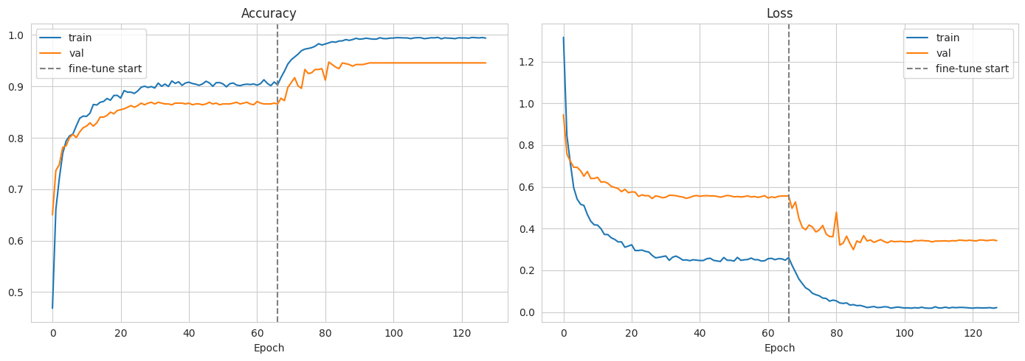Figure 7. Actual VGG16 training/validation accuracy and loss curves.
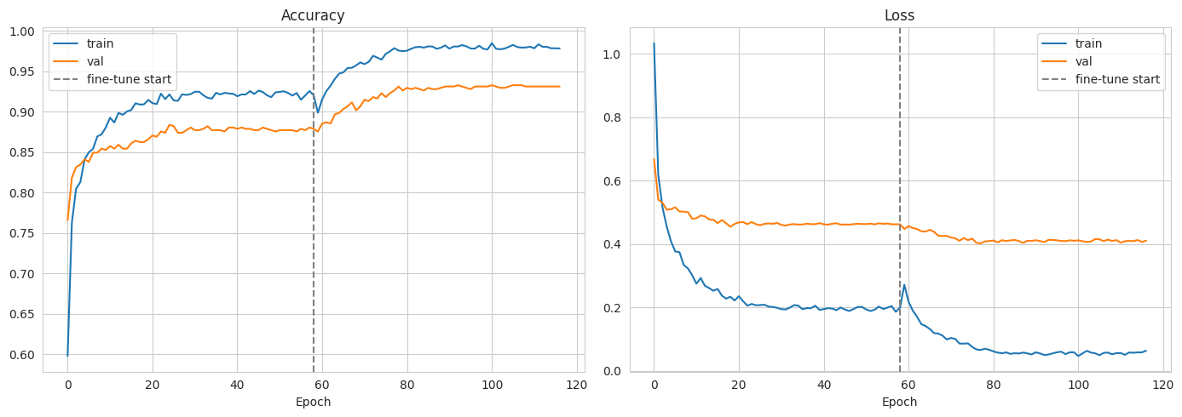
Figure 8. Actual ResNet50 training/validation accuracy and loss curves.

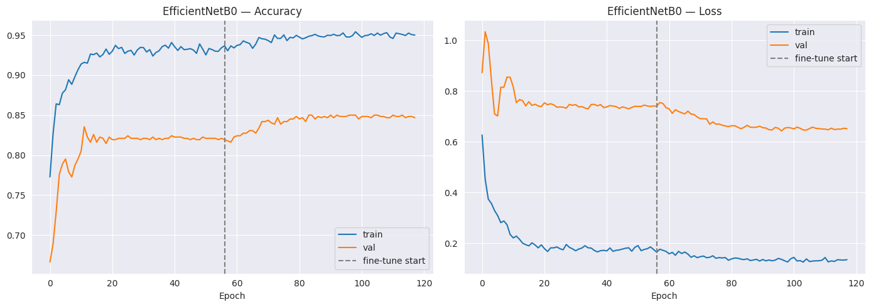
Figure 9. Actual EfficientNetB0 training/validation accuracy and loss curves.
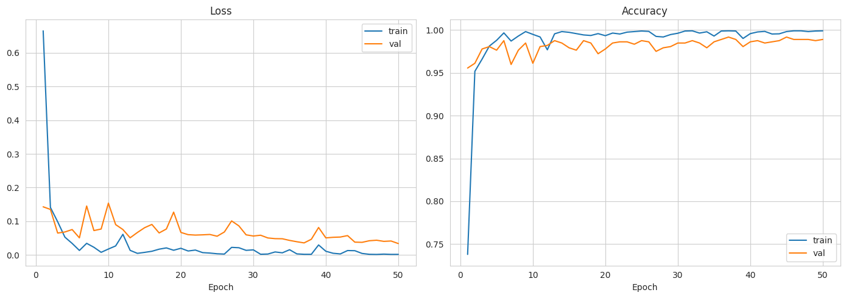
Figure 10. Actual ViT training/validation accuracy and loss curves.
The curves provide evidence about the training behavior. VGG16 and ResNet50 show training and validation accuracy converging at high values. EfficientNetB0 shows a clearer separation between training and validation performance, which is consistent with a larger generalization gap in this run. The ViT curves reach high validation accuracy and remain close to the training trend. These observations are limited to the displayed runs and do not imply behavior outside the tested data.

6.5 ROC/AUC
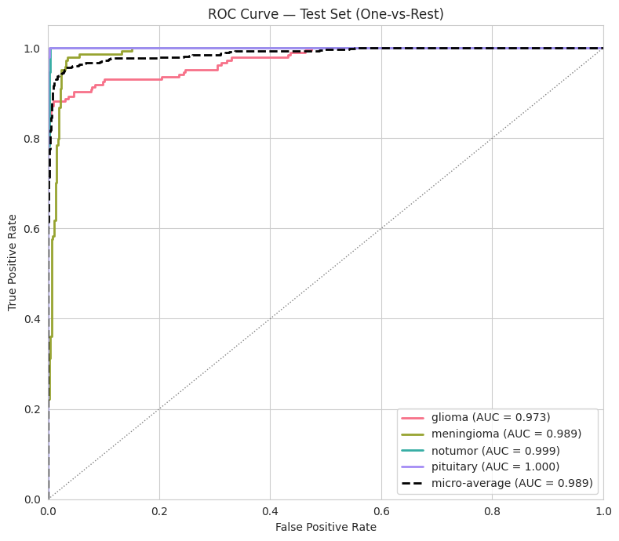
Figure 11. Actual VGG16 one-vs-rest ROC curve.
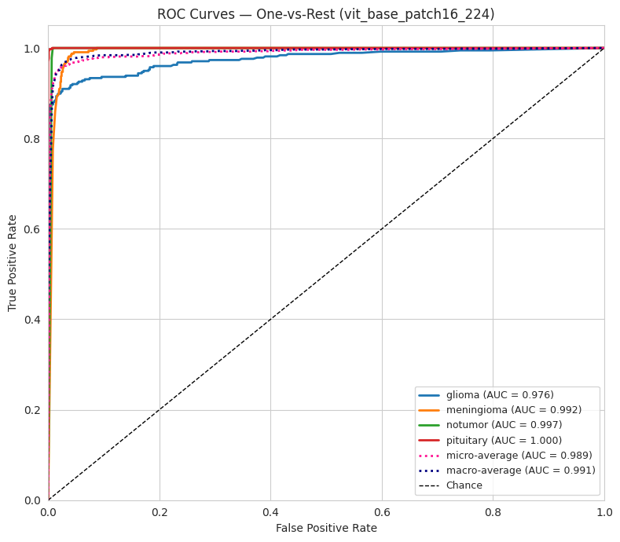
Figure 12. Actual ViT one-vs-rest ROC curve.
The ViT reports a macro-average AUC of 0.9911 and a micro-average AUC of 0.9892. The VGG16 generates a one-vs-rest ROC figure with class and micro-average AUC values .

6.6 Model Size and Inference Time
Model | Total parameters | Trainable parameters | Model size | Latency / image | Throughput
VGG16 | 14,881,476 | 7,245,188 | 112.15 MB | 104.867 ms | 70.95 images/s
ResNet50 | 24,153,860 | 15,538,052 | 211.36 MB | 113.342 ms | 56.84 images/s
EfficientNetB0 | 4,597,927 | 1,887,796 | 32.78 MB | 82.332 ms | 253.56 images/s
ViT | 85,801,732 | 85,801,732 | 327.37 MB | 8.349 ms | 359.68 images/s

EfficientNetB0 is the smallest of the four baselines by both parameter count and saved model size, while the ViT has the largest parameter count and saved file. The reported ViT latency is also the lowest in this run. These timing values are hardware-dependent and should therefore be interpreted as measurements of the executed notebook environment rather than universal model speeds.

7. Proposed Image-to-Graph Approach

7.1 Motivation
The GCN changes the representation of the MRI rather than simply changing the image classifier. Instead of feeding a regular image grid to a CNN or transformer, it divides the MRI into local regions and represents the relationships between neighboring regions explicitly. This is useful for testing whether region-level structure can be learned directly by a graph model.

7.2 Image-to-Graph Conversion
Each MRI is converted to grayscale and resized to 128×128. SLIC segmentation is then applied with a target of 75 superpixels. The actual number of regions varies by image; the notebook reports an average of 61.3 nodes per graph in the train+validation pool. Adjacent superpixels are connected using a Region Adjacency Graph.

7.3 Node Definition and Features
Each superpixel becomes one graph node. Five features are calculated for every node: mean intensity, standard deviation of intensity, normalized centroid x-coordinate, normalized centroid y-coordinate, and the fraction of the full image area occupied by the superpixel.
Node feature | Definition in notebook
Mean intensity | Mean grayscale intensity of pixels inside the superpixel
Intensity standard deviation | Standard deviation of grayscale intensity inside the superpixel
Centroid x | Mean x-coordinate normalized by image width
Centroid y | Mean y-coordinate normalized by image height
Area fraction | Superpixel area divided by total image area

7.4 Edge Definition and Edge Weights
Two nodes are connected when their corresponding superpixels share a boundary in the RAG. For neighboring regions u and v, the edge weight is calculated as 1/(1+|mean_intensity_u−mean_intensity_v|). Therefore, regions with more similar mean intensity receive larger weights. The code stores both directions of each undirected connection in edge_index.

7.5 Number of Nodes and Edges
Graph property | Notebook value
Target SLIC segments | 75
Average nodes per graph | 61.3
Average edge entries per graph | 309.0
Graph image size | 128×128 grayscale
Train+validation graphs | 5,652
Held-out test graphs | 575

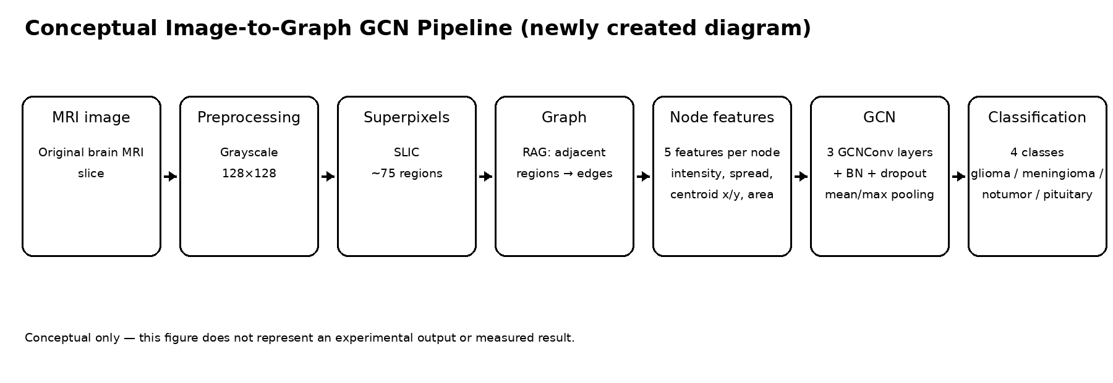
Figure 13. Newly created conceptual diagram showing the image-to-graph pipeline used by the proposed GCN.

8. Proposed GCN Architecture

8.1 Architecture
The proposed model contains three GCNConv layers. Each graph-convolution layer has 64 output channels and is followed by batch normalization. Dropout with probability 0.4 is applied after the first two graph-convolution layers. After the third layer, node representations are summarized using both global mean pooling and global max pooling. The two pooled vectors are concatenated to form a 128-dimensional graph representation, which is passed through a 128-unit fully connected layer, ReLU, dropout, and a four-class output layer.
Layer | Configuration
GCNConv 1 | 5 → 64
BatchNorm 1 | 64 features
Dropout | p = 0.4
GCNConv 2 | 64 → 64
BatchNorm 2 | 64 features
Dropout | p = 0.4
GCNConv 3 | 64 → 64
BatchNorm 3 | 64 features
Global pooling | Mean pooling + max pooling
Classifier | 128 → 128 → 4
Total parameters | 26,116

8.2 Training Procedure
The GCN is trained with weighted cross-entropy loss and the Adam optimizer at learning rate 1×10⁻³ with weight decay 1×10⁻⁴. The batch size is 32. A ReduceLROnPlateau scheduler halves the learning rate after three epochs without validation-loss improvement, with a minimum learning rate of 1×10⁻⁶. Early stopping uses patience 6 after a minimum of 50 epochs, with a maximum of 60 epochs .

8.3 Five-Fold Cross-Validation
The GCN uses stratified five-fold cross-validation on the 5,652-image train+validation graph pool. The held-out 575-image test set is not used during cross-validation. The fold results are:
Fold | Val accuracy | Precision macro | Recall macro | F1 macro
1 | 79.58% | 80.16% | 80.58% | 80.22%
2 | 81.61% | 81.62% | 82.52% | 81.84%
3 | 79.03% | 78.88% | 80.05% | 79.30%
4 | 79.20% | 78.79% | 80.38% | 79.29%
5 | 78.85% | 79.03% | 80.19% | 79.26%
Mean ± std | 79.65% ± 1.13% | 79.70% ± 1.21% | 80.74% ± 1.01% | 79.98% ± 1.12%

The five cross-validation folds are relatively close. The best validation accuracy is 81.61% in fold 2, while the lowest is 78.85% in fold 5. The standard deviation of validation accuracy is 1.13 percentage points.

9. GCN Results

9.1 Held-Out Test Performance
Metric | GCN result
Test accuracy | 74.96%
Precision macro | 71.00%
Recall macro | 77.00%
F1 macro | 72.61%
Test samples | 575
Total parameters | 26,116

9.2 Classification Report

Class | Precision | Recall | F1 | Support
glioma | 74.00% | 57.00% | 65.00% | 176
meningioma | 65.00% | 56.00% | 60.00% | 142
notumor | 59.00% | 97.00% | 73.00% | 58
pituitary | 88.00% | 98.00% | 93.00% | 199
Macro avg | 71.00% | 77.00% | 73.00% | 575
Weighted avg | 75.00% | 75.00% | 74.00% | 575

9.3 Exact Model-Generated Confusion Matrix
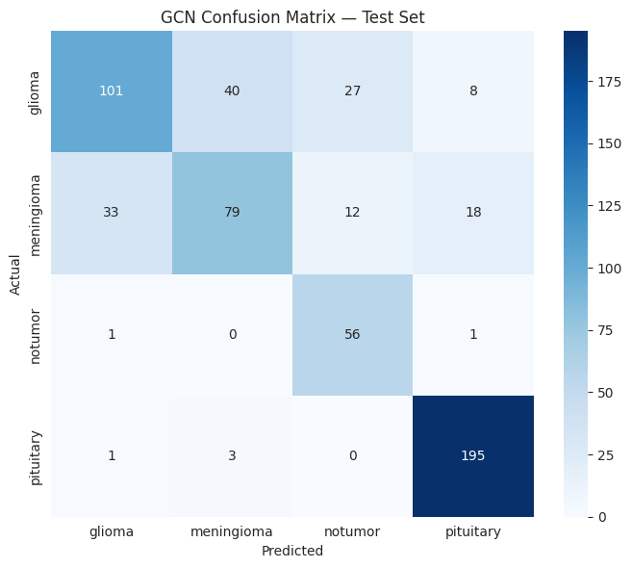
Figure 14. Exact GCN test-set confusion matrix.
The confusion matrix shows that pituitary is the strongest GCN class, with 98% recall. The model also detects notumor well in recall (97%), but its precision is only 59%, indicating that many samples predicted as notumor belong to another class. Glioma and meningioma have the weakest recall values, 57% and 56%, respectively, which contributes to the lower macro F1-score.

9.4 Explainability
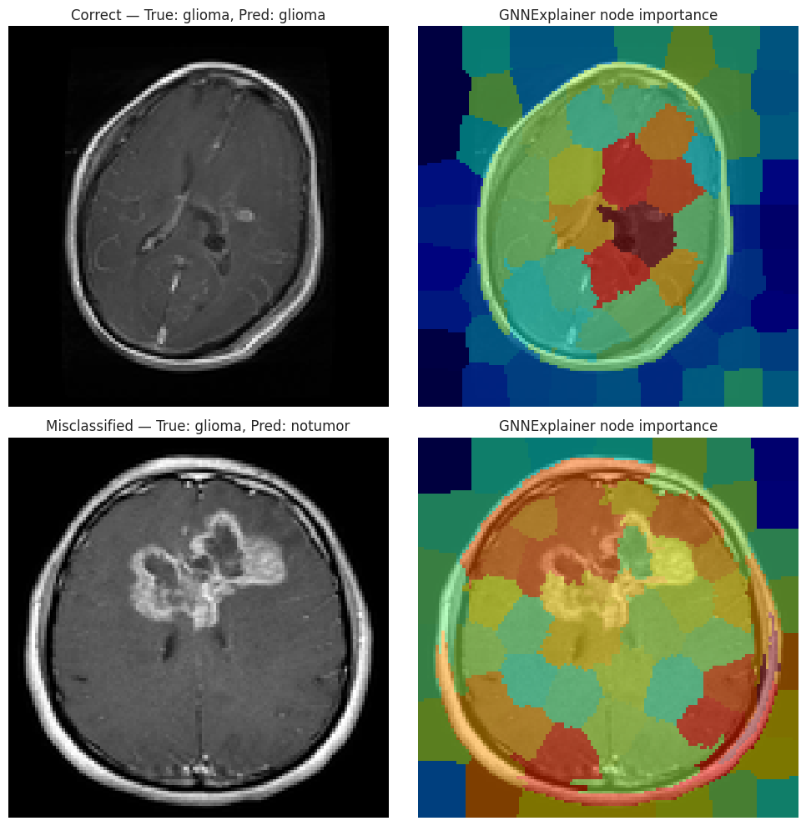
Figure 15. Actual GNNExplainer output for one correctly classified and one misclassified test image, with node importance mapped back to superpixel regions.
The GNNExplainer output connects the graph representation back to the original MRI image. For the selected correct and incorrect examples, the highlighted regions show which superpixel nodes received higher importance scores for the model prediction. This provides a graph-specific explanation without inventing a pixel-level heatmap.

10. CNN vs GCN Comparison

10.1 Overall Performance
Model | Accuracy | Macro F1 | Parameters | Model size | Latency
VGG16 | 93.86% | 93.36% | 14,881,476 | 112.15 MB | 104.867 ms
ResNet50 | 93.39% | 92.22% | 24,153,860 | 211.36 MB | 113.342 ms
EfficientNetB0 | 88.01% | 87.44% | 4,597,927 | 32.78 MB | 82.332 ms
ViT | 94.97% | 94.65% | 85,801,732 | 327.37 MB | 8.349 ms
GCN | 74.96% | 72.61% | 26,116 | Not available | Not available

10.2 Performance Discussion
The image-based models outperform the proposed GCN on the reported held-out test accuracy. Among the CNNs, VGG16 reaches 93.86%, while ViT gives the highest result overall at 94.97%. The GCN reaches 74.96% accuracy and 72.61% macro F1 on its held-out test set.
The GCN's five-fold cross-validation results are stronger than its final held-out test result: mean validation accuracy is 79.65%, compared with 74.96% on the final test set. The difference is 4.69 percentage points. This indicates that the graph representation learned useful patterns within the cross-validation folds, but performance dropped on the final held-out set.

10.3 ViT vs GCN Comparison
On the reported held-out test sets, ViT outperforms GCN on every directly available classification metric. ViT reaches 94.97% accuracy and 94.65% macro F1-score, whereas GCN reaches 74.96% accuracy and 72.61% macro F1-score. The accuracy gap is 20.01 percentage points and the macro F1 gap is 22.04 percentage points.
Metric | ViT | GCN
Test accuracy | 94.97% | 74.96%
Macro precision | 94.20% | 71.00%
Macro recall | 95.68% | 77.00%
Macro F1-score | 94.65% | 72.61%
Test samples | 1,273 | 575

For the subset of 573 filepaths that could be matched between the two pipelines, McNemar statistic of 107.0796 with p-value 0.0000, significant at α = 0.05. The paired counts were GCN correct / ViT correct = 430, GCN correct / ViT wrong = 112, GCN wrong / ViT correct = 1, and GCN wrong / ViT wrong = 30. This paired analysis provides additional evidence that the ViT made substantially more correct predictions on the matched images.

10.4 Important Comparison Constraint
VGG16 uses 603 test images, ResNet50 575, EfficientNetB0 609, ViT 1,273, and GCN 575. This is a consequence of specific duplicate and leakage cleaning. Therefore, the overall accuracy table should be read as a report of the executed experiments, not as a perfectly controlled single-test-set benchmark. The paired McNemar analysis is more directly comparable because it uses the 573 filepaths that could be matched between the GCN and ViT outputs.

11. Limitations
- The baseline models produce different final test-set sizes after their individual duplicate and leakage-cleaning steps.
- The GCN model does not report a plotted training/validation curve, AUC value, inference latency, or saved model-file size.
- The GCN graph construction is CPU-intensive and requires a separate superpixel/RAG preprocessing step before graph classification.
- The GCN uses grayscale 128×128 input, so it does not preserve the full three-channel image representation used by the image baselines.
- The GCN test accuracy is lower than its five-fold validation mean, indicating that the final held-out set remains a meaningful challenge for the graph representation.
- The paired GCN-versus-ViT comparison is limited to 573 matched images because the two models do not produce identical final test sets.
- The experiments are based on a single brain MRI dataset and therefore do not establish performance on independent clinical datasets.

12. Conclusion
This task evaluated several image-based baselines and a proposed superpixel-graph GCN for four-class brain tumor MRI classification. The uploaded image baselines achieved strong test performance, with VGG16 reaching 93.86% accuracy and ViT reaching 94.97%. ResNet50 achieved 93.39%, while EfficientNetB0 achieved 88.01%.
The proposed GCN successfully converted MRI images into graphs using SLIC superpixels and a Region Adjacency Graph. Each graph used five node features and intensity-based edge weights, and the GCN contained three 64-channel graph-convolution layers followed by mean/max pooling and a small classifier. Its five-fold cross-validation mean accuracy was 79.65%, while the final held-out test accuracy was 74.96% with a macro F1-score of 72.61%.
Based strictly on the executed results, the GCN did not outperform the uploaded image baselines in this experiment. Its main value in the project is the alternative graph representation and the ability to examine region relationships through GNNExplainer. Under the current graph construction and training settings, the graph representation did not provide a performance advantage over the tested image models.

13. References
- Masoud Nickparvar, Brain Tumor MRI Dataset, Kaggle. Dataset used in all uploaded notebooks.
- K. Simonyan and A. Zisserman, “Very Deep Convolutional Networks for Large-Scale Image Recognition,” 2014.
- K. He, X. Zhang, S. Ren, and J. Sun, “Deep Residual Learning for Image Recognition,” CVPR, 2016.
- M. Tan and Q. V. Le, “EfficientNet: Rethinking Model Scaling for Convolutional Neural Networks,” ICML, 2019.
- A. Dosovitskiy et al., “An Image is Worth 16x16 Words: Transformers for Image Recognition at Scale,” ICLR, 2021.
- T. N. Kipf and M. Welling, “Semi-Supervised Classification with Graph Convolutional Networks,” ICLR, 2017.
- R. Achanta, A. Shaji, K. Smith, A. Lucchi, P. Fua, and S. Süsstrunk, “SLIC Superpixels Compared to State-of-the-Art Superpixel Methods,” IEEE TPAMI, 2012.
- PyTorch Geometric documentation and library used for the GCN implementation in the uploaded notebook.
- TensorFlow/Keras and timm libraries used for the uploaded image-classification baselines.

