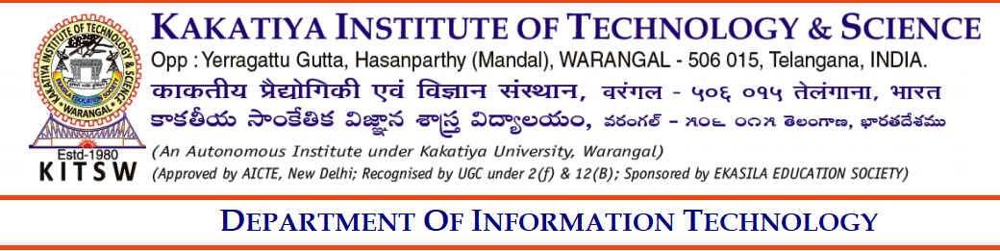
U18IT510-SEMINAR
ABSTRACT

Semester | : | V semester
Name of the Student | : | KANNE ASRITHA , NANUVALA AKSHITHA, BANOTHU OMKAR, THATIPELLI SHIVA KUMAR.
Roll Number | : | B23IT023 ,B23IT002 ,B23IT051 ,B24IT130L.
Seminar Title | : | Edge AI: The Future of AI-Powered Devices
Domain Name  Abstract: |  | Artificial Intelligence and Edge Computing in IoT
Edge AI is an emerging technology that combines artificial intelligence (AI) with edge computing, allowing data to be processed locally on devices at the edge of the network, such as IoT devices, smartphones, cameras, sensors, and industrial machines. Unlike traditional AI systems that rely on cloud computing for data processing, Edge AI enables real-time analytics, faster decision-making, reduced latency, and lower bandwidth usage. This approach also enhances data privacy and security, as sensitive information can be processed locally without transmitting it to central servers.
Edge AI is widely applied in autonomous vehicles, where instant processing of sensor data is crucial for safety; in smart healthcare, for real-time patient monitoring and predictive diagnostics; in industrial automation, for monitoring machinery and preventing failures; and in smart cities, for surveillance, traffic management, and energy optimization. By reducing dependency on cloud infrastructure, Edge AI also improves system reliability in remote or connectivity-limited areas.

Recommended / Not Recommended (NR)
If NR, Remarks __________________________________________________________________

Seminar Supervisor | Seminar Coordinator | Head of the Department
Name: Dr. Y. Bhavani | Smt. D. Jyothi | Dr. T. Senthil Murugan
Designation :Associate Professor | Assistant Professor | Assoc. Prof. & Head,  Dept. of IT

