A COURSE PROJECT REPORT
on
HABIT TRACKER
U18IT504- WEB TECHNOLOGIES

Submitted to
Department of Information Technology

BY
K.Asritha
B23IT023

Under the Supervisior of
Smt.S.B.Swathi
Assistant Professor

DEPARTMENT OF INFORMATION TECHNOLOGY
KAKATIYA INSTITUTE OF TECHNOLOGY & SCIENCE, WARANGAL-15
2025- 2026



C E R T I F I C A T E

This is to certify that K.ASRITHA(B23T023) of V- Semester B.Tech. Information Technology has satisfactorily completed the project entitled “HABIT TRACKER” in the partial fulfilment of the requirement of B.Tech degree during this academic year 2025-2026.

SUPERVISOR CHAIRMAN,DSEC

Smt.S.B.Swathi
Assistant Professor

Dr. T. Senthil Murugan

Professor & Head, Dept. of I.T.

ACKNOWLEDGEMENT
I wish to take this opportunity to express my deep gratitude to all the people who have extended their cooperation in various ways during my Seminar. It is my pleasure to acknowledge the help of all those individuals.
I thank Dr. K. Ashoka Reddy, Principle of Kakatiya Institute of Technology & Science, Warangal, for his strong support.
I thank Dr. T.Senthil Murugan, Professor & Head, Department of Information Technology for her constant support in bringing shape of this Seminar.
I would like to thank my supervisor, Smt.S.B.Swathi, Associate Professor of Information Technology for her guidance and help throughout the Seminar.
In completing this Seminar successfully all our faculty members have given an excellent cooperation by guiding us in every aspect. All your guidance helped me a lot and I am very grateful to you.

K.Asritha
B23IT023

ABSTRACT
The Habit Tracker is a web-based application designed to help individuals monitor, maintain, and improve their daily routines and personal goals.
It allows users to create, manage, and track habits based on daily, weekly, or monthly frequencies. Each habit is associated with notes and a progress bar that visually represents the user’s consistency. The system also supports challenges and rewards to motivate users, along with notifications to remind them of incomplete tasks.
The application features a user-friendly interface with dark and light mode options, providing an engaging and customizable experience. By using local storage to save user data, the Habit Tracker ensures continuity and personalized tracking, enabling users to develop productive habits and achieve long-term goals efficiently.
The Habit Tracker project explores how technology can influence human behaviour and improve time management by creating awareness of daily routines. Instead of just monitoring habits, it focuses on analyzing patterns, identifying bottlenecks, and suggesting improvements to help users make informed lifestyle changes. The system emphasizes motivation through visual insights, challenges, and subtle feedback rather than mere tracking. By combining interactive design with behavioural analysis, this project aims to enhance productivity, encourage consistency, and promote long-term personal growth.

CONTENTS
1 | Introduction | 1
2 | Problem definition | 2
3 | Proposed method | 3
4 | Experimentation and results | 4
5 | Advantages of Proposed Method | 7
5 | Conclusion | 8
6 | Poster | 9
7 | References | 10

LIST OF FIGURES
Figure No. | Name of the figure | Page No.
2.1 | The Frustration of Inconsistent Habit | 2
4.1 | Login successful | 4
4.2 | Login unsuccessful | 5
4.3 | User progress and habit List | 5
4.4 | Rewards | 6
6.1 | The Reward of a maintained Streak | 8

CHAPTER 1
INTRODUCTION

In today’s fast-paced world, people often struggle to maintain consistency in their daily routines and achieve personal or professional goals. Developing positive habits and eliminating unproductive ones requires constant effort, motivation, and self-discipline. A Habit Tracker is a software application designed to assist individuals in monitoring, managing, and improving their habits over time. By providing an organized platform where users can create habits with specific frequencies—daily, weekly, or monthly—the application helps users stay focused on their objectives. Visual elements such as progress bars, charts, and notifications enhance user engagement, allowing them to see tangible growth and remain motivated to complete tasks consistently.
Moreover, modern Habit Tracker systems include interactive features such as challenges, rewards, and note-taking, which promote discipline and accountability. These features not only encourage users to complete their routines but also help in analyzing behavioural patterns, identifying areas for improvement, and making informed lifestyle adjustments. By combining habit monitoring with behavioural insights, the project provides a user-friendly and effective tool for personal development. Ultimately, the Habit Tracker aims to enhance productivity, foster self-improvement, and support users in achieving long-term goals through structured habit management.

CHAPTER 2
PROBLEM STATEMENT

Many people struggle to develop and maintain healthy habits due to a lack of accountability, motivation, and visibility into their progress. Traditional methods, such as paper journals or spreadsheets, can be time-consuming and difficult to keep up with. Furthermore, existing habit tracking apps often lack customization, personalization, and social features, making it hard for users to tailor the app to their unique needs and get support from others.
Our habit tracking app aims to solve these problems by providing a user-friendly and customizable platform for tracking and improving daily habits. By incorporating features such as personalized habit tracking, habit streaks, reminders, analytics, accountability, and rewards, our app helps users stay motivated, stay on track, and celebrate their progress. With our app, users can build the habits they need to achieve their goals and live healthier, more fulfilling lives.

Fig 2.1 The Frustration of Inconsistent Habit

CHAPTER 3
PROPOSED METHOD
- Customizable Habit Tracking: The proposed application will allow users to customize their habit tracking experience by selecting the habits they want to track, setting individualized goals, and choosing how often they want to receive reminders and progress updates.

- Personalized Insights and Feedback: The proposed system will provide users with personalized insights. and feedback based on their habits and progress, which can help them stay motivated and make meaningful changes.

- Comprehensive Tracking: The proposed system will offer a comprehensive tracking system that allows users to see the bigger picture of their habits and progress over time. This includes the ability to view progress in graphs and charts, set reminders and notifications, and track habit streaks

- Data Privacy: The proposed system will prioritize data privacy and security by implementing strong encryption and protection measures to ensure the safety of user data.

CHAPTER 4
EXPERIMENTATION AND RESULTS
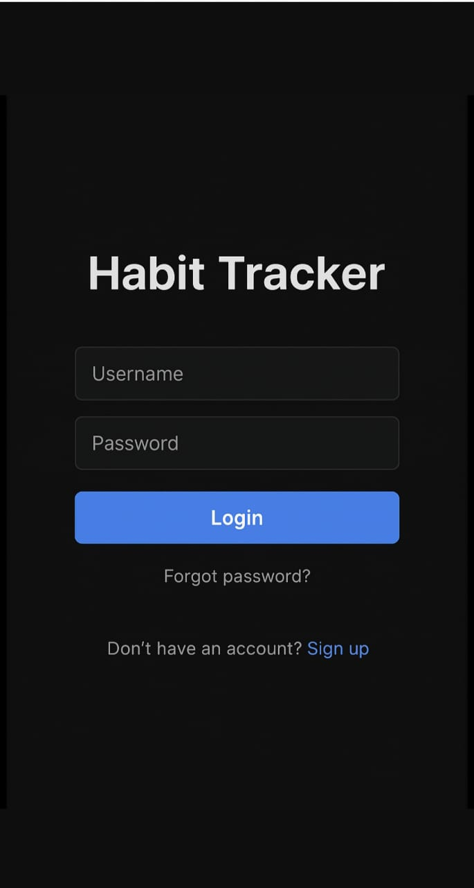
Fig 4.1 Login successful
Users must provided two pieces of information
- Username : To identify the user’s account.
- Password: For security verification.
- Login: Login button is a prominent rectangular button, Tapping this button submits the entered credentials to the system for validation
If the user enters the user name and password correctly then it shows login successful.
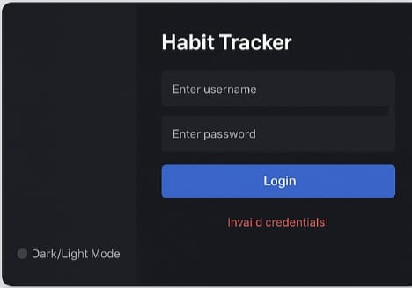
Fig 4.2 Login Unsuccessful
If the username or password is incorrect it will show Invalid credentials!.
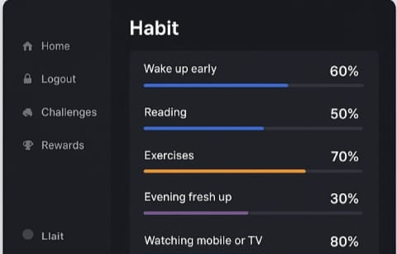
Fig 4.3 User Progress and Habit List
After successfully logging in, the application displays a new page—the main dashboard named 'Habit'. This page features a navigation sidebar on the left with options such as Home, Logout, Challenges, and Rewards. The central area of the page shows a list of tracked habits, each represented by a progress bar and a percentage. When a user completes a habit or finishes the intended work for that habit, the corresponding progress bar will incrementally fill up towards 100%."

Fig 4.4 Reward
After successfully completion of award it gives the rewards weekly and every monthly which makes users to participate regularly.

CHAPTER -5
ADVANTAGES OF PROPOSED METHOD

- Improved accountability: The habit tracking application helps users track their habits and progress over time, making them accountable for their actions and motivating them to stick to their goals.

- Increased awareness: By monitoring their habits, users can gain insights into their behaviour patterns and identify areas for improvement, helping them develop healthier habits and make better choices.

- Enhanced motivation: The application includes features such as reminders, motivational quotes, and community support to keep users motivated and engaged in their habit-building journey.

- Customized experience: The app provides a personalized experience to each user based on their habits, progress, and goals, making it easy to track and improve their unique habits.

- Better overall well-being: By developing healthy habits and sticking to them, users can improve their physical, mental, and emotional well-being, leading to a better quality of life.

- Visual Progress Monitoring : Progress bars and charts provide motivation by showing tangible growth over time.

- Goal Achievement – Breaks large goals into manageable habits, making them easier to achieve.

CHAPTER 6
CONCLUSION
The Habit Tracker project provides an intuitive and interactive way for users to manage their daily routines and build positive habits. By allowing users to create habits, add notes, and track their progress visually through progress bars, the system encourages consistency and self-discipline. The addition of rewards and achievements motivates users to stay engaged and committed to their goals, making habit formation more enjoyable and effective.
Overall, this project highlights the role of technology in personal development and time management. It demonstrates how a simple digital tool can help users monitor their activities, stay organized, and achieve their objectives efficiently. The habit tracker not only promotes productivity but also fosters a structured approach to improving daily life, ultimately contributing to long-term personal growth and well-being.
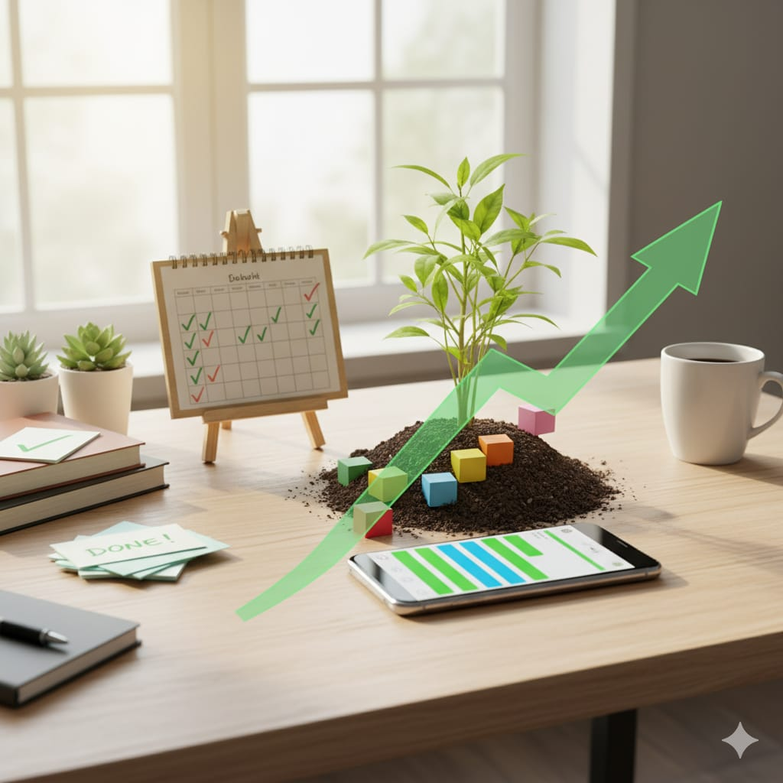
Fig 6.1 The Reward of a maintained Streak

CHAPTER 7
POSTER

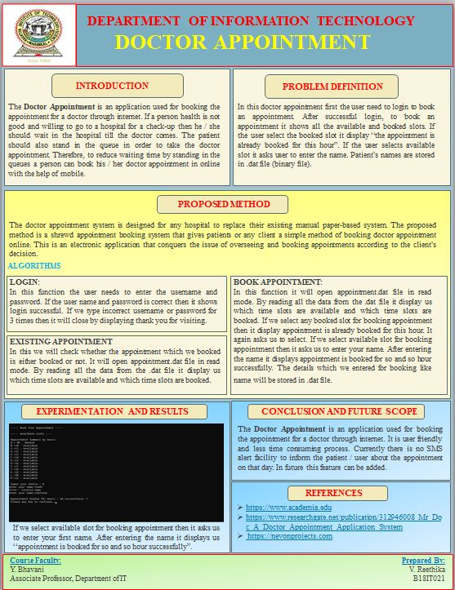
REFERENCES
- Verplanken, B., & Wood, W. (2006). Interventions to break and create consumer habits. Journal of Public Policy & Marketing, 25(1), 90-103.
- [https://www.geeksforgeeks.org/create-a-health-tracker-using-html-css-javascript/](https://www.geeksforgeeks.org/create-a-health-tracker-using-html-css-javascript)
- [https://developer.mozilla.org/en-US/docs/Learn/JavaScript/Client-side_web_APIs/Introduction](https://developer.mozilla.org/en-US/docs/Learn/JavaScript/Client-side_web_APIs/Introduction)

