**Name : Bushra**

**St.id : 63759**

**Cl.id : 103348**

**Course : Discrete Mathematics**

**ASSIGNMENT#01- Stephen Warshall’s-Algorithm**

**C-program**

#include<stdio.h>

***// by changing max you can change the length of your matrix – either by 2 ,3 or 4 or more***

int max= 3;

void trans_closure(int [][max],int[][max],int);

void main(){

int adj_mat[max][max],tr[max][max],i,j,k;

printf("enter the matrix \n");

for(i=0;i<max;i++)

{

for(j=0;j<max;j++)

{

scanf("%d",&adj_mat[i][j]);

}

}

trans_closure(adj_mat,tr,max);

printf(" 1 2 3 4 \n");

for(i=0;i<max;i++)

{

printf("%d: ",i+1);

for(j=0;j<max;j++)

printf("%d " ,tr[i][j]);

printf("\n");

}

}

void trans_closure(int adj_matr[][max],int t[][max],int n){

int i,j,k;

for (i=0;i<n;i++){

for (j=0;j<n;j++){

if (adj_matr[i][j]==1){

t[i][j]=1;

}

else{

t[i][j]=0;}

}}

for (k=0;k<n;k++){

for(i=0;i<n;i++){

for(j=0;j<n;j++){

t[i][j]=t[i][j]||(t[i][k]&&t[k][j]);

}}}

}

**Output:**

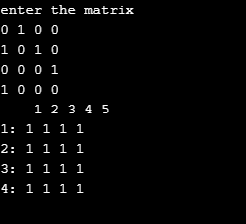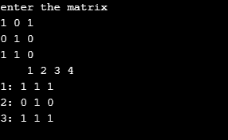

Followed by the output of example 4 i.e. defined in the book:

