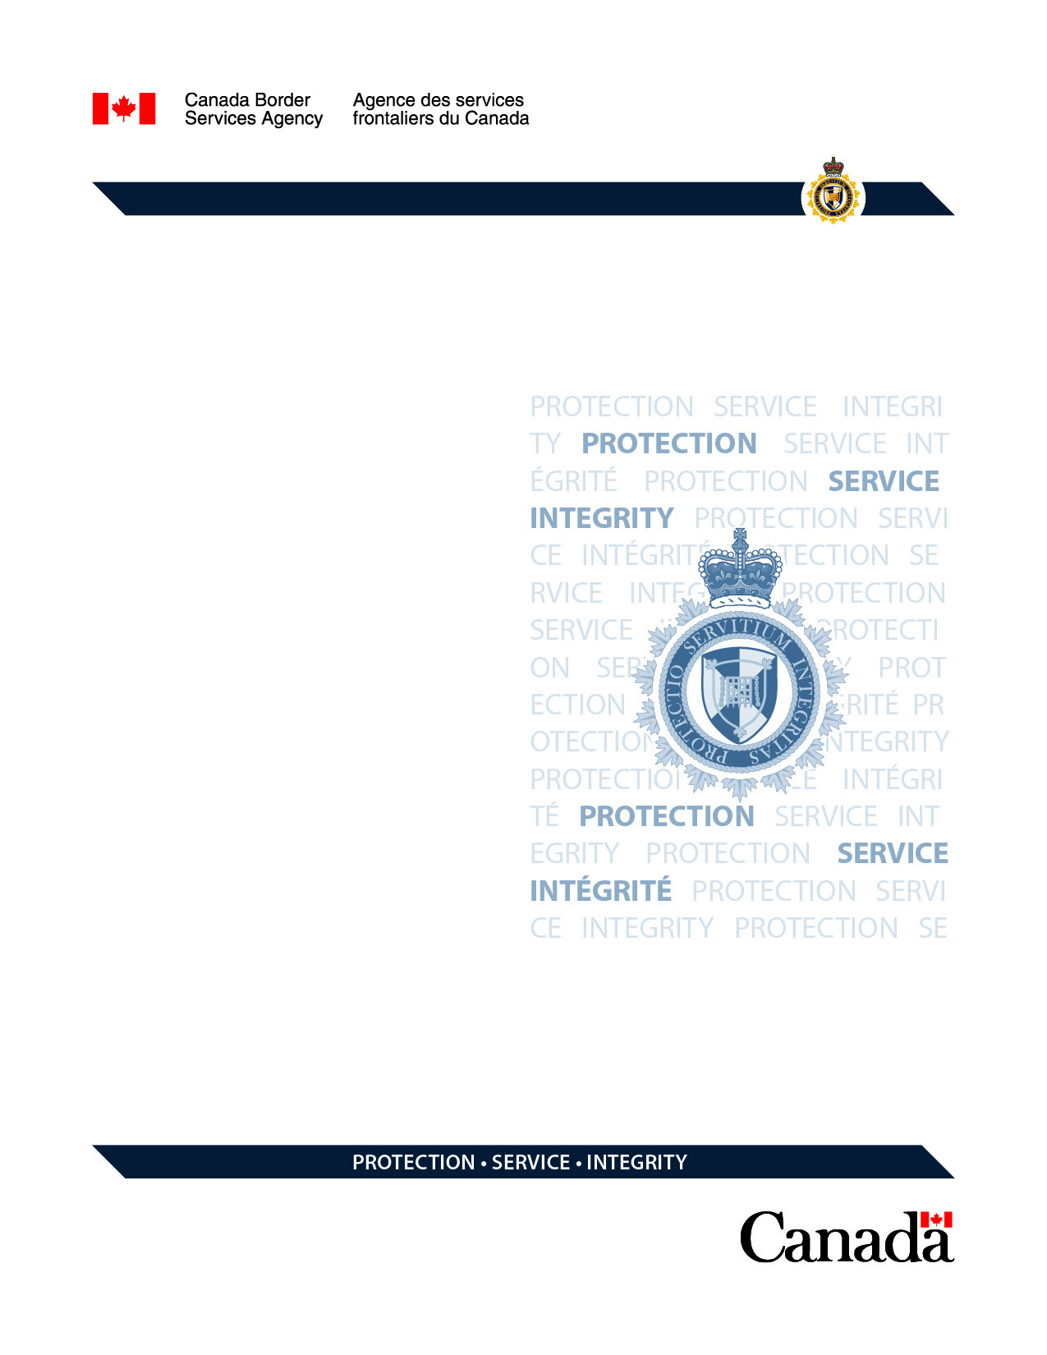

**Algonquin College Project Delta-ACE**

**Requirements**

Version: 0.1

|  |  |  |
| --- | --- | --- |
| **Version** | 0.1  1.0 |  |
| **File Name** | AlgnqnClgPrjctDelta-ACEReq.docx |
| **Author** | Mobile Center of Expertise (MCOE) |
| **Revision Date** | 2018-12-04 04:51 AM |

**Revision History**

| Version | Date | Changes Made | Changes Made By |
| --- | --- | --- | --- |
| 0.1 | 2018-12-04 | Initial | Wael Hussein |
|  |  |  |  |
|  |  |  |  |

***Table of Contents***

1 Background 4

2 Requirements 4

# Background

What if there was an easy way to identify places to hide contraband in any given vehicle, plane or vessel? That’s the idea behind Advanced Conveyance Examination (ACE).

# Requirements

Develop a mobile application that will allow Canada Border Services Agency (CBSA)’s Border Officer (BSO)’s the ability to identify possible contraband concealment locations in any given vehicle.