**Task 1: Run Gitea in Codespace and Create an Initial Repo**

**1. Set up Gitea:**

* **Run a Gitea server inside your Codespace.**
* **Use HTTPS for communication (SSH is not supported in Codespace).**

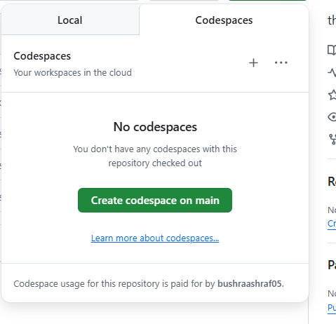

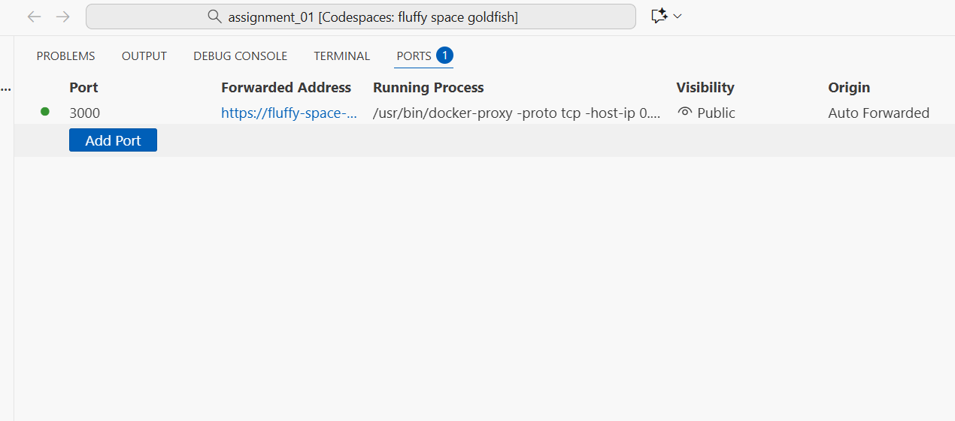

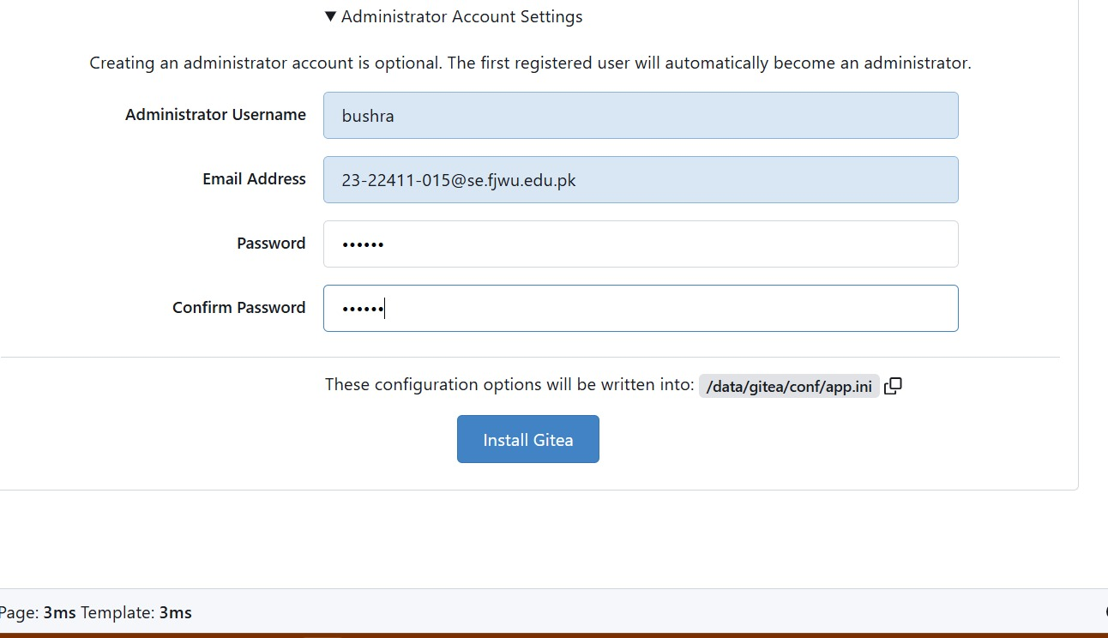

**2. Create a Repository:**

* **Create a new repository on your Gitea server.**

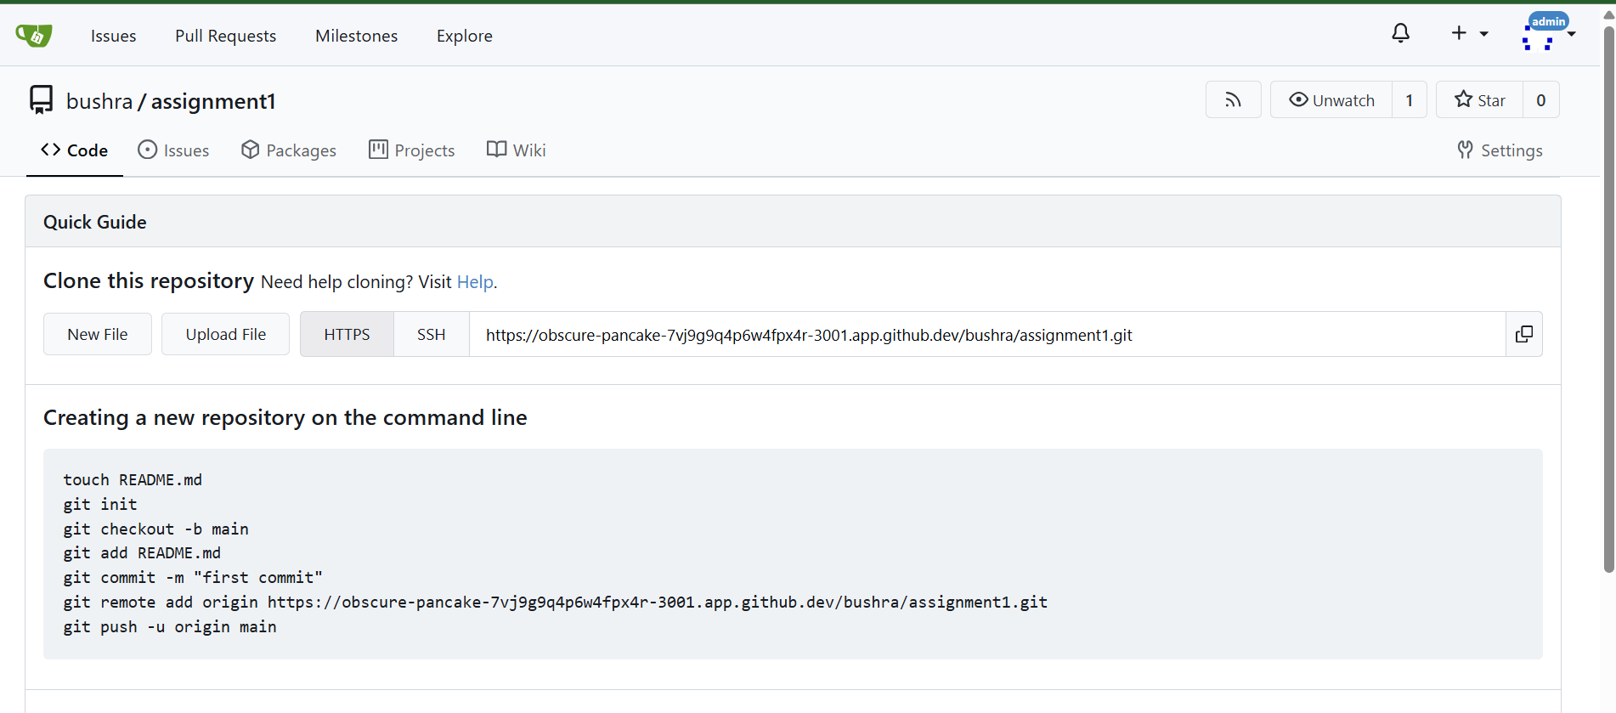

**3. Add Remote Repo:**

* **- Add a README.md file listing each student's name and roll number.**
* **Use the following command to add your Gitea repository as a remote:git remote add gitea <your_gitea_repo_https_url>**
* **Push your initial commit containing the README.md to Gitea**

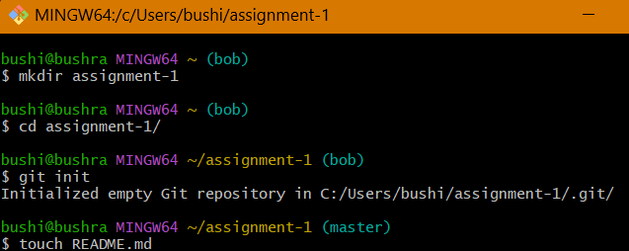

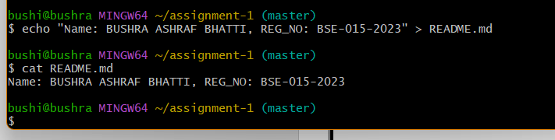

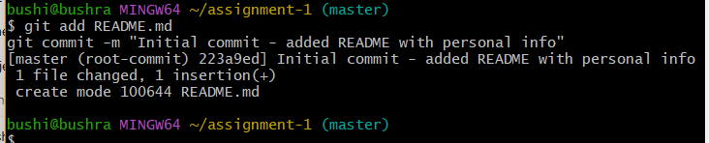

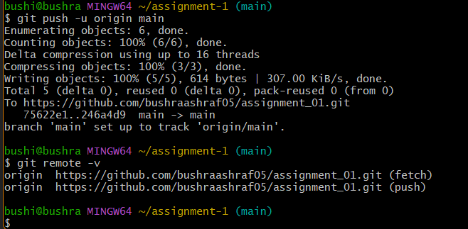

Task 2: Mirror README.md from Gitea to GitHub

1. Continue Working with Your Existing Repository: - You will use the same repository that you created and pushed to your Gitea server in Task 1.
2. Create GitHub Repository: - Create a new GitHub repository named assignment 1.

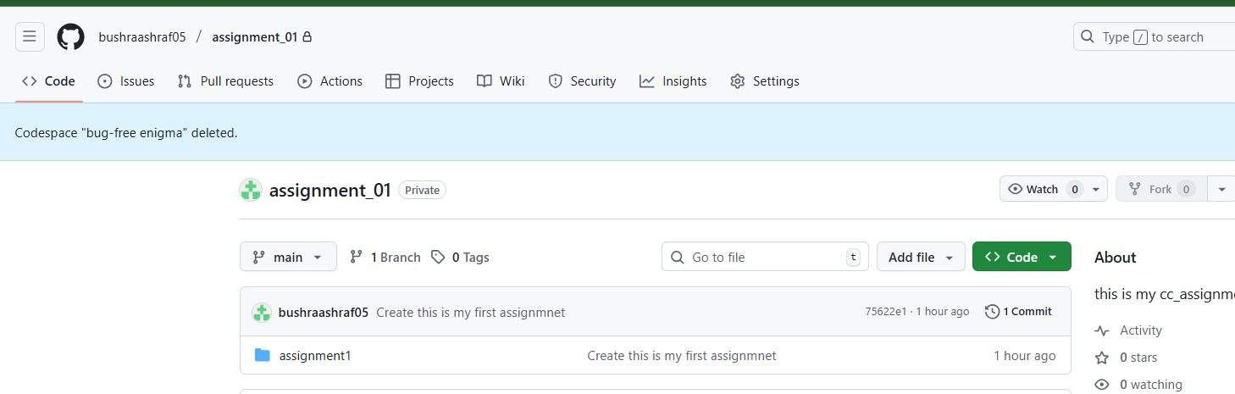

1. Add GitHub as a Second Remote:

- Add your GitHub repository as a remote to your local repository: git remote add github