**Name: Bushra Ashraf Bhatti**

**Submitted to: Dr. Sobia Khalid**

**Reg_no: 2023-BSE-015**

**Assignment_2**

**Implementation of the merge sort along with the running time. Take array of size 8.**

arr = [int(input(f"Enter element {i+1}: ")) for i in range(8)]

print("Original:", arr)

n = len(arr)

size = 1

while size < n:

    for start in range(0, n, 2*size):

        mid = min(start + size, n)

        end = min(start + 2*size, n)

        left, right = arr[start:mid], arr[mid:end]

        i = j = 0

        for k in range(start, end):

            if j >= len(right) or (i < len(left) and left[i] < right[j]):

                arr[k] = left[i]; i += 1

            else:

                arr[k] = right[j]; j += 1

    size *= 2

print("Sorted:", arr)

**output:**

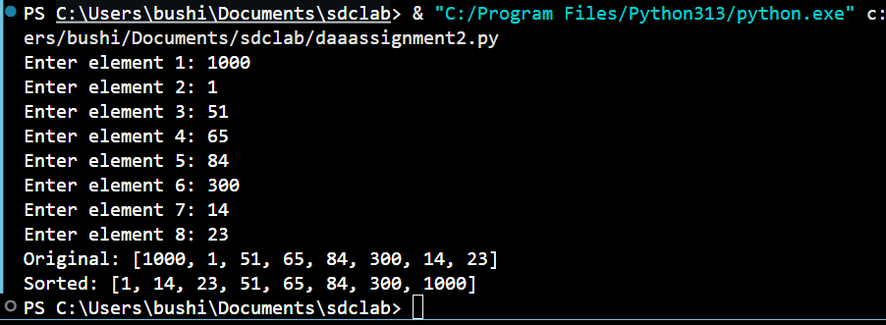

**Time complexity:**

