# Introduction

Blockchain is incorruptible digital ledger of immutable transactions, that can be programmed, to record virtually everything of value. Blockchain stores record in a distributed database which spread across all the nodes of the network using peer-to-peer (P2P) network. In P2P network, all nodes are connected to each other and these nodes can directly share data without the need of central server. Blockchain only update the ledger via consensus mechanism. This attribute gives the power of decentralization to the blockchain. It uses cryptography to secure transaction and block. Each block in a blockchain is connected to the next block using hash of previous block. Genesis block is a first block of the blockchain. “Data can only be added in the blockchain with time-sequential order” [1]. Each single transaction is recorded in a block, and on reaching the capacity of block, the block is added to the ledger called blockchain. Each transaction and block have a unique hash code, if someone wants to change the data of a transaction, the hash code of transaction and the block changes which will make the chain invalid.

Food customers/consumers are becoming more health-conscious and want to know more about the food they get. They want to know about the quality of the food and the time when the food was made or brought from the source. “Customers are more likely to switch to a brand that provides more in-depth product information beyond what’s provided on the physical label” [2]. Right now, there is no easy way to check where your food e.g. rice or meat, came from and how fresh they are. The complex chain from raw material to consumer is not known to the consumer. In order to address this problem, a blockchain based solution is proposed which empowers the customers with more data about the food.

# Objective

Our Project objective is to design a secure food tracking system which impose blockchain features and characteristics. Traditional systems for food traceability are much more time consuming, more expensive, can be easily hacked and less secure. In order to overcome these problems, blockchain technology is quite helpful. This system will allow access to the consumer to get the detail information including its quality, making time and other aspect related to the food that they are going to purchase. As it provides transparency and traceability throughout the whole transaction process.

# Problem Description

Food borne diseases rate is increasing day by day, there is a need for enhancing the trust of customers on food. Blockchain technology is providing efficient solution for secure food tracing system. Firstly, it will help us in keeping every transaction secure between food source, processing, warehouse, transportation, and retailers. Secondly, it will exchange the traditional system of tracking and manual monitoring system. As the traditional way of tracing food chain is not efficient enough to provide detailed information about food. Customers used to take interest in more detailed information specifically about the food they get.

# Methodology

Initially, an account of the entity is created, which belongs to one of the existing domains, which is able to perform certain actions. Account have certain number of roles, which are permissions. An “asset”[4] is used to show some product or value in the blockchain. Each asset corresponds to one of the products in the real world.

An account having the grantable permissions are allowed to deploy a smart contract. After the registration of the nodes in the consortium, they are allowed to do transaction using their “private key”[5]. All the main entities which are participating in moving a product from source to consumer will enter the information of the product in the blockchain using their private key. This will allow the grantable entities to trace the product.

Transactions of any entity is permanently recorded in blocks. Transactions in block can only be added in the blockchain with time-sequential order. Structure of the block is shown in Figure1.

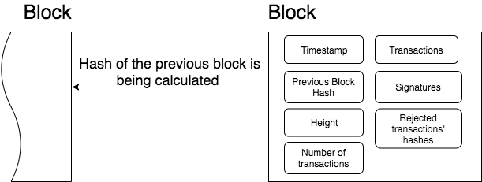

“Figure 1:Structure of Block” [6]

Transaction will only be the part of block, after it is gone through a process of “consensus” [3]. Consensus is the single point of agreement, on a single transaction, among all the distributed entities.

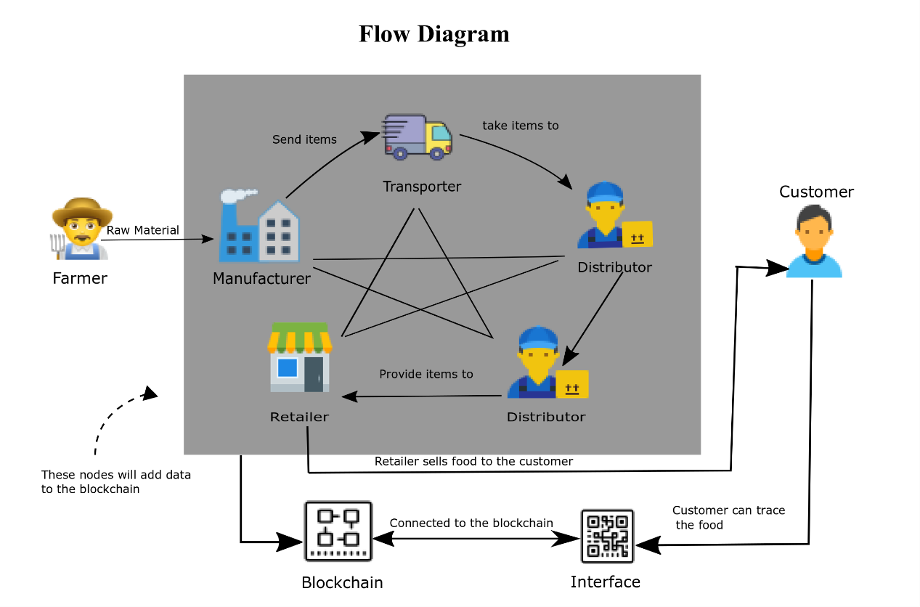

Figure 2: Traceability of food chain

Traceability system based on the blockchain will provide data tampering prevention which were found in conventional systems. At the end, customers will be able to trace the product, and they will get all the necessary information about the product from its source to the customer.

# Project Scope

The proposed shared system with many nodes, such as farmer, manufacturer, transporter, distributer, retailer and customer. The aim is to provide the complete traceability of the food from farmer to customer. As the product goes through multiple stages, and at each stage, information about the product is recorded in distributed ledger. A customer scans a code of the product, in which a query is encoded. This query will show a complete traceability of the product.

# Feasibility Study

* + 1. **Risks Involved**:
* The information about the money transfer between entities, should be kept private between the entities only, not to the customer.
* One part of development is dependent on previous one, therefore, the parts of the project must be completed on time.
  + 1. **Resource Requirement**:
* Dockers.
* Hyperledger.
* VS code.

# Solution Application Areas

According the solution proposed in this proposal many brands will be able to provide safe and secure food items to gain the customer trust and improve their reputation in business.

# Tools/Technology

* Blockchain Technology.
* Hyperledger Project.
* Dockers.
* Java.
* Node JS.
* VS Code.

# Expertise of the Team Members

We have studied in our course about traditional databases (SQL, ORACLE) also have hands on experience of JavaScript, Java.

# Milestones

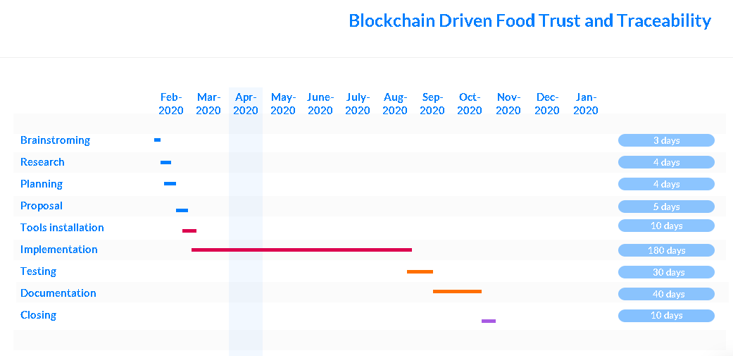

# References