Techment Training 2020

Assignment 1

Algorithm for The Glass House problem:

Input: A two digit number.
Output: A number between 1 to 18.

step1: Start
step2: Read input
step3: lastDigit← input%10
firstDigit← input/10
houseNumber← firstDigit+lastDigit
step4: print “The glass house number”
print houseNumber
step5: Stop.

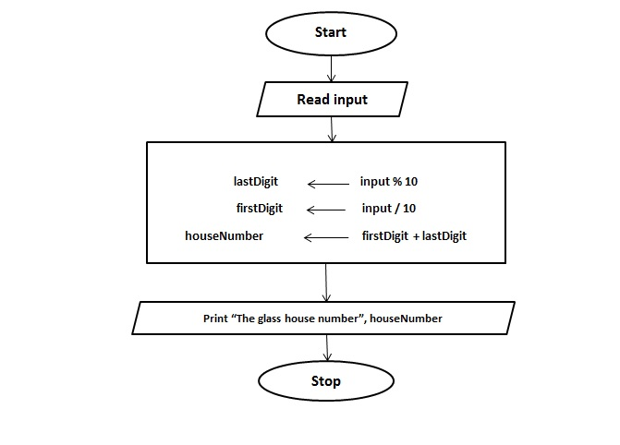
Fig:- Flow Chart

Algorithm for The Traffic Congestion – Even Odd Rule problem:

Input: A day number.
Output: Even or Odd car number permitted.

step1: Start
step2: Read todayDay
step3: If todayDay between 1 to 31 then
if (todayDay%2)==0 then
print “Car With Even Number Registration Should Permitted Today”
else
print “Car With Odd Number Registration Should Permitted Today”
else
goto step 4
step4: print “Invalid Input”
step5: Stop.

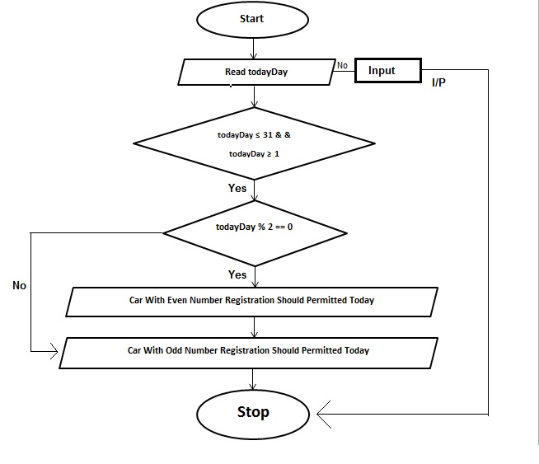

Algorithm for Choosing The Best Horse problem:

Input: Weight of Horse.
Output: Chossing the best horse among them.

step1: Start
step2: Read horseWeight[0], horseWeight[1], horseWeight[2]
step3:for i← 0 to 2 do
for j← i+1 to 2 do
if horseWeight[i]==horseWeight[j] then
goto step4
end for loop
end for loop
step4: If horseWeight[0] > horseWeight[1] and horseWeight[0] > horseWeight[2] then
print”Best Horse is ”
print horseWeight[0]
else if horseWeight[1] > horseWeight[2]
print”Best Horse is ”
print horseWeight[1]
else
print”Best Horse is ”
print horseWeight[3]
go to step5
step4: print “Horse weight value is not distinct”
step5: Stop.

Start
Read horseWeight[1],
horseWeight[2], horseWeight[3]
i<=2
j<=2
i=0
j=i+1
Horse weight is not distinct
Print “Best horse”, horseWeight[1]
horseWeight[0]==horseWeight[1]
&& horseWeight[0]==horseWeight[2]
horseWeight[1]==horseWeight[2]
horseWeight[i]==horseWeight[j]
Print “Best horse”, horseWeight[0]
Print “Best horse”,
horseWeight[2]
Stop

No

Yes

Yes
Yes

No

No

Yes

fig:- Flow chart for choosing best horse

