Day 1 (26 May 2020)

Computer Language

A computer language is a system of communication with a computer. Such languages are used to create computer code or program code, the set of instructions forming a computer program which is executed by a computer.

Algorithm:

a procedure for solving a mathematical problem (as of finding the greatest) common divisor in a finite number of steps that frequently involves repetition of an operation

Code Convention:

Code conventions improve the readability of the software, allowing engineers to understand new code more quickly and thoroughly.

1. Java code convention:

- 80% of the lifetime cost of a piece of software goes to maintenance.
- Hardly any software is maintained for its whole life by the original author.
- If we ship your source code as a product, you need to make sure it is as well packaged and clean as any other product you create.

1.1 File Name

This section lists commonly used file suffixes and names.

1.1.1 File Suffixes
JavaSoft uses the following file suffixes:

File Type Suffix
Java source .java
Java bytecode .class

Day 2 (27 May 2020)

Data Structure

Data Structure is a representation of the logical relationship existing between individual elements of data.

Data structure mainly specifies the following four things:-

- Organization of data

- Accessing methods

- Degree of associativity

- Processing alternatives for information

Classification of Data Structure

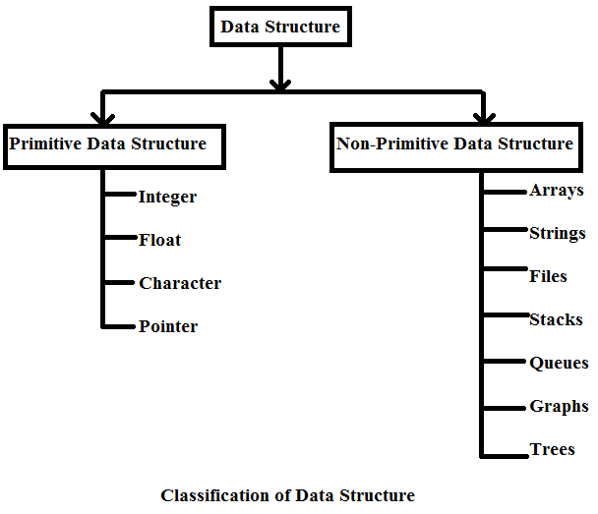

Primitive Data Structure :- The data structure that are atomic or indivisible are called primitive. Example are integer, real, float, Boolean and characters.

Non-Primitive data structure :- The data structure that are not atomic are called non primitive or composite. Examples are records, arrays and strings.

Arrays:- An array is defined as a set of finite number of homogenous elements or data items. It means an array can contain one type of data only, either all integers, all floating point.

numbers or all characters.3

Exp:- int a[10]

Concepts of array:

- The individual element of an array can be accessed by specifying name of the array, followed by index or subscript inside square bracket.

- The first element of the array has index zero[0]. So in an array of 10 elements the first array will be a[0] and last a[9]

- The elements of array will always be stored in consecutive memory location.
- The size of an array can be calculate by this equation

(upper bound- lower bound )+1 (9-0)+1

- Arrays can always be read or written through loop. In case of one dimensional array it required one loop for reading and one loop for writing and in case of two dimensional array it requires two loops for each operation.

- Operation performed on array

- Creation of an array

- Traversing of an array

- Insertion of new elements

- Deletion of required elements

- Modification of an element

- Merging of arrays

Lists:- A list can be defined as a collection of variable number of data items. List are the most commonly used non-primitive data structures.

An element of list must contain at least two fields, one for storing data or information and other for storing address of next element.
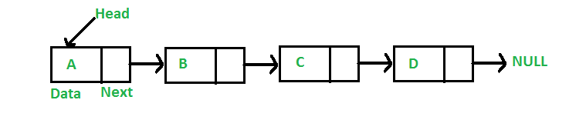

Stack :- A stack is also an ordered collection of elements like array but it has a special feature that deletion and insertion of elements can be done only from one end, called the top of the stack.It is a non primitive data structure.

- It is also called as last in first out type of data structure(LIFO).

- At the time of insertion or removal of an element base of stack remains same.

- Insertion of element is called Push

- Deletion of element is called Pop

Stack implementation

- Static implementation (using array)

- Dynamic implementation(using pointer)

Queue :- Queues are first in first out type of data structures. In a queue new elements are added to the queue from one end called rear end and the elements are always removed from other end called the front end.

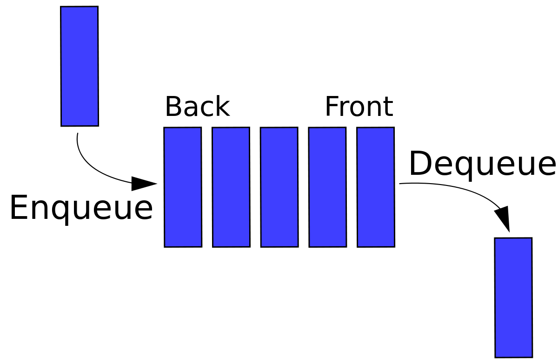

- New elements are added to the queue from one end called REAR end

- Elements are always removed from other end called front end

- Exp. : queue of railway reservation.

- FIFO

Queue Implementation
- Static implementation (using array)

- Dynamic implementation(using pointer)

Day 3 (28 May 2020)

IDE:

An integrated development environment (IDE) is used to write codes using a specific programming language. Java developers commonly use the Eclipse IDE for building a wide variety of software solutions. This saves them a lot of time and effort required in coding. For example, this development platform is widely used for J2EE development.
Framework:

A framework, or software framework, is a platform for developing software applications. It provides a foundation on which software developers can build programs for a specific platform. For example, a framework may include predefined classes and functions that can be used to process input, manage hardware devices, and interact with system software.

Eclipse:

Eclipse is an integrated development environment used in computer programming. It contains a base workspace and an extensible plug-in system for customizing the environment.

Feature of Eclipse:

- Automatic Error Reporting.
- Git Flow.
- Docker Tools
- JDT Improvements
- e4 Tools
- C/C++ Launching
- UI Monitoring
- Platform Improvements
- Mac Layout

Day 4 (29 May 2020)

Logging:

the process of writing log messages during execution of program. Allows to report and persist error, warning and info messages for analysis. Logger is the object which performs the logging in applications.

Log messages can be sent to
• console,
• a file
• a stream
• memory
• a TCP Socket on a remote host.

Component of Log4j:

Log4j has three main components:

• loggers: Responsible for capturing logging information.
• appenders : Responsible for publishing logging information to various preferred destinations.
• layouts: Responsible to format logging information in different styles.

Features of Log4j:

- Thread-safe.
- Optimized for speed.
- Supports internationalization. ➢
- Based on a named logger hierarchy. ➢
- Not restricted to a predefined set of facilities. ➢
- Supports multiple output appenders per logger. ➢
- Logging behavior can be set at runtime using a configuration file.

