The DevOps is the combination of two words, one is **Development** and other is **Operations**. It is a culture to promote the development and operation process collectively.

In simple words, DevOps can be defined as an alignment of development and IT operations with better communication and collaboration.

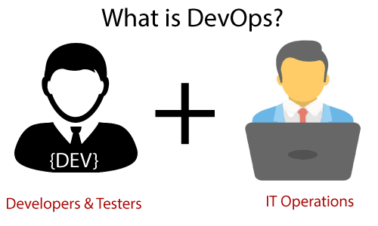

DevOps promotes collaboration between Development and Operations team to deploy code to production faster in an automated & repeatable way.

DevOps helps to increase organization speed to deliver applications and services. It also allows organizations to serve their customers better and compete more strongly in the market

DevOps has become one of the most valuable business disciplines for enterprises or organizations. With the help of DevOps, **quality**, and **speed** of the application delivery has improved to a great extent.

Why DevOps?

Before going further, we need to understand why we need the DevOps over the other methods.

* The operation and development team worked in complete isolation.(lot of gaps)
* After the design-build, the testing and deployment are performed respectively. That's why they consumed more time than actual build cycles.
* Without the use of DevOps, the team members are spending a large amount of time on designing, testing, and deploying instead of building the project.
* Manual code deployment leads to human errors in production.
* Coding and operation teams have their separate timelines and are not in synch, causing further delays.

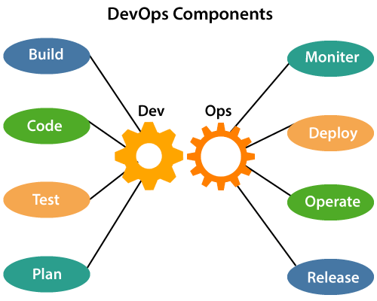

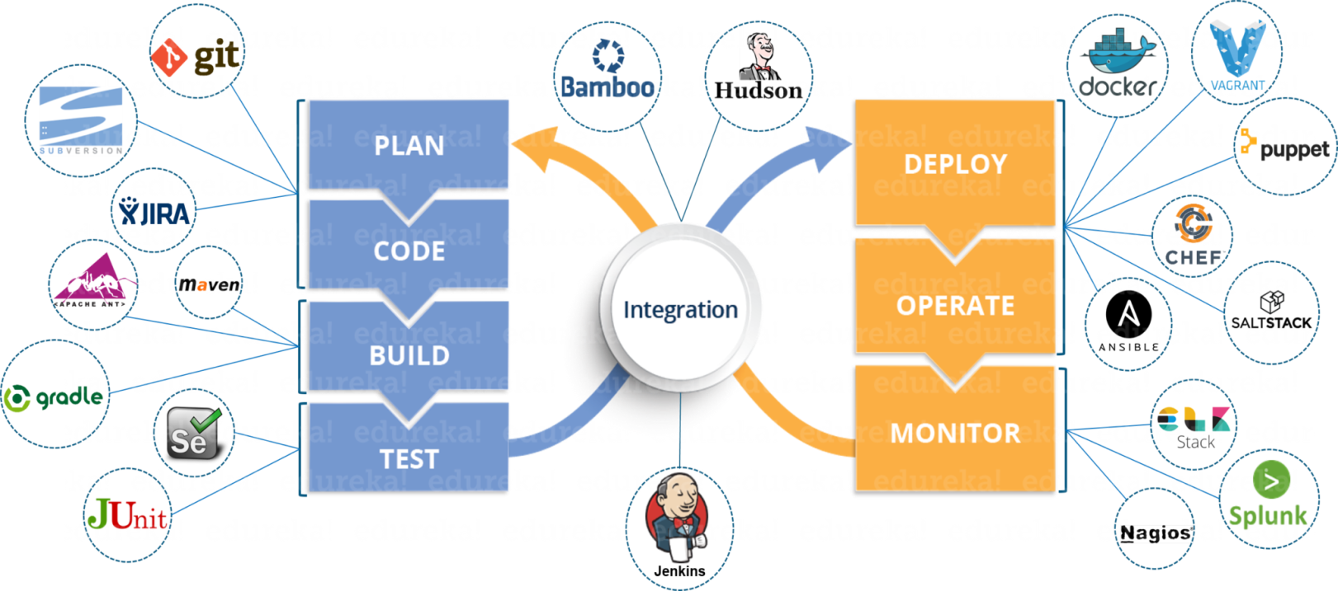

Life Cycle of DevOps

