**Test Case ID: CRM_TC_P_026----Feature: Service SIM**

Subfeature: Manage SIM EBU

Error Message: Keyword 'Input Text' failed after retrying for 40 seconds. The last error was: Variable '${Attach}' not found. Did you mean:  
 ${Batch}

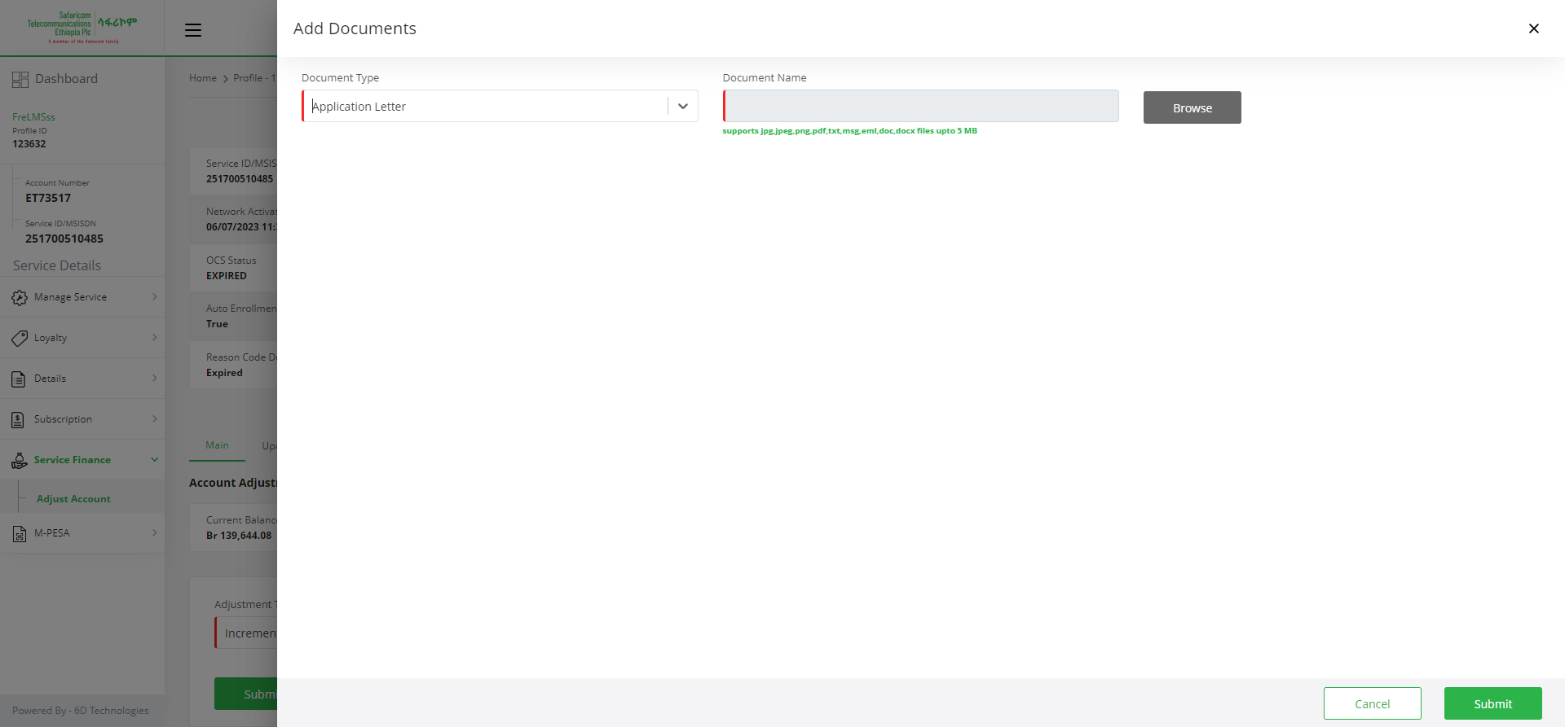

**Test Case ID: CRM_TC_P_026----Feature: Service SIM**

Subfeature: Manage SIM EBU

Error Message: Keyword 'Input Text' failed after retrying for 40 seconds. The last error was: Variable '${Attach}' not found. Did you mean:  
 ${Batch}

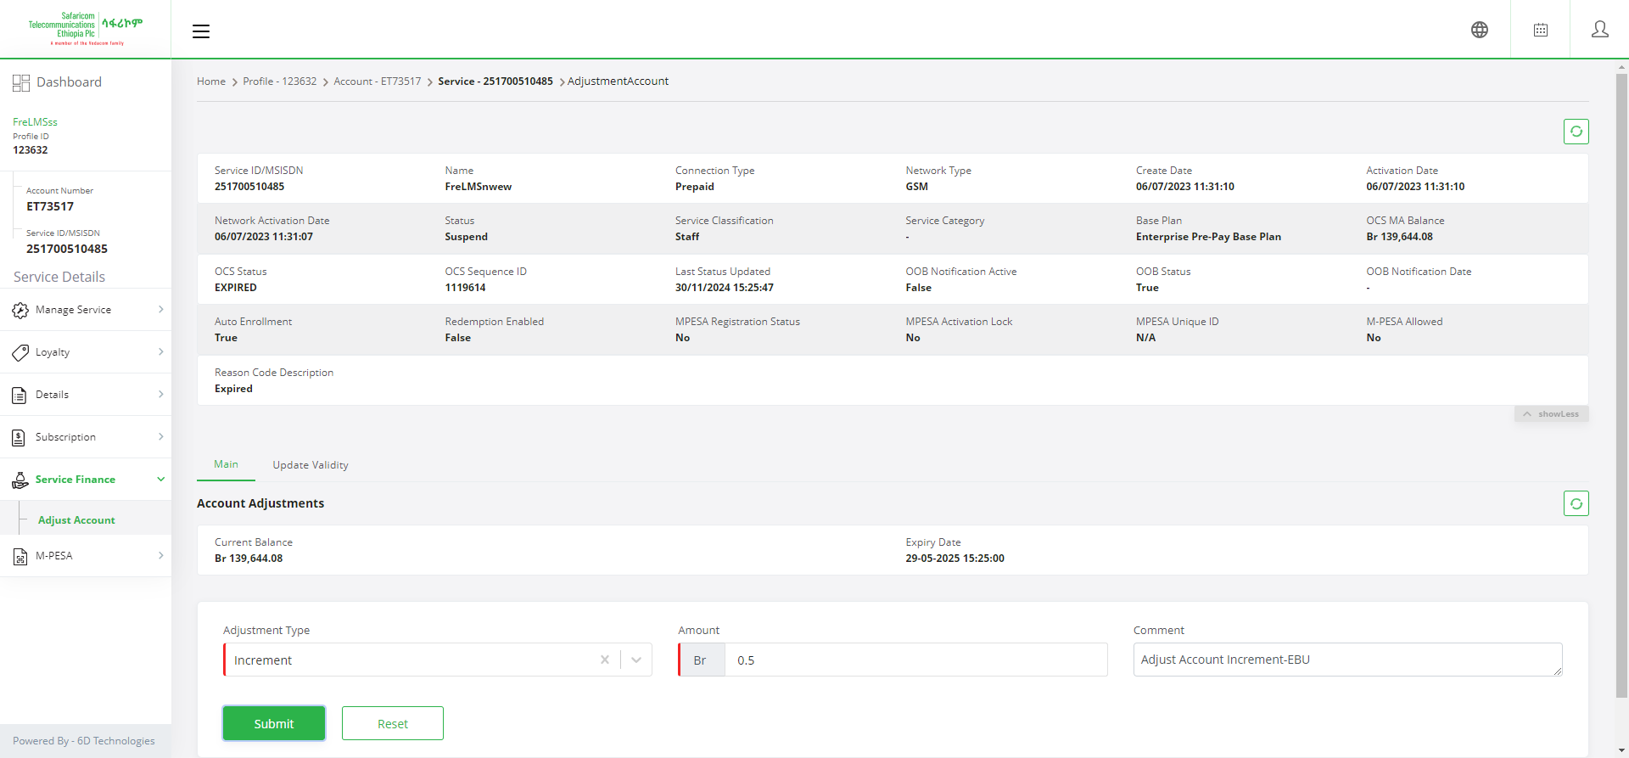

**Test Case ID: CRM_TC_P_026----Feature: Service SIM**

Subfeature: Manage SIM EBU

Error Message: Keyword 'Choose File' failed after retrying for 40 seconds. The last error was: Variable '${Attach}' not found. Did you mean:  
 ${Batch}

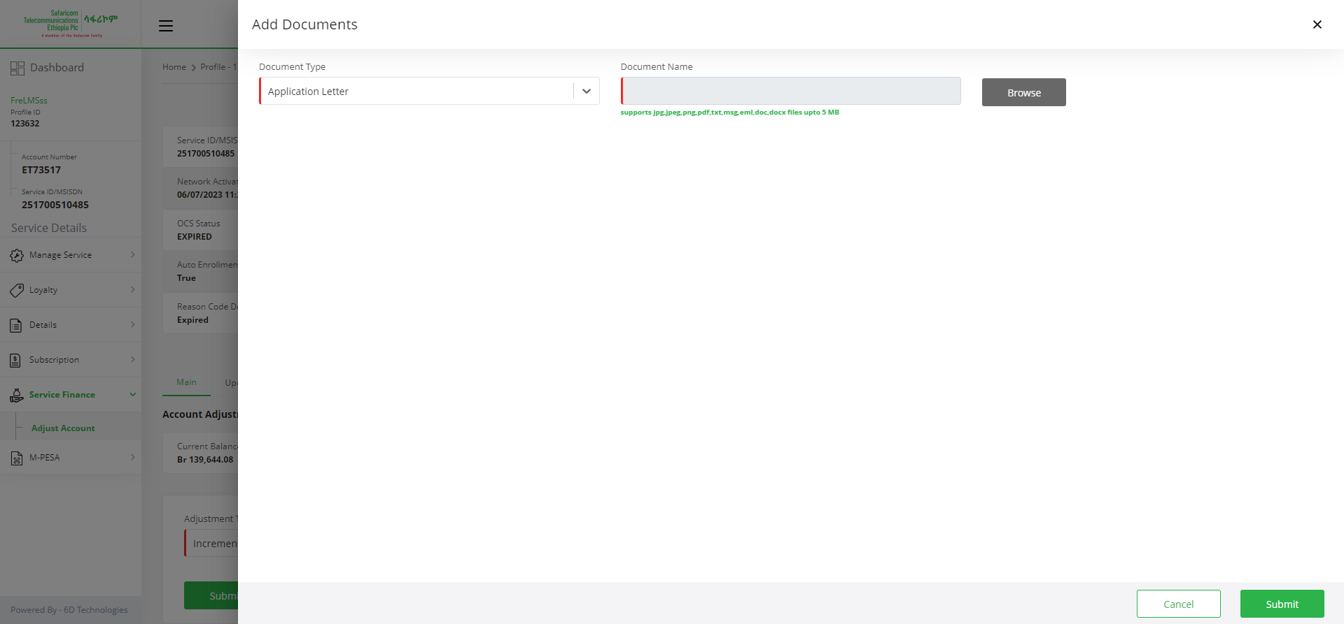

**Test Case ID: CRM_TC_P_026----Feature: Service SIM**

Subfeature: Manage SIM EBU

Error Message: Keyword 'Choose File' failed after retrying for 40 seconds. The last error was: Variable '${Attach}' not found. Did you mean:  
 ${Batch}

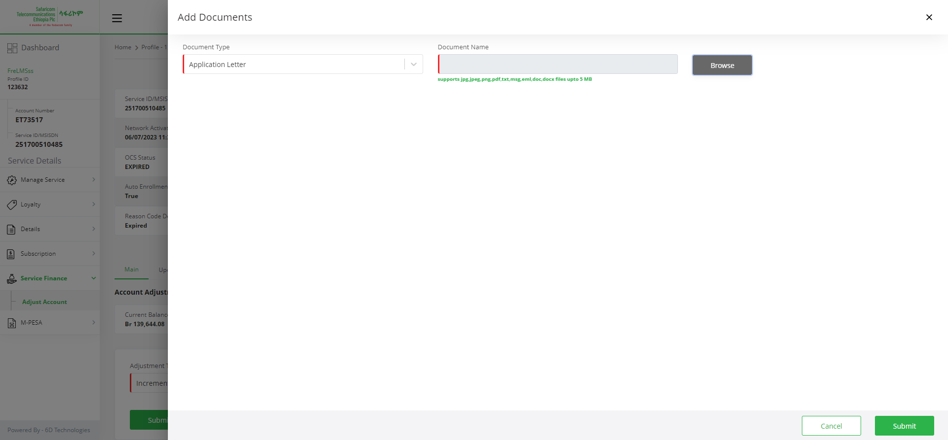

**Test Case ID: CRM_TC_P_026----Feature: Service SIM**

Subfeature: Manage SIM EBU

Error Message: Variable '${Attach}' not found. Did you mean:  
 ${Batch}

