**Test Case ID: CRM_TC_P_028----Feature: Adjust Main Balance**

Subfeature: increment

Screenshot: Adjust Main Balance_1

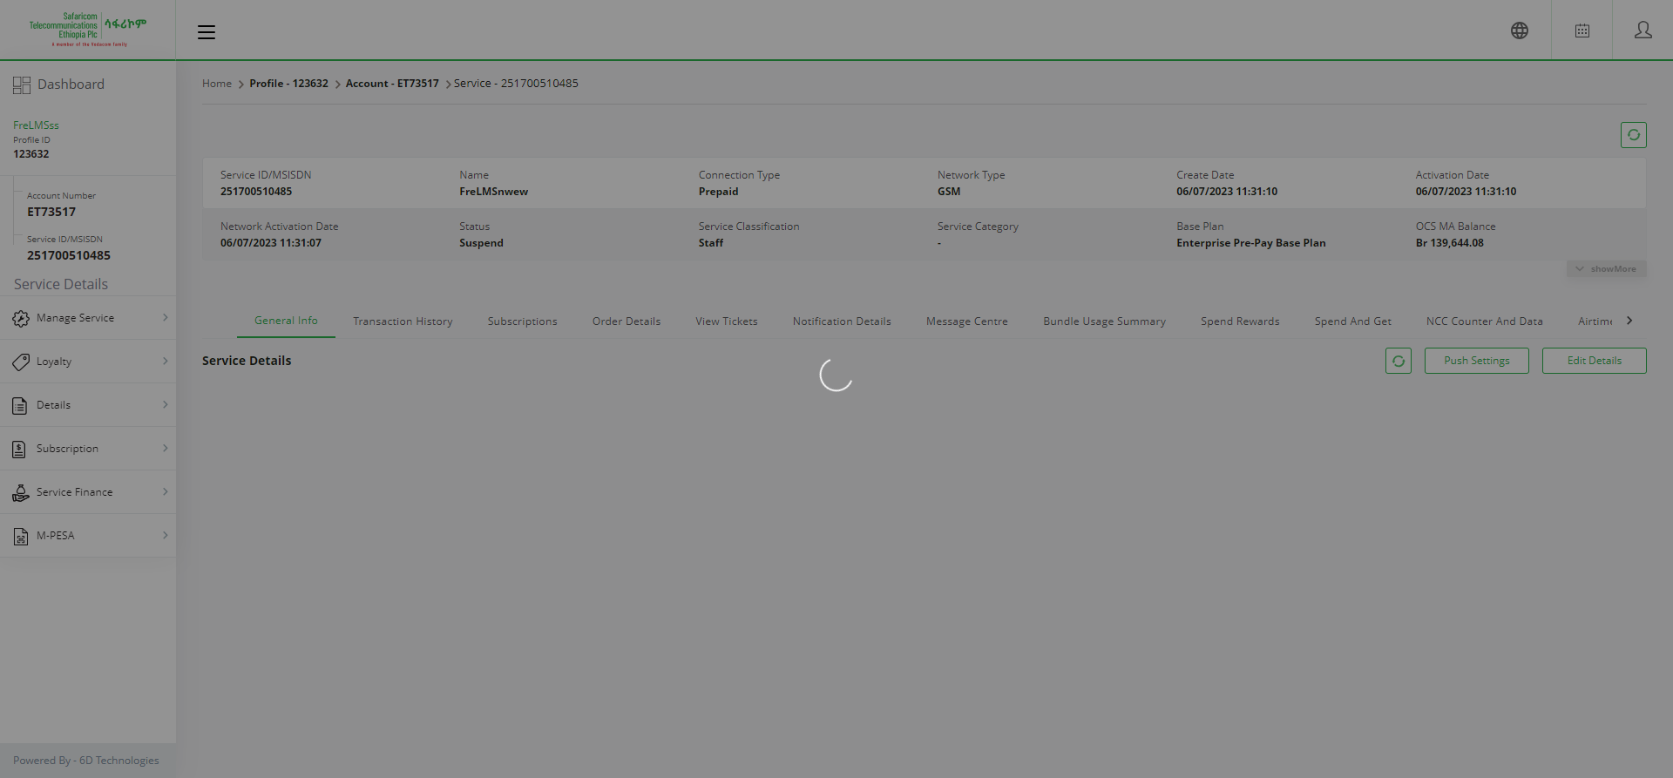

**Test Case ID: CRM_TC_P_028----Feature: Adjust Main Balance**

Subfeature: increment

Screenshot: Adjust Main Balance_2

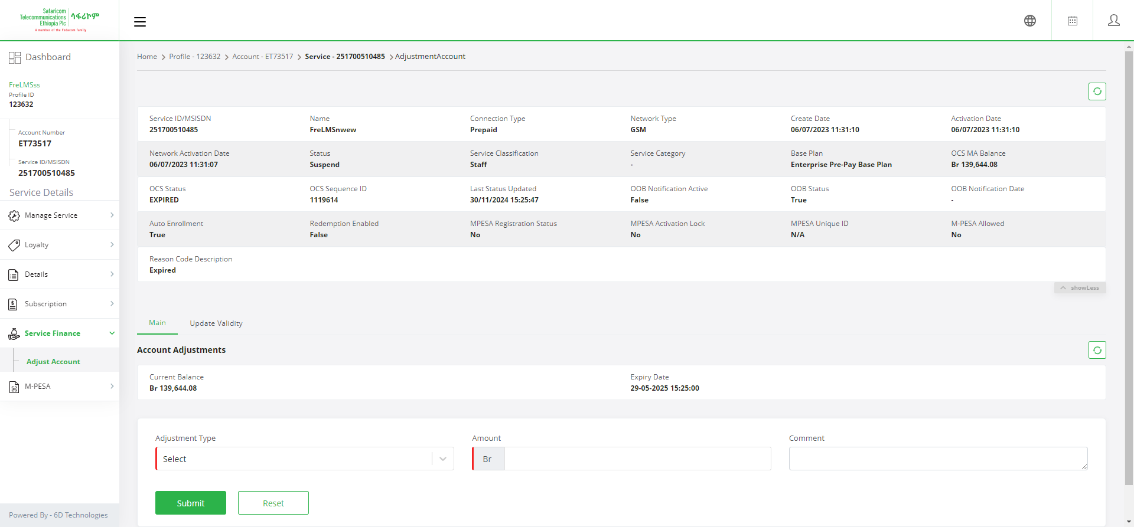

**Test Case ID: CRM_TC_P_028----Feature: Adjust Main Balance**

Subfeature: increment

Screenshot: Adjust Main Balance_3

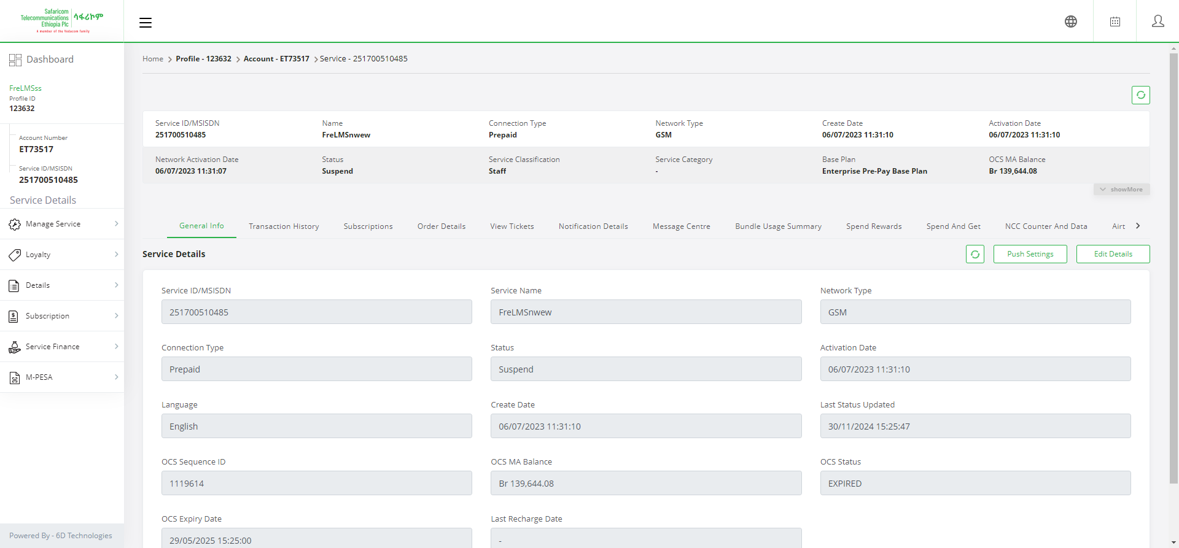

**Test Case ID: CRM_TC_P_028----Feature: Adjust Main Balance**

Subfeature: increment

Screenshot: Adjust Main Balance_4



**Test Case ID: CRM_TC_P_028----Feature: Adjust Main Balance**

Subfeature: increment

Screenshot: Adjust Main Balance_5

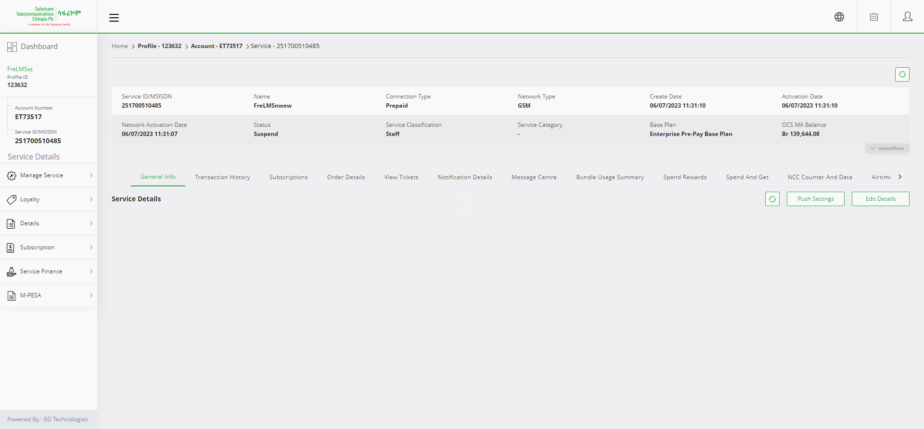

**Test Case ID: CRM_TC_P_028----Feature: Adjust Main Balance**

Subfeature: increment

Screenshot: Adjust Main Balance_6



**Test Case ID: CRM_TC_P_028----Feature: Adjust Main Balance**

Subfeature: increment

Screenshot: Adjust Main Balance_7

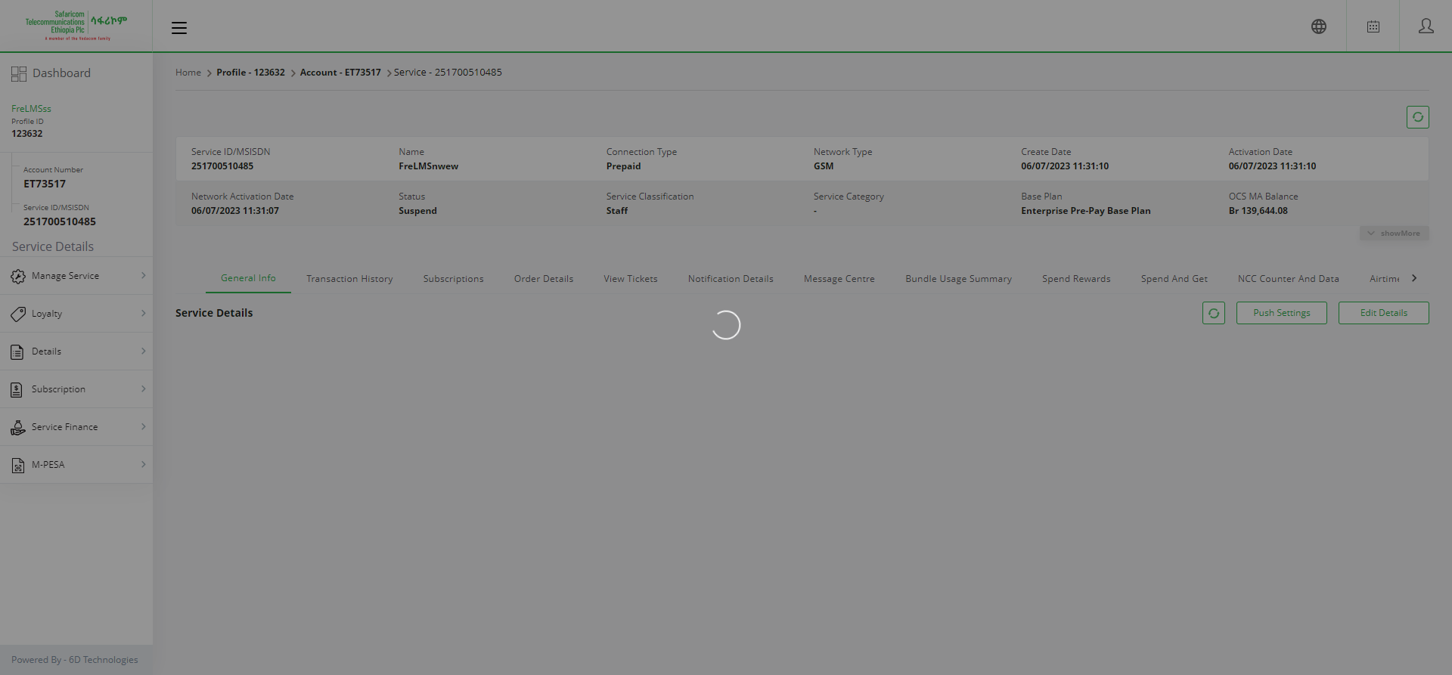

**Test Case ID: CRM_TC_P_028----Feature: Adjust Main Balance**

Subfeature: increment

Screenshot: Adjust Main Balance_8



**Test Case ID: CRM_TC_P_028----Feature: Adjust Main Balance**

Subfeature: increment

Screenshot: Adjust Main Balance_9



**Test Case ID: CRM_TC_P_028----Feature: Adjust Main Balance**

Subfeature: increment

Screenshot: Adjust Main Balance_10



**Test Case ID: CRM_TC_P_028----Feature: Adjust Main Balance**

Subfeature: increment

Screenshot: Adjust Main Balance_11



**Test Case ID: CRM_TC_P_028----Feature: Adjust Main Balance**

Subfeature: increment

Screenshot: Adjust Main Balance_12



**Test Case ID: CRM_TC_P_028----Feature: Adjust Main Balance**

Subfeature: increment

Screenshot: Adjust Main Balance_13

