The Camelina MAGIC population consists of 16 genotypes. All genotypes were grown over 3 different experiments spanning from April 2025 to October 2025. (See “CamelinaMAGIC-ALL-ExperimentDates.xlsx” for exact dates)
Six genotypes are grown in each experiment. “Hoga” is present in each of the three experiments to act as a control.
Each genotype is replicated 4 (sometimes 5 to fill the space) times in both control and drought treatments. (See “CamelinaMAGIC-ALL-Randomization.xlsx” for the randomization of each experiment)
Seeds are planted in sand in 4 inch pots approximately 17 days prior to the start of the experiment. The roots of the seedlings are then washed off prior to transplanting into the 3L pots of sand of the Plant Array. Each pot contains 4 plants.
All water being supplied to the plants contains a dilute (10% of recommended rate) of Hoagland modified basal salt mixture.
Treatments:
The beginning of the experiment starts by watering 3 times overnight (23:00, 00:30, 02:00) for 2.5 minutes. This allows each pot to reach maximum water holding capacity and drain the excess. This is the “Normal Water” conditions, and the Control Treatment is watered this way for the entire experiment.
The Drought Stress treatment (DR_100) waters normally for around 21 days. This allows all the plants to settle into the Array and start growing to a point where we can induce drought stress.
Drought Stress then starts by limiting the water supplied by 100 g of the previous days’ transpiration. Example, the plant transpired 150 g the previous day, so it will be supplied 50 g of water overnight. This lasts for 6 days.
Daily Transpiration is measured as the difference between the weight of the pot at the start of the day to the end of the day. These measurements are taken as an average over 30 minutes from 04:00-04:30 (Day Start) and 21:00-21:30 (Day End).
After this period, we enter into what we call “Hold Stress”. For the next 5 days we like to hold the plant in the stressed state by only providing back the water it transpired the day previous. So if it transpired 30 g the previous day, it would be watered with 30 g overnight.
We then “re-water slowly” after these 5 days so the recovery slope is more gradual. This stage waters the plant with 200% of the previous day’s transpiration. For example, if it transpired 50 g the previous day, it will be watered with 100 g overnight.
After these five days most plants have returned slowly to their maximum water holding capacity and we start watering normally again until the end of the experiment. Usually about a week or so.
You can see in this picture the weight of the pot as it goes from the normal watering and drops down during drought and a gradual weight gain as we slowly rewater.
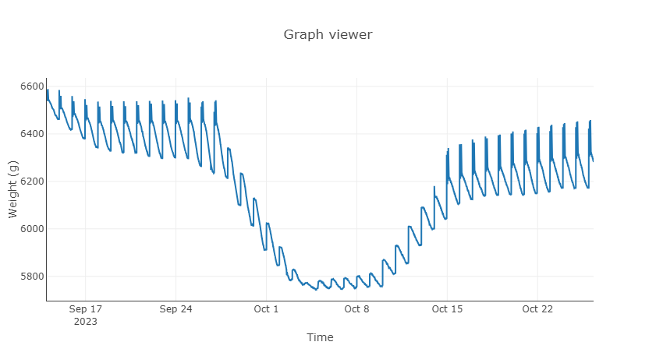
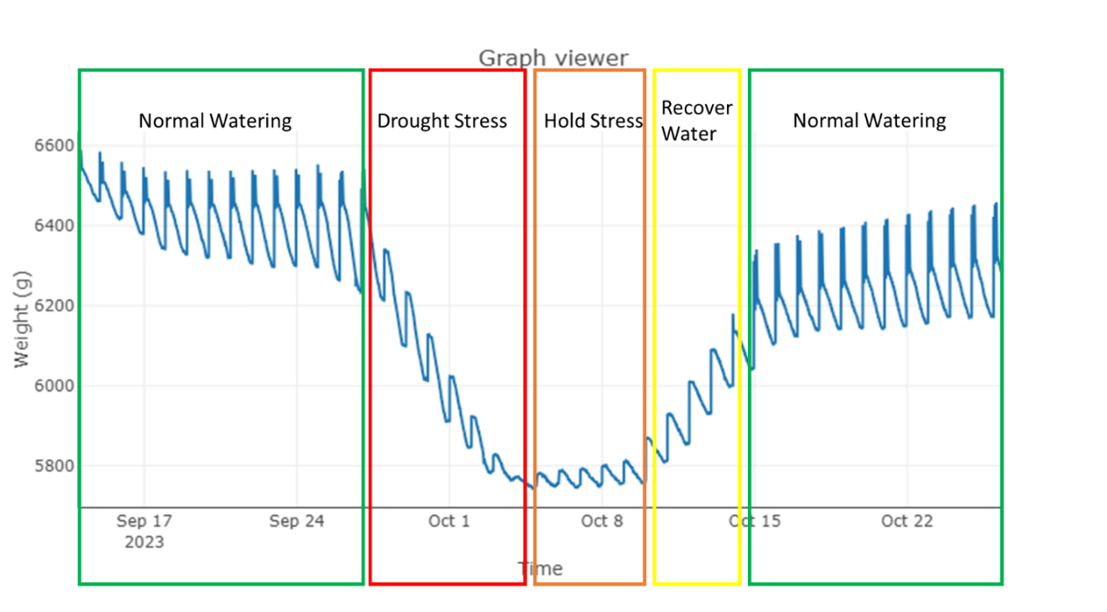

This is what the daily transpiration curve looks like during the experiment.

