Output:
Task 1
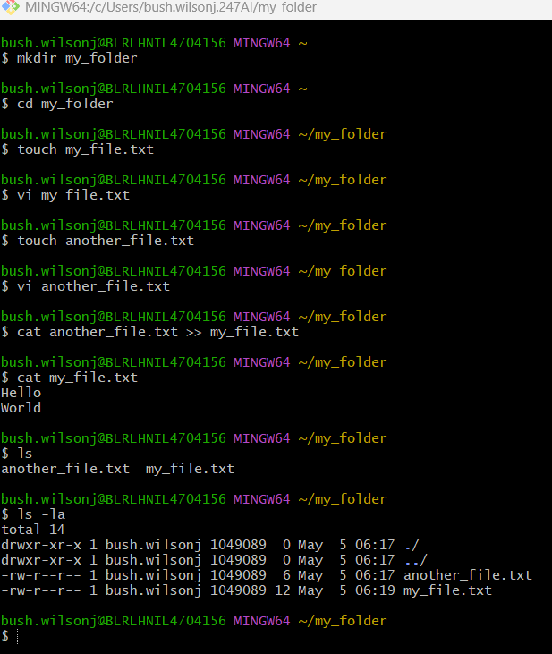

Task 2:
