# **How Blockchain Development Is Shaping the Future of Trading Platforms: A 2025 Guide**

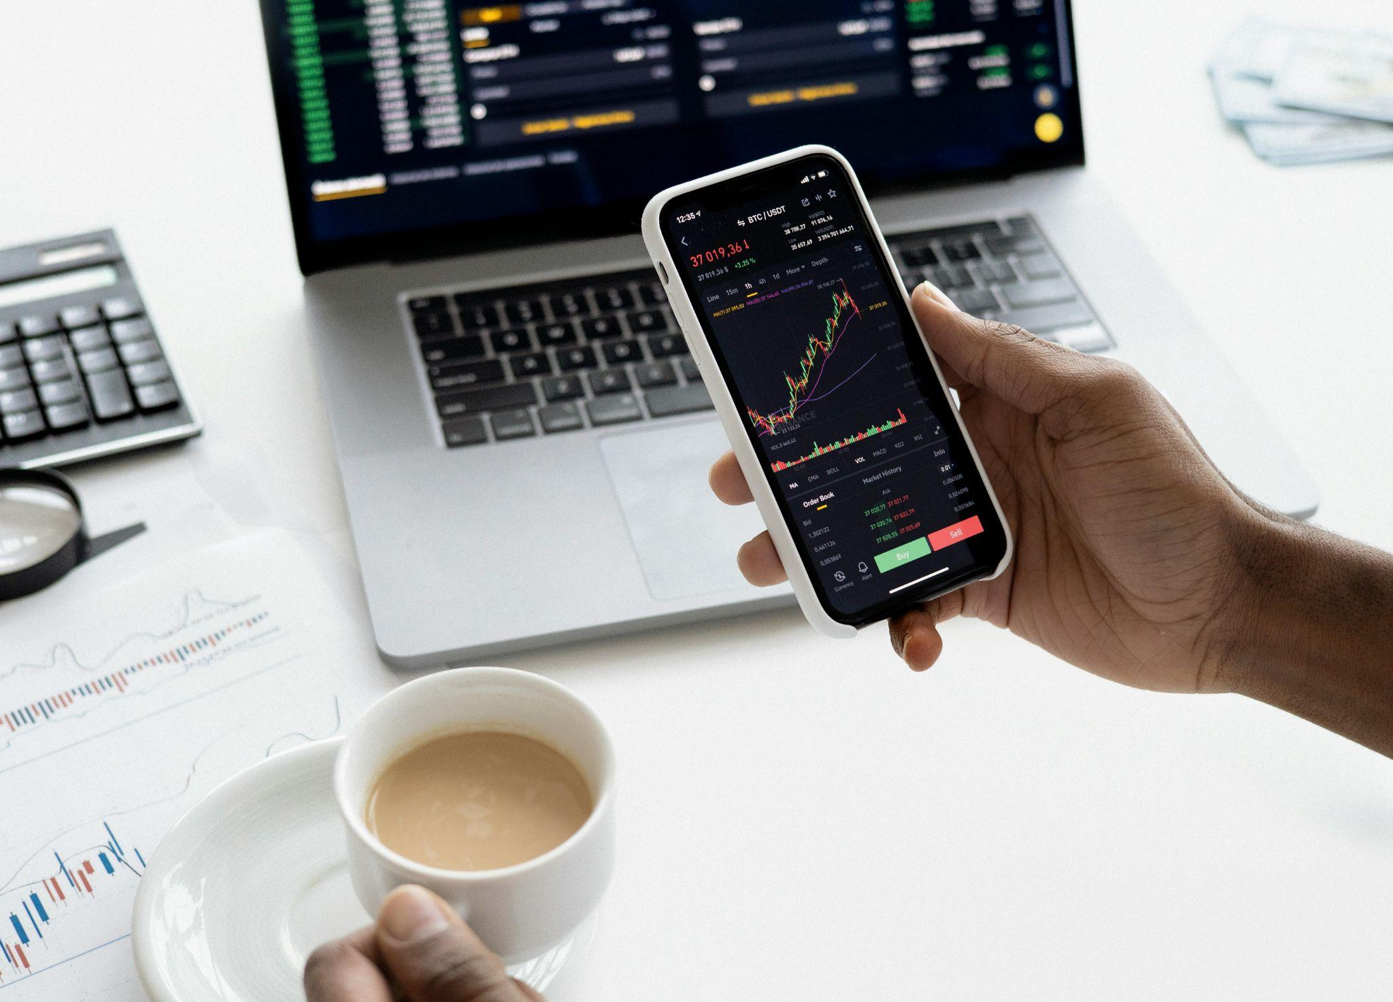

[*https://www.pexels.com/photo/person-holding-a-smartphone-6801874/*](https://www.pexels.com/photo/person-holding-a-smartphone-6801874/)

In 2025, blockchain is no longer just about crypto. It’s become the digital backbone for a new wave of trading platforms. These platforms are using blockchain to improve everything, from speed and transparency to asset access and user control. If you’re an individual investor or a global financial institution, chances are your trades are already touched by blockchain in some way.

This guide takes you through how blockchain is shaping the future of trading platforms, with examples, data, and insights from around the world.

## **The Current State of Blockchain in Trading**

Blockchain is now part of how modern trading works. If you are looking for a clear and up-to-date [blockchain guide](https://www.etoro.com/crypto/blockchain-guide/), start with this fact: more than half of global trading platforms use blockchain in some way. It is becoming a key part of how financial systems stay fast, secure, and transparent.

Over 50% of global trading platforms have integrated some form of blockchain technology into their systems, [according to a 2025 Deloitte report](https://ts2.tech/en/blockchain-technology-comprehensive-report-2025-background-evolution-trends-future-outlook-26th-of-june-2025/). This includes clearing, settlement, and even real-time custody tools.

The value of tokenized assets, including equities, fixed income, and real estate has crossed $500 billion globally, driven by launches from firms like BlackRock, Citi, and Siemens. That number is expected to reach [$1.5 trillion by 2028](https://www.debutinfotech.com/blog/asset-tokenization-trends#:~:text=In%202025%2C%20the%20asset%20tokenization%20market%20is,$500%20billion%20by%20the%20end%20of%202025.) if current growth rates hold.

Blockchain-based systems are also speeding up trade processing. Platforms like Fireblocks, Avalanche Evergreen, and Polygon CDK support sub-5-second settlement times, compared to the old T+2 (two-day) standard in traditional markets. Meanwhile, blockchain-based clearing systems are handling over $100 billion in transaction volume monthly, especially in tokenized treasuries and funds.

## Why Blockchain Is a Game-Changer for Trading Platforms

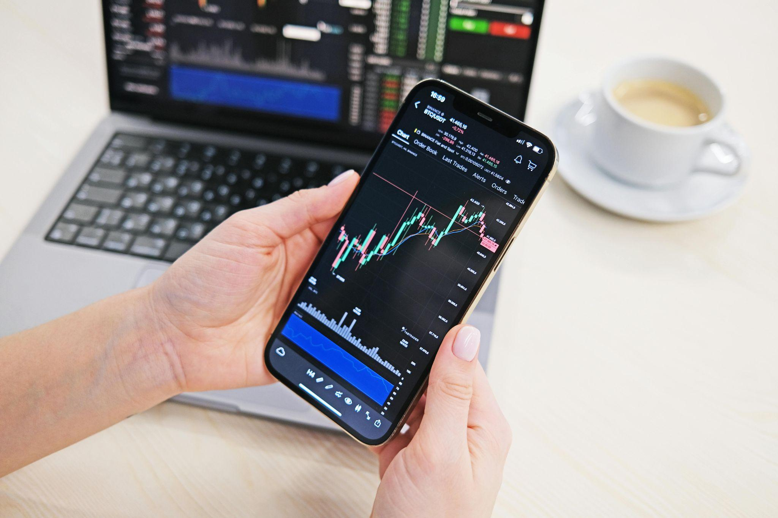

The benefits of blockchain are not theoretical anymore. They’re practical, measurable, and being adopted at scale. Here’s what blockchain does for trading:

1. **Instant Settlement:** Trades settle in real time or close to it. There’s no need to wait two days for confirmation, which lowers risk and frees up capital.
2. **Reduced Cost Structure**: Blockchain eliminates many back-office processes. There’s no need for reconciliation teams, custodians, or clearinghouses in many blockchain-based models.
3. **Built-In Transparency**: All activity is verifiable on-chain. This allows for instant audits, smoother tax reporting, and greater trust between participants.
4. **Smart and Programmable Assets**: Tokens can include logic — for example, unlocking only after a certain date or automatically paying yields.
5. **Global Market Access:** Anyone with a mobile phone and internet can access tokenized markets. This opens trading to populations in emerging markets that were previously excluded.

These advantages are why asset managers, banks, exchanges, and developers are moving quickly to integrate blockchain into their infrastructure.

## What Blockchain Enables Inside Trading Platforms

Under the hood, blockchain unlocks new capabilities that transform how platforms operate. Let’s look at four core areas:

* **Clearing and Settlement:** Settlement happens in near real time. That removes the need for intermediaries, reduces default risk, and improves liquidity efficiency.
* **Tokenization of Assets:** Traditional assets like bonds, ETFs, and property can be converted into digital tokens. These tokens are then easier to fractionalize, trade globally, and manage via code.
* **Custody and Ownership:** Blockchain creates an open record of who owns what. You can use self-custody wallets or opt for platforms that use smart contracts to manage secure digital custody.
* **Identity and Compliance:** Instead of storing sensitive user data, platforms can verify identities through cryptographic proofs. Access to tokens can be restricted based on geography, KYC status, or regulatory rules, all enforced by smart contracts.

## Global Examples Leading Blockchain Innovation in Trading



Different regions are moving at different speeds, but many are already implementing blockchain on the ground.

[In Europe](https://www.marketsmedia.com/regulated-digital-asset-markets-in-europe-from-policy-to-practice/), the EU’s MiCA regulation provides a structured legal framework for trading crypto and tokenized assets. SIX Digital Exchange (Switzerland) is live with tokenized equity and bond trading, integrated with traditional market infrastructure.

In Asia, Singapore and Hong Kong are conducting government-backed pilots for tokenized sovereign bonds. Japan’s SBI Group has launched multiple blockchain investment platforms, including real estate funds for retail buyers.

In the United States, Nasdaq is testing blockchain clearing systems through its Digital Assets division. The SEC has greenlit pilot programs for broker-dealers to use blockchain rails for trading and settlement.

[In the Gulf Region](https://www.biztoday.news/2025/07/07/uae-leads-middle-easts-34b-crypto-surge-emerging-as-regional-powerhouse/), the UAE and Bahrain lead with fully licensed crypto exchanges and blockchain sandbox programs. Kuwait and Saudi Arabia are exploring tokenized infrastructure investments, including sovereign bond offerings on-chain.

These case studies show that blockchain isn’t only a crypto trend. It’s a global upgrade to how finance is managed and accessed.

## Real-World Asset Tokenization: The Fastest Growing Trend

Tokenization is at the heart of blockchain’s transformation of finance. This process turns real-world assets into digital versions that can be stored, transferred, and traded on blockchain networks.

Which assets are being tokenized in 2025?

* Stocks and index funds (ETFs)
* Government and corporate bonds
* Treasury bills and money market instruments
* Real estate, from commercial properties to vacation rentals
* Precious metals like gold
* Private equity and venture capital shares

Why investors are excited:

* **Fractional access: Y**ou can invest $50 in a $500,000 asset.
* **24/7 markets:** No waiting for market open hours.
* **Built-in logic:** Tokens can include automated dividend payments or redemption dates.
* **Liquidity potential:** Private market assets can become tradable instantly.

[By mid-2025,](https://medium.com/@subunit_xyz/global-market-overview-the-rise-of-tokenized-real-estate-worldwide-b8aeaf2f3f88) more than $2.1 billion in real estate alone has been tokenized across 20+ countries, with firms like RedSwan, RealT, and Securitize leading the space.

## How DeFi Influences Platform Design

Decentralized finance (DeFi) is shaping the architecture of next-generation trading platforms — even ones that operate under regulation.

What DeFi Brings to the Table:

* **No closing hours**: Platforms run 24/7 with no downtime.
* **Liquidity pools:** Instead of matching individual buyers and sellers, smart contracts provide liquidity for all users.
* **Automated features:** Trading, staking, borrowing, and yield farming are all executed without human intervention.
* **Transparency**: Anyone can see volumes, fees, and wallets in real time.

Even regulated exchanges are borrowing from this design. For instance, some new hybrid platforms allow users to connect MetaMask wallets but still run KYC on the backend.

## Compliance and Regulation: Blockchain Helps, Not Hurts

Blockchain can actually improve compliance. In 2025, more regulators will recognize this.

How It Works:

* Tokens can be programmed to include jurisdictional access rules or investor accreditation requirements.
* Every transaction is timestamped and permanent, creating an audit-friendly trail.
* KYC/AML procedures can be run through secure, privacy-preserving cryptographic tools.

Regulators in the EU, U.S., and Singapore are now building their frameworks to work with, not against blockchain infrastructure. The key shift is viewing smart contracts and on-chain data as tools to enhance transparency, not threats to oversight.

## Better Experiences for Retail Traders

For retail users, blockchain-backed platforms offer more control, speed, and financial independence.

What’s better for the user:

* Trades execute faster and with lower slippage
* No need to rely on banks or brokers to hold assets
* Fees are lower, especially on decentralized platforms
* More markets are open to small, global investors

In some cases, platforms are eliminating gas fees entirely by covering them internally. Others offer auto-claim features where users receive staking rewards or dividends without clicking anything.

Retail traders now have access to tools once reserved for hedge funds — without traditional barriers to entry.

## What This Means for the Future

The old infrastructure behind finance, built decades ago, is being replaced. What’s emerging is:

* Faster
* More open
* Transparent
* Programmable
* Global by design

For developers, it’s time to think in terms of wallets, tokens, and smart contracts. For investors, it’s time to understand how these tools change everything from fees to custody. And for regulators, it’s a chance to build oversight into the very code running the markets.

## Final Takeaway: It’s Already Happening

For traders, developers, investors, and even regulators, this is the time to act. Learning how blockchain fits into trading platforms isn’t just a technical advantage — it’s a strategic one. The tools, the talent, and the capital are already moving in this direction.

The future of trading is already being built, and it's built on-chain. The only question now is: will you be using it, building on it, or still waiting for “real” adoption that already arrived?