Baseline Triage Classification Models
Results, Metric Justification, and Failure-Mode Reflection
Aiden Daniel · Mercer General Hospital ED Triage Feasibility Pilot · Supervisor: Dr De Freitas

1. Purpose
Following approval of the Week 5 feasibility memo, this report documents Phase 2: a defensible baseline for AI-assisted triage classification on the Mercer Yale EMMLC extract. The brief from Dr De Freitas and Dr Reyes was explicit — a model must beat a coin flip, and its evaluation must be explainable to a clinician without reference to F1 scores or precision/recall jargon. This report presents two baseline classifiers, justifies a single clinically defensible primary metric, and honestly names the failure mode of greatest concern.

2. Method
Dataset: the Week 5 cleaned Yale EMMLC emergency department triage extract (55,121 visits). Features: 208 variables available at the point of triage — seven vital signs and 201 chief-complaint flags. Demographic, administrative, and outcome-only fields (disposition, previous disposition) were excluded as data leakage, alongside a housekeeping row-index column carried over from the raw export that held no clinical signal. Target: Emergency Severity Index (ESI), levels 1 (most critical) to 5 (least urgent).
The data were split 80/20, stratified on ESI, with a fixed random seed (random_state = 42) recorded for reproducibility. Two baselines were trained: a logistic regression classifier on standardised features, and a depth-bounded decision tree (max_depth = 5, chosen to keep the model interpretable and to limit overfitting given how rare ESI 1 and ESI 5 are in this dataset). Both were compared against a stratified random-guess baseline (scikit-learn's DummyClassifier).

3. Results
Model | Accuracy | Macro F1 | Weighted F1 | Recall — ESI 1
Dummy (stratified guess) | 0.375 | 0.204 | — | 0.00
Logistic Regression | 0.667 | 0.492 | 0.661 | 0.25
Decision Tree (depth 5) | 0.556 | 0.216 | — | 0.00

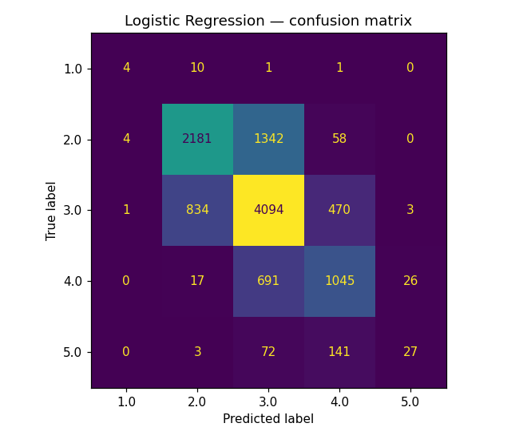  Figure 1. Logistic regression — confusion matrix. | 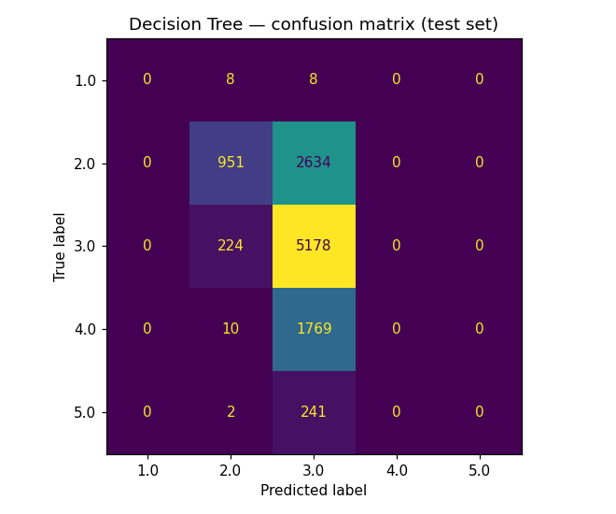  Figure 2. Decision tree — confusion matrix.

4. Primary Metric: Recall for ESI 1
The chosen primary metric is recall for ESI 1 — the fraction of truly critical patients the model correctly flags as critical. Accuracy is not defensible here: ESI 1 makes up only 0.3% of visits, so a model can score 66–67% accuracy while never once correctly identifying a critical patient, which is exactly what the decision tree does. In a triage context the two error types are not symmetric. A false negative on ESI 1 — a critical patient scored as lower-acuity — risks a delay to resuscitation or emergency intervention; a false positive (over-triage) costs staff time and observation capacity but does not directly endanger the patient. Because under-triage is the clinically dangerous direction of error, recall on the rarest, most severe class is the number that should be reported first, ahead of overall accuracy or any blended score.

5. Macro vs Weighted F1
Macro F1 averages performance across all five ESI levels equally; weighted F1 lets the large classes dominate the average. The gap between them here — 0.492 macro versus 0.661 weighted for logistic regression — shows that the headline weighted score is propped up almost entirely by performance on the common, mid-acuity classes (ESI 2–4). It hides the near-total failure on the rare classes at both ends of the scale (ESI 1 and ESI 5). Reporting only the weighted figure to Dr Reyes would overstate how safe this model is; macro F1 and recall for ESI 1 are the figures that actually surface the risk.

6. Failure-Mode Reflection
Decision tree — recall 0.00 for ESI 1. At depth 5 the tree never predicts class 1 (or class 5) for any test patient: it collapsed to choosing only between ESI 2 and ESI 3, the two largest classes. All 16 truly critical patients in the test set were under-triaged; none were flagged. This is the failure mode of greatest concern — a model that looks reasonable on accuracy while being clinically blind to the exact patients triage exists to catch.
Logistic regression — recall 0.25 for ESI 1. Of 16 true ESI 1 patients, 4 were correctly identified; 10 were predicted as ESI 2 (an adjacent, still-serious under-triage of one level), 1 as ESI 3, and 1 as ESI 4 (a two-level under-triage — the more dangerous kind of miss, since it more plausibly delays care long enough to matter). Logistic regression is meaningfully better than the tree on the metric that matters, but still misses three in four of the sickest patients in the dataset — nowhere near deployable, and that limitation should be stated plainly rather than buried under the model's respectable-looking 66.7% accuracy.

7. Recommendation
- Neither baseline is deployable on current performance; recall for ESI 1 (0.00–0.25) is the figure that should gate any deployment decision, not accuracy.
- Class-weighted or cost-sensitive variants (e.g. class_weight = "balanced") should be tried next, specifically to raise ESI 1 recall, even at the cost of precision or overall accuracy.
- Ensemble methods (random forest, gradient boosting) are reasonable next steps for Week 7+, but only if evaluated on the same primary metric — a more "sophisticated" model that still shows 0% ESI 1 recall is not progress.
- Recall for ESI 1 should be reported as the headline metric in every future iteration, with macro F1 as a secondary check and accuracy quoted only for context.

8. Reproducibility
All code is committed to GitHub: Week6_Tutorial2_Implement_LR_and_DT.ipynb (model training) and Week6_Tutorial3_Model_Evaluation.ipynb (evaluation) in /notebooks; confusion-matrix figures in /docs/figs. random_state = 42 is fixed throughout for both the train/test split and both models, so all figures in this report are exactly reproducible from the committed notebooks.

References
[1] Agency for Healthcare Research and Quality, Emergency Severity Index (ESI): A Triage Tool for Emergency Department Care, Version 4 — Implementation Handbook, 2020 ed. Rockville, MD: AHRQ.
[2] F. Pedregosa et al., "Scikit-learn: Machine Learning in Python," Journal of Machine Learning Research, vol. 12, pp. 2825–2830, 2011.

