**Project Design Phase-II**

**Data Flow Diagram & User Stories**

|  |  |
| --- | --- |
| Date | 31 January 2025 |
| Team ID | LTVIP2025TMID59924 |
| Project Name | HealthAI: Intelligent Healthcare Assistant Using IBM Granite |
| Maximum Marks | 4 Marks |

**Data Flow Diagrams:**

A Data Flow Diagram (DFD) is a traditional visual representation of the information flows within a system. A neat and clear DFD can depict the right amount of the system requirement graphically. It shows how data enters and leaves the system, what changes the information, and where data is stored.



Example: DFD Level 0 (Industry Standard)

**Example:** [**(Simplified)**](https://developer.ibm.com/patterns/visualize-unstructured-text/)

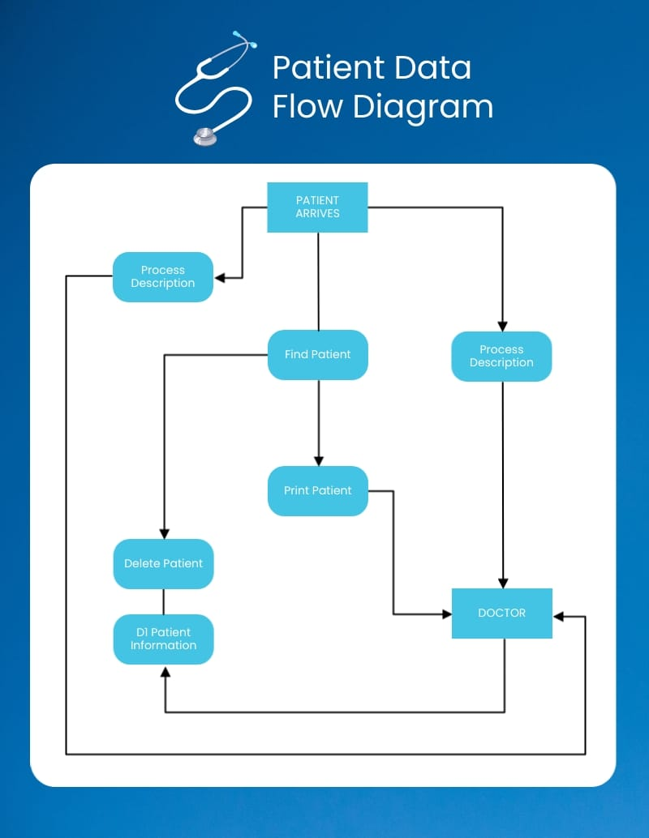

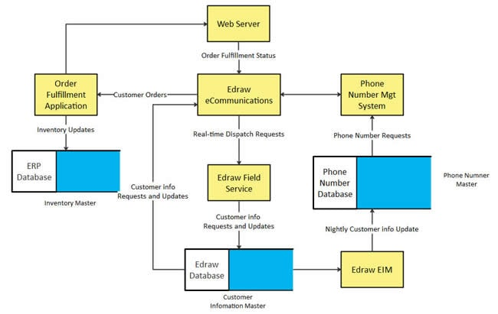

**User Stories**

Use the below template to list all the user stories for the product.

| **User Type** | **Functional Requirement (Epic)** | **User Story Number** | **User Story / Task** | **Acceptance criteria** | **Priority** | **Release** |
| --- | --- | --- | --- | --- | --- | --- |
| Customer (Mobile user) | Registration | USN-1 | As a user, I can register for the application by entering my email, password, and confirming my password. | I can access my account / dashboard | High | Sprint-1 |
|  |  | USN-2 | As a user, I will receive confirmation email once I have registered for the application | I can receive confirmation email & click confirm | High | Sprint-1 |
|  |  | USN-3 | As a user, I can register for the application through Facebook | I can register & access the dashboard with Facebook Login | Low | Sprint-2 |
|  |  | USN-4 | As a user, I can register for the application through Gmail |  | Medium | Sprint-1 |
|  | Login | USN-5 | As a user, I can log into the application by entering email & password |  | High | Sprint-1 |
|  | Dashboard |  |  |  |  |  |
| Customer (Web user) |  |  |  |  |  |  |
| Customer Care Executive |  |  |  |  |  |  |
| Administrator |  |  |  |  |  |  |
|  |  |  |  |  |  |  |
|  |  |  |  |  |  |  |
|  |  |  |  |  |  |  |
| Customer (Web user) | Symptom Analysis & Disease Prediction | USN-1 | As a user, I can enter my symptoms and receive a list of possible conditions with confidence scores. | I can see relevant conditions and likelihood estimates based on input. | High | Sprint-1 |
| Customer (Web user) | Personalized Treatment Plan | USN-2 | As a user, I can input a diagnosed condition and receive a tailored treatment plan. | I receive a step-by-step plan with medications, follow-ups, and advice. | High | Sprint-1 |
| Customer (Web user) | Health Analytics | USN-3 | As a user, I can view my health trends using graphs and data summaries. | I see line charts of heart rate, glucose, BP, and AI-generated insights. | Medium | Sprint-2 |
| Customer (Web user) | Patient Chat | USN-4 | As a user, I can ask health-related questions and receive an intelligent AI response. | I get helpful, empathetic answers and alerts when to seek medical attention. | High | Sprint-1 |