Intrusion Detection System Using Machine and Deep Learning Techniques

Abstract
The project consists of an effective IDS that employs machine learning and deep learning techniques in the improvement of threat identification in network systems. The models are intended to detect and categorize malicious actions by extracting and evaluating the traffic information with sophisticated methods and algorithms to achieve maximal precision of the detection and minimal possibility of false alarms. With the use of feed-forward supervised machine learning classifiers and deep learning structures, the IDS is capable of detecting old and new patterns of attack and can manage the changes in patterns in real time. In addition, with this system, One-Time Passwords (OTP) from Gmail is adopted for the multiple-factor authentication of user access for higher security. Together with standard notifications these alerts also include information for security administrators to react immediately to incoming threats and to get an extensive overview about possible risks in the network traffic. The proposed IDS is to create the base of proactive and adaptive defence strategy which can increase security of the network infrastructure.

.

Acknowledgements

Contents
Introduction 5
Background and Context 5
Security and Challenges of IDS 6
Machine Learning and Deep Learning For IDS 7
Aims 8
Objectives 8
Summary 9
Literature Review: 10
Methodology 12
Research Design 12
System Design 13
Threat Detection Module: 14
Control Mechanism: 14
Memory Alert Generation: 15
Data Collection 15
Data Pre-processing: 16
Implementation: 16
Results and Discussion 20
Threat Detection Module 20
Machine Learning Models: 21
Control Mechanism 24
Memory Alert Generation: 26
Evaluation 28
Threat Detection 28
Control Mechanism 28
Memory Alert Generation: 28
Conclusion 29
References: 32

Introduction

Background and Context

Advancements in technology have become the order of the day amidst the connected world hence the integration of sophisticated technologies has transformed different sectors through encouraging efficiency and introducing new ways of doing things mechanically. But this concerns the issue of network security and how the integrity and confidentiality of frequently accessed sensitive data will be maintained; this includes patient medical record data and other corporate operational data. This represents an appropriate trend of needing security frameworks that can accommodate the several types of threats as the network infrastructures become heterogeneous, and are increasingly geographically dispersed.
In this kind of security environment, a good Intrusion Detection System (IDS) is essential. That is used as a preventive measure that detects and estimates malicious activities in the networks. By applying the intelligence of machine learning and deep learning an IDS is able to monitor the traffic patterns in a network for anomalous behaviour on its own. In order to boost this security even higher more strict access control measures like one time password generated and sent through the email have been adopted in order to allow only those with permission access sensitive data information. Also, network traffic alerts help security administrators to address the identified threats vigorously making real-time decisions to defend other vulnerable assets. Taken together, these measures support a diverse and robust security model capable of protecting the data’s integrity, personal information, and businesses and organisational continuity as the globalised world continues to advance (Jang-Jaccard, 2014).
IDS are versatile because they are used in almost every field for monitoring, detecting and preventing the intrusion activities of a network. IDSs play an important role in the corporate environment to safeguard company data, patents, and business information by detecting malicious activities, and notifying the administrator. For examples in the field of finance and banking IDSs are also successfully implemented to protect data of transactions and customers information thus ensuring compliance with regulatory acts and excluding the possibility of fraudulent actions. IDSs can also be employed in government and defence industries to counter espionage, cyber operations and/or leakage of data that is sensitive or of a national concern. These systems are however accompanied by advanced threat intelligence that enable them to identify patterns that suggest nation-state attacks or terrorism related cyber threats. IDSs prove useful to educational institutions because the institutions have heaps of data on their students and other faculty members; second, because IDSs help protect students’ personal data; and third, because the institutions risk losing vital research data and creations to hackers .
In critical infrastructure sectors i.e. energy and utilities IDSs are used to protect operational technology (OT) networks that manage devices for power stations, water treatment plants and other core industries. Says an organisation: any weakness in these networks would have catastrophic repercussions on citizens’ lives and the nation as a whole. Within the e-commerce environment IDSs operate on the forefront as they analyse transactions and discover fraud activity which attempts to penetrate payment systems and steal customer information. Last but not least, IDSs are deployed to implement security measures in the emergent field of cloud computing to ensure security of data residence in several connected networks and prevent the leakage of data in multi-tenancy applications. These applications effectively demonstrate the applicability and usability of IDSs as basic security instruments adjustable to particular requirements of different sectors, as well as of providing protection of both informational and operational resources in the face of constant changes in threat profiles (Thakur et.al, 2015).

Security and Challenges of IDS
Network Intrusion Systems (IDS) consist of multiple security solutions to address unauthorized access, data theft, or other atrocities in networks. Anomaly detection represents a basic security function of IDS that sets up a standard for normal network traffic and sounding an alarm when abnormality is observed, which might be a sign of intrusion. This capability is done by signature based detection where IDS compares the traffic with the database of attack patterns or signatures to enable it to recognize well known threats and counter them instantly. IDSs very often are used in association with other security systems like firewalls and SIEM (Security Information and Event Management) systems to provide the multi-layered system so that the administrators could quickly correlate the events in different security tools (Khraisat et.al, 2019).

Nevertheless, it is important to point out that IDSs face certain problems, how much the latter might be related to the more or less solid features of IDSs. A major challenge is that the attackers are always changing their profile – coming up with new and more challenging techniques that IDS will be hard put to detect since they do not have signatures that would make them easy to identify unlike virus or worms, thus the need for IDS to update its database and enhance the new anomaly detection techniques. Another is that there are a lot of false positives, that yield low signals that are often labelled as threats when they are actually not, thus increasing the alert fatigue in the security team who may miss out on true threat because they are always overwhelmed by the number of alerts that they receive. Further, encrypted traffic is also a problem since IDS get confused with encrypted data streams and due to legal restriction not able to decrypted data. Last of all, ethical issues experienced with IDSs are intrusion on the users’ privacy as these devices dissect all the network traffic thereby violating user’s rights and regulations with regard to data privacy. These illustrate how necessitated it is for IDS technologies to be continuously improved including the integration of machine learning and artificial intelligence in order to help to reduce resource utilization and enhance IDS accuracy, adaptability as well as overall network security (Ahsan et.al, 2022)..

Machine Learning and Deep Learning For IDS
Trends such as ML and DL are disrupting IDS because of the corrections that they bring to the identification of new and sophisticated threats in real time. The principal weakness of signature- and rule-based methods is the inability to differentiate new previously unknown types of attacks. On the other hand, self-learning and clustering algorithms like ML and DL are much more efficient at detecting intrusion even when tested on big data sets and thus ideal for contemporary dynamic networks. For example, decision trees, random forest, support vector machines or SVM are examples of the machine learning techniques widely used to categorize network behaviour into either benign or malicious. These particular algorithms are trained on large data sets and are thus able to detect unusual traffic patterns on networks that it has never encountered before, let alone recognize specific attack signatures of a virus. IDS based on ML augments its knowledge with new information and can adapt to a threat more efficiently than non-ml based IDS. The use of ML and DL in IDS also has application-specific challenges as shown below. While implementing an ML model, a lot of labelled data are needed for supervised training, and preparing such data might be a time-consuming and expensive process. DL models are effective, however they require plenty of computer resources and their usage may potentially be too slow for real-time applications due to their complexity. In addition, these models can be very susceptible to adversarial attacks where small modifications to the traffic are made that are intended to fool the IDS. To overcome these challenges, researchers are configuring Integrated IDS with ML And DL with conventional techniques and enhancing the benefits of each to provide better clarity of IDS from advanced attacks. However, the ML and DL technologies for IDS are a leap forward in improving the methods of securing a network environment from new, diverse, and sophisticated threats.

Aims
- To Develop a Robust Intrusion Detection System: Basically, develop the advanced IDS that should properly detect and counter different attacks that occur in the system with the help of machine learning and deep learning algorithms.
- To Enhance Detection Accuracy and Speed: Employ effective algorithms to have a better detection rate and still have a small response time to identify the threats.
- To Adapt to Evolving Threats: Design a framework that can evolve with emerging novel threats applicable in real-time dynamic networks.

Objectives
- To Analyse the CICIDS2017 Dataset: This complete dataset must be used for comprehending the normal and the abnormal traffic pattern in Networks that will help in developing a groundwork for training as well as the testing of the IDS.
- To Implement Various Machine Learning Algorithms: Experiment over the similar algorithms as a decision tree, support vector machine, and random forest in order to identify anomalies in traffic flow.
- To Leverage Deep Learning Techniques: A) Enhance the deep learning models where you have left some models like Convolutional Neural Networks on capture of pelt and detection accuracy.
- To Evaluate Model Performance: Evaluate the system with such results as accuracy, precision, recall and or false positive rates with respect to the acceptable norm for practical use.

Summary
Due to the increased connection between Information Technology systems in the present world, IDS are very important tools in identifying and preventing unlawful intrusions and protecting important data in networks. IDSs are implemented in many sectors of the economy and organizations, such as healthcare, finance, government and critical infrastructure because they actively defend by analysing the network activity. However, the current IDS approach has its shortcomings because of new emerging threats, high false positives, and large distributed networks. To overcome these drawbacks IDS technology has incorporated some machine learning (ML) and deep learning (DL) techniques to make IDS way more smarter to detect threats. Decision trees and other support vector machines enhance IDSs by classifying data while identifying the suitable network behaviours or patterns consistent with new or previously unidentified threats. However, using DL techniques, such as CNNs and RNNs, the detection capability is improved and identifies multiple-stage attacks hidden in the network traffic. While it is easy to identify that ML and DL based IDSs come with numerous advantages, it is also important to look at the challenges that come with them including the following; Stringent requirement for labelled data Computationally intensive models. Thus, present day IDS solutions frequently use hybrid approaches where machine learning, or in particular, deep learning is combined with traditional techniques to ensure both high detection rates and flexibility of the security system. These solutions include integrating systems that include real-time traffic alerts and access control via one-time password (OTP) authentication, which goes along way into offering comprehensive and proactive IDS security that can effectively protect organizations from virtually all forms of cyber threats.

Literature Review:
Intrusion Detection Systems (IDS) can be classified into four main types: These are; Host based IDS, Network based IDS, Wireless based IDS and Network Behaviour Analysis IDS, and Mixed IDS. HIDS mainly concentrate on watching and analysing flows within one or several computers, for instance, system that store considerable secret information or servers that provide public access. On the other hand, NIDS function by capturing network traffic from specific segments using sensors for the intention of detecting intrusions in network applications and protocols. WIDS works in an almost similar way as NIDS, however specializes in analysing wireless network traffic from WLAN, ad hoc, WSN and WMN. Following protocols are benefited from NBA systems that can increase the detection capacity, by analysing the traffic pattern of the network to depict the traffic which usually correlates with the particular attack types. Closely integrated IDS technologies as Multiple IDS systems also known as Mixed IDS (MIDS) give more effective solution with less false alarms (Liao et.al, 2013). With obvious advantages of IDS technologies, there are some challenges; mainly in term of providing absolute corresponding detection accuracy. In this case, false positives (FP) and false negatives (FN) are key factors that define the accuracy of such approach. While using the IDS some activities are assumed to be threats when in real they are harmless which is called False positives and on the other hand, some actual malicious activities are assumed to be harmless by IDS which is called False negatives. Since the implications of false negative can be significant, most security administrators directly focus on false negative more than false positives, although the latter may be huge in quantity. This approach leads to more flagged incidences and security personnel must always distinguish between real threats and false positives This leads to augmenting the burden on security personnel (Khraisat et.al, 2019).
Nevertheless, anomaly-based Intrusion Detection Systems (AIDS) have received high attentions from the researchers since they solve the problem of SIDS. AIDS works by developing a model of the normal system behaviour learned during the use of machine learning or statistical or knowledge based techniques. Any significant amount from the set average is considered as an outlier, which may indicate an intrusion. However, SIDS depend on pattern matching systems to look for attacks that are already recognized, therefore being equivalent to knowledge-based or misuse detection systems. SIDS work by comparing the occurring activities against a database of intrusions; if a match is detected an alarm is sounded (Liu, 2019). This approach is based on the principle that the host logs are searched for previously seen command sequences or actions identified as malware and the host is attacked based on it. Of the two, the study of AIDS has the following advantages. These are more efficient in identifying internal threats; the instance when an attacker resumes use of the account is at odd with normal usage. Further, the identification of what is normal usage by a user without triggering an alert is difficult for the hackers, because the system is based on a user profile. SIDS, on the other hand, rely on the patterns which are provided ahead of time that makes it difficult for them to identify new threats but makes it precise on identifying threats as they were identified before. This complementary relation specifies advantages of one approach concerning the possible absence of the other approach’s advantages for the achievements of the comprehensive intrusion detection goal (Haq et.al, 2015).
Denial of Service (DoS) attacks are designed to momentarily interrupt or prevent services to the user by flooding network resources and loading systems with superfluous, unwanted requests. As such, DoS attacks can be understood as a type of large class of resource depletion attacks against computers and networks. On a different note, the remote-to-local attacks describe a number of break-ins to achieve illicit local access based on the accessibility of restricted local resources including file servers. The variety of attack data arises from different behaviours, such as host behaviour derived from system logs and network behaviour from the network traffic. These basic kinds of attacks also show different behaviour patterns: Packets are used for data transmission at the network level and they are like pieces of text messages that have to be read with the help of computers which are basically informed through ones and zeros. Telnet packets include headers and application data; the headers contain structure info such as: IP addresses, packet ports, and other structure fields of the certain protocol. HTTP and DNS are the standard communication procedures of a network and they both differ in format. Packet parsing detection methods are device-oriented and essentially target in the protocol header fields in an endeavour to uncover security threats and irregularities in network conduct. This approach allows for different levels of details of the network activities analysis focusing on various types of attacks (Almseidin et.al, 2017).

Methodology

Research Design
The design of this research is carefully aligned with the aims of this work to meet the key challenges and system requirements. This selection is particularly important for those systems that have restricted measurable computing power to the extent that passage of data which is not considered important to the analysis is omitted to avoid the overloading of the devices. Due to the use of progressive artificial intelligence inclusive of machine learning and deep learning algorithms for pattern identification, the IDS is capable of independently identifying and handling eventualities within the systems, thus strengthening security features continually. Prospective risks factor into the adoption of secure measures, strong encrypted communication, and secure authentication to counter insecure protocols, inefficient encryption, and basic authentication. Finally, the identification of performance indicators like training and testing accuracy, F1 score, and response times under the actual context proves the utility and efficiency of the proposed system. This structured approach not only helps in assessing the proposed security solutions systematically but also to make the assessment valid, reproducible and generalizable across a wide range of system settings, which will be a big step forward for the advancement of security technology in terms of AI assimilation, versatility and effectiveness.

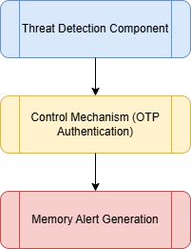

System Design
The proposed IDS consists of three core components which are Threat Detection, Control Mechanism, and Memory Alert Generation.
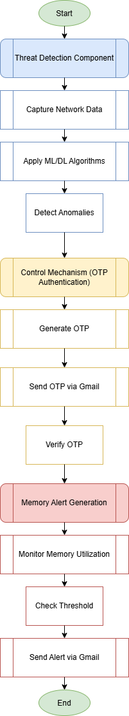

Threat Detection Module:
This module is a critical component of the IDS, relying on complex computational methods, including machine learning and deep learning to study the traffic patterns with an intent of detecting possible threats and abnormalities. To ensure real-world usability and potency of the module the latter applies data from CICIDS2017 dataset which has been recognized as providing the exhaustive set of the replica of real-world attacks. This arrangement allows the module to use validated AI models that have been trained in an environment resembling actual networks to detect various forms of cyber threats effectively. The developed model is highly configurable, allowing for tailored setups based on specific network characteristics and threat profiles. This module can utilize a range of machine learning and deep learning algorithms from basic decision trees and support vector machines to more complex neural networks depending on the desired accuracy and detection speed. The flexibility to select and configure these algorithms based on the system requirements enhances its adaptability to different system settings and environments. For instance, simpler models like logistic regression can be deployed in resource-constrained devices, while more complex deep learning models may be utilized in scenarios where higher computational resources are available. The training and testing processes are performed by the CICIDS2017 dataset, which includes a diverse data of attack simulations. Users can configure the module to focus on DDoS types of attacks most relevant to their environment for enhancing the precision of the threat detection capabilities.

Control Mechanism:
This module plays a significant role in the system environment to ensure the security and integrity of the system by providing properly implemented authentication and authorization control. It aims to check the intrusion since only the authenticated users and the devices are allowed to communicate within the system. Normal security features like username, password, has been incorporated in the module and the Python Hashlib has also been used to enhance credential hashing. Moreover, Flask is useful for web application interfaces for ACL, which will help for native applications since it is flexible and can change and adapt accordingly. The Control Mechanism is intended to provide optimal security through strict observed access policies that might be as tailored in terms of operational flexibility. It offers a wide array of technologies for users; this extends from password use to many factor authentication types of technologies.

Memory Alert Generation:
The Memory Alert Generation module entails data capturing from the network through PyShark which is a Python interface with Wireshark packet analyser utilized to monitor or analyse real-time network traffic. One continuously checks for memory usage and compares it with an expected value set for the system. Based on the output of the memory usage, if it rises beyond the limit believed to be a resource depletion or an attack, the module sends out an auto-message. These notifications can be sent to particular users with the help of Gmail in an attempt to use email for timely notifications of administrators about possible troubles. I find that this proactive mechanism helps me respond to changes in memory usage before it becomes a real problem to the network infrastructure you provide. The use of PyShark facilitates appropriate data collection and analysis and by integrating the real-time event identification with the use of Gmail as an alerting system facilitates quick intervention. The Memory Alert Generation configuration then involves integrating PyShark, which is a tool that offers real packet capture and analysis solution. The aspects include identifying and authenticating a Gmail account with credentials then setting of SMTP server parameters to enable successful emailing dispatch. When the memory usage rises above the limit, it triggers an alert email to certain people for instance system administrator or the security team. The email includes the information that would be used to identify the possible issue, such as the current memory usage level as well as other information.

Data Collection
The data collected using the CICIDS2017 dataset which was created by the Canadian Institute for Cybersecurity. The dataset has been considered an important data source in the intrusion detection system studies, as it covers almost all possible types of attacks and normal network traffic. There are different forms of cybercrimes included in the dataset such as DoS, DDoS, port scanning, and web application attacks among others. The dataset has a time frame of five days of the traffic that any enterprise network is likely to experience making the data ideal for training and testing of machine learning and deep learning models. The data from the CICIDS2017 dataset was received in the form of packet capture files called PCAP where raw packet details containing the header and the payloads along with other features such as source and destination IP-addresses, time stamp, and the port numbers.

Data Pre-processing:
Data preprocessing is one of the important steps because the models will perform as per the provided data. When data will not be biased then machine learning models will provide more accurate results compared to the unbiased data. That’s why, it is assured to clean the data, format the data and make the data ready for the machine learning methods. The existence of significant amounts such as null values, repetitive and conflicting information in raw network traffic data due to inherent randomness. The pre-processing tries to exclude irrelevant information and format the raw data into some standard form. The data sets in form of CSV files were captured from the CICIDS2017 dataset. After data extraction, data pre-processing was done to handle missing value, eliminate duplicate records and features that bear no significant impact when it comes to the identification of anomalies or cyber-attacks. Some of the most commonly used feature selection methods like correlation analysis were used to identify the network traffic features most effective for threat detection. Furthermore, features such as Min-Max scaling normalization was used to transform the features in the data set into a range of 0-1 so as to enhance the performance of the machine learning models. The pre-processing is very important in order to enhance the accuracy of the models as well as the degrees of efficiency.

Implementation:
The Google Collab environment and Jupyter Notebook Anaconda is used for the IDS that consists of three imperative modules derived from the platform which is highly suitable for complex computational analysis for security. The Threat Detection employs the use of supervised machine learning and deep learning to efficiently classify the various cyber threats based on network traffic analysis with the help of Pyshark library and CICIDS2017 dataset. The Control Mechanism boosts security by imposing high security checks for authentication and authorization processes by secure hashing from Python’s Hashlib and secure user session management from Flask that only allows verified users and devices to have access to the limited privileges granted the module to restrict their admittance. The memory alert module is designed to monitor memory usage constantly and based on the predefined thresholds stays alert for eventual suspicious activity in the network. Beyond these parameters, which might suggest high memory utilization, likely due to threats including memory-borne DoS attacks, the module engages a warning system. The alert generation process uses Python SMTP to build a connection with a Gmail account that will be used to send out the notification email. This type of email alerting includes parameters containing information such as memory status and context that help the system administrator to evaluate and address the problem before it occurs. The implementation also enables real time monitoring of networks and alerts thereby strengthening networks against memory anomalous conditions or attacks.
Following are the key snippets from the code part of the modules:
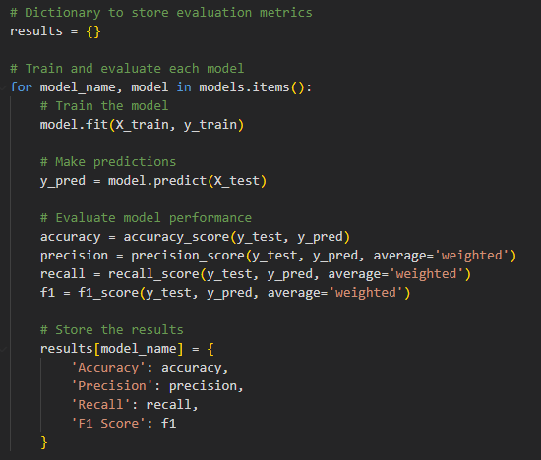
Threat Detection: it shows the neural network layers of the model and training parameters
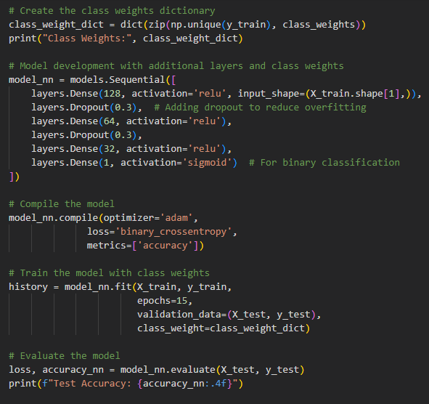
Control Mechanism: it shows that how the OTP is sent through user credentials
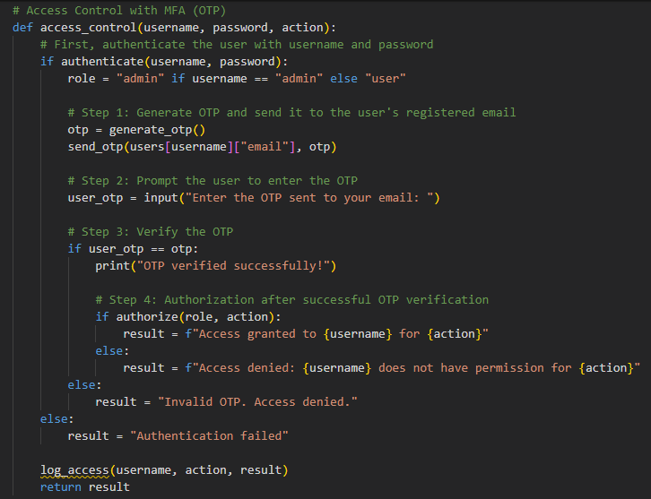

Memory Alert Generation: The following show the memory usage and network traffic
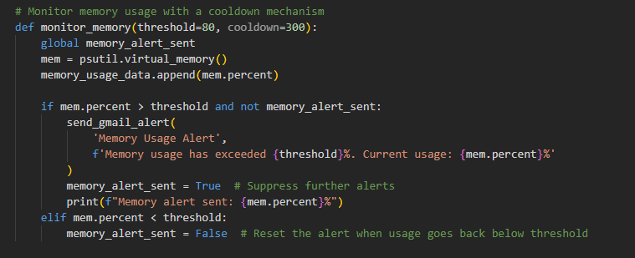
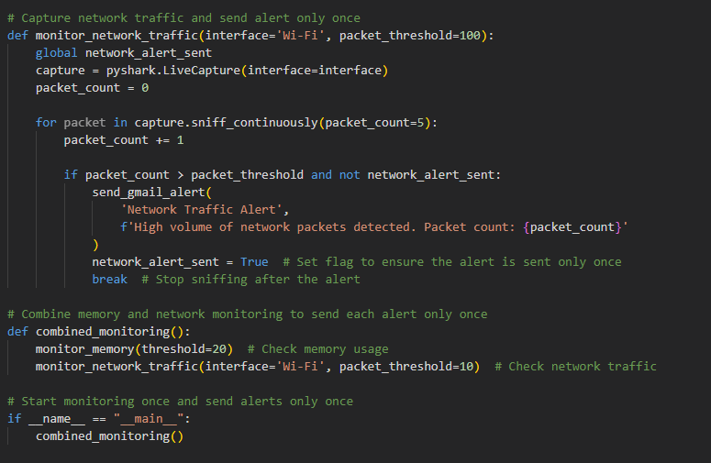

Results and Discussion
The proposed Intrusion Detection System has three key components that are Threat Detection, Control Mechanism, and Alert Generation Mechanism. The development environment Google Collab and Jupyter notebook platform on Virtual studio code have been used to execute the machine and deep learning based models. This section provides detailed discussion of the development and results drawn from the models.

Threat Detection Module
The various threats such as DDoS attacks have been analyzed by applying random forest and neural networks to detect the threats. The performance analysis of the Threat Detection Model shows that the application of both machine learning and deep learning algorithms is effective in detecting malicious network activities with emphasis on DDoS (Distributed Denial of Service) attacks. As observed from the result obtained, Random Forest classifier combined with a Neural Network has an improved capability of identifying abnormal traffic patterns. The proposed Random Forest model delivered a reasonably good accuracy, due to its being an ensemble learning technique wherein multiple decision trees are built to make a more reliable forecast and decrease the model’s volatility.
Traffic Distribution of Data
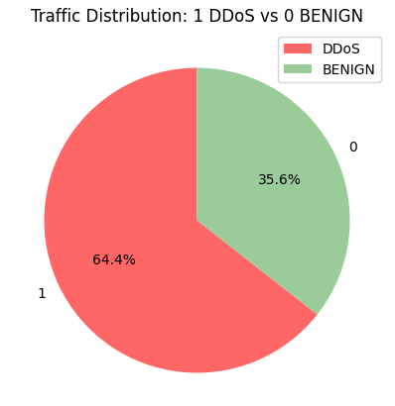
Network Data Packets
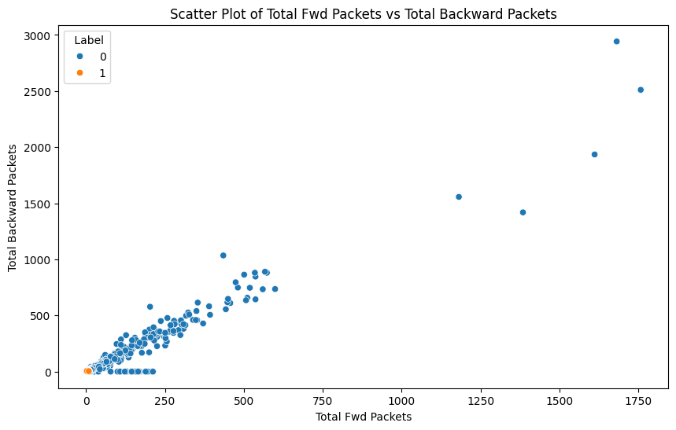

Machine Learning Models:
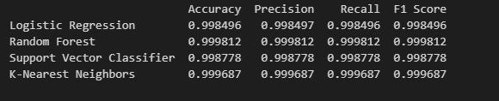
The following confusion matrices are drawn from the results of Logistic Regression, Support Vector Machine, Random Forest, and K-Nearest Neighbours. Compared to the results of these models, the random forest had a high level of accuracy in classifying both the benign and DDoS traffic. The other models also provided sufficient results but the results were mixed with a certain level of misclassification probably due to closely related traffic patterns.
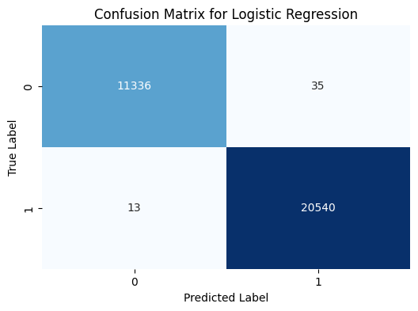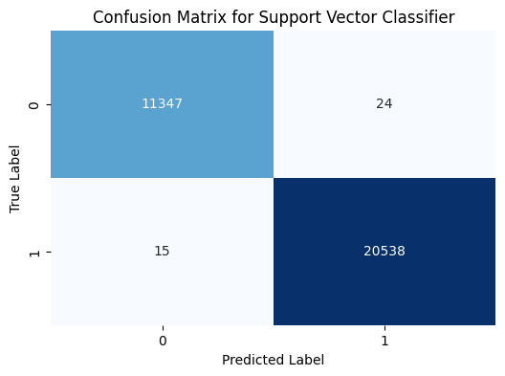
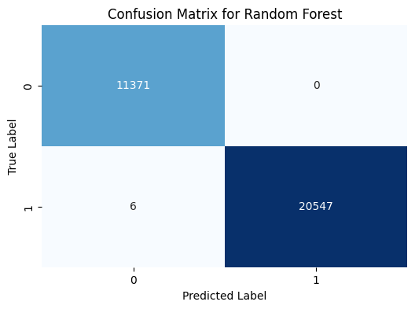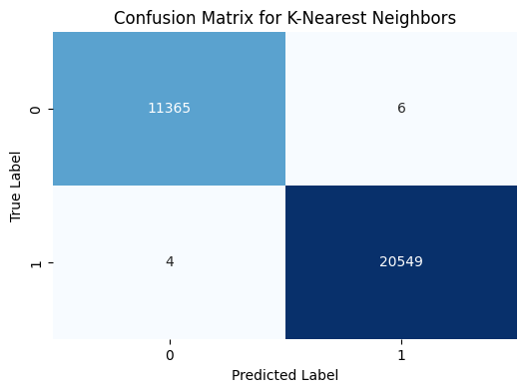

Similarly, the performance of the Neural Network was up to the mark as well, particularly after a proper tuning of a few of its parameters and after raising the number of epochs during the training process. The neural network achieved an almost similar level of accuracy to the Random Forest classifier although it required fine-tuned hyper parameters and a large training data set. Following image shows the training history in which the accuracy in the epochs is depicted and both the training and validation accuracy improve as the training advances.
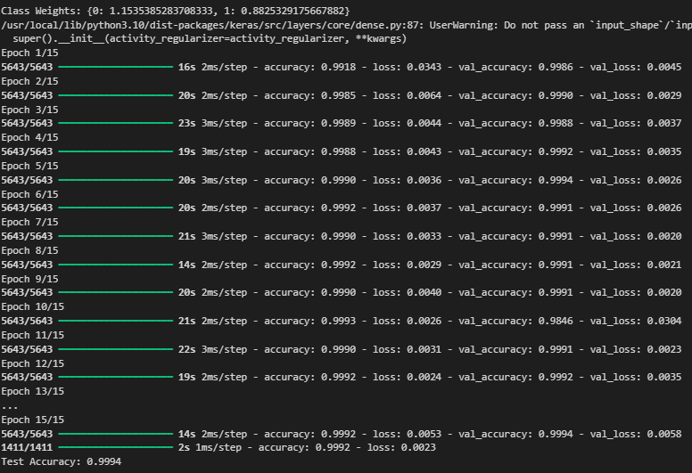
The confusion matrix illustrated following represents the final confusion matrix of the neural network which clearly depicts a better detection rate for both the classes which denotes that the model has a good generalization capability in dealing with unseen data.
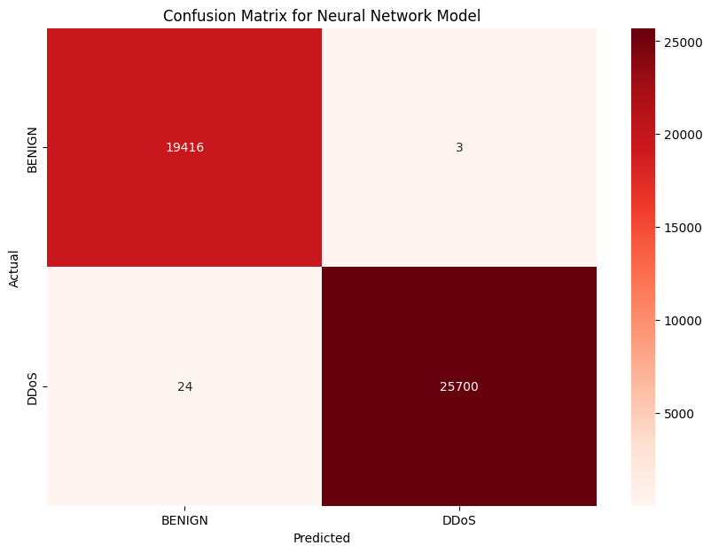
However, there is the issue of False Positive and False Negative when the distribution of data was a little off-center or when the pattern that the attacks followed was very similar to that of normal traffic. It is also improved by class balancing and use of better feature extraction methods to enable the model to differentiate between normal and abnormal traffic effectively. The Neural Network model also gave good results especially after tweaking some of the parameters into the network and training it for a few more iterations. .The developed neural network gave the accuracy similar to the Random Forest classifier’s accuracy that was a little more sensitive to the hyperparameter optimization and the quantity of train data. The training history graphs depict the accuracy on epochs that present a consistent increase in the training and the validation accuracy as the model is trained on the data. The last confusion matrix that was obtained from the above neural network training and testing showed better detection rates for both the classes DDoS and Benign traffic, this suggested that the model learned sufficiently from the training data and has ability to predict well on unseen data.

Control Mechanism
As observed from the outcome of the Access Control Model, the proposed system offers a very efficient solution in the protection of the sensitive resources by applying several layers of security measures including identification, approval, and MFA. The authentication component that identifies the users using username and passwords showed a good level of performance as the passwords were hashed using SHA-256. It is important to guarantee that even if the attacker gains the access to the database, he will not be able to retrieve original passwords because of the one way function of the hash. The access control system successfully limited the access by performing comparison of the credentials input with a hash stored with the server, so only authorized users would be permitted a chance to go through the next security measure. The following snapshot shows the information of system access and the roles defined in the database.
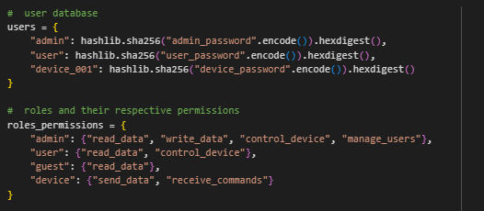
Following are the tests of system access to write/read data based on the defined rules on database.
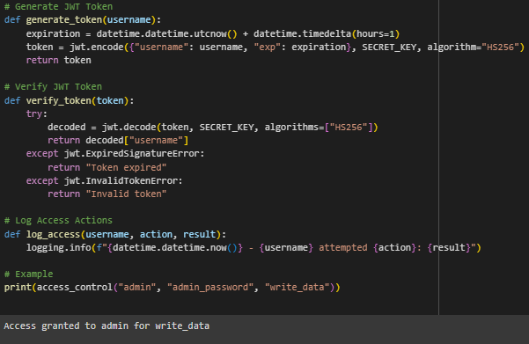
The access details are correct so it provides access to write data.
The following are the tests of multifactor authentication using OTP sent to user/admin email.
NEED TO ADD SNAPSHOTS OF GMAIL OTP

One of the key achievements of the model implemented was to introduce MFA using Gmail OTP which went beyond the normal username and password model. MFA feature worked seamlessly as designed; it provides and requests a one-time code which will be delivered to the user’s registered email for him to enter before authorization. This minimizes the case of penetration even if the user loses his or her password since the attacker also requires the user’s email account. When testing in the model the OTP and its verification is seamless and the number of OTP generated and validated simultaneously did not affect the performance of the system. This feature improves the protection of the accounts with a high level of access such as admin, users, and the valuable resources.

Memory Alert Generation:
Following output shows the alert sent when memory usage increase from 20%
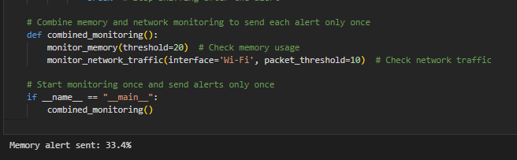
Live Network Data Packets:
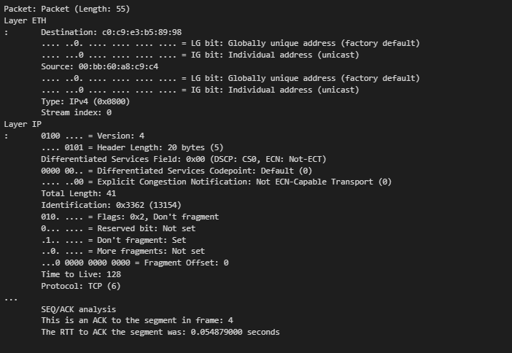
As illustrated by the findings from the Memory Alert Generation module, memorization can be seen as an effective tool to track the memory consumption and notify the administrators about exceeding indicated levels of utilization. The module works successfully to check the memory consumption and if it finds it high, an alert is sent out through Gmail to the parties concerned. Such information as time, and current memory usage also included in this notification makes it possible to determine and act on existing predicaments swiftly. Furthermore, the module also captures the networks data packet using the Wireshark, its command line tool TShark tools by which, provides detailed demons for the networks activity that is experienced along with the memory spike. The packet capture and analysis functionality assists in determining such things as specific traffic on your network that may be out of the ordinary, or particular processes allowing one to have an idea about what is consuming memory in particular at a specific timeframe. In sum, the outcomes corroborate the successful integration of real-time monitoring and alerting with targeted, network-level examination and reveal the module as an effective solution for preventive alerting and optimal response to memory usage fluctuations across networked systems.

Evaluation
The developed modules have been evaluated using quantitative metrics to assess accuracy, efficiency, and security effectiveness, as well as qualitative assessments to gauge usability and integration capabilities with existing systems.

Threat Detection
Performance of the Threat Detection Module was evaluated on the CICIDS2017 dataset to assess how well the module performs in detecting different threats. The evaluation metrics were precision, recall and F1-score which balanced the best precision along with best recall that gave a measurement of how accurate the model was in identifying threats without suggesting numerous incorrect ones. Also, the time to process a real time stream data was determined to establish the ability of the module in handling real time data streams. Overall, the accuracy on test data is satisfactory as shown in the results section.

Control Mechanism
The quantitative results show that the control mechanism received a series of functional stress tests and penetration tests to demonstrate that it was capable of adequately controlling the authentication and authorization functions. The performance assessment was conducted on the system security from unauthorized access and the flexibility in providing security while tested under varying loads. Of particular interest, basic measures like response time on authentication requests, as well as the passing rate of the access controls against prototypic attacks. Additional user feedback was also taken with the view of establishing how easy it was to configure and manage from an administration standpoint. The access control model also performed well because it only provides access to authenticated users based on the defined roles.

Memory Alert Generation:
The evaluation of the Memory Alert Generation module was based on parameters such as accuracy, response time and its influence on network monitoring and security. For the purpose of making certain conclusions concerning the performance of the computed module, the latter was tested with reference to different network conditions and rates of memory utilization with the main reference being to the real-time results concerning the threshold values’ breaches. In this case, the feedback of the module during evaluation was a timely sending of notifications on memory usage to a Gmail account provided as the norm for informing administrators of such pertinencies. The performance of the alerts was confirmed by comparing memory usage values with normal thresholds, thus excluding most false alarms while including all actual failures. As for the efficiency of the developed module, the delivery time of the alert and the resource overhead were estimated. The assessment also validated the fact that the designed module can indeed act as a valuable solution for improving security and management over the network providing an early preventive measure for controlling and overcoming memory threats.

Conclusion
The comprehensive Intrusion Detection System (IDS) includes three main parts; Threat Detection, Control Mechanism, Memory Alert Generation; making it a greatly secured system. The Threat Detection component relies on machine learning and deep learning techniques for the generation of complex programs to help detect multiple forms of cyber threats then categorizing them in a way that helps in detection of known threats as well as new forms of cyber threats. The dynamic capability of Control Mechanism; such as One-Time Password (OTP) Authentication through Gmail, thus restricting the access of such systems and resources to only authorized personnel. The layer of access control improves on security performance by minimizing risks that emanate from inadequate security and data breach. The Memory Alert Generation module extends the IDS by continuously and efficiently capturing memory related data by using PyShark, Wireshark and TShark and by generating real time alert in Gmail if memory crosses a predefined limit. The proactive approach for monitoring means one can quickly discover and respond to applications that are likely to hog resources or indeed an attack, all of which will go a long way into making the system more robust. Together these modules for the proposed IDS system are fully equipped to identify, monitor and counter any given security threats. As the system furthers the security of any networked environment by effectively delivering real-time alerts, defining strong access controls, and analyzing network traffic with sufficient detail to protect the integrity, confidentiality, and availability of necessary data and resources.

The Control Mechanism which is made of several security mechanisms that include; Authentication for the act of proving the identity of users or a device as being genuine and real before being granted access to a particular resource through authorization. Multi-factor authentication is the process by means of which an individual device or program is required to prove that it has several factors that qualify it to access a resource. Logging is the process by which the activities of role-based access control mechanism, encrypted passwords through secure password hashing and Gmail OTP for multi-factor authentication. The model has been implemented by the usage of role based authorization restricting the user to a certain number of activities based on specified role. For instance, the admin users were authorized to read and write data, control devices and manage other users while the normal users were only allowed to read data or control a few devices. Logging is also effective in capturing each of the access attempts including the unauthorized ones and it was done alongside a timestamp and the action taken. The logging capability is quite advantageous for audits and investigations; especially where there has been attempted break or where there has been a breach in security. Considering all these things, the access control model proposes a rather comprehensive security turnkey with the relatively higher convenience, good flexibility on role configuration and multi-factoring protection.
The memory alert is important as it outlines traffic bottlenecks that might cause memory increases thereby facilitating threat understanding. The real time alert feature which synchronizes with Gmail alert helps administrators to be notified of any abnormality thus enhancing swift process intervention. These outcomes prove that the identified module is effective, reliable, and capable of functioning fine under various network conditions, so its adoption can enrich security and resources management activities. Because potential memory-based threats can often be rapidly and effectively contained and eliminated by this module, network security is improved on individual elements for scaling; in addition to various asset protection, it ensures systematic stability.

References:

Liao, H.J., Lin, C.H.R., Lin, Y.C. and Tung, K.Y., 2013. Intrusion detection system: A comprehensive review. Journal of Network and Computer Applications, 36(1), pp.16-24.
Khraisat, A., Gondal, I., Vamplew, P. and Kamruzzaman, J., 2019. Survey of intrusion detection systems: techniques, datasets and challenges. Cybersecurity, 2(1), pp.1-22.
Liu, H. and Lang, B., 2019. Machine learning and deep learning methods for intrusion detection systems: A survey. applied sciences, 9(20), p.4396.
Almseidin, M., Alzubi, M., Kovacs, S. and Alkasassbeh, M., 2017, September. Evaluation of machine learning algorithms for intrusion detection system. In 2017 IEEE 15th international symposium on intelligent systems and informatics (SISY) (pp. 000277-000282). IEEE. on intelligent systems and informatics (SISY) (pp. 000277-000282). IEEE.
Haq, N.F., Onik, A.R., Hridoy, M.A.K., Rafni, M., Shah, F.M. and Farid, D.M., 2015. Application of machine learning approaches in intrusion detection system: a survey. IJARAI-International Journal of Advanced Research in Artificial Intelligence, 4(3), pp.9-18.
Jang-Jaccard, J. and Nepal, S., 2014. A survey of emerging threats in cybersecurity. Journal of computer and system sciences, 80(5), pp.973-993.
Thakur, K., Qiu, M., Gai, K. and Ali, M.L., 2015, November. An investigation on cyber security threats and security models. In 2015 IEEE 2nd international conference on cyber security and cloud computing (pp. 307-311). IEEE.
Ahsan, M., Nygard, K.E., Gomes, R., Chowdhury, M.M., Rifat, N. and Connolly, J.F., 2022. Cybersecurity threats and their mitigation approaches using Machine Learning—A Review. Journal of Cybersecurity and Privacy, 2(3), pp.527-555.
Narayanan, S.N., Ganesan, A., Joshi, K., Oates, T., Joshi, A. and Finin, T., 2018, October. Early detection of cybersecurity threats using collaborative cognition. In 2018 IEEE 4th international conference on collaboration and internet computing (CIC) (pp. 354-363). IEEE.

