The Web Service of
Weather

B Level Specification
for
Software Development

CENG 423-Internet Based Programming

Melisa BAY
1305012011

Fatma Büşra UÇARSU
1305011013

Table of Contents
1. Architecture 5
2. Requirements 7
2.1. Functional Requirements 8
2.1.1. onlıne request Processing 8
2.1.1.1. clıent request 8
2.1.1.2. onlıne processing 8
2.1.1.3. outputs 8
2.1.2. offlıne request Processing 9
2.1.2.1. clıent request 9
2.1.2.2. offlıne processing 9
2.1.2.3. outputs 9
2.2. Process Requirements 10
2.2.1. Physical Structure 10
2.2.2. Development Environment 10
3. Data Dictionary 11

Architecture

The web service of weather displays weather information requested by the client via a web page. The data stored during these operations are stored in the database. The data found is used to display when searching on the page.

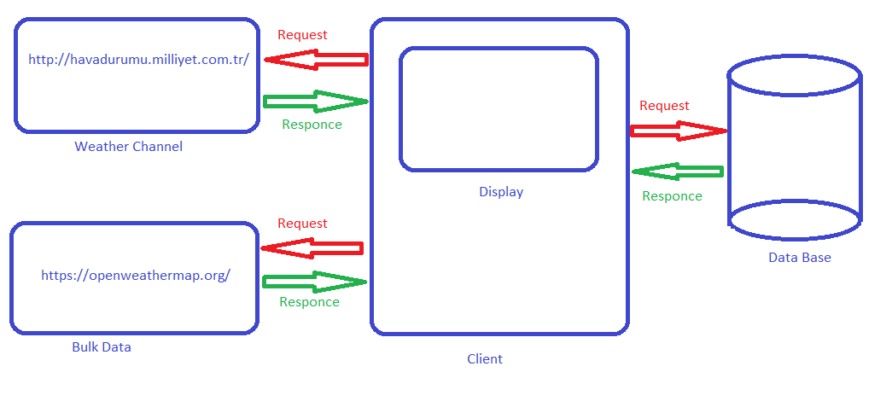
Figure 1 – The Web Service of Weather Diagram

If the path specification is not valid, or no path specification is provided, The Web Service of Weather program will send an error message to standard output.

Processing is divided into the two major components shown in Figure 2.,

- First main component is the system connected to the website when there is internet.
- First line operation accepts a path specification from the command line, saves the current working directory name, and sets the current working directory to match the input path specification.
- The second line examines all filenames in each instruction in the root directory tree from the specified path. The third line sends each name and corresponding path.
- The third line records each encountered file name only once in its storage mechanism. It associates this name with every name that is named.
- Second main component is the system receives information from the database when there is no internet.
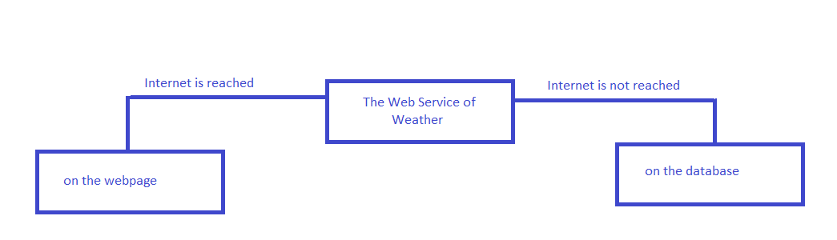

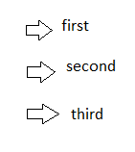
Figure 2 – The Web Service of Weather Module Diagram
When the Internet is reachable, sub-modules are started to be used. The process sequence is followed this.

- Requirements

Processing for the The Web Service of Weather program is divided here into two major processes, online request and offline request. Each of these processes is responsible for a set of requirements, described in this section.

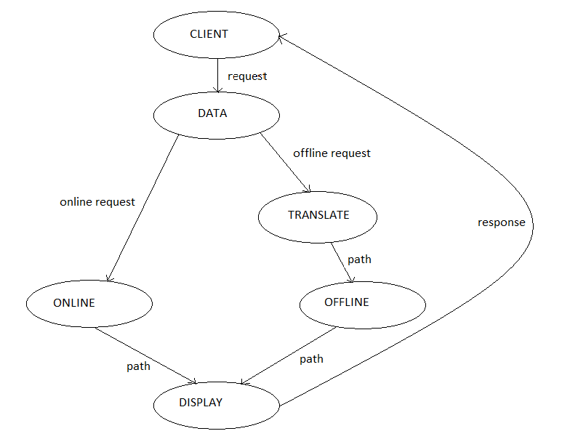

Figure 3 - Data Flow Diagram 1

2.1. Functional Requirements
These sections describe the activities required of the The Web Service of Weather program.

Online Request Processing

Here the link variable is created, “http://havadurumu.milliyet.com.tr/”
This variable is the name of the city that the user wants to search for and is applied to the link. Then the desired data of the city that the user is looking for is displayed to the user. The ‘function query’ function displays the data that the user is looking for and records the data to the database at the same time.

Client request

- The path spec message contains a user supplied specification of the desired starting path.

Online processing

The online request accepts the city with a button selected from the search field and takes the name of the current working directory identified by the identifier. The city returns the weather value of the city to the screen.

Outputs

During the online request process, we read the weather value from the webpage we specified using data parsing. Upon completion of these activities, they pull and load their web-based data.

Offline Request Processing

When the Internet is turned off, the user system will enter the city name.

Earlier we recorded our database with import code from ‘’https://openweatherermap.org/bulk’’. If the user does not have an active internet connection, we display it from the database of the data the user is looking for.

Client request
The path spec message contains a user supplied specification of the desired starting path.

      - Offline processing

The offline request retrieves the data we have previously pushed from the bulk data into the database in the absence of an internet connection. Afterwards we accept the city with a button selected from the search field and retrieve the name of the current working directory identified by the identifier. The city’s wheather turns to city. The offline request retrieves the data we have previously pushed from the bulk data into the database in the absence of an internet connection. Afterwards we accept the city with a button selected from the search field and retrieve the name of the current working directory identified by the identifier. The city’s wheather turns to city.

Outputs

During the offline request process, we read the weather value from the bulk data that we have already sent the data base. Upon completion of these activities,The city’s wheather turns to city.
This is the city's 14-day average temperature.

Process Requirements
These requirements specify physical structure of the code developed and the environment where it must operate.

Physical Structure

Requirement:

We build Linux Ubuntu 17.10, php 7.0, Apache Tomcat, Nginx, Apache 2, Mysql .

- Shall be prepared as a Php and Css codes,using the program Sublime Text.
- Shall the interface for the web page to be created will be easy and convenient for the client.
- Shall will bring daily, monthly and yearly wheather data from the weather site with services.
- Shall the data that received will throw it into the database we created.
- Shall will show the average of the monthly and yearly wheather to the client except for the daily weather.
6)Shall for all the output, data will come form the database that we created.
7)Shall use text and will show a visual according to the result.
8)Shall will bring visual data from the weather site with services.
9)Shall prepare a Sublime Text which:
-In this code editing and text editor, we will write Css and Php codes.Then we will run the code in the browser with localhost, client will see the output as a HTML.
-Reports success or failure and any warning encountered by the build.

Development Environment

If there is no internet connection the output, data will come form the database that we created.Otherwise the output will come from the link that we chose the parse.For thiss process we used Sublime Text for Php and Css codes, http://json.parser.online.fr/ (online) and mysql server for database.At the end of all this client will see the output as a HTML.

Data Dictionary
Figure 4 - Data Dictionary
Message Name | Integration
Client | (in a network) a desktop computer or workstation that is capable of obtaining information and applications from a server.
Web Service | A web service is a function that can be accessed by other programs over the web (Http).
Request | Is a search that the client made in practice
Online Request | A search made by a client with an internet connection
Offline Request | A search made by a client with have not an internet connection
Path | Name of subdirectory, passed to win32 API to navigate
Link | Internet site where we receive the data by parsing it while having internet connection
Translate/Import | Registration of Bulk data in the database
Display | Show of the customer's search on the screen
Response | The customer's search is returned to the user after processing.
Data | In computing, data is information that has been translated into a form that is efficient for movement or processing
Database | A structured set of data held in a computer, especially one that is accessible in various ways.
Bulk Data | Electronic collection of data composed of information from multiple records, whose primary relationship to each other is their shared origin from a single or multiple databases.

