The Web Service of
Weather

C Level Specification
for
Software Development

CENG 423-Internet Based Programming

Melisa BAY
1305012011

Fatma Büşra UÇARSU
1305011013

Table of Contents

1. Architecture 3
2. Design 5
2.1. The web servıces of weather processıng 6
2.1.1. on the webpage module processıng 6
2.1.2. on the database module processıng 6
2.2. the web servıce of weather Calling Structure 7
3. Data Dictionary 7
4. Source Code 8

Architecture

The web service of weather displays weather information requested by the client via a web page. The data stored during these operations are stored in the database. The data found is used to display when searching on the page.

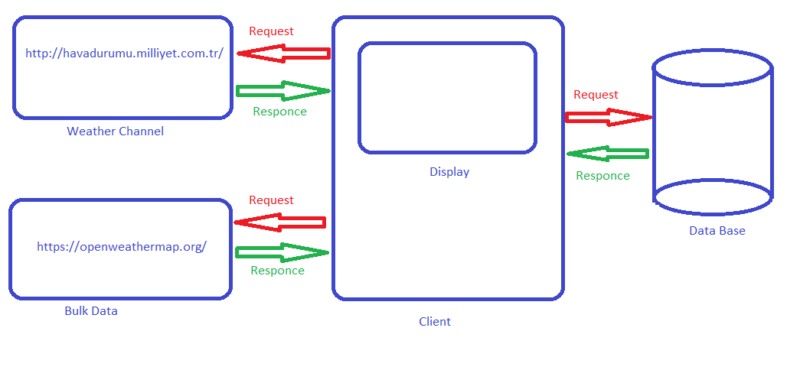
Figure 1 – The Web Service of Weather Diagram

If the path specification is not valid, or no path specification is provided, The Web Service of Weather program will send an error message to standard output.

Processing is divided into the two major components shown in Figure 2.,

- First main component is the system connected to the website when there is internet.
- First line operation accepts a path specification from the command line, saves the current working directory name, and sets the current working directory to match the input path specification.
- The second line examines all filenames in each instruction in the root directory tree from the specified path. The third line sends each name and corresponding path.
- The third line records each encountered file name only once in its storage mechanism. It associates this name with every name that is named.
- Second main component is the system receives information from the database when there is no internet.

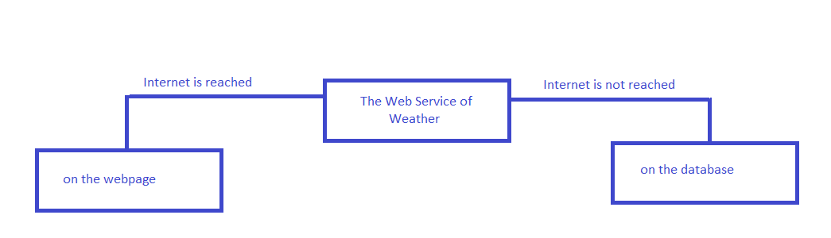
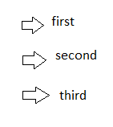

Figure 2 – The Web Service of Weather Module Diagram

When the Internet is reachable, sub-modules are started to be used. The process sequence is followed this.

2.Design

This section describes the processing activities implemented by the Web Service of Weather.
The pictures below shows the classes used in the Web Service of Weather
and their relationships with each other.

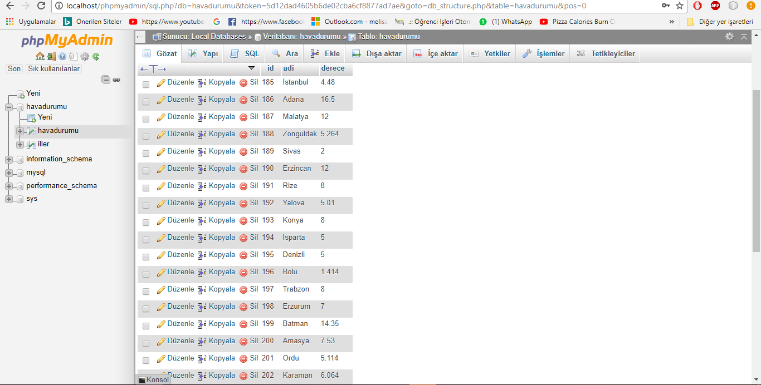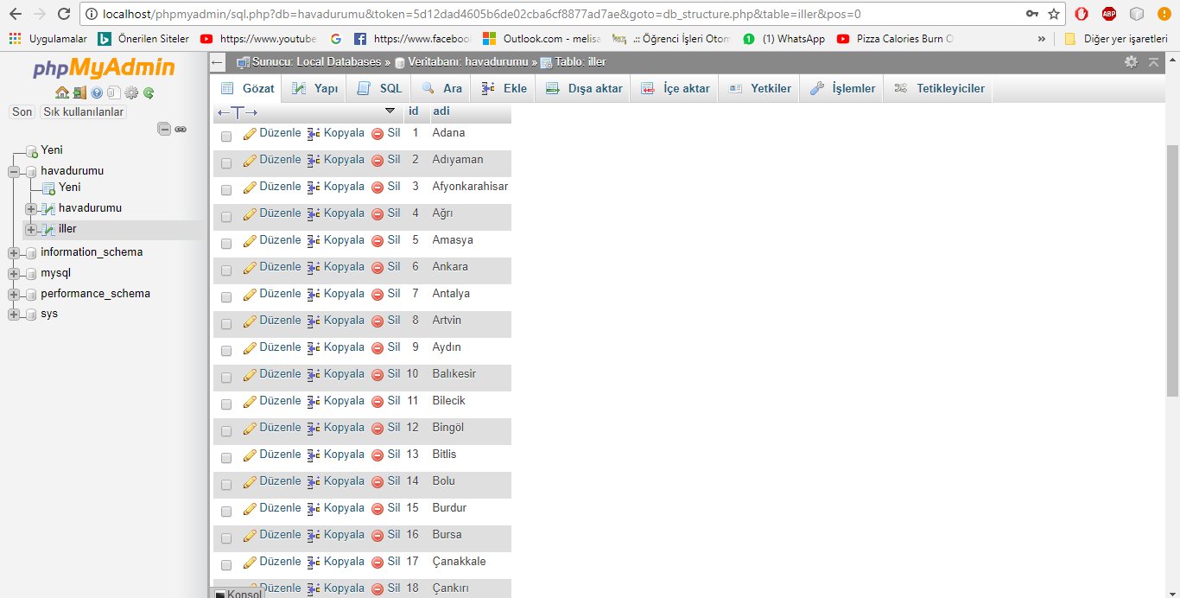
Figure 3 -The Web service of Weather Logical and Physical Structure

2.1. The Web Services of Weather Processing
All the Web Services of Weather is supported by the two modules: on the webpage and on the database.

On the Webpage Module Processing

When the Internet is on the user system will enter the city name. After the necessary operations are performed in the First, Second, Third parts shown in Figure_1, the information is saved in the data base.

On the Database Module Processing

When the Internet is turned off, the user system will enter the city name. When the Internet is present, the information stored in the database is sent to the screen.

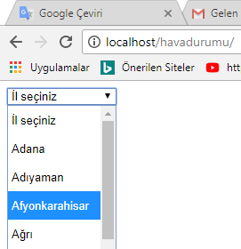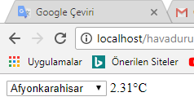

Figure 4 -The Web service of Weather Usage

2.2.The Web Service of Weather Calling Structure

All of the functions and global functions are reused, without modification.
All other functions are also available in this program.

- The user selects the desired city from the search box.
- Search block, the customer is assigned to the desired city 'iller' variable.
- This variable is assigned to the relevant link variable.
- The new connection is inquired over the internet and the weather of the city requested by the user is taken and the change is assigned.
- "centigrade degrees" is shown to the user.

- Data Dictionary

Message Name | Integration
Client | (in a network) a desktop computer or workstation that is capable of obtaining information and applications from a server.
Web Service | A web service is a function that can be accessed by other programs over the web (Http).
Request | Is a search that the client made in practice
Webpage Module | A search made by a client with an internet connection
Databse Module | A search made by a client with have not an internet connection
Link | Internet site where we receive the data by parsing it while having internet connection
Translate/Import | Registration of Bulk data in the database
Display | Show of the customer's search on the screen
Response | The customer's search is returned to the user after processing.
Data | In computing, data is information that has been translated into a form that is efficient for movement or processing
Database | A structured set of data held in a computer, especially one that is accessible in various ways.
Bulk Data | Electronic collection of data composed of information from multiple records, whose primary relationship to each other is their shared origin from a single or multiple databases.

- Source Code

Source code for the The Web service of Weather program consists of the files:

- weather_14.json
- veritabaniVeriler.php
- simple_html_dom.php
- jsonacevirme.php
- index.php
- havadurumu.sql
- havadurumu.json

Listings for these files are attached.

