Opdracht Briefing

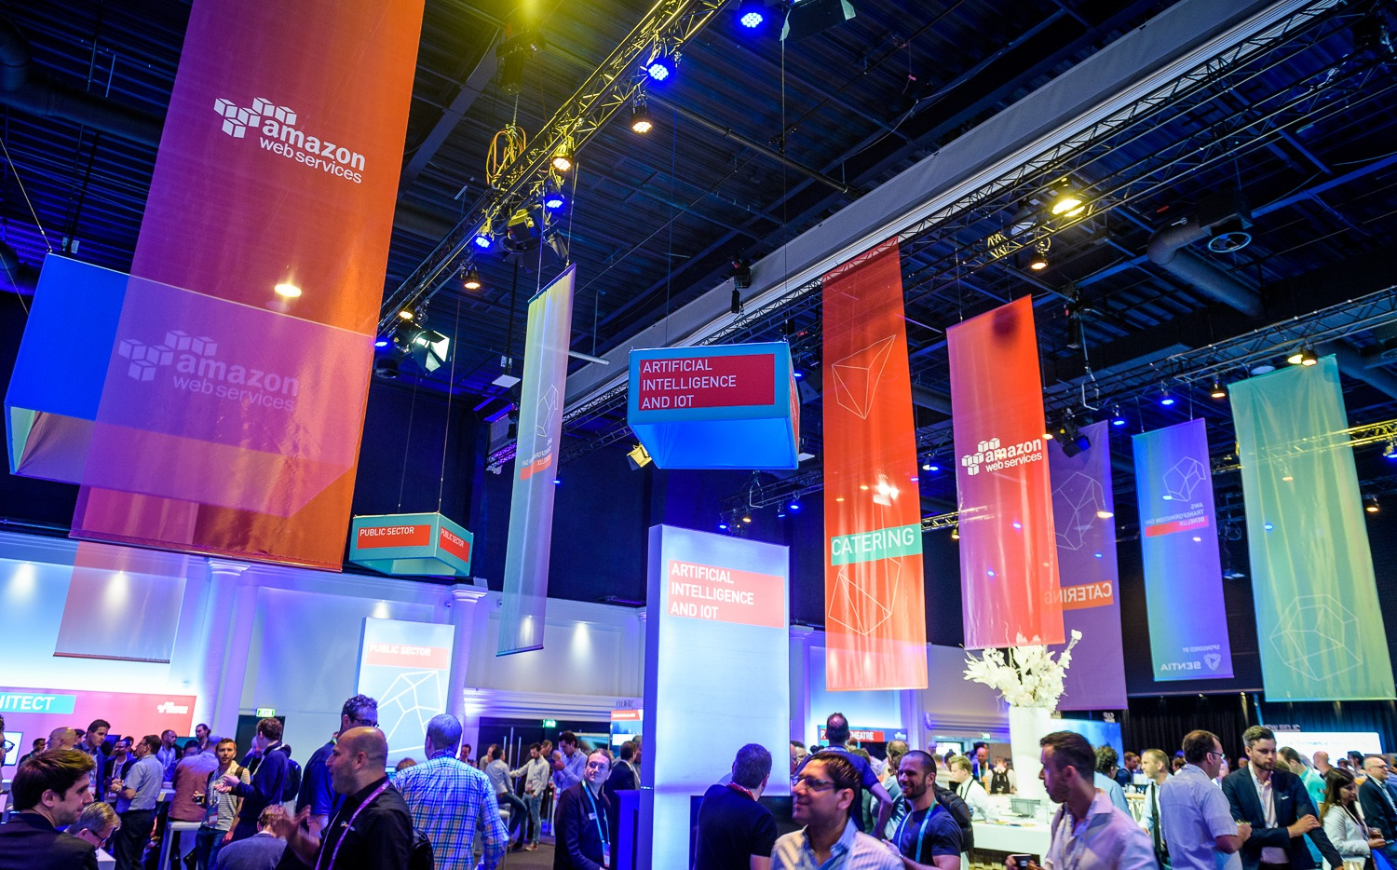Thomas Dwarshuis – Robin Galema – Noah van Schijndel – Michelle de Wit – Büsra Yaydemir

Inhoud

Brief summary 3

Problem definition 3

Desired Outcome 3

## Brief summary

Most venues –conference centers, event spaces, music halls, etc. –host events for many different companies. Companies and organisations often invitepartners or sponsorsin their meeting rooms. In this challenge we are looking for ways to dynamically adapt a venue’s or meeting room’s look and feel to reflect any brand identity.

## Problem definition

This challenge comes in two cases:

**Dutch Technology Week** – In 2020 the Dutch Technology Week for the first time will have a festival heart: Hall A of the famous Klokgebouw at Strijp-S. On specific days different events will be hosted/entered from this hall, i.e.: Official Opening of DTW, Night of the Nerds and Quiz Night XL. The hall’s appearance should easily be changed to reflect the event’s brand identity.

**Fontys ICT Innovation Lab** – In the Innovation Lab at TQ5, Fontys School of ICT actively collaborates with so-called Partners-in-Innovation on applied research projects. For meetings with partners we would like to turn our corner officeTQ5-2.501 into a dynamically branded meeting room.

## Desired Outcome

The desired outcome is a system that enables a user to easily create, maintain and activate brand identity themes for the aforementioned spaces. Different tasks may require their own specific media of interaction. Themes admin may require some computer skills. Activating should be intuitive and easy to use for anyone.