N-Gram Algorithm

Buşra KELEŞ
2013510119 Computer Engineering
Dokuz Eylul University
Izmir, Turkey
busra.keles@ceng.deu.edu.tr
Büşra Candan
2014510017 Computer Engıneering
Dokuz Eylul University
Izmir, Turkey
candanbusra@outlook.com

Introduction
N-Gram Algorithm is the method for finding the repeat rate in a given sequence. The name is composed of n and grams. N is the value at which the repeat is checked. Gram was used to express the pain in this sequence.
In this study, an n-gram algorithm was implemented in Java. The program was tested for 1-gram, 2-grams, and 3-grams on a part of Turkish Novel Corpus, which includes 5 novels. The program outputs were analyzed separately according to the total running time and items-numbers of item list (top 100 items) for 1, 2, and 3-grams.

DEFINITION OF THE ALGORITHM

Methods, Inputs, and Outputs of the Program
The following methods were used in the program:
- ngrams method- The n-gram algorithm was used in this method. This method is hearth of the code. [1]
- main method –
- Which of the 1-gram, 2-grams or 3-grams is to be executed,
- File operations, [2]
- Calculating total running time, [3]
are included in this method.
- Inputs- Value of N
- Outputs- Total running time and items list (top 100 items)

SCREENSHOTS OF THE PROGRAM
The program screenshots are shown in the following.

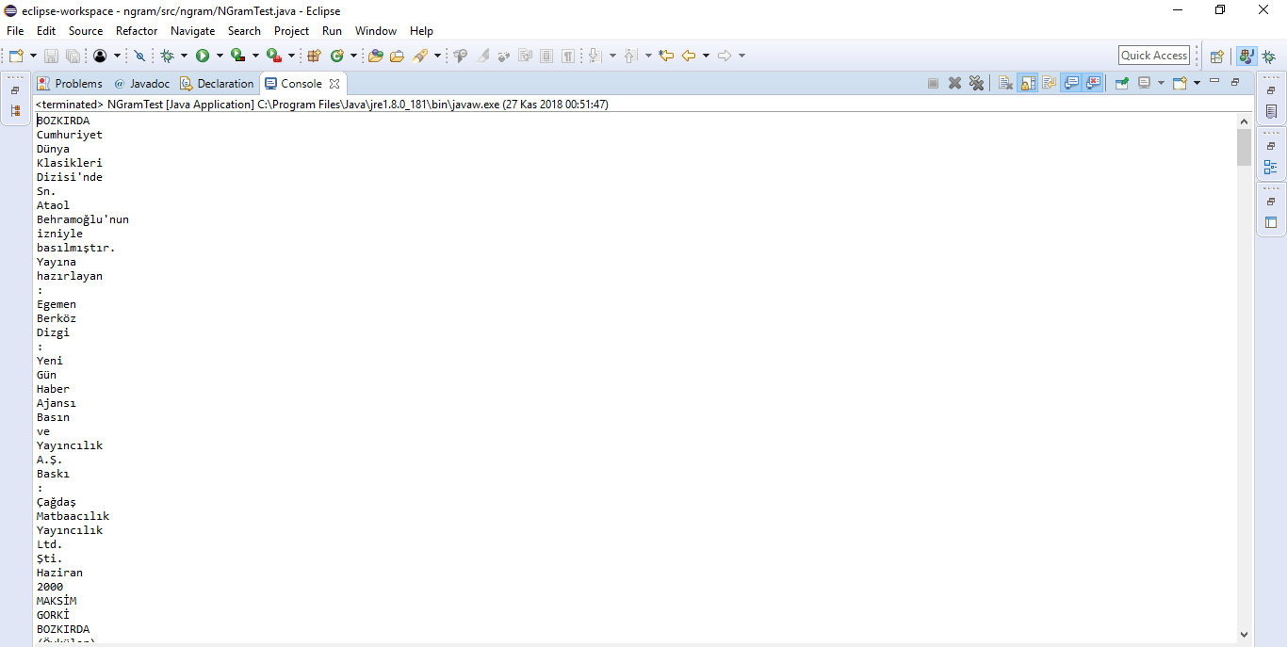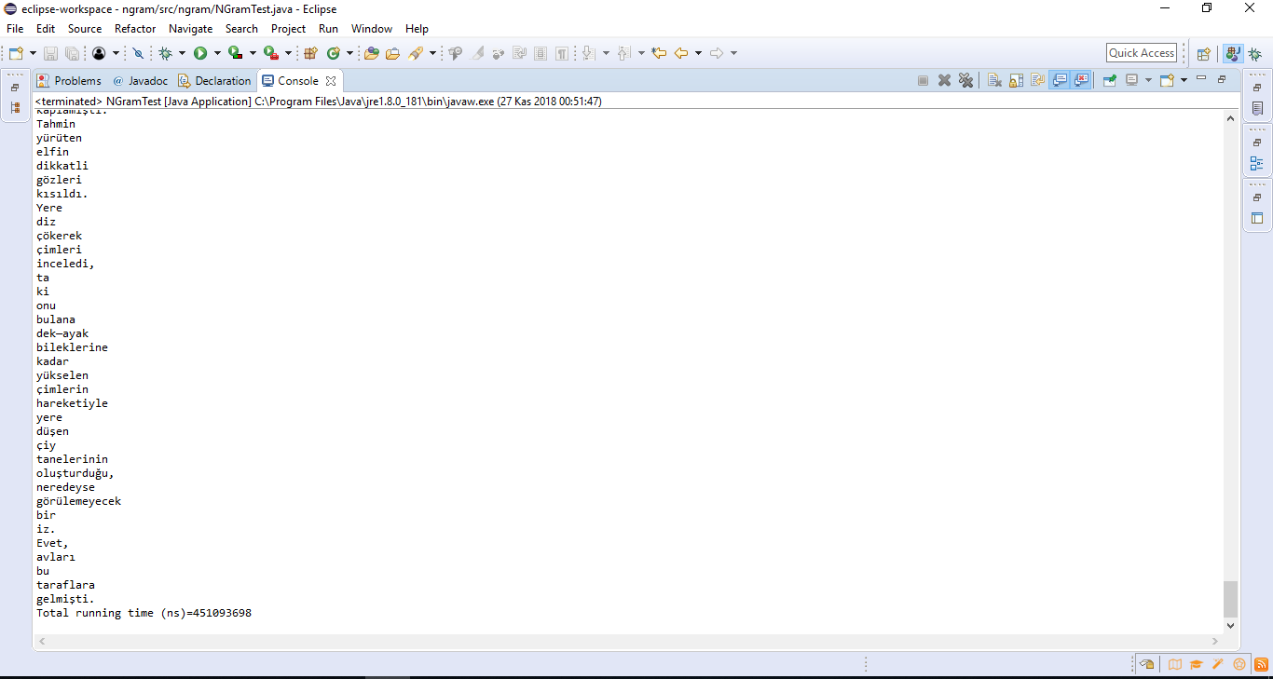

Figure 1: 1-gram algorithm outputs and total running time

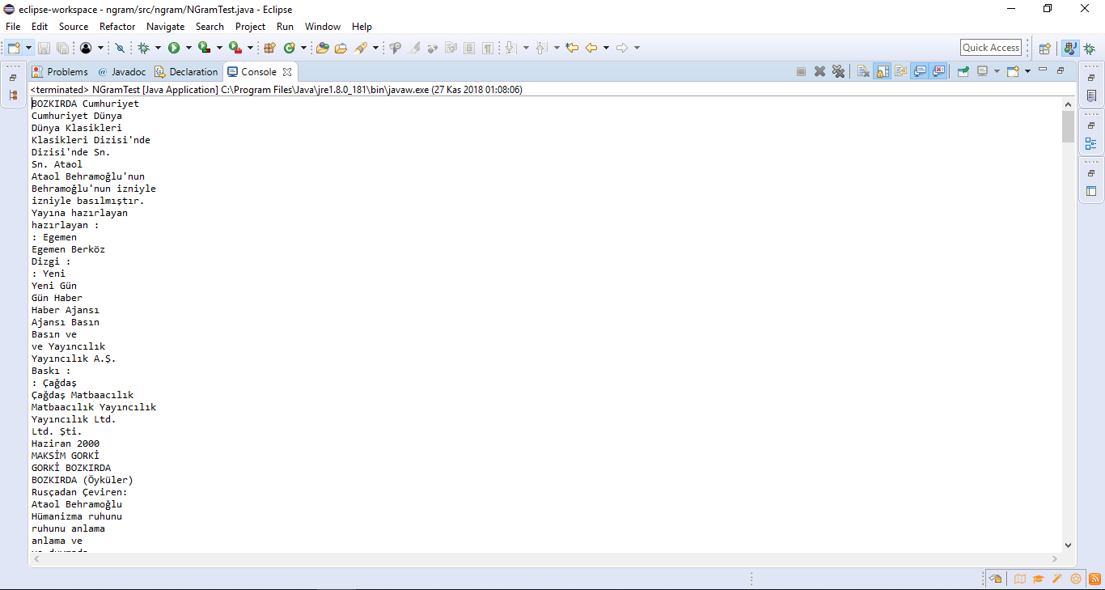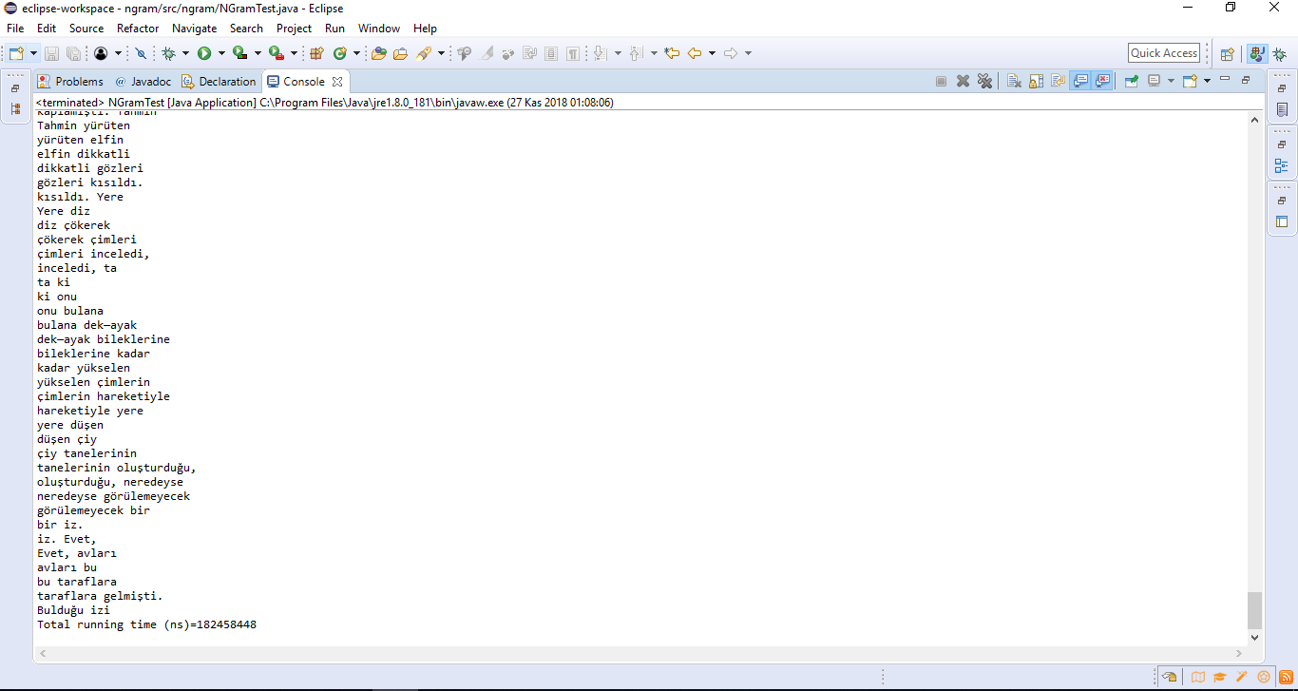

Figure 2: 2-grams algorithm outputs and total running time
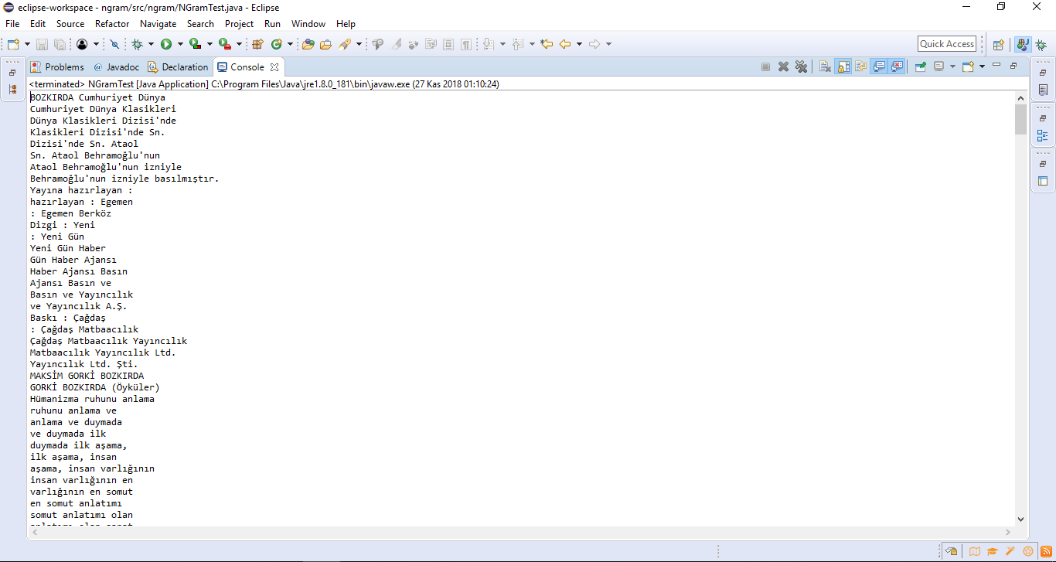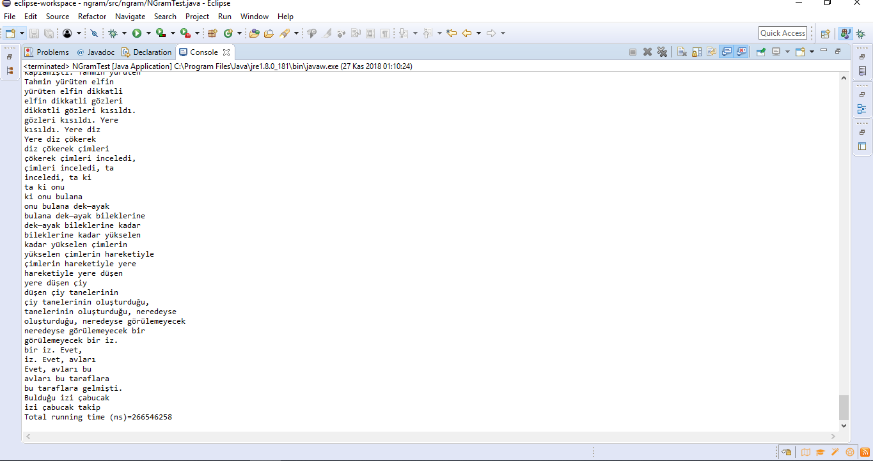

Figure 3: 3-grams algorithm outputs and total running time

TEST RESULTS
 | Average Total Running Time(s)
1-gram | 0.5239747
2-grams | 0.308274827
3-grams | 0.217310733
Table 1. Results of n-gram algorithm comparison
The average value of running times in 30 trials is given in Table 1 in seconds. According to the Table 1, 1-gram running time is bigger than 2-grams, and 2-grams running time also bigger than 3-grams.

Acknowledgment

References

- https://stackoverflow.com/questions/3656762/n-gram-generation-from-a-sentence
- https://stackoverflow.com/questions/1844688/how-to-read-all-files-in-a-folder-from-java
- https://github.com/belenyasin/Java-Gecen-Sure-Hesaplama

