What I did with AWS and DynamoDB?
hi! I made some additions to a desktop application I developed with AWS. With these, I want to explain how I entered the Cloud System and what I did.
First of all, let’s talk about AWS. AWS, Amazon Web Service is a platform that offers cloud-based services. AWS provides services in many areas such as data storage, data processing, data analysis, artificial intelligence and machine learning. AWS services make it easier to process and analyze large data sets, develop and deploy applications.
There are dozens of services you can access through AWS. I have added some titles below.
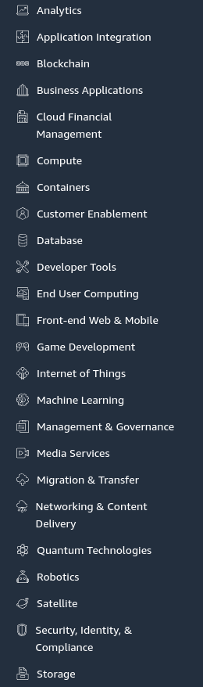
Since I will use AWS for data storage in my own project, I used DynamoDB service. DynamoDB is a high-performance and scalable NoSQL database. This database is used to efficiently store data and provide fast access.

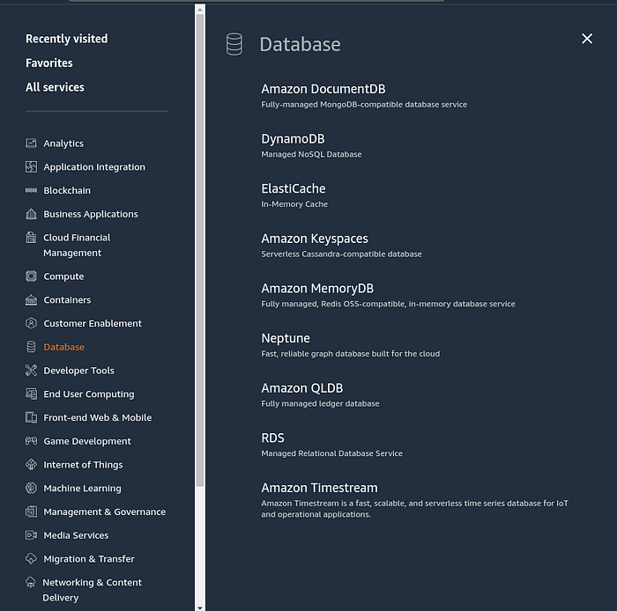

AWS Access Key ID and AWS Secret Access Key are required to establish a connection with AWS. This information can be generated from Security Credentials > Access Key.

You need to enter this information from the terminal to establish the connection on your computer. Or, if you use Python in your project, you need to connect with the boto3 library. boto3 is an SDK for interacting with AWS services via Python. boto3 allows you to work programmatically with AWS services and manage various AWS resources. Here is the part of my connection to send data to the AWS database:

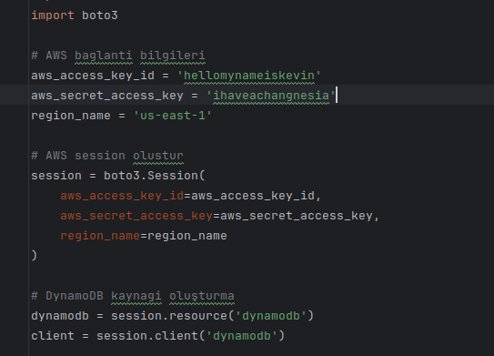

The boto3.Session function creates a session with the given access keys and zone name. The session is used for all interactions with AWS.session.resource(‘dynamodb’) function returns the DynamoDB resource and session.client(‘dynamodb’) function returns the DynamoDB client. These objects are used to perform operations on DynamoDB.

After making the connection and accessing the database, I started throwing the data I had into the database. For this part, I created a text file with random names. I wrote a code to assign each data in this file as columns and to assign values between 0–100 to these columns every 5 seconds. The main part where this code was executed was as follows:

def main():
# Read parameters
current_directory = os.path.dirname(os.path.abspath(__file__))
file_path = os.path.join(current_directory, 'items_parameters.txt')
parameters = read_parameters_from_file(file_path)
# Get next table name
table_name = get_next_table_name()
# Create table
table = create_table(table_name)
print(f"Table {table_name} created successfully")
# Add data
data_id = 1
while True:
add_data_to_table(table, data_id, parameters)
print(f"Data added to table {table_name}")
data_id += 1
time.sleep(5) # add data every 5 second

First of all, I started by reading my text file and making the names in it as parameters. Then I created the tables by adding 1 to the table if there is a table with this name in the database (for example, if there is a table with this name, the new table name should be given as Veriler2). Finally, I assigned an id and grew my tables by giving new values to these items every 5 seconds with a loop. By continuing this process as long as the code was running, I was able to continue uploading my data to the AWS database. Also, my add_data_to_table function I wrote for the values I added between 0–100 was as follows:

# Adding data
def add_data_to_table(table, data_id, parameters):
data = {'dataId': data_id}
for param in parameters:
data[param] = random.randint(0, 100)
table.put_item(Item=data)

Up to this point, I have created a connection between my application and AWS and managed to upload data to the Cloud System with a code. In the next step, I will try to pull this data and work on real-time data display.

See you in my next article. ☁️ 👋🏻

