## Controller

The selected topology has been designed as to control the desired average output current and ripple of output current by adjustments of duty cycle in buck converter. The block diagrams and input – output relations of blocks are shown in Figure 1. The measurement on shunt resistor is the feedback providing the system with current control. While Figure 1 shows the basic blocks and conceptual solution of control, other blocks such as isolation, amplifiers, comparators can be placed according to solution approach.

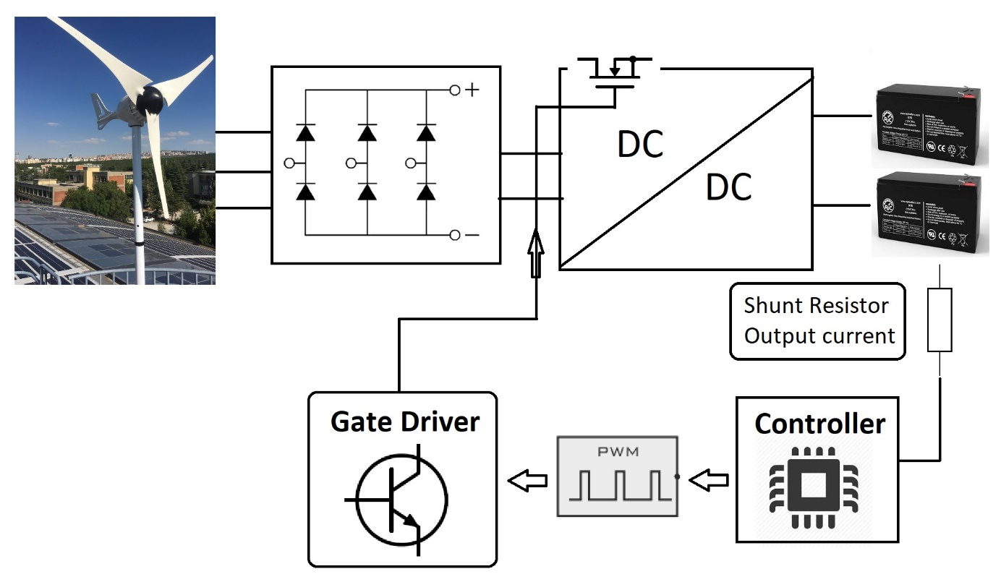

Figure Block diagram of system and controller

The control of converters can be accomplished with some different ways. For instance, controller can be used digital controller such as arduino or programmable. Then, pwm generator and gate driver can be constructed externally. On the other hand, there are some integrated circuits which can handle analog control, pwm generation and gate driving in a single package. Moreover, some of them may include switching componenets, generally mosfets, are called switchers.

The each solution can advantages and disadvantages in system level. For instance, external enhanced mcu can be used for applications requiring complex user interfaces or hard control algorithms. On the other hand, switchers can be used for converters with low input voltage for the sake of small volume. One of the packed controller can be seen in Figure 2. These are easy-to-use controllers.

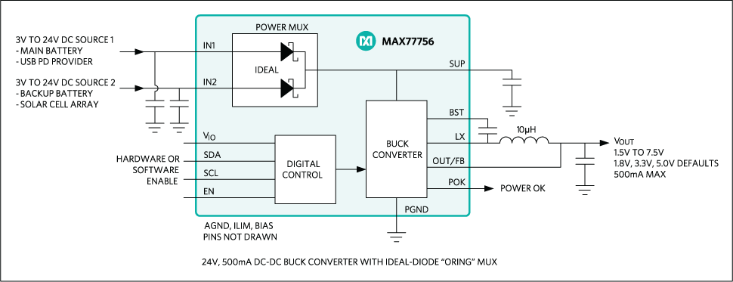

Figure MAX77756 step-down controller, switcher example [1]

Before revealing the detail of the chosen solution approach for control, the requirements of the control and controller can be examined in Table 1.

Table Requirements and significant considerations for selection of controller

|  |  |  |
| --- | --- | --- |
| Requirements | Value | Explanation |
| Input Voltage | ≥ 400V | Considered for internal regulators. |
| Switching frequency | 50kHz | PWM generation |
| Output current | ≥ 2A | Considered for internal regulators. |
| Isolation | NA | Safety of external digital controllers |
| Gate driving current | Depend of switch | Turn on time of switch |
| Threshold voltage | Depend of switch | Required min. Voltage to turn on switch |
| Feedback | Analog or digital | Sensed voltage or current information |

The internal regulator ICs can’t be used due to input voltage ratings of them and thermal considerations. Hence, usage of external switch is decided. On the other hand, digital controllers are considered as last choice due to isolation and external supply, which put the external analog regulators in a first place to find. Then, the research is focused on ICs that are generally used as LED drivers. As a result, AL9910A is selected as controller, PWM generator and gate driver. Figure 3 shows the typical application of AL9910A.

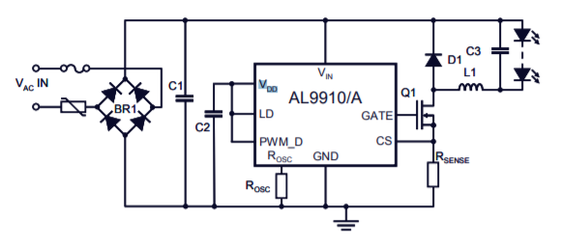

Figure Typical application circuit of AL9910A

AL9910A controller does not isolation and moreover, it eliminates external power supplies. *“The AL9910 drives external MOSFETs at switching frequencies up to 300kHz, with the switching frequency determined by a single resistor. The AL9910 topology creates a constant current through the LEDs providing constant light output. The output current is programmed by one external resistor and is ultimately determined by the external MOSFET chosen and therefore allows many low current LEDs to be driven as well as a few high current LEDs.”* [2]