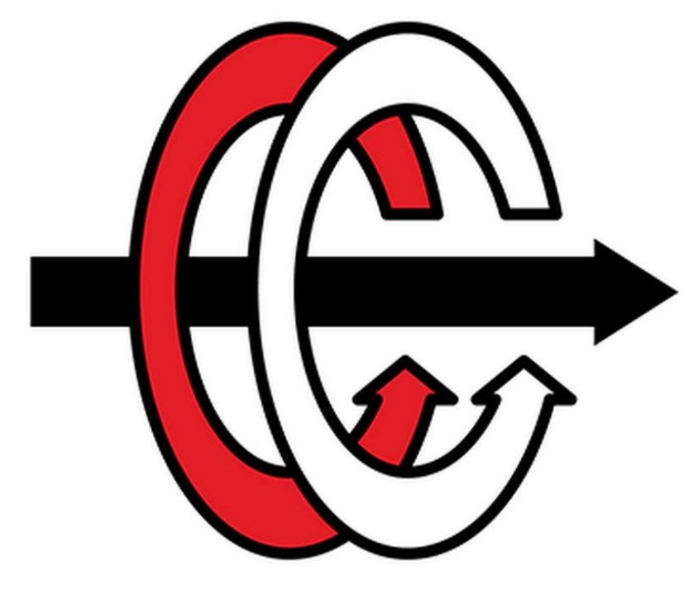

**MIDDLE EAST TECHNICAL UNIVERSITY**

**DEPARTMENT OF ELECTRICAL and ELECTRONICS ENGINEERING**

**EE 463 – STATIC POWER CONVERSION I**

**Term Project Report**

Eren Özkara 2232551

Büşra Nur Koçak

Yunus Çay

Table of Contents

Introduction 3

Topology Selection 4

Three Phase Thyristor 4

Advantages 4

Disadvantages 4

Three Phase Diode Rectifier with Buck Converter 5

Advantages 5

Disadvantages 5

Detailed Simulation 5

Uncontrolled 3 Phase Rectifier 5

Buck Converter 5

Battery 6

Controller 9

PCB Design 10

Component Selection 11

Conclusion 11

# Introduction

# Topology Selection

In order to control the output current in the project, we need to use controlled rectifier or uncontrolled rectifier + buck converter topologies. Therefore, these topologies have been discussed.

## Three Phase Thyristor

* Thyristor rectifier topologies are generally used in systems with high voltage and current.
* In this topology, the average output voltage of the thyristor rectifier can be controlled by adjusting the firing angle of the thyristors. Thus, output current can be adjusted with the firing angle.

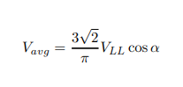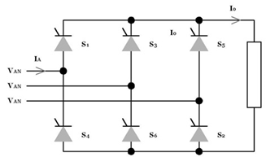

*Figure 1. Three Phase Thyristor Topology and its Output Voltage Equation*

### Advantages

* This topology consists of only 6 thyristors; therefore, the topology structure is not complex.
* In this topology, the input current THD is low because the third harmonics of the input current are not observed.

### Disadvantages

* Although this topology contains only 6 thyristors, thyristors are expensive components compared to diodes.
* To control six thyristors at the same time, six gate drivers and other components are required, which increases the cost considerably.
* Operating and controlling 6 gate drivers synchronously is a very complex process.

## Three Phase Diode Rectifier with Buck Converter

* DC / DC converters are used in many areas such as electrical vehicles, PV - Grid systems.
* 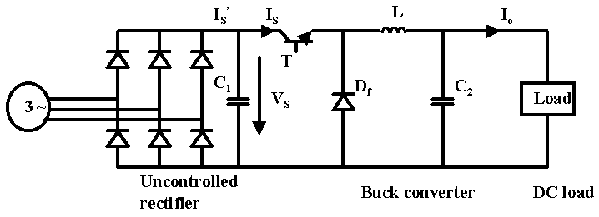In this topology, AC voltage will be converted to DC with an uncontrolled rectifier and then to the desired DC voltage value with a buck converter.
* In this topology, the duty cycle of the buck converter is controlled by sensing the output current.



*Figure 2. Three Phase Rectifier + Buck Converter Topology and its Output Voltage Equation*

### Advantages

* In this topology, the output voltage ripple can be easily reduced by placing a capacitor at the rectifier output and controlling the buck converter output voltage.
* This topology requires only one gate signal. This is a great advantage over controlled rectifiers. Also, the gate signal does not need to be synchronous.
* Although this topology requires more components, its cost is considerably lower than 3 phase-controlled rectifiers.
* In this topology, the input current THD is low because the third harmonics of the input current are not observed.

### Disadvantages

* In this topology, its efficiency will theoretically be less since MOSFET and diode are used in addition to 3 phase-controlled rectifiers.
* Using an LC filter increases the size of the topology.

# Detailed Simulation

## Uncontrolled 3 Phase Rectifier

## Buck Converter

## Battery

In this part, battery part will be analysed, and some test will be applied.

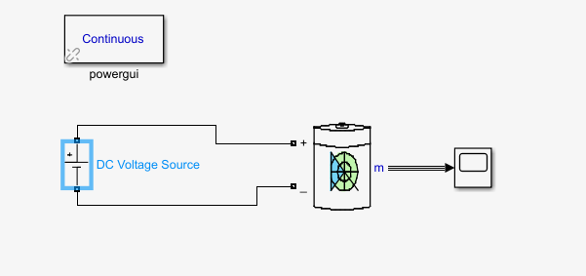

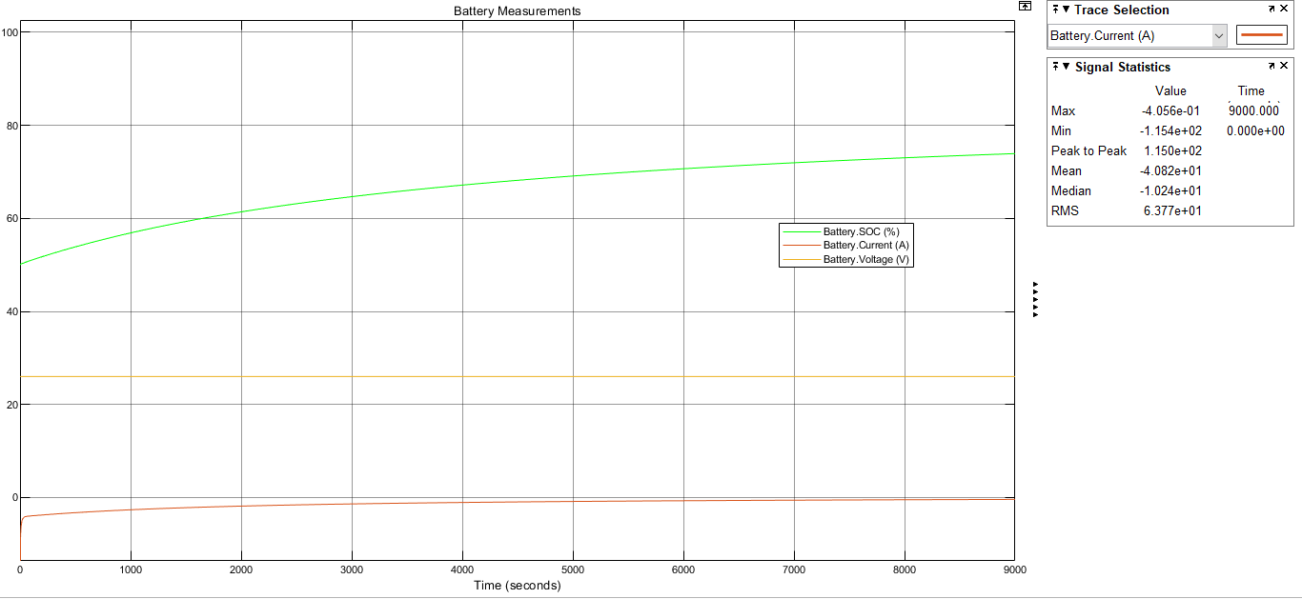

*Figure. Constant Voltage Battery Test*

In this test, battery behaviour was observed when a constant voltage of 25 volts was applied to the battery. As can be seen from the graph, it is not enough to give constant input voltage to obtain constant current. Therefore, an increasing voltage must be applied to the battery.

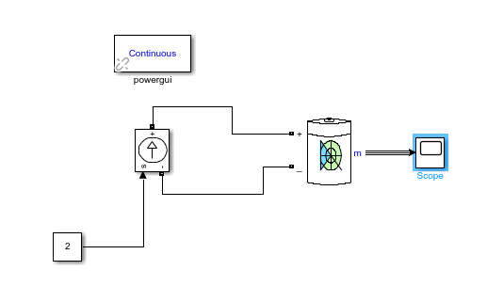

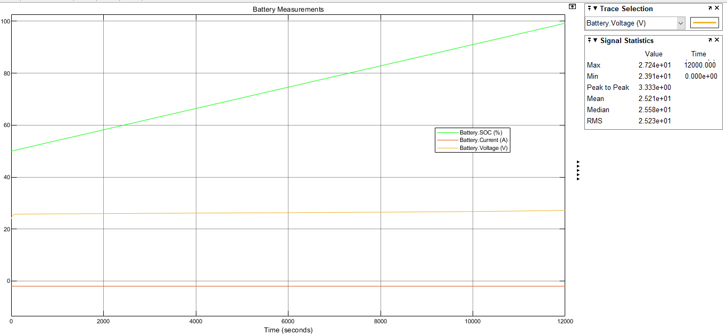

*Figure. Constant Current Battery Test*

In this test, a constant input current of 2 amps was applied to the battery. As can be seen from the graph, an increasing voltage between 24-27 volts should be applied to the battery to charge from %50 to %100.

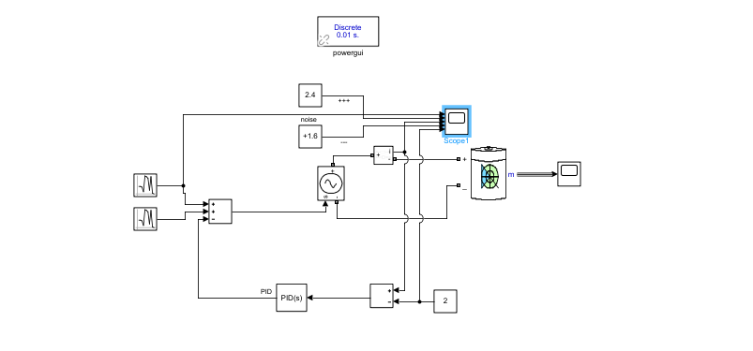

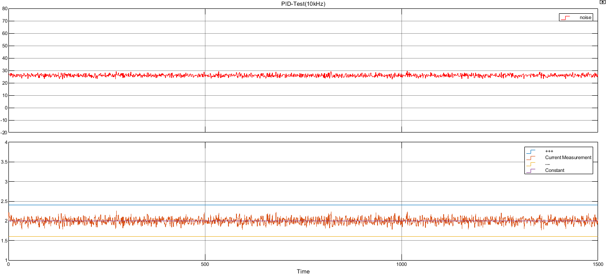

*Figure. P controller test with noisy input*

In this test, the P controller with a noisy input voltage, was tested to obtain a constant 2 ampere output current. The Buck converter part is symbolized as a controlled voltage source. Despite the small noise, high output noise was observed, so controls continued to be improved.

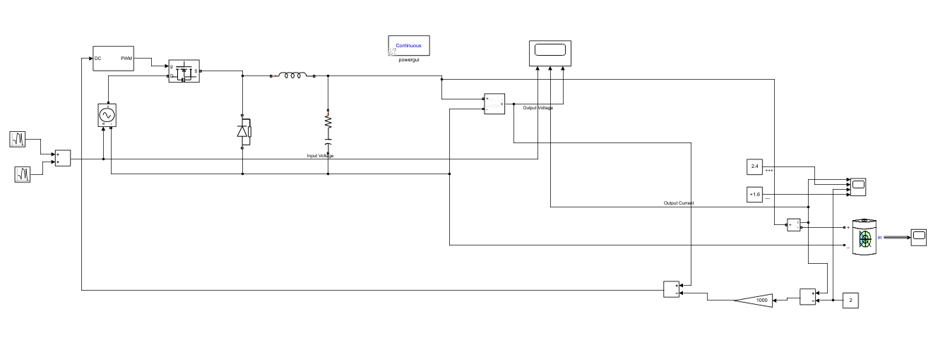

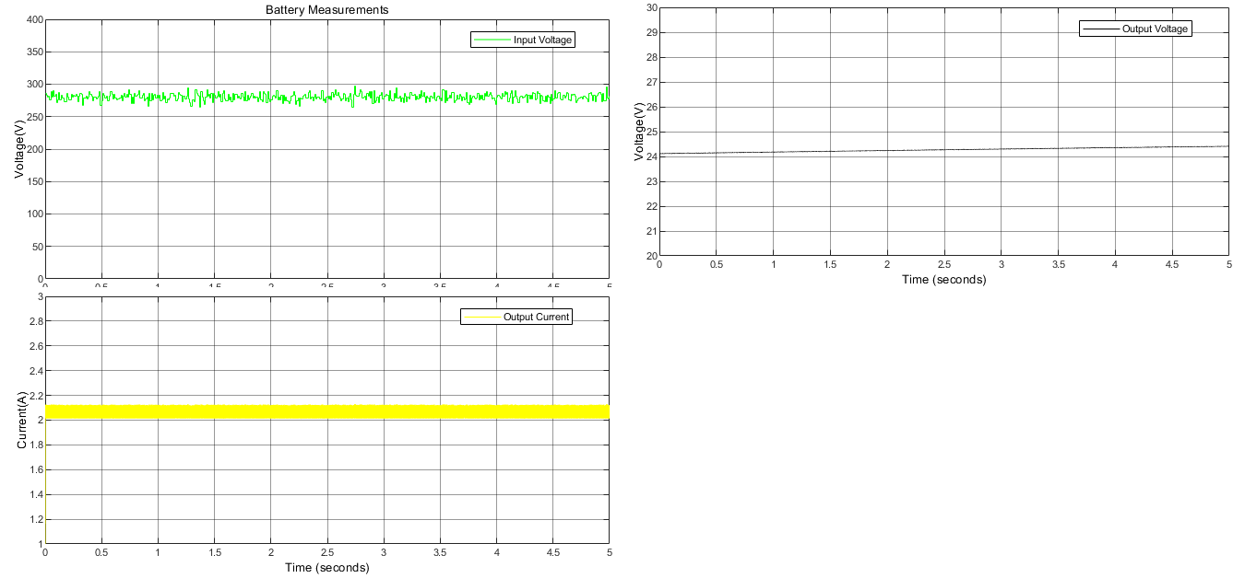

*Figure. Buck Converter and Battery Test with P controller*

In this test, the battery and buck converter part are connected. Buck converter's input is symbolized as noisy input with an average value of 280 V. The controls part has been converted into a cascade controller. In the test, an offset was observed in the output, so the P controls part will be converted into PI controls. In the following sections, all parts were combined with the rectifier and simulations were made.

## Controller

## Completed Simulation

# PCB Design

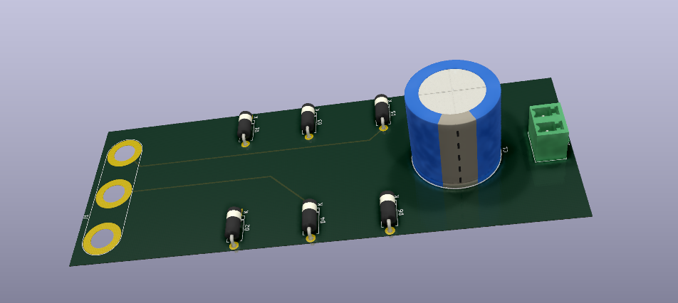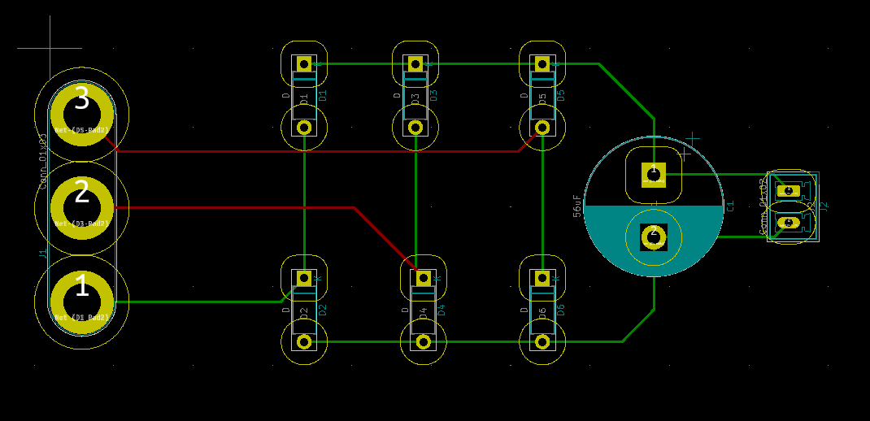

*Figure. PCB Design of Uncontrolled Rectifier*

In this part, the points we pay attention to while designing PCBs will be mentioned. Until now, only the PCB design of the rectifier part has been made for practical purposes. Because as the components used change, it can create big changes in PCB design. For example, thermal conditions have not yet been taken into consideration, but will be available in future designs.

* The footprint of the components will be added to the design by looking at the datasheet. If that footprint is not already available in the program library used, the footprint will be created.
* Considering high voltage conditions, suitable trace spacing will be left according to IPC2221B standards.
* Space will be left for the heatsink, considering the components that consume high power.
* The appropriate track width will be calculated considering the IPC2221 standard. Magnitude of the current should be considered because high current causes heating in traces.
* Silk layer will be used as much as possible to make the design more descriptive.
* PCB thickness will be as recommended in the datasheet of the components used. For example, 1 oz / ft2 is chosen for the rectifier.
* If necessary, control traces will be drawn on the inner layer to avoid noise.
* 90-degree angles will be avoided while drawing traces. Because this reduces the trace thickness, 45-degree angles should be used instead.
* If necessary, nodes will be made at important points.

# Component Selection

# Conclusion