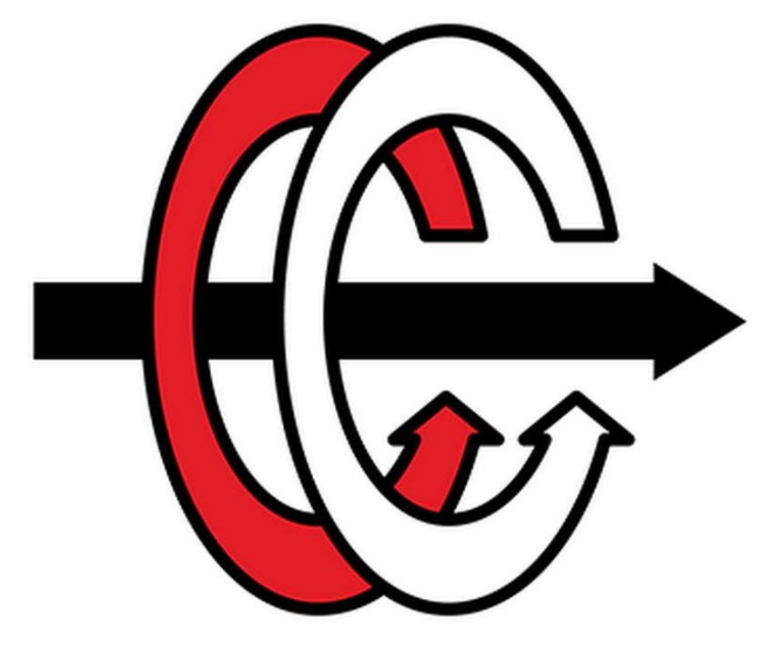

**MIDDLE EAST TECHNICAL UNIVERSITY**

**DEPARTMENT OF ELECTRICAL and ELECTRONICS ENGINEERING**

**EE 463 – STATIC POWER CONVERSION I**

**Term Project Report**

Eren Özkara 2232551

Büşra Nur Koçak 1929355

Yunus Çay

Table of Contents

Introduction 3

Topology Selection 3

Three Phase Thyristor 3

Advantages 3

Disadvantages 4

Three Phase Diode Rectifier with Buck Converter 4

Advantages 4

Disadvantages 4

Detailed Simulation 5

Uncontrolled 3 Phase Rectifier 5

Buck Converter 5

General Structure and Calculations of Buck Converter 5

Buck Converter Simulation with Estimated Values 7

Battery 9

Controller 11

Completed Simulation 11

PCB Design 12

Component Selection 13

Component Selection for Buck Converter 13

Conclusion 15

# Introduction

In this report, topologies that can be used in the project were discussed and compared. Then the simulation details and the details of the topology used were explained. Equations used in design, analytical calculations and design decisions were mentioned. The progress steps of the design were explained. Then, the points to be considered while designing PCBs were discussed. Finally, the selected components and their properties were mentioned.

# Topology Selection

In order to control the output current in the project, we need to use controlled rectifier or uncontrolled rectifier + buck converter topologies. Therefore, these topologies have been discussed.

## Three Phase Thyristor

* Thyristor rectifier topologies are generally used in systems with high voltage and current.
* In this topology, the average output voltage of the thyristor rectifier can be controlled by adjusting the firing angle of the thyristors. Thus, output current can be adjusted with the firing angle.

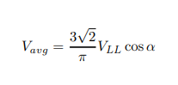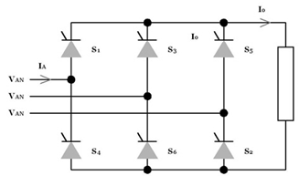

*Figure 1. Three Phase Thyristor Topology and its Output Voltage Equation*

### Advantages

* This topology consists of only 6 thyristors; therefore, the topology structure is not complex.
* In this topology, the input current THD is low because the third harmonics of the input current are not observed.

### Disadvantages

* Although this topology contains only 6 thyristors, thyristors are expensive components compared to diodes.
* To control six thyristors at the same time, six gate drivers and other components are required, which increases the cost considerably.
* Operating and controlling 6 gate drivers synchronously is a very complex process.

## Three Phase Diode Rectifier with Buck Converter

* DC / DC converters are used in many areas such as electrical vehicles, PV - Grid systems.
* 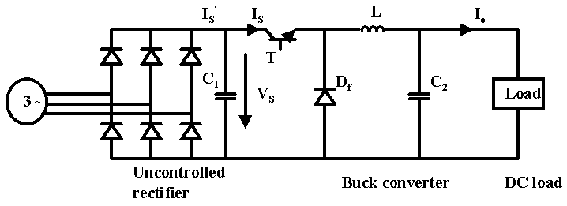In this topology, AC voltage will be converted to DC with an uncontrolled rectifier and then to the desired DC voltage value with a buck converter.
* In this topology, the duty cycle of the buck converter is controlled by sensing the output current.



*Figure 2. Three Phase Rectifier + Buck Converter Topology and its Output Voltage Equation*

### Advantages

* In this topology, the output voltage ripple can be easily reduced by placing a capacitor at the rectifier output and controlling the buck converter output voltage.
* This topology requires only one gate signal. This is a great advantage over controlled rectifiers. Also, the gate signal does not need to be synchronous.
* Although this topology requires more components, its cost is considerably lower than 3 phase-controlled rectifiers.
* In this topology, the input current THD is low because the third harmonics of the input current are not observed.

### Disadvantages

* In this topology, its efficiency will theoretically be less since MOSFET and diode are used in addition to 3 phase-controlled rectifiers.
* Using an LC filter increases the size of the topology.

# Detailed Simulation

## Uncontrolled 3 Phase Rectifier

The modelled PMSM generator supplies three phase current to the system and 3-phase diode rectifier gives rectified signal as a output. The output voltage ripple is decreased with parallel capacitor which is place just before the buck converter. The modelled PMSM generator and rectifies can be seen in Figure 4. Input of generator is mechanical torque and other specifications of PMSM are provided in the project description.

The generated voltage difference on motor terminals depends on mechanical torque. Since the load current does not change, electrical torque of generator is constant, so difference between mechanical torque and electrical torque returns as a speed of shaft according to Equation (1). The constant electrical torque results in a significant observation about efficiency. Increase in the speed of rotor results in a more viscous friction loss. Hence, for constant output power applications are not efficient from the point of mechanical power and output power view.

|  |  |  |
| --- | --- | --- |
|  |  | (1) |

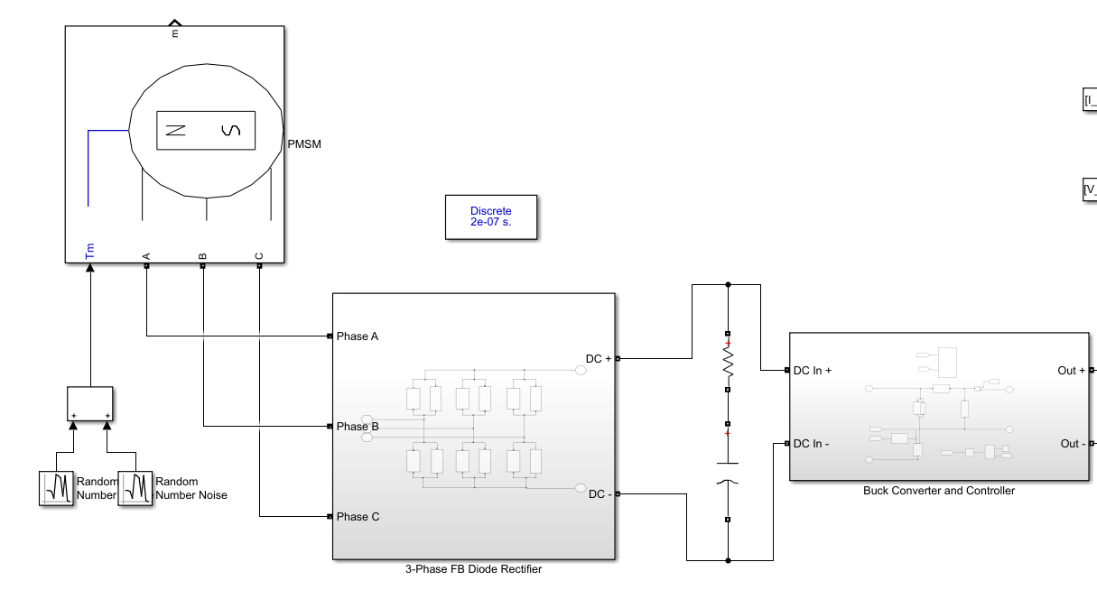

Figure 4 Modelled PMSM generator and 3-phase FB diode rectifier

3-phase diode rectifier works without a control which is handled by characteristics of diode. The output voltage equals to the greatest line-to-line instantly. Since, the ripple frequency is six times of input line-to-line voltages, ripple is considerably low. The mean voltage of output without a dc-link capacitor is calculated in Equation (2). However, the output voltage is slightly less than generated voltage in generator due to commutation and stator resistance. While generator current results in a voltage drop on stator resistance, the armature reactance causes commutation.

|  |  |  |
| --- | --- | --- |
|  |  | (2) |

Output voltage ripple decreases as the pulse number of rectifier increases. The 3-phase diode rectifier is called as 6-pulses rectifier. In addition to pulse number, DC-link capacitor filters out high frequency components of output voltage, so that the output voltage ripple decreases. Thus, the DC-link capacitor is placed just before the buck converter to decrease ripple as shown in Figure 4.

## Buck Converter

## General Structure and Calculations of Buck Converter

The DC voltage, which is the output of the three phase full wave diode rectifier described in part …, have been connected into an buck converter to step down the voltage value from 250 V (Vmax) to 25 V nominal value for charging the battery. The main structure of the buck converter can be seen from the Figure …. An approximate inductance and capacitance values have been calculated by specifying the on and off cases of switching element of the buck converter, which is MOSFET in this case.

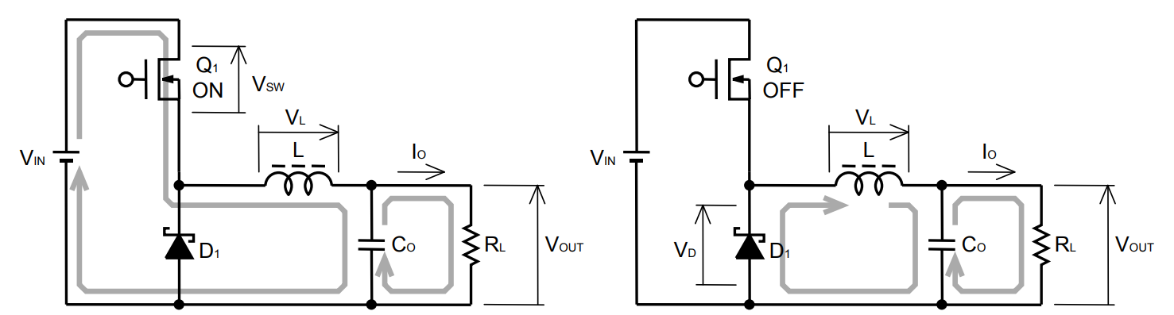

Figure 3: Buck converter ON and OFF cases of the MOSFET

The output current of the buck converter is intended to be 2A with %20 of average current as ripple, while the battery is being charged. Therefore, ON and OFF states of the MOSFET have been considered separately for the same output current level to specify a formula for calculating required inductance value to apply intended output current ripple, Formula 1.

|  |  |  |
| --- | --- | --- |
|  |  | (1) |

: Input Voltage (V) = 250 V

: MOSFET ON state voltage drop (V) = 0.3 V

: Output Voltage (V) =25 V

: Diode forward voltage drop (V) = 0.7 V

: Switching frequency (Hz) = 10kHz

: Output current ripple ratio = 0.2 A/A

: MOSFET ON state voltage drop = 2 A

The values specified above taken into consideration to calculate only an approximate inductance. According to these L have been calculated as 5.76 mH, which is known to be very high value for an inductor. The main reason for such high inductance is to decrease the ripple on the output current. Moreover, since the frequency value is located in the denominator as seen in the Formula (1), the use of low frequency caused the inductor value to increase. Because, the ripple voltage already specified before, frequency is choosed to be the factor that can be changed to adjust the inductance value. Considering the effects of the frequencies in the 10 kHz- 100 kHz range on the conduction losses and switching losses, 50 kHz have been seen as a suitable value to reduce the inductor value by keeping the overall power loss level sufficiently low. Therefore, the inductor value have been achieved to decrease to 1.2 mH, which is 5 times less than the value calculated before, by changing the switching frequency with 50 kHz.

Yunus’un power loss hesaplamaları eklenebilir.

The conduction losses and switchign losses of switches are the most important parameters effecting efficiency of converter. Since the different step-down converter topologies are available, the switches are named as high-side and low side switch. While the high side switch represents the mosfet, low-side switch represents the diode for non-synchronous buck converter. The calculation of conduction losses for different type of switches are shown in Table xxx.

Table xxx is used to decide step-down converter topologies between synchronous and non- synchronous converters. The duty cycle is taken as 0.1 for the sake of simplicity according to given mechanical torque values. Therefore, conduction losses of low-side switch is dominant. On the other hand, IGBT is eliminated due to increase in switching frequency. Whereas mosfets are generally used for high frequency and relatively low reverse voltage applications, IGBTs are chosen for low frequency and high reverse voltage applications.

All in all, the high-side switch is mosfet type and the low-side switch can be diode or mosfet. Although the type of low-switch affects the topology, the consideration of cost and efficiency is more important than driver characteristic and topology. Hence, low-switch is chosen as diode, which makes the converter non-synchronous.

|  |  |  |
| --- | --- | --- |
| Switch | Type | Conduction Loss |
| High-side | MOSFET |  |
| High-side | IGBT |  |
| Low-side | MOSFET |  |
| Low-side | IGBT |  |
| Low-side | Diode |  |

If switching loss of diode and mosfet were high compared to conduction loss, the selection of switch type could depend on switching loss and swithcing frequency. However, the switching loss of components are approximately 5 times less for mosfet and 3 times less for diode. The switching loss calculations can be seen in Table xxx.

While gate driver current and gate charge are considered for mosfet, reverse recovery charge is considered as an important parameter for selection. Thus, gate driver is chosen as strong to supply high gate currents and type of diode is selected as fast diode.

|  |  |  |
| --- | --- | --- |
| Switch | Type | Switching Loss |
| High-side | MOSFET |  |
| Low-side | Diode |  |

While the inductor is effective in adjusting the output current ripple, capacitor plays an important role in output voltage ripple. Moreover, ESR of the capacitor which stands for ‘Equivalent Series Resistance’ is also an important factor while choosing a capacitor, as can be seen from the Formula (4), where ESL value is assumed to be 0 H. Both ON and OFF states of the MOSFET have been taken into consideration while analyzing the factors affecting the capacitor value.

|  |  |  |
| --- | --- | --- |
|  | [] | (2) |

: Maximum Input Voltage (V)

: Inductor ripple current (A)

: Output capacitor (F)

ESR: Equivalent series resistor of output capacitor (Ω)

ESL: Equivalent series inductor of output capacitor (H)

The finilized approximation used in the capacitor calculations can be seen from Formula (4).

|  |  |  |
| --- | --- | --- |
|  |  | (3) |

|  |  |  |
| --- | --- | --- |
|  |  | (4) |

Hence, approximate capacitor value is calculated as with 0.2 Ω ESR value. Because one of the most important parameters are specified as the ESR in output voltage ripple and capacitor calculations, it was decided to pay attention to the small ESR value, during the selection of capacitor. As the output voltage and current ripples of the converter is already specified before, an upper limit has been determined fort he ESR value.

## Buck Converter Simulation with Estimated Values

An example circuit have been set, using the estimated values, which are calculated at part …. The aim of this circuit is to show that the calculated inductor and capacitor values can reduce the input voltage level to the desired output voltage level with the specified ripple voltage as can be seen from Figure …. Moreover, inductor effect on output current waveform with the addition of a control system can be seen from Figure ….

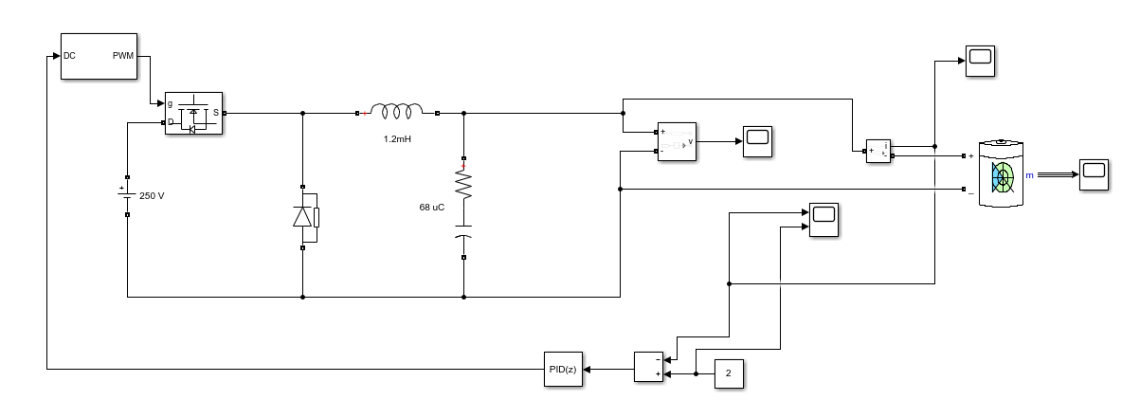

Figure 4: Buck converter Simulink circuit with PI controller

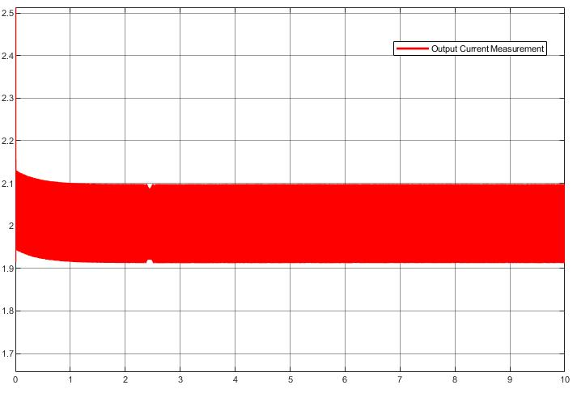

Figure 5: Output current measurement of the buck converter

## Battery

In this part, battery part will be analysed, and some test will be applied.

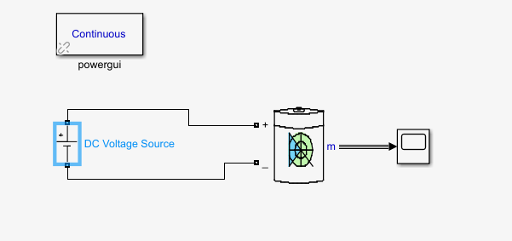

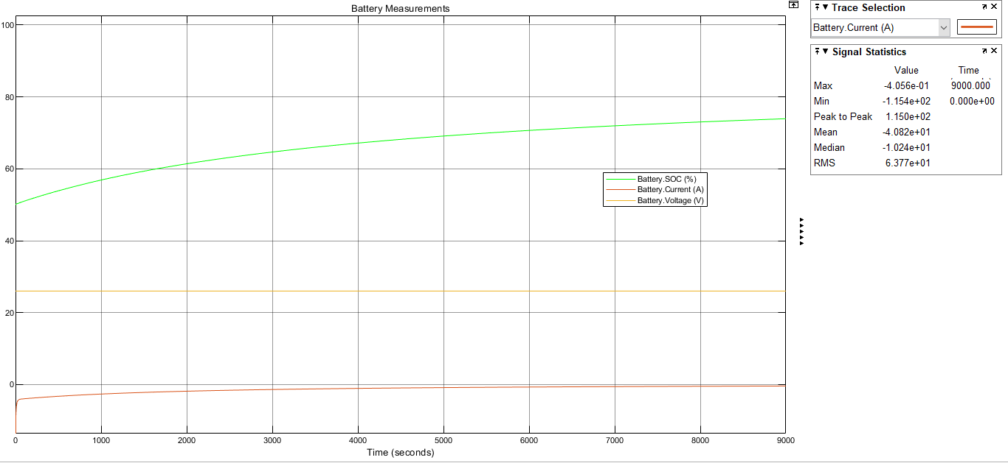

*Figure. Constant Voltage Battery Test*

In this test, battery behaviour was observed when a constant voltage of 25 volts was applied to the battery. As can be seen from the graph, it is not enough to give constant input voltage to obtain constant current. Therefore, an increasing voltage must be applied to the battery.

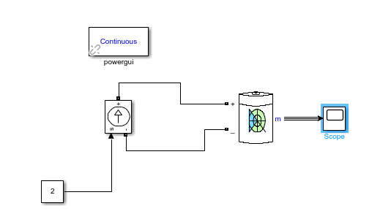

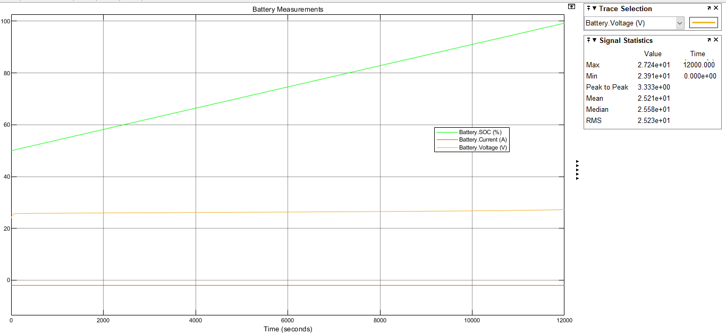

*Figure. Constant Current Battery Test*

In this test, a constant input current of 2 amps was applied to the battery. As can be seen from the graph, an increasing voltage between 24-27 volts should be applied to the battery to charge from %50 to %100.

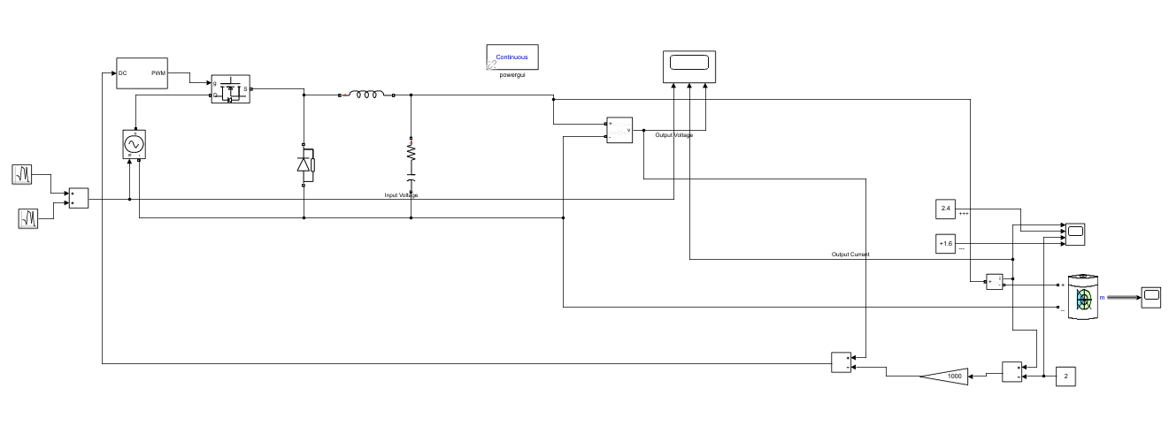

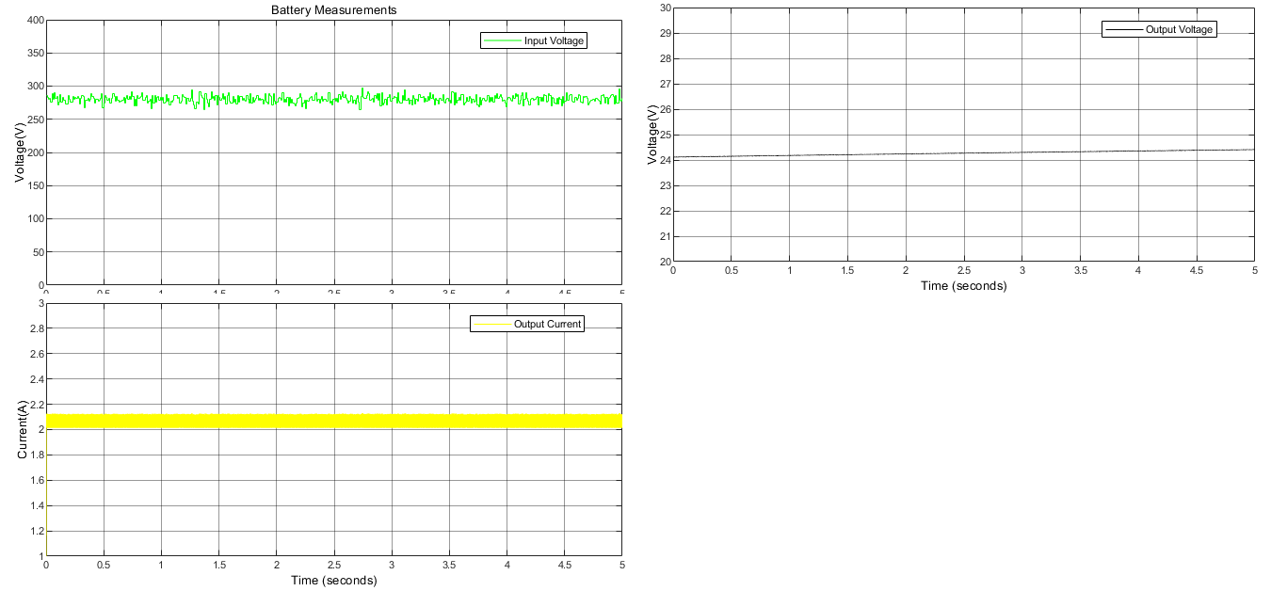

*Figure. Buck Converter and Battery Test with P controller*

In this test, the battery and buck converter part are connected. Buck converter's input is symbolized as noisy input with an average value of 280 V. In the test, an offset was observed in the output, so the P controls part will be converted into PI controls. Also, controller is simplified. In the following sections, all parts were combined with the rectifier and simulations were made in discrete time.

## Controller

The selected topology has been designed as to control the desired average output current and ripple of output current by adjustments of duty cycle in buck converter. The block diagrams and input – output relations of blocks are shown in Figure 1. The measurement on shunt resistor is the feedback providing the system with current control. While Figure 1 shows the basic blocks and conceptual solution of control, other blocks such as isolation, amplifiers, comparators can be placed according to solution approach.

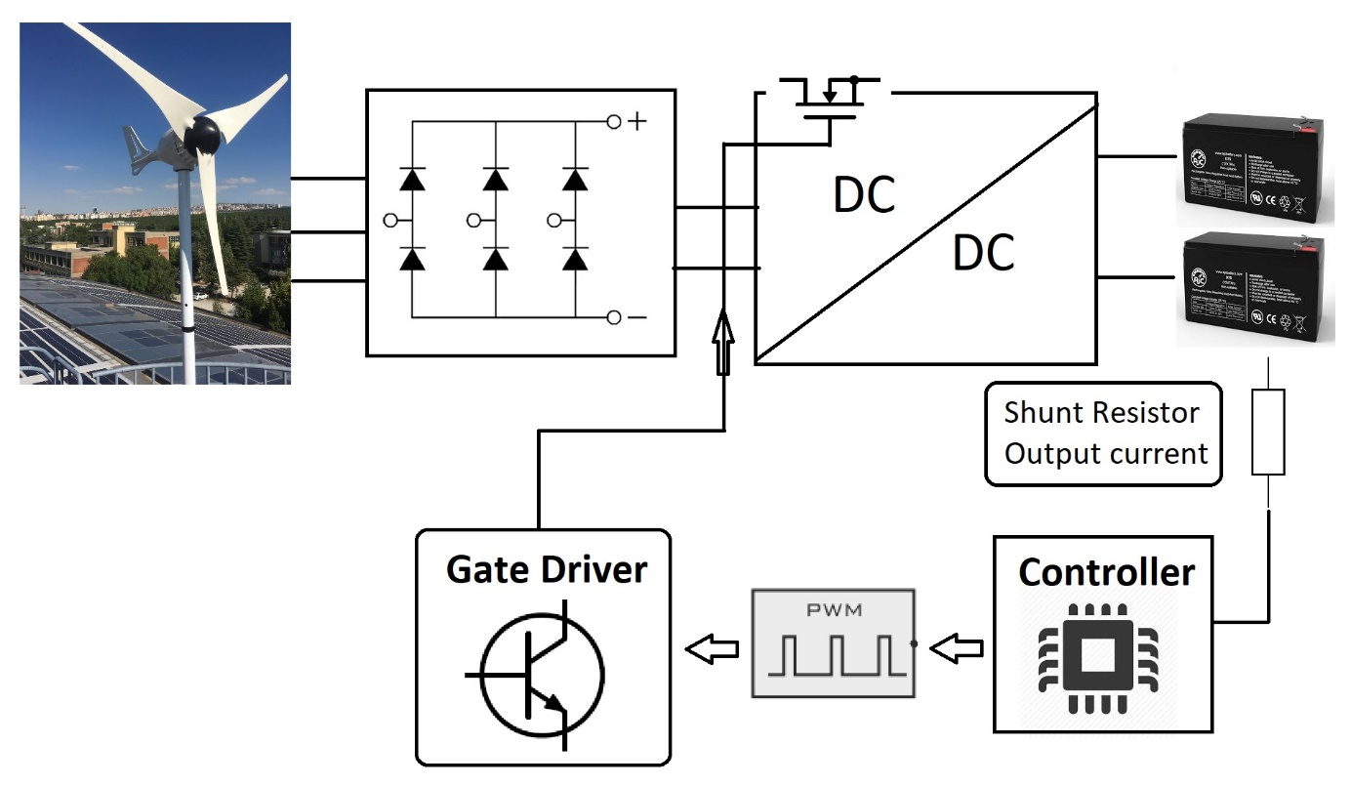

Figure 1 Block diagram of system and controller

The control of converters can be accomplished with some different ways. For instance, controller can be used digital controller such as arduino or programmable. Then, pwm generator and gate driver can be constructed externally. On the other hand, there are some integrated circuits which can handle analog control, pwm generation and gate driving in a single package. Moreover, some of them may include switching componenets, generally mosfets, are called switchers.

The each solution can advantages and disadvantages in system level. For instance, external enhanced mcu can be used for applications requiring complex user interfaces or hard control algorithms. On the other hand, switchers can be used for converters with low input voltage for the sake of small volume. One of the packed controller can be seen in Figure 2. These are easy-to-use controllers.

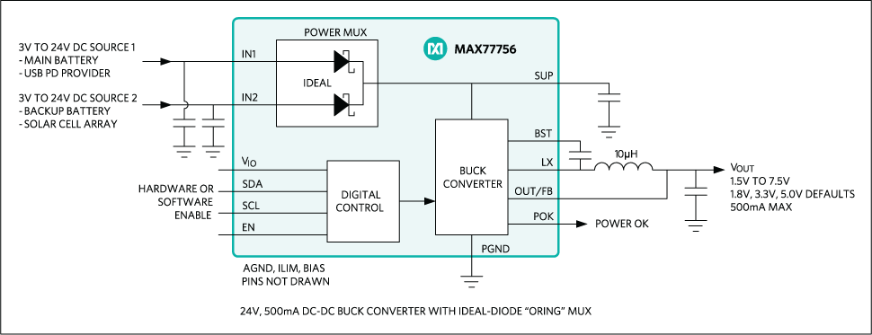

Figure 2 MAX77756 step-down controller, switcher example [1]

Before revealing the detail of the chosen solution approach for control, the requirements of the control and controller can be examined in Table 1.

Table 1 Requirements and significant considerations for selection of controller

|  |  |  |
| --- | --- | --- |
| Requirements | Value | Explanation |
| Input Voltage | ≥ 400V | Considered for internal regulators. |
| Switching frequency | 50kHz | PWM generation |
| Output current | ≥ 2A | Considered for internal regulators. |
| Isolation | NA | Safety of external digital controllers |
| Gate driving current | Depend of switch | Turn on time of switch |
| Threshold voltage | Depend of switch | Required min. Voltage to turn on switch |
| Feedback | Analog or digital | Sensed voltage or current information |

The internal regulator ICs can’t be used due to input voltage ratings of them and thermal considerations. Hence, usage of external switch is decided. On the other hand, digital controllers are considered as last choice due to isolation and external supply, which put the external analog regulators in a first place to find. Then, the research is focused on ICs that are generally used as LED drivers. As a result, AL9910A is selected as controller, PWM generator and gate driver. Figure 3 shows the typical application of AL9910A.

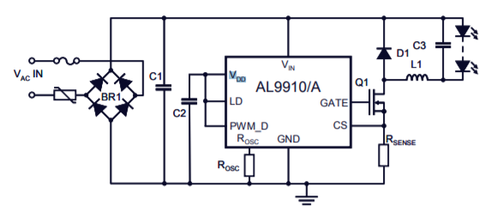

Figure 3 Typical application circuit of AL9910A

AL9910A controller does not need isolation and moreover, it eliminates external power supplies. *“The AL9910 drives external MOSFETs at switching frequencies up to 300kHz, with the switching frequency determined by a single resistor. The AL9910 topology creates a constant current through the LEDs providing constant light output. The output current is programmed by one external resistor and is ultimately determined by the external MOSFET chosen and therefore allows many low current LEDs to be driven as well as a few high current LEDs.”* [2]

## Completed Simulation

The input mechanical torque, rectified output voltage and battery voltage can be seen in Figure xxx.

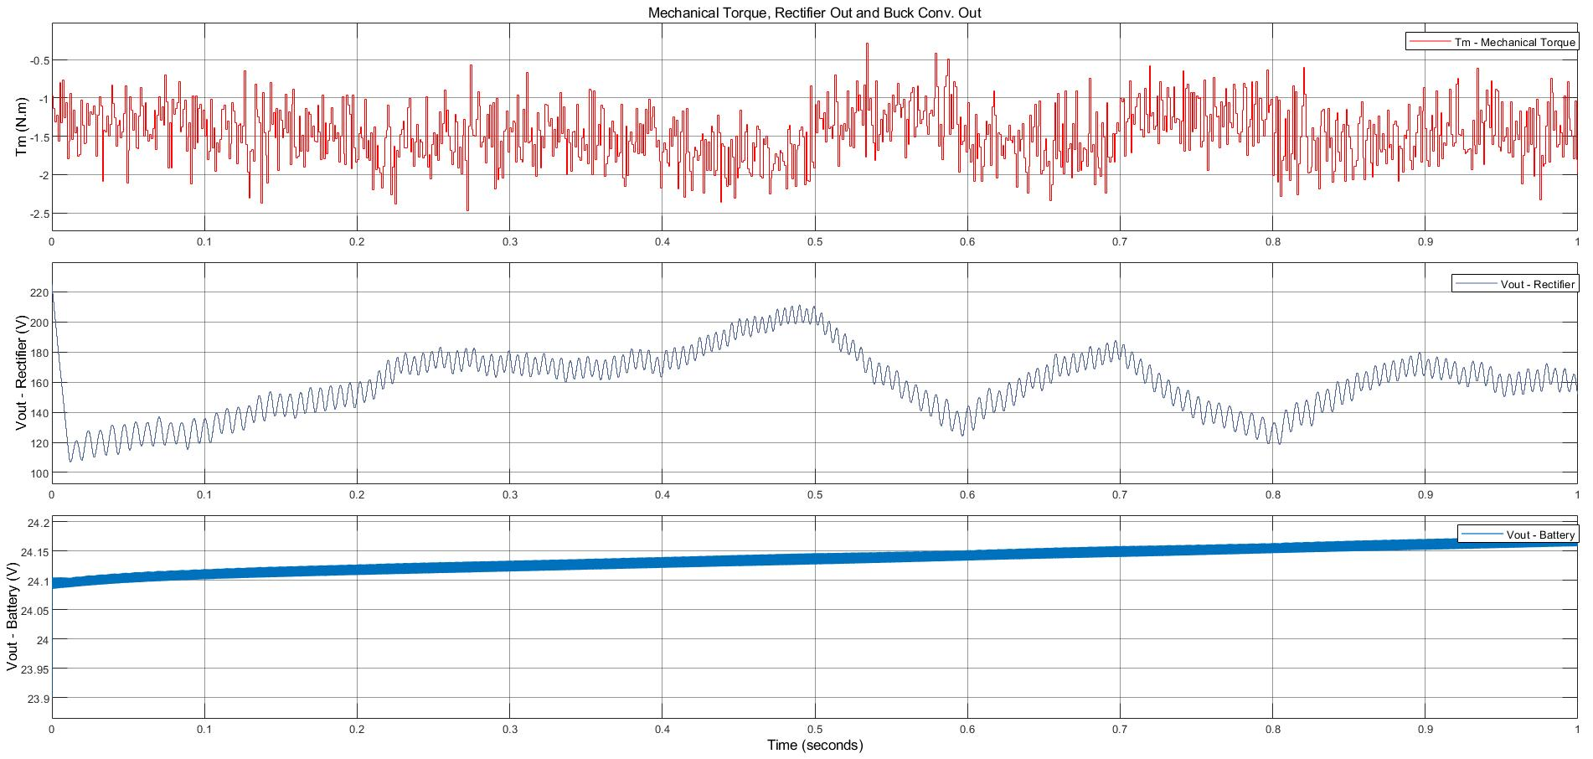

The output current, reference current and limiting values for ripple can be seen in Figure xxx.

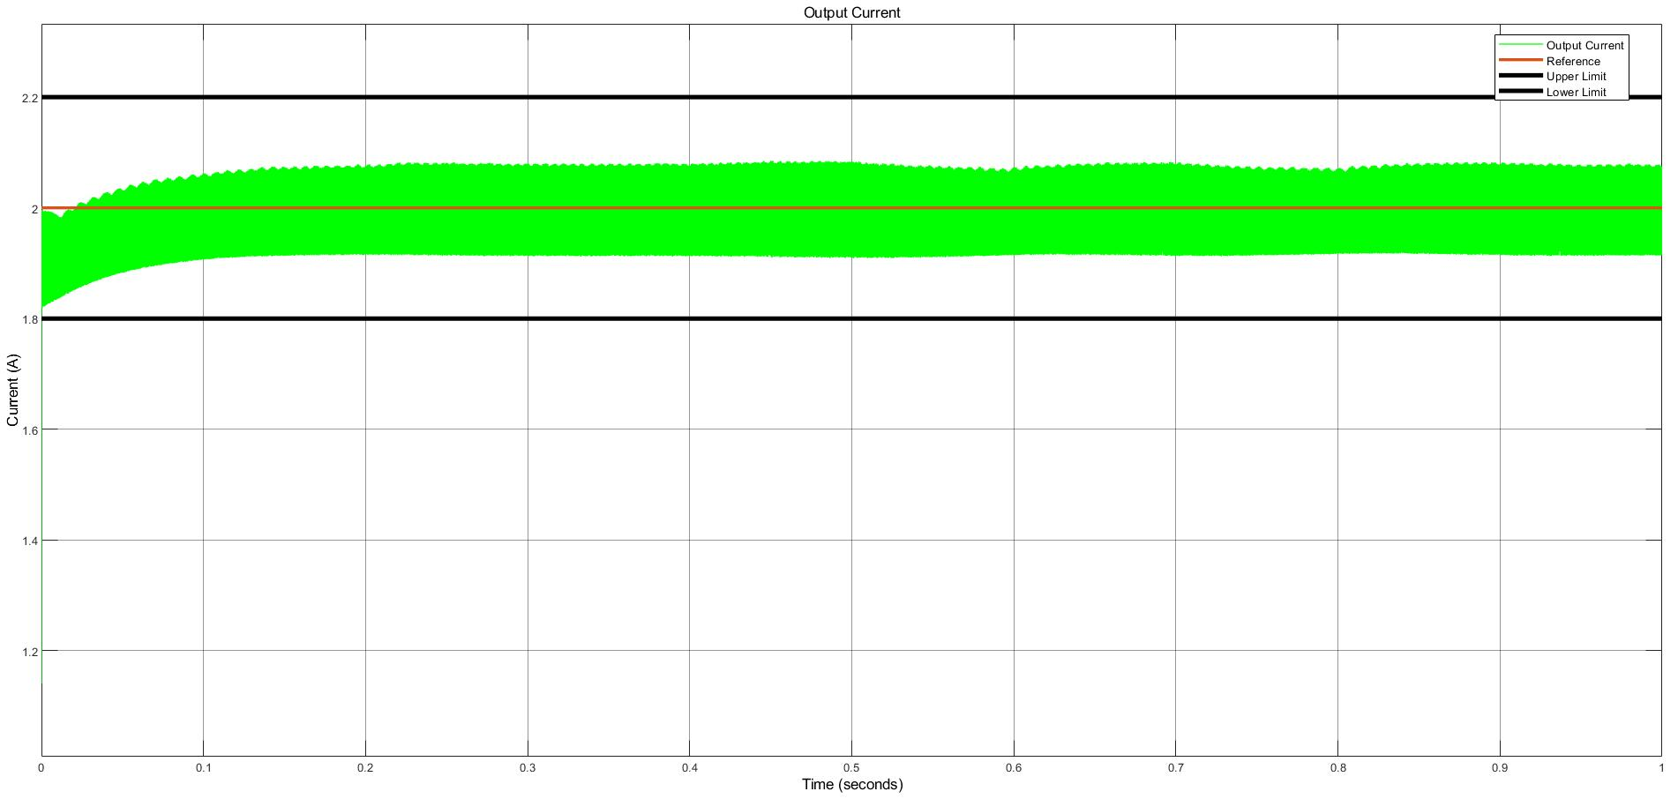

# PCB Design

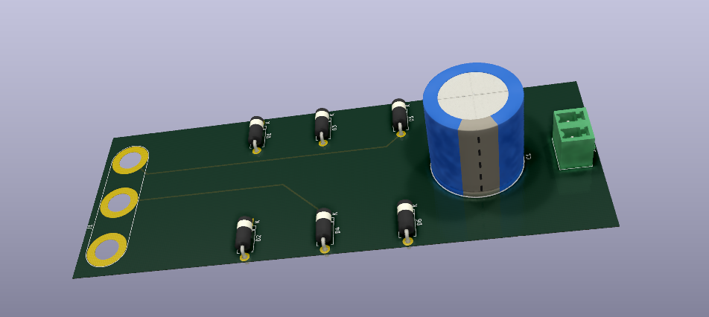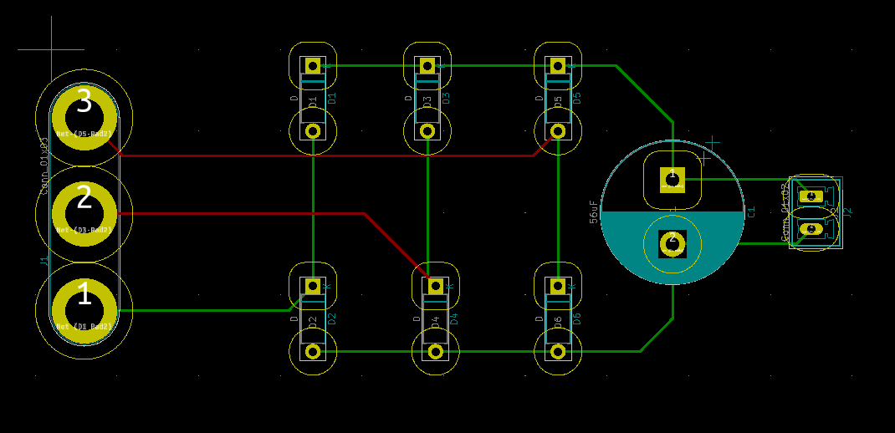

*Figure. PCB Design of Uncontrolled Rectifier*

In this part, the points we pay attention to while designing PCBs will be mentioned. Until now, only the PCB design of the rectifier part has been made for practical purposes. Because as the components used change, it can create big changes in PCB design. For example, thermal conditions have not yet been taken into consideration, but will be available in future designs.

* The footprint of the components will be added to the design by looking at the datasheet. If that footprint is not already available in the program library used, the footprint will be created.
* Considering high voltage conditions, suitable trace spacing will be left according to IPC2221B standards.
* Space will be left for the heatsink, considering the components that consume high power.
* The appropriate track width will be calculated considering the IPC2221 standard. Magnitude of the current should be considered because high current causes heating in traces.
* Silk layer will be used as much as possible to make the design more descriptive.
* PCB thickness will be as recommended in the datasheet of the components used. For example, 1 oz / ft2 is chosen for the rectifier.
* If necessary, control traces will be drawn on the inner layer to avoid noise.
* 90-degree angles will be avoided while drawing traces. Because this reduces the trace thickness, 45-degree angles should be used instead.
* If necessary, nodes will be made at important points.

# Component Selection

## Component Selection for Buck Converter

**Rectifier**

The diode rectifier is constructed with single diodes. The seperate usage has advantages in terms of cost and fault. The production of single diodes can be manufactured in huge amonts, which can provide them with low cost. Also, single diodes can be replaced easily.

The important parameters are breakdown voltage and forward current ratings. There is no need to fast diodes because the electrical frequency of generator cannot excess the 60Hz due to small pole-pair number. The selected rectifier diode is shown in Table xxx

|  |  |  |  |
| --- | --- | --- | --- |
| **Rectifier Diode** | Reverse Voltage | Forward Current | Cost |
| S1G | 400V | 1A | 6x0.22$ = 1.32$ |

**Inductor**

The main point while choosing an inductor is its current ratings in addition to inductance. Eventhough, 2A average values expected on top of the inductor, It was observed in … that the current value on the inductor can reach peak values of 2.15 A. Therefore, special attention has been given to the saturation curretns during the selection of the inductor. The inductor models which use ferrite core as magnetic material have been preferred due to their ability to operate at higher frequencies and allowing higher inductor values with smaller size. Two different inductor values have been compared to determine the advantages and disadvatanges each have.

|  |  |  |  |  |
| --- | --- | --- | --- | --- |
|  | Inductance (mH) | Current Rating (A) | Saturation Current | Price |
| 1140-272K-RC | 2.7 | 2.2 | 3.9 | 9.56 $ |
| AIRD-03-152K | 1.5 | 2 | 3.4 | 5.52 $ |

Eventhough, high inductance value can decrease the output current ripple even further, considering the price of 1140-272K-RC, choosing AIRD-03-152K evaluated to be more appropriate. When the %10 tolerance of the AIRD-03-152K also included, it can be said that this inductor will not cause any problem in providing the required inductance value fort he converter to supply current within the previously specified ripple current range.

**Capacitor**

One of the most important factors in capacitor selection is the ESR which value. It is already calculated in the part … and an upper bound have been set as 0.25 due to the rating between output voltage and current ripple values. It can be also seen from the Formula … that the required capacitor value increases as the ESR value choosed to be close to 0.25. Therefore, capacitors with around 0.2 Ω ESR values tried to be compared according to their capacitance values and most importantly voltage ratings as capacitor should be able to charge at least until the value of converter output.

|  |  |  |  |  |
| --- | --- | --- | --- | --- |
|  | Capacitance (µF) | Voltage Rating (V) | ESR (mΩ) | Price |
| ESC686M035AE3AA | 68 | 35 | 220 | 0.30 $ |

The selected capacitor, ESC686M035AE3AA, can be seen from the Table with its values seen as important.

**Diode**

As the diode will guide the converter during the OFF times of the MOSFET, which will be about %90 dur to the input and output voltage rate of the rectifier, it choosed to be super fast rectifier diode, which lowers the switching losses due to its fast reverse recovery time. While choosing diode, it should be also considered that the voltage rating accros it will be approximately around 400 V coming from the rectifier voltage.

|  |  |  |  |  |  |
| --- | --- | --- | --- | --- | --- |
| Diode (Buck Conv) | VRRM | IF(AV) | VFD | Qrr | Cost |
| ES3G | 400V | 3A | 1.1V | 50nC | 0.18$ |
| UF5404 | 400V | 3A | 1.0V | 8nC | 0.60$ |

**MOSFET**

The most important parameter while choosing a mosfet for switching applications is its Ron resistance to decrease conduction loss. Different type of mosfets have been compared and IPS60R1K0PFD7S have been found to be more suitable to use in the converter, considering its resistance and price.

|  |  |  |  |  |
| --- | --- | --- | --- | --- |
|  | VDS (V) | RDS(on) (Ω) | ID (A) | Price($) |
| SPN04N60S5 | 600 | 0.95 | 0.8 | 0.986 |
| IPU60R1K4C6 | 650 | 1.4 | 3.2 | 0.75 |
| IPS60R1K0PFD7S | 650 | 1.0 | 4.7 | 0.63 |

**Gate Driver**

Gate driver is has many parameters such as gate driver current, isolation, input voltage range, feedback and cost. These parameters can be satisfied few gate drivers. Hence, the gate driver is presented as a single in Table xxx.

|  |  |  |  |
| --- | --- | --- | --- |
|  | VIN | FSW | Cost |
| AL9910A | 520V | Up to 300kHz | 1.54€ = 1.88$ |

**Inductor Selection and Calculations**

**Ferrite Cores**

Toroidal shape Ferrite core values have been examined as a starting point for designing the inductor for the buck converter with the specified rated values. One of the main properties of the ferrite cores is that their high permeability values, which increase flux density. Although it is quite easy to reach high inductor values with less winding, they have not been seen as a reasonable option in high current applications because of their low saturation flux density, which is generally around 0.5 T. According to the Formulas (5), since reducing the rated current is not an option and the radius value is limited by physical factors, the only option is to reduce the µ value to decrease operating flux density for allowing reasonable amount of N turns. Therefore, it has been considered appropriate to look at magnetic core materials with lower permeability and higher maximum flux density values. In case of ferrite core use, it has been decided to examine the changes in the case of including an air gap in the core design.

|  |  |  |
| --- | --- | --- |
|  |  | (5) |

**Iron Powder Cores**

Iron powder toroidal cores have much lower permeability and higher saturation flux density values comparing with the toroidal ferrite cores. When the variables seen in the equation (…) are evaluated, the permeability decreases can only be caused by the increase in the number of turns. Even though keeping B value seems to be as desired due to the saturation effect, it makes that very difficult to reach the required level of inductance. Therefore, the problem with iron powder cores is requiring high number of turns.

**Cable**

The average and maximum current values passing through the inductor have been observed as 2 and 2.15 A respectively, Figure …. Therefore, the cable thickness to be used in the inductor windings have been chosen as 22 AWG (American Wire Gauge), which is able to carry 3A of current trough it at 60° with 0.644 mm thickness.

# Conclusion

In the ongoing project, inductor design will be made if it needed. Appropriate design will be applied for the selected controls. PCB designs will be made according to the points mentioned. Thermal simulation will be done, heatsink will be placed where necessary and thermal calculations will be made.