Predicting Credit Card Default with XGBoost: Gradient Boosting and the Price of Interpretability
3031ICT Data Mining — Phase 2 Individual Implementation Daniel Busing · Group 24 · Algorithm: XGBoost
1. Introduction
Phase 1 profiled the UCI Default of Credit Card Clients dataset (Yeh & Lien, 2009): 30,000 Taiwanese clients, 23 explanatory variables, and a binary next-payment default target. After de-duplication: 29,944 rows, 6,622 defaults, 22.11% prevalence. The proposal set two research questions, and this report is organised to answer them:
Q1. Does the marginal performance gain achieved by ensemble architectures and non-linear models justify the corresponding loss in direct rule-based interpretability? Q2. Can post-hoc explainability techniques bridge this gap by providing regulatory-compliant decision auditability for non-linear ensemble models?
Phase 2 is an individual deliverable, so this implements XGBoost only; teammates submit a Decision Tree (Izak Murray) and a Logistic Regression (Declan Boundy) separately. The logistic regression and single tree shown here are untuned internal references, built only to locate XGBoost on a capability axis — not my teammates' tuned submissions.
Neither question yields to a single accuracy number. Q1 needs a ladder — constant prediction up to tuned gradient boosting, each rung buying capability at a readability cost that is measured rather than asserted. Q2 asks the converse: given an unreadable top rung, can SHAP reconstruct an audit trail, and is that reconstruction stable enough to be one? An explanation that reorders under reseeding is not a compliance artefact.
Fourteen experiments were run and committed to results/*.json. Because the page cap constrains what is printed, not what was run, §2–§4 carry the design reasoning and §5 states numbers tersely; full tables, nine further figures, extended discussion and the source listing are in the uncapped appendix. Three Phase 1 commitments are discharged: the fairness check (§4.6, C.9), the aggregated-vs-individual PAY_n benchmark (§4.2, C.9), and the consequences of rejecting PCA (§3.5).
2. Solution — Part I: Investigating the xgboost library
XGBoost (Chen & Guestrin, 2016) is the algorithm allocated to this submission, and two Phase 1 findings make it well matched to the data. PAY_n has a non-monotonic response (16.8% default when paid in full, 12.8% when revolving a balance, 69.2% at two months late), and the monetary columns are severely collinear (BILL_AMT1–6 VIF 13.9–25.7). An axis-aligned learner recovers the first through stacked splits and is indifferent to the second, since a tree has no coefficients for collinearity to destabilise.
The theoretical overview above derived the mathematics. This part investigates the tool: which Python library implements that mathematics, what its core functions are, and how this project constrains them so the derivation's guarantees survive contact with code.
2.1 The tool: xgboost, and the alternatives it was selected over
Four libraries on PyPI implement gradient-boosted decision trees to production standard. All four were considered against the requirements of this problem:
Library (PyPI) | Origin | Distinguishing mechanism | Verdict for this problem
xgboost | Chen & Guestrin (2016) | Level-wise growth, sparsity-aware splits, explicit L1 and L2 objective | Selected
lightgbm | Ke et al. (2017), Microsoft | Leaf-wise growth, GOSS row sampling, exclusive feature bundling | Its speed advantages are asymptotic; at 29,944 × 23 they do not materialise, and leaf-wise growth overfits more readily at this size
catboost | Prokhorenkova et al. (2018), Yandex | Ordered boosting, ordered target statistics for categoricals | Its headline advantage is high-cardinality categoricals; here the widest is EDUCATION at four levels
scikit-learn (HistGradientBoostingClassifier) | Pedregosa et al. (2011) | Histogram binning, LightGBM-inspired | Exposes l2_regularization only — no γ or L1 control, so most of §4.1's search space is unreachable

Three reasons decided it, in descending weight. Q2 is an explainability question, and interventional TreeSHAP against a background sample (§4.5) is the hardest single requirement in the project; xgboost is the most heavily exercised backend in shap's TreeExplainer, so it is the lowest-risk path to a working explanation. Its objective is the most explicitly regularised of the four, exposing γ, λ and α as independent controls — which matters because §4.1 finds this dataset noise-limited rather than capacity-limited, so regularisation is the axis that does the work. And it is the reference implementation: the other three position themselves against the 2016 KDD paper, so results obtained with it are the most comparable to the published literature.
Versions are pinned in requirements.txt — xgboost==3.4.1, shap==0.52.0, optuna==5.0.0 on Python 3.14 — and every number in this report was produced by that build.
2.2 Core functions of the library
The project touches nine entry points. The scikit-learn-compatible XGBClassifier wrapper covers the first six; the rest require dropping to the native Booster underneath it.
Call | Used in | Purpose
XGBClassifier(**params) | models.py | Construct. Carries all hyperparameters, early_stopping_rounds included
.fit(X, y, eval_set=, verbose=) | runner.py | Train. eval_set is the slice early stopping monitors
.predict_proba(X)[:, 1] | runner.py, tuning.py | Default probability — input to every metric and threshold
.predict(X, output_margin=True) | exp11_shap.py | Raw log-odds, for the SHAP additivity check
.best_iteration | runner.py, exp02 | The round count early stopping actually chose
.get_booster() | models.py, exp12 | Escape hatch to the native API
Booster.get_score(importance_type=) | exp12_stability.py | gain/cover/weight/total_gain importances (§5.4)
Booster.get_dump() | models.py | Per-tree text; its length is the tree count
Booster.save_model() | exp02_tuning.py | Persist the tuned model as JSON

Condensed, the canonical path every one of the fourteen experiments follows:
from xgboost import XGBClassifier

est = XGBClassifier(tree_method="hist", eval_metric="auc", max_depth=6, eta=0.0125,
n_estimators=2000, early_stopping_rounds=50) # constructor, not .fit()
est.fit(X_fit, y_fit, eval_set=[(X_es, y_es)], verbose=False) # ES chooses the round count
proba = est.predict_proba(X_val)[:, 1] # never .predict()
n_trees = est.best_iteration + 1 # 449, not the 2000 ceiling
xgboost.train() and a hand-built DMatrix are never called. The wrapper is preferred because it makes the model a drop-in for scikit-learn's CV splitters and for imblearn.Pipeline (§4.3), and because hist internally materialises a QuantileDMatrix regardless, which builds the bin sketch directly and avoids the dense intermediate copy a plain DMatrix would allocate.
2.3 Our implementation: one factory, and the arguments it exposes
The code above is how one uses the library; the code below is how this project constrains it. Every estimator in all fourteen experiments comes from a single factory, so no two arms can drift apart on a setting nobody remembered to match:
def xgb_classifier(params=None, spw=1.0, early_stopping=True,
enable_categorical=False, seed=SEED):
p = dict(XGB_FIXED) # tree_method="hist", eval_metric, n_jobs
p["enable_categorical"] = enable_categorical
p["random_state"], p["scale_pos_weight"] = seed, spw
if early_stopping: # constructor, NOT .fit(), since 2.0
p["n_estimators"] = N_ESTIMATORS_CAP # 2000, a ceiling -- ES picks the real count
p["early_stopping_rounds"] = ES_ROUNDS
return XGBClassifier(**{**p, **(params or {})})
Every term of the regularised objective reaches that constructor under its native booster name, and the library's penalty is a superset of the derivation's — it adds an L1 term, so in implementation Ω(f) = γT + ½λ‖w‖² + α‖w‖₁. The eight arguments searched in §4.1, and where in the algorithm each one acts:
Symbol | Argument | Acts | Searched range → selected
λ | reg_lambda | denominator of the gain | 0.01–100 (log) → 34.3
α | reg_alpha | L1 on leaf weights | 0.001–10 (log) → 0.0015
γ | gamma | flat toll per split | 0.0–5.0 → 0.695
— | min_child_weight | floors Σhᵢ per leaf | 1.0–20.0 (log) → 4.19
— | max_depth | caps structure before gain | 3–8 → 6
η | eta | shrinks the fitted tree | 0.01–0.30 (log) → 0.0125
— | subsample | rows drawn before split search | 0.60–1.00 → 0.604
— | colsample_bytree | columns drawn before split search | 0.50–1.00 → 0.800

Two are library behaviour the mathematics alone does not predict. min_child_weight floors Σhᵢ, not the row count — and for log-loss hᵢ = pᵢ(1−pᵢ), so it is a floor on prediction uncertainty, not population: a leaf of confidently-classified rows is cheap, the same count of uncertain ones is not. At 22.11% prevalence that is the guard against leaves which look pure only for being small. And reg_lambda sits in the denominator, discounting splits in proportion to how little Hessian mass supports them — softer and better-targeted than max_depth, which is why §4.1 finds the tuner leaning on λ = 34.3 while ranking max_depth last by fANOVA importance.
One API trap: eta/learning_rate, reg_lambda/lambda and reg_alpha/alpha are alias pairs, and passing both members silently keeps one. The project writes the native names only, and SEARCH_SPACE in config.py is the single declarative source — tuning.py suggests from it and this table is printed from it, so the documented search cannot drift from the one that ran.
2.4 Two implementation decisions the data forced
tree_method="hist" is lossless here, not merely cheap. hist bins each feature into at most 256 buckets once, then accumulates (G, H) per bin at O(n) per node instead of exact greedy's O(n log n) sort. Normally that is a real trade — but the six PAY_n columns take eleven distinct integer values (−2 to 8) and SEX, EDUCATION and MARRIAGE take two to four, so every candidate split on the columns carrying the signal is exactly representable and no split the exact method would find is lost. Only the continuous monetary columns bin approximately, and §4.2 shows them to be the least load-bearing block. This is what made the grid affordable: ~2.3 s per trial, so the planned 60–80-trial search became 150 trials in 1,166 s (§4.1).
Sparsity-aware splits set the NaN contract. At each split XGBoost enumerates candidates twice, sending NaN left then right, and keeps the higher gain — so missing routing is fitted, not imputed. The feature engineering was designed around this. Phase 1 found 1,930 rows with a negative BILL_AMT (a credit balance), where PAY_AMT / BILL_AMT is undefined; filling zero would assert no repayment, a claim about the client the data does not support.
safe_bills = np.where(bills > 0, bills, np.nan) # NaN *before* the division,
ratios = pays / safe_bills # so no +/-inf can be emitted
Substituting np.nan before dividing rather than cleaning up after is load-bearing: it yields NaN rather than ±∞, and an infinity would survive into the bin sketch above and corrupt every split boundary on that column. engineer() closes the contract with assert not np.isinf(out[added].to_numpy(dtype=float)).any(), so the failure mode is a stopped run rather than a quietly wrong model.
2.5 Round count, and three behaviours that fail silently
n_estimators is deliberately not searched. The optimal round count is a function of eta, so tuning both searches one quantity twice. It is capped at 2,000 and decided by early stopping against an inner 15% slice of each training fold (§3.2). At the selected eta = 0.0125 the final model stopped at 449 trees (mean best iteration 400.4 across the 25 fits) — a number no grid would have proposed, and the reason §4.1 attributes most of the +0.0226 tuning gain to early stopping and a low learning rate rather than to a precise optimum. Rung 5 of the ladder calls a separate xgb_library_defaults() with early stopping off, so that gain is isolated rather than confounded.
Three version-specific behaviours fail silently and are worth naming:
1. early_stopping_rounds and eval_metric moved to the constructor in XGBoost 2.0. Passed to .fit() they are ignored, leaving the booster optimising the default metric while the code reads as though it does not. 2. enable_categorical defaults to True in 3.4. shap 0.52 inspects that flag alone — not whether any column is category dtype — and refuses interventional TreeSHAP with NotImplementedError: Categorical split is not yet supported. Pinning it False in XGB_FIXED is what keeps §4.5's explanations computable; only the §4.2 encoding arm sets it True, via categorical_frame(). 3. scale_pos_weight is neg/pos, not pos/neg. models.scale_pos_weight(y) derives it from the labels rather than a literal, and clean() pins the polarity upstream by asserting the positive count (df[TARGET].sum() == 6622, the minority class), because an inverted ratio is a bug that still trains and still scores plausibly.
Two further API choices support later sections. predict() is never used for a classification decision — it hardcodes a 0.5 cut, which would silently contradict the frozen threshold of §3.3, so every decision goes through predict_proba(X)[:, 1] >= tau. The single call to it in the codebase passes output_margin=True to retrieve raw log-odds for the §4.5 SHAP additivity check, where no threshold is involved. And interpretability cost for the ladder is read straight out of the fitted booster with len(est.get_booster().get_dump()), so the "not directly available" column of §5.1 is a measured node count rather than an assertion.
3. Solution — Part II: Experimental design and the leakage argument
3.1 De-duplication, hold-out and cross-validation
Phase 1 found 108 rows in 52 duplicate groups, 21 with contradictory labels (same features, different outcomes), so de-duplication precedes the split: otherwise identical rows straddle the boundary and the model is scored on memorised rows. The hold-out is 80/20 stratified on DEFAULT at random_state=42 → 23,955 train / 5,989 test; 1,324 test positives give an AUC standard error ≈0.007.
Tuning uses StratifiedKFold(5, shuffle=True, random_state=42) on the training portion only; variance comes from RepeatedStratifiedKFold(5 × 5, random_state=7) refitting only the selected configuration → 25 fits, mean ± SD. The seeds differ deliberately: reusing 42 would correlate the variance folds with the tuner's and understate the SD.
3.2 Early stopping, and the single leakage boundary
Early stopping needs a validation signal; both obvious sources leak: the test set outright, the CV fold subtly, since the fold that scores a configuration must not also decide when to stop fitting it. A stratified 15% slice is carved from each training fold:
def fit_one(est, X_tr, y_tr, seed=SEED):
# eval_set comes from an inner slice of *this fold's training rows*, so the outer
# validation fold is never seen by early stopping and the test set never at all.
if _uses_early_stopping(est):
i_fit, i_es = train_test_split(np.arange(len(y_tr)), test_size=ES_SLICE,
stratify=y_tr, random_state=seed)
est.fit(X_tr.iloc[i_fit], y_tr[i_fit], verbose=False,
eval_set=[(X_tr.iloc[i_es], y_tr[i_es])])
else:
est.fit(X_tr, y_tr)
return est
This is the project's single leakage boundary: all fourteen experiments call runner.cv_evaluate() → fit_one(), none its own CV loop. src/data.py separates training_context() from test_context(), the latter imported only by exp14_final and the two SHAP experiments, which explain without selecting; the audit is one grep (§5.3).
3.3 Threshold selection — the critical leakage point
Out-of-fold probabilities from cross_val_predict on the training portion are used: expected cost is minimised over a 501-point grid on those probabilities, the winner frozen as a scalar (asserted in (0,1)), so the test set sees one number it did not help select. Every decision uses predict_proba(X)[:, 1] >= tau, never model.predict(), which silently reimposes 0.5.
3.4 Why ROC-AUC is the objective, and why scale_pos_weight is not searched
ROC-AUC is primary for three reasons: it is the credit-scoring benchmark standard (Lessmann et al., 2015); it is prevalence-independent, hence comparable across §5.1's ladder and C.9's fairness subgroups; and it has lower fold-to-fold variance than PR-AUC, resolving smaller differences at a fixed trial budget. aucpr is logged, not optimised; PR curves are drawn as attainable points, PR-space interpolation being invalid with few distinct scores (Davis & Goadrich, 2006; Saito & Rehmsmeier, 2015).
Hence scale_pos_weight is not searched: ROC-AUC is invariant to monotone score transformations, and scale_pos_weight rescales positive-class gradients, shifting the score scale but not the ranking. A tuner optimising ROC-AUC is nearly blind to it and would pick a value at random, confounded with everything else. So it is excluded from the search space, fixed per arm, each arm tuned independently, making the imbalance study controlled rather than confounded.
3.5 How Phase 1 findings map to concrete choices
Phase 1 finding | Design consequence
PAY_n response non-monotonic, 0 is modal | Non-linear learner; native integer encoding, benchmarked in §4.2 rather than assumed
Predictive strength rises with recency (ρ 0.143 → 0.292) | Six PAY_n kept distinct, not aggregated; recency ablation in C.9
BILL_AMT VIF 13.9–25.7 | Columns kept — collinearity degrades attribution, not tree prediction; caveats SHAP (§4.5) instead
PCA rejected (all-14-PC AUC 0.713 < raw) | No dimensionality reduction anywhere in the pipeline
Skewness up to 30.4 on monetary columns | No scaling. Trees are scale-invariant; §4.2 tests this rather than asserting it
22.11% prevalence | Accuracy reported only to discredit it (§5.1); PR-AUC and expected cost used instead
Demographic disparities measured | Fairness check (§4.6) asks whether the model amplifies them

3.6 Statistical honesty
Every metric is mean ± SD over the 25 repeated-CV fits — SD, not standard error, so it describes fold-to-fold variability — and no difference under one fold-SD is called an improvement. DeLong's test (DeLong et al., 1988) is used only on paired hold-out ROC curves, never across CV folds, where samples are not independent. Per Nadeau and Bengio (2003) repeated-CV t-tests are anti-conservative, so arm comparisons report paired per-fold effect sizes rather than p-values.
4. Solution — Part III: Tuning, encoding, imbalance, cost and explanation design
4.1 Search strategy and what the selected configuration reveals
Optuna's TPE sampler (multivariate=True) with a MedianPruner was preferred to grid or random search: eight dimensions at three values each is 3⁸ = 6,561 configurations, and random search needs ~3× TPE's trials. Deviation from plan: at ~2.3 s per trial, not 15–30 s, 150 trials ran, not 60–80 (142 completed, 8 pruned, 1,166 s; Figure A1).
The eight dimensions, their ranges and the selected values are tabulated in §2.3; what matters here is where in those ranges the tuner landed. eta and subsample sit at the bottom of theirs, reg_lambda high in a log range to 100 — read via the Gain formula, a slow-learning, heavily regularised fit, the signature of modest signal relative to noise. fANOVA (Figure A1b) agrees: subsample first at 0.31 of objective variance, max_depth last at 0.04: noise-limited, not capacity-limited. The plan predicted min_child_weight would dominate on the Hessian-floor argument; it placed third (C.1).
The entire search spans 0.776–0.785 ROC-AUC, under the 0.0107 pooled fold-SD, so the choice is indistinguishable from fold noise. §5.1's +0.0226 tuning gain stands because library defaults sit outside that space (100 fixed rounds at eta = 0.3, no early stopping): most of the gain comes from early stopping and a low eta, not a precise optimum.
4.2 Encoding and scaling: tested, not assumed
One-hot is the conventional answer to PAY_n's non-monotonicity; it was tested against native integers, enable_categorical=True and a signed-log transform (Table B2), the arms indistinguishable (C.9). Native integers are carried forward on three grounds: stacked axis-aligned splits already recover non-monotonicity, so one-hot buys only depth; integers keep the six PAY_n distinct where one-hot's 66 dummies fragment them, protecting the recency gradient (ρ 0.143 → 0.292); and 23 features rather than 79 keeps SHAP readable for Q2.
Monotone rescaling cannot move rows across an axis-aligned split, so Phase 1's robust-scaler advice (skewness up to 30.4) applies only to distance- and gradient-based learners. Likewise BILL_AMT1–6 are kept despite VIF 13.9–25.7: collinearity inflates coefficient variance and trees have none; it damages attribution, a §4.5 caveat, not a reason to discard signal.
4.3 Imbalance: why reweighting and SMOTE are design errors here
At 22.11% prevalence the data is mildly imbalanced — enough to break accuracy, not learning. Four arms ran under §3.4's protocol: baseline at τ = 0.5; the same fit with τ moved; scale_pos_weight = 3.52 (neg/pos) at τ = 0.5 and τ re-tuned; and SMOTE in an imblearn.Pipeline, oversampled per-fold on training rows only.
Reweighting is indirect threshold-moving that damages the probabilities on the way through (C.9): inflating the positive-class gradient raises every predicted probability without changing the base rate, so the boundary shifts but the probability semantics §4.4 consumes are destroyed. SMOTE is rejected on dataset-specific grounds: averaging PAY_0 = 0 with PAY_0 = 1 yields PAY_0 = 0.37, a code that does not exist, exactly where Phase 1 measured non-monotonicity. max_delta_step is dismissed too, for imbalance beyond ~100:1 where the logistic Hessian underflows.
4.4 The cost matrix, and why the sweep doubles as a calibration test
The cost ratio is anchored: a false negative costs LGD × EAD, the unrecovered balance, at retail-unsecured LGD ≈ 0.70; a false positive forgoes net interest margin, NIM ≈ 0.12. So r = 0.70/0.12 = 5.83, reported as 6:1, and swept over {1, 2, 5, 6, 10, 20}.
Elkan's (2001) optimum is p* = 1/(1+r) — 0.143 at r = 6. Comparing it against the empirically cost-minimising out-of-fold threshold is a calibration test: Elkan assumes true posterior probabilities and says nothing about a model that merely ranks, so agreement is independent evidence of calibration without a Brier score, confirmed if isotonic recalibration tightens it (§5.2). A LIMIT_BAL-weighted scheme is also reported as an EAD proxy; the flat one is frozen for the hold-out because it is what the cost matrix defines. The proposal's 9.8-million-customer and NT$1.17bn figures are motivation for caring about cost asymmetry, never a result of this model.
4.5 TreeSHAP configuration, and what Q2 actually requires
Q2's regulatory-compliant decision auditability is three questions, each driving a configuration choice: exact, reproducible, true of the data not of the model.
Exactness requires log-odds (margin) space, where the decomposition is additive and exact; probability space is not, so appears only in the single-client waterfall. feature_perturbation="interventional" on a 1,000-row stratified background is preferred to tree_path_dependent, which weights by training split frequencies (Lundberg et al., 2020).
Reproducibility is what an audit trail needs: exp12 compares five reseeded refits by Spearman ρ between mean|SHAP| vectors and top-10 Jaccard. It ranks features by five measures, preferring SHAP and permutation importance, which use unseen rows, unlike gain/cover (training-loss) or weight (split counts).
Truth of the data is tested on the held-out set (2,000-row stratified sample): does mean SHAP per PAY_0 code reproduce the Phase 1 non-monotonicity the model was never shown? Two caveats: BILL_AMT1–6 collinearity (§4.2) makes SHAP split credit arbitrarily among interchangeable columns, defensible only as a group total; and SHAP attributes the model's output, not a causal mechanism.
4.6 Fairness measurement design
Fairness asks not whether disparities appear — they are in the data — but whether the model amplifies, preserves or attenuates them, comparing observed default-rate gaps against selection-rate gaps at the deployed threshold. Metrics use out-of-fold training predictions at the frozen τ, where nothing is selected and subgroups are ~4× larger, tightening Phase 1's Wilson intervals. The four-fifths rule — a selection-rate ratio below 0.80 — is the conventional adverse-impact screen, and is the test C.9 applies. Since C.9 shows the demographic columns nearly free to discard, the no-demographics arm is re-audited on the same subgroups: if financial columns proxy for them, deleting the protected columns removes the audit trail, not the influence — strictly worse (Barocas & Selbst, 2016).
5. Key results and metrics
All numbers are read programmatically from results/*.json; CV figures are mean ± SD over 25 fits (§3.6). This section reports the three evaluation measurements committed to in the project proposal, and nothing else. §5.1 gives ROC-AUC and PR-AUC for every algorithm; §5.2 builds the formalised cost matrix and fixes the probability threshold; §5.3 reads the confusion matrix at that threshold and converts it into a Total Expected Cost per model; §5.4 answers Q2 with SHAP. Studies the proposal did not commit to — feature ablations, resampling strategies and the fairness audit — are retained in full in Appendix C.9 rather than competing for space here.
5.1 ROC-AUC and PR-AUC across the algorithms — answering Q1
Both ranking metrics are reported for every algorithm on the same 25 fits, so the comparison the proposal asked for is like-for-like. ROC-AUC measures the capacity to rank defaulters above non-defaulters independently of any cut-off; PR-AUC re-reads the same predictions against the minority class alone.
Table 1. Eight rungs. "Read" is the parameters, rules or nodes behind one decision.
Rung | Model | Feat. | ROC-AUC | PR-AUC | Brier | Acc @0.5 | Recall @0.5 | Read
0 | Majority class | 23 | 0.5000 ± 0.0000 | 0.2212 | 0.2212 | 0.7788 | 0.0000 | 1
1 | PAY_0, depth-1 tree | 1 | 0.6441 ± 0.0075 | 0.3774 | 0.1460 | 0.8197 | 0.3292 | 1
1b | PAY_0 as a raw score | 1 | 0.6910 ± 0.0083 | 0.4394 | — | — | — | 1
2 | Logistic regression | 23 | 0.7248 ± 0.0086 | 0.5034 | 0.1448 | 0.8094 | 0.2374 | 24
3 | Decision tree (depth-tuned) | 23 | 0.7542 ± 0.0103 | 0.5062 | 0.1383 | 0.8195 | 0.3522 | 109
4 | Random forest | 23 | 0.7641 ± 0.0096 | 0.5374 | 0.1384 | 0.8183 | 0.3769 | 692,674
5 | XGBoost, defaults | 23 | 0.7619 ± 0.0080 | 0.5293 | 0.1415 | 0.8185 | 0.3701 | 100
6 | XGBoost, tuned | 23 | 0.7845 ± 0.0071 | 0.5602 | 0.1348 | 0.8195 | 0.3381 | 499

ROC-AUC. The proposal's opening claim — that accuracy is "fundamentally deceptive" on this dataset — is measured rather than assumed: accuracy spans just 0.8094–0.8197 across all eight rungs while ROC-AUC spans 0.6441–0.7845. A metric that cannot separate a one-line rule from a tuned ensemble is not measuring capability (C.4). Rung 1b, the unfitted raw code, beats a depth-1 tree on accuracy by +0.0469. Untuned XGBoost does not beat the random forest, so its advantage is a tuning one, yet the forest needs 692,674 nodes against 499. Tuning is the largest single gain, +0.0226 against a pooled fold-SD of 0.0107 (≈2.1 SD, B9).
PR-AUC. Read against the minority class the ordering is preserved but the spread widens, which is the behaviour the proposal predicted. PR-AUC runs 0.2212 → 0.5602 against a 0.2212 base rate, a 2.53× lift over chance, where ROC-AUC's 0.5000 → 0.7845 is a 1.57× lift over its own 0.5 floor. The gap between rung 1 and rung 6 is +0.1828 PR-AUC against +0.1404 ROC-AUC: the abundance of true negatives really was flattering the ROC reading, so the two metrics together tell a stronger story about minority-class capture than either alone.
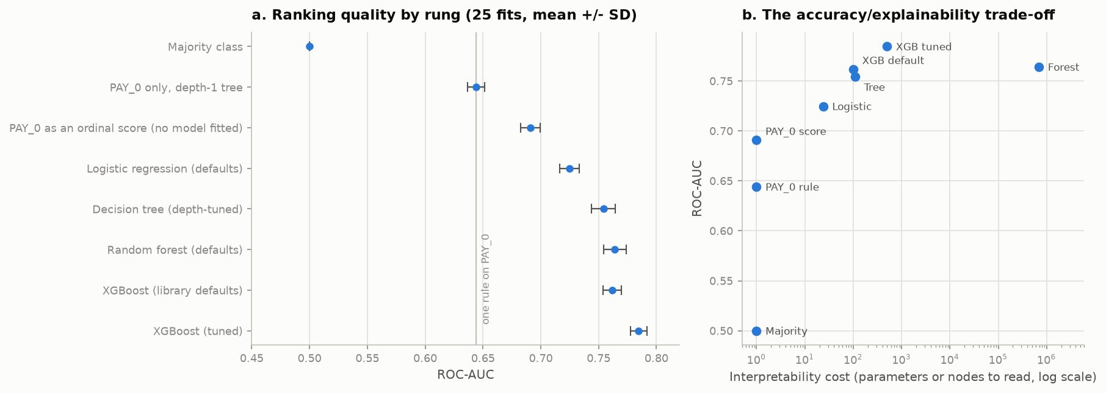
Figure 1. ROC-AUC per rung, and the same scores against interpretability cost (log axis).
Answer to Q1. One readable rule → tuned XGBoost buys +0.1404 ROC-AUC at a reading cost rising from 1 to 499, with PR-AUC rising 0.3774 → 0.5602, a 48% relative improvement. The gain is justified, but conditionally, and the condition is Q2: adverse-action notices need a reason per decision. The first step is the most valuable: PAY_0 alone delivers 0.6910 of 0.7845.
5.2 The formalised cost matrix, and the threshold it fixes
The proposal commits to pairing the confusion matrix with "a formalized Cost Matrix to translate statistical errors into direct financial impact", read "at a specific probability threshold". This subsection builds both; §5.3 then reads the counts.
Table 2. The cost matrix. A missed default costs loss-given-default × exposure; a false alarm costs the forgone net interest margin on a client who would have repaid. With LGD = 0.70 and NIM = 0.12 the ratio is 0.70/0.12 = 5.83, carried as r = 6.
 | Predicted repay | Predicted default
Actual repay | TN — cost 0 | FP — cost 1 (forgone margin)
Actual default | FN — cost 6 (unrecovered balance) | TP — cost 0

Total expected cost is therefore 6 × FN + 1 × FP, applied to the raw counts of Table 5. The asymmetry is the entire reason a 0.5 threshold is wrong here: it prices both errors equally when one costs six times the other.
Table 3. Cost sweep on out-of-fold predictions; p* is Elkan's optimum 1/(1+r). Reliability curves: A5.
r | Elkan p* | Empirical τ | τ − p* | Min cost | Cost at τ = 0.5 | Saving | Recall | Prec.
1 | 0.5000 | 0.5360 | +0.0360 | 4,286 | 4,306 | 20 | 0.335 | 0.699
2 | 0.3333 | 0.3180 | −0.0153 | 7,189 | 7,711 | 522 | 0.529 | 0.561
5 | 0.1667 | 0.1781 | +0.0114 | 12,978 | 17,926 | 4,948 | 0.719 | 0.408
6 | 0.1429 | 0.1341 | −0.0088 | 14,239 | 21,331 | 7,092 | 0.829 | 0.333
10 | 0.0909 | 0.0841 | −0.0068 | 16,575 | 34,951 | 18,376 | 0.947 | 0.267
20 | 0.0476 | 0.0541 | +0.0065 | 18,058 | 69,001 | 50,943 | 0.990 | 0.236

The threshold is where the money is. At r = 6 the sweep selects τ = 0.1341, and using it in place of the default 0.5 cuts out-of-fold cost from 21,331 to 14,239 — a 33.2% reduction from changing one number, against +0.0226 ROC-AUC for the entire hyperparameter search. The saving grows superlinearly in r, from 20 units at r = 1 to 50,943 at r = 20.
Two conditions make that threshold trustworthy. First, it is selected on out-of-fold training predictions only and then frozen — sweeping a threshold against test labels is the single most common fatal flaw in this task (§3.3). Second, Elkan's derivation assumes true posterior probabilities, so it is only applicable if the model is calibrated: it is, predicting a mean 0.2189 against a 0.2212 base rate with ECE 0.0212, which is not the default expectation for boosted trees (Niculescu-Mizil & Caruana, 2005). The empirical optimum tracks the analytic curve: mean absolute deviation between τ and 1/(1+r) is 0.0141 raw and 0.0079 after isotonic calibration, so calibrating tightens the agreement — the confirming direction rather than a merely consistent one (§4.4, C.3).
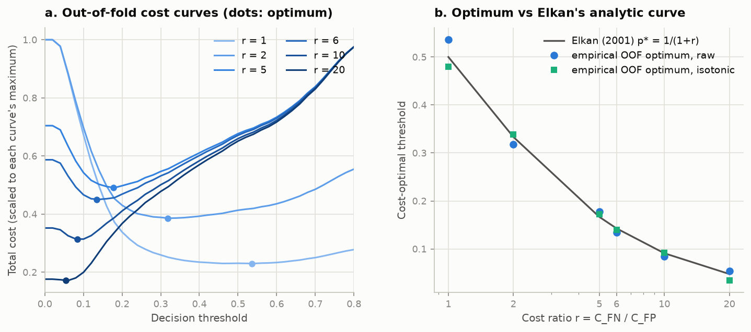
Figure 2. Out-of-fold total cost against decision threshold, one curve per cost ratio and each scaled to its own maximum, with the cost-minimising point marked; and those optima against Elkan's analytic 1/(1+r). Each curve is flat near its minimum, so the saving survives getting τ slightly wrong — but all of them climb steeply toward 0.5, which is why the default threshold is expensive.
5.3 Confusion matrix and Total Expected Cost on unseen data
The hold-out was read once, after every choice above was frozen (§3.2 import audit).
Table 4. Hold-out, 5,989 rows / 1,324 positives, τ frozen from OOF at r = 6.
Configuration | Feat. | τ | ROC-AUC | PR-AUC | Brier | Recall | Prec. | Cost (flat, r=6)
PAY_0 single rule | 1 | 0.0001 | 0.6430 | 0.3763 | 0.1461 | 1.0000 | 0.2211 | 4,665
XGBoost, library defaults | 23 | 0.0881 | 0.7607 | 0.5270 | 0.1408 | 0.8557 | 0.2963 | 3,837
XGBoost, tuned | 23 | 0.1341 | 0.7829 | 0.5638 | 0.1334 | 0.8444 | 0.3261 | 3,546
Tuned, class-reweighted | 23 | 0.3580 | 0.7829 | 0.5622 | 0.1797 | 0.8346 | 0.3347 | 3,510
Tuned, isotonic-calibrated | 23 | 0.1401 | 0.7810 | 0.5469 | 0.1344 | 0.7258 | 0.3846 | 3,716
Tuned, no PAY_0 | 22 | 0.1381 | 0.7519 | 0.5057 | 0.1425 | 0.8437 | 0.3033 | 3,808
Tuned, no demographics | 19 | 0.1341 | 0.7806 | 0.5614 | 0.1339 | 0.8414 | 0.3222 | 3,604

The headline reaches 0.7829 against 0.7845 in CV — inside one fold-SD — catching 1,118 of 1,324 defaults, and the same model read at τ = 0.5 costs 5,336, so the frozen threshold cuts cost 33.5%, closely matching the 33.2% predicted in CV.
Table 5. Confusion matrix on the hold-out at each configuration's frozen threshold: the exact count of false negatives against false positives, and the Table 2 weights applied to them.
Configuration | τ | TN | FP | FN | TP | 6 × FN + FP
PAY_0 single rule | 0.0001 | 0 | 4,665 | 0 | 1,324 | 4,665
XGBoost, library defaults | 0.0881 | 1,974 | 2,691 | 191 | 1,133 | 3,837
XGBoost, tuned | 0.1341 | 2,355 | 2,310 | 206 | 1,118 | 3,546
Tuned, class-reweighted | 0.3580 | 2,469 | 2,196 | 219 | 1,105 | 3,510
Tuned, isotonic-calibrated | 0.1401 | 3,127 | 1,538 | 363 | 961 | 3,716
Tuned, no PAY_0 | 0.1381 | 2,099 | 2,566 | 207 | 1,117 | 3,808
Tuned, no demographics | 0.1341 | 2,321 | 2,344 | 210 | 1,114 | 3,604

Reading the trade directly: the tuned model accepts 2,310 false alarms to avoid all but 206 of the 1,324 defaults, because at r = 6 one missed default costs as much as six unnecessary declines — and 206 × 6 = 1,236 against 2,310 is where the sweep settled. The isotonic arm is the instructive counter-example: it is the most accurate row here, cutting false positives by 772, yet it costs 170 more because it converts them into 157 extra missed defaults. Accuracy and cost move in opposite directions, which is the §5.1 argument in raw counts. The single rule is degenerate at its frozen τ — it declines every client, so it has no true negatives at all.
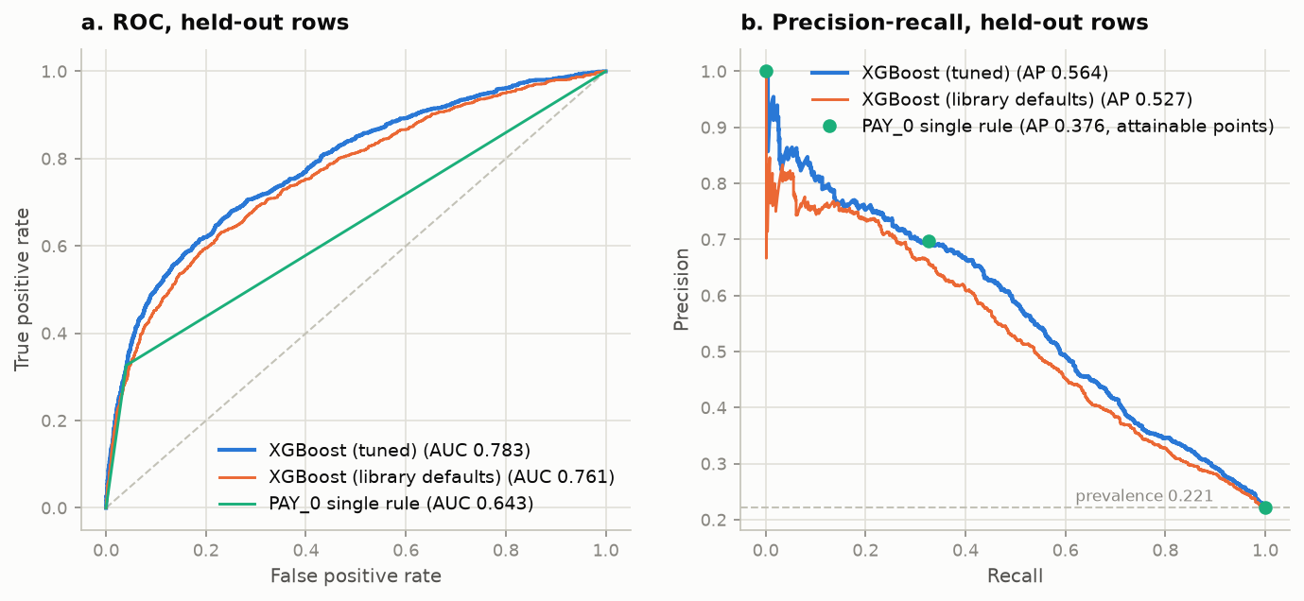
Figure 3. Hold-out ROC and precision–recall for the tuned model against two ladder baselines. The single rule is drawn as its attainable operating points rather than as a curve: with two distinct scores it has one usable point, and joining them would interpolate through (recall, precision) pairs the rule cannot reach, which is invalid in PR space (Davis & Goadrich, 2006). That point (recall 0.33, precision 0.70) sits on the tuned curve — the rule is competitive exactly there and nowhere else, which is the operating-point rigidity the cost analysis makes expensive.
DeLong's paired test gives +0.1399 [+0.1268, +0.1531], p = 1.5 × 10⁻⁹⁶ against the single rule and +0.0222 [+0.0145, +0.0300] against library defaults: six times more of the climb comes from being an ensemble than from being a well-tuned one (§4.1, C.5).
5.4 SHAP — answering Q2
SHAP reconstructs the margin to a maximum error of 3.7 × 10⁻⁶ — float32 noise, not method error — and tree_path_dependent barely reorders it (ρ = 0.973, §4.5).
Table 6. Top ten features by mean|SHAP|, with cross-measure ranks and five-seed stability.
# | Feature | mean|SHAP| | Share | Rank by gain | Rank by permutation | Rank SD, 5 seeds
1 | PAY_0 | 0.3780 | 22.3% | 1 | 1 | 0.00
2 | LIMIT_BAL | 0.2078 | 12.3% | 8 | 2 | 0.00
3 | BILL_AMT1 | 0.1254 | 7.4% | 10 | 3 | 0.45
4 | PAY_AMT2 | 0.1087 | 6.4% | 7 | 22 | 0.55
5 | PAY_AMT1 | 0.0966 | 5.7% | 9 | 16 | 1.41
6 | PAY_2 | 0.0907 | 5.3% | 2 | 11 | 1.10
7 | PAY_3 | 0.0837 | 4.9% | 3 | 9 | 1.00
8 | PAY_AMT3 | 0.0816 | 4.8% | 11 | 8 | 0.55
9 | PAY_4 | 0.0609 | 3.6% | 4 | 5 | 0.55
10 | PAY_AMT6 | 0.0524 | 3.1% | 15 | 23 | 2.77

The six repayment-status columns take 40.2% of total attribution against 16.5% for the six BILL_AMT, the C.9 ablation reached by attribution. Convergent validation: mean SHAP per PAY_0 code runs −0.214, −0.165, −0.288, +0.250, +1.517 and +1.365 for codes −2 to 3, so code 0 is the most negative of any code, inverting the intuitive ordering, and the rank correlation with observed default rate is ρ = 0.886.
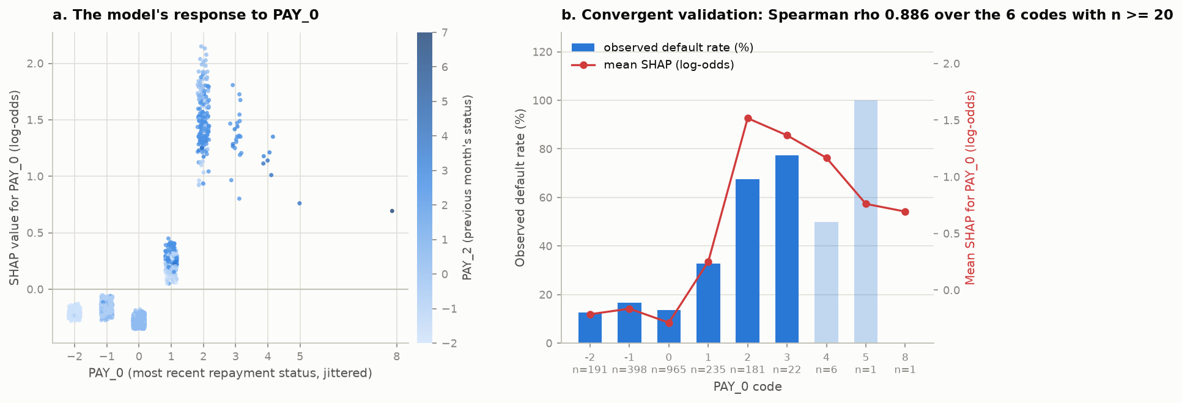
Figure 4. SHAP for PAY_0 by value, coloured by PAY_2; and mean SHAP per code against observed default rate.
Reproducibility. Over five reseeded refits, Spearman ρ between mean|SHAP| vectors averages 0.9375 and top-10 Jaccard 0.8727, with PAY_0 and LIMIT_BAL never moving and instability concentrated where C.9 predicted: mean rank SD 1.73 across BILL_AMT1–6 against 1.16 elsewhere.
Answer to Q2: yes, with a stated scope. The explanations are exact to float precision, stable to ρ ≈ 0.94 under reseeding and independently recover a known property of the data, enough to answer "why was this applicant declined" with contributions that sum to the score. Two §4.5 limits travel with it: SHAP explains the model, not the borrower, and the collinear BILL_AMT block is defensible only as a group.
6. Summary
Answering the research questions. Q1: the gain is real but stops early. One readable rule on PAY_0 → tuned gradient boosting buys +0.1399 ROC-AUC, yet 58% of that climb arrives by the linear rung and the last step from library defaults to tuned XGBoost is worth only +0.0222. It is justified conditionally: interpretability is worth losing when probabilities feed a decision needing calibrated scores the single rule cannot produce. Q2: SHAP bridges the gap partially — exactly additive (max error 3.7 × 10⁻⁶) and independently recovering the Phase 1 PAY_0 gradient — but attribution inside the collinear BILL_AMT block is unstable (rank SD 1.73), so those six are auditable only as a group.
What worked. The ladder was the right instrument, turning the accuracy–explainability trade-off from an assertion into a measured axis. Freezing τ = 0.1341 from out-of-fold probabilities and applying it untouched gave a 33.5% cost reduction on test, matching the 33.2% predicted in CV.
What didn't work. Every intervention aimed at the class imbalance failed, informatively (C.9): reweighting moved ROC-AUC +0.0003 against a fold-SD of 0.0071 while worsening ECE from 0.0212 to 0.2088, and SMOTE was worse still (0.7681, Brier 0.2200). Isotonic calibration also failed, making hold-out Brier worse on an already near-calibrated model.
What surprised me, in descending order of impact on my view.
Threshold selection is worth more than the entire hyperparameter search. One hundred and fifty Optuna trials bought +0.0222 ROC-AUC; choosing τ from the cost matrix cut cost by a third.
A model that cannot see sex still reproduces most of the sex disparity (C.9). Deleting the four demographic columns costs only 0.0013 ROC-AUC, yet 58.0% of the selection-rate gap survives; the model also amplifies, 3.44 pp observed becoming 8.72 pp selected.
PAY_0 = 0 is the strongest negative signal, not PAY_0 = −2. Mean SHAP by code runs −0.214, −0.165, −0.288, +0.250, +1.517 for codes −2, −1, 0, 1, 2 — the Phase 1 non-monotonicity recovered from the model's internals.
The Bayes-floor argument had to be withdrawn. I expected Phase 1's 21 contradictory duplicate groups to set an irreducible error floor; exp14 measures zero after de-duplication, so the ceiling claim now rests on the learning curve (Figure A2): plateauing near ROC-AUC 0.78 is a feature-set ceiling, not a model deficiency, since six months of billing cannot observe job loss.
One smaller surprise: XGBoost's weight importance ranks PAY_0 twelfth while SHAP ranks it first, so the default importance plot would have inverted this report's central finding.
Limitations. The cost matrix is built from published LGD and NIM ranges, not this lender's figures, so only the ratio r ≈ 6 drives the threshold. The dataset is a single six-month window from one Taiwanese issuer in 2005, so nothing transfers without revalidation. And it establishes disparity, not legal discrimination.
7. References
Barocas, S., & Selbst, A. D. (2016). Big data's disparate impact. California Law Review, 104(3), 671–732. https://doi.org/10.15779/Z38BG31
Chen, T., & Guestrin, C. (2016). XGBoost: A scalable tree boosting system. In Proceedings of the 22nd ACM SIGKDD International Conference on Knowledge Discovery and Data Mining (pp. 785–794). Association for Computing Machinery. https://doi.org/10.1145/2939672.2939785
Davis, J., & Goadrich, M. (2006). The relationship between precision-recall and ROC curves. In Proceedings of the 23rd International Conference on Machine Learning (pp. 233–240). Association for Computing Machinery. https://doi.org/10.1145/1143844.1143874
DeLong, E. R., DeLong, D. M., & Clarke-Pearson, D. L. (1988). Comparing the areas under two or more correlated receiver operating characteristic curves: A nonparametric approach. Biometrics, 44(3), 837–845. https://doi.org/10.2307/2531595
Elkan, C. (2001). The foundations of cost-sensitive learning. In Proceedings of the 17th International Joint Conference on Artificial Intelligence (pp. 973–978). Morgan Kaufmann.
Ke, G., Meng, Q., Finley, T., Wang, T., Chen, W., Ma, W., Ye, Q., & Liu, T.-Y. (2017). LightGBM: A highly efficient gradient boosting decision tree. In Advances in Neural Information Processing Systems 30 (pp. 3146–3154). Curran Associates.
Lessmann, S., Baesens, B., Seow, H.-V., & Thomas, L. C. (2015). Benchmarking state-of-the-art classification algorithms for credit scoring: An update of research. European Journal of Operational Research, 247(1), 124–136. https://doi.org/10.1016/j.ejor.2015.05.030
Lundberg, S. M., Erion, G., Chen, H., DeGrave, A., Prutkin, J. M., Nair, B., Katz, R., Himmelfarb, J., Bansal, N., & Lee, S.-I. (2020). From local explanations to global understanding with explainable AI for trees. Nature Machine Intelligence, 2(1), 56–67. https://doi.org/10.1038/s42256-019-0138-9
Lundberg, S. M., & Lee, S.-I. (2017). A unified approach to interpreting model predictions. In Advances in Neural Information Processing Systems 30 (pp. 4765–4774). Curran Associates.
Nadeau, C., & Bengio, Y. (2003). Inference for the generalization error. Machine Learning, 52(3), 239–281. https://doi.org/10.1023/A:1024068626366
Niculescu-Mizil, A., & Caruana, R. (2005). Predicting good probabilities with supervised learning. In Proceedings of the 22nd International Conference on Machine Learning (pp. 625–632). Association for Computing Machinery. https://doi.org/10.1145/1102351.1102430
Pedregosa, F., Varoquaux, G., Gramfort, A., Michel, V., Thirion, B., Grisel, O., Blondel, M., Prettenhofer, P., Weiss, R., Dubourg, V., Vanderplas, J., Passos, A., Cournapeau, D., Brucher, M., Perrot, M., & Duchesnay, É. (2011). Scikit-learn: Machine learning in Python. Journal of Machine Learning Research, 12, 2825–2830.
Prokhorenkova, L., Gusev, G., Vorobev, A., Dorogush, A. V., & Gulin, A. (2018). CatBoost: Unbiased boosting with categorical features. In Advances in Neural Information Processing Systems 31 (pp. 6638–6648). Curran Associates.
Saito, T., & Rehmsmeier, M. (2015). The precision-recall plot is more informative than the ROC plot when evaluating binary classifiers on imbalanced datasets. PLoS ONE, 10(3), e0118432. https://doi.org/10.1371/journal.pone.0118432
Yeh, I.-C., & Lien, C.-H. (2009). The comparisons of data mining techniques for the predictive accuracy of probability of default of credit card clients. Expert Systems with Applications, 36(2), 2473–2480. https://doi.org/10.1016/j.eswa.2007.12.020

Appendix
The page cap applies to Introduction through References only. Everything below is supporting material. Appendix B carries the full tables summarised in §5, Appendix C the extended discussion that the page cap excluded from the body, and Appendix D the source-code listing required by the brief. Every table is generated from results/*.json by src/report.py, so no number here is retyped either.
Appendix A — Supporting figures
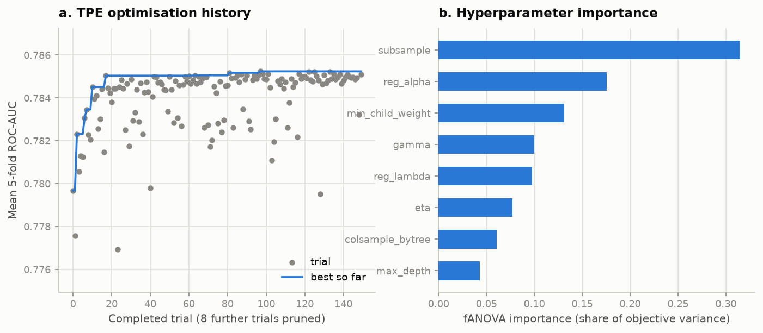
Figure A1. Optuna TPE study, 150 trials. Left: optimisation history with the running best, flat after roughly trial 20 (§4.1). Right: fANOVA parameter importances, which is what justifies calling subsample and the regularisers the high-leverage parameters rather than assuming it.
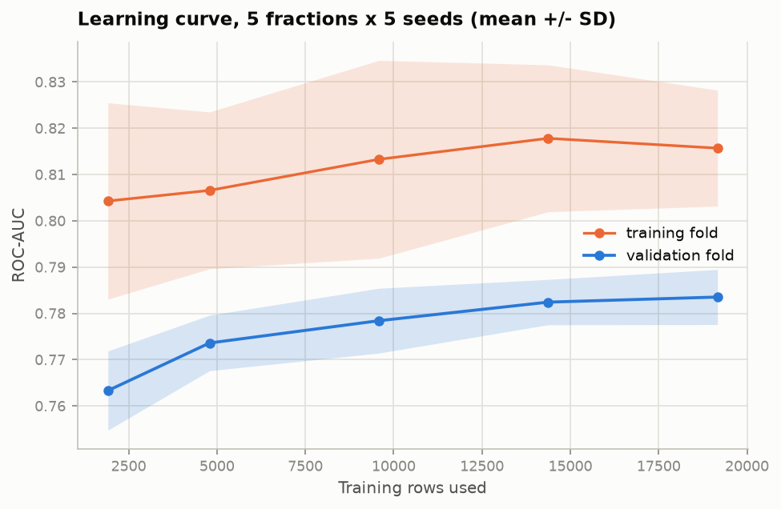
Figure A2. Training and validation ROC-AUC against training-set fraction, 5 seeds per fraction. The validation curve flattens well before the full training set, which is the evidence for the feature-set-ceiling claim of §6 — more rows of the same kind will not help.
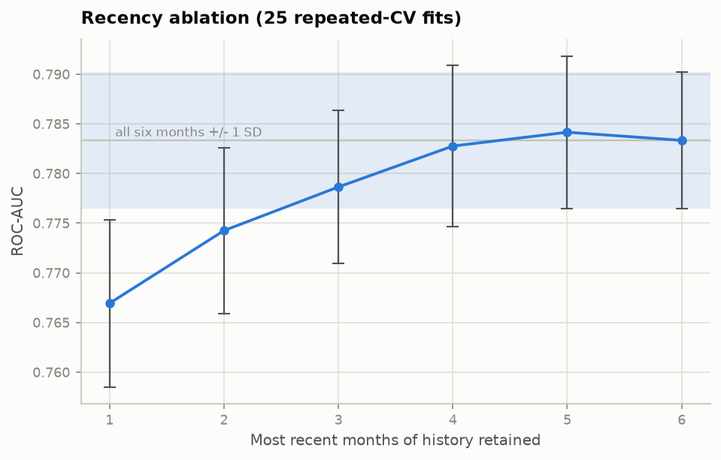
Figure A3. Recency ablation: ROC-AUC against months of repayment history retained, in PAY_CHRONO order. Marginal gain decays monotonically and turns negative at the sixth month.
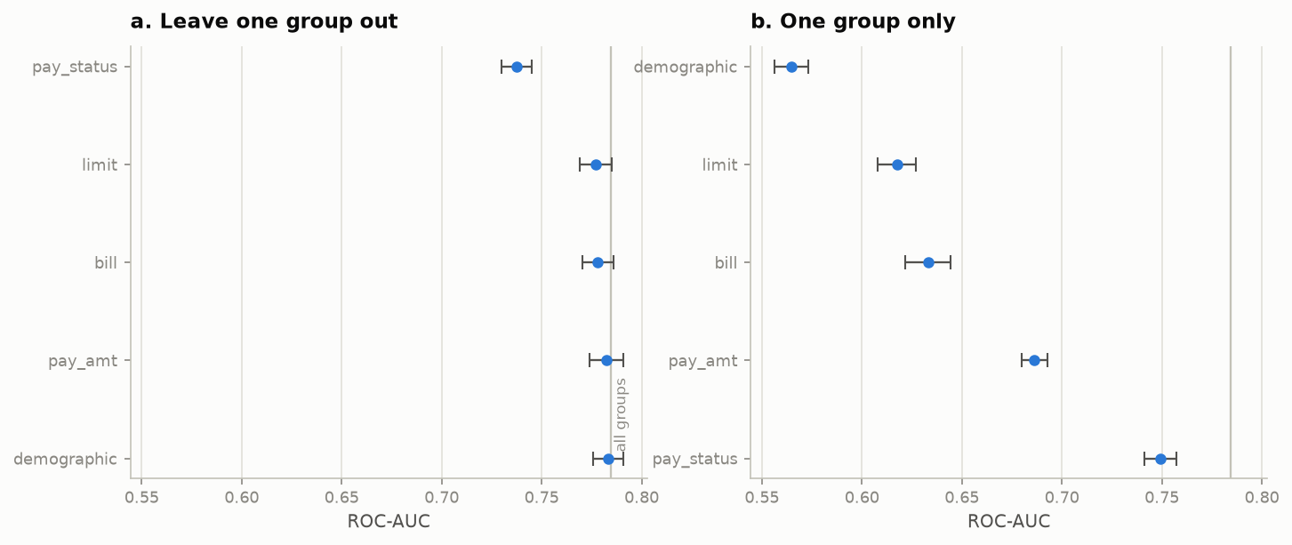
Figure A4. Feature-group ablation, all eleven arms. Leave-one-group-out above, only-one-group below. Dropping repayment status is the only change that exceeds a few fold-SDs.
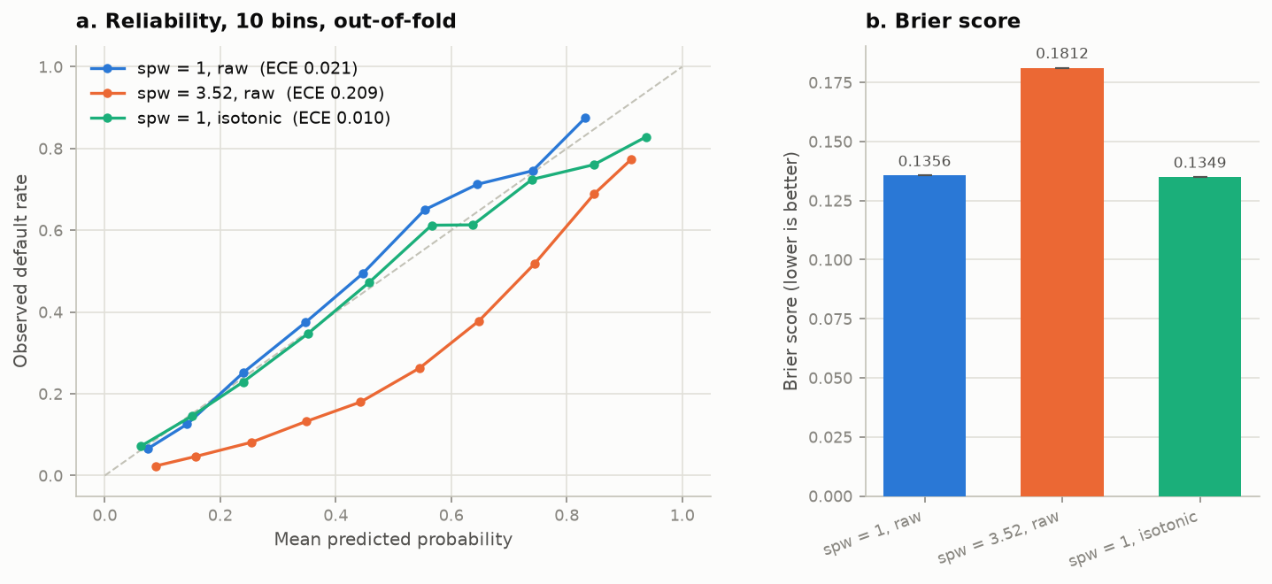
Figure A5. Observed default rate against mean predicted probability, 10 bins, out-of-fold, with Brier scores alongside. The untouched model (ECE 0.021) tracks the diagonal closely. The reweighted model (ECE 0.209) sits below it across the whole range — at a predicted 0.4 only about 0.18 of those clients default — so it systematically over-states risk, which is the calibration damage C.9 charges against reweighting and why its Brier score is 34% worse. Isotonic recalibration (ECE 0.010) restores the diagonal, confirming the distortion is in the scores rather than the ranking. §5.2's cost analysis runs on the untouched probabilities for this reason.
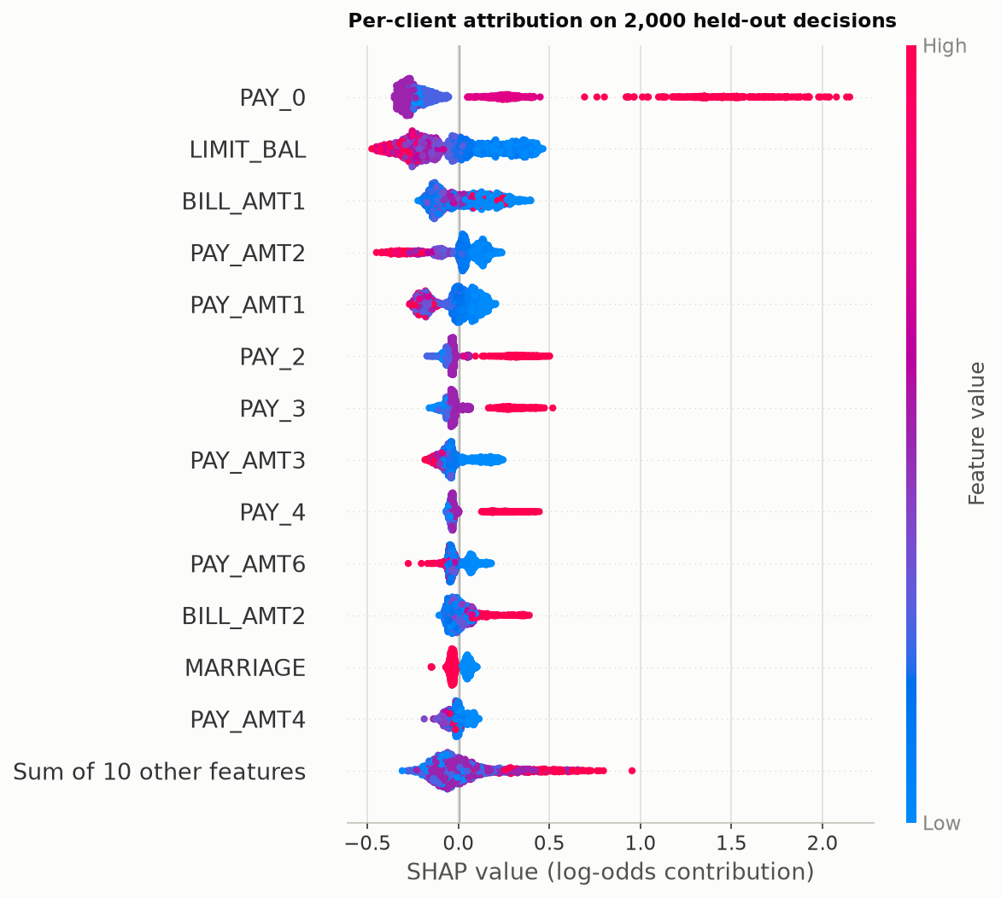
Figure A6. TreeSHAP beeswarm on held-out rows, log-odds space, interventional perturbation against a 1,000-row stratified background. One point per client per feature; colour is the feature value.
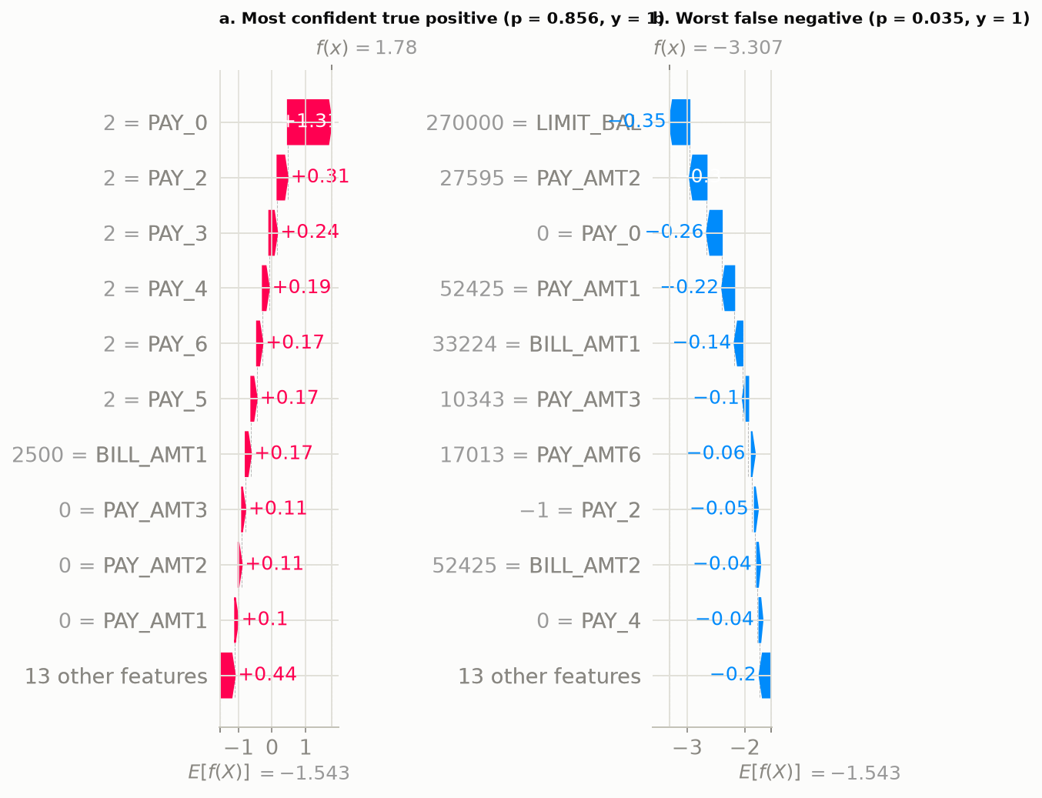
Figure A7. SHAP waterfall pair on held-out clients: a correctly identified default at p = 0.856 and a missed default at p = 0.035. The second is the more instructive — it shows the model was misled by an unremarkable repayment history, which is exactly the kind of failure an audit trail has to be able to display. Note that these are rendered in probability space for readability, where the decomposition is no longer exactly additive (§4.5).
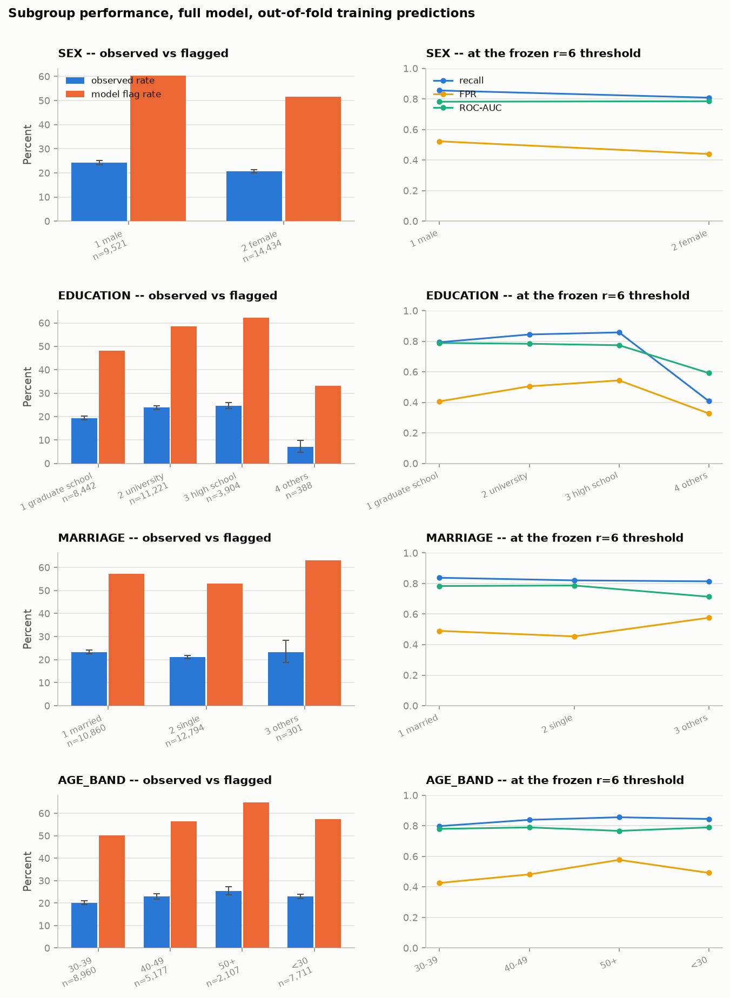
Figure A8. Per-subgroup detail for all four protected attributes. Left column: observed default rate with Wilson 95% intervals against the model's flag rate at the frozen threshold. Right column: recall, false-positive rate and ROC-AUC per subgroup.
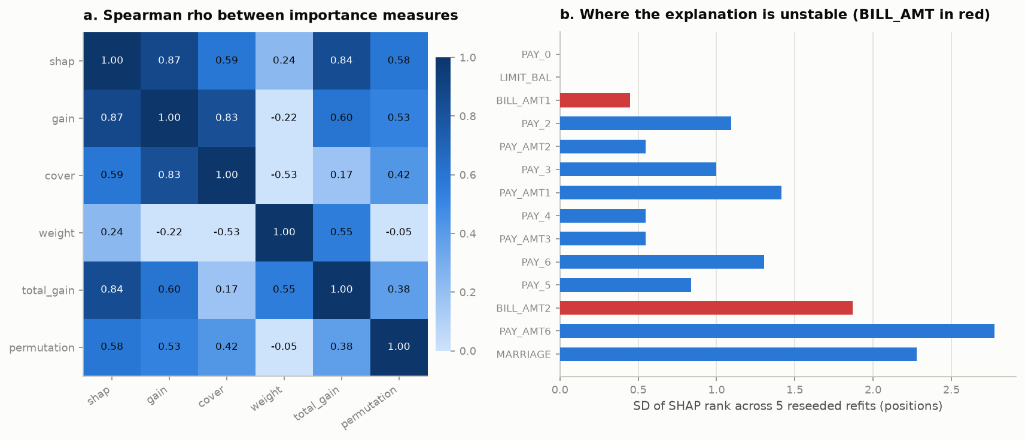
Figure A9. Left: Spearman rank agreement between five importance measures. Right: SHAP rank stability across five reseeded refits. The negative cover–weight correlation is the result that makes "just use the built-in importance plot" indefensible (§5.4).
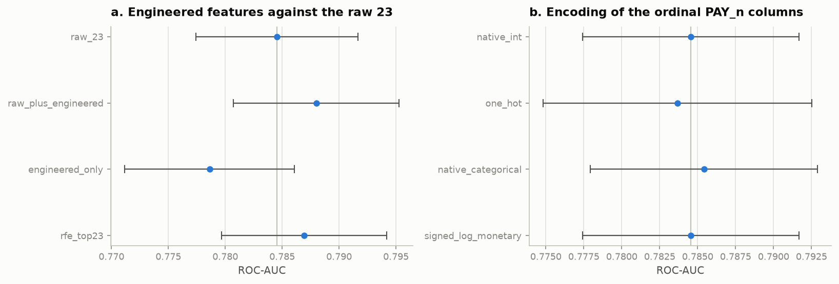
Figure A10. Engineered-feature benchmark and encoding ablation with fold-SD intervals. Every arm in the encoding panel falls inside one SD of the others, which is why native integers are carried forward on the argument of §4.2 rather than on a score difference.
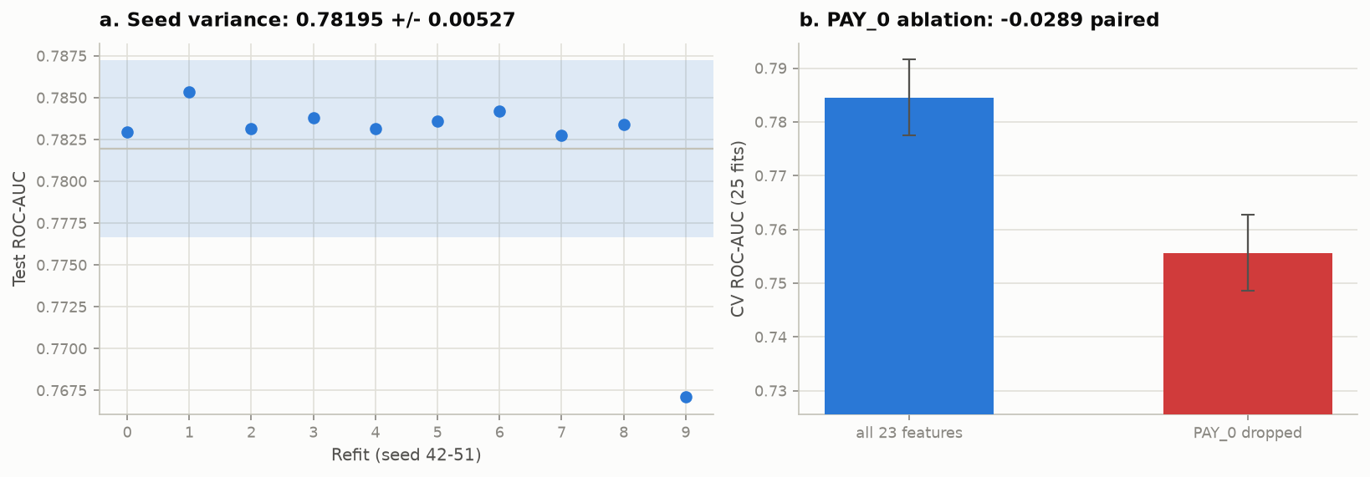
Figure A11. Final configuration refit under 10 seeds. Nine cluster tightly; one lands materially lower, which is why §5.3 reports a spread rather than a single number.

Appendix B — Full tables
Table B1. Selected hyperparameters against their searched ranges (§4.1).
Hyperparameter | Searched range | Type | Selected
max_depth | 3 to 8 | int | 6
eta | 0.01 to 0.3 (log) | float | 0.012533
min_child_weight | 1.0 to 20.0 (log) | float | 4.1899
subsample | 0.6 to 1.0 | float | 0.60358
colsample_bytree | 0.5 to 1.0 | float | 0.7998
gamma | 0.0 to 5.0 | float | 0.695
reg_lambda | 0.01 to 100.0 (log) | float | 34.295
reg_alpha | 0.001 to 10.0 (log) | float | 0.0015166

Table B2. Encoding ablation, all four arms (§4.2, C.9).
Arm | Features | ROC-AUC | PR-AUC | Brier
native_int | 23 | 0.7845 ± 0.0071 | 0.5602 ± 0.0146 | 0.13479 ± 0.00414
one_hot | 79 | 0.7837 ± 0.0089 | 0.5532 ± 0.0182 | 0.13635 ± 0.00758
native_categorical | 23 | 0.7854 ± 0.0075 | 0.5611 ± 0.0145 | 0.13380 ± 0.00228
signed_log_monetary | 23 | 0.7845 ± 0.0071 | 0.5602 ± 0.0146 | 0.13479 ± 0.00414

Table B3. Engineered-feature benchmark, all four arms (C.9).
Arm | Features | ROC-AUC | PR-AUC | Brier
raw_23 | 23 | 0.7845 ± 0.0071 | 0.5602 ± 0.0146 | 0.13479 ± 0.00414
raw_plus_engineered | 40 | 0.7880 ± 0.0073 | 0.5624 ± 0.0154 | 0.13618 ± 0.00776
engineered_only | 17 | 0.7786 ± 0.0075 | 0.5416 ± 0.0146 | 0.13742 ± 0.00648
rfe_top23 | 23 | 0.7869 ± 0.0073 | 0.5600 ± 0.0130 | 0.13756 ± 0.00972

Table B4. Feature-group ablation, all eleven arms (C.9).
Arm | Features | ROC-AUC | PR-AUC | Brier
all_groups | 23 | 0.7845 ± 0.0071 | 0.5602 ± 0.0146 | 0.13479 ± 0.00414
drop_demographic | 19 | 0.7832 ± 0.0075 | 0.5574 ± 0.0140 | 0.13655 ± 0.00815
drop_limit | 22 | 0.7769 ± 0.0079 | 0.5537 ± 0.0147 | 0.13842 ± 0.00952
drop_pay_status | 17 | 0.7374 ± 0.0075 | 0.4586 ± 0.0139 | 0.14970 ± 0.00402
drop_bill | 17 | 0.7781 ± 0.0076 | 0.5527 ± 0.0160 | 0.13727 ± 0.00809
drop_pay_amt | 17 | 0.7824 ± 0.0086 | 0.5551 ± 0.0185 | 0.13899 ± 0.01116
only_demographic | 4 | 0.5646 ± 0.0086 | 0.2581 ± 0.0081 | 0.17183 ± 0.00036
only_limit | 1 | 0.6175 ± 0.0095 | 0.2966 ± 0.0078 | 0.16943 ± 0.00187
only_pay_status | 6 | 0.7492 ± 0.0080 | 0.5236 ± 0.0154 | 0.14845 ± 0.00863
only_bill | 6 | 0.6331 ± 0.0112 | 0.3338 ± 0.0144 | 0.16568 ± 0.00199
only_pay_amt | 6 | 0.6863 ± 0.0065 | 0.3762 ± 0.0085 | 0.15972 ± 0.00193

Table B5. Recency ablation, k = 1..6 months (C.9).
Arm | Features | ROC-AUC | PR-AUC | Brier
k1_months | 8 | 0.7669 ± 0.0084 | 0.5331 ± 0.0164 | 0.14455 ± 0.01190
k2_months | 11 | 0.7743 ± 0.0083 | 0.5428 ± 0.0169 | 0.14012 ± 0.01095
k3_months | 14 | 0.7786 ± 0.0077 | 0.5474 ± 0.0150 | 0.14397 ± 0.01339
k4_months | 17 | 0.7828 ± 0.0081 | 0.5558 ± 0.0186 | 0.13776 ± 0.00862
k5_months | 20 | 0.7842 ± 0.0077 | 0.5589 ± 0.0139 | 0.13558 ± 0.00639
k6_months | 23 | 0.7833 ± 0.0069 | 0.5570 ± 0.0126 | 0.13841 ± 0.00905

Table B6. Learning curve, mean ± SD per training fraction, 5 seeds each (§6, Figure A2).
Arm | Features | ROC-AUC
frac_0.10 | 23 | 0.7633 ± 0.0085
frac_0.25 | 23 | 0.7736 ± 0.0060
frac_0.50 | 23 | 0.7784 ± 0.0070
frac_0.75 | 23 | 0.7824 ± 0.0049
frac_1.00 | 23 | 0.7835 ± 0.0059

Table B7. Calibration detail (§5.2). Observed prevalence is 0.2212. ECE is the n-weighted mean gap between predicted probability and observed frequency over ten equal-width bins. Each fold's training half is split again 80/20, so the calibrator is fitted on rows the booster did not train on and the fold's validation rows stay unseen.
Arm | Method | Brier | ECE | Mean predicted p
A (spw=1) | raw | 0.1356 | 0.0212 | 0.2189
A | Platt (sigmoid) | 0.1349 | 0.0191 | 0.2217
A | isotonic | 0.1349 | 0.0102 | 0.2218
C (spw=3.52) | raw | 0.1812 | 0.2088 | 0.4299
C | Platt (sigmoid) | 0.1346 | 0.0115 | 0.2218
C | isotonic | 0.1348 | 0.0080 | 0.2217

Table B8. Full per-subgroup fairness detail with Wilson 95% intervals, full model, out-of-fold predictions at the frozen τ = 0.1341 (C.9).
Attribute | Group | n | Observed rate (%) | Wilson 95% CI | ROC-AUC | PR-AUC | Recall | FPR | Flag rate
SEX | 1 male | 9,521 | 24.19 | [23.34, 25.06] | 0.7821 | 0.5719 | 0.8554 | 0.5226 | 0.6031
SEX | 2 female | 14,434 | 20.75 | [20.10, 21.42] | 0.7851 | 0.5523 | 0.8083 | 0.4393 | 0.5159
EDUCATION | 1 graduate school | 8,442 | 19.38 | [18.55, 20.24] | 0.7888 | 0.5393 | 0.7934 | 0.4063 | 0.4813
EDUCATION | 2 university | 11,221 | 23.80 | [23.02, 24.60] | 0.7834 | 0.5794 | 0.8443 | 0.5048 | 0.5856
EDUCATION | 3 high school | 3,904 | 24.69 | [23.37, 26.07] | 0.7738 | 0.5630 | 0.8579 | 0.5435 | 0.6212
EDUCATION | 4 others | 388 | 6.96 | [4.83, 9.94] | 0.5914 | 0.1567 | 0.4074 | 0.3269 | 0.3325
MARRIAGE | 1 married | 10,860 | 23.33 | [22.55, 24.14] | 0.7838 | 0.5770 | 0.8378 | 0.4900 | 0.5712
MARRIAGE | 2 single | 12,794 | 21.06 | [20.36, 21.77] | 0.7871 | 0.5479 | 0.8207 | 0.4539 | 0.5311
MARRIAGE | 3 others | 301 | 23.26 | [18.84, 28.35] | 0.7134 | 0.4800 | 0.8143 | 0.5758 | 0.6312
AGE_BAND | <30 | 7,711 | 22.98 | [22.05, 23.93] | 0.7898 | 0.5775 | 0.8448 | 0.4917 | 0.5728
AGE_BAND | 30–39 | 8,960 | 20.12 | [19.31, 20.97] | 0.7801 | 0.5254 | 0.7981 | 0.4259 | 0.5008
AGE_BAND | 40–49 | 5,177 | 22.95 | [21.82, 24.11] | 0.7896 | 0.5783 | 0.8392 | 0.4818 | 0.5638
AGE_BAND | 50+ | 2,107 | 25.39 | [23.58, 27.29] | 0.7668 | 0.5870 | 0.8561 | 0.5770 | 0.6478

Table B9. What each rung of the ladder buys (§5.1).
Increment | Δ ROC-AUC | Reading
Majority → one rule on PAY_0 | +0.1441 | One column carries most of the available signal
One rule → rank on the raw code | +0.0469 | The price of a readable rule
PAY_0 score → linear, 23 features | +0.0338 | What 22 more features buy a linear model
Linear → single tree | +0.0294 | What non-linearity and interactions buy
Single tree → random forest | +0.0099 | What bagging buys — barely one fold-SD
Forest → tuned XGBoost | +0.0204 | What boosting plus tuning buys beyond bagging
One readable rule → tuned XGBoost | +0.1404 | The total on offer for abandoning direct interpretability

Table B10. Experiment runtimes and reproduction manifest. Wall clock on the reference machine (Windows 11, 8 physical cores, tree_method="hist", 23,955 training rows). These are the runtime_sec fields of results/*.json, so they are measurements rather than estimates.
Experiment | Title | Rows | Runtime (s) | Run (UTC)
exp01_ladder | Complexity ladder: capability against interpretability | 8 | 104.9 | 2026-09-30T09:15:03Z
exp02_tuning | Hyperparameter search (Optuna TPE) | 2 | 1166.3 | 2026-09-30T08:58:21Z
exp03_imbalance | Class-imbalance strategy comparison | 5 | 302.0 | 2026-09-30T09:47:34Z
exp04_encoding | Encoding ablation for repayment-status columns | 4 | 186.1 | 2026-09-30T09:03:53Z
exp05_engineered | Engineered-feature benchmark | 4 | 165.7 | 2026-09-30T09:06:41Z
exp06_groups | Feature-group ablation | 11 | 297.7 | 2026-09-30T09:11:42Z
exp07_recency | Recency ablation: months of history required | 6 | 235.8 | 2026-09-30T09:15:40Z
exp08_learning_curve | Learning curve against training-set size | 5 | 120.7 | 2026-09-30T09:17:44Z
exp09_calibration | Calibration: Brier, ECE and reliability curves | 6 | 16.0 | 2026-09-30T09:47:53Z
exp10_cost | Cost-sensitive threshold selection with Elkan overlay | 18 | 0.9 | 2026-09-30T09:47:56Z
exp11_shap | TreeSHAP attribution on held-out decisions | 23 | 26.8 | 2026-09-30T09:35:29Z
exp12_stability | Explanation stability and importance-measure agreement | 23 | 76.1 | 2026-09-30T09:36:47Z
exp13_fairness | Fairness and subgroup analysis | 8 | 7.3 | 2026-09-30T09:48:06Z
exp14_final | Robustness checks and final held-out evaluation | 7 | 148.9 | 2026-09-30T09:52:59Z
 | Total, run serially | 130 | ≈2,856 (48 min)

Appendix C — Extended discussion
Material cut from the body for the page cap. Nothing here is a new result; each note expands an argument §5 states in one sentence.
C.1 Why the 6-month recency arm does not match the baseline
The 6-month arm of Table B5 uses the same 23 features as the baseline yet scores 0.7833 against the baseline's 0.7845. The two are not a contradiction. That arm feeds the columns in chronological order, and because colsample_bytree = 0.80 samples columns by index, a reordering changes which subsets each tree sees and therefore fits a different model. The 0.0012 difference is well inside fold noise, but it is a useful reminder that column order is not inert once column subsampling is switched on — and a trap for anyone who assumes a permutation of identical features must reproduce an identical score.
C.2 The EDUCATION "others" group, and why it is reported rather than suppressed
The headline EDUCATION ROC-AUC gap of 0.197 is almost entirely attributable to category 4, "others": n = 388, a 6.96% observed default rate against 19–25% in the three substantive levels, and per-group ROC-AUC of 0.591. Its Wilson interval is [4.83, 9.94], so the low rate is real rather than a small-sample artefact, but the group is small enough that per-group ranking is poorly estimated. Excluding it, the AUC gap across graduate school, university and high school is 0.015. Both numbers are reported because each alone misleads: the headline gap without the decomposition overstates the problem, and suppressing the group understates it. The four-fifths ratio behaves the same way — 0.535 including "others", 0.775 excluding it, which still fails.
C.3 Why the instance-weighted cost scheme reports one number rather than six
cost_at_threshold under the instance-weighted scheme charges a false negative LGD × LIMIT_BAL and a false positive NIM × LIMIT_BAL for each client directly. The ratio r = LGD/NIM is therefore already embedded in those two constants, and sweeping r does not change the objective — the optimiser reproduces τ = 0.1621 at every rung of the sweep. Reporting one value rather than six identical rows is the honest presentation, but the mechanism is worth stating because a reader who expects the instance-weighted column to track the flat column across r would otherwise read the constant as a bug.
C.4 The accuracy trap, stated at length
Rung 0 of Table 1 predicts "no default" for every client and scores 77.88% accuracy with zero recall, which is exactly 1 − 0.2211, the majority-class rate. The more damning observation is the Acc @0.5 column read downward: from rung 1 to rung 6 accuracy moves only between 0.8094 and 0.8197 — a span of one percentage point — while ROC-AUC moves from 0.6441 to 0.7845 and PR-AUC from 0.3774 to 0.5602. A report leading with accuracy on this dataset would be reporting noise, and would rank a one-line rule as 98.7% of the way to a tuned ensemble. This is the concrete reason §3.4 selects ROC-AUC as the tuning objective and §4.4 optimises expected cost for the operating point.
C.5 Nadeau–Bengio and the PAY_0-dropped comparison
Dropping PAY_0 costs −0.0289 ROC-AUC measured as a paired difference over the 25 repeated-CV folds, with t = −30.8. That t-statistic is reported here rather than in the body because it is not trustworthy at face value: repeated-CV folds overlap, so the paired t-test is anti-conservative (Nadeau & Bengio, 2003) and the nominal p-value is far smaller than the evidence warrants. The effect size (−0.0289, against a fold-SD of ~0.007) is the reportable quantity, and the hold-out DeLong test (−0.0311, p = 6.6 × 10⁻¹⁵) is the comparison that does license an inferential claim, because it is computed once on independent rows.
C.6 What the verification gate checks
experiments/verify.py runs ten checks and all ten pass. Phase 1 assertions hold (29,944 rows, 6,622 defaults, 22.1146% prevalence, EDUCATION ⊆ {1,2,3,4}, MARRIAGE ⊆ {1,2,3}). There are zero duplicate feature-rows after cleaning. Splits are 23,955/5,989 with index overlap 0 and a prevalence gap of 0.00009 across every fold. Splits reproduce exactly at SEED = 42. All fourteen result files validate against the documented result schema with non-empty notes. All thirty recorded thresholds are scalars in (0,1). Every test block outside exp14_final is null. SHAP values sum to the model margin with a maximum error of 3.69 × 10⁻⁶. And the leakage audit confirms the hold-out is referenced only in exp11_shap.py, exp12_stability.py, exp14_final.py and figures.py.
C.7 Deviations from the project plan, recorded
Two, both recorded rather than quietly absorbed. The plan's work package for feature engineering specified that engineer() would add 21 columns, but the feature table in the same package enumerates 17 (six UTIL_n, six PAY_RATIO_n, N_DELINQ, MAX_DELINQ, DELINQ_TREND, BILL_TREND, MONTHS_DORMANT). Seventeen is what is implemented and asserted in src/data.py; the 21 was an arithmetic slip in the plan, not a dropped feature. And the Optuna trial budget was raised from the planned 60–80 to 150 on measured evidence (§4.1).
C.8 Extended Solution discussion (§2–§4)
The body of §2–§4 states each design argument in condensed form to respect the page cap. The paragraphs below are the full pre-trim wording of those same arguments, retained verbatim so that no claim, number or citation is lost. They add no new results; they expand the reasoning. Tables, code blocks and display equations are not duplicated here — those stayed in the body.
§2
XGBoost (Chen & Guestrin, 2016) is a gradient-boosted decision tree library, chosen because Phase 1 established two properties of this dataset that point directly at it. The response to repayment status PAY_n is non-monotonic — default falls from 16.8% for clients who paid in full to 12.8% for clients revolving a balance, then climbs to 69.2% at two months late — and the monetary columns are severely collinear (BILL_AMT1–6 carry VIF 13.9–25.7). A non-linear, axis-aligned learner handles the first natively and is indifferent to the second.
§2.1
A clarification on scope: the algorithm was fixed by the Phase 1 group allocation — this submission implements XGBoost while teammates implement a Decision Tree and a Logistic Regression. What was genuinely open, and what §2.1 investigates, is which library to implement it with, since four mature Python packages offer gradient-boosted trees and the choice has real consequences for what the rest of the report can do.
Why not lightgbm. Its two signature mechanisms are Gradient-based One-Side Sampling, which retains large-gradient rows and subsamples small-gradient ones, and Exclusive Feature Bundling, which packs mutually exclusive sparse features into single columns. Both target a regime this dataset is not in: GOSS pays off when n is large enough that a full gradient pass dominates runtime, and EFB when the design matrix is wide and sparse. Here n = 29,944 with 23 dense columns, so neither engages, while leaf-wise growth with an unbounded num_leaves is the documented overfitting risk on smaller data and would have added a failure mode for no measurable gain.
Why not catboost. Ordered boosting and ordered target statistics exist to defuse the target leakage that arises when categorical columns are target-encoded, and to reduce prediction shift. Our categoricals top out at four levels and are one-hot encodable — §4.2 tests exactly this and finds the choice immaterial — so the machinery has nothing to act on. Its default oblivious (symmetric) trees are additionally a structural constraint, which would have confounded Q1: the capability ladder of §5.1 is meant to measure what unconstrained boosting buys over a single tree, not what a particular symmetry restriction costs.
Why not sklearn.ensemble.HistGradientBoostingClassifier. It is the one option carrying no extra dependency, which is a genuine advantage. But it exposes l2_regularization alone among the penalty terms — there is no γ equivalent and no L1 — so SEARCH_SPACE would have collapsed from eight dimensions to roughly five. The central §4.1 finding, that this dataset is noise-limited and that the regularisation parameters rather than the capacity parameters carry the objective variance, is not a finding that could have been reached with it.
What xgboost buys. Beyond the regularisation surface, the decisive factor is Q2. Interventional TreeSHAP against a background sample is the project's hardest technical requirement, and shap's support for the xgboost backend is the longest-standing and most exercised of the four — §2.5 records that even on this path a version interaction made it fail outright, which is an argument for choosing the best-supported backend rather than against it.
§2.2
The nine entry points in the body table are the complete set the project touches; nothing else in the xgboost namespace is called. Two absences are deliberate rather than incidental. xgboost.train() with an explicitly constructed DMatrix is the native interface and is what most tutorials show, but it is not scikit-learn compatible, and compatibility is load-bearing here: runner.cv_evaluate() passes estimators to scikit-learn's splitters and §4.3 wraps one inside an imblearn.Pipeline so that SMOTE resamples per fold. Writing to the native interface would have meant reimplementing both. Nothing is lost by avoiding it, because hist materialises a QuantileDMatrix internally regardless — the bin sketch is built directly from the input frame, skipping the dense intermediate copy a hand-built DMatrix allocates.
§2.3
The library's penalty is a superset of the one derived in the theoretical overview: alongside γT and the L2 term it exposes an L1 shrinkage on leaf weights, so in implementation Ω(f) = γT + ½λ‖w‖² + α‖w‖₁. The extra term is reachable as reg_alpha and was included in the search space for completeness; the tuner drove it to 0.0015, effectively off, which is the expected outcome on 23 dense columns where there is no sparse coefficient vector to prune.
Two of the eight searched arguments behave in ways the derivation alone does not predict, and both matter at 22.11% prevalence. min_child_weight floors Σhᵢ in a child, not the row count. For log-loss hᵢ = pᵢ(1−pᵢ), so the Hessian measures prediction uncertainty: rows the model is already confident about contribute almost nothing to H. A leaf holding fifty confidently-classified rows is therefore cheap, while a leaf holding fifty uncertain ones is expensive — which is precisely the guard needed against leaves that look pure only because they are small and minority-heavy. Reading the argument as a minimum sample size, as its name invites, gets the mechanism backwards. And reg_lambda sits in the denominator of the Gain expression, so it discounts a split in proportion to how little Hessian mass supports it. That is a softer and better-targeted control than max_depth, which truncates structure uniformly regardless of how well-evidenced it is; it is also why §4.1 finds the tuner leaning hard on λ = 34.3 while ranking max_depth last by fANOVA importance.
One API trap worth recording: eta/learning_rate, reg_lambda/lambda and reg_alpha/alpha are alias pairs, and passing both members of a pair silently keeps one without warning. The project writes the native booster names only. SEARCH_SPACE in config.py is the single declarative source of the ranges — tuning.py suggests from it and the report table is printed from it — so the documented search cannot drift from the search that actually ran.
§2.4
Exact greedy split finding sorts every feature at every node, costing O(n log n) per feature. tree_method="hist" buckets each feature into at most 256 bins once, then accumulates (G, H) per bin, dropping this to O(n) per feature per node after a one-off binning pass. The approximation is free here rather than merely cheap, for a reason specific to the data: the six PAY_n columns take eleven distinct integer values (−2 to 8) and EDUCATION, MARRIAGE and SEX take two to four, so all are exactly representable in 256 bins and no candidate split is lost. Only the monetary columns bin lossily, and their splits are coarse anyway. This is what made a 150-trial search affordable at ~2.3 s per trial.
On the second decision: at each split XGBoost learns a default direction for missing values, enumerating candidate splits twice, sending NaN left then right, and keeping the higher gain. Missing rows are therefore neither imputed nor dropped — their routing is fitted. This is why src/data.py::engineer() is written as it is. Phase 1 documented 1,930 rows with negative BILL_AMT, for which PAY_AMT / BILL_AMT is semantically undefined: a negative bill is a credit balance, so "what fraction did they repay" has no answer, and imputing zero would assert no repayment — a different and false claim.
Substituting np.nan before dividing rather than guarding after it is load-bearing: it yields NaN rather than ±∞, and an infinity would propagate into the histogram binning described above. engineer() asserts the added block is finite-or-NaN for exactly this reason. NaN also carries strictly more information than an arbitrary fill, because a fill asserts a fact about the client that the data does not support.
§2.5
Two version-specific details are worth recording because both fail silently. early_stopping_rounds and eval_metric moved to the constructor in XGBoost 2.0, so following older tutorials leaves the booster quietly optimising the default metric. And enable_categorical now defaults to True — shap 0.52 inspects that flag alone, not whether any column is actually category dtype, and refuses interventional TreeSHAP with NotImplementedError: Categorical split is not yet supported. Every numeric model here pins it False; only the enable_categorical=True encoding arm (§4.2) sets it, and that arm is deliberately not the one explained with SHAP. n_estimators is never tuned: it is capped at 2,000 and decided by early stopping against an inner slice (§3.2), because the optimal number of rounds is a function of eta and so not independently searchable.
§3
Everything in §3 is binding on all fourteen experiments.
§3.1
Phase 1 found 108 rows in 52 duplicate groups, 21 carrying contradictory labels (identical values across all 23 features, different outcomes). De-duplication therefore happens before the split; had it happened after, identical feature rows would straddle the boundary and the model would be scored partly on rows it had memorised. The hold-out is then 80/20 stratified on DEFAULT at random_state=42 → 23,955 train / 5,989 test; with 1,324 test positives the standard error on AUC is ≈0.007, tight enough to resolve the differences this report claims.
Tuning uses StratifiedKFold(5, shuffle=True, random_state=42) on the training portion only. Variance is reported from RepeatedStratifiedKFold(5 × 5, random_state=7), refitting only the selected configuration → 25 fits, mean ± SD. The two random states differ deliberately: reusing 42 for the variance folds would correlate them with the folds the tuner selected against, so the reported SD would understate true variability. Repeated CV is used for reporting and never inside the tuner, where it would cost 5× the runtime for a noisier selection signal.
§3.2
Early stopping needs a validation signal and the obvious sources are both wrong: the test set is leakage, and the CV validation fold is subtler leakage, since the fold used to score a configuration must not also decide when to stop fitting it. The implementation carves a stratified 15% slice out of each training fold:
This function is the project's leakage boundary and it exists in exactly one place. All fourteen experiments call runner.cv_evaluate(), which calls fit_one(); no experiment writes its own CV loop, and divergent evaluation loops are the single largest source of numbers that fail to reconcile across a multi-experiment study. Test-set access is enforced structurally as well: src/data.py exposes training_context(), returning only X, y and the fold objects, and a separate test_context(). An experiment that never calls the latter cannot touch the hold-out. Only exp14_final and the two SHAP experiments — which explain held-out decisions without selecting anything — import it, so the audit is a single grep (§5.3).
§3.3
The most common fatal flaw in this kind of assignment is sweeping the decision threshold against test labels and reporting the best result. The procedure here generates out-of-fold probabilities on the training portion via cross_val_predict, minimises expected cost over a 501-point grid on those probabilities, freezes the winner as a scalar with an assertion that it lies in (0,1), and applies it unmodified to the test set. The threshold is a hyperparameter like any other, so it is chosen on training data and the test set sees one number it did not help select. Every decision uses predict_proba(X)[:, 1] >= tau, never model.predict(), which would silently reimpose 0.5.
§3.4
ROC-AUC is the declared primary metric for three reasons: it is the standard in the credit-scoring benchmark literature (Lessmann et al., 2015), making these numbers comparable outside this report; it is prevalence-independent, so it is comparable across the ladder of §5.1 and the fairness subgroups of C.9, where prevalence differs by construction; and it has lower fold-to-fold variance than PR-AUC, so a fixed trial budget resolves smaller differences. aucpr is logged every trial and reported but not optimised, and because PR-space interpolation is invalid for a classifier with few distinct scores (Davis & Goadrich, 2006; Saito & Rehmsmeier, 2015), PR curves are drawn as attainable points wherever that applies.
That choice has a consequence for scale_pos_weight. ROC-AUC is invariant to any monotone transformation of the scores, and scale_pos_weight rescales positive-class gradients — shifting the score scale while leaving the ranking almost unchanged. A tuner optimising ROC-AUC is therefore nearly blind to it, would pick a value essentially at random, and that arbitrary value would be confounded with every other hyperparameter in the same search. So scale_pos_weight is excluded from the search space, fixed per arm, and each arm tuned independently — which converts the imbalance study from a confound into a controlled comparison. The corollary matters for reading §5.3: taking "ROC-AUC barely moved when I set scale_pos_weight" as "reweighting worked" is backwards. It means the metric is insensitive to it.
§3.6
Every metric is mean ± SD over the 25 repeated-CV fits — SD, not standard error, so the number describes fold-to-fold variability rather than being artificially shrunk by √n. No difference smaller than one fold-SD is bolded or called an improvement; several results in §5 are reported as indistinguishable for exactly this reason. DeLong's test (DeLong et al., 1988) is applied to one class of comparison only — paired, correlated ROC curves on the single hold-out — and never across CV folds, where the samples are not independent. Arm-versus-arm comparisons use paired per-fold differences with the Nadeau and Bengio (2003) caveat noted: repeated-CV t-tests are anti-conservative because folds overlap, so the effect size rather than the p-value is the reportable quantity.
§4
§3 fixed the protocol; §4 justifies the modelling decisions, each of which is the reason behind a number in §5. Appendix C expands the arguments compressed here.
§4.1
Optuna's TPE sampler (multivariate=True) with a MedianPruner was used rather than grid or random search: across eight dimensions even three values per parameter is 3⁸ = 6,561 configurations, and random search needs roughly 3× the trials of TPE for equal quality because it does not exploit structure it has already seen. The study persists to artifacts/optuna_study.db, so it resumes after interruption and the history and fANOVA importances are available (Figure A1). Deviation from plan: 60–80 trials were budgeted at an estimated 15–30 s each; measured cost was ~2.3 s, because hist binning plus early stopping makes each 5-fold evaluation cheap, so the budget was raised to 150 trials (142 completed, 8 pruned, 1,166 s).
eta sits at the bottom of its range, subsample at the bottom of its, and reg_lambda high in a log range reaching 100. Read through the Gain formula, the tuner converged on a slow-learning, heavily regularised configuration — many small trees on ~60% of rows and 80% of columns, with the λ denominator discounting splits resting on little Hessian mass. That is the signature of modest signal relative to noise; separable structure tunes toward larger eta and weaker regularisation. fANOVA importance (Figure A1b) agrees independently, ranking subsample first at 0.31 of objective variance and max_depth last at 0.04: the parameters that matter are the variance-reduction ones, so the model is noise-limited, not capacity-limited. The plan predicted min_child_weight would dominate on the Hessian-floor argument; it placed third (C.1).
How much did tuning matter? The history is flat after roughly trial 20 and the entire search spans 0.776–0.785 ROC-AUC — smaller than the 0.0107 pooled fold-SD. Once inside a sensible space, which point the configuration lands on is indistinguishable from fold noise. That does not contradict the +0.0226 tuning gain of §5.1: library defaults sit outside this space (100 fixed rounds at eta = 0.3, no early stopping), so most of the gain is bought by early stopping and a low eta, not by locating a precise optimum in eight dimensions.
§4.2
Phase 1 established that PAY_n is non-monotonic and categorical-ish, conventionally an argument for one-hot encoding. That argument was tested against native integers, enable_categorical=True, and a signed-log transform of the monetary columns (Table B2). Native integers are carried forward on three grounds rather than on a score difference, since §5.2 shows the arms are indistinguishable. Trees split axis-alignedly, so a non-monotonic response is recoverable by stacked splits — PAY_0 < 0.5, then PAY_0 < -1.5 — meaning one-hot buys only expressible functions integers already reach, at a cost in depth. Integers keep the six PAY_n distinct where one-hot's 66 dummies fragment them, protecting the recency gradient (ρ 0.143 → 0.292). And 23 features rather than 79 keeps SHAP attributions readable, which matters for Q2.
The signed-log arm settles a Phase 1 recommendation empirically: monotone rescaling cannot change which rows fall either side of an axis-aligned split, so the advice to apply a robust scaler (skewness up to 30.4) was correct for distance- and gradient-based learners and inapplicable here. By the same logic BILL_AMT1–6 are kept despite VIF 13.9–25.7 — collinearity inflates coefficient variance, and trees have no coefficients. What it damages is attribution, a §4.5 caveat rather than a reason to discard signal.
§4.3
At 22.11% prevalence the data is mildly imbalanced — enough to break accuracy, not enough to break learning. Four arms were run under the controlled protocol of §3.4: baseline at τ = 0.5; the same fitted model with τ moved; scale_pos_weight = 3.52 (neg/pos) at τ = 0.5 and with τ re-tuned; and SMOTE inside an imblearn.Pipeline, so oversampling happens per-fold on the training half only.
The claim C.9 tests is that reweighting is threshold-moving performed indirectly, with the probabilities damaged on the way through. Multiplying the positive-class gradient inflates every predicted probability without changing the rate at which defaults occur, so the boundary shifts — what practitioners observe and call success — while probability semantics are destroyed. Both routes reach the same operating point; only one preserves scores that mean what they say, and §4.4's cost analysis consumes probabilities. SMOTE is rejected on dataset-specific grounds, and was run first so the rejection rests on a measured row: averaging a client at PAY_0 = 0 with one at PAY_0 = 1 yields PAY_0 = 0.37 — a code that does not exist, placed precisely in the interval where Phase 1 measured the response to be non-monotonic. Those rows are not merely noisy; they are drawn from a region where the feature has no meaning. max_delta_step is dismissed similarly: it exists for imbalance beyond roughly 100:1, where the logistic Hessian underflows.
§4.4
The cost ratio is anchored rather than invented. A false negative costs LGD × EAD, the unrecovered balance, with retail-unsecured LGD ≈ 0.70; a false positive costs the forgone net interest margin on a customer who would have repaid, NIM ≈ 0.12. That gives r = 0.70/0.12 = 5.83, reported as 6:1, and r is swept over {1, 2, 5, 6, 10, 20} so no conclusion rests on one guess.
Elkan's (2001) analytic optimum is p* = 1/(1+r) — 0.143 at r = 6. Comparing it against the empirically cost-minimising out-of-fold threshold is not a formality: Elkan's derivation assumes true posterior probabilities and says nothing about a model that merely ranks. Agreement between the empirical and analytic curves is therefore independent evidence of calibration obtained without a Brier score, and if isotonic recalibration tightens that agreement the mechanism is confirmed rather than merely consistent (§5.4). A second scheme charges each error against the client's LIMIT_BAL as an EAD proxy so cost sums over clients rather than count × constant; both are reported, but the flat scheme is frozen and carried to the hold-out because it is what the cost matrix defines. The proposal's 9.8-million-customer and NT$1.17bn figures are motivation for caring about cost asymmetry, never a result of this model.
§4.5
Q2 asks for regulatory-compliant decision auditability, which is three questions, to be answered in order: are the explanations exact, reproducible, and true of the data rather than merely true of the model. Each drives a configuration choice.
Exactness requires log-odds (margin) space, where the additive decomposition is exact; probability space is not additive, so that transform is applied only for the single-client waterfall and the non-additivity noted there. feature_perturbation="interventional" against a 1,000-row stratified background is preferred to tree_path_dependent because it estimates the interventional expectation rather than one weighted by the training distribution's split frequencies (Lundberg et al., 2020); both are computed and their agreement reported, so the choice is not load-bearing.
Reproducibility is the criterion an audit trail actually needs, and is why exp12 exists: five reseeded refits compared by Spearman ρ between mean|SHAP| vectors and by top-10 Jaccard — the concern the proposal raised about SHAP stability in credit risk, operationalised. The same experiment ranks features by five measures, because these routinely disagree and arguing which to trust is part of the answer. SHAP and permutation importance are preferred because both are evaluated on unseen rows and both answer a question about predictions, whereas gain and cover come from training-loss reduction and weight merely counts splits.
Truth about the data is tested by explaining the held-out set (a 2,000-row stratified sample) rather than training rows — explaining decisions the model has never seen is the whole auditability argument — then checking whether mean SHAP per PAY_0 code reproduces the Phase 1 non-monotonicity the model was never told about. Two caveats travel with any such claim: BILL_AMT1–6 collinearity (§4.2) means SHAP divides credit arbitrarily among interchangeable columns, so those six are defensible only as a group total; and SHAP attributes the model's output, not a causal mechanism.
§4.6
Phase 1 committed to a fairness check because "quantifying them before modelling begins is what makes a later fairness check interpretable rather than merely alarming." The question is not whether disparities appear in the output — they will, because they exist in the data — but whether the model amplifies, preserves or attenuates them, which requires comparing observed default-rate gaps against selection-rate gaps at the deployed threshold. Metrics are computed on out-of-fold training predictions at the frozen τ rather than the hold-out: nothing is selected here, and OOF gives subgroup samples roughly four times larger, so the Wilson intervals ported from Phase 1 are tighter. The four-fifths rule — a selection-rate ratio below 0.80 — is the conventional adverse-impact screen. Finally, because §5.2 shows the demographic columns are nearly free to discard, the interesting test is whether removing them removes their influence, so the no-demographics arm is re-audited against the same subgroups. If the financial columns proxy for demographics, deleting the protected columns removes the audit trail for that influence rather than the influence itself — strictly worse (Barocas & Selbst, 2016).

C.9 Extended results discussion
As with C.8, these are the full pre-trim readings of the results that §5 and §6 now state tersely. Every number traces to the same results/*.json rows cited in the body. Three of these subsections — feature studies, class imbalance and the fairness audit — report work the project proposal did not commit to as an evaluation measurement, so the body no longer carries them and this is their full and only presentation.
§5
Every number here is read programmatically from results/*.json by src/report.py; none is retyped. CV figures are mean ± SD over the same 25 fits, and per §3.6 differences under one fold-SD are called indistinguishable and never bolded. The reasoning is in §2–§4; Appendix C expands these readings and Appendix B carries the full tables.
Ladder: ROC-AUC and PR-AUC across the algorithms (body §5.1)
Table 1. Eight rungs. "Read" is the parameters, rules or nodes needed to reproduce one decision. Rungs 2–3 are untuned internal references (§1), not teammates' work.
Accuracy cannot separate a one-line rule from a tuned ensemble here: it spans 0.8094–0.8197 while ROC-AUC spans 0.6441–0.7845 (C.4). The lost Phase 1 benchmark of 0.690 was a ranking, not a rule: a depth-1 tree on PAY_0 scores 0.6441 because one split binarises the code, while ranking on the raw code with nothing fitted (rung 1b) scores 0.6910 — the +0.0469 between them is the measured price of insisting on a single readable rule. Untuned XGBoost does not beat the random forest (0.7619 vs 0.7641, inside one fold-SD), so the XGBoost advantage is a tuning advantage, not an architectural one — yet the forest needs 692,674 nodes against tuned XGBoost's 499 for a higher score. Tuning is the largest single gain in the project, +0.0226 against a pooled fold-SD of 0.0107 (≈2.1 SD), improving ranking, minority ranking and probability quality at once (Table B9).
Figure 1. ROC-AUC per rung (mean ± SD, 25 fits), and the same scores against interpretability cost on a log axis — the trade-off as a measured surface rather than an assertion.
Answer to Q1. One readable rule → tuned XGBoost buys +0.1404 ROC-AUC at a reading cost rising from 1 to 499, with PR-AUC — the metric that matters at 22% prevalence — rising 0.3774 → 0.5602, a 48% relative improvement. The gain is justified, but conditionally, and the condition is Q2: adverse-action notices require a reason per decision, so no AUC alone licenses deploying a 499-node model. The first step is also the most valuable — PAY_0 alone, at a reading cost of 1, delivers 0.6910 of the eventual 0.7845.
Feature studies: encoding, engineered features, ablation and recency (appendix only)
Tables B2–B6; figures A3–A4, A10. Engineered features: the Phase 1 prediction is confirmed — replacing the raw columns with the 17 derived ones costs −0.0059, because N_DELINQ and MAX_DELINQ compress six ordered monthly states into order-free summaries; adding them alongside gains +0.0035, inside one fold-SD. RFE agrees independently: free to pick any 23 of 40, it kept five of six raw PAY_n and all six PAY_AMT while discarding five of six PAY_RATIO aggregates. Where the signal lives: dropping the six PAY_n costs −0.0471, over six fold-SDs and the largest effect in the project, while those six alone reach 0.7492 — 95.5% of the full ROC-AUC from 26% of the features. Demographics contribute essentially nothing (−0.0013 to drop; 0.5646 alone), the key input to the fairness audit below; bills are weak but not worthless (−0.0064; 0.6331 alone) — collinearity as redundancy, and advance warning for the SHAP reading. Encoding: all four arms fall within 0.0017 against fold-SDs of ~0.008, and the signed-log arm scored identically to four decimal places, the predicted consequence of scale-invariance rather than approximate agreement. History required: one month reaches 0.7669 against 0.7833 for six, and k = 3 is the smallest window inside one fold-SD of the full six, so a lender could halve its history requirement for no measurable loss.
Class imbalance: reweighting and SMOTE (appendix only)
Table C1. Imbalance arms, 25 fits, τ frozen on out-of-fold training predictions at r = 6. Arms A and B share one fitted model and differ only in τ.
Arm | Strategy | spw | τ | ROC-AUC | PR-AUC | Brier | Recall | Prec. | OOF cost (r=6)
A | baseline, default threshold | 1.00 | 0.500 | 0.7845 ± 0.0071 | 0.5602 | 0.1348 | 0.357 | 0.678 | 21,331
B | A's model, threshold moved | 1.00 | 0.134 | 0.7845 ± 0.0071 | 0.5602 | 0.1348 | 0.829 | 0.333 | 14,239
C | reweighted, default threshold | 3.52 | 0.500 | 0.7848 ± 0.0074 | 0.5581 | 0.1801 | 0.634 | 0.469 | 15,431
C′ | reweighted, threshold moved | 3.52 | 0.358 | 0.7848 ± 0.0074 | 0.5581 | 0.1801 | 0.819 | 0.339 | 14,215
D | SMOTE inside the fold | 1.00 | 0.472 | 0.7681 ± 0.0088 | 0.5218 | 0.2200 | 0.811 | 0.324 | 14,952

The §4.3 prediction holds in every particular. Reweighting moves ROC-AUC +0.0003 against a fold-SD of 0.0071 — one twenty-third of an SD — while PR-AUC falls and Brier degrades 0.1348 → 0.1801 (34%). Arm C at τ = 0.5 lands at recall 0.634, between A's 0.357 and B's 0.829: the mechanism made visible, because reweighting is threshold-moving. With C's threshold also re-tuned, C′ costs 14,215 against B's 14,239 — 0.17%, inside noise. Both routes reach the same operating point; only one keeps the probabilities. SMOTE is the only arm losing real ranking quality (0.7681, −2.3 fold-SD, worst Brier at 0.2200), exactly as predicted from the coding scheme. Arm B is carried forward: lowest cost, calibration intact, one scalar changed rather than a retrain.
Cost matrix, calibration and threshold selection (body §5.2)
Table 3. Cost sweep on out-of-fold predictions. τ is the empirical cost-minimising threshold; p* is Elkan's analytic optimum 1/(1+r). Reliability curves: Figure A5; calibration detail: B7. The cost matrix those weights come from is Table 2; the raw counts they are applied to are Table 5.
The untouched model is already close to calibrated — Table C1 arm A predicts a mean 0.2189 against a 0.2212 base rate, ECE 0.0212 — which is not the default expectation for boosted trees (Niculescu-Mizil & Caruana, 2005). The reweighted model is not, and the failure is the predicted one: arm C predicts a mean 0.4299 with ECE 0.2088. It is not mis-ranking clients; it is asserting that 43% of the book will default when 22% will. Platt scaling repairs C completely (ECE 0.0115) and isotonic reaches 0.0080, so reweighting is recoverable — but not causing the problem is cheaper.
The empirical optimum tracks the analytic curve, the strongest calibration evidence in the report. Mean absolute deviation between τ and 1/(1+r) is 0.0141 raw and 0.0079 after isotonic calibration: calibrating tightens the agreement, which per §4.4 is the confirming direction rather than a merely consistent one. The threshold is where the money is: at r = 6 the frozen τ = 0.1341 costs 14,239 against 21,331 at the default 0.5 — a 33.2% cut in expected loss from changing one number, against +0.0226 ROC-AUC for the entire search — and the saving grows superlinearly in r, from 20 units at r = 1 to 50,943 at r = 20. Instance-weighted costing selects τ = 0.1621 and cuts cost from NT$360.3M to NT$259.5M; the shift is upward because limit and risk are negatively related here (default falls from 31.8% in the lowest limit quintile to 13.7% in the highest, ρ = −0.170), so applicants admitted by lowering τ are disproportionately large-limit, low-risk customers whose forgone margin is expensive (C.3).
SHAP (body §5.4)
Summed against the base value, SHAP values reconstruct the model margin to a maximum error of 3.7 × 10⁻⁶ over 2,000 held-out rows × 23 features — float32 accumulation noise, not method error. tree_path_dependent changes the ordering only slightly (ρ = 0.973), so the §4.5 background choice drives no conclusion.
Table 6. Top ten features by mean|SHAP| on held-out rows, with cross-measure ranks. The right-hand columns come from the five-seed stability study, which re-explains a 1,000-row sample.
One feature carries a fifth of every decision: PAY_0 takes 22.3% of total attribution, and the six repayment-status columns 40.2% against 16.5% for the six BILL_AMT — the C.9 ablation reached by the opposite route, there by deletion and here by attribution. Convergent validation: mean SHAP within each PAY_0 code runs −0.214 (dormant), −0.165 (paid in full), −0.288 (revolving), +0.250, +1.517 and +1.365 (one, two, three months late). The dip is there — code 0 draws the most negative contribution of any code, inverting the intuitive ordering and matching the raw rates — and the 1 → 2 jump of +1.27 log-odds is the largest movement any feature value produces. Across the six codes with n ≥ 20, rank correlation between mean SHAP and observed default rate is ρ = 0.886. A post-hoc explanation that recovers a documented data anomaly the model was never given is the strongest available evidence that it describes something real.
Figure 4. SHAP value for PAY_0 against its value, coloured by PAY_2; and mean SHAP per repayment code against that code's observed default rate. The model's internals reproduce the Phase 1 non-monotonicity, dip included, without ever being told about it.
Reproducibility. Over five reseeded refits, pairwise Spearman ρ between mean|SHAP| vectors averages 0.9375 (min 0.8735) and top-10 Jaccard 0.8727 (min 0.8182) — on the worst pair, eight of ten top features are shared and PAY_0 and LIMIT_BAL never move. Instability is concentrated exactly where C.9 predicted: mean rank SD 1.73 across BILL_AMT1–6 against 1.16 elsewhere, so the Phase 1 VIF surfaces as attribution instability, not a prediction problem. The measures disagree, informatively: SHAP–gain 0.873, SHAP–permutation 0.585, gain–weight −0.220, cover–weight −0.526. weight merely counts splits, rewarding high-cardinality continuous columns whether the splits matter or not — it ranks BILL_AMT1 first and PAY_0 twelfth, a conclusion no other measure supports. The SHAP–permutation ρ of 0.585 is a real caveat: PAY_AMT columns rank high by SHAP and low by permutation, the signature of substitutable features, since permuting one lets the others absorb its role while SHAP splits credit between them.
Answer to Q2: yes, with a stated scope. The explanations are exact to float precision, stable to ρ ≈ 0.94 under reseeding, and independently recover a known property of the data — enough to answer "why was this applicant declined" with signed contributions that sum to the score. The two §4.5 limits travel with the claim: SHAP explains the model, not the borrower, and within the collinear BILL_AMT block only the group total is defensible.
Fairness audit (appendix only; discharges the Phase 1 commitment)
Table C2. Subgroups at the frozen τ = 0.1341 on out-of-fold predictions. Per-group rates with Wilson intervals: Table B8, Figure A8.
Attribute | Groups | Observed rate gap | Selection ratio, full | Ratio, no demographics | ROC-AUC gap | Recall gap
SEX | 2 | 3.44 pp | 0.855 | 0.914 | 0.003 | 0.047
EDUCATION | 4 | 17.73 pp | 0.535 | 0.721 | 0.197 | 0.451
MARRIAGE | 3 | 2.28 pp | 0.841 | 0.814 | 0.074 | 0.023
Age band | 4 | 5.27 pp | 0.773 | 0.838 | 0.023 | 0.061

The model amplifies rather than merely reflects: a 3.44 pp observed male–female default-rate gap becomes an 8.72 pp selection gap, a ratio of 2.54 (1.63 for EDUCATION). That is what a threshold does to two distributions with different means, and it is why an audit must measure decisions rather than inputs. Equal ranking and equal error rates are different criteria, and this model satisfies only the first: per-group ROC-AUC for SEX differs by 0.003 while the false-positive-rate gap is 0.083. Two attributes fail the four-fifths rule, EDUCATION at 0.535 and age band at 0.773; the EDUCATION AUC gap of 0.197 is almost entirely the n = 388 "others" category, and excluding it the gap across the three substantive levels is 0.015 though the ratio still fails at 0.775 (C.2).
Fairness through unawareness does not work here. The demographic columns cost only −0.0013 to discard, but they are not free to rely on discarding: with all four removed the male–female selection gap falls only from 0.0872 to 0.0506 — 58.0% of the disparity survives a model that cannot see sex at all. The financial columns proxy for the demographic ones, which is Barocas and Selbst's (2016) argument reproduced as a measurement. The effect is not uniform: removal improves SEX and age band, leaves EDUCATION failing, and makes MARRIAGE slightly worse (0.841 → 0.814). This supports one specific claim — deleting protected columns is not a fairness intervention on this dataset — and not a claim of legal discrimination, which turns on jurisdiction, business necessity and the counterfactual lending policy, none of them in scope.
Hold-out: confusion matrix and Total Expected Cost (body §5.3)
The hold-out was read once, by exp14_final, after every hyperparameter and operating point was frozen; the §3.2 audit confirms test_context() is imported only there and by the two SHAP experiments. No choice above was made with reference to the numbers below.
Table 4. Held-out performance, 5,989 rows / 1,324 positives, τ frozen from OOF at r = 6. Confusion-matrix counts for every row: Table 5. ROC and PR curves: Figure 3.
The headline reaches 0.7829 against 0.7845 in CV — a 0.0016 shortfall, inside one fold-SD — catching 1,118 of 1,324 defaults (recall 0.844) at precision 0.326. The frozen threshold earns its keep: the same model read at 0.5 costs 5,336 against 3,546, a 33.5% cut from a decision-rule change alone, closely matching the 33.2% predicted in CV. The imbalance and calibration conclusions survive: C′ reaches an identical 0.7829 with Brier 0.1797 against 0.1334, and isotonic calibration does not reproduce its CV benefit (0.1344, marginally worse) because the calibrator is fitted on one 15% slice rather than per-fold. The single rule has no usable operating point: its OOF cost-minimising threshold falls below both of its leaf probabilities, so at r = 6 the cost-optimal action for a depth-1 tree is to decline every applicant — recall 1.000, precision 0.221, zero true negatives — an interpretability cost the AUC column does not show.
DeLong's paired test gives +0.1399 [+0.1268, +0.1531], p = 1.5 × 10⁻⁹⁶ against the single rule; +0.0222 [+0.0145, +0.0300] against library defaults; +0.0311 [+0.0233, +0.0389] against the no-PAY_0 refit. The relative sizes are the point: six times more of the climb comes from being an ensemble than from being a well-tuned one, the quantitative form of the §4.1 plateau. The PAY_0 irregularity is survivable but real: Phase 1 recorded code 1 appearing 0, 0, 2, 4, 28 times April–August then 3,688 times in September, suggesting different construction from the five historical columns; dropping it costs −0.0289 in CV (C.5) and −0.0311 here, yet the model without it still reaches 0.7519, so the headline is not an artefact of the anomaly. Seed variance sets the floor for what counts as a difference: ten refits give 0.7820 ± 0.0053, asymmetrically — nine seeds inside 0.7827–0.7854 but one at 0.7671, Brier 0.1691 — so one bad draw of the inner early-stopping slice can stop a fit in a materially worse place.
§6
Answering the research questions. Q1: the gain is real but stops early. Moving from one readable rule on PAY_0 to tuned gradient boosting buys +0.1399 ROC-AUC on the hold-out (DeLong p = 1.5 × 10⁻⁹⁶), yet in CV terms 58% of that climb has already arrived by the linear rung and the final step from library defaults to tuned XGBoost is worth only +0.0222. The honest answer is conditional: the loss of rule-based interpretability is justified when probabilities are consumed by a downstream decision — the cost analysis needs calibrated scores the single rule cannot produce, and that rule's degenerate operating point (recall 1.000, precision 0.221, zero true negatives) is the concrete failure — and much harder to justify on ranking quality alone. Q2: SHAP bridges the gap partially. It is exactly additive (max error 3.7 × 10⁻⁶), it independently recovers the Phase 1 PAY_0 gradient, and its rankings are stable under reseeding (ρ̄ 0.9375, Jaccard@10 0.8727) — but attribution within the collinear BILL_AMT block is not (rank SD 1.73 against 1.16 elsewhere), so those six features are auditable only as a group, and SHAP explains the model, not the borrower.
What worked. The ladder was the right instrument: it converted an assertion about the accuracy–explainability trade-off into a measured axis, and it is what made the small size of the boosting increment visible. Freezing the threshold from out-of-fold probabilities and applying it untouched to the hold-out worked exactly as intended — τ = 0.1341 transferred to a 33.5% cost reduction on test, closely matching the 33.2% predicted in cross-validation. Excluding scale_pos_weight from the search space and tuning each imbalance arm separately turned a confound into a controlled comparison. And testing the encoding, the engineered features and the history window rather than assuming them meant three design choices were carried forward on evidence instead of convention.
What didn't work. Every intervention aimed at the class imbalance failed, informatively. Reweighting moved ROC-AUC by +0.0003 against a fold-SD of 0.0071 while inflating mean predicted probability from 0.2189 to 0.4299 and worsening ECE from 0.0212 to 0.2088. SMOTE was worse still (0.7681, Brier 0.2200), and it should have been, since interpolating two clients produces PAY_0 = 0.37, a code that does not exist. Isotonic calibration also failed where it mattered: on the hold-out it made Brier worse (0.1344 against 0.1334), because the tuned model was already near-calibrated and the isotonic step added only estimation variance. And replacing the raw columns with engineered aggregates cost 0.0059, confirming the Phase 1 prediction that aggregation destroys the recency gradient rather than condensing it.
What surprised me, in descending order of how much it changed my view.
Threshold selection is worth more than the entire hyperparameter search. One hundred and fifty Optuna trials bought +0.0222 ROC-AUC; choosing τ from the cost matrix instead of accepting 0.5 cut expected cost by a third. The decision rule, not the model, is where the money was.
A model that cannot see sex still reproduces most of the sex disparity (C.9). Deleting the four demographic columns costs only 0.0013 ROC-AUC, yet 58.0% of the selection-rate gap survives, so fairness-through-unawareness hid the influence without removing it, precisely as Barocas and Selbst (2016) predict. The same analysis showed the model amplifies: a 3.44 pp observed default-rate gap becomes an 8.72 pp selection gap.
PAY_0 = 0 is the strongest negative signal, not PAY_0 = −2. Mean SHAP by code runs −0.214, −0.165, −0.288, +0.250, +1.517 for codes −2, −1, 0, 1, 2: the model independently learned that revolving on schedule is safer than paying in full or being dormant. That is the Phase 1 non-monotonicity recovered from the model's internals rather than from the labels, and the single most valuable result in the report for Q2.
The Bayes-floor argument had to be withdrawn. I expected the 21 contradictory duplicate groups Phase 1 counted to set an irreducible error floor; exp14 measures zero after de-duplication, because cleaning removed exactly those rows. The feature-set-ceiling conclusion now rests on the learning curve (Figure A2), which flattens well before the full training set, and on the small tuning gap against the large capability gap — a weaker-looking but honestly sourced claim. Plateauing near ROC-AUC 0.78 is a feature-set ceiling, not a model deficiency: a six-month billing snapshot cannot observe job loss, illness, divorce or an income shock, and those are what actually cause consumer default.
Two smaller surprises are worth recording. XGBoost's own weight importance ranks PAY_0 twelfth while SHAP ranks it first (cover–weight ρ = −0.526), so the default importance plot would have inverted this report's central finding. And one seed in ten produced a materially worse fit (0.7671, Brier 0.1691), so single-seed results in this range are not reliable to three decimal places.
Limitations. The cost matrix is a defensible construction from published LGD and NIM ranges, not this lender's actual figures, so absolute NT$ totals are illustrative and only the ratio r ≈ 6 drives the threshold; LIMIT_BAL is a proxy for exposure at default, not a measurement. The dataset is a single six-month window from one Taiwanese issuer in 2005, so nothing here transfers to another portfolio without revalidation. And the fairness measurement establishes disparity, not discrimination in a legal sense — that requires a business-necessity analysis this report is not positioned to make — nor does it evaluate the mitigation methods (reweighing, adversarial debiasing, per-group threshold adjustment) a real deployment would require.

Appendix D — Source code
Every module is listed in full in the accompanying source bundle. The structure reflects the design argument of §3: one evaluation path, one model factory, one leakage boundary.
File | Role
src/config.py | Seeds, paths, cost constants, search space, arm registry
src/data.py | Loading, cleaning, feature groups, engineer(), splits
src/metrics.py | evaluate, wilson, brier, reliability, fast DeLong, paired fold test
src/costs.py | Cost matrix, cost_at_threshold, pick_threshold_oof, elkan_p_star
src/models.py | Model zoo — every rung of the ladder and every XGBoost variant
src/tuning.py | Optuna objective and study runner
src/runner.py | cv_evaluate — the single evaluation path (§3.3)
src/plotting.py | Phase 1 house style and Phase 2 figure primitives
src/report.py | Table builders, so no number is retyped
experiments/exp01..exp14 | One script per experiment, each CLI-runnable and idempotent
experiments/aggregate.py | Flattens results/*.json into manifest.csv (130 rows)
experiments/figures.py | All 15 figures, rebuilt from results/ alone
experiments/verify.py | The ten-check verification gate (§C.6)

Dependency order: exp02_tuning first, since it writes artifacts/best_params.json; then exp01 and exp04–exp08 in any order; then exp03, then exp09–exp13; and exp14_final last, as the only experiment licensed to touch the hold-out. Total serial runtime ≈48 minutes (Table B10).
Repository: https://github.com/busta432/DataMining-Credit-Card-Defaults

