CramIT

Autonomous AI Operations Blueprint
22 Specialised Agents · 5 Business Functions · Full Automation

Version 3.0
19 May 2026

CONFIDENTIAL

Table of Contents
Table of Contents 2
1. Executive Summary 4
2. Architecture Overview 5
3. Coordination Infrastructure 6
3.1 Central Task Queue 6
3.2 Agent Activity Log 6
3.3 Escalation System 6
3.4 Kill Switch 6
4. NESA Band Integration — Key Business Requirement 8
4.1 How NESA Bands Work 8
4.2 Multiple Choice Results 8
4.3 Written Response Results — Band-Tiered Model Answers 8
4.4 Band Tracking Over Time 8
4.5 Data Sources and Agent Responsibilities 8
5. Agent Roster — Detailed Specifications 10
5.1 Content Agent 11
5.2 Incident & Monitoring Agent 12
5.3 Service Desk Agent 13
5.4 Billing & Subscription Agent 14
5.5 Accounts / Finance Agent 15
5.6 Marketing Agent 16
5.7 Notification & Engagement Agent 17
5.8 Referral & Partnerships Agent 18
5.9 Analytics & Insights Agent 19
5.10 QA / Testing Agent 20
5.11 Development Agent 21
5.12 Compliance Agent 22
5.13 Data Protection Agent 23
5.14 Competitor Intelligence Agent 24
5.15 Onboarding Agent 25
5.16 Pricing Optimisation Agent 26
5.17 SEO & Content Marketing Agent 27
5.18 Feedback Synthesis Agent 28
5.19 UX / Design Agent 29
5.20 Database & Infrastructure Agent 30
5.21 Syllabus & Standards Agent 31
5.22 Security & Threat Agent 32
6. Implementation Roadmap 33
7. Cost Projections 34
8. Appendix: Database Tables 36

1. Executive Summary
CramIT is an AI-powered HSC exam practice platform for NSW students. This blueprint defines the autonomous agent architecture that will operate the business with minimal human intervention.
The system comprises 22 specialised AI agents organised across 5 business functions, coordinated through a shared task queue in Supabase, with built-in escalation paths to ensure no issue goes unresolved.
The goal is not zero human involvement from day one — it is a phased approach where agents start by notifying and recommending, then graduate to acting autonomously as trust is established. Each agent has explicit guardrails defining what it can and cannot do, and every action is logged for full auditability.
Estimated total operating cost for the full agent fleet is $55–$230 per month, scaling with user base — well within the margins of a subscription business generating $7.99–$19.99 per student per month.

2. Architecture Overview
The following master topology diagram shows all 22 agents organised into 5 functional clusters, connected through the central orchestration layer. Each cluster is colour-coded to indicate its business function.
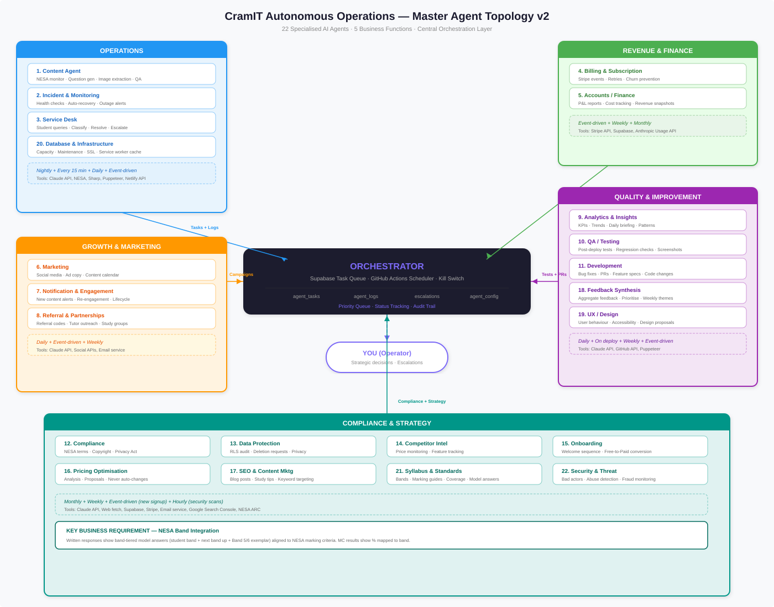
- Operations (blue) handles content generation, system health, and student support.
- Revenue & Finance (green) manages payments and financial reporting.
- Growth & Marketing (orange) drives new signups and retains existing users.
- Quality & Improvement (purple) ensures code quality, testing, and continuous improvement.
- Compliance & Strategy (teal) handles legal requirements, competitive intelligence, and strategic optimisation.
- All agents communicate through the central Orchestrator — a combination of the Supabase agent_tasks table and GitHub Actions scheduler. The Orchestrator routes tasks, tracks status, and ensures escalations reach the human operator.

3. Coordination Infrastructure
The agents coordinate through a set of Supabase tables that act as a shared message bus. Every agent reads from and writes to these tables, creating a unified system with full auditability.
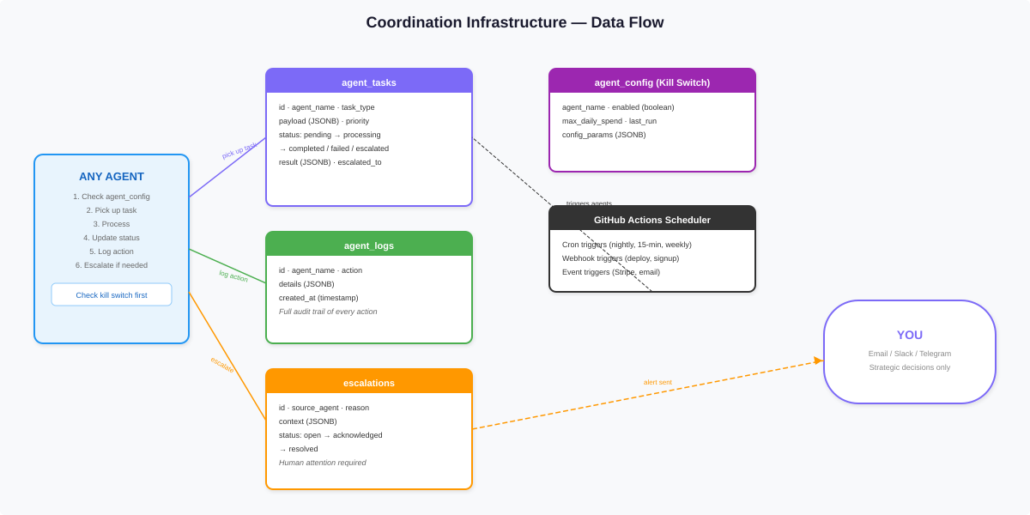

3.1 Central Task Queue
The agent_tasks table is the heart of the system. When one agent needs another to do something, it creates a row with the target agent name, task type, and payload. The target agent picks up pending tasks, processes them, and updates the status. Fields include: id, agent_name, task_type, payload (JSONB), status (pending / processing / completed / failed / escalated), priority (1–10), timestamps, result (JSONB), and escalated_to.

3.2 Agent Activity Log
The agent_logs table provides a complete audit trail. Every action every agent takes is recorded with timestamp, agent name, action description, and details as JSONB. This is essential for debugging, compliance, and understanding agent behaviour over time.

3.3 Escalation System
The escalations table captures anything an agent cannot resolve. Fields include source_agent, reason, context (JSONB), and status (open / acknowledged / resolved). All escalations route to a single alerting channel — email, Slack, or Telegram — so the operator has one place to check.

3.4 Kill Switch
The agent_config table contains a row per agent with an enabled boolean flag, max_daily_spend limit, and configuration parameters. Every agent checks this table before running. Flipping the enabled flag to false instantly pauses that agent. The spend limit prevents runaway API costs from a malfunctioning agent.

4. NESA Band Integration — Key Business Requirement
CramIT will integrate NESA performance band descriptors and marking guidelines directly into the student experience. This is a core differentiator — no other HSC platform maps student practice performance to NESA band descriptors with actionable, band-tiered feedback.

4.1 How NESA Bands Work
NESA assigns every HSC student to a performance band (Band 1–6) for each course, based on their HSC mark. Band 6 (90–100) represents the highest standard. Each band has a published descriptor summarising the knowledge, skills, and understanding typically demonstrated by students at that level. NESA also publishes marking guidelines for each exam, defining the quality of response required to achieve specific marks, and exemplar responses through the Assessment Resource Centre (ARC).

4.2 Multiple Choice Results
For MC questions, the result displays the student’s percentage score mapped to the corresponding NESA performance band. MC questions are binary (right or wrong) — the existing per-option explanations already provide the learning feedback. The band mapping gives the student context for where their overall performance sits on the HSC scale.

4.3 Written Response Results — Band-Tiered Model Answers
This is the key enhancement. For written responses, after the student submits their answer and receives their keyword-match score, the app provides band-tiered feedback:
1. The student’s achieved band with the NESA descriptor for that level, explaining what students at that band typically demonstrate.
2. A model answer at the next band up (e.g., Band 4 model if the student scored Band 3), showing specifically what additional depth, terminology, evaluation, or structure would be needed to improve.
3. The exemplar Band 5/6 model answer representing the highest standard — this is equivalent to the existing model answer display but now explicitly labelled and contextualised within the NESA framework.
This builds directly on the existing written response pattern in the HMS and VET Construction quizzes (keyword scoring + model answer reveal), adding richer, band-calibrated output that gives students a concrete, step-by-step path to improvement rather than a single gold-standard answer that may feel unreachable.

4.4 Band Tracking Over Time
Student band performance is tracked across multiple quiz attempts, enabling a progression view: “Two weeks ago you were performing at Band 3. After focused practice, you’re now consistently in Band 4 territory.” This provides motivation and measurable progress.

4.5 Data Sources and Agent Responsibilities
The Syllabus & Standards Agent (Agent 21) is responsible for sourcing, structuring, and maintaining all NESA band data — performance band descriptors, marking criteria, band-mapping logic, and exemplar responses from the ARC. The Content Agent (Agent 1) uses this data when generating written response questions, producing band-tiered model answers aligned to the marking criteria. Implementation detail of the code changes is deferred to the development phase.

5. Agent Roster — Detailed Specifications
Each of the 22 agents below includes its purpose, trigger mechanism, frequency, inputs, outputs, tools used, estimated cost, workflow diagram, and escalation rules.

5.1 Content Agent
Function Cluster | Operations
Purpose | Monitor NESA for new HSC exam papers, generate quiz questions using Claude AI, extract diagrams/images from PDFs, validate question quality, and retire problematic questions.
Trigger | Scheduled (GitHub Actions cron — 11pm Sydney daily) + on-demand via agent_tasks
Frequency | Nightly
Inputs | NESA website, existing subject JSON files, content_issues table (flagged questions)
Outputs | New subject JSON files committed to GitHub, cropped diagram images, updated subjects/index.json, entries in agent_logs
Tools / APIs | Claude API (Vision + Text), Node.js, Sharp (image cropping), pdftoppm (PDF rasterisation), GitHub API (commit), NESA website
Estimated Cost | $0.50–$2.00/day

Workflow Diagram
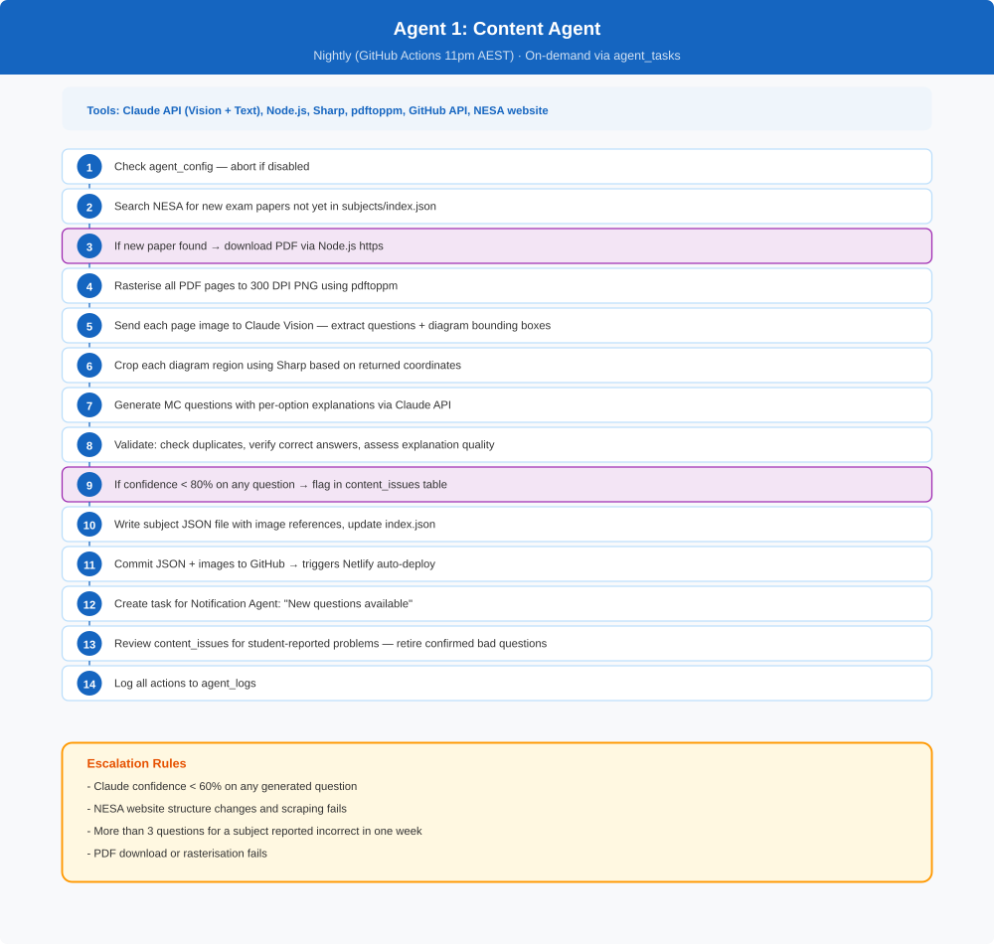

5.2 Incident & Monitoring Agent
Function Cluster | Operations
Purpose | Detect outages and errors before students notice them. Auto-resolve simple issues. Alert the operator for anything it cannot fix.
Trigger | Scheduled (every 15 minutes via GitHub Actions)
Frequency | Every 15 minutes
Inputs | Netlify site URL, Supabase health endpoint, Stripe webhook status, client_errors table
Outputs | Entries in agent_logs, entries in escalations if issues found, auto-restart actions
Tools / APIs | HTTP requests (fetch), Netlify API (redeploy), Supabase admin API, Stripe API
Estimated Cost | ~$0.10/day

Workflow Diagram
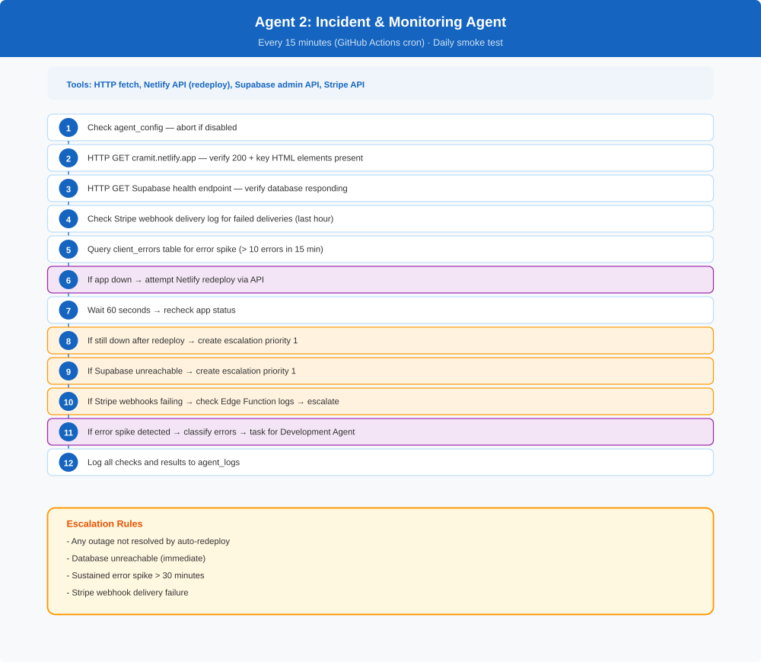

5.3 Service Desk Agent
Function Cluster | Operations
Purpose | Handle all inbound student queries automatically. Classify, resolve, or escalate.
Trigger | Event-driven (inbound email webhook or in-app support form submission)
Frequency | On-demand (per incoming query)
Inputs | Student message (email/form), student Supabase profile, subscription status, subject selections
Outputs | Reply email/message to student, entries in agent_tasks for other agents, entries in agent_logs
Tools / APIs | Claude API, Supabase (profiles, subscriptions, subject_selections), Email service (Postmark/SendGrid)
Estimated Cost | $0.02–$0.05 per interaction

Workflow Diagram
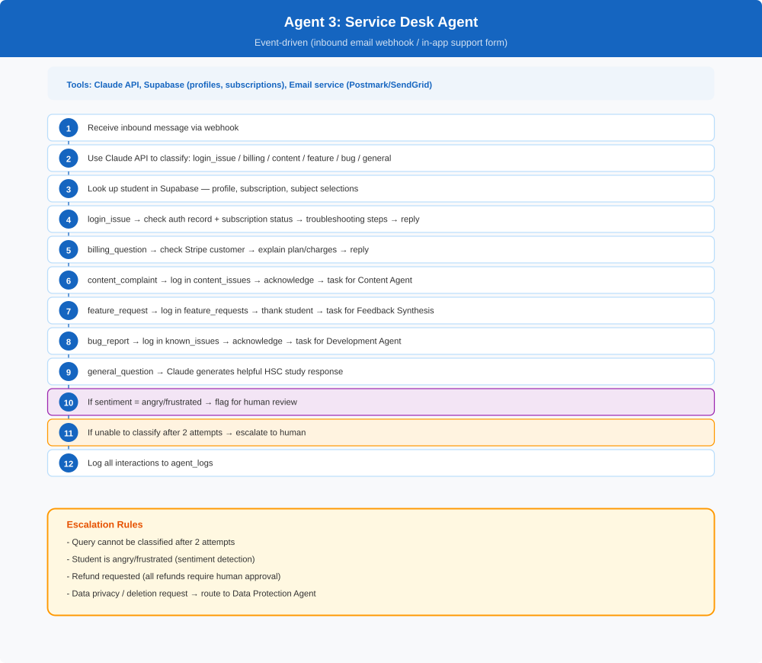

5.4 Billing & Subscription Agent
Function Cluster | Revenue & Finance
Purpose | Monitor payment health, handle billing events from Stripe, execute churn prevention sequences.
Trigger | Event-driven (Stripe webhooks via clever-action Edge Function) + scheduled daily
Frequency | Event-driven + Daily
Inputs | Stripe webhook events, subscriptions table, profiles table
Outputs | Updated subscriptions table, churn prevention emails, entries in agent_logs
Tools / APIs | Stripe API, Supabase, Email service (Postmark/SendGrid)
Estimated Cost | ~$0.01 per event

Workflow Diagram
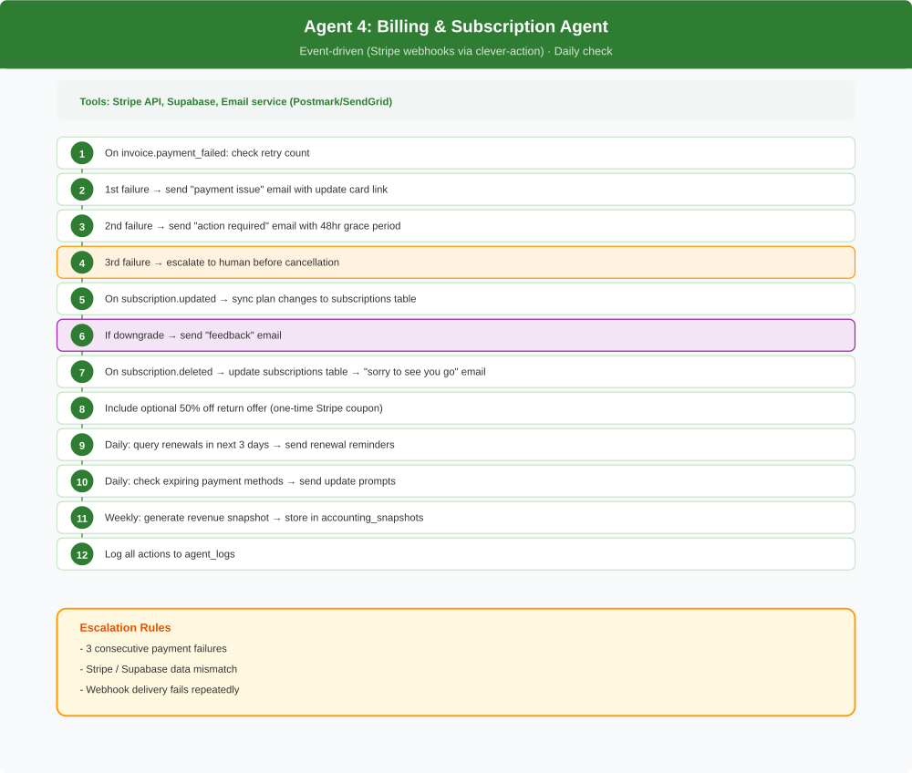

5.5 Accounts / Finance Agent
Function Cluster | Revenue & Finance
Purpose | Track all income, expenses, and generate P&L reports. Provide full financial visibility.
Trigger | Scheduled (weekly + monthly)
Frequency | Weekly summary, Monthly full P&L
Inputs | Stripe API (revenue, fees, refunds), Claude API usage (AI costs), Netlify/Supabase usage, email service costs
Outputs | Weekly summary email, monthly P&L report in accounting_reports table, entries in agent_logs
Tools / APIs | Stripe API, Anthropic Usage API, Supabase
Estimated Cost | $0.10–$0.30 per report

Workflow Diagram
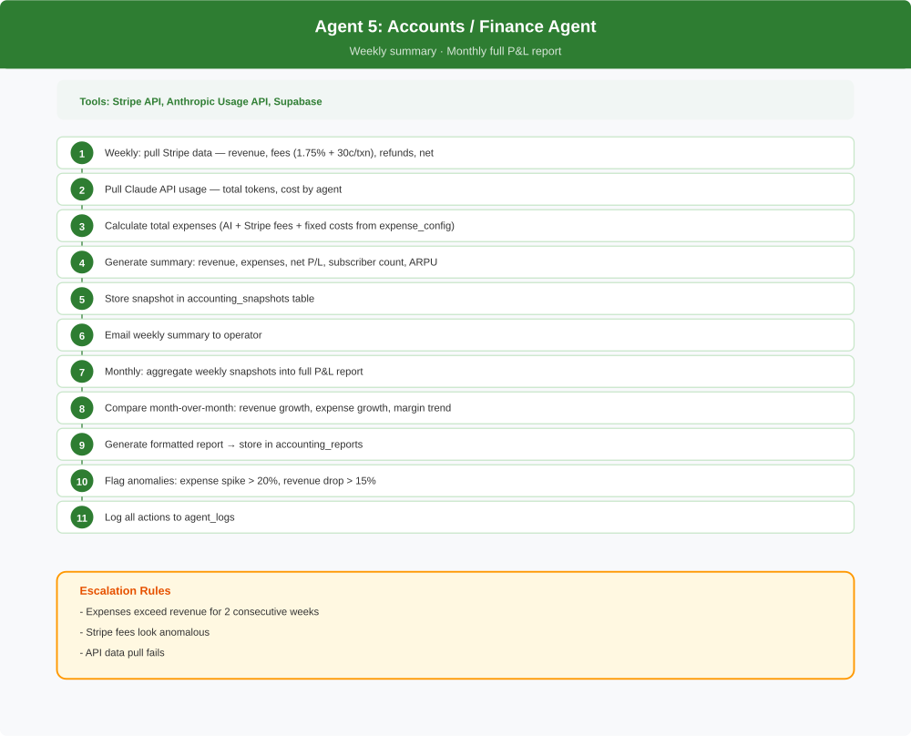

5.6 Marketing Agent
Function Cluster | Growth & Marketing
Purpose | Create and distribute marketing content across channels. Drive new student signups.
Trigger | Scheduled (content calendar) + event-driven (new subject, exam season)
Frequency | Daily content creation + campaign bursts
Inputs | Content calendar (marketing_calendar table), subject data, analytics data, competitor data
Outputs | Social media posts, ad copy, blog content drafts, UTM-tagged links, entries in agent_logs
Tools / APIs | Claude API, Social media APIs (Buffer/Later), Supabase
Estimated Cost | $0.50–$2.00/day

Workflow Diagram
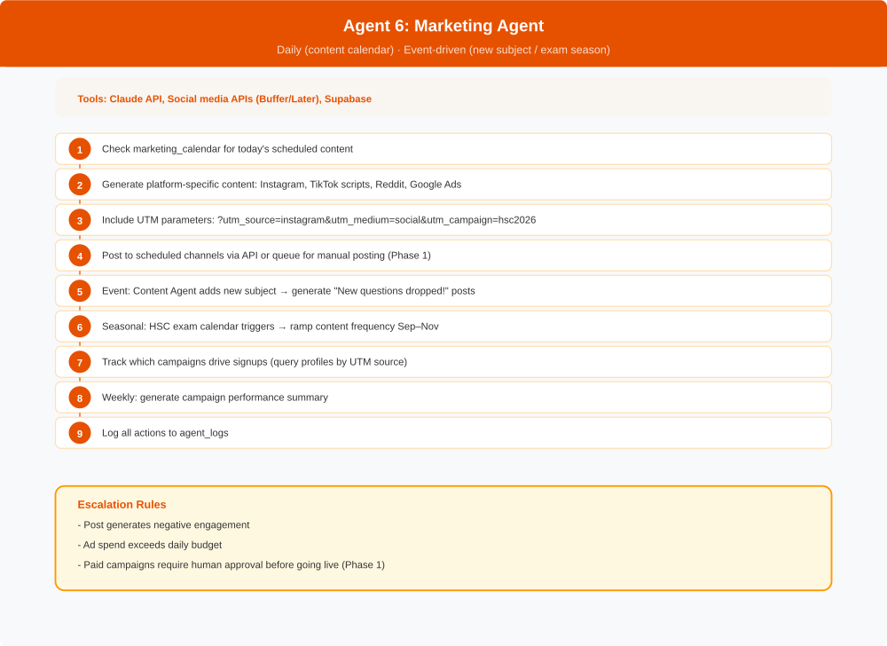

5.7 Notification & Engagement Agent
Function Cluster | Growth & Marketing
Purpose | Communicate with existing users — new content alerts, re-engagement, lifecycle messages.
Trigger | Event-driven (new content, user inactivity, subscription events) + scheduled
Frequency | Event-driven + Daily inactivity check
Inputs | profiles table, subscriptions table, subject_selections table, Content Agent output, user activity data
Outputs | Push notifications, emails, in-app banners, entries in agent_logs
Tools / APIs | Email service (Postmark/SendGrid), Supabase, Claude API (personalised messages)
Estimated Cost | $0.05–$0.20/day + email costs

Workflow Diagram
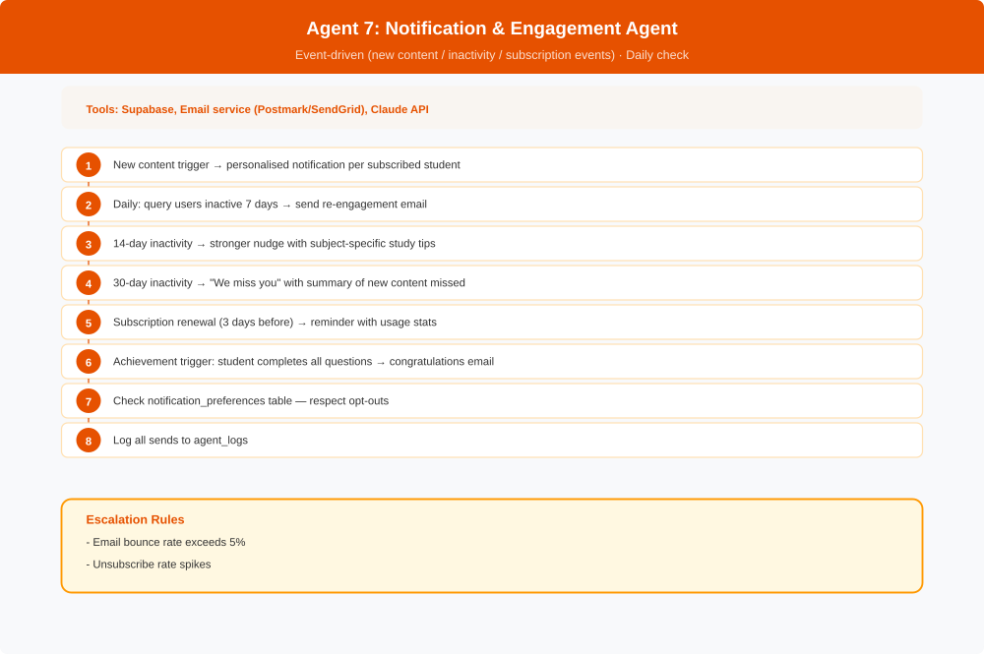

5.8 Referral & Partnerships Agent
Function Cluster | Growth & Marketing
Purpose | Manage referral program and outreach to HSC tutors and study groups.
Trigger | Scheduled (weekly outreach) + event-driven (referral code used)
Frequency | Weekly
Inputs | referral_codes table, profiles table, tutor/study group contact list
Outputs | Referral tracking, outreach emails, reward fulfilment, entries in agent_logs
Tools / APIs | Claude API, Supabase, Email service, Stripe (coupon codes)
Estimated Cost | $0.10–$0.50/week

Workflow Diagram
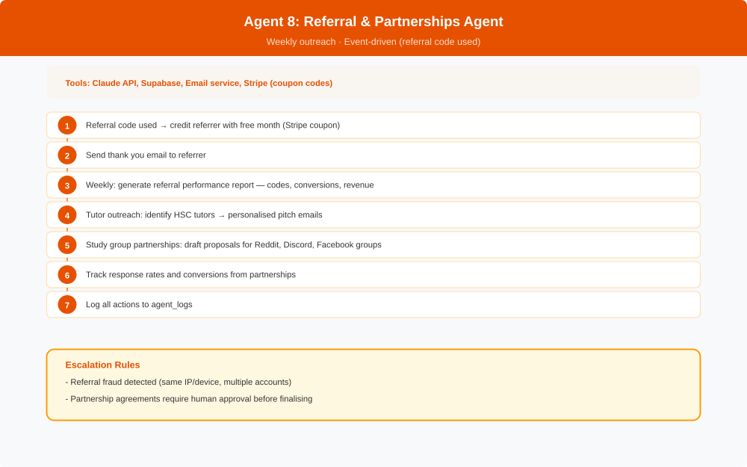

5.9 Analytics & Insights Agent
Function Cluster | Quality & Improvement
Purpose | Calculate key metrics, identify trends, generate daily business briefing.
Trigger | Scheduled (daily)
Frequency | Daily
Inputs | All Supabase tables (profiles, subscriptions, subject_selections, client_errors, agent_logs)
Outputs | Daily briefing email, analytics_snapshots table entries, insight-driven tasks for other agents
Tools / APIs | Supabase (all tables), Claude API (insight generation), Email service
Estimated Cost | $0.10–$0.30/day

Workflow Diagram
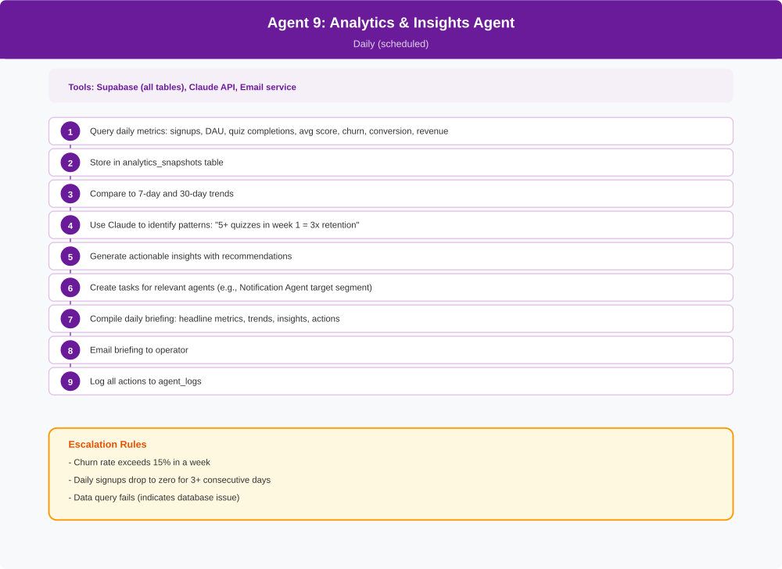

5.10 QA / Testing Agent
Function Cluster | Quality & Improvement
Purpose | Automated testing after every deployment. Catch regressions before students do.
Trigger | Event-driven (Netlify deploy webhook) + scheduled daily smoke test
Frequency | On every deploy + Daily
Inputs | Netlify deploy notification, app URL, expected quiz data
Outputs | Test results in qa_results table, pass/fail notification, tasks for Development Agent
Tools / APIs | Puppeteer/Playwright (headless browser), Supabase, Netlify API
Estimated Cost | ~$0.05/day

Workflow Diagram
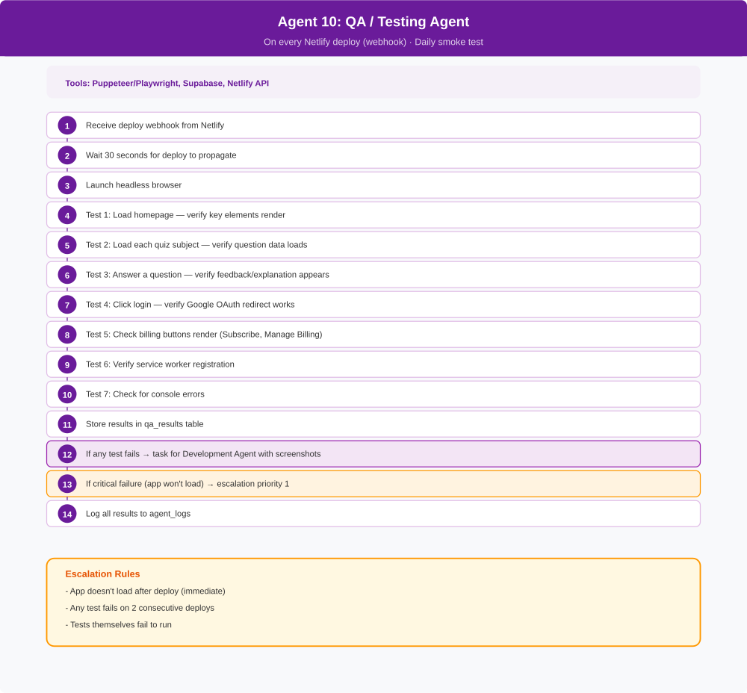

5.11 Development Agent
Function Cluster | Quality & Improvement
Purpose | Propose and implement code changes for bug fixes and simple feature requests.
Trigger | Event-driven (tasks from Service Desk / QA / Feedback Synthesis) + weekly backlog review
Frequency | On-demand + Weekly
Inputs | known_issues table, feature_requests table, QA test failure reports, current codebase (GitHub)
Outputs | GitHub Pull Requests with proposed changes, detailed specs in change_proposals table
Tools / APIs | Claude API, GitHub API (branches, commits, PRs), Supabase
Estimated Cost | $1–$5 per PR

Workflow Diagram
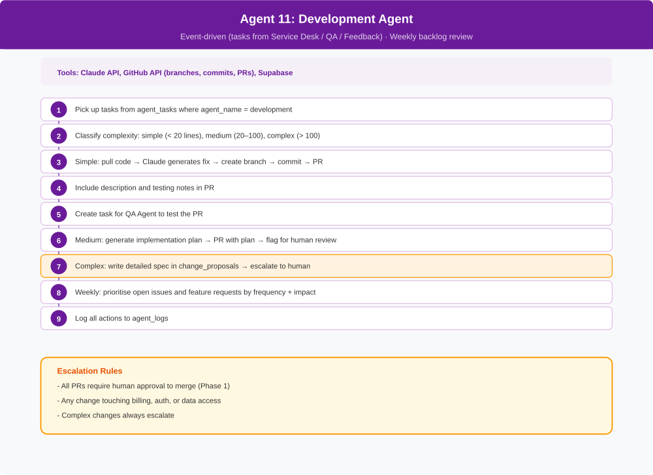

5.12 Compliance Agent
Function Cluster | Compliance & Strategy
Purpose | Monitor legal and regulatory requirements. Ensure NESA content usage stays within bounds.
Trigger | Scheduled (monthly) + event-driven (new subject added)
Frequency | Monthly + On new content
Inputs | NESA terms of use, Australian Privacy Act requirements, current privacy policy, generated question content
Outputs | Compliance status report, flagged issues in compliance_issues table, entries in agent_logs
Tools / APIs | Claude API, Web fetch (NESA terms page), Supabase
Estimated Cost | $0.20–$0.50/month

Workflow Diagram
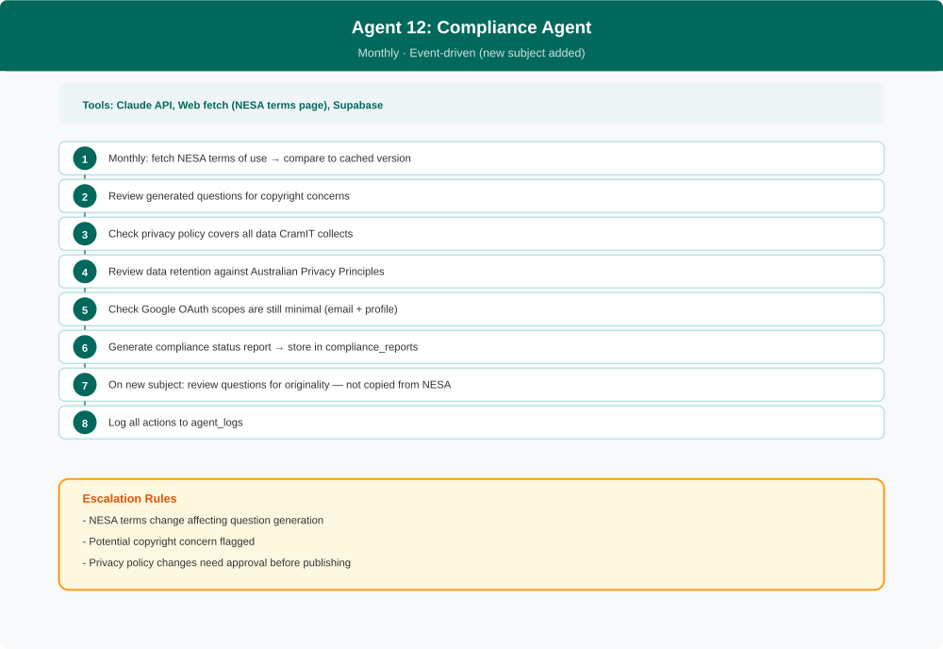

5.13 Data Protection Agent
Function Cluster | Compliance & Strategy
Purpose | Protect student data. Handle deletion requests. Audit access controls.
Trigger | Event-driven (data deletion request from Service Desk) + scheduled (monthly audit)
Frequency | Monthly + On-demand
Inputs | Supabase RLS policies, profiles table, data deletion requests, Google OAuth configuration
Outputs | Audit reports in security_audit table, completed deletion confirmations, entries in agent_logs
Tools / APIs | Supabase admin API, Claude API (audit analysis)
Estimated Cost | $0.10–$0.30/month

Workflow Diagram
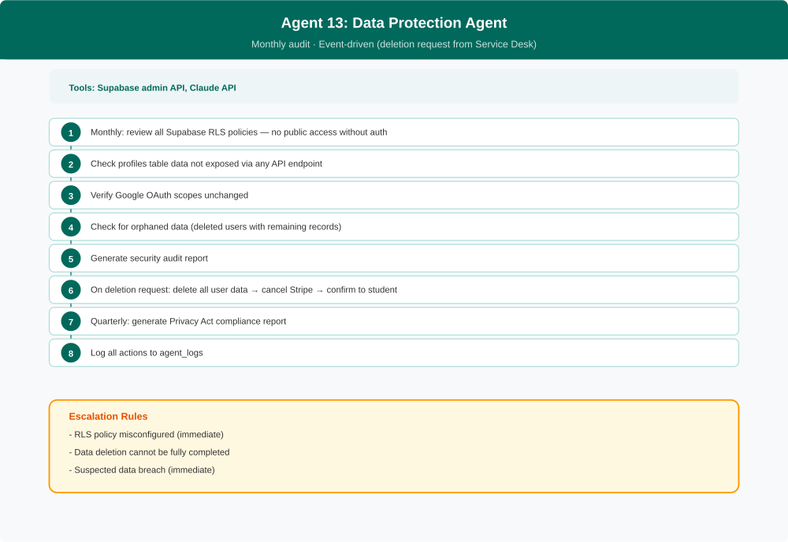

5.14 Competitor Intelligence Agent
Function Cluster | Compliance & Strategy
Purpose | Monitor competitors for pricing changes, new features, and market moves.
Trigger | Scheduled (weekly)
Frequency | Weekly
Inputs | Competitor websites (Studyclix, ATAR Notes, Neap, Past Papers AU), app store listings
Outputs | Weekly competitive brief email, entries in competitor_intel table, entries in agent_logs
Tools / APIs | Claude API, Web fetch, Supabase
Estimated Cost | $0.30–$1.00/week

Workflow Diagram
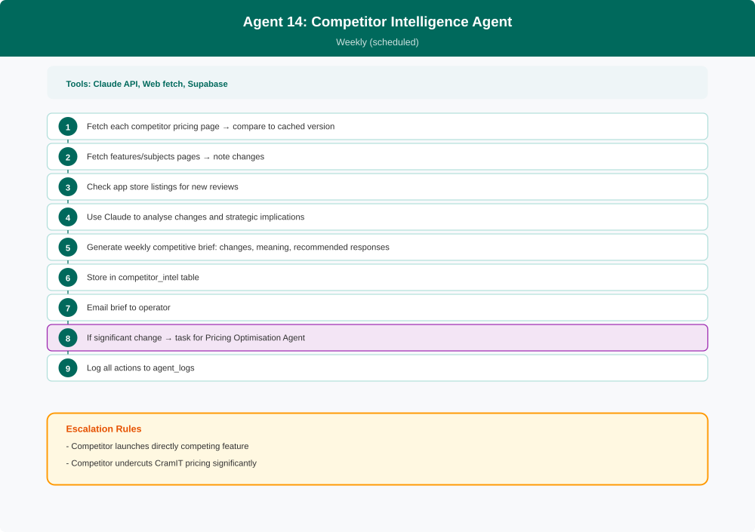

5.15 Onboarding Agent
Function Cluster | Compliance & Strategy
Purpose | Convert free users to paying subscribers through a structured welcome sequence.
Trigger | Event-driven (new user signup via Supabase auth webhook)
Frequency | On-demand per new signup
Inputs | New user profile, subject selection, subscription status
Outputs | Onboarding emails (Day 0, 1, 3, 7, 14), in-app welcome state, entries in agent_logs
Tools / APIs | Supabase, Email service (Postmark/SendGrid), Claude API (personalised content)
Estimated Cost | $0.02–$0.05 per new user

Workflow Diagram
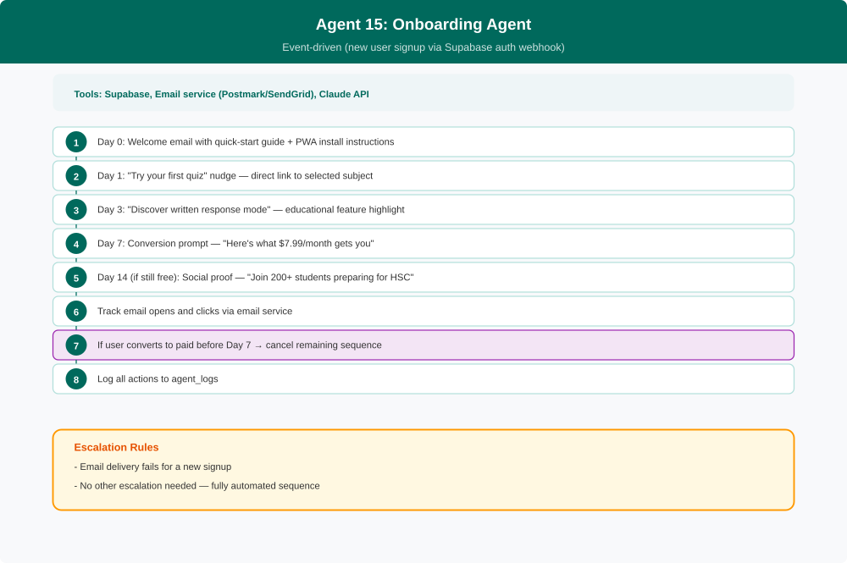

5.16 Pricing Optimisation Agent
Function Cluster | Compliance & Strategy
Purpose | Analyse pricing data and suggest optimisations. Never changes prices autonomously.
Trigger | Scheduled (monthly) + event-driven (task from Competitor Intelligence Agent)
Frequency | Monthly
Inputs | analytics_snapshots, competitor_intel, subscriptions (plan distribution), Stripe data
Outputs | Pricing recommendations in pricing_proposals table, entries in agent_logs
Tools / APIs | Claude API, Supabase
Estimated Cost | $0.20–$0.50/month

Workflow Diagram
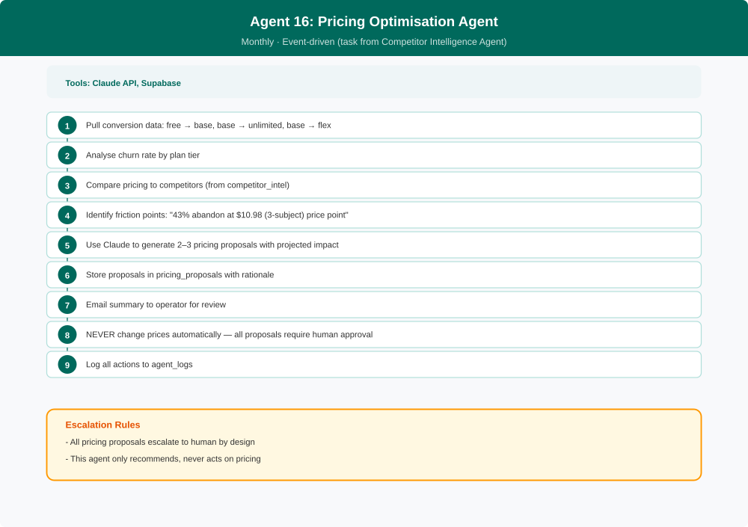

5.17 SEO & Content Marketing Agent
Function Cluster | Compliance & Strategy
Purpose | Generate blog content and study tips targeting HSC search terms to drive organic traffic.
Trigger | 2–3 posts per week (scheduled) + event-driven (new subject added)
Frequency | 2–3 posts/week
Inputs | Target keyword list (seo_keywords table), subject data, analytics, NESA syllabus dot points
Outputs | Blog posts (Markdown committed to GitHub), meta descriptions, entries in agent_logs
Tools / APIs | Claude API, GitHub API, Supabase
Estimated Cost | $0.30–$1.00/week

Workflow Diagram
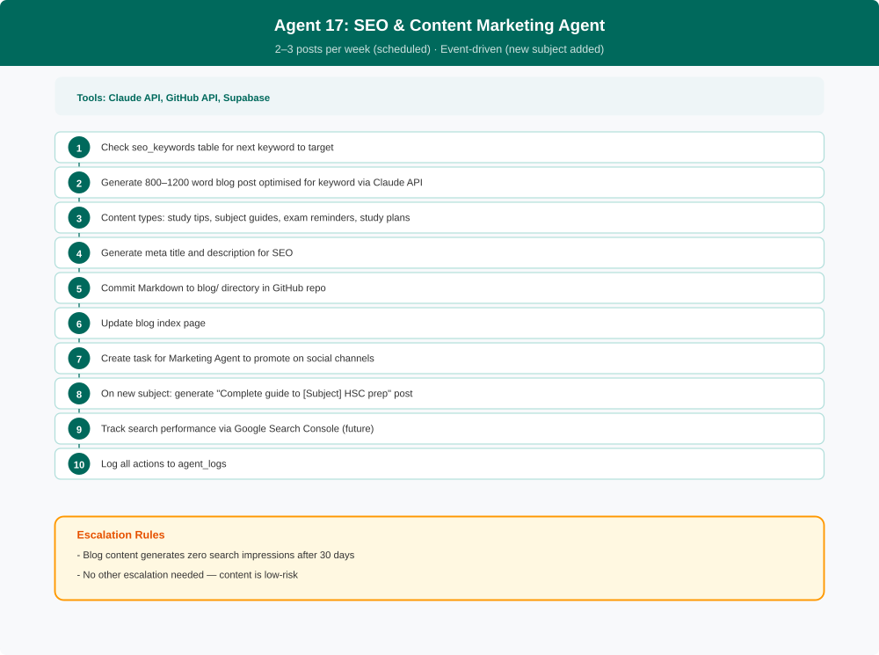

5.18 Feedback Synthesis Agent
Function Cluster | Quality & Improvement
Purpose | Aggregate all student feedback and create prioritised action items.
Trigger | Scheduled (weekly)
Frequency | Weekly
Inputs | content_issues, feature_requests, known_issues, Service Desk interaction logs
Outputs | Weekly feedback report, prioritised action items in agent_tasks, entries in agent_logs
Tools / APIs | Claude API, Supabase
Estimated Cost | $0.10–$0.30/week

Workflow Diagram
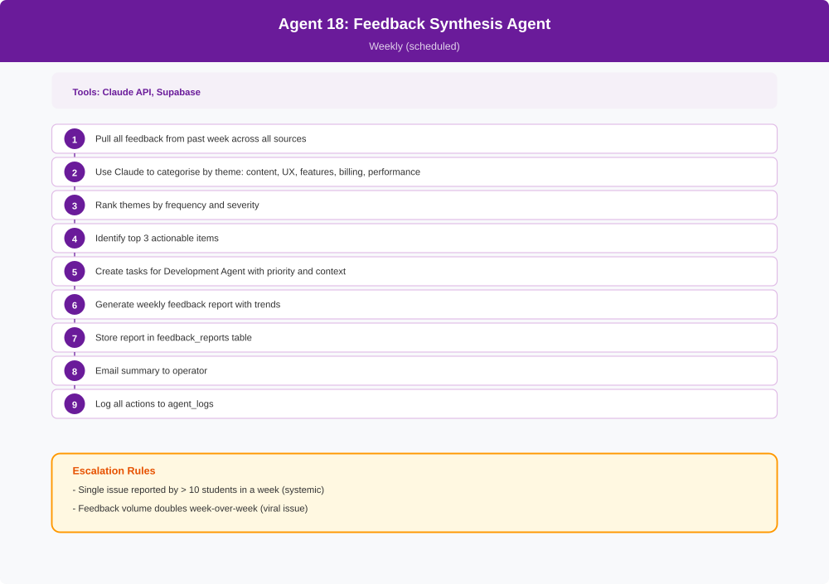

5.19 UX / Design Agent
Function Cluster | Quality & Improvement
Purpose | Analyse user behaviour patterns, identify UX friction points, run accessibility audits, and generate design proposals for UI improvements. Works upstream of the Development Agent — designs first, then Development implements.
Trigger | Event-driven (Analytics insights, feature requests) + weekly design review
Frequency | Weekly + On-demand
Inputs | Analytics data (drop-off points, completion funnels), user behaviour patterns, feature_requests table, current CSS/HTML
Outputs | Design proposals in design_proposals table with mockups and rationale, accessibility audit reports, tasks for Development Agent
Tools / APIs | Claude API, Supabase (analytics data, user behaviour), GitHub API
Estimated Cost | $0.20–$0.50/week

Workflow Diagram
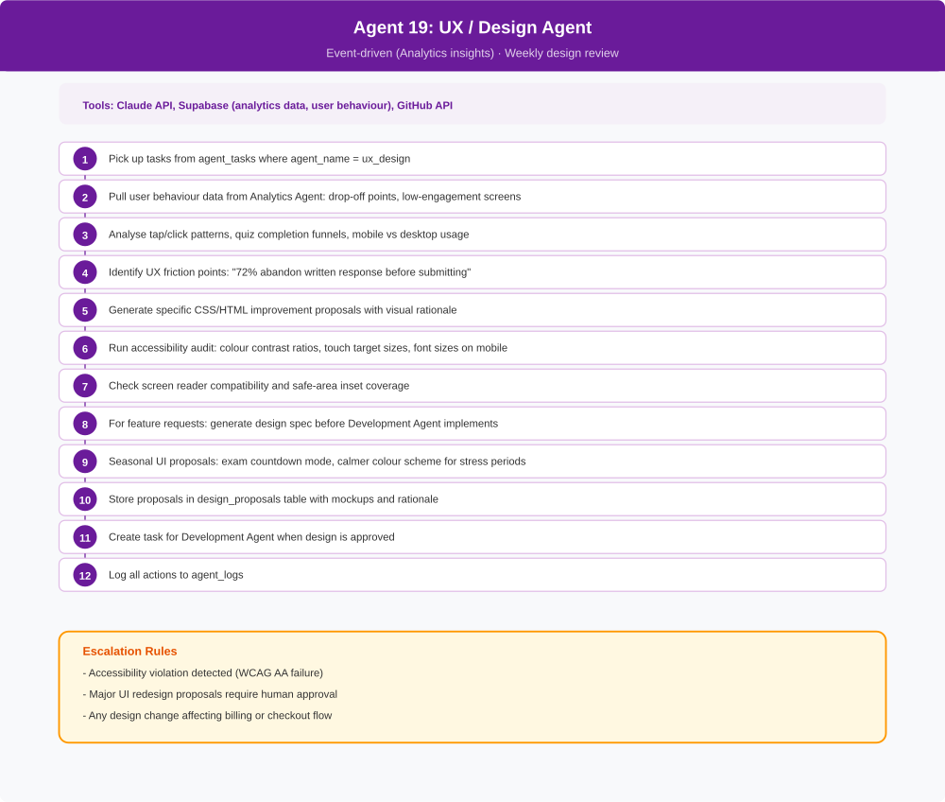

5.20 Database & Infrastructure Agent
Function Cluster | Operations
Purpose | Monitor infrastructure capacity across all platforms (Supabase, Netlify, GitHub Actions). Handle database maintenance, archiving, and service worker cache health. Alert before free tier limits are hit.
Trigger | Daily capacity check + weekly maintenance + event-driven (threshold alerts)
Frequency | Daily + Weekly
Inputs | Supabase admin metrics, Netlify usage stats, GitHub Actions minutes, SSL cert status, DNS health
Outputs | Infrastructure health reports in infra_health table, archived old logs, capacity alerts, entries in agent_logs
Tools / APIs | Supabase admin API, Netlify API, GitHub API, DNS monitoring tools
Estimated Cost | $0.05–$0.15/day

Workflow Diagram
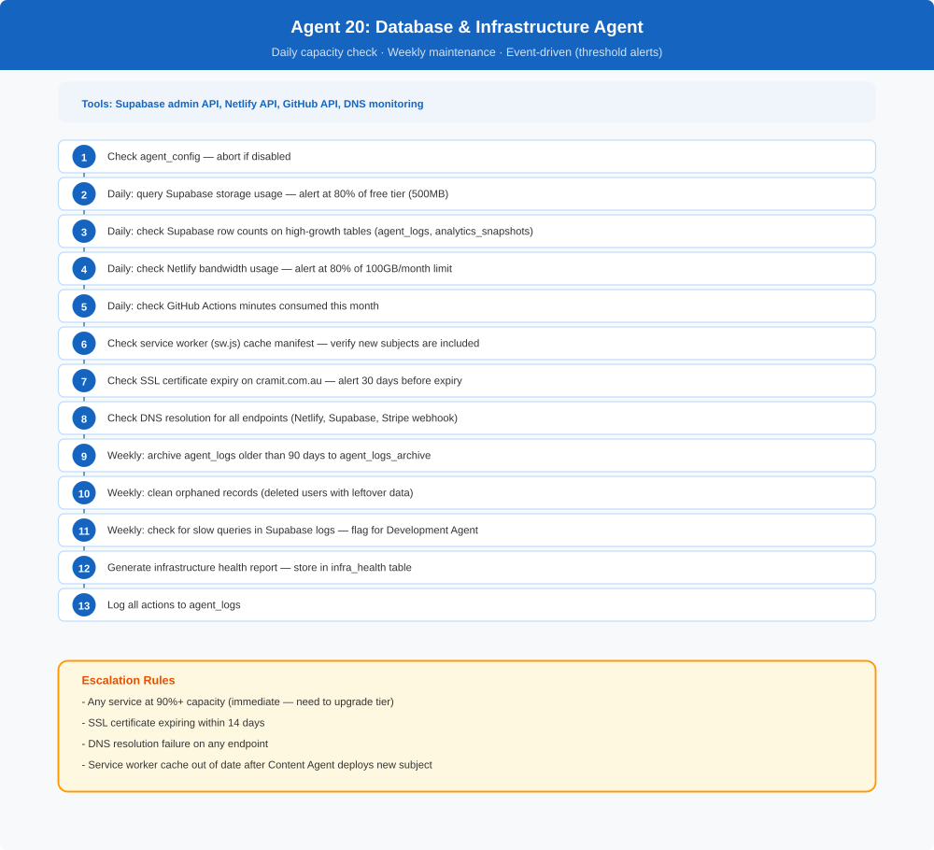

5.21 Syllabus & Standards Agent
Function Cluster | Compliance & Strategy
Purpose | Monitor NESA syllabus documents for changes, map questions to syllabus dot points, maintain NESA performance band descriptors (Bands 1–6), extract marking criteria and guidelines, scrape exemplar responses from NESA ARC, and maintain band-mapping logic for each subject. Provides the data foundation for the NESA Band Integration feature.
Trigger | Monthly syllabus check + on new subject added + annual band descriptor update
Frequency | Monthly + On new content + Annual
Inputs | NESA syllabus documents, NESA performance band descriptors, NESA marking guidelines, NESA ARC exemplar responses, existing question data
Outputs | Updated band_descriptors table, marking_criteria table, band_mapping table, syllabus coverage reports in syllabus_reports table, tasks for Content Agent (coverage gaps)
Tools / APIs | Claude API, Web fetch (NESA syllabus pages, band descriptor pages, ARC), Supabase
Estimated Cost | $0.30–$1.00/month

Workflow Diagram
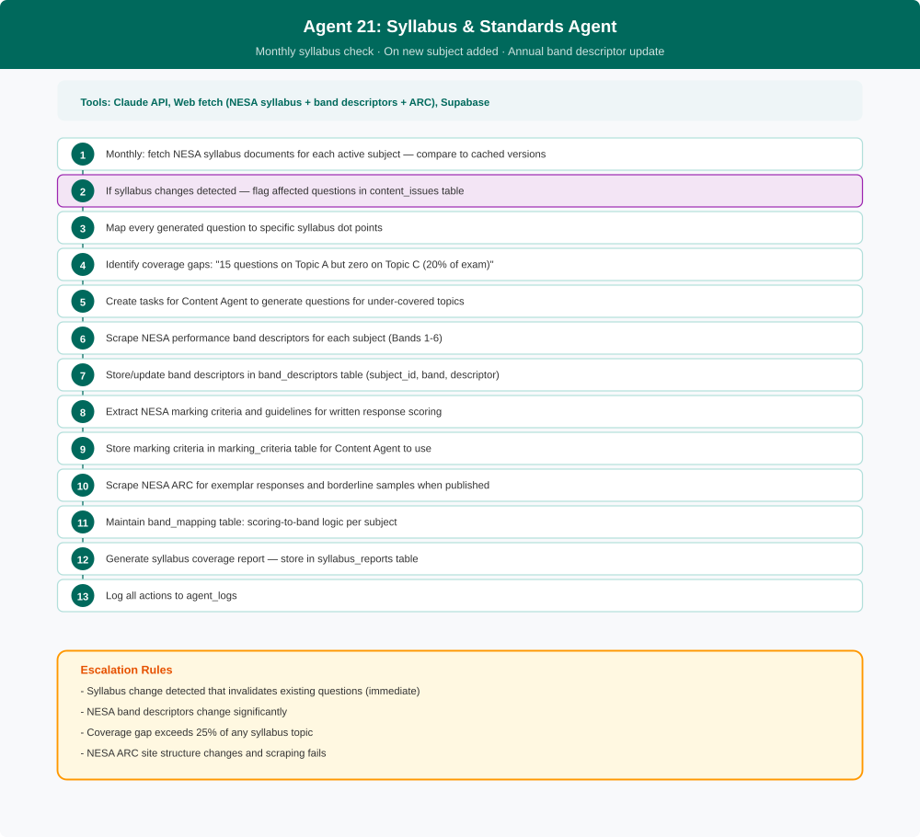

5.22 Security & Threat Agent
Function Cluster | Compliance & Strategy
Purpose | Monitor for external threats and abuse. Detect suspicious login patterns, credential stuffing, free-tier abuse (multiple accounts), question data scraping, and fraudulent Stripe activity. Different from Incident Agent (checks if things work) and Data Protection Agent (audits own policies) — this agent watches for bad actors.
Trigger | Hourly security scan + event-driven (suspicious activity detected)
Frequency | Hourly + On-demand
Inputs | Supabase auth logs, request logs, Stripe transaction data, agent API usage patterns
Outputs | Security events in security_events table, account restrictions, weekly security summary, entries in agent_logs
Tools / APIs | Supabase admin API, Stripe API, Claude API (pattern analysis)
Estimated Cost | $0.10–$0.30/day

Workflow Diagram
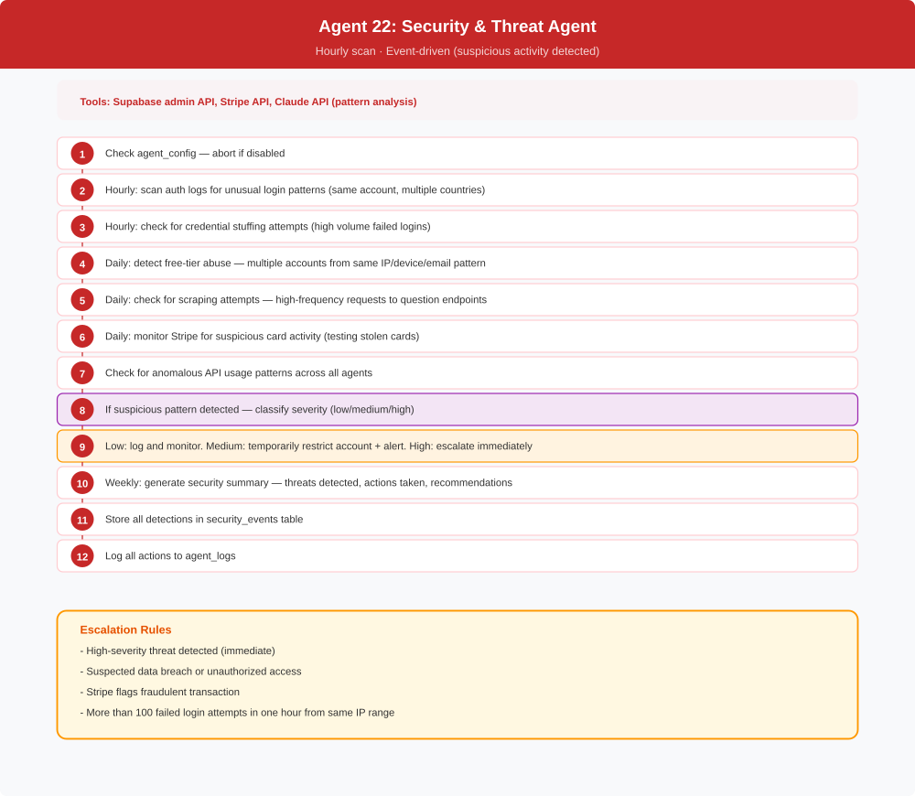

6. Implementation Roadmap
The agents are deployed in 5 phases, starting with core operations and expanding to full autonomous operations over 4 months. Each phase builds on the previous one, and agents only graduate to autonomous action after trust is established through supervised operation.

Phase | Timeline | Agents Deployed | Milestone
Phase 1 | Weeks 1–2 | Content (expanded), Incident & Monitoring, QA / Testing, Database & Infrastructure | Core operations stable, auto-monitored
Phase 2 | Weeks 3–4 | Service Desk, Billing & Subscription, Onboarding, Security & Threat | Student-facing automation + security live
Phase 3 | Month 2 | Analytics & Insights, Accounts / Finance, Notification & Engagement, Syllabus & Standards | Business intelligence + NESA band integration
Phase 4 | Month 3 | Marketing, SEO & Content Marketing, Referral & Partnerships, UX / Design | Growth engine + design quality
Phase 5 | Month 4+ | Development, Feedback Synthesis, Compliance, Data Protection, Competitor Intelligence, Pricing Optimisation | Full autonomous operations

7. Cost Projections
All costs are estimates based on Claude API pricing for Sonnet model usage. Actual costs will vary with user base size, support query volume, and content generation frequency. The total represents the cost of running a fully automated business operation.

Agent | Frequency | Daily Cost | Monthly Cost
1. Content Agent | Nightly | $0.50–$2.00 | $15–$60
2. Incident & Monitoring | Every 15 min | $0.10 | $3
3. Service Desk | Per query | $0.02–$0.05 each | $1–$15
4. Billing & Subscription | Per event | $0.01 each | $0.50–$3
5. Accounts / Finance | Weekly + monthly | $0.05 | $1.50–$3
6. Marketing | Daily | $0.50–$2.00 | $15–$60
7. Notification & Engagement | Daily + events | $0.05–$0.20 | $1.50–$6
8. Referral & Partnerships | Weekly | $0.02 | $0.50–$2
9. Analytics & Insights | Daily | $0.10–$0.30 | $3–$9
10. QA / Testing | Per deploy + daily | $0.05 | $1.50
11. Development | On-demand | $1–$5 per PR | $4–$20
12. Compliance | Monthly | — | $0.50
13. Data Protection | Monthly | — | $0.30
14. Competitor Intelligence | Weekly | $0.15 | $1–$4
15. Onboarding | Per signup | $0.03 each | $1–$5
16. Pricing Optimisation | Monthly | — | $0.50
17. SEO & Content Marketing | 2–3x/week | $0.10 | $1–$4
18. Feedback Synthesis | Weekly | $0.05 | $0.50–$1
19. UX / Design | Weekly + events | $0.03–$0.07 | $1–$2
20. Database & Infrastructure | Daily + weekly | $0.05–$0.15 | $1.50–$4.50
21. Syllabus & Standards | Monthly + events | — | $0.30–$1
22. Security & Threat | Hourly | $0.10–$0.30 | $3–$9
TOTAL |  |  | $55–$230/month

Plus email service costs: Postmark free tier covers 100 emails/month, then approximately $10/month for standard volume. Total all-in operating cost at launch: approximately $65–$240/month.

7.1 AI Written Response Marking — Variable Cost Model

Overview
The NESA Band Integration feature (detailed in Section 1.4) introduces live Claude AI marking of student written responses. Unlike the fixed-cost agent fleet above, this is a variable cost that scales directly with student usage — and therefore directly with revenue. Each written response submission triggers a Claude API call that evaluates the student’s answer against NESA marking criteria and returns a band rating (Band 1–6), marks awarded, and specific feedback on the student’s own writing.

Cost Per Submission
Claude Sonnet API pricing (2026): approximately $0.003 per 1,000 input tokens and $0.015 per 1,000 output tokens. A typical written response marking call uses approximately 800 input tokens (question + marking criteria + student response) and 300 output tokens (band rating + mark + feedback). Estimated cost per marking call: ~$0.007 (under one cent).

Variable Cost by Subscriber Scale
Active Subscribers | Written Submissions/Day* | Daily AI Cost | Monthly AI Cost
100 students | ~50 | ~$0.35 | ~$10
500 students | ~250 | ~$1.75 | ~$53
1,000 students | ~500 | ~$3.50 | ~$105
5,000 students | ~2,500 | ~$17.50 | ~$525
10,000 students | ~5,000 | ~$35.00 | ~$1,050
*Assumes 50% of active subscribers attempt one written question per day. Many students use MC mode only — actual usage is likely lower.

Revenue vs Cost Ratio
At $7.99/month average subscription and 1,000 students: monthly revenue ≈ $7,990. Monthly AI marking cost ≈ $105. AI marking cost represents approximately 1.3% of revenue at this scale. This ratio holds as the business grows — both revenue and marking usage scale proportionally, so the margin impact remains negligible at every stage.

Cost Control Guardrails
Rate limiting per student: Cap AI marking calls at 20 per student per day. Students who exhaust their quota fall back to keyword-match scoring with a note that AI marking resets tomorrow. This caps per-student daily cost at ~$0.14 regardless of behaviour.
Paid tier only: AI band marking is a paid-tier feature. Free tier students receive keyword-match feedback only. This gates the highest-usage population behind a paywall.
Monthly spend cap: Set a hard monthly cap in the Anthropic Console at 150% of the projected marking cost for the current subscriber count, with an alert at 100%. The Accounts / Finance Agent (Agent 5) includes AI marking costs in its weekly P&L snapshots.
Per-subject toggle: The agent_config table kill switch pattern applies. A per-subject AI marking toggle allows the feature to be enabled/disabled for individual subjects — useful for phased rollout or managing unexpected traffic spikes.

Implementation Note
This feature is parked for future development. The existing keyword-matching implementation in checkWrittenAnswer() continues to run at zero marginal cost. When prioritised, the upgrade will be implemented as a Netlify serverless function (/.netlify/functions/mark-written) that proxies the Anthropic API call server-side, keeping the API key out of the browser. A written_submissions table will be added to Supabase at that time to log all AI marking calls for auditability and cost tracking.

8. Appendix: Database Tables
The following tables must be created in Supabase to support the agent coordination system. All tables should have RLS enabled with appropriate policies.

Table Name | Purpose
agent_tasks | Central task queue — all agents read from and write to this
agent_logs | Full audit trail of every action every agent takes
escalations | Issues requiring human attention
agent_config | Kill switch + config per agent (enabled, max_daily_spend)
content_issues | Student-reported or AI-flagged question problems
feature_requests | Student feature requests via Service Desk
known_issues | Bug reports from Service Desk and QA Agent
analytics_snapshots | Daily KPI snapshots from Analytics Agent
accounting_snapshots | Weekly revenue/expense snapshots
accounting_reports | Monthly P&L reports
competitor_intel | Weekly competitor analysis data
pricing_proposals | Pricing change recommendations (human approval required)
seo_keywords | Target keywords for Content Marketing Agent
qa_results | Test results from QA Agent
feedback_reports | Weekly synthesised feedback reports
marketing_calendar | Scheduled marketing content
referral_codes | Referral program tracking
notification_preferences | Student notification opt-out preferences
compliance_reports | Monthly compliance status reports
security_audit | Data protection audit results
change_proposals | Complex change specs from Development Agent
client_errors | Client-side error logs from index.html
expense_config | Fixed cost entries for P&L calculation
design_proposals | UX/Design Agent proposals with mockups and rationale
infra_health | Daily infrastructure health snapshots from Database & Infrastructure Agent
band_descriptors | NESA performance band descriptions per subject (Bands 1–6)
marking_criteria | NESA marking guidelines and criteria for written response scoring
band_mapping | Scoring-to-band mapping logic per subject
syllabus_reports | Syllabus coverage reports and dot-point mapping
security_events | Security detections from Security & Threat Agent

End of Blueprint
CramIT Autonomous Operations Blueprint v1.0 — 26 March 2026

