CS446 Assignment3

- Requirements

By utilizing Python language, and relevant libraries please create a web service code Lastname_Assignemnt3.py. Your code shall implement following functionalities.

- Shall implement a webservice and connect to mongodb server. The mongodb server shall have “cs446” database and “oscars” collection, which is populated with the contents of “oscar_age_female.csv” and “oscar_age_male.csv” files.
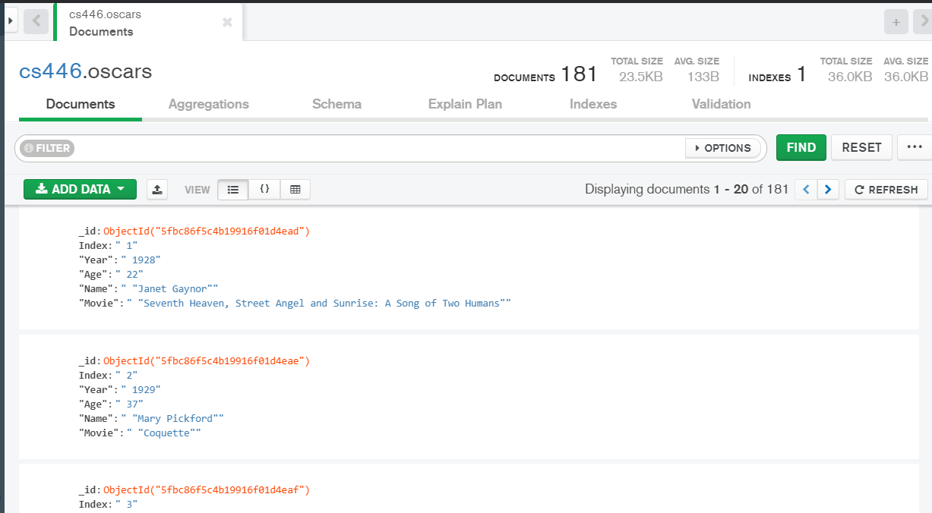

2. Shall implement the following “post” method.
http://<servername>:<port>/populate

Example:
When a client sends the following json data with a post method, the server shall store the data in the “oscars” collection.

{
"Index": "999",
"Year": "2020",
"Age": "51",
"Name": "Renee Zellweger",
"Movie": "What/If"
}
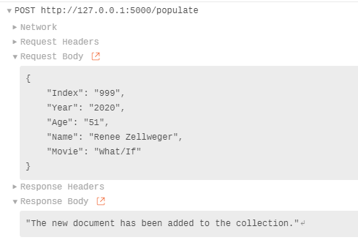
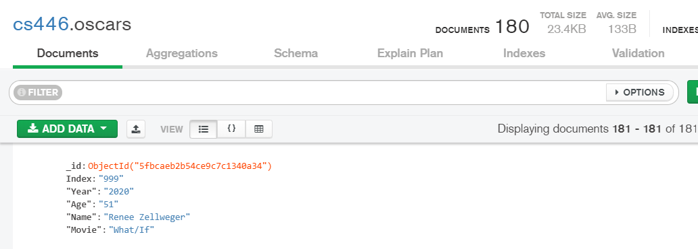

3. Shall implement the following “get” method.
http://<servername>:<port>/index

Example:
When a client sends the following json data with the “GET” method, the server shall search the data in the “oscars” collection and respond with correct result:

Request:
{
"Index": "999"
}
Response:
{
"Index": "999",
"Year": "2020",
"Age": "51",
"Name": "Renee Zellweger",
"Movie": "What/If"
}

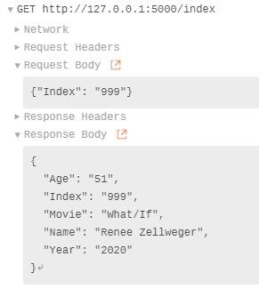
4. Shall implement the following “get” method.
http://<servername>:<port>/year

Example:
When a client sends the following json data with the “GET” method, the server shall search the data in the “oscars” collection and respond with correct result:

Request:
{
"Year": "2020"
}
Response:
{
"Index": "999",
"Year": "2020",
"Age": "51",
"Name": "Renee Zellweger",
"Movie": "What/If"
}

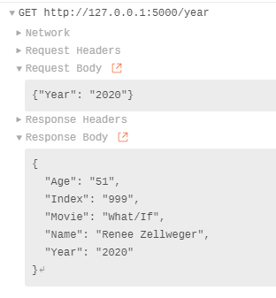

5. Shall implement the following “get” method.
http://<servername>:<port>/age

Example:
When a client sends the following json data with the “GET” method, the server shall search the data in the “oscars” collection and respond with correct result:

Request:
{
"Age": "51"
}
Response:
{
"Index": "999",
"Year": "2020",
"Age": "51",
"Name": "Renee Zellweger",
"Movie": "What/If"
}

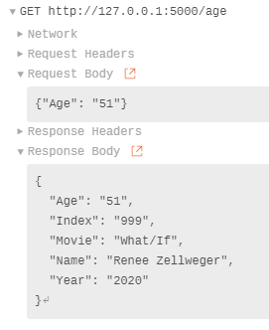

6. Shall implement the following “GET” method.
http://<servername>:<port>/name

Example 1:
When a client sends the following json data with the “GET” method, the server shall search the data in the “oscars” collection and respond with correct result:

Request:
{
"Name": "Zellweger"
}

Response:
{
"Index": "999",
"Year": "2020",
"Age": "51",
"Name": "Renee Zellweger",
"Movie": "What/If"
}

Example 2:
When a client sends the following json data with the “GET” method, the server shall search the data in the “oscars” collection and respond with correct result:

Request:
{
"Name": "Renee "
}

Response:
{
"Index": "999",
"Year": "2020",
"Age": "51",
"Name": "Renee Zellweger",
"Movie": "What/If"
}

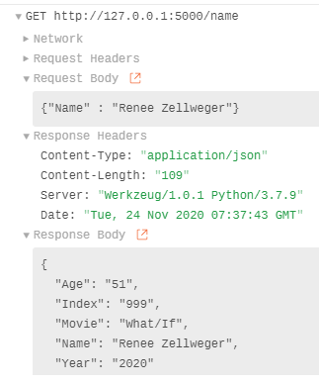

7. Shall implement the following “GET” method.
http://<servername>:<port>/movie

Example 1:
When a client sends the following json data with the “GET” method, the server shall search the data in the “oscars” collection and respond with correct result:

Request:
{
"Movie": "What"
}

Response:
{
"Index": "999",
"Year": "2020",
"Age": "51",
"Name": "Renee Zellweger",
"Movie": "What/If"
}

Example 2:
When a client sends the following json data with the “GET” method, the server shall search the data in the “oscars” collection and respond with correct result:

Request:
{
"Movie": “If"
}

Response:
{
"Index": "999",
"Year": "2020",
"Age": "51",
"Name": "Renee Zellweger",
"Movie": "What/If"
}

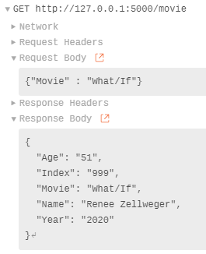

8. Shall implement a “GET” method for the following URL.
http://<servername>:<port>/movie/<string:if>

Example:
When a client tried to open the url http://<servername>:<port>/movie/if , the server shall search the data in the “oscars” collection and respond with correct result:

Response:
{
"Index": "999",
"Year": "2020",
"Age": "51",
"Name": "Renee Zellweger",
"Movie": "What/If"
}

- Grade:
Total: 25

- Submission
- Create a <Lastname>_Assignment3 folder. Place your code (<Lastname>_Assignment3.py) in this folder.

- Take a representative screen capture of each functionalities (1 to 8) while your program is in action. Save the screen capture images your program. Name the images of B, C, and D requirements: <LastName>_Assignment3_image1.png

<LastName>_Assignment3_image1.png

….

<LastName>_Assignment3_image8.png

- Place all the files in the <LastName>_Assignment3 folder:

- Compress <Lastname>_Assignment3 folder and create zip a file named <Lastname>_Assignment3.zip

- Upload <Lastname>_Assignment3.zip to Assignment3 Assignment dropbox.

