GEAR VR Samsung

Technical Specification
source: https://www.sizescreens.com/samsung-gear-vr-2017-specifications/
Type Screen | Super AMOLED
Diagonal Size (inches) | 5.1 – 6.4 inches  depends on smartphone
Size (mm/in) | depends on smartphone
Aspect ratio | 16:9/18.5:9  depends on smartphone
Pixels Per Inch (PPI) | depends on smartphone
Resolution | 2560 × 1440 px (QHD) /  2960 × 1440 px (QHD+)  depends on smartphone
Refresh Rate | 60 Hz or above
Field of view | 101°
Lens (Type/D) | n/a
Interpupillary distance (IPD) | 62 mm
OS/Apps | Android  Oculus Store/SamsungVR/  Google Play
Control | Touchpad and buttons on the right side
Controller | Yes
Sensors | Accelerometer, Gyro Sensor,  Proximity Sensor
Connections | USB Type-C & Micro USB,  USB Type-C for power connection,  OTG USB memory,  3rd-party controller
Dimensions of VR (mm) | 207.1 × 120.7 × 98.6
Weight (g) | 345  (excluding phone)

Source: https://www.samsung.com/ph/wearables/gear-vr-r323/SM-R323NBKAXTC/
101° FOV
345 g Weight (g)
Accelerometer, Gyro Sensor, Proximity Sensor Sensors
98.6 x 207.8 x 122.5 mm Dimension (HxWxD)
source: https://www.samsung.com/za/support/mobile-devices/what-are-the-specifications-for-the-new-samsung-gear-vr/
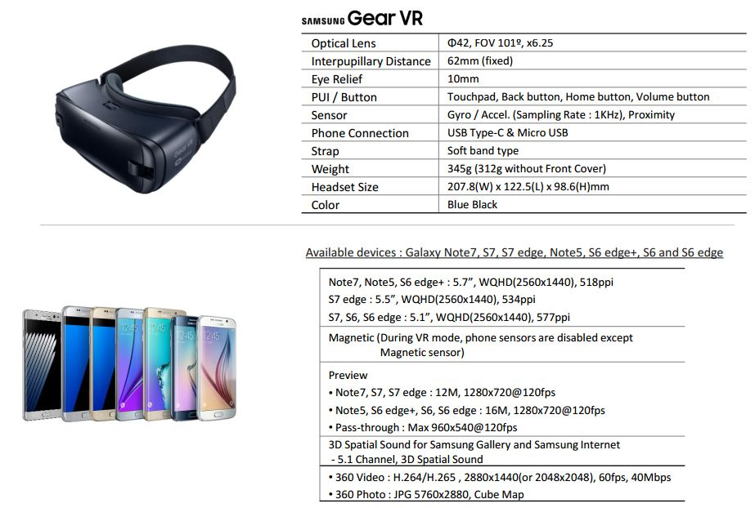

VR HACK
https://techshift.net/how-do-you-hack-gear-vr/
https://www.are.na/ultimape/vr-samsung-gear-vr-hacks
https://www.divideworks.com/projects/hack-your-gear-vr
https://www.roadtovr.com/students-hack-positional-tracking-onto-gear-vr-steamvr-tracking/ (++++)
http://androaddyct.blogspot.com/2016/11/run-any-vr-app-and-game-on-gear-vr-no_15.html?m=1
https://youtu.be/tE4SfFLI_mg

